Importing CVR Data into an Excel Spreadsheet using Microsoft 2010

- Open the text file on the CD. Right click on the screen, and choose “Select All”:

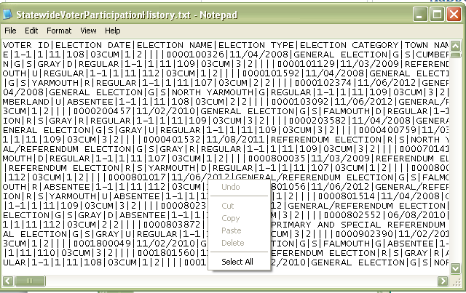

- Right click on the screen again, and choose “Copy”:

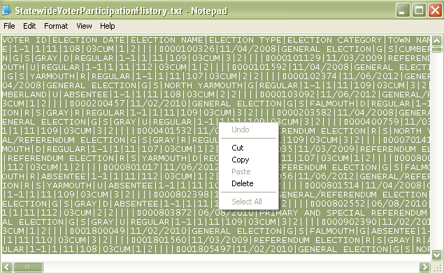

- Open up a new Excel spreadsheet and place the cursor in the first cell. Rick-click in the cell, and choose “Paste”:
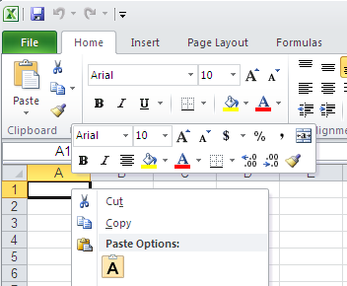

- The copied text file will appear in the spreadsheet. The text file is a “pipe-delimited” file, which means that each field (column) is separated by the “pipe” character on the keyboard. You will see these “pipe” characters in the data you just copied into the spreadsheet.

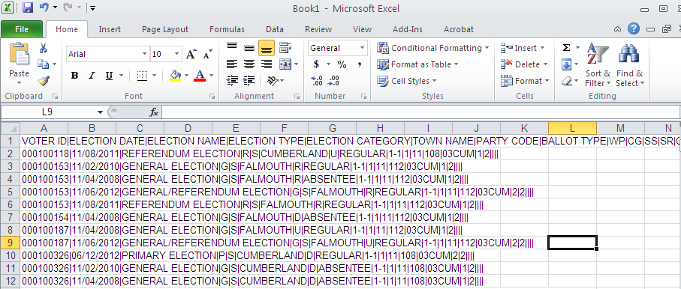

- Excel converts the “pipe” delimiters to columns using the “Text to Columns” feature. An icon for this is found under the Data ribbon:

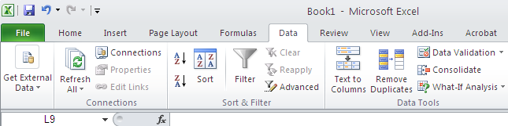

- Click on the Text to Columns icon, and a conversion wizard will appear. Choose “Delimited” as the file type, and click “Next”:

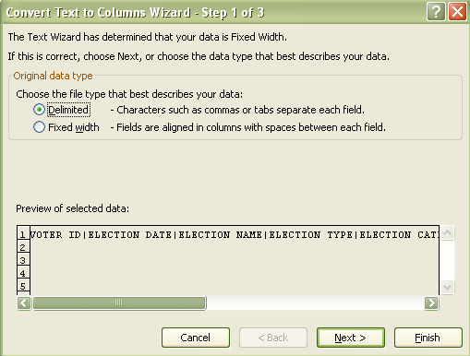

- On the next screen, you will indicate that the delimiter is the “pipe” character. Check the box next to “Other”, deselect any other boxes that are checked, and place the “pipe” character in the selection box (the “pipe” character is located under the Backspace button on your keyboard; as an upper case character):

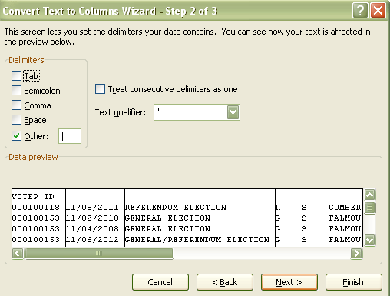

- Click on “Next”, which takes you to the next screed of the wizard. Here, you need to designate any columns containing numbers as Text, so they will sort properly. Scroll to the right to get them all:

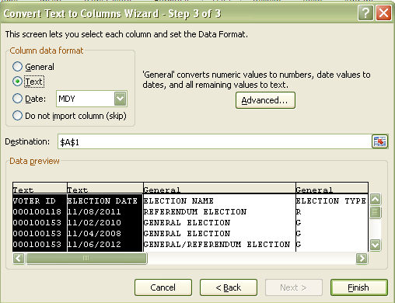
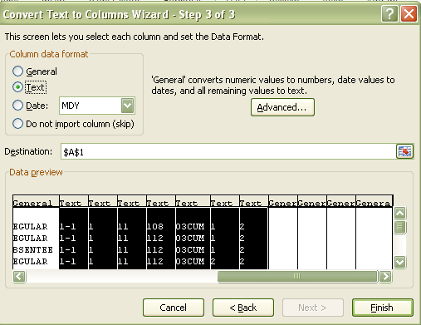

- Click “Finish”, and the data should now appear in columns.

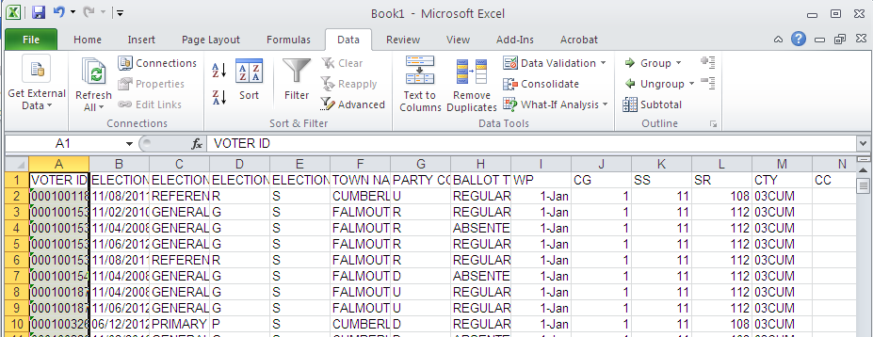

- Adjust your column widths and apply any formatting that you want to the spreadsheet.

