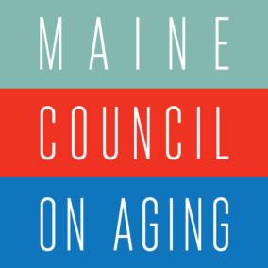

2018 Wisdom Summit
Maine Blueprint for Action On Healthy Aging

Blueprint for Transportation

According to Maine's 2025 Strategic Transit Plan, nearly a third of older Mainers “live in communities without access to fixed route transit or one of the larger flex route transit systems”. Plus, only a handful of communities are served by volunteer driver programs. While volunteer programs help allow non- driving residents remain at home and still access food, friends, and care, they are disconnected from
public transit providers and are not networked together. Generally, transportation options are not linked or well-coordinated, challenging riders to navigate the transportation options that will work for them.

Recommendations
    - Increase transportation accessibility and coverage options. Start by surveying all transit options and sharing that information broadly.
    - MCOA: Continue to collaborate with Maine Department of Transportation (DOT) to build a volunteer transportation network that supports, connects and grows Maine’s current volunteer driver programs, and connects these networks with public transit options.
    - Streamline available transportation services by addressing barriers that limit kinds of riders and coordinating service. (e.g. 2 mostly empty buses going to the same location dropping off different types of people). In Portland, older kids going to school can ride public buses at no cost.
    - Maximize public funding of transportations at all levels - municipal, state, and federal - through reducing limitations and increasing coordination and information sharing.
    - Pilot expanded transportation services in very rural areas – i.e. to the end of every dirt road.
    - Encourage development/deployment of technology that can assist people easily finding the ride they need.
    - Support the emerging statewide mobility network called Moving Maine, and consider whether that network can help solve larger transportation needs.

Legislative/Government
    - Support DOT’s leadership in coordinating transportation networks (formal and volunteer).
    - Explore options for accessing non-medical transportation as a benefit under Medicaid.

