Central York County Connections Study
Advisory Committee Meeting
September 27, 2011 10-1 pm
Alfred Parish Church, Alfred

Attendees: Leo Ruel, Lyman; Suzanne McKechnie, Region Economic Growth Council; Chris MacClinchey, Southern Maine Regional Planning Commission; Brad Littlefield, Sanford; Larry Torno, Lebanon; Geoff Titherington, Bonanza, Sanford; Hazen Carpenter, Springvale; Denis Rioux, Biddeford Conservation Commission; Diane Robbins, Arundel; Donna DerKinderen, Arundel; Ken Creed, York County Community Action; Gerry Audibert, MaineDOT; Sara Devlin, MTA; Uri Avin, Parsons Brinckerhoff; Steve Rolle, Parsons Brinckerhoff; Carol Morris, Morris Communications; Ben Ettelman, Morris Communications

Meeting began at 10:05

Gerry Audibert: Good morning and thank you for coming to this Advisory Committee meeting for the Central York County Connections Study. Today we have a lot of new data to share with you. We want to know your thoughts as we look at this new information today. In Phase III, we will continue to look at the strategies in even greater detail but I do want to note that we are not looking at specific alignments. All of the strategies are conceptual in nature. That being said, we continue to refine what we understand as the local impacts and benefits for each strategy. I want to emphasize that no decisions have been made regarding any of the information or strategies that we are going to share with you today and no decisions will be made today. We are strictly sharing what we have learned so far and asking that you folks provide feedback on what you hear. Thank you.

Carol Morris: Good morning and thank you for coming this morning. The agenda for today is as follows:

- Welcome and Study Update
- Agenda Overview/Timeline
- Phase II MOE Results
- Additional Discussion
- Other Factors
- Phase III Tasks
- Next Steps

The project timeline is as follows:

- Phase I: Study Initiation: Sept. 2010 – Dec. 2010
- Phase II: Initial Development and Evaluation of Conceptual Strategies: Nov. 2010 – Oct. 2011
- Phase III: Detailed Screening and Evaluation of Strategies: Nov. 2011 – April 2012
- Phase IV: Study Finalization: April 2012 – July 2012

We are currently in Phase II, we will be moving into Phase III after we receive public comments from you and at the upcoming public meeting and we will be looking to wrap the study up by July 2012.

In Phase II, I want to remind you that we intentionally looked at very extreme concepts in order to understand the full effect of the potential benefits and impacts of increasing transportation connections in central York County. We have talked about the majority of the MOEs in previous meetings and we will review those with you today. Today, we will primarily be focusing on cost and economic benefit MOEs. As we move into Phase III, we will be looking at more focused strategies, so what we talk about today is just a piece of the picture - we will focus on more details in the next phase.

The goals of today’s meeting are as follows:

- Committees’ full understanding of benefits and impacts of the Phase II highway strategies
- Discussion of other factors contributing to which strategies move forward
- Clear understanding by the Study Team of each committee member’s opinion
- Understanding of Phase III Tasks
- No Decisions Will Be Made Today

Uri Avin presents a slide showing the nine Regional Strategies

Uri Avin: Good morning and thank you for being here today. This slide shows the nine regional strategies that we have been evaluating, with which you are all familiar.

Uri Avin presents a slide showing the three Local Strategies

In this slide we show the three local strategies that we evaluated and will also be discussing today.

The following are the MOEs for Phase II. The black MOEs are those that we have discussed in previous meetings. Today we are going to focus on the MOEs in red:

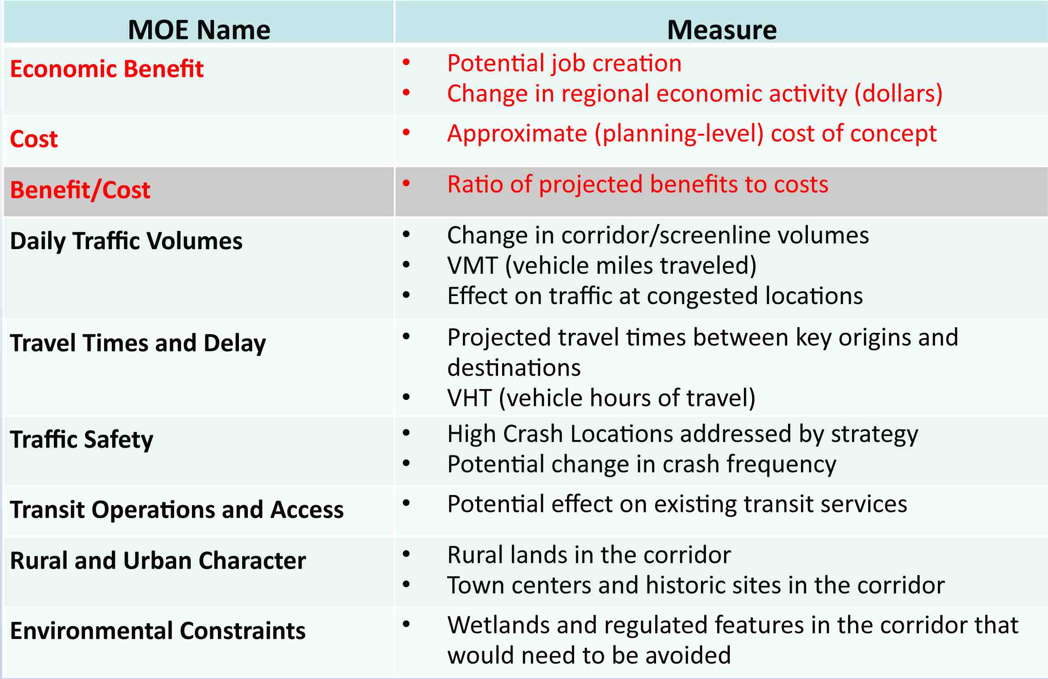

We have decided to add a benefit/cost analysis MOE for this phase as MaineDOT and MTA decided that even at this level it would be worthwhile to see what the relative cost/benefit of each strategy is. Doing this additional work is what has extended the time between the last meeting and this one.

We converted the data into a simplified ranking format in order to more easily summarize the strategies and to compare the impacts and benefits of each strategy relative to each other. Your handout has the cutoff points and more detail on the MOEs. The following is a summary of how each strategy fared under each Phase II MOE:

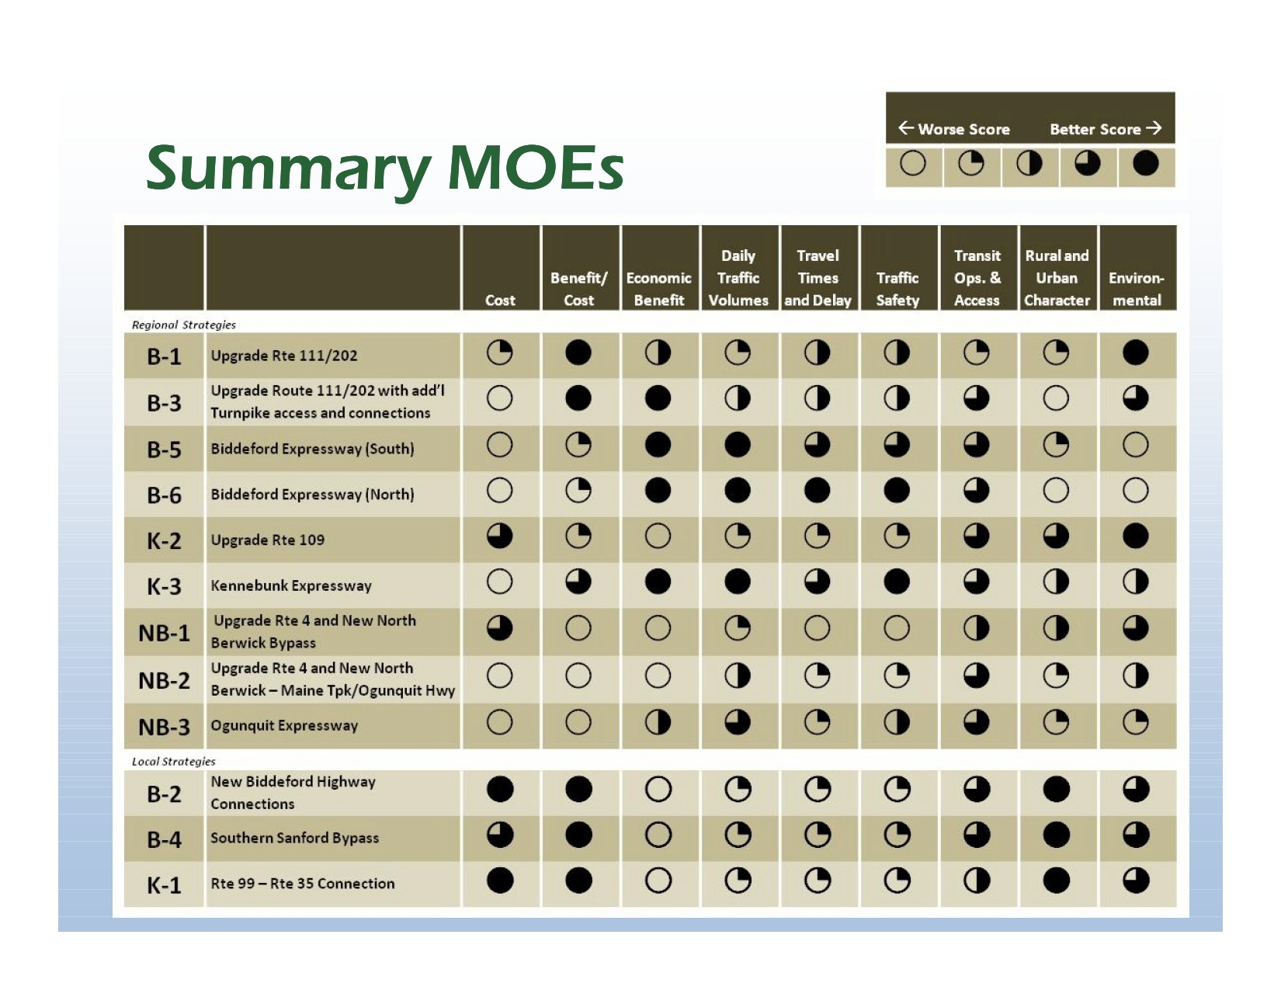

When you step back and look at this chart some patterns do emerge. You’ll see that the three NB options on the whole do not look very good. K3 does fairly well. B5 and B6 do well on a few MOEs but fare poorly in others. In general the strategies are a mixed bag in terms of how they measure up against all of the MOEs.

Steve Rolle: I am going to talk about the capital costs of the strategies. We estimated capital costs even though these strategies are still conceptual at this point in the study. The following elements were involved in deriving costs:

- Construction Costs:
  - Generic right-of-way (ROW) costs
    - 12% to 20% of construction cost
    - Adjusted to reflect approximate share of new ROW needed.
  - Unit construction costs
    - Based on quantities (miles, square feet, etc)
    - Components include roadway, structures and intersection improvements.
- Lifecycle costs estimated separately: Investment in rehabilitation and replacement (R&R) over 100-year project lifetime.

The following slide summarizes the construction costs that we calculated based on the previous parameters:

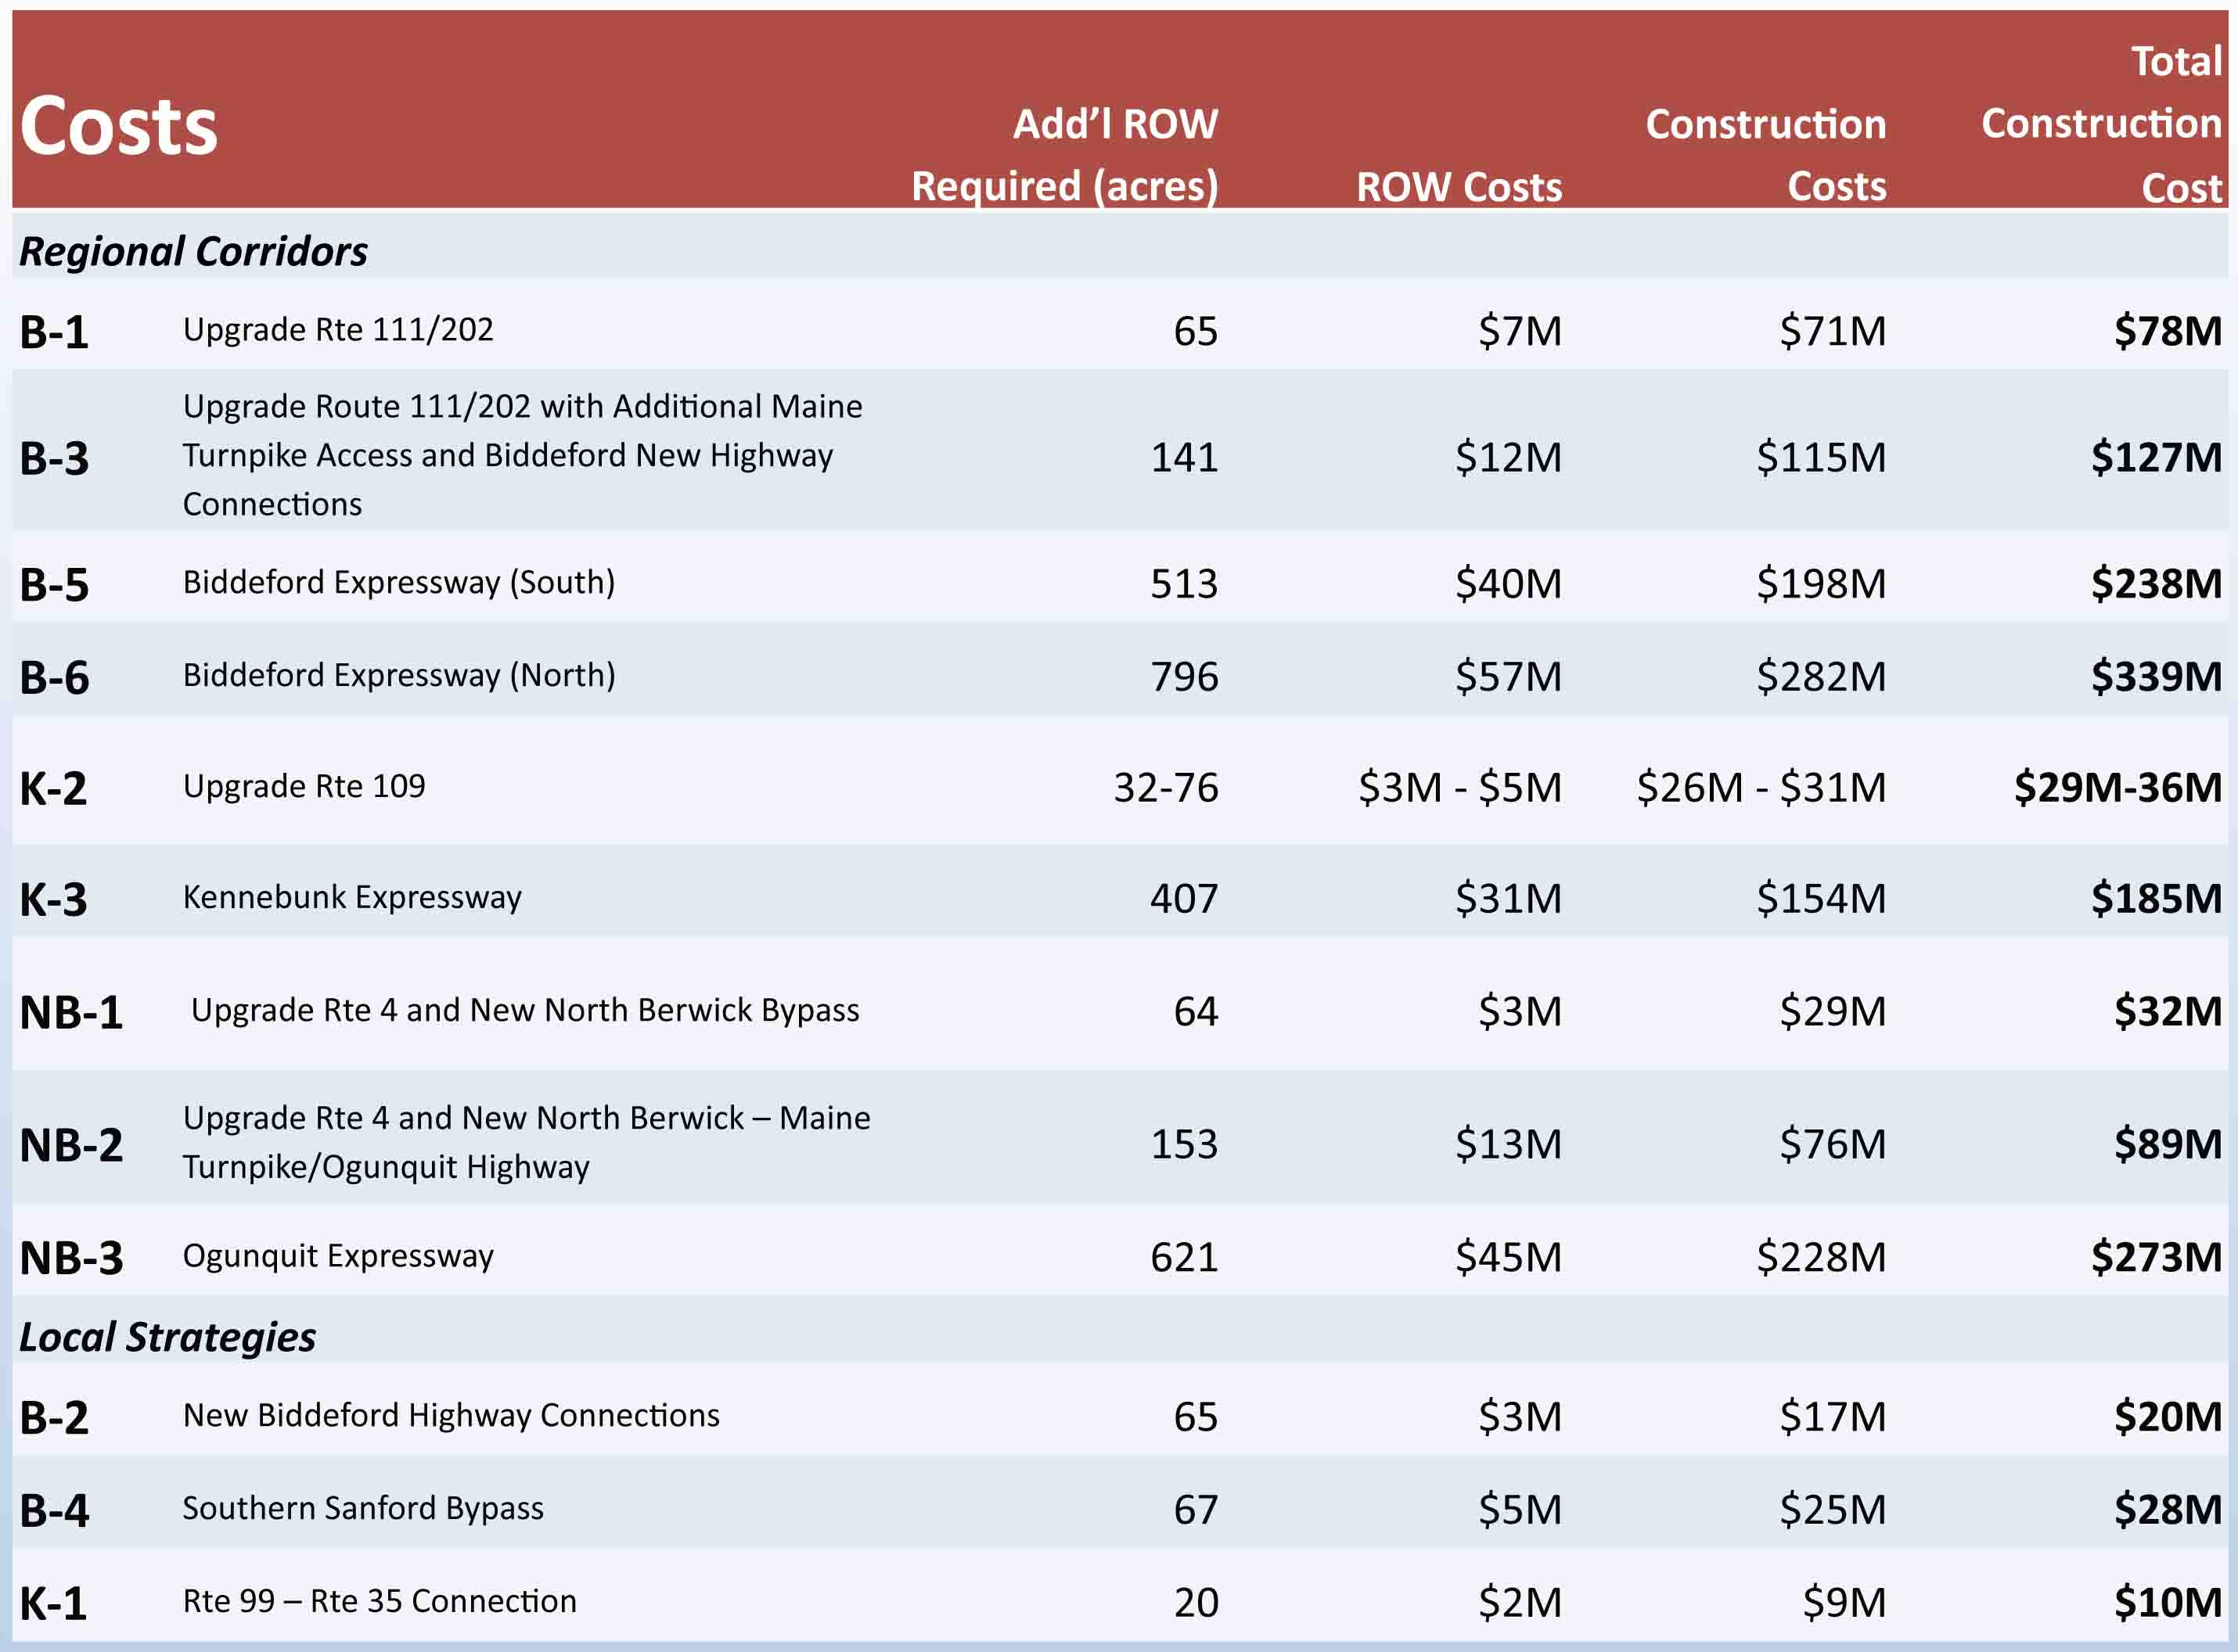

The new alignments - and especially expressways – have very high costs, from $185 million and up. For comparison purposes, the Wiscasset Bypass project was estimated at $115 million. The corridor upgrades, which are aggressive expansions, are also generally quite costly.

Another new piece of analysis that we did was the benefit/cost analysis. There is a well-developed, standard approach to performing benefit/cost analysis and the MaineDOT and FHWA have established parameters that are used for the analysis. We look at the following benefits:

- State of Good Repair (Reduced pavement damage)
- Economic Competitiveness (Travel time savings, reduced users’ costs [fuel, operating & maintenance] and oil imports)
- Livability (Reduced noise)
- Sustainability (Reduced emissions)
- Safety (Crash reduction)

We calculate a dollar amount for the benefits – in this case over a 25-year period - and compare that to the cost of the project.

Gerry Audibert: The overriding reason to do benefit/cost ratio at this stage was to do a reality check, as some of these strategies show huge costs. We want to find out if there are significant benefits. When you look at the benefits divided by the cost, if you are significantly under 1, you are looking at a poor investment. We need to somehow monetarily determine if the investment is worthwhile. We will do another round of benefit/cost analysis in Phase III.

Steve Rolle: Again, the MaineDOT, FHWA and other agencies have documented costs that are assigned to things such as time savings and accidents, for example. The following are the resulting benefit/cost ratios, with anything with over 1 considered to provide benefits of greater value than the cost of the initial capital investment plus periodic rehab and eventual replacement (R&R) costs. Because we have conducted the analysis at a fairly conceptual level of development, 1 should probably not be considered a strict cut-off point, though the results still offer some strong indications of potential cost effectiveness:

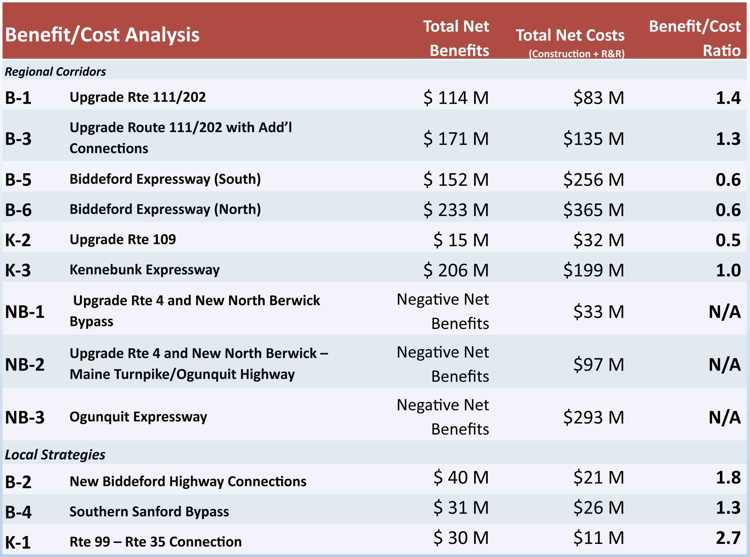

Another thing worth noting is that the analysis was conducted using models and tools that are really meant to assess the larger scale projects, so the results for the local strategies (B-2, B-4, K-1) involve a little more uncertainty in terms of whether the benefit/cost ratios might be a little overstated.

Geoff Titherington: The work that is being done on Route 109 to Wells will cut down on traffic congestion. When you do benefit/cost ratios, do you take into account that if there was a new road from Route 202 to Route 111 it would take truck traffic off local roads, so local roads would last longer?

Steve Rolle: Yes. For this exercise we looked at truck benefits and auto benefits separately. We ran two different models, one that looks at auto traffic and another that looks at truck travel patterns. Pavement damage is one of the factors that we look at, as well as noise emitted by truck traffic. So those are accounted for.

The next thing we looked at was to specifically consider the benefits to the regional economy. PRISM is a model that was used to quantify the economic benefits expected for each strategy. PRISM evaluated the following three factors:

- Gross Regional Product (GRP) – value of all goods and services generated in a region.
- Effects of monies re-circulating through the regional economy
- Jobs created
  - Not an estimate of jobs or economic production shifted within a region, but new jobs/economic production drawn to the region

The following bar chart shows the results of the analysis in terms of Gross Regional Product (GRP) and monies recirculating through the local and regional economy:

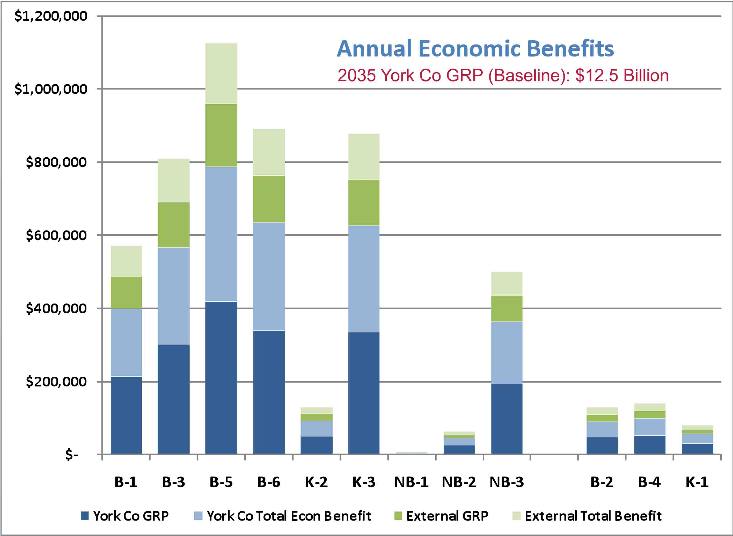

The dark blue represents increased GRP in York County. The dark green also represents increases in the GRP, but occurring outside of York County. The light shade of both the green and blue represents the re-circulating of that money going back into the economy for both York County and external areas. These are annual benefits projected for the year 2035 (but shown in current dollars); they range from $600,000 to $1.1 million in annual benefits. To put that in context though, in 2035 the gross regional product of York County is estimated to be $12.5 billion, so this really shows a very small incremental change to that total amount, relative to the entire county-wide economy.

Hazen Carpenter: I am surprised that K3 scored so highly on economic impacts. What is the economic benefit of going to Kennebunk?

Steve Rolle: In some regard, it mimics the effects of the Biddeford corridor options. If you are in south Sanford, by the airport, the Kennebunk option (K3) is a convenient way to get to the turnpike and travel toward Portland. But it also potentially could serve travelers heading south on the turnpike. The other important aspect to consider is that there are benefits to people who do not use this new route at all. This new road takes traffic off of both Route 111 and Route 109, so users of those roads are seeing reduced congestion.

Gerry Audibert: It’s not that people are going to Kennebunk; people are traveling to the turnpike and then traveling to Portland or to the Portsmouth/Boston area. K3 cuts the time in that sense.

Hazen: I don’t think there are products that are made in Sanford that are going north; most things are going to and coming from the south.

Uri Avin: When you look at the daily traffic volumes for Routes 111 and 202, the 2035 baseline is projected to be between 20,000 and 29,000 trips per day. If you look at K3 for example, you will see that that projection lowers daily trips on Route 111 to 15-25 thousand trips.

Diane Robbins: How are you getting to that number?

Uri Avin: We run a travel model that is set up for the entire region and is adjusted to reflect current traffic patterns and then you project out into the future. It projects the change in trip patterns.

Steve Rolle: That data was one of the items we reviewed at the last meeting.

Diane Robbins: Is historical data reflected in that as well? Does it look at 20 years ago compared to today?
Steve Rolle: Yes. The land use forecasts, which determine the volume of traffic growth that is expected in the future, consider historic trends..

Donna DerKinderen: What time of the year is assumed when using this model?
Steve Rolle: The model is adjusted to reflect a “typical summer day.” The volumes are adjusted to correspond to traffic count data that generally matches the peak conditions for the 30th busiest day of the year.

Donna DerKinderen: If you assume 13 weeks of summer, 5 weekdays, that’s 65 days a year, which represents 17.8% of the actual travel time in a given year. If you are using that as your baseline, I don’t think your data is accurate to begin with. Route 111 has very distinct travel patterns and if you put your counters out at one time you will get a very different number than if you put it out at another time. To consider rebuilding a road based on the peak time, and trying to solve a problem that doesn’t exist more than 75% of the time seems wrong to me. Additionally, looking at the economic data, a $400,000 dollar increase for the economy is an increase of only .0032% over the baseline. Why bother spending hundreds of millions of dollars for such a negligible increase?

Carol Morris: That is why we are here today, to have that discussion. There have been no decisions made and this process is about understanding what the benefits and impacts are and to discuss your opinions towards them.

Steve Rolle: Those are good points. In terms of the assumptions we made for the traffic modeling, adjusting to the peak volume for the 30th busiest day is standard engineering practice for the transportation planning industry here and throughout most of the country. When you look at traffic fluctuations throughout the year, the 30th busiest is actually fairly representative to what you see for much of the year. The top 15% is generally much higher and that is where you see major increases in traffic volume. We don’t plan or build for that peak, and that is the reason the 30th busiest day is used as standard practice. Maine is different, particularly along the coast because of the intensity of traffic in the summer months but in the interior of the county this is accurate.

Carol Morris: The 30th busiest day is considered the best practices way to measure traffic throughout the country and so it gives us an apples to apples comparison to use as we work towards a decision.

Gerry Audibert: The traffic demand model was developed based on a statewide model that MaineDOT has developed over the years. The model we used for this project is a combination of our model, the model developed for the ME-NH Connections Study and Southern Maine Regional Planning Commission’s model, so it is specific to this area. We put counters (the rubber tubes) out every year in southern Maine and we do three-day counts. We do it in the spring through fall and make sure to do a count during June, July and August in order to account for the busy summer months. We apply factors to the data depending on when it was collected. That gets us to the 30th busiest hour, which as Carol noted is the industry standard. For some of the coastal communities we apply a seasonal factor, as there are huge increases in summer. We are comfortable with the model results, but it is a model. In planning, there are assumptions that we have to make. In terms of the economic impacts, the $400,000 increase over $12.5 billion tells the story. Those economic realities are part of the story, we will continue to look at all of the pieces of the puzzle and today, again, we are here to share what we found and hear comments.

Steve Rolle: It’s important when looking at any traffic analysis results to recognize that there is uncertainty involved. For example, we are projecting out to 2035 and don’t really know whether we will realize the growth that we are projecting. It may be higher, or it may be lower, but it’s our and Charlie Colgan’s best guess at reasonable representation of conditions at this time. Because of the various uncertainties involved in projecting conditions, it’s best to think of these as indicators of potential future results, rather than black or white judgments.

Suzanne McKechnie: Does the economic take into account the potential growth of tourism?
Steve Rolle: We need to check with the economist that developed the model. I think so, but I want to confirm.

Suzanne: McKechnie: Right now Sanford gets 60,000 tourists that travel through town in the summer time.

Uri Avin: I believe it is included in the industry categories, we will check. (NOTE: Tourism was included as part of sectors under headings like recreation and hospitality industries.)

Gerry Audibert: When we get to Phase III we will look into more detail regarding induced growth of tourism.

Steve Rolle: This is another case where the economic analysis would not capture any shifting of economic activity within the region (York County). Only new economic activity is reflected.

Diane Robbins: The problem on Route 111 is the lack of speed limit signs and people travel below the speed limit. There also are a number of speed limit changes that cause traffic not to flow.

Gerry Audibert: What you are mentioning are some of the items we will hit on in the next phase, particularly access management. The speed limits are set at the 85th percentile as that is the speed that most people are comfortable driving. Things like curb cuts, hills and curves affect speed limit as well. I would assume that these speed limits were based on traffic engineer analysis. Speed zones have been reviewed and they probably were reduced based on safety concerns. There were a number of fatalities a few years ago on Route 111.

Diane Robbins: Not where the 45 mph zone is. That’s because of the bank and the storage facility. The majority of the fatalities on Route 111 are “Operating Under the Influence” drivers and they don’t belong on the road anyway.

Uri Avin: Looking at the number of minutes reduced based on these strategies, you’ll see that the reductions are very small. That is partly because the roads are not very congested.

Carol Morris: To some extent that translates into why we didn’t find a huge amount of economic benefit - the time savings is not that big.

Donna DerKinderen: Are we spending a lot of time and money trying to solve a problem that doesn’t exist?
Uri Avin: The goal of the study was to look and see if there was anything that you can do in terms of transportation improvements that will have economic benefits for the greater Sanford area. What the data is showing is that the transportation improvements are not really having a substantial impact. When you balance that against the cost, you have unfavorable results. The direction you are heading is the conclusion that we are seeing at the end of this phase of the study.

Diane Robbins: You might get more benefit out of doing the small things.

Uri Avin: The study was based on the idea that there should be economic benefit and help to central York County. We can make movement and safety better but it won’t necessarily make a difference to the economic potential of the area.

Diane Robbins: I think there is a roadblock with the 35 mph zones.
Uri Avin: When we model the traffic we are assuming higher speeds and we didn’t see any significant economic benefits, even at higher speeds.

Steve Rolle: We looked at all of the strategies separately, so if we looked at expanding Route 111, we assumed existing conditions on Route 109, for example. There are a number of small improvements that we could look at on the Route 111 corridor.

Gerry Audibert: We looked at passing lanes on Route 111 in a previous study.

Diane Robbins: When you come out of Biddeford its 40 mph. The police strictly enforce that speed limit. When the speed limit increases people don’t realize that. If you improved signage you would keep traffic moving.

Gerry Audibert: Analysis shows that even with better signage and people following the speed limit, you would only gain a couple minutes in travel times. Even with a new facility you are only gaining five minutes.

Dennis Rioux: Is there a difference between the Route 111 corridor in B1 and B3?

Steve Rolle: No, we assumed the exact same improvements to 111. The only difference was the connection to the Turnpike and local connections to Waterboro Road and Route 1 under B3.

Dennis Rioux: What is the difference between the summer months and the rest of the year, and might the 30th busiest day be skewed?

Steve Rolle: We will put together MaineDOT data on how they estimate seasonal variation and provide that to the group at a future meeting. NOTE: This information will be emailed to the committee within the next few weeks.

Diane Robbins: Do you do counts in the winter?

Gerry Audibert: We do counts in the spring, summer and fall. We also do more detailed analysis every third year in the southern part of the state.

Steve Rolle: And there is enough count data to see what the seasonal variation is.

Gerry Audibert: We do have the historic counts as well, we don’t go back too far because it depends on the economy.

Steve Rolle: Historically there was big growth in the late 80s, early 90s.

Chris MacClinchey: There are areas that have a year around count with radar in order to truth out the counts.

Steve Rolle: We are going to go back and quickly look at the following MOES, which we have reviewed in detail during prior meetings:

- Daily Traffic Volumes
- Travel Times and Delay
- Traffic Safety
- Transit Operations and Access
- Rural and Urban Character
- Environmental Constraints

The following is a summary of the Daily Traffic Volumes MOE:

- New Expressways (B-5, B-6, K-3, NB-3) would:
  - Reduce traffic on existing highways
  - Attract modest traffic volumes relative to capacity
  - Increase overall traffic volumes
  - Would generally improve congested locations, except for NB-2 and NB-3 in Ogunquit.
- Upgraded corridors (B-1, B-3, K-2, NB-1) would:
  - Attract more traffic to the upgraded highway.
  - Increase overall traffic volumes, but less so than new corridors.
  - Could adversely affect congested locations in Sanford and Biddeford without additional improvements (such as proposed in B3)
- Local Strategies (B-2, B-4, K-1) improve circulation in specific locations, but effects are limited to local conditions.

The following is a summary of Travel Time and Delay MOE:

- New Biddeford and Kennebunk Expressways (B-5, B-6, K-3) would result in the greatest improvement in specific point-to-point travel times and VHT reduction.
- Upgraded corridors in the Biddeford Corridor (B-1, B-3) also improve travel times and reduce VHT.
- Improvements in the North Berwick/Ogunquit Corridor (NB-1, NB-2, NB-3) were least effective in reducing regional VHT and point-to-point travel times.
- Local Strategies (B-2, B-4, K-1) have some effect on regional VHT, but do not improve point-to-point travel times for the regional trips studied.

The following is a summary of the Traffic Safety MOE:

- Measures:
  - Potential to physically improve current HCLs
    - Rated Low, Moderate or High
  - Potential change in crash frequency
    - This is a regional-scale analysis
    - Changes in the amount of travel
    - Changes in roads on which travel occurs
- Improvements in the Biddeford Corridor (B-1, B-3) are an opportunity to address current High Crash Locations on Route 111
- New corridors (B-5, B-6, K-3, NB-3) shift traffic from existing corridors with higher crash rates to new corridors with theoretically lower crash rates
- Increases in VMT partially offset this benefit, especially on NB-3.
- All strategies except NB-1 show some potential for reducing crashes
- All strategies, including NB-1, may have local crash benefits that cannot be identified in the regional context.

The following is a summary of the Transit Operations and Access MOE:

- Measure:
  - General assessment of how Phase II Highway Strategies might affect existing transit services.
    - Is the ability to access transit compromised or improved?
    - Could changes in traffic operations harm or benefit bus services on those corridors?
  - Phase II Highway Concepts are likely to only minimally affect access to transit
    - Wells Transportation Center may benefit from options that reduce congestion on Rte. 109
    - Biddeford Park and Ride may benefit from strategies that reduce congestion on Rte. 111 near exit 32
  - Options that reduce congestion on corridors used by bus transit may help bus reliability during peak periods

Chris MacClinchey: Are you only looking at existing service?

Steve Rolle: Yes, and what is out there today likely operates on the corridors that any future service would.

Ken Creed: In the immediate future yes. We have some things in the works for improvement but not for expansions as funding is very difficult to find.

Steve Rolle: The large providers that operate north of Biddeford to Portland were not affected because even the largest strategies did not meaningfully change traffic patterns north of Biddeford.

Chris MacClinchey: In Phase III, will you look at potential transit as a strategy to improve the conditions?

Steve Rolle: Yes, we will. We have had conversations with the transit providers, and we will continue to communicate with them.

Uri Avin: Okay, I am going to talk about the last two MOEs. The following is a summary of the Impacts to Rural and Urban Character MOE:

- Purpose: Assess potential to adversely affect rural and urban character
- Components:
  - ROW length in miles that traverse open fields and woodlands zoned for low density
  - Historic town centers, sites and districts
- New corridors largely affect rural lands
- Upgrades potentially affect parcels fronting on existing corridors, including historic sites and town centers
- Biddeford Corridor has the greatest amount of affected land (rural and urban)
- Route 109 Upgrade’s (K-2) score reflects a bypass completely around High Pine.

The following map shows the strategies and their potential conflicts with urban and rural character within the study area:

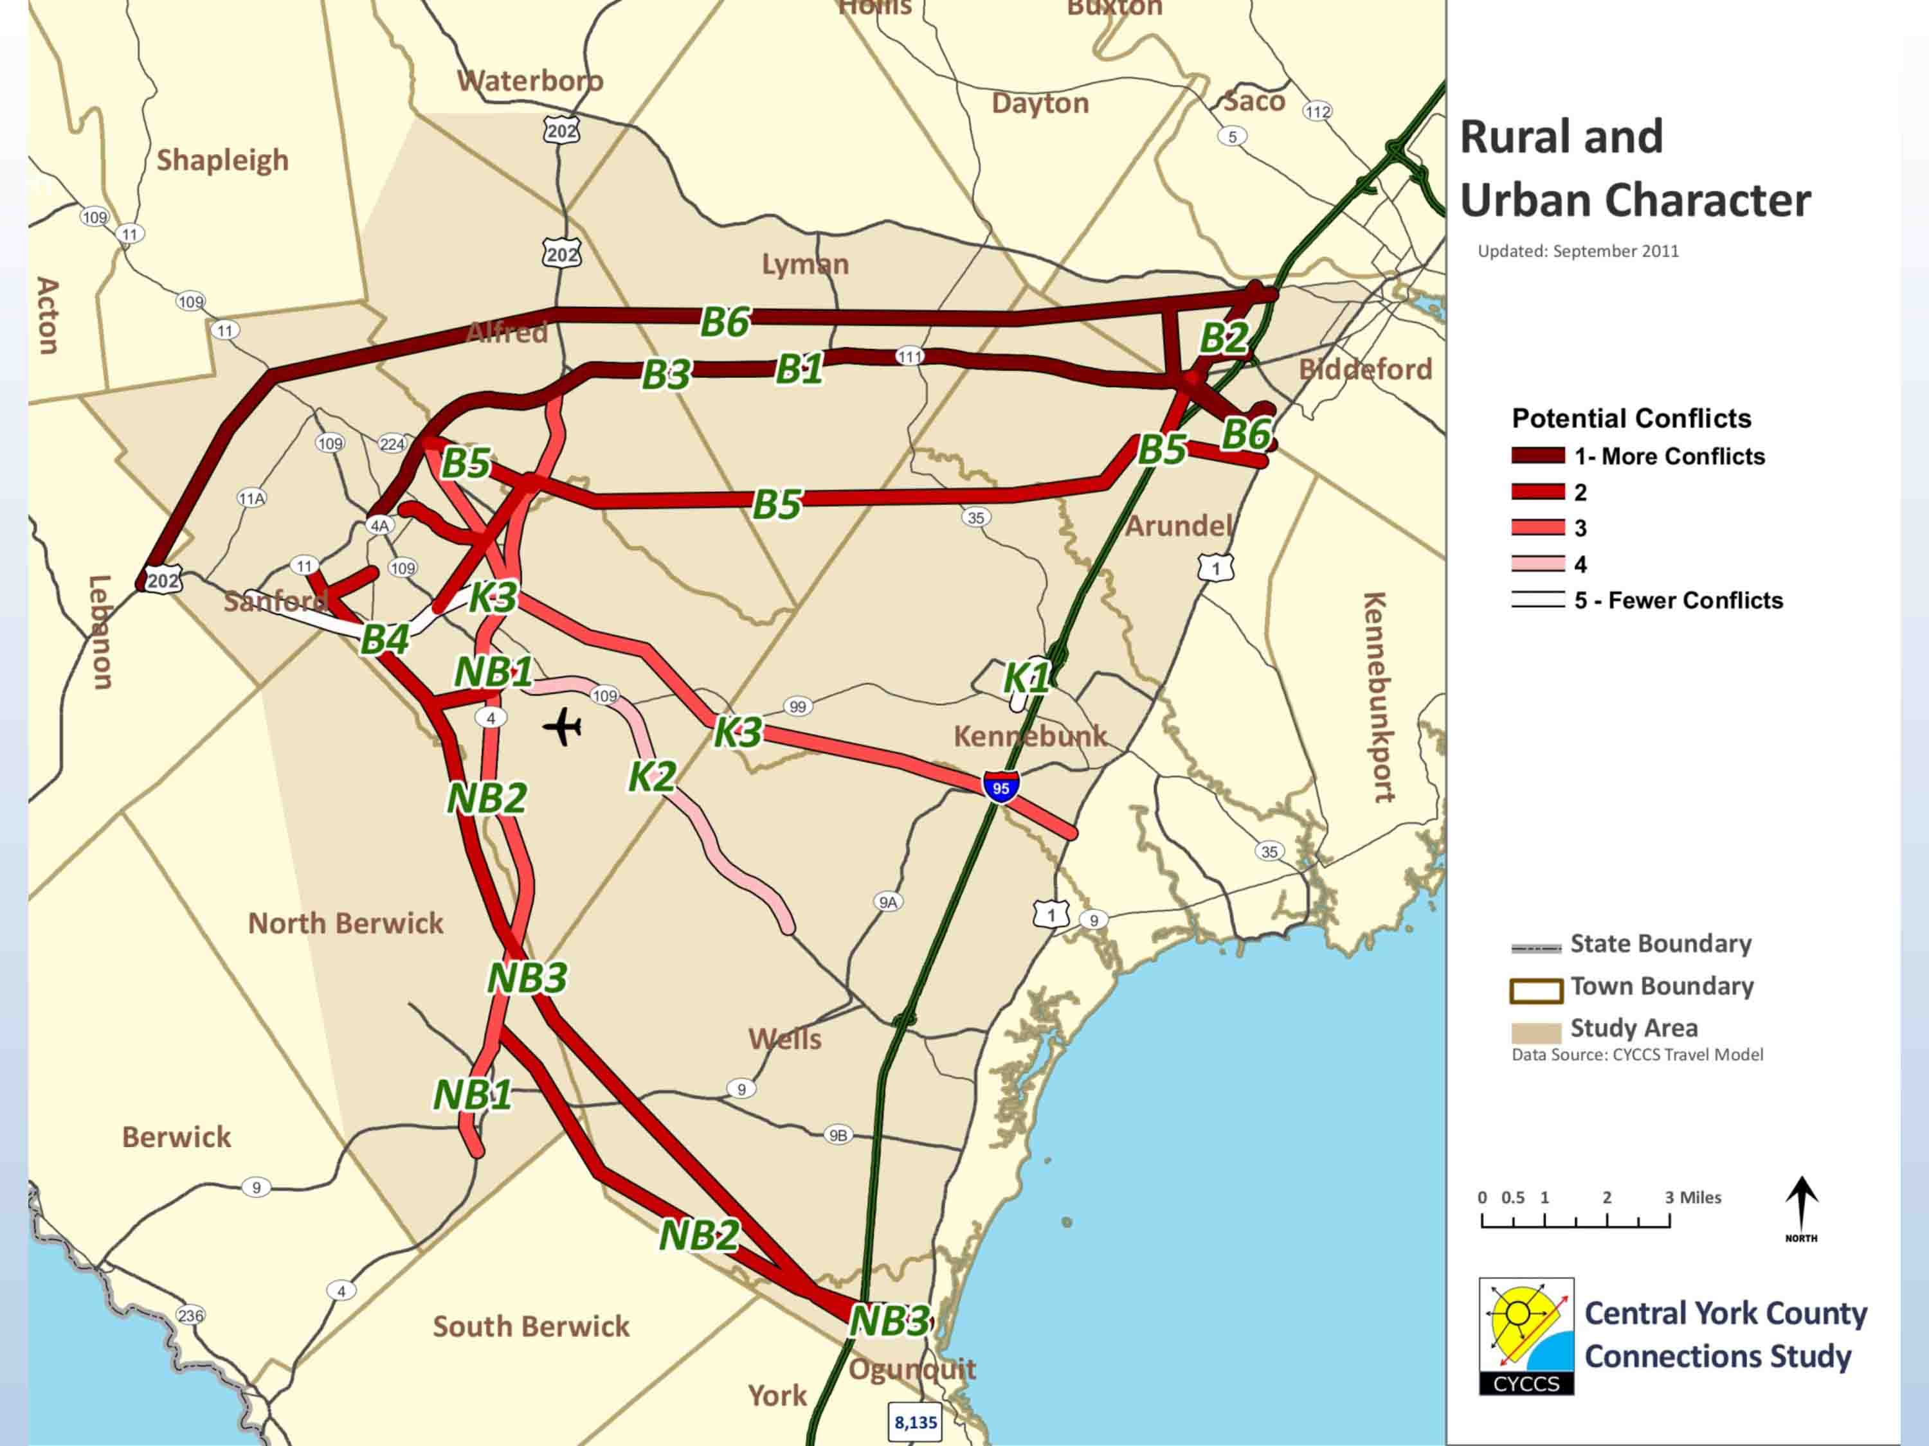

The darker lines represent more conflicts and the lighter shaded lines represent strategies that have fewer conflicts.

The following is a summary of the Environmental Constraints MOE:

- Purpose: Assess potential to affect environmental resources
- Components:
  - Wetlands
  - Other regulated natural resources
  - Miles of alignment
- Upgrades have fewer constraints because the ROWs have previously been developed
- New Expressways in the Biddeford Corridor (B-5, B-6) traverse the most land with regulated resources

The following map shows designated conservation areas within the study area:

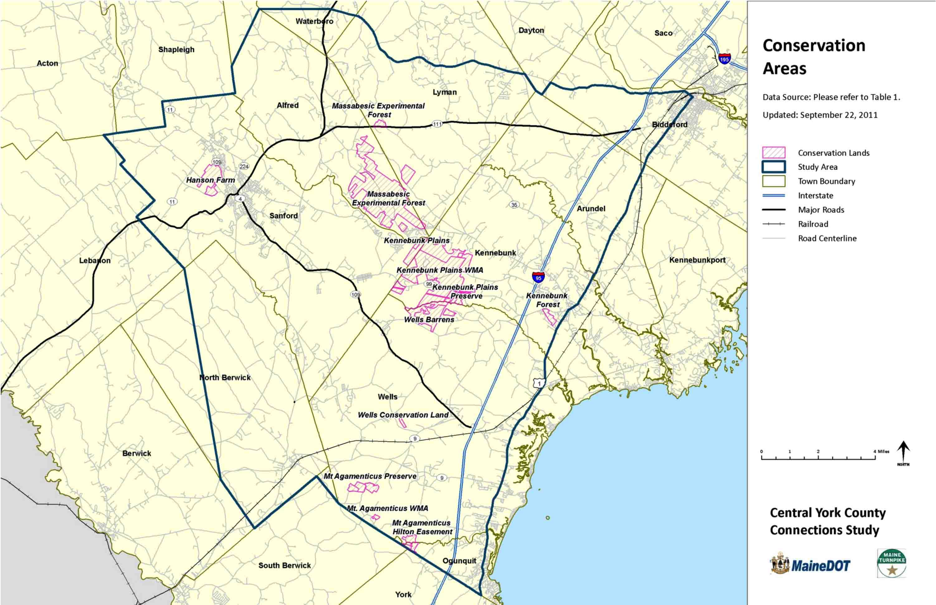

The following map shows each strategy’s conflicts with environmental constraints. The darker line represents strategies that have more conflicts and the lighter lines represent strategies that have fewer conflicts. The environmental resources are not weighted as to their intrinsic value and so the results are a generalized reflection largely influenced by their overall length:

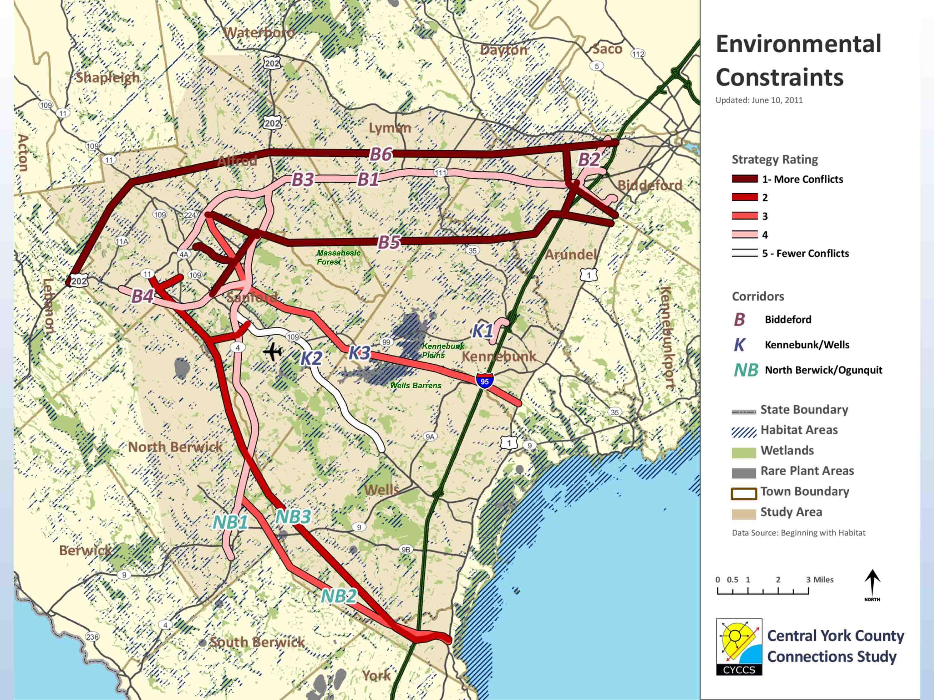

Chris MacClinchey: On the K3 corridor, I’m not sure if you pick up on the Branch Brook aquifer section, which is the source for the water for Kennebunk and Wells.

Steve Rolle: I will check the natural resources map and verify that is there. (NOTE: The Branch Brook aquifer section is included in the natural resource maps.)

Carol Morris: B5 and B6 are shown having more impacts because they cover a lot more ground. K3 is a lighter color but we fully acknowledge that there are a lot of natural resources in that area. This is just a general grading rather than a detailed analysis based on alignment.

Uri: So I want to talk very briefly about the Phase III tasks. The following are the strategies that we will be analyzing in Phase III:

- Specific highway improvement elements
- Land use and access management approaches
- Improvements to transit services
- Transportation Systems Management (TSM) approaches
- Travel Demand Management (TDM) approaches

To go back to an earlier summary graphic, the following is a table that has all of the rankings for all of the Phase II MOEs:

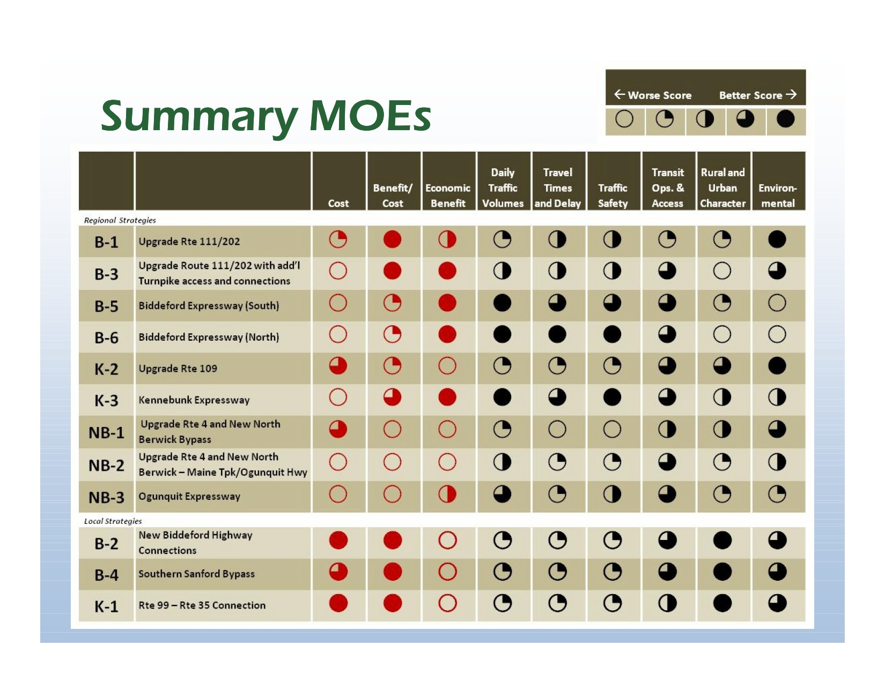

The red represents the new MOEs that we shared for the first time today.

Carol Morris: Now, we would like to go through each strategy and ask if you understand and agree with the rating and also what you think of the strategy. Again we are not making any decisions today, but we are simply trying to solicit as many comments as we can.

So we will start by discussing Strategies B1 and B3:

Diane Robbins: I don’t know about outside of Arundel, but in Arundel, the whole section up to the Lyman line is a rural conservation area and there are additional restrictions to keep it rural. Four lanes is in direct conflict with what our comprehensive plan has outlined for that area.

Donna DerKinderen: B1 and B3 are the same except for the improvements (at each end). In view of that, and since B1 exacerbates the problems at the I-95 intersection, I think we should not consider B1 any further. I also think the environmental constraints will be greater than they are indicated in your ratings.

Leo Ruel: When you talk about four lanes, how would other roads connect?
Steve Rolle: They would be signalized at major intersections. How minor roads connect would have to be determined. There would likely be increased access management considerations, such as limited left turns from some roads.

Leo Ruel: The only way you could improve Jackson’s Corner is to create an overpass.

Donna DerKinderen: For Route 111, a lot of the homes are close to the road. You may be able to widen the road and not impact the house directly but the livability would suffer. Four lanes are not practical. Adding turning lanes and passing lanes is reasonable, but four lanes on Route 111 is not feasible. It has severe impacts on the agricultural land as well.

Steve Rolle: Is there a version of a Route 111 upgrade that works? What would that look like? Are there some sections that would benefit from expansion to four lanes?

Donna DerKinderen: Some of that was looked at in a previous Route 111 study. That emphasized keeping that corridor as it is, and targeting potential problem intersections. Also it is an east-west highway, and the sun is in your eyes in the morning and afternoon.
Steve Rolle: In terms of the Route 111 study, the passing lanes and turning lanes have not been implemented. But most of the rest of the recommendations have been implemented.

Diane Robbins: Going to four lanes is difficult for agriculture; it will make it difficult for tractors to cross the road. Building four lanes also gets you into eminent domain issues, which will not be favorable. When you look at what you gain, there is not enough benefit for this to be worth the impacts it presents. I think small improvements such as signage and turning lanes are better.

Hazen Carpenter: The region needs a four lane, east-west highway. If it isn’t done now, it will have to be done in the future.

Dennis Rioux: The worst problem on Route 111 is getting into Route 111 heading towards Biddeford from the Hill Road. There is traffic that moves fairly smoothly, even at peak times except when you get into Biddeford. I don’t see the benefits being worthwhile based on the amount of impacts. I think minor improvements are the best strategy to pursue.

Chris MacClinchey: When you look at all of the options, B3 seems to be one of the more practical alternatives that will have an impact on improving the conditions over time. The additional connections to the Turnpike will alleviate some of the congestion issues. I don’t think a four-lane road will look much different than a two-lane road. This has fewer impacts than building a new road somewhere else.

Ken Creed: B3 makes the most sense of the B strategies, whether it ends up being four lanes or some variation.

Carol Morris: Wonderful, thank you. Now let’s look at the B5 and B6 Strategies:

Ken Creed: I think you should take these options off the table altogether.

Carol Morris: Does anyone disagree with that sentiment?

The majority of the Advisory Committee agreed that Strategy B5 and B6 are far too costly, have too many negative impacts and offer limited benefits and should be removed from further consideration

Carol Morris: Thanks. Now let’s talk about Strategy K2

Ken Creed: Route 109 is greatly improved; most of the safety issues have been addressed. The sight issues and intersections are much safer and that road is in good shape. High Pine moves along well.

Geoff Titherington: The work that they have done with the trees in High Pine has calmed traffic. That is going to make that project successful. I don’t think anyone is looking to do more work in that area.

Steve Rolle: From what we found, there was not much regional economic benefit gained from bypassing High Pine.

Ken Creed: I believe that that one can come off the table as well.

Carol Morris: Anyone want to disagree or provide more input?

No further comments.

Carol Morris: Okay, let’s talk about K3.

Diane Robbins: Is this going to go through the Blueberry Plains?
Chris MacClinchey: It looks like it will go through part of that and it may impact the Branch Brook aquifer.

Steve Rolle: If this were to move forward the specific routing of this would be challenging.

Diane: I don’t think your environmental evaluation is quite as comprehensive and doesn’t take into account all that you are going to run into.

Chris MacClinchey: If you are going to carry a new road forward, this is the option to carry forward as the cost/benefit ratio is positive, but there are a lot of challenges.

Brad Littlefield: I’m not sure that the environmental impacts are as great as some people think they are.

Carol Morris: If this were to move forward, if you couldn’t find a way to wiggle the road through, it would be considered infeasible.

Hazen Carpenter: The road is not going north or south, so I don’t see the benefit.

Donna DerKinderen: That is the one route that came out ahead of all other strategies based on the ratings. Based on that it should stay on the table.

Geoff Titherington: I think there would be interest in this from Sanford but not from people from Kennebunk. Sanford is not a destination for people from Kennebunk.

Suzanne McKechnie: People who want to go to a service center from Kennebunk right now have the options of Biddeford or Portland. There is an option to grow Sanford into that destination as it continues to develop.

Chris MacClinchey: The Lowes and Wal-Mart are attractive for people from Kennebunk as there is less traffic than going to Biddeford.

There were mixed reactions but in general the Advisory Committee was willing to keep K3 on the table.

Carol Morris: Okay, thanks. Let’s look at the NB1, NB2 and NB3 Strategies.

Gerry Audibert: Is there any support for these strategies?

Hazen Carpenter: I would scratch NB1 but I like the south access to the Turnpike. NB3 is very costly so maybe just NB2 should be considered further. I like NB2 and NB3.

The majority of the Advisory Committee indicated that Strategy NB1, NB2 and NB3 are too costly and offer very limited benefits and should be removed from further consideration.

Carol Morris: Now let’s talk about the local strategies. Let’s start with B2.

Hazen Carpenter: York County is the gateway to Maine; it serves a lot of the Lake Region area. An easier way to get to Ogunquit would make sense.

Dennis Rioux: I don’t like this. I can understand that this would relieve congestion; but the environmental and rural character impacts to that local area would be large. We recently had a zoning effort to expand the commercial zoning along Route 111 in Biddeford and there was a room full of people in opposition to those changes. A land trust owns two parcels in that area, and they are in the process of acquiring two more. There is an effort to conserve 700 acres of property owned by Ernie Clair. There is benefit but great environmental and rural character costs and there would be great local opposition.

Donna DerKinderen: If we eliminate Strategy B2, and there is no relief of interstate congestion at Biddeford Crossing, then there is no point in doing anything on Route 111 because there will be increased speeds that just lead to congestion on both ends. You need to solve the ends before you attack the middle. I think you should take B2 out and take B3 out as well.

Dennis Rioux: Of course what happens with the Racino may change this altogether.

Diane Robbins: The sequencing of the traffic lights causes problems on Route 111 in Biddeford. One of the things we are trying to do is to make it easier for businesses to get from point A to point B in a cost effective manner. One of the things that happened in Biddeford is that they put the new interchange in before they decided to put in Biddeford Crossing. You can’t get past that to get to the Turnpike. There is a significant amount of traffic getting onto the Turnpike from points west on Route 111. If we could find a way to get them off Route 111 and onto the turnpike before the Biddeford Crossing that would improve traffic congestion in that area.

Carol Morris: Great, thank you. We are now going to look at Strategy B4.

Hazen Carpenter: I think this should be included with B3 because you are improving Route 111 and Route 202 and when you get to Sanford there will be a bottleneck.

Diane Robbins: I think you are not going to be able to find a right of way to put this road in. And if you do, are you going to have another 35 mph zone?

Steve Rolle: The assumption would be that this would be built with a high degree of access control to prevent curb cuts in order to avoid that.

Brad Littlefield: I’m not sure that this is solving a problem. What it does do, if you do this with K3 it makes sense, without it, I don’t think it does anything.

Steve Rolle: If you have improvements to the south, if you are coming from points west of Sanford, instead of having to go to through downtown Sanford you would take this road. Finding a feasible alignment would be a big challenge.

Brad Littlefield: It depends on what we do with an expressway. If there is no expressway, there is no point of considering this strategy.

Steve Rolle: In all of the expressway strategies we assumed local road improvements because you can’t just dump the new road into existing infrastructure. So if a new expressway were to move forward, local road upgrades would be considered as well.

Chris MacClinchey: This option seems to be one that addressed the issues affecting Sanford the most in terms of congestion downtown. It’s not a regional answer, but it is worth exploring.

Carol Morris: Last, we will talk about Strategy K1.

Chris MacClinchey: Where is this going to connect to the Turnpike and cross the river?

Steve Rolle: We had it cross the river just north of the Turnpike. You could go either north or south with this strategy. For this analysis we assumed it was immediately adjacent to the turnpike to the north.

Chris MacClinchey: I’m on the Kennebunk planning board and the economic development commission. In your ratings of this strategy, you say there are no impacts to town centers; where in relation to west Kennebunk village would this go?

Steve Rolle: I believe it would run south of that, hugging the Turnpike right-of-way

Chris MacClinchey: I think the rating for the urban and rural impacts MOE is a little high and I think there would be serious resistance to this from Kennebunk.

Brad Littlefield: Does it make more sense if there is an expressway, with a separate interchange from Route 99?

Steve Rolle: That would be an expensive project.

Sarah Devlin: The existing interchange is tied in with the service plaza as well.

Brad Littlefield: If K3 makes sense somewhere down the road, if we integrated those connectors, doesn’t it make your cost/benefit ratio more attractive? As the cost increases so does the benefit.

Steve Rolle: We were trying to look at an inexpensive way to make a connection in K1. We have an existing highway out there. It is not heavily used today and is in pretty good shape and if you are in south Sanford that is the quickest way to get to the Turnpike. That is what we were trying to do with K1. This strategy makes use of the roads that are out there.

Carol Morris: All right, thanks for your input. Now we want to show you what we are going to look at in Phase III.

Uri Avin: The following are other factors affecting decision making as we move forward:

- Additional Environmental, Historic, Archeological and Other Impacts
- Ability to Secure Environmental Permits
- Ability to Secure Funding
- Degree of Public Support
- Constructability
- Potential for Refinement in Phase III

We will also be looking at the role of land use and access management. There are four general strategies that we will be looking at:

- Through zoning regulations, reduce the number of new trips generated
- Provide direct access to streets other than the primary highway
- Improve parcel interconnectivity and local circulation
- Manage the number and operation of commercial and residential driveways

Carol Morris: We would do the analysis knowing that making these decisions is in the hands of municipalities.

Uri Avin: We will also be looking at the effects of TDM, TSM and Transit Improvements:

- Transportation Systems Management (TSM)
  - TSM strategies focus on increasing efficiency, safety and capacity of roadways through better management of existing transportation system infrastructure. Examples are:
  - Updated traffic signal systems
  - Real time driver and transit information
- Travel Demand Management (TDM):
  - TDM improves accessibility and addresses traffic congestion by increasing individuals’ travel options and so reducing travel demand, rather than increasing highway capacity. Examples are:
  - Facilitating carpooling and vanpooling
  - Flexible work schedules

The roles of TDM, TSM and Transit Improvements are as follows:

- Identify the range of potential TDM, TSM and Transit options
- Of these, are there strategies that should be considered in all Phase III packages?
- How can specific strategies be paired with highway corridor improvements to realize efficient, equitable and sustainable solutions?
Chris MacClinchey: So you will be looking at increasing transit options as part of looking at TDM?

Uri Avin: Yes.

Brad: Is the final recommendation going to be one strategy or more?
Uri Avin: We envision that there would be some prioritized recommendations and a record as to why they are prioritized that way.

Carol Morris: The next steps are as follows:

- Resolution of recommendations for Phase III strategies
  - Public input – Public meeting
  - Follow-up Committee meetings
  - Recommendations for inclusion in Phase III

Leo Ruel: is there a deadline for a change in ordinances?
Uri: No, these would be recommendations coming out of the study and some towns are already doing things.

Leo Ruel: I want to make it happen.

Gerry Audibert: They will be prioritized. We will certainly identify relatively easy, low-cost options that could move forward more quickly.

Carol Morris: The final report is due in June or July.

Brad Littlefield: When does this have to be reported to the Legislature?

Gerry Audibert: A status report is due in December. They asked for a report on recommendations. We are not going to be ready with a full report by then, and while we will have more information by April, we will not have a final report for this upcoming session.

Carol Morris: Thanks very much for coming.

NOTE: Overall, the Advisory Committee agreed that, of the regional strategies, B-3 and K-3 were worthy of more detailed analysis.

Meeting adjourned at 1:06 pm.

