Central York County Connections Study
Public Informational Meeting
March 29th, 2010 6-8 pm
Kennebunk Town Office Council Chambers

Presenters: Gerry Audibert, MaineDOT; Uri Avin, Parsons Brinckerhoff; Steve Rolle, Parsons Brinckerhoff; Carol Morris, Morris Communications.

In Attendance: Penny Vaillancourt, MaineDOT; Sara Devlin, MTA; Ben Ettelman, Morris Communications.

Meeting began at 6:04 pm.

Gerry Audibert: Hello and thank you for coming to this public informational meeting for the Central York County Connections Study. We are going to walk through what the study has accomplished to date and what the next steps will be.

Carol Morris: Hello, my name is Carol Morris and I am the public outreach consultant for the Central York County Connections Study. The agenda for today is as follows:

- Welcome
- Study Overview and Timeline
- Purpose and Need Statement
- Phase II Major Strategies and Evaluation
- Discussion
- Potential Phase III Locally Focused Strategies
- Next Steps

Carol Morris presents a slide showing a Map of the Study Area

This slide shows a map of the study area that includes the following towns in Central York County:

- Alfred
- Arundel
- Biddeford
- Kennebunk
- Ogunquit
- Lyman
- North Berwick
- Sanford
- Waterboro
- Wells

The purpose of the Central York County Connections Study is to identify, evaluate and recommend feasible transportation and related land use strategies that will:

- Enhance regional economic growth;
- Increase regional transportation interconnectivity;
- Improve traffic safety;
- Direct expected travel demand through a strong mix of multimodal strategies; and
- Preserve and improve existing infrastructure.

These purposes are to be achieved while striving to maintain the visual, cultural and historic character of village centers and rural areas and minimizing environmental impacts.
The study timeline is as follows:

- Study Initiation: Sept. 2010
- Development and Evaluation of Major Conceptual Strategies (Phase II): Nov. 2010 – Feb 2011
- Refinement and Detailed Assessment of Strategies (Phase III): March 2011 – July 2012
- Recommendations and Study Completion: August 2012

The following are the agencies and committees who have been involved in the study along with their responsibilities:

- Study Team: Consultants, MaineDOT, MTA, SMRPC
  - Manage and conduct study
- Steering Committee: Ten communities in Study Area
  - Inform Study process by local understanding and regional perspective
  - Update municipal officials
- Advisory Committee: Diverse interest groups
  - Voice of the public
  - Update constituents

Much of the study information is communicated to the public through the study website, which can be found at www.connectingyorkcounty.org. All study data is on the website and anyone can make a comment on the website after this meeting if you would prefer to do so - it will hold just as much weight as comments made at the committee and public informational meetings.

The goals for today’s meeting are as follows:

- Public understanding of benefits and impacts of the major highway strategies
- Discussion of major highway strategies and their feasibility
- Public understanding of other locally focused strategies and next steps

Uri Avin: My name is Uri Avin and I am the project manager for the Central York County Connections study. I am going to provide some background for the analysis that we did and we will talk about the evaluation of the analyses as well.

Uri Avin presented a slide titled Population and jobs will continue to grow

We looked at projected growth for the study area and this is one of the fastest growing areas in the state, projected to grow approximately 1% per year.

In this slide you will see that York County is expected to grow about 17% in population and about 35% in jobs by the year 2035. These projections show that York County will see approximately 32,000 people moving into this area over the next 25 years and about 20,000 jobs created. This information is used in a travel demand model, which shows us the driving patterns and volumes on the roads in the study area.

Uri Avin presented a slide showing the growth in traffic volume between 2010 and 2035 on Route 111, Route 109 and Route 4

As you can see in this slide, the increase in population and jobs will lead to growth in traffic over the next 25 years. Traffic is projected to increase by the following amounts:

- Total Vehicle-Miles Traveled (VMT) will increase by 29%
- Traffic on Route 111 will increase by about 30% near the Arundel/Biddeford line.
- Traffic will increase by about 56% near the Sanford/Wells line, though volumes are relatively light here today.

The Central York County Connections Study followed this study process:

- FIRST: Studied very large-scale, conceptual highway strategies such as new roads or major improvements of existing roads (Phase II)
  - “What if” scenario analysis to test upper limits of potential benefits and impacts.
  - Needed to understand potential contribution these might make to regional economy.
- NEXT: will consider specific problems and solutions at a more focused level (Phase III)
  - Consider improvements of a smaller, more local scale.

Uri Avin presented a slide showing the Regional Strategies Tested

This slide shows the nine strategies that we tested in order to address increased regional access to central York County.
Uri Avin presented a slide showing the Local Strategies Tested

In addition to the nine regional strategies we also looked at three local strategies, pictured on this slide. We will look at these strategies in more detail in the next phase of the study. These strategies are primarily focused on reducing local traffic in Sanford and Biddeford.

Now Steve Rolle is going to talk about how we evaluated these strategies.

Steve Rolle: Hello, my name is Steve Rolle. Does anybody have any questions on what we’ve covered so far?

Question: It seems that the goal of the study was to facilitate traffic west to Sanford as most of these strategies end in Sanford. How did you develop the metric for studying population growth? I believe the projected growth in jobs and population is misleading because they should be broken down by town, rather than looked at on a regional level only.

Steve Rolle: And that is what we’ve done. What you’re seeing here is only a summary. The population and job forecasts were done by town and then divided down by census track level, and then down to the traffic analysis zone, which is a very small area within the towns themselves. The growth forecast therefore does vary by town. There is a technical memo that details these projections on the website.

Comment: If you have developed data at the local level, presenting them as a whole is misleading.

Carol Morris: Because this is a regional study, we look at the big picture to get a sense of how the area will grow as a whole.

Steve Rolle presented the following slide titled How the Strategies were Evaluated

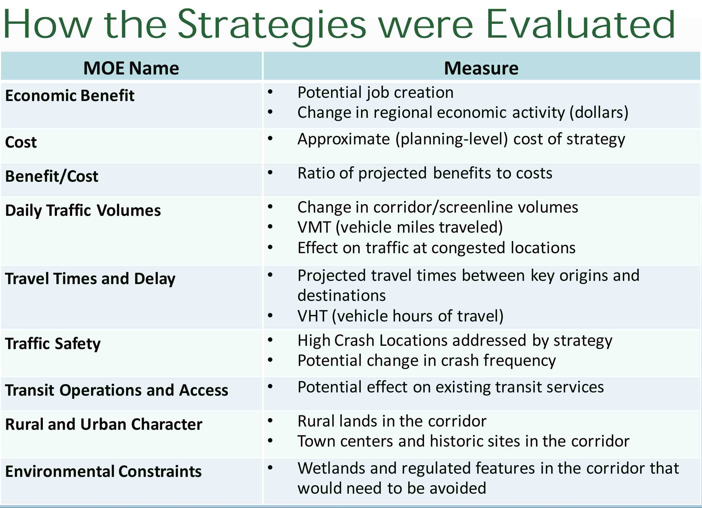

Steve Rolle: I want to talk specifically about how these strategies were evaluated. We developed a set of Measures of Effectiveness (MOEs) that are shown in the above slide. Next to each MOE you will see the actual measure used to evaluate the strategy for each MOE.

Steve Rolle presented the following slide titled MOE Ratings

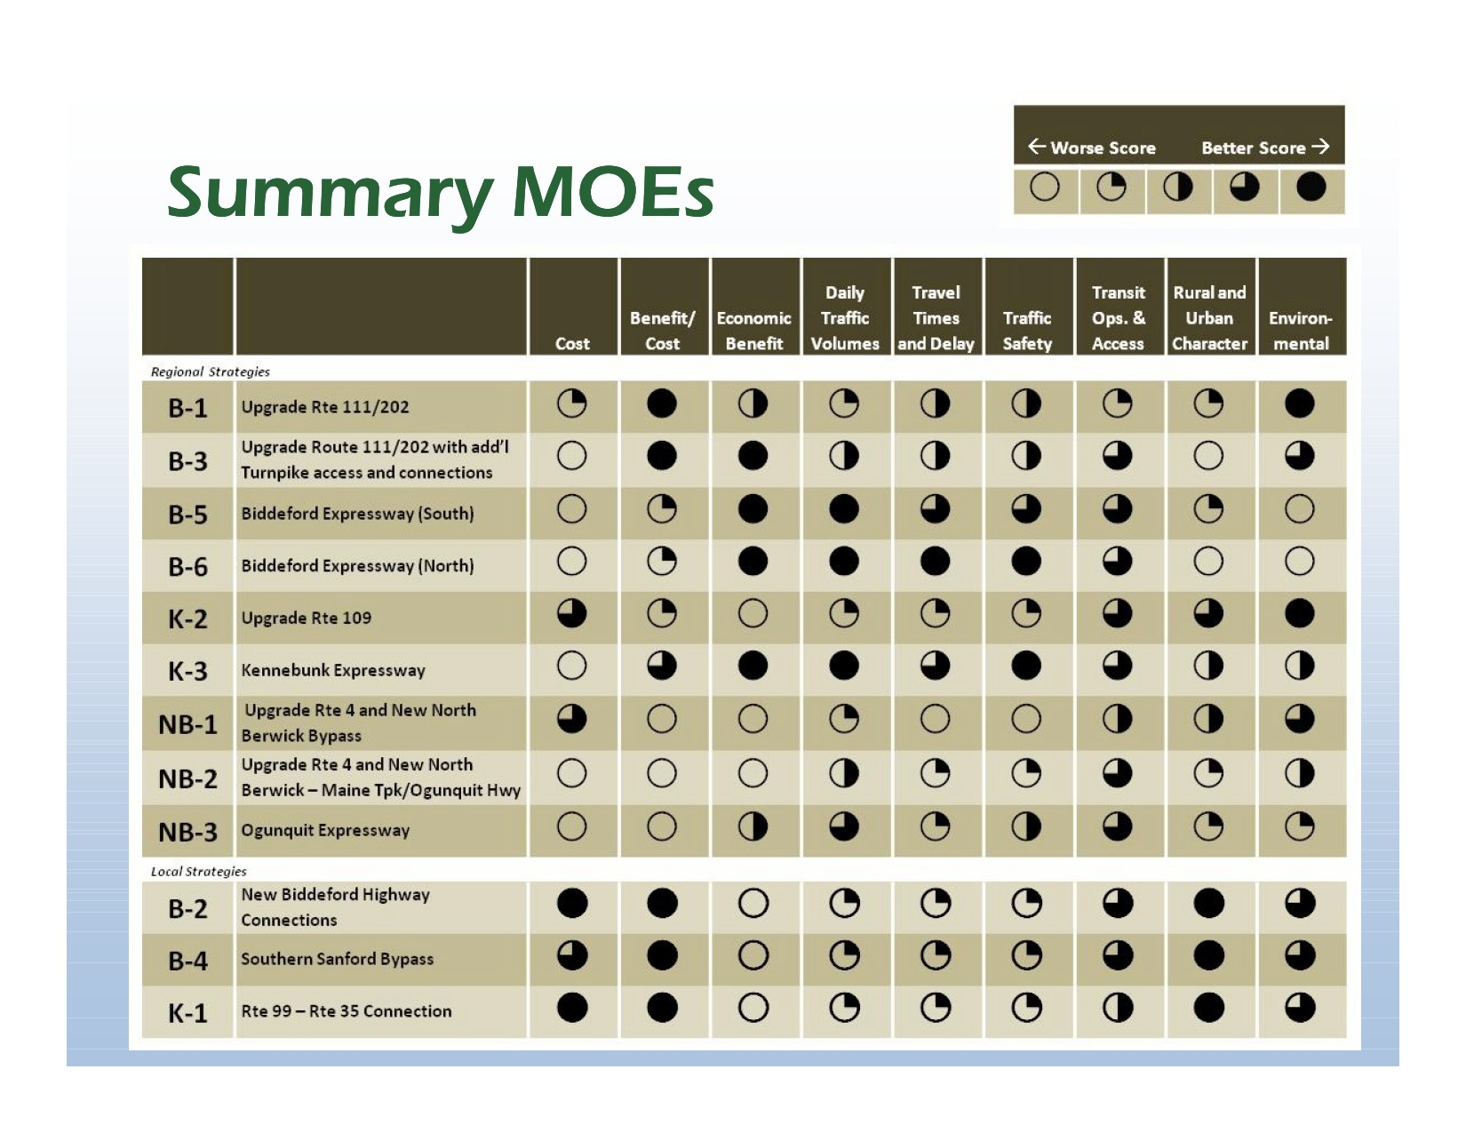

These are summary ratings for each Measure of Effectiveness. The full circle shows the best score, and the MOEs with open circles represent a MOE where the Strategy did not score well. We did this for each of the nine MOEs.

As you can see, all the new corridors have considerable costs associated with them.
We had two MOEs that looked at economic impacts for each strategy. The first MOE that we used to evaluate the economic impact of the twelve strategies was benefit to cost ratio. Benefit to cost ratio looks at the perceived benefits of each strategy and compares that to the total cost of the strategy. The benefits that are considered in the cost benefit ratio are as follows:

- State of Good Repair (Reduced pavement damage)
- Economic Competitiveness (Travel time savings, reduced users’ costs [fuel, operating & maintenance] and oil imports)
- Livability (Reduced noise)
- Sustainability (Reduced emissions)
- Safety (Crash reduction)

Steve Rolle presented the following slide showing Benefit Cost Ratios for the 12 strategies

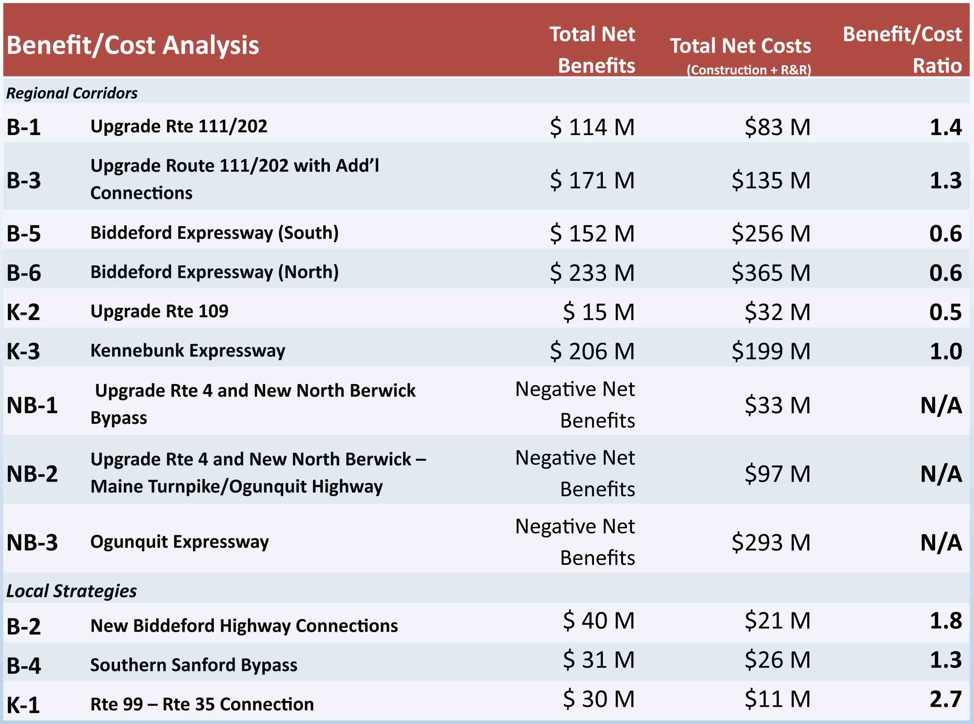

The above slide shows the bottom line result of the benefit cost analysis. The total net benefits are on the left and the total cost is the next column. The far right column is the benefit cost ratio. Anything at one or higher is considered to potentially have greater benefits than costs and is a candidate to look at in greater detail. In general, you’ll note that the corridor upgrades to existing corridors scored better than the new alignments.

Question: The benefit cost ratio on the Biddeford Expressway, does that include that the expressway could be a tolled road?

Steve Rolle: No, we did not look at tolling at this stage.

Question: The word benefit, where is the benefit going, to the consumer, the state or the towns?

Steve Rolle: We consider a wide range of benefits that could be realized by all of those groups.

Comment: A benefit to one person might not be a benefit to another. If you have a bypass, you may be causing a detriment to the community you are bypassing, rather than a benefit.

Uri Avin: Yes, and in a complete evaluation of a bypass you would look at the potential downside of declining local economies. In this analysis, which is a fairly standard analysis for studies like this, the benefits are clearly defined. This primarily looks at time, distance, travel speeds and saving money on fuel and maintenance. These are primarily focused on the individual. Climate impacts based on better or worse air quality are also looked at in the cost benefit ratio. The benefits are spelled out by federal guidelines and standards. So this analysis is by the book. If any of these strategies went forward they impact on rural character and those factors would then need to get built into the analysis.
Question: What is the relationship to cost benefit analysis and the economic benefit analysis?

Uri Avin: The first phase looked at economic benefit, which was economic growth from improved accessibility. We used a model to look at what industries would improve if a certain amount of time were cut off the drive time. We translated that into dollars spent in the economy. That is different than cost benefit ratio. We did both analyses.

Question: Looking at K3, you have a $206 million benefit. I have to assume that that economic benefit is for Sanford, not Kennebunk.

Steve Rolle: These are travel benefits that are realized throughout the region. Some areas benefit more than others but the benefits are aggregated by the analysis on a regional level so you cannot discern what town receives more benefit. However, you can infer that areas that experience the greatest improvement in travel accessibility are those that will receive the bulk of the benefits.

Comment: We should not consider K3 when the state spent a bunch of money on Route 109 in Wells.

Question: Is there going to be a town-by-town analysis?

Uri Avin: There is not a town-by-town analysis, the model and approach does not look at town-by-town economic benefit analysis. This model looks at overall benefit for the region.

Steve Rolle: I am going to move ahead and talk about the Economic Impacts MOE now. The following are the specific measures that the modeling tool that we used, called PRISM, produced when looking at the time reduction each of the strategies provided:

- Modeling Tool: PRISM
  - Measures new economic production drawn to the region as a result of transportation investments
  - Estimates “Regional Economic Impacts”
  - Gross Regional Product – value of all goods and services generated in a region
  - Effects of monies re-circulating through the regional economy
  - Jobs created

Steve Rolle presented the following slide showing Annual Economic Benefits

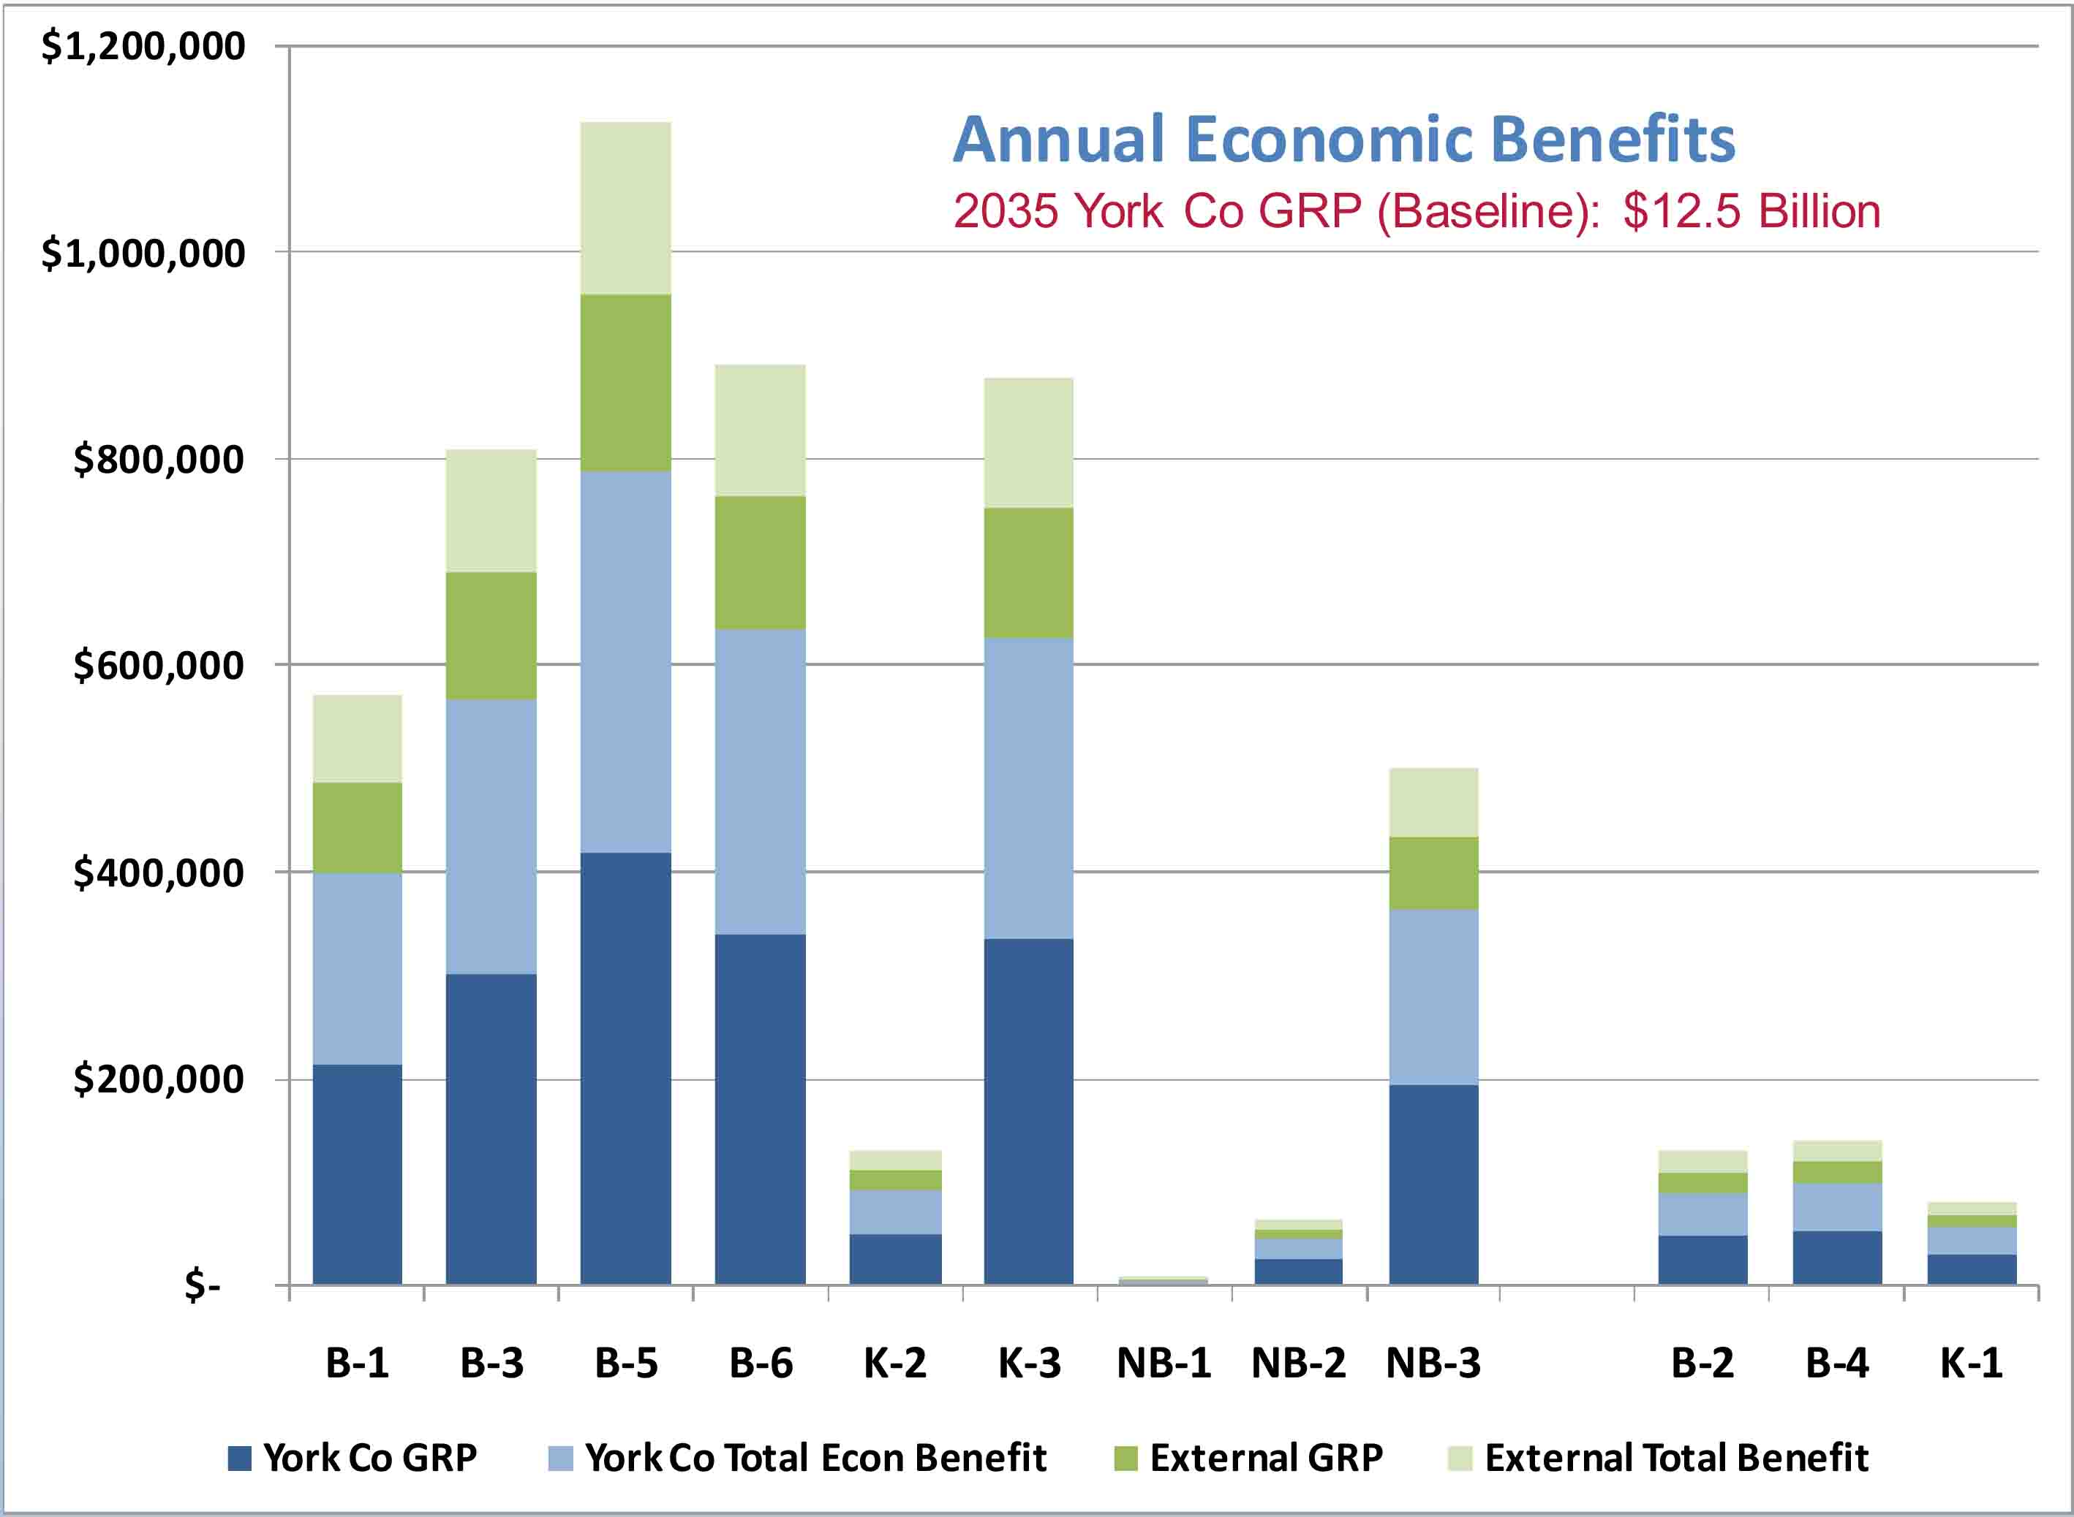

The above slide shows the results by strategy of the economic impact analysis. It is important to note that these are annual estimated benefits, and represent new economic activity to the region (not simply shifting activity from one location to another). The best projected estimated benefits for any of the strategies produced a little over $1 million per year, and that includes benefits that are realized in the surrounding regions outside of York County as well. As a point of context, the estimated Gross Regional Product for York County is $12.5 billion. So while a million dollars of additional annual economic activity is still considerable, it is a very small percentage of the economic activity that is already occurring in York County using existing infrastructure. I’d also point out that the economic benefits associated with the corridor upgrades in the Biddeford Corridor (B-1 and B-3) are fairly competitive with the new Expressway corridors (B-5, B-6, K-3. NB-3).
Uri Avin: I am going to talk about the MOEs that look at impacts based on each of the strategies. The members of the Steering Committee and Advisory Committee clearly stated that they were very interested in understanding what the impacts to the urban and rural character would be for each of these strategies.

The following are the findings based on each strategy’s impacts to rural and urban character within the study area:

- New corridors largely affect rural lands
- Upgrades potentially affect properties fronting on existing corridors, including historic sites and town centers
- Biddeford Corridor has the greatest amount of affected land (rural and urban)
- Route 109 Upgrade’s (K-2) score reflects bypass completely around High Pine

Uri Avin presented the following slide with a map titled Urban and Rural Character

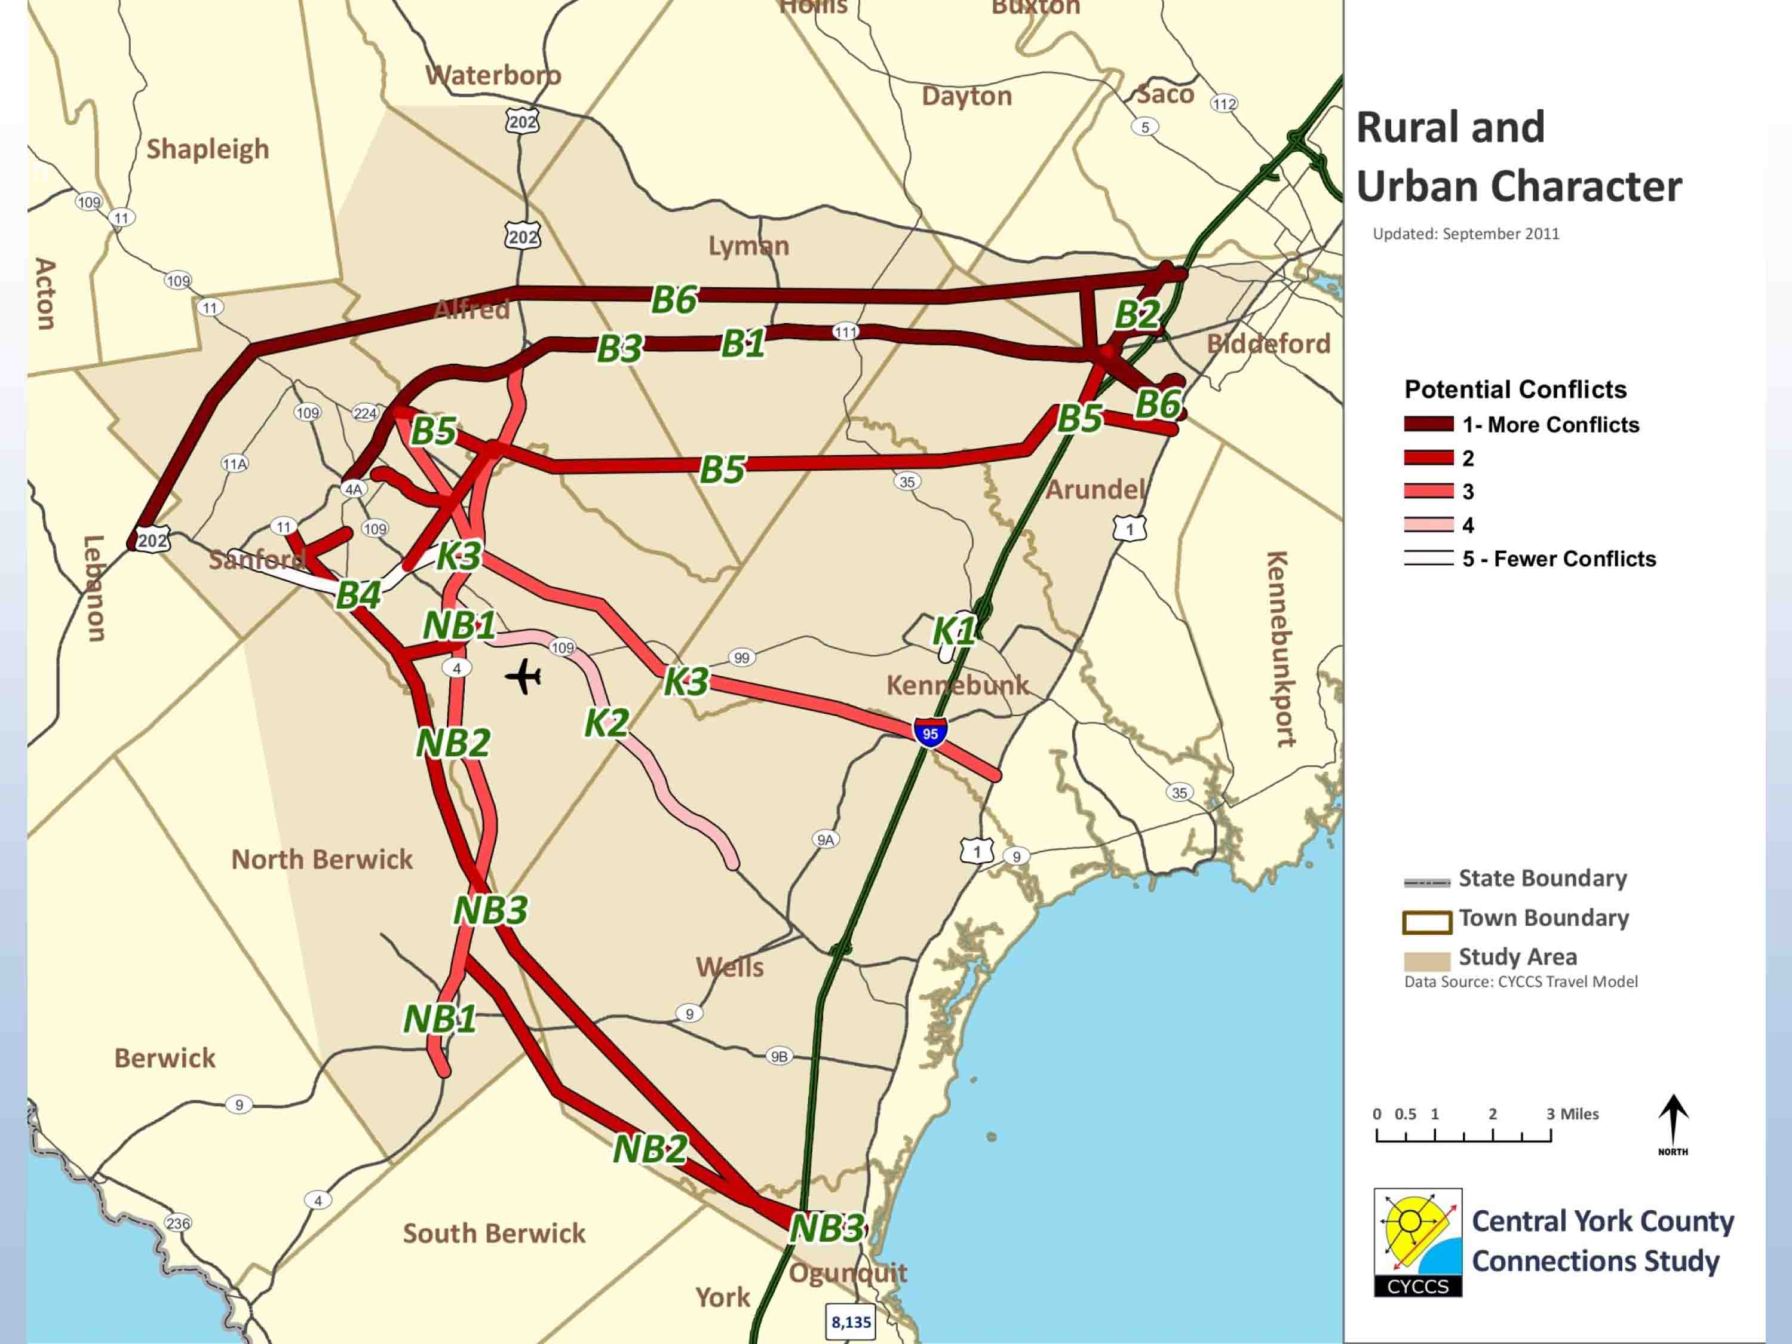

The above slide shows impacts to urban and rural character. These are the nine regional strategies. The darker colors represent more impacts to rural and urban character.

We received natural resources mapping from the state. We also looked at mapping from local towns and received information on locally protected resources. We mapped all of this information and looked at the potential impacts that the strategies would have on natural resources. The following are the findings based on each strategy’s impacts to natural resources within the study area:

- Upgrades have fewer constraints because the rights-of-way have previously been developed
- New Expressways in the Biddeford Corridor (B-5, B-6) traverse the most land with regulated resources

Uri Avin presented the following slide with a map titled Environmental Constraints

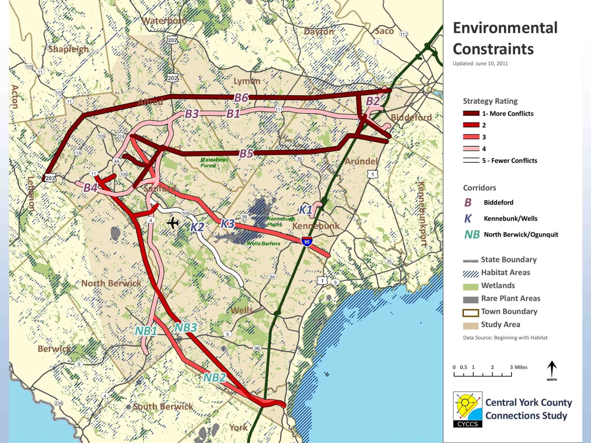

The above slide shows impacts to natural resources. These are the nine regional strategies. The darker colors represent more impacts to natural resources. Not all resources are represented on this map. We have received more detailed information but this map shows the major features and gives us a perspective on environmental impacts. It is important to note that we did not weight any of the different resources against each other.

We are now going to segue into some of the bottom line conclusions that have been made based on these analyses. MaineDOT and MTA have spent the past several months thinking about what the analysis tells us and how we should move forward into the next phase.

Carol Morris presented the following slide titled Consensus on Further Study for Highway Strategies

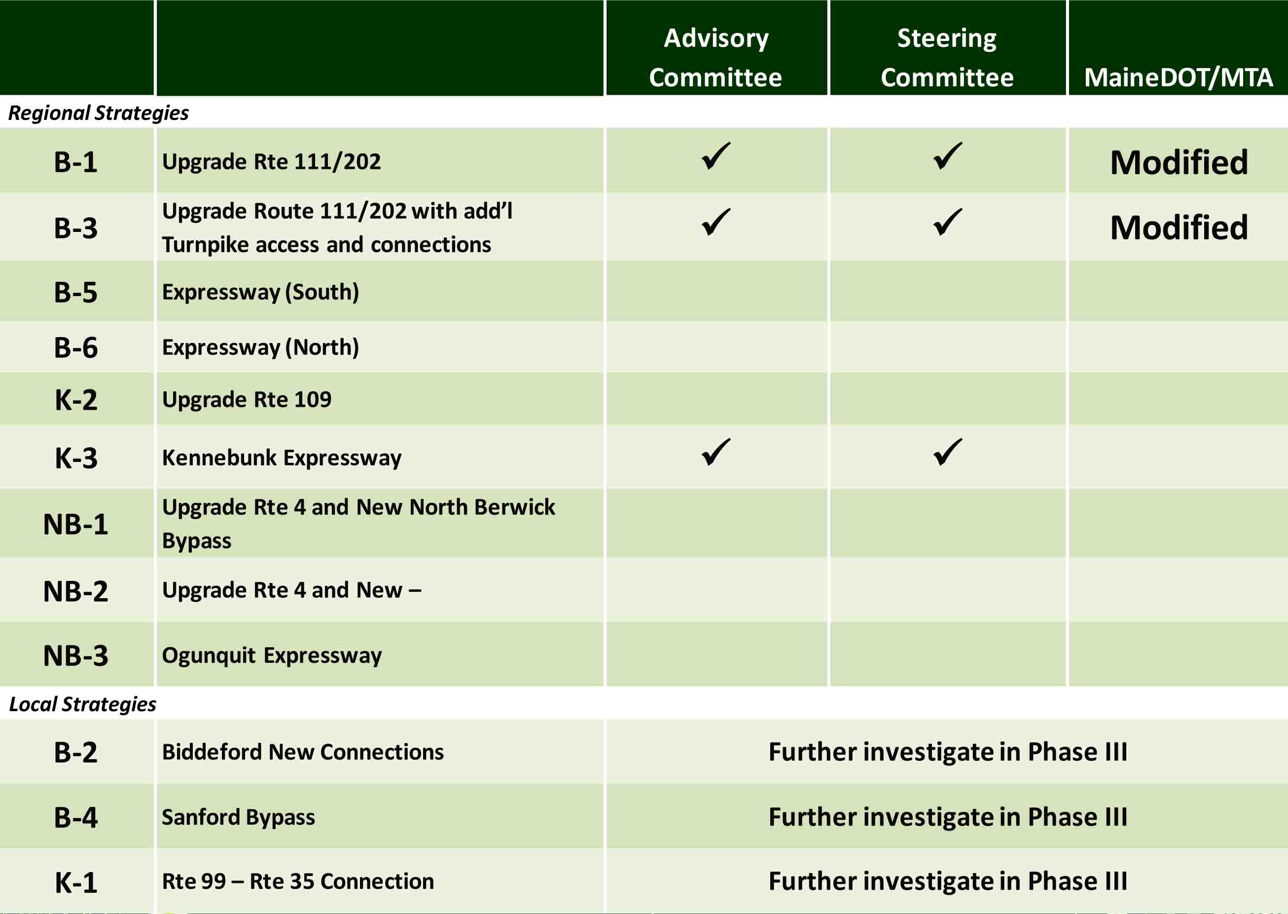

Carol Morris: This slide shows what the consensus was from the Advisory Committee and Steering Committee in terms of what strategies should be kept on the table for further consideration. There was a great deal of discussion about K3 and the feelings were mixed on this alignment. The sense was that, while there was not overwhelming support for K3, both committees felt it should stay on the table as it had some potential benefits and was the most promising of the new roads. They expressed concern that the public would want to know that the major improvements were seriously considered and not taken off the table too early. As was mentioned, MaineDOT and MTA then spent time thinking about what strategies should move forward into Phase III.

Gerry Audibert: We have been talking about highway strategies tonight but they are not the only strategies that we are looking at. We heard from the Advisory Committee and the Steering Committee regarding these strategies. I want to remind everyone that all of the strategies developed were done so with our purpose and need statement in mind. MTA and MaineDOT spent some time thinking about what is feasible and practicable to move forward into Phase III. Federal funding is not what it used to be. MaineDOT used to get earmarks for road projects and those are not part of future funding. We also looked at the benefit cost and the economic impacts. Those are two different analyses but they came back with a similar conclusion that all of the strategies do very little for the local economy. Some have better benefits than others such as savings on accident costs, numbers of collisions, travel time value, vehicle miles travelled, etc. A lot of these do not fare well as new roads cut time but add a lot of miles. MaineDOT looked at these and asked whether any of the regional strategies were feasible to move forward and the answer was no. None provide enough benefit for the cost because they are not affordable. We feel that B1 and B3 could be supportable in a modified state. We disagree with the feasibility of K3; it costs too much, so it is not feasible. However, the local strategies are worth considering moving forward and will be looked at in more detail in Phase III, along with a modified B1 and B3. K3 will not move forward for more detailed consideration.

Question: Have you done a traffic study on how many cars per hour are on the roads?
Gerry Audibert: We do have traffic counts from last summer.

Steve Rolle: Some of that data will be on the next few slides, and we will also look at that in more detail in Phase III.

Question: Can you explain the net benefit of K2, why it is so low ($15 million)?

Steve Rolle: K2 is an interesting result. The low result is because there is not a lot of congestion to be addressed or travel times savings to be realized by improving Route 109. There are safety issues that could be addressed, and the current upgrades to that, but not much improvement potential in terms of travel times.

Question: I don’t understand why K2 is off the table when it has the same benefit as K3. It goes to the same place from the same area for the same traffic. How is the difference over $100 million? The state spent a lot of money on Route 109 to upgrade it.

Steve Rolle: One aspect is that the strategies are compared to the existing conditions. What we found was, in upgrading the Route 109 corridor you can’t make a difference in travel time. The new corridor (K3) was a very short direct route with a higher speed limit (65 mph). That would draw on traffic that uses both Route 109 and Route 111 today to the new corridor, so the level of economic benefit associated with that improvement is higher.
Gerry Audibert: The approach to the study is looking at potential economic impact, trying to understand what a high-speed highway would do to improve the economy of the region. What we found is that we are saving just minutes in travel time, and that is not enough to attract major development, especially in Sanford.

Carol Morris: Frankly, we were surprised by how well K3 did in the traffic model. We believe that K3 pulled traffic from north and south and that is why it shows some benefit in comparison to K2.

Comment: That clearly illustrates that there is no economic value to Kennebunk because the vast majority of those vehicles are going straight from the turnpike to Sanford. That would hurt Kennebunk’s economy.

Gerry Audibert: We have not looked at that at the local level. That would be part of the Phase III analysis if strategy K3 were to be moved forward for further consideration, which it is not. We also looked at labor market areas; K3 was in the middle of the Portland market as well as markets to the south so it drew commuters travelling to both markets.

Comment: I don’t believe the problem is getting from Route 1 or the highway to Sanford; the problem is getting through Sanford. The amount of time you save to get to Sanford is minimal, the amount of time it takes to get though Sanford is still very high.

Gerry Audibert: That is why we are looking at the local strategies and not the new highways.

Comment: I am concerned with Strategy B2; we have been looking after this block of land for a long time. We are trying to put 3-4,000 acres in conservation. That is the biggest deeryard and we are very close to determining if that is prime cottontail habitat. When you see the vernal pools and the brooks and the wildlife, it is phenomenal for southern Maine and very important to our quality of life. We do not want any road to disrupt that area. Hill Road should be looked at for improvements because that road gets a lot of traffic.

Gerry Audibert: These local strategies are not specific alignments but rather recognition of congestion at the Turnpike interchange. We don’t know if we would be able to do anything there based on environmental constraints and we have heard from the conservation folks on the Advisory Committee that there are many considerations there. We are only saying that we want to look at this area in more detail.

Steve Rolle: We are going to talk about what to expect in Phase III of the study. The additional analysis that will occur in Phase III is as follows:

- Update and investigate safety issues
- Level of Service (LOS) analysis for major segments and intersections
- Input from SC, AC and public

The following are the potential focus areas for strategies in Phase III:

- Highway Improvements:
  - Intersection improvements
  - Passing lanes or other capacity improvements
  - Safety projects
  - Local strategies initially investigated in Phase II
- Land use and access management approaches
- Transportation Systems Management (TSM):
  - Traffic signal upgrades, roundabouts, improved signage
- Multimodal, Travel Demand Management (TDM) and Transit
  - Improvements to support and enhance transit service
  - Opportunities to leverage rideshare and TDM programs
  - Improve walkability/bikability through design

Steve Rolle presented a slide showing a map of Potential Focus Areas – Safety

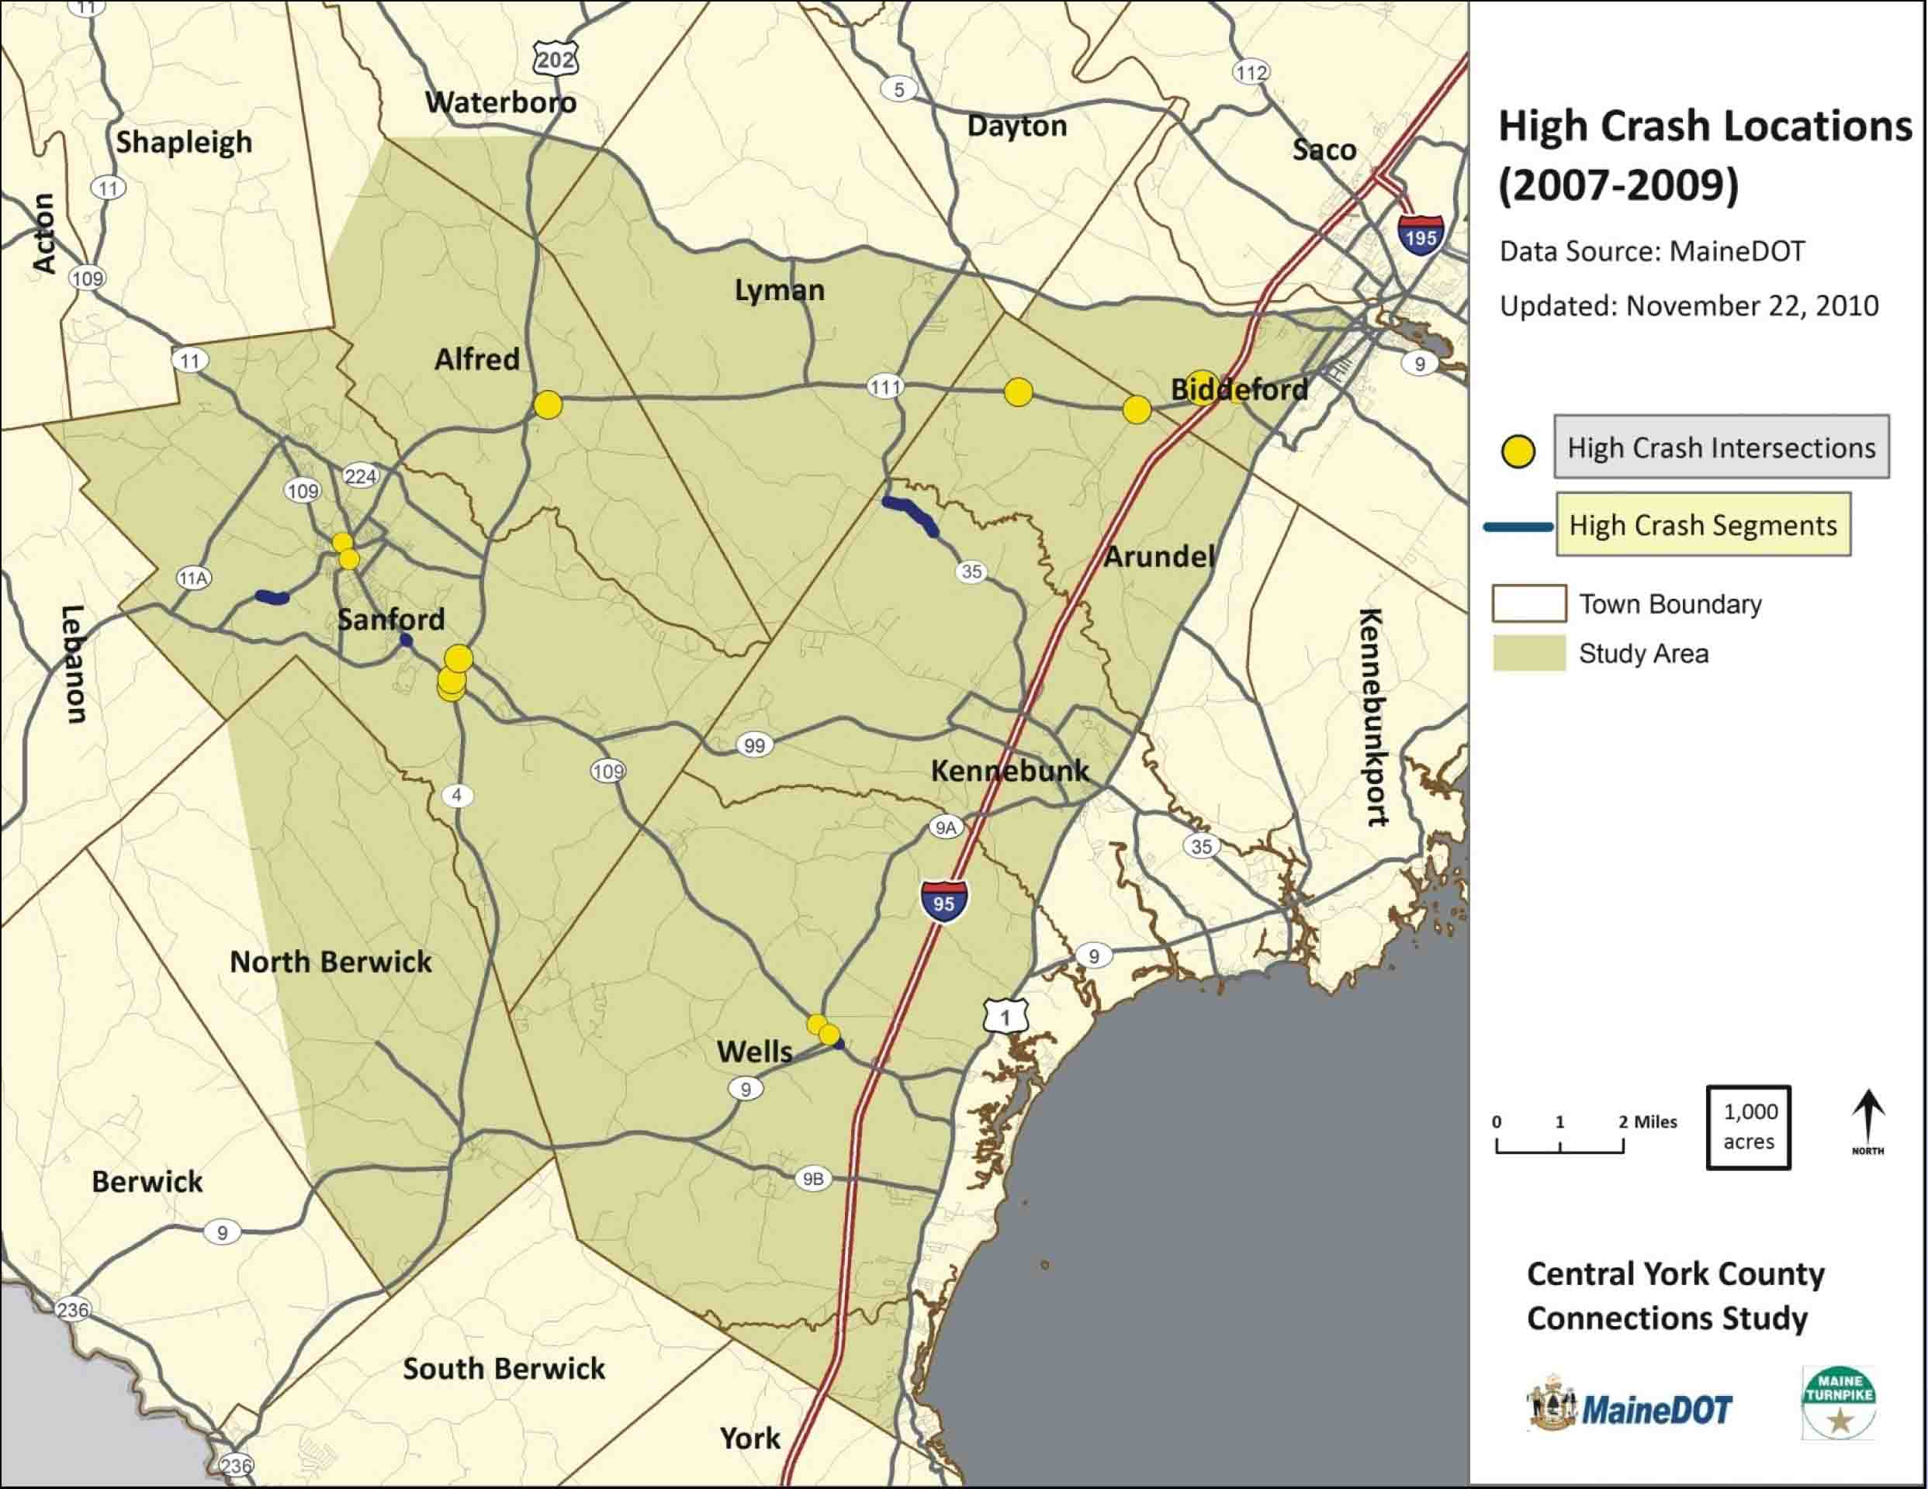

This map shows the High Crash Locations in the study area and this is where we will focus on safety projects.
Comment: Another thing about Hill Road, why don’t you put in a right hand cut so people can take a right onto Hill Road.

Steve Rolle: Thank you. That’s a location that DOT will be improving in the coming year. (Post-meeting note: construction is scheduled for 2013).

Steve Rolle presented a slide showing a map of Potential Focus Areas – High Traffic Areas

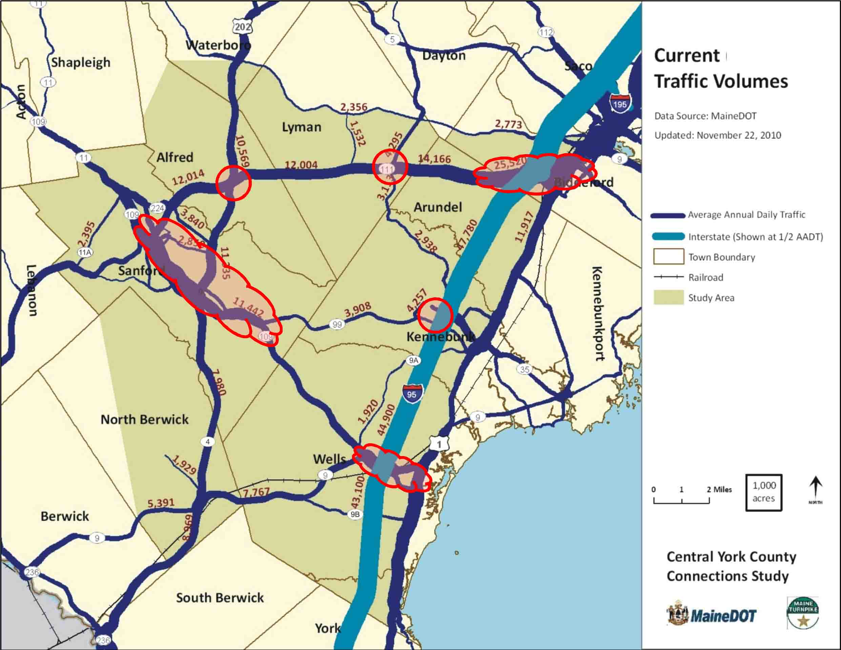

This map shows where in the study area there are high traffic volumes. We want to know where the primary congested areas are.

Comment: Signage coming off of Route 99 would solve that problem of people looking for the turnpike.
Steve Rolle: Yes, we will identify strategies like signage, which are inexpensive but effective strategies to implement.

Uri Avin: One of the themes of the evening has been the lack of public funding for transportation projects. There are local actions that can take place to preserve and maintain capacity on the infrastructure that we have in place currently. There are strategies that local municipalities can utilize, such as potential land use and access management strategies. We have looked at all of the zoning, subdivision and site development plans of all of the towns and analyzed what towns can be doing differently to protect the investments made on the major roads. The following are options for towns to consider:

- Through zoning regulations, reduce the number of new trips generated
- Provide direct access to streets other than the primary highway
- Improve parcel interconnectivity and local circulation
- Manage the number and operation of commercial and residential driveways

I want to point out that Sanford has done a good job of addressing issues of access by inserting a Major Thoroughfare Plan into their comprehensive plan. The potential strategies utilized in a Major Thoroughfare Plan are as follows:

- Limited use in Maine but powerful tool
- Community identifies where new roads are needed
- To provide access or connect network
- Community lays out general location
- Developments required to:
  - Protect the right-of-way
  - Build the segment of the road

These strategies and tools help preserve the existing infrastructure and rights of way and by including it in a town’s comprehensive plan it provides legal force. This is used throughout the country to preserve capacity and movements on major arterial roads. We will look at these as part of Phase III to provide ideas and recommendations for municipalities to consider.

Comment: I am from Lyman, and we had a problem with proposed frontage roads because they wanted to connect the back lots of all of these properties and the cost was on the landowners and there was no connection on each end, and it went through a bunch of wetlands as well. That is why the proposal was turned down. There is another way of dealing with this; you can group commercial properties together with a parking area and a simple access with a traffic signal. That would have made more sense than what was proposed.

Uri Avin: I agree. Even with the idea that was developed there is potential for success. We will be looking at that portion of Lyman and what potential there is to maintain and preserve the ability of traffic to move through Rte. 111 while still providing commercial development opportunities for local landowners.

Carol Morris: (Asking the gentleman from Lyman) Do you think that the folks in Lyman would be open to other possibilities for access management?

Comment: I think that they would, the way this project was brought to the table was ineffective and that is why it was turned down. For Strategy K3, it seems that there is a simple solution by connecting Route 99 and Route 9A on the shortest end.
Steve Rolle: Yes, we did look at something similar; connecting Route 99 to Alfred Road and eventually exit 25. Today, whenever you want to go between those corridors you have to drive into town and back out again to do it. We’ll be looking at that idea in greater detail in Phase III.

Question: Have you figured any cost estimates for road improvements that would be needed if you made a connection from Exit 32 to South Street, as the traffic would increase on that road?

Steve Rolle: These are very much simple, planning-level cost estimates that haven’t considered the specific details, and that is particularly true for the local strategies at both ends of Route 111. We did assume that there would be the need for improvements at the intersections, but not to the connecting streets beyond that. That is something that we would look at in greater detail in the next phase.

Comment: I’m from Biddeford. I think that all considerations should be connected together and as we have heard, the importance of open space, including the large block of unfragmented habitat in Biddeford. I wonder if you have given consideration to not slicing up large blocks of habitat as it has value for the economy, for the culture, for the population and I would like to see transportation planners taking that into account and planning for how to avoid fragmenting habitat. I also wonder how much consideration has been made to the possibility that car culture is dead, and whether that is factored into your plan.

Uri Avin: About fragmenting habitat, it has been our mission to see if any of these options helped the economy of the region. The answer to that question is not really, which is the major reason, along with the cost of these strategies that these are not being considered for further analysis. At a more detailed level we have maps with all habitat and at this next phase we will look in great detail at natural resources including un-fragmented habitat and wildlife, etc. and take into account how any road improvements would negatively affect those.

Comment: I am looking forward to Phase III because you are talking about closer analysis on safety and quality of life and that ties into tourism. Tourists come here because of our natural resources.

Uri Avin: In Phase III there will be field analysis to make sure that anything that we are not aware of will get mapped. In terms of car culture, we assume that people’s behavior would be to buy more fuel-efficient vehicles, that population would continue to grow and that the car culture would still exist. We were conservative and assumed that there would continue to be car dependency in the future and that people were not going to stop driving cars. We did not assume that large-scale transit would be viable, as this remains a very rural area. It is possible to look at those more radical scenarios but it is very hard to make assumptions when looking at those scenarios.

Comment: The results of the wetlands study showed that there are a lot of wetlands throughout the entire study area.

Steve Rolle: The information that we have that is mapped is data that has been collected by the state and is available in their geographical information systems. When you look at those maps there are a lot of wetlands and other resource features and we are aware of those.

Comment: Am I to assume that when looking 25-30 years down the road that you have not looked at the resurrection of railroads?

Gerry Audibert: There are a lot of narrow gauge rails; a lot of those rights of way are gone now. The issue of funding for transit is really difficult. Transit and rail are capital intensive and there is no real funding stream and if you are not seeing a high level of ridership it is very difficult to sustain transit financially, particularly rail.

Carol Morris: Maine has developed a State Rail Plan where the entire rail infrastructure was evaluated. That should be on the state website at some point, and it is that study that looked at rail potential, as that needs to be done on a statewide and regional basis.
Comment: A lot of the old rail beds have been converted to trails and the rest have just become overgrown, I don’t see those being converted back to train anytime soon.

Gerry Audibert: Yes that is right. In terms of wetlands, if you have anything that we have not mapped, please let us know. The Natural Resources Technical Memorandum is quite substantial. We will be talking with the municipalities as well.

Comment: I am on the Biddeford Open Space Committee and we are interested in working with you on local solutions and we have maps for a lot of natural resources. In terms of speed, quicker is not always better, meandering roads are fantastic visually.

Comment: I understand that there are general assumptions regarding transit, I was wondering if any specific look was made on transit services in the area.

Steve Rolle: We have not looked at transit opportunities in great detail yet, which is something that we will look at in more detail in Phase III, including the expansion of the Zoom service. We have had preliminary discussions regarding transit and multimodal options and we will look at those strategies in Phase III.

Comment: I am with the Sanford Economic Growth Council and as central York County’s service center community, there are many people in Sanford who believe that a spur is the answer. I am pleased that if there is no consideration for a spur, there is still consideration for other options to increase access to Sanford. We have transportation infrastructure issues and we appreciate this consideration.

Question: What options are no longer being considered for further analysis and consideration?

Uri Avin: The only options that we are looking at are modified versions of B1, B3 and all local strategies. None of the new expressway options are being carried forward for further consideration.

Carol Morris: The next steps for Phase III are as follows:
- Resolution of recommendations for Regional Strategies
- Develop recommendations for Local Strategies
- Final Public Meeting – July 2012

Thank you very much for coming out this evening.

Meeting adjourned at 7:56 pm.

