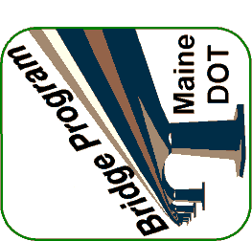
Preliminary Design Report
Common Bridge #1234 over Raging River
Anytown, ME – STP-1000(000) – WIN 010000.00

