2011 Annual Census of
Maine’s Fatal Occupational Injuries
A Report Provided to the US Department of Labor:
Statistical Factors Regarding Maine’s 2011 Work Related Fatalities

Twenty-Six Maine Workers Died from

Occupational/Work-Related Injuries in 2011.

The Bureau of Labor Standards of the Maine Department of Labor annually participates in the Census of Fatal Occupational Injuries (CFOI) conducted by the Bureau of Labor Statistics of the U.S. Department of Labor (US DOL). This informational report provides statistical data and charts derived from the 2011 Census. It also presents 2011 occupational fatality rates for the United States and Maine and key data points pertaining to Maine’s fatalities.
Maine’s participation in the CFOI is funded by the federal Bureau of Labor Statistics and the Safety Education and Training Fund (SETF) in Maine.

States collect data through conducting research, verifying occupational fatalities with supporting documentation and submitting case data to the Bureau of Labor Statistics for review and compilation.

The US DOL limits occupational fatalities to those which result from injuries.

2003 – 2011 Occupational Fatalities
Table 1 lists Maine’s annual totals of occupational fatalities for the years 2003 to 2011. There were 181 occupational fatalities in that period with an average of 20 fatalities per year. The largest annual total of fatalities during this period, 26, occurred in 2011.

Table 1: Maine’s Occupational Fatalities from 2003 – 2011
Year | 2011 | 2010 | 2009 | 2008 | 2007 | 2006 | 2005 | 2004 | 2003
Total  Fatalities | 26 | 20 | 16 | 24 | 21 | 20 | 15 | 16 | 23

Fatalities within Occupational Categories
Figure 1 illustrates reportable data for Maine’s 2011 occupational fatalities in four occupational categories. In Transportation and Material Moving, there were seven fatalities, accounting for 27 percent of 2011’s occupational fatalities. Farming, Fishing and Forestry and Construction and Extraction occupations each incurred four fatalities, accounting for 31 percent, and Service Occupations had three fatalities accounting for 12 percent. Eight additional fatalities occurred within a broad range of occupational categories or were not reportable.

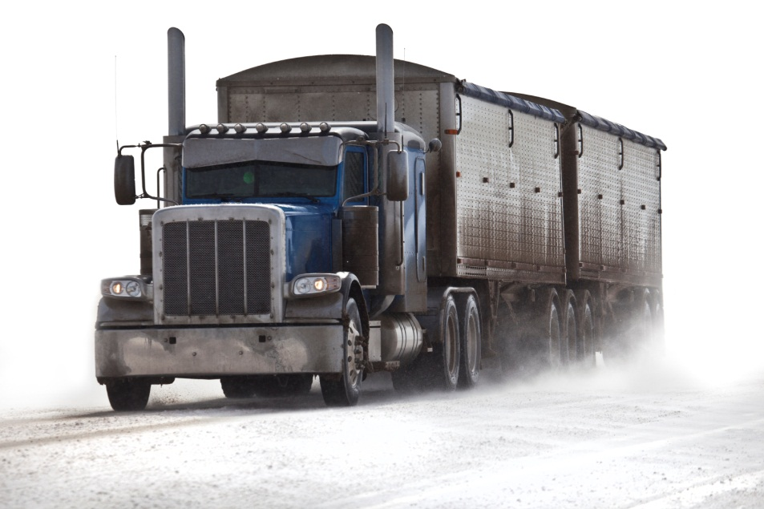

Types of Fatal Events
Figure 2 provides reportable data from Maine’s 2011 types of fatal events. Transportation Incidents accounted for 16 fatalities, 61.5 percent of all 2011 occupational fatalities. Violence and Other Injuries by Persons or Animals accounted for four fatalities, 15.4 percent, and Exposure to Harmful Substances or Environments accounted for three, 11.5 percent. Three fatalities fell under the fatal event category of Other or were not reportable.

Primary Sources Causing Fatalities
Figure 3 provides reportable data for three primary sources that contributed to Maine’s 2011 occupational fatalities. Highway Vehicles, Motorized, were involved in nine fatalities, 35 percent of all 2011 fatalities. Persons, Plants, Animals and Minerals were involved in four fatalities and Aircraft were involved in three. These 16 fatalities accounted for 61.5 percent of all 2011 occupational fatalities.

Secondary Sources
Environmental and elemental conditions of Ice, Sleet and Snow or High Winds, Gusts, Turbulence were secondary sources involved in five occupational fatalities.

Age Categories
Figure 4 provides reportable data regarding age categories for Maine’s 2011 occupational fatalities. Sixteen fatalities, 61.5 percent, involved workers who were age 45 and older. Of those 16 workers, 19.2 percent were in the age 45-to-54 range, eight, 30.7 percent were in the age 55-to-64 range and three, 11.5 percent, were age 65 and older.

U.S. 2011 occupational fatality age data reflects that 58 percent were over age 45, with 26 percent in the age 45-to-54 range, 20 percent in the age 55-to-64 range and 12 percent were age 65 and older.

2011 U.S. Fatality Rate and Maine Fatality Rate
In 2011, there were 4,693 occupational fatalities in the United States.¹ The national occupational fatality rate per 100,000 employed persons was 3.5.¹ Maine’s rate of occupational fatalities during 2011 was 4.2. This represents an increase of .9 in Maine’s occupational fatality rate from 3.3 in 2010.

Other Key Points:
- Twenty-three (88.5 percent) of Maine’s 2011 occupational fatalities were male workers.
- Nine of the fatalities that were Transportation Incidents involved workers over age 45, with six of those fatalities being between the ages of 55 and 64 years.
- Maine’s 2011 fatalities in the occupational category of Agriculture, Forestry, Fishing and Hunting accounted for 19.2 percent of total fatalities. U.S. occupational fatalities in this category accounted for 12.1 percent of national fatalities.
- The average age of workers who died from occupational injuries in Maine in 2011 was 49.

Sources:
Except for numbered references, data for this report was extracted from the Census of Fatal Occupational Injuries (CFOI), Maine Department of Labor, 2011. CFOI is a federal program that, in most cases, is administered by the states.

- See the national CFOI website: (http://www.bls.gov/iif/oshcfoi1.htm)

Research for this report was prepared by Barbara A. Spillane
Research and Statistics Unit, Division of Technical Services
Bureau of Labor Standards
Maine State Department of Labor

For more information on fatal occupational injuries, contact
Barbara A. Spillane, 207-623-7905
TTY users call Maine Relay 711.

Maine Department of Labor provides equal opportunity in employment and programs.
Auxiliary aids and services are available to individuals with disabilities upon request.

