Modified Stipend Time & Effort Certifications are only for the use of employees receiving a stipend to provide services above and beyond their institutional base salary (IBS) due to COVID-19 (2 CFR 200.430(i)(iii)). An employee’s IBS should never be included on a modified stipend certification.

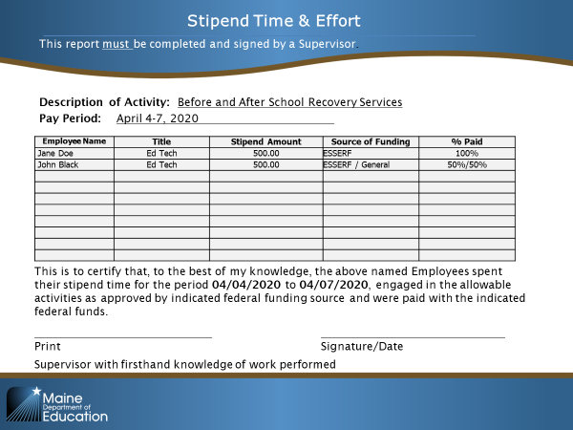
- Affirmation Statement
- Signed by Supervisor with firsthand knowledge
- Employee Name
- Job Title
- Stipend Amount
- Source of Funding
- % by Funding Source
- Description of Activity
- Certification Period

**All employees that are paid a stipend must certify their time and effort**

Stipend Time & Effort
COVID-19

This report must be completed and signed by a supervisor. This modified Stipend Time & Effort Certification is only for the use of employees receiving a stipend to provide services above and beyond their institutional base salary due to COVID-19.

Description of Activity: _________________________________________________________________________________

Pay Period: ________________________________

Employee Name | Title | Stipend Amount | Source of Funding | % Paid

This is to certify that, to the best of my knowledge, the above-named employee(s) spent 100% of their stipend time for the period
to , 20 engaged in allowable activities as approved by the indicated federal funding source and were paid with the indicated federal funds.

Print Signature/Date
Supervisor with firsthand knowledge of work performed

