13-188 DEPARTMENT OF MARINE RESOURCES
CHAPTER 26: SEA URCHINS

TITLE INDEX

26.01 Nighttime Harvesting Prohibition
26.02 Sea Urchin Minimum Size and Tolerance
26.03 Sea Urchin Maximum Size and Tolerance
26.05 Sea Urchin Drag Regulation
26.07 Sea Urchin Harvesting Season 2026-2027 pursuant to 12 M.R.S. §6749
26.10 Log Book
26.12 Tagging
26.15 Sea Urchin Harvester License Limited Entry System
26.19 Limited Access Areas
26.20 Targeted Closures
26.30 Sea Urchin Zone Council Elections
26.40 Tote Limits
26.50 Urchin Electronic Reporting

APPENDICES

Appendix A Calendar: Sea Urchin Season for Maine Zone 1
Appendix B Calendar: Sea Urchin Season for Maine Zone 2
Appendix C Calendar: Sea Urchin Season for Whiting and Dennys Bays Limited Access Area (Zone 2)

26.01 Nighttime Harvesting Prohibition

It shall be unlawful to fish for or take sea urchins during the nighttime hours between sunset (as defined in 12 M.R.S. §6001(46)) until ½ hour before sunrise (as defined in 12 M.R.S. §6001(45)) within Maine’s coastal waters.

26.02 Sea Urchin Minimum Size and Tolerance

- Prohibition. It is unlawful for any person to take, possess, ship, transfer, transport, buy, or sell a sea urchin having a shell measuring less than 2¹/₁₆ inches in the longest diameter, measuring from the top or bottom of the urchin, exclusive of spines.

- Exceptions to 26.02(1) prohibition

- Possession tolerance for all persons. Any person may possess sea urchins measuring less than 2¹/₁₆ inches if they comprise less than 5% of any bulk pile.

- Take tolerance for harvesters

- Zone 1 and 2 divers. Zone 1 and 2 divers may take sea urchins that are less than 2¹/₁₆ inches if they comprise less than 20% of any bulk pile prior to culling on board.

- Take tolerance for all other harvesters. All licensed sea urchin harvesters except Zone 1 and 2 divers may take sea urchins that are less than 2¹/₁₆ inches prior to culling on board.

- Sea urchin obtained outside the state of Maine. Any person exceeding the possession tolerance of this regulation for sea urchins measuring less than 2¹/₁₆ inches shall not be in violation of Chapter 26.02 if that person is in possession of a bill of lading for the amount of the sea urchins exceeding the tolerance amount showing those sea urchins were lawfully obtained from an origin outside the State of Maine. The absence of a bill of lading shall be prima facie evidence that the sea urchins were taken from waters within the jurisdiction of the State of Maine.

- Tolerance. Tolerance shall be determined by numerical count of not less than ½ bushel taken at random from various parts of the bulk pile or by count of the entire bulk pile if it contains less than ½ bushel.

If any person is found in possession of sea urchins measuring less than 2¹/₁₆ inches that comprise more than 5% of the bulk pile pursuant to 26.02(2)(A) or 20% pursuant to 26.02(2)(B)(1), that bulk pile shall be considered contraband and subject to seizure.

- Culling requirement. Sea urchins measuring less than 2¹/₁₆ inches must be culled on board immediately after take, and liberated alive into the marine waters.

26.03 Sea Urchin Maximum Size and Tolerance

- Prohibition. It is unlawful for any person to take, possess, ship, transfer, transport, buy, or sell a sea urchin having a shell measuring more than 3 inches in the longest diameter, measuring from the top or bottom of the urchin, exclusive of spines.

- Exceptions to 26.03(1) prohibition

- Possession tolerance for all persons. Any person may possess sea urchins measuring more than 3 inches if they comprise less than 5% of any bulk pile.

- Take tolerance for harvesters

- Zone 1 and 2 divers. Zone 1 and 2 divers may take sea urchins that are more than 3 inches if they comprise less than 20% of any bulk pile prior to culling on board.

- Take tolerance for all other harvesters. All licensed sea urchin harvesters except Zone 1 and 2 divers may take sea urchins that are more than 3 inches prior to culling on board.

- Sea urchins obtained outside the state of Maine. Any person exceeding the possession tolerance of this regulation for sea urchins measuring more than 3 inches shall not be in violation of Chapter 26.03 if that person is in possession of a bill of lading for the amount of the sea urchins exceeding the tolerance amount showing those sea urchins were lawfully obtained from an origin outside the State of Maine. The absence of a bill of lading shall be prima facie evidence that the sea urchins were taken from waters within the jurisdiction of the State of Maine.

- Tolerance. Tolerance shall be determined by numerical count of not less than ½ bushel taken at random from various parts of the bulk pile or by count of the entire bulk pile if it contains less than ½ bushel.

If any person is found in possession of sea urchins measuring more than 3 inches that comprise more than 5% of the bulk pile pursuant to 26.03(2)(A) or 20% pursuant to 26.03(2)(B)(1), that bulk pile shall be considered contraband and subject to seizure.

- Culling requirement. Sea urchins measuring more than 3 inches must be culled on board immediately after take, and liberated alive into the marine waters.

26.05 Sea Urchin Drag Regulation

- It shall be unlawful to fish for, possess or take sea urchins with a drag, or combination of drags, in excess of 5 feet six inches effective fishing width (by measuring from the extreme outside of the mouth of the drag or drags), within Maine’s coastal waters.

- Escape panel - Zone 2. It shall be unlawful to fish for, possess, or take sea urchins in Zone 2 with a drag that does not have an escape panel.

- Configuration of Escape Panel

- The panel shall consist of a single layer of netting in the top of the drag above the chains.

- There can be no liner or other material or device obstructing any part of the panel.

- The panel must be at least 2 feet deep (from front to back of the drag) and extend across the full width of the drag.

- The mesh of the netting must be hung “square”, not “diamond”, that is, the twines of the mesh going one way must run parallel to the front (mouth) of the drag and the twines of the mesh going the other way must run perpendicular to the front (mouth) of the drag, not diagonally.

- The meshes must measure at least 2 inches from the middle of one knot to the middle of the next adjacent knot.

- Method of mesh measurement. Mesh size shall be measured by lining up 5 consecutive knots perpendicular to the front of the drag or parallel to the front of the drag and measuring the distance from the middle of one knot to the middle of the next knot with a ruler or tape measure. The mesh measurement shall be the average of the 5 consecutive measures. These measurements must be made at least 2 meshes away from the edges of the panel.

- Exception. It shall be lawful to fish for, take, or possess sea urchins with a drag that qualifies as a scallop drag under Chapter 11.07 if the drag meets the requirements of Chapter 26.05(1).

26.07 Sea Urchin Harvesting Season 2026-2027 pursuant to 12 M.R.S. §6749.

Harvesters may choose 15 of the available days in Zone 1 and 30 of the potential 40 available days in Zone 2.

- Zone 1 [as defined by 12 M.R.S. §6749-N(1)]. Harvesters may choose 15 of the available fishing days.

- One season for divers, trappers, rakers and draggers. The Zone 1 season for all harvesters who have certified Zone 1 on forms provided by the Commissioner, is open Mondays, Tuesdays, Wednesdays, Thursdays and Fridays in November and December 2026, and January and February 2027, except for Friday, December 25, 2026, which shall remain closed. Divers, trappers, rakers and draggers may fish no more than a total of 15 of these days.
- Zone 2 [as defined by 12 M.R.S. §6749-N(2)]. Harvesters may choose 30 of the potential 40 days.

- Early season for divers, trappers and rakers. The Zone 2 season for divers, trappers and rakers who have certified the early season on forms provided by the Commissioner, is open Tuesdays, Wednesdays and Thursdays in October 2026, with the exception of October 1, 2026 which shall remain closed; Mondays, Tuesdays, Wednesdays and Thursdays in November, 2026, with the exception of November 2, 9, 19 and 26, 2026, which shall remain closed; and Mondays, Tuesdays, Wednesdays and Thursdays in December 2026, with the exception of December 10, 24 and 31, 2026 which shall remain closed. Divers, trappers, and rakers may fish no more than a total of 30 of these days.

- Late season for divers, trappers and rakers. The Zone 2 season for divers, trappers and rakers who have certified the late season on forms provided by the Commissioner, is open December 15, 16, 17, 22, 23 ,24, 29, 30 and 31, 2026; Tuesdays, Wednesdays and Thursdays in January 2027 and February 2027; and is open March 2, 3, 4, 9, 10, 16 and 17, 2027. Divers, trappers, and rakers may fish no more than a total of 30 of these days.

- Early season for draggers. The Zone 2 season for draggers who have certified the early season on forms provided by the Commissioner, is open Mondays, Tuesdays, Wednesdays, and Thursdays in November 2026, except Monday, November 2, 9, 16, and 30, 2026, and Thursday, November 26, 2026, which shall remain closed; Wednesdays, Thursdays, Fridays and Saturdays in December 2026, with the exception of December 2, 25 and 26, 2026, which shall remain closed; Wednesdays, Thursdays and Fridays in January 2027, with the exception of January 1 and 29, 2027, which shall remain closed; and February 3 and 4, 2027. Draggers may fish no more than a total of 30 of these days.

- Late season for draggers. The Zone 2 season for draggers who have certified the late season on forms provided by the Commissioner, is open December 1, 2, 3, 9, 10, 11, 16, 17, 18, 22, 23, 24, 29, 30 and 31, 2026; Wednesdays, Thursdays and Fridays in January 2027, except January 1, 6, 13, and 29, 2027, which shall remain closed; Wednesdays, Thursdays and Fridays in February 2027, with the exception of February 17 and 24, 2027, which shall remain closed, and March 3, 4, 10, 11, 17 and 18, 2027 are open. Draggers may fish no more than a total of 30 of these days.

- Designation of Zone 2 early or late season:

- A person who holds a sea urchin harvesting license for Zone 2 may not harvest sea urchins in Zone 2 unless that person certifies on forms provided by the Commissioner that the person will fish for or take sea urchins during either the early season or the late season.

- A person who has certified the early or late season may, between May 1st and August 15th change that certification to the other time period as the time period in which that person will fish for or take sea urchins.

26.10 Log Book

See Chapter 8.10(3)(A) Landings Program.

26.12 Tagging

Each bulk pile (tote) of sea urchins must be tagged by the harvester once landed on shore. Each tag must include the date of harvest and the harvester license number. The tag must accompany each tote of sea urchins at all times until arrival at the purchasing dealer’s licensed facility.

Exception. A harvester who sells a bulk pile (tote) of sea urchins to a licensed dealer at the landing location is not required to tag the tote provided the licensed dealer purchasing the sea urchins tags each tote with the date of harvest and the harvester license number.

26.15 Sea Urchin Harvester License Limited Entry System

Beginning August 1, 2004, no new sea urchin harvesting licenses will be issued, and no lotteries will be held.

26.19 Limited Access Areas

Transiting exception. Any vessel possessing urchins onboard, may transit the Limited Access Area, only if the vessel has all fishing gear (dredges, drags, regulators, buoyancy compensators, fins, tanks, weight belts) securely stowed. Securely stowed shall mean the main wire shall not be shackled or connected to the dredges or drags, and the towing swivel will be at the block or on the winch for draggers, while regulators, buoyancy compensators and tanks should be disconnected with fins and weight belts removed for divers.

- Whiting and Dennys Bay area (Zone 2). Harvesters may choose up to 12 days of the following applicable season open days for the Whiting and Dennys Bay limited access area to fish within their 30 days available for harvest.

- Early season for divers, trappers and rakers. It shall be unlawful to fish for, take, or possess urchins west of a line starting at the western end of Mahar Point, Pembroke, due south to the nearest point of land on Crow Neck, Trescott, to include all of Whiting and Dennys Bay except by divers, trappers, and rakers who have certified the early season on forms provided by the Commissioner on October 13, 20, and 27, 2026 and Tuesdays in November and December 2026.

- Late season for divers, trappers and rakers. It shall be unlawful to fish for, take, or possess urchins west of a line starting at the western end of Mahar Point, Pembroke, due south to the nearest point of land on Crow Neck, Trescott, to include all of Whiting and Dennys Bay except by divers, trappers and rakers who have certified the late season on forms provided by the Commissioner on December 29, 2026; Tuesdays in January 2027, and Tuesdays in February 2027, and March, 2, 9, and 16, 2027.

- Early season for draggers. It shall be unlawful to fish for, take, or possess urchins west of a line starting at the western end of Mahar Point, Pembroke, due south to the nearest point of land on Crow Neck, Trescott, to include all of Whiting and Dennys Bay except by draggers who have certified the early season on forms provided by the Commissioner, on November 5, 12, and 19, 2026; December 3, 10, and 17, 2026; January 7, 14, 21 and 28, 2027; and February 3 and 4, 2027.

- Late season for draggers. It shall be unlawful to fish for, take, or possess urchins west of a line starting at the western end of Mahar Point, Pembroke, due south to the nearest point of land on Crow Neck, Trescott, to include all of Whiting and Dennys Bay except by draggers who have certified the late season on forms provided by the Commissioner, on December 3, 10 and 17, 2026; January 7, 14, 21 and 28, 2027; February 4, 11 and 25, 2027; and, March 4 and 11, 2027.

26.20 Targeted Closures

It shall be unlawful to fish for, take, or possess urchins taken by any method within any of the following closed areas. All directions are relative to True North (not magnetic).

Transiting exception. Any vessel possessing urchins onboard, may transit these targeted closures, only if the vessel has all fishing gear (dredges, drags, regulators, buoyancy compensators, fins, tanks, weight belts) securely stowed. Securely stowed shall mean the main wire shall not be shackled or connected to the dredges or drags, and the towing swivel will be at the block or on the winch for draggers, while regulators, buoyancy compensators and tanks should be disconnected with fins and weight belts removed for divers.

- Cat Ledges area. It shall be unlawful to fish for, take, or possess urchins inside a line drawn from the southwestern tip of Pratt Island, Southport Island, then south to Red Gong “4CL”, then northeast to the prominent point on the eastern shore of Christmas Cove.

26.30 Sea Urchin Zone Council Elections

- Elections and term. The Sea Urchin Zone Council shall hold its first election for those members specified in 12 M.R.S. §6749-X, sub-§1 by March 2008, and a biennial election thereafter beginning in December 2010, to re-elect or replace the elected members whose terms are expiring. Council members shall have terms of two years.

- Election of council members. Election of council members shall be by a plurality vote of eligible voters participating in the election.

- Eligibility of council members. To be eligible for election as a council member an individual must hold a valid license of a type specified in 12 M.R.S. §6749-X, sub-§1 and be at least 18 years of age. An individual who has been convicted of a marine resources law violation within the previous 6 years is not eligible for election as a council member unless a waiver from this requirement has been granted by the commissioner for good cause as determined by the commissioner in his or her discretion.

- Eligibility to vote. An individual who holds a valid license of a type specified in 12 M.R.S. §6749-X, sub-§1 and is at least 18 years of age shall be eligible to vote to fill vacant council positions representing the same type of license held by the voter. If the license type is specific to Zone 1 or Zone 2, as defined under 12 M.R.S. §6749-N, then the individual shall only be eligible to participate in the election if the individual holds the eligible license in the same zone.

- Election process. Each individual shall have one vote in the election for each seat for which they are eligible to vote. The vote shall be by secret mailed ballot and the ballots shall be collected by the Department of Marine Resources. The ballots shall be tallied, and the results shall be made known to the Commissioner, members of the Sea Urchin Zone Council and the public.

- Vacancies. Any vacancy occurring in the membership of the Sea Urchin Zone Council including one created by reason of resignation, ineligibility, or death shall be filled by the candidate from the most recent election who received the second greatest number of votes. If no such candidate is available or is willing to serve as representative, then a special election will be held. Council members elected to fill a vacancy shall serve for the remainder of the vacated member’s term.

- Removal of council members. A council member whose urchin license is suspended or revoked, or who fails to renew the license, shall automatically be removed from the Sea Urchin Zone Council. A Council member who misses three consecutive meetings without notifying an officer or other Council member of the intended absence from a meeting may be removed from the Council by affirmative vote of the Council.

26.40 Tote Limits

- Zone 1. It is unlawful for Zone 1 sea urchin divers, rakers or trappers to fish for, take, possess at sea, or land more than nine (9) standard size stackable fish totes of sea urchins per day. While on shore, Zone 1 sea urchin divers, rakers, or trappers may not possess, transport, or sell more than the harvester’s weekly Zone 1 tote limit.

It is unlawful for Zone 1 drag vessels to fish for, take, possess at sea, or land more than nine (9) standard size stackable fish totes of sea urchins per day. While on shore, Zone 1 sea urchin drag vessels may not possess, transport, or sell more than the harvester’s weekly Zone 1 tote limit.

- Zone 2. It is unlawful for Zone 2 sea urchin divers, rakers or trappers to fish for, take, possess at sea, or land more than six (6) standard size stackable fish totes of sea urchins per day. While on shore, Zone 2 sea urchin divers, rakers, or trappers may not possess, transport, or sell more than the harvester’s weekly Zone 2 tote limit.

It is unlawful for Zone 2 drag vessels to fish for, take, possess at sea, or land more than six (6) standard size stackable fish totes of sea urchins per day. While on shore, Zone 2 sea urchin drag vessels may not possess, transport, or sell more than the harvester’s weekly Zone 2 tote limit.

- Implementation of daily and weekly tote limits. It is unlawful to offload sea urchins, or any parts of sea urchins, and then return to fishing for sea urchins the same day in Maine’s territorial waters. In addition, it is unlawful to transfer sea urchins, or any parts of sea urchins to or from another vessel at sea, except for tender vessels transiting to primary vessels during diving operations.

Weekly tote limits, calculated from Monday to Friday, are equal to the daily zone tote limit multiplied by the number of open days for the zone in which the license holder is authorized and elects to fish that week.

It is unlawful for a licensed sea urchin dealer to purchase a quantity of sea urchins from a licensed harvester greater than the licensed harvester’s weekly zone tote limit each week. All sales of sea urchins must be completed weekly by Friday at 11:59 p.m. It is unlawful for a person other than a licensed sea urchin dealer to possess sea urchins held over from the previous harvest week.

Standard size stackable fish totes, with respect to the sea urchin fishery, is defined as 28” Long x 16" Wide x 11" Deep when measured inside at the shelf level. The tote shall retain its original size and shape when filled. A tote, when full, must allow for a straight edge to clear without hinderance when swiped over the top of the tote.

26.50 Urchin Electronic Reporting

For the purpose of this section, “DMR-issued reporting device” means a transaction card or other Department developed and approved technology provided for the purpose of recording urchin transactions.

- Eligibility. In order to be eligible for a DMR-issued device for the electronic reporting of urchin landings, an individual must be licensed according to 12 M.R.S. §6748, 6748-A, 6748-D, or 6302-A subsection 3 paragraph B. Valid reporting devices may only be issued by the Department of Marine Resources.

- Harvester use. It is unlawful for an individual licensed under 12 M.R.S. §6748, 6748-A, 6748-D, or 6302-A subsection 3 paragraph B to sell or transfer urchins the license holder has taken, unless the harvester presents a DMR-issued reporting device and records each transaction. DMR-issued reporting devices may only be used to sell urchins which were harvested by the individual identified on the reporting device. A law enforcement officer may seize or deactivate the reporting device of an individual who has used their reporting device to sell urchins they did not harvest.

- Dealer Use. It is unlawful for a person licensed under 12 M.R.S. §6851 subsection 2-B, subsection 2-C, or §6852 to purchase or transfer urchins from an individual licensed under 12 M.R.S. §6748, 6748-A, 6748-D, or 6302-A subsection 3 paragraph B, without recording the transaction using the electronic recording device specified by the Department for that purpose. DMR provided reporting software must be synchronized for updates to the reporting system prior to the purchase of urchins on each fishing day. A person licensed under 12 M.R.S. §6851 subsection 2-B or subsection 2-C may not purchase urchins from a harvester that does not present a DMR-issued reporting device. In the event of any failure of the reporting software or equipment, the Commissioner may authorize the use of paper reports until such time as the system is operational.

- Records required. A person licensed in accordance with 12 M.R.S. §6851 subsection 2-B or subsection 2-C shall maintain documentation to account for all urchins in their possession. Any urchins legally obtained from other jurisdictions must have sufficient documentation to demonstrate their origin. Failure to provide proper documentation will be prima facie evidence that the urchins are illegal and are subject to seizure.

- The Department will deactivate the reporting device of any individual who has met or exceeded their sea urchin harvest days. The onus is on the license holder to track days fished; harvesting beyond the number of allocated season days is considered fishing out of season and is prohibited.

- An individual licensed according to 12 M.R.S. §6748, 6748-A, 6748-D, or 6302-A subsection 3 paragraph B that has declared into either the Zone 1 or Zone 2 fishery, must report all landed and retained sea urchins daily to the Department via an approved electronic reporting option by 11:59 PM the day of landing or retention. If no landings or retention occurred on a day open for fishing in the license holder’s declared zone, a negative report is required.

Exception. Daily electronic reporting is not required if the license holder sells all their harvested sea urchins to a licensed dealer on the day of harvest and does not intend to hold any of the harvested sea urchins for sale later in the week.

Appendix A:

Sea Urchin Season for Maine Zone 1
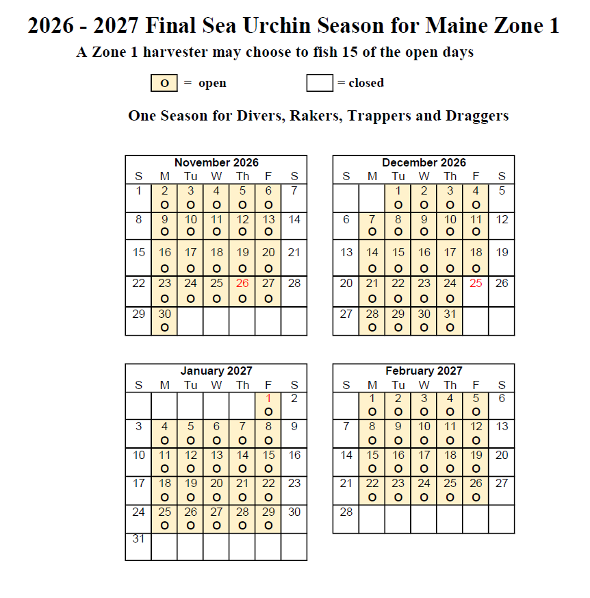

Appendix B:
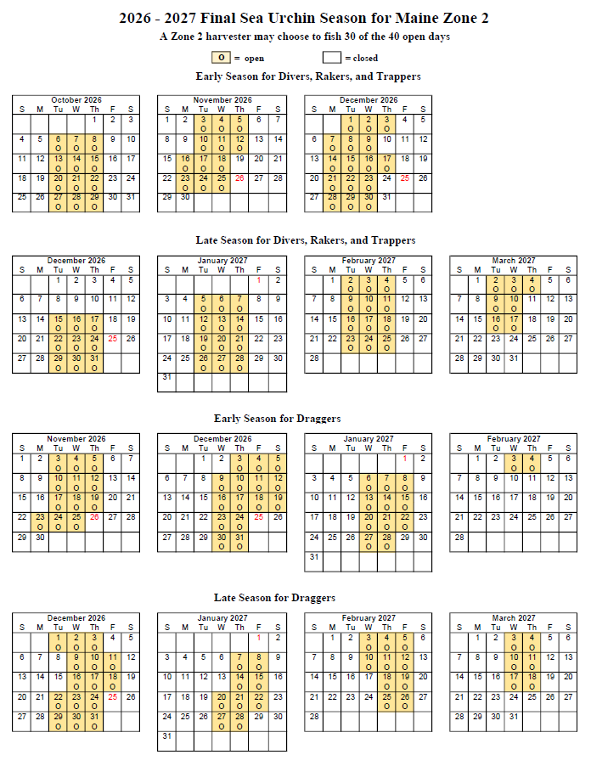
Sea Urchin Season for Maine Zone 2

Appendix C:
Sea Urchin Season for Whiting and Dennys Bay Limited Access Area (Zone 2)
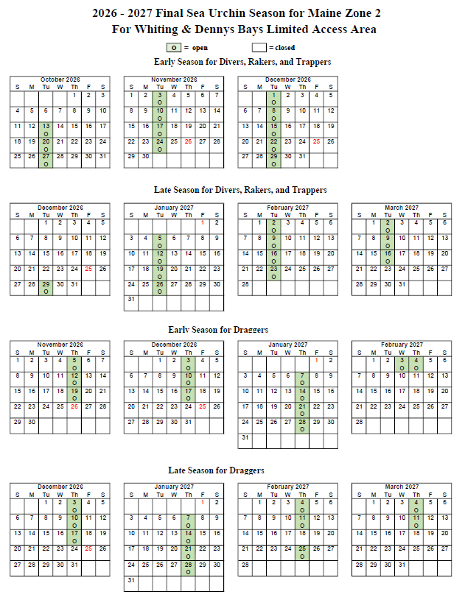

INDEX

STATUTORY AUTHORITY:
12 M.R.S. §§ 6171, 6171-A, 6302-A, 6749, 6749-C, 6749-U

EFFECTIVE DATE:
December 22, 1993 (EMERGENCY)
May 30, 1994

AMENDED:
August 14, 1994 – Section 26.05
July 27, 1996 – Section 26.10
July 31, 1996 – Section 26.07
August 14, 1996 – Section 26.10
July 22, 1997 – Section 26.07
August 25, 1998 – Section 26.07, calendars
December 12, 1998 – Section 26.20 added
January 31, 1999 – Section 26.15 added
May 18, 1999 – Section 26.20
August 28, 1999 – Section 26.07, calendars
August 21, 2000 – Sections 26.02, 26.03, 26.07, calendars
November 19, 2000 – Sections 26.05, 26.20(7)
July 21, 2001 – Sections 26.02, 26.03, 26.07, calendars
March 25, 2002 – Sections 26.02, 26.03, 26.15
June 24, 2002 – Section 26.07
March 24, 2003 – Section 26.15(2)(G)
April 21, 2003 – Section 26.15
August 3, 2003 – Sections 26.01, 26.05
August 3, 2003 – Section 26.02
August 3, 2003 – Section 26.03
August 3, 2003 – Section 26.06
August 3, 2003 – Section 26.07(1), calendar (earlier calendar removed)
August 3, 2003 – Section 26.07(2), calendar (earlier calendar removed)
September 16, 2003 – Section 26.05
December 17, 2003 – Section 26.10
June 12, 2004 – Section 26.20(1,2,3,5,6,7) repealed
August 22, 2004 – Section 26.15
August 22, 2004 – Section 26.07(1), calendars
August 22, 2004 – Section 26.07(2), calendars
August 28, 2005 – Section 26.07(1), calendar
August 28, 2005 – Section 26.07(2), calendar
July 24, 2006 – Section 26.07(1), calendar
July 24, 2006 – Section 26.07(2), calendar
July 24, 2006 – Section 26.12
July 29, 2007 – Section 26.07(2), calendar
July 29, 2007 – Section 26.07(1), calendar
January 27, 2008 – Section 26.30
July 22, 2008 – Section 26.07(1), calendar
July 22, 2008 – Section 26.07(2), calendar
July 20, 2009 – Section 26.07(1), calendar
July 20, 2009 – Section 26.07(2), calendar
September 21, 2009 – Section 26.19
August 23, 2010 – Section 26.07(1), calendar
August 23, 2010 – Section 26.07(2), calendar
August 22, 2011 – Section 26.07(1), calendar
August 22, 2011 – Section 26.07(2), calendar
July 23, 2012 – Sections 26.07(2), calendar, 26.10, 26.12, 26.19
December 8, 2012 – Section 26.19(2) added (EMERGENCY, Expires 03/08/13)
July 25, 2013 – Sections 26.07(1)(2), 26.10, 26.19, 26.40 added, calendar
July 8, 2014 – Sections 26.07(1)(2), 26.19(1) amended; Section 26.20 deleted; Section
26.40(1-3) amended & added, calendar
August 8, 2015 – Sections 26.07(1)(2), 26.19(1) amended, Section 26.50 added, calendars
July 12, 2016 – Sections 26.07, 26.19 amended and calendars
August 7, 2017 – Sections 26.07, 26.19 amended and calendars
August 21, 2018 – Sections 26.07, 26.19, 26.20, 26.50 calendars
July 17, 2019 – Sections 26.07, 26.19, 26.40, calendars
August 29, 2020 – Sections 26.07, 26.19, calendars
August 20, 2021 – Sections 26.07, 26.19, calendars
August 16, 2022 – Sections 26.07, 26.19, calendars
August 20, 2023 – Sections 26.07, 26.19, calendars
October 6, 2024 – Sections 26.07, 26.12, 26.19, 26.40, 26.50, calendars
September 30, 2025 – Sections 26.07, 26.19, 26.50, calendars,

NON-SUBSTANTIVE CORRECTIONS:
September 26, 2025 – accessibility issues were resolved by agency; edits also made
by agency (addition of page numbers, rule history information)

AMENDED:
August 19, 2026 – Section 26.01, 26.07, 26.19, Appendices A-C: calendars

