13-188 DEPARTMENT OF MARINE RESOURCES
CHAPTER 11: SCALLOPS

TITLE INDEX

11.01 Definitions
11.02 Reporting
11.03 Atlantic Sea Scallops Harvesting Season, Closed Days and Rotational Management
11.04 Configuration of Scallop Drag
11.05 Scallop Harvesting Grear Restrictions
11.06 Municipal Mooring Field Closures
11.07 Atlantic Sea Scallops Limitations
11.08 Targeted Scallop Conservation Closures
11.09 Limited Access Areas
11.10 Cobscook Bay Limits and Restrictions
11.11 Open and Closed Scallop Fishing Days
11.12 Rotational Management Plan
11.13 Trigger Mechanism
11.14 Commercial Scallop License Limited Entry System

APPENDICES

Appendix A Calendar: Open Harvest Days for Zone 1 Drag
Appendix B Calendar: Open Harvest Days for Zone 1 Dive
Appendix C Calendar: Open Harvest Days for Zone 2 Drag
Appendix D Calendar: Open Harvest Days for Zone 2 Dive
Appendix E Calendar: Open Harvest Days for Zone 3 Drag
Appendix F Calendar: Open Harvest Days for Zone 3 Dive

11.01 Definitions

- Chafing gear or cookies. “Chafing gear or cookies”, with respect to the scallop fishery, means steel, rubberized, or other types of donut rings, disks, washers, twine, or other material attached to or between the steel rings of a sea scallop drag or dredge.

- Drag, dredge, drag gear, or dredge gear. “Drag, dredge, drag gear, or dredge gear”, with respect to the scallop fishery, means gear consisting of a mouth frame attached to a holding bag constructed of metal rings, or any other modification to this design, that can be or is used in the harvest of scallops.

- Drag or dredge bottom. “Drag or dredge bottom”, with respect to the scallop fishery, means the rings and links found between the bail of the drag or dredge and the club stick, which, when fishing, would be in contact with the sea bed. This includes the triangular shaped portions of the ring bag commonly known as “diamonds”.

- Drag or dredge top. “Drag or dredge top”, with respect to the scallop fishery, means the mesh panel in the top of a drag or dredge and immediately adjacent rings and link found between the bail of the dredge, the club stick, and the two side panels. The bail of the dredge is the rigid structure of the forward portion of the drag or dredge that connects to the warp and holds the drag or dredge open. The club stick is the rigid bar at the tail of the drag or dredge bag that is attached to the rings.

- Scallop Management Zone One (1). “Scallop Management ‘Zone One (1)’” includes all coastal waters West of a line beginning at the easternmost point of Fort Point State Park on Cape Jellison then running southwesterly to channel marker #1 South of Sears Island, then running southwesterly to channel marker RW “II” located between Marshall’s Point and Bayside in the Town of Northport, then running southwesterly to Graves channel marker southeast of the Town of Camden, then running southeasterly to the Penobscot Bay Buoy “PB” East of Rockland Harbor, then running southerly to the TBI whistle southwest of Junken Ledge, then running southeasterly to Red Nun #10 buoy at Foster Ledges, then running due South magnetic to the boundary of the State’s coastal waters to the New Hampshire border.

- Scallop Management Zone Two (2). “Scallop Management ‘Zone Two (2)’” includes all coastal waters East of the line defined in the preceding subsection 5 for Zone One, including all coastal waters of the Penobscot River North of Fort Point State Park to the Lubec-Campobello Island bridge; and all territorial waters surrounding Machias Seal Island and North Rock.

- Scallop Management Zone Three (3). “Scallop Management ‘Zone Three (3)’” includes all coastal waters North and East of the Lubec-Campobello Island bridge including all of Cobscook Bay and the St. Croix River inside Maine territorial waters.

- Commercial Scallop License. “Commercial Scallop License” refers to a handfishing scallop or handfishing with tender license issued under 12 M.R.S. §6701 or a scallop dragging license issued under 12 M.R.S. §6702.

11.02 Reporting

See Chapter 8.

11.03 Atlantic Sea Scallops Harvesting Season, Closed Days and Rotational Management

- A person may not fish for or take scallops by dragging in Maine’s territorial waters from April 16th to November 30th, both days inclusive.

- A person may not fish for or take scallops by diving in Maine’s territorial waters from April 30th to November 14th, both days inclusive.

- A person may not fish for or take scallops except on an open day as established in 11.11.

- A person may not fish for or take scallops from a rotational management area in Zone 2, except from an open rotational management area as established in 11.12.

11.04 Configuration of Scallop Drag

- Minimum mesh size

- Twine top restrictions. The mesh size of net material on the top of a scallop dredge in use by or in possession of vessels in the Atlantic sea scallop fishery shall not be smaller than 5.5 inches (13.97 cm).

- For vessels rigged with a dredge or dredges, and each individual dredge is greater than 8 ft (2.44 m) in width, there must be at least seven rows of non-overlapping steel rings unobstructed by netting or any other material, between the terminus of the dredge (club stick) and the net material on the top of the dredge (twine top).

- For vessels rigged with a dredge or dredges, and each individual dredge is greater than 3.5 ft (1.07 m) and less than or equal to 8 ft (2.44 m) in width, there must be at least four rows of non-overlapping steel rings unobstructed by netting or any other material, between the club stick and the twine top of the dredge.

- For vessels rigged with a dredge or dredges, and each individual dredge is 3.5 feet (1.07 m) or less in width, there must be at least one row of non-overlapping steel rings unobstructed by netting or any other material, between the club stick and the twine top around the circumference of the top of the dredge. The twine top must be hung on no more than two diamond meshes per ring on the top and bottom and a single diamond mesh per ring on the sides. Alternative designs may be approved by permit from the Commissioner.

- Measurement of mesh size. Mesh size is measured by using a wedge-shaped gauge having a taper of 2 cm in 8 cm and a thickness of 2.3 mm, inserted into the meshes under a pressure or pull of 5 kg. The mesh size is the average of the measurements of any series of 20 consecutive meshes for nets having 75 or more meshes, and 10 consecutive meshes for nets having fewer than 75 meshes. The mesh in the regulated portion of the net will be measured at least five meshes away from the lacings running parallel to the long axis of the net.

- Chafing gear and other gear obstructions

- Chafing gear restrictions. No chafing gear or cookies shall be used on the top of a scallop dredge.

- Link restrictions. No more than double links between rings shall be used in or on all parts of the dredge bag, except the dredge bottom. No more than triple linking shall be used in or on the dredge bottom portion and the diamonds. Damaged links that are connected to only one ring, i.e., “hangers”, are allowed, unless they occur between two links that both couple the same two rings. Dredge rings may not be attached via links to more than four adjacent rings. Thus, dredge rings must be rigged in a configuration such that, when a series of adjacent rings are held horizontally, the neighboring rings form a pattern of horizontal rows and vertical columns.

- Dredge or net obstructions. No material, device, net, dredge, ring, or link configuration or design shall be used if it results in obstructing the release of scallops that would have passed through a legal sized and configured net and dredge, as described in this part, that did not have in use any such material, device, net, dredge, ring, or link configuration or design.

- Minimum ring size. A person may not use a drag to fish for or take scallops in the territorial waters with rings that measure less than 4 inches.

11.05 Scallop Harvesting Gear Restrictions

- State waters drag size restriction. It shall be unlawful to possess on any vessel fishing for scallops, or to fish for or take scallops, in Maine's territorial waters:

- Any scallop drag or combination of scallop drags that exceed 10 feet 6 inches in width (by measuring from the extreme outside of the mouth of the drag or drags).

- Dragging for scallops Damariscotta River, Lincoln County. It shall be unlawful to fish for or take scallops in the Damariscotta River with any scallop drag (chain sweep or rock drag) north of a line drawn from Emerson Point, at the southernmost tip of Ocean Point in the town of Boothbay, easterly to Thrumcap Island, then northerly to the southern tip of Rutherford Island, South Bristol from April 16th to ½ hour after sunset December 31st of each year.

- Scalloping in the Frenchboro Cable Area - hand scallop fishing allowed

- It shall be lawful to take scallops by hand, unless prohibited by other statute or regulation in the Frenchboro Cable Area described in 12 M.R.S. §6954-A(1) (hereafter "Frenchboro Cable Area”).

- It shall be unlawful to operate any watercraft when towing a drag or trawl while taking scallops by hand in the Frenchboro Cable Area.

- It shall be unlawful to use a watercraft rigged for dragging while taking or attempting to take scallops by hand in the Frenchboro Cable Area.

- It shall be unlawful to possess scallops aboard a watercraft rigged for dragging while taking or attempting to take scallops by hand in the Frenchboro Cable Area.

11.06 Municipal Mooring Field Closures

It shall be unlawful to fish for, take, or possess scallops taken by dragging within any of the following closed areas. All directions are relative to True North (not magnetic).

Transiting exception. A vessel may not transit within the following closed areas with any part of a drag, including the cable, in the water.

- Inner Blue Hill Harbor. West of a line drawn from the most western point of Sculpin Point, Blue Hill to the closest point of land on Parker Point, Blue Hill Neck.

- Bartlett Landing. East of a line starting at the town pier 44° 20.576’ N, 068° 25.042’ W, running south to the northern tip of west point 44° 20.274’ N, 068° 25.264’ W.

- Seal Harbor. North of a line starting at the southern end of Crownshield Pt 44° 17.286’ N, 068° 14.620’ W running in an easterly direction to 44° 17.416’ N, 068° 14.180’ W.

- Northeast Harbor. North of a line starting at a private pier on the western side of the Harbor 44° 17.244’ N, 068° 16.787’ W running in a north easterly direction to the southern tip of land on the east side of the harbor 44° 17.432’ N, 068° 16.583’ W.

- Somes Sound Harbor. North of a line starting at the northern tip of Mason Point 44° 21.491’ N, 068° 19.626’ W then running in a southeasterly direction to the southern tip of Squantum Point 44° 21.425’ N, 068° 19.311’ W.

- Western Blue Hill Bay (Blue Hill). Inside and westerly of a line beginning at the easternmost point of High Head, Blue Hill, then running northeast to the most eastern tip of Sand Point, Blue Hill.

- Pennamaquan River. Inside and up river of a line drawn from the Eastern tip of Kelly Point, Pembroke and running in a Northeast direction to GC “11” and then continuing in a direction of true North to Hersey Neck.
- Sullivan Harbor. Inside and north of a line starting at Edgewater Point, Sullivan, 44° 31.214’ N, 068° 12.692’ W, continuing in an easterly direction for approximately .6 nm to an unnamed point, 44° 31.023’ N, 068° 11.902’ W, Sullivan.

11.07 Atlantic Sea Scallop Limitations

- Atlantic sea scallops, minimum size. In Maine Territorial Waters, it shall be unlawful to possess Atlantic sea scallops whose shells are less than 4 inches in the longest diameter, effective on December 1, 2004 and thereafter in accordance with 12 M.R.S. §6721(1)(A) & (B).

- Atlantic sea scallops, night harvesting prohibition. Effective November 1, 1986, it shall be unlawful to fish for or take scallops during the nighttime hours between sunset (as defined in 12 M.R.S. §6001(46)) until ½ hour before sunrise (as defined in 12 M.R.S. §6001(45)) within Maine's territorial waters.

- Atlantic sea scallops, culling required. Scallops less than the minimum legal size must be immediately liberated. It is prima facie evidence of possession of illegal scallops if a vessel contains scallops smaller than the minimum size while a scallop license holder or crewmember is shucking scallops.

- Atlantic sea scallops, shellstock ratio to meat conversion, possession limit, daily limit

- Shellstock ratio to meat conversion. For the purposes of this regulation, one and a half bushels of shellstock shall be equal to one gallon of scallop meat.

- Daily harvest and possession limits

- Daily Harvest and Possession Limit for Individuals Issued a License under §6702 or 6302-A for scallop dragging. It is unlawful to fish for, take or possess more than 15 gallons of scallop meat or any aggregate of meat and shellstock, which is greater than the equivalent of 15 gallons of meat per day per vessel.

- Daily Harvest and Possession Limit for Individuals Issued a License under §6701 or 6302-A for scallop diving. It is unlawful for an individual licensed under §6701 or 6302-A for scallop diving to fish for, take or possess more than 15 gallons of scallop meat or any aggregate of meat and shellstock, which is greater than the equivalent of 15 gallons of meat per day.

- Daily Limit Restrictions. It is unlawful to unload any portion of a day’s catch and return to fishing in Maine’s territorial waters. It is unlawful to transfer to or receive from another vessel any scallop shellstock or scallop meats.

- Atlantic sea scallops harvested seaward of Maine’s territorial waters. A vessel may possess or land more than 15 gallons of scallop meats per day within Maine’s territorial waters only if it meets each of the following requirements:

- The scallop meats were harvested seaward of Maine’s territorial waters.

- The vessel holds a valid current Federal Permit (Title 50(A) §648.4) that authorizes possession of more than 15 gallons of scallop meats per day.

- The amount of scallop meats on board does not exceed the maximum amount authorized by the vessel’s Federal Permit.

- The vessel has all fishing gear (dredges, drags) securely stowed when transiting Maine’s territorial waters. Securely stowed shall mean the main wire shall not be shackled or connected to the dredges or drags, and the towing swivel will be at block or on the winch.

11.08 Targeted Scallop Conservation Closures

Targeted closures are imposed as conservation measures to assist in rebuilding specific areas of the state. Targeted closures may be implemented based on depletion, seed, the presence of spat-producing scallops, and other conservation factors as determined by the Commissioner. Targeted closures are not seasonal closures and are implemented in order to improve and enhance the conservation and rebuilding of the resource in these specific areas.

It shall be unlawful to fish for, take, or possess scallops taken by any method within any of the following closed areas.

Transiting exception. Any vessel possessing scallops onboard may transit these targeted closures only if the vessel has all fishing gear (dredges, drags, regulators, buoyancy compensators, fins, tanks, weight belts) securely stowed. Securely stowed shall mean the main wire shall not be shackled or connected to the dredges or drags, and the towing swivel will be at block or on the winch for draggers, while regulators, buoyancy compensators and tanks should be disconnected with fins and weight belts removed for divers.

- Lower Muscle Ridge

Northern boundary: East and South of a line beginning at the most eastern tip of Whitehead Island, St. George, to the southern tip of Seal Island (Hay Ledges) continuing to the most southwestern point of Graffam Island, then continuing to the southwestern point of Pleasant Island and continuing in a southeasterly direction to the northeastern tip of Two Bush Island.

Southern boundary: North of a line starting at the most southern point of Whitehead Island, St. George, to the southern end of Two Bush Island.

- Eastern Casco Bay

Eastern boundary: West and North of a line drawn from the most southern tip of Gun Point, Harpswell, to G “3”, South of Round Rock; continuing in a southwesterly direction to R N “2” at Eastern Drunkers Ledge.

Western boundary: East and North of a line draw from R N “2” at Eastern Drunkers Ledge to the most southern tip of Jaquish Island; then east of a line from the most northwestern tip of Jaquish Island at Latitude 43º 42.950’ N, Longitude 70º 00.137’ W to the most southeastern tip of land along Jaquish Gut at Latitude 43º 43.043’ N, Longitude 70º 00.128’ W.

- Upper Sheepscot River

Western boundary: East of a line drawn from the most southern tip of Hockomock Point, Woolwich to the most northern tip of Mill Point, Arrowsic Island, and following the shoreline to the Arrowsic Island-Georgetown Island bridge, and then continuing along the northern coastline to the northeast tip of Dry Point, Georgetown Island.

Eastern boundary: West of a line drawn at the most northern tip of Soldier Point, Georgetown Island running north to the most southern tip of Westport Island.

Southern boundary: North of a line drawn from the most southern point of Kehail Point running northeasterly to the most southern point of Barters Island and continuing southeasterly to the most northwestern tip of Sawyer Island.

- New Meadows River

Southeast boundary: North of a line drawn from the southernmost tip of Birch Point, Phippsburg, to the southernmost tip of Long Island, Harpswell, then continuing along the western coastline to the northern tip of Long Island, Harpswell, then a line drawn due west to the nearest point of land on Sebascodegan Island, Harpswell.

Southwestern boundary: North of the Route 24 Gurnet Bridge (Harpswell).

- Card Cove. West of a line drawn from the southeasternmost tip of Pinkham Point, Harpswell, in a southwesterly direction to the nearest point of land and to include all of Card Cove, Harpswell.

- Beals-Jonesport Bridge

Eastern boundary: West of a line drawn from the most eastern tip of Perio Point, Beals to OW Look’s wharf, Jonesport.

Western boundary: East of the Jonesport-Beals Bridge.

- East Moosabec Reach

Western boundary: Inside and east of the Jonesport-Beals Bridge

Eastern boundary: Inside and west of a line starting at the eastern tip of Kelley Point, Jonesport and running southwesterly to the eastern tip of Pig Island; and, continuing southwesterly to the northeastern tip of Great Wass Island.

- Upper Cranberry Isles. North of a line starting at the eastern point of Seawall Point running northeasterly to the northwestern tip of Spurling Point, Great Cranberry; then continuing along the northern shore of Great Cranberry to Long Point and running northeasterly to the tip of Haddock Point; then continuing along the shore of Little Cranberry to Marsh Head; and then running northerly to Otter Point, Mount Desert Island.

- Upper Western Casco Bay

Southern boundary: North of a line drawn from the most southwestern point of Basin Point,
Harpswell (Harpswell) running southeasterly to the southwestern tip of Bailey Island.

- Casco Bay Islands

Southern boundary: North of a line drawn from the northern point of Ship Cove, South Portland running northeasterly to the southwestern tip of Cushing Island and running along the southeastern shore of Cushing Island to most northern point of White Head; then continuing northeasterly to RN4 and then northeasterly to the western most point of Jewell Island, and then running northeast to the southwestern point of Basin Point, Harpswell.

- Lower Blue Hill Rotational Area

Eastern boundary: North and West of a line from the southernmost tip of Lopaus Point to the northernmost point of Black Island, continuing from the westernmost tip of Black Island to the northernmost tip of Swans Island Head.

Western boundary: North and East of the line from the most southeastern point of Naskeag Point, Brooklin to the northern most tip of Swan’s Island Head, Swan’s Island.

Northern boundary: South of a line drawn from the easternmost point of Harriman Point due East to the southern tip of Hardwood Island, then South to the northern tip of Moose Island, then from the southern tip of Moose Island East to Reed Point, Mount Desert Island.

- Upper Narraguagus

Southern boundary: North of a line starting at the southern tip of Flint Island and running southwesterly to the R N “2” buoy, and continuing westerly to the southern tip of Bois Bubert Island; and, continuing north along the eastern shore of Bois Bubert Island to the northern tip and running north to Tom Leighton Point, Milbridge.

- Inner Chandler Bay

Eastern boundary: West of a line starting at the southwestern tip of Bunker Hole on Great Spruce Island and running southwesterly to the G1 Bell; continuing eastward to the RN2 at Bay Ledges and then continuing southerly to the eastern point of Beals Harbor on Head Harbor Island.

Southern boundary: North of a line starting at the northeastern most tip of Sand Cove, Great Wass Island and running southeasterly to the southwestern most tip of Brim Cove, Steele Harbor Island, continuing along south along the western shore of Steele Harbor Island to the southeastern point of Upper Herring Cove and then running northeast to the southwestern point of Black Head, Head Harbor Island.

- Cobscook, Whiting and Dennys Bays

Northern boundary: South and west of a line drawn from the northern tip of Kendall Head, Eastport to the southern tip of Cummings Cove, Deer Island, Canada.

Eastern boundary: West of the international maritime boundary line.

Southern boundary: North and west of the International Bridge between Lubec and Campobello Island.

Exception. Harvest by drag only may occur on Monday, January 12, 2026, in Cobscook, Whiting and Dennys Bay. Harvest by dive only may occur on Saturday, January 17, 2026, in Cobscook, Whiting and Dennys Bay.

11.09 Limited Access Areas

It shall be unlawful to fish for, take, or possess scallops taken by any method within any of the following Limited Access Areas except by divers on December 5, 6, 12, 13, 19 and 20, 2025 and April 1, 7, 14, 21 and 28, 2026 in areas 1, 3, 4 and 5 in Zone 1. In area 2 of Zone 3, December 6, 13, 20, and 27, 2025; January 3, 10, 17, 24, and 31, 2026; February 7, 14, 21 and 28, 2026; and March 7 and 14, 2026. All directions are relative to True north (not magnetic).

It shall be unlawful to fish for, take, or possess scallops taken by any method within any of the following Limited Access Areas except by draggers on January 5, 12, 19 and 26, 2026; February 2, 9, 16, and 23, 2026; and, March 2, and 9, 2026 in areas 1, 3, 4 and 5 in Zone 1. In area 2 of Zone 3, December 1, 8, 15, 22, and 29, 2025; January 5, 12, 19 and 26, 2026; February 2, 9, 16, and 23, 2026; and March 2 and 9, 2026. All directions are relative to True north (not magnetic).

Transiting exception. Any vessel possessing scallops onboard, may transit these Limited Access Areas, only if the vessel has all fishing gear (dredges, drags, regulators, buoyancy compensators, fins, tanks, weight belts) securely stowed. Securely stowed shall mean the main wire shall not be shackled or connected to the dredges or drags, and the towing swivel will be at block or on the winch for draggers, while regulators, buoyancy compensators and tanks should be disconnected with fins and weight belts removed for divers.
The Commissioner may close harvesting for the remainder of the season in the Limited Access Areas listed below though emergency rulemaking if the Department has information that indicates there is a likelihood that between 30 percent and 40 percent of the harvestable biomass has been removed.

- Outer Western Casco Bay

Northern boundary: South of a line drawn from the most southwestern point of Basin Point, Harpswell (Harpswell) running southeasterly to the southwestern tip of Bailey Island.

Western boundary: East of a line drawn from the most southwestern point of Basin Point (Harpswell) to the northern tip of Jewell Island.

Southern boundary: North of a line drawn from the southern tip of Jewell Island, running easterly to the R N “2” at Eastern Drunkers Ledge, then continuing north to the southwestern tip of Bailey Island.

- Muscle Ridge

Eastern boundary: West and South of a line drawn from the most eastern tip of Ash Point, South Thomaston at Latitude 44º 02.805’ N, Longitude 069º 04.393’ W to RW “PA” Mo (A) GONG; then continuing southwest to the northern tip of Two Bush Island.

Western boundary: North of a line starting at the northern end of the Rackliff Island causeway then following the shore to the most southern point of Rackliff Island continuing to the most southern point of Norton Island and then continuing to the most southern point of Whitehead Island then to the southern end of Two Bush Island.

- Lower Sheepscot River

Eastern boundary: West and North of the Townsend Gut Bridge connecting Southport Island and West Boothbay Harbor.

Northern boundary: South of a line drawn from the most southern point of Kehail Point running northeasterly to the most southern point of Barters Island and continuing southeasterly to the most northwestern tip of Sawyer Island.

Western boundary: East of a line drawn at the most northern tip of Soldier Point, Georgetown Island running north to the most southern tip of Westport Island.

Southern boundary: North of a line drawn from the most southern point of Outer Head Island at Griffith Head, Georgetown to the most southern tip of Cape Island, Southport.

- Damariscotta River. North of a line drawn from Emerson Point at the southern most tip of Ocean Point in the town of Boothbay, easterly to Thrumcap Island, then northerly to the southern tip of Rutherford Island, South Bristol.

11.10 Cobscook Bay Limits and Restrictions

- Cobscook Bay

- Shellstock ratio to meat count. For the purposes of 12 M.R.S. §6728, one and a half bushels of shellstock shall be equal to one gallon of scallop meat.

- Daily harvest and possession limits

- Daily Harvest and Possession Limit for Individuals Issued a License under §6702 or 6302-A for scallop dragging. Except as allowed pursuant to Chapter 11.19(2), it is unlawful to fish for, take or possess more than 10 gallons of scallop meat or any aggregate of meat and shellstock, which is greater than the equivalent of 10 gallons of meat per day per vessel.

- Daily Harvest and Possession Limit for Individuals Issued a License under §6701 or 6302-A for scallop diving. It is unlawful for an individual licensed under §6701 or 6302-A for scallop diving to fish for, take or possess more than 10 gallons of scallop meat or any aggregate of meat and shellstock, which is greater than the equivalent of 10 gallons of meat per day.

- Daily limit. Any vessel which has taken scallops within the restricted area of Cobscook Bay, as defined by 12 M.R.S. §6728(1), may not land scallops and return to fishing for scallops within that restricted area on the same day. It is unlawful to transfer to or receive from another vessel any scallop shellstock or scallop meats.

- Harvester meat count. Except as allowed pursuant to Chapter 11.19(2), no vessel or person may take, possess or transfer shucked scallops which measure more than 35 meats per 16 oz. certified measure from or within the Cobscook Bay Restricted Area, as defined by 12 M.R.S. §6728 (1). The meat count shall be measured by selecting small scallop meats from the harvester’s catch.

- Limited access areas: See Chapter 11.09(4).

2. Non-Cobscook Bay scallops, landing and possession restrictions

- Possession. Vessels transiting or landing scallops within the restricted area of Cobscook Bay, as defined by 12 M.R.S. §6728(1), and which have been fishing exclusively outside of the restricted area may possess more than ten gallons of scallop meat or scallops which measure more than 35 meats per 16 oz. certified measure.

- Landing scallops harvested outside the restricted area, in Cobscook Bay. Vessels which are transiting or landing in the restricted area and which are in possession of more than ten gallons of scallop meat or scallops measuring more than 35 meats per 16 oz. certified measure, which have been harvested outside the restricted area, may not possess any shellstock and must have all fishing gear (dredges, drags) securely stowed when transiting the restricted area.

11.11 Open and Closed Scallop Fishing Days

- Zone 1 season for draggers. The Atlantic Sea Scallop harvesting season in Maine’s territorial waters for draggers in Zone 1 is open December 8, 2025 through to March 31, 2026, both days inclusive, with the following exceptions:

- In December 2025 fishing is prohibited on Fridays, Saturdays and Sundays, and also Thursday, December 25, 2025.

- In January, February, and March 2026, fishing is prohibited on Fridays, Saturdays and Sundays.

- Zone 1 season for divers. The Atlantic Sea Scallop harvesting season in Maine’s territorial waters for divers in Zone 1 is open December 3, 2025 through to April 29, 2026, both days inclusive, with the following exceptions:

- In the month of December 2025, fishing is prohibited on Sundays, Mondays, and Tuesdays, as well as Thursday, December 25 and Wednesday, December 31, 2025.

- Fishing is prohibited in the month of January. In the months of February 2026 and March 2026, fishing is prohibited on Sundays, Mondays, Tuesdays, and Wednesdays.

- In the month of April 2026, fishing is prohibited on Sundays and Mondays.

- Zone 2 season for draggers. The Atlantic Sea Scallop harvesting season in Maine’s territorial waters for draggers in Zone 2 is open December 1, 2025 through to March 26, 2026, both days inclusive, with the following exceptions:

- In December 2025, fishing is prohibited on Fridays, Saturdays and Sundays, and also Thursday, December 25, 2025

- In January, February, and March 2026, fishing is prohibited on Fridays, Saturdays and Sundays, except for Friday, January 30, 2026, which will remain open.

- Zone 2 season for divers. The Atlantic Sea Scallop harvesting season in Maine’s territorial waters for divers in Zone 2 is open November 18, 2025 through to April 18, 2026, both days inclusive, with the following exceptions:

- In the month of November 2025, fishing is permitted on days 18, 19, 20, 21, 22, 25, 26, 28, and 29, 2025. December 2025, fishing is prohibited on Sundays, Mondays, Tuesdays and Wednesdays and also Thursday, December 25, 2025.

- In the months of January, February, and March 2026 fishing is prohibited on Sundays, Mondays, Tuesdays, and Wednesdays, and also Thursday, January 1, 2026. April 2026, fishing is prohibited on Sundays, Mondays and Tuesdays.

- Zone 2 State waters season. The Atlantic Sea Scallop harvesting season in Maine’s territorial waters around Machias Seal Island and North Rock is open December 1, 2025 through March 31, 2026, both days inclusive.

- Zone 3 season for draggers. The Atlantic Sea Scallop harvesting season in Maine’s territorial waters for draggers in Zone 3 is open December 1, 2025 through March 25, 2026, both days inclusive, with the following exceptions:

- Fishing is prohibited on Thursdays, Fridays, Saturdays and Sundays in the month of December 2025, and also Wednesday, December 24, 2025.

- Fishing is prohibited on Thursdays, Fridays, Saturdays and Sundays in the months of January, February and March 2026.

- Zone 3 season for divers. The Atlantic Sea Scallop harvesting season in Maine’s territorial waters for divers in Zone 3 is open December 4, 2025 through to March 28, 2026 both days inclusive, with the following exceptions:

- Fishing is prohibited on Sundays, Mondays, Tuesdays and Wednesdays in the month of December 2025, and also Thursday, December 25, 2025.

- Fishing is prohibited on Sundays, Mondays, Tuesdays and Wednesdays in the months of January, February and March 2026.

11.12 Rotational Management Plan

All areas in the Third Rotation as described in 11.12(1)(C) are closed to harvest during the 2025-2026 scallop season.

All areas in the First Rotation as described in 11.12(1)(A) are open to all individuals issued a license under §6701 or 6302-A for scallop diving only.

All areas in the Second Rotation as described in 11.12(1)(B) are open to individuals issued a license under §6702 or 6302-A for scallop dragging only.

- Zone Two (2): Eastern Maine

- First Rotation. All directions are relative to True North (not Magnetic unless specified as such).

Transiting exception. Any vessel possessing scallops onboard may transit these closed areas, only if the vessel has all fishing gear (dredges, drags) securely stowed. Securely stowed shall mean the main wire shall not be shackled or connected to the dredges or drags, and the towing swivel will be at block or on the winch.

- The Bold Coast

Eastern boundary: South and West of a line drawn from the international bridge that connects Lubec to Campobello Island, New Brunswick, Canada.

Western boundary: North and East of a line starting at the most western tip of Jim’s Head in the town of Trescott and True south to the three-mile limit.

(2) Little Kennebec/Englishman Bay:

Eastern boundary: South and West of a line starting at Bucks Head, Machiasport proceeding East to the southern end of Northwest Head on Cross Island then True South to the three-mile limit.

Western boundary: East and South of a line starting at the most northeastern point of Great Head, Roque Island then northeast to the most southern end of Shoppee Point, Roque Bluffs and from the eastern tip of Great Spruce Island to the day board at East Black Rock ‘RW Bn’, and then True South to the three mile limit, including Roque Island harbor however not to include the Thoroughfare between Roque Island and Great Spruce Island.

(3) Addison

Eastern boundary: South and West of a line starting at the most eastern end of Tibbett Island going due North to the closest point of land on Moose Neck and southeast to the most northern tip of eastern Plummer Island then the most western tip of Toms Island then True South to the three-mile limit.

Western boundary: East and South of a line starting at Strout Point in the town of Milbridge to the most northern tip of Foster Island in the town of Milbridge then the most southeastern tip of Fosters Island to the most northern tip of Dyers Island; continuing from southern tip of Dyers Island to the most northwestern tip of Flint Island and the most southwestern tip of Flint Island then running True South to the three mile limit.

(4) Frenchman’s Bay

Eastern boundary: South and West of a line starting from the southern most tip of Schoodic Point True South to the three-mile limit (western boundary of the Zone A lobster management zone).

Western boundary: East and North of a line starting at the most eastern end of Otter Point, Mount Desert Island continuing SE (135º) to the three-mile limit at Latitude 44° 16.080’ N, Longitude 68° 07.919’ W.

(5) Swan’s Island

Eastern boundary: South and West of a line starting at Bass Harbor Head then in a southeast direction to the most easterly Point of Great Gott Island continuing on True South to the three-mile limit.

Western boundary: East and South of a line from the southernmost tip of Lopaus Point to the northern most point of Black Island; continuing from the western most tip of Black Island to the northern most tip of Swans Island Head, Swans Island; continuing South from West Point, Swans Island to Long Point, Marshall Island; then East of a line from the southwestern most tip of Lower Head, Marshall Island running True South to the three mile limit.

(6) Isle Au Haut Bay

Eastern boundary: South and West of a line starting at Moose Island, Deer Isle, to the westernmost point of Farrel Island, then True South to the three-mile limit.

Western boundary: South of a line starting at the southernmost point of Stinson Point, Deer Isle west to Mullen Head, North Haven; then East of a line starting at Fish Point, North Haven to Calder Wood Point on Calderwood Neck, Vinalhaven; continuing from the southernmost point of Lane Island, Vinalhaven, True South to the three mile limit.

(7) Upper Penobscot Bay

Eastern boundary: Northwest of a line from Deer Isle bridge and the most southwestern point of Little Deer Isle to the most northern point of Pickering Island, then to the most eastern tip of Dark Harbor, Islesboro; continuing on from Grindel Point, Islesboro due West to the Sea Urchin Zone line at Latitude 44° 16.913’ N, Longitude 68° 58.508’ W.

Western boundary: East of the Sea Urchin Zone Line.

(8) Outer Islands (Machias Seal Island and North Rock). Territorial waters surrounding
Machias Seal Island and North Rock.

- Second Rotation. All directions are relative to True North (not Magnetic unless specified as such).

Transiting exception. Any vessel possessing scallops onboard may transit these closed areas, only if the vessel has all fishing gear (dredges, drags) securely stowed. Securely stowed shall mean the main wire shall not be shackled or connected to the dredges or drags, and the towing swivel will be at block or on the winch.

(1) The Cutler Shore

Eastern boundary: South and West of a line starting at the most western tip of Jim’s
Head in the town of Trescott and South to the three-mile limit.
Western boundary: North and East of a line drawn South from Western Head, Cutler
to the three-mile limit.

(2) Chandler Bay/Head Harbor Island

Eastern boundary: North and West a line starting at the most northeastern point of
Great Head, Roque Island then northeast to the most southern end of Shoppee Point, Roque Bluffs and from the eastern tip of Great Spruce Island to the day board at East Black Rock ‘RW Bn’, and then True South to the three-mile limit, including the Thoroughfare between Roque Island and Great Spruce Island.

Western boundary: East of the Jonesport Bridge then True South from the most Eastern tip of Little Pond Head to the three-mile limit.

(3) Narraguagus/Pigeon Hill Bay

Eastern boundary: South and West of a line starting at Strout Point in the town of Milbridge to the most northern tip of Foster Island in the town of Milbridge then the most southeastern tip of Fosters Island to the most northern tip of Dyers Island; continuing from southern tip of Dyers Island to the most northwestern tip of Flint Island and the most southwestern tip of Flint Island then running True South to the three mile limit.

Western boundary: North and East of a line starting at the most southern tip of Petit Manan to EB gong, then South to the northern most tip of Green Island; then from the southeastern top of Green Island to the northern tip of Petit Manan Island; then from the southern tip of Petit Manan Island to N”2”, then to G”1” bell, then True South to the three mile limit.

(4) Cranberry Isle Area

Eastern boundary: South and West of a line starting at the most eastern end of Otter Point, Mount Desert Island continuing SE (135º) to the three-mile limit at Latitude 44° 16.080’ N, Longitude 68° 07.919’ W.

Western boundary: North and East of a line starting at Bass Harbor Head Light then in a southeast direction to the most easterly point on the eastern head of Great Gott Island continuing on True South to the three-mile limit.

(5) Lower Blue Hill Bay/Jericho Bay

Eastern boundary: North and West of a line from the southernmost tip of Lopaus Point to the northernmost point of Black Island; continuing from the westernmost tip of Black Island to the northernmost tip of Swans Island Head.

Western boundary: North and East of the line from the most southeastern point of Naskeag Point, Brooklin to the northern most tip of Swan’s Island Head, Swan’s Island.

Northern boundary: South of a line drawn from the easternmost point of Harriman Point due East to the southern tip of Hardwood Island, then South to the northern tip of Moose Island, then from the southern tip of Moose Island East to Reed Point, Mount Desert Island.

(6) East Isle Au Haut Bay

Eastern boundary: West of a line from the eastern tip of Coles Head on Whitemore Neck, Deer Isle to the western most point of Millett Island, then South to Richs Point, Isle Au Haut; then from the southern tip of Eastern Head, Isle au Haut, True South to the three-mile limit.

Western boundary: South and East of a line starting at Moose Island, Deer Isle, to the westernmost point of Farrel Island, then True South to the three-mile limit.

(7) Mid Penobscot Bay

Northern boundary: South of a line from the most northwestern point of Little Deer Isle to the most northern point of Pickering Island, then to the most eastern tip of Dark Harbor, Islesboro; continuing on from Grindel Point, Islesboro due West to the Sea Urchin Zone line at Latitude 44° 16.913’ N, Longitude 68° 58.508’ W.

Southern boundary: North of a line starting at the southernmost point of Stinson Point, Deer Isle, West to Mullen Head, North Haven AND North of a line starting at Pulpit Rock, North Haven due West to the Sea Urchin Zone line at Latitude 44° 09.551’ N, Longitude 69° 01.510’ W.

(8) Outer Islands (Machias Seal Island and North Rock). Territorial waters surrounding
Machias Seal Island and North Rock.

- Third Rotation. All directions are relative to True North (not Magnetic unless specified as such).

Transiting exception. Any vessel possessing scallops onboard, may transit these closed areas, only if the vessel has all fishing gear (dredges, drags) securely stowed. Securely stowed shall mean the main wire shall not be shackled or connected to the dredges or drags, and the towing swivel will be at block or on the winch.

- Machias Area. North and East of a line starting at Bucks Head, Machiasport proceeding east to the southern end of Northwest Head on Cross Island then due South to the three mile limit, and West of a line drawn due south from Western Head, Cutler to the three mile limit.

- Wohoa/Western Bay

Eastern boundary: West of the Jonesport Bridge then True South from the most
Eastern tip of Little Pond Head to the three mile limit.

Western boundary: North and East of a line starting at the most eastern end of
Tibbett Island going due North to the closest point of land on Moose Neck and
southeast to the most northern tip of eastern Plummer Island then the most
western tip of Toms Island; then True South to the three mile limit.

- Gouldsboro/Dyer Bay

Eastern boundary: South and West of a line starting at the most southern tip of Petit Manan to EB gong. then South to the northern most tip of Green Island; then from the southeastern top of Green Island to the northern tip of Petit Manan Island; then from the southern tip of Petit Manan Island to N”2”; then to G”1” bell; then True South to the three mile limit.

Western boundary: North and East of a line starting from the southernmost tip of Schoodic Point True South to the three mile limit (western boundary of the Zone A lobster management zone).

- Upper Blue Hill Bay/Union River. North of a line from Eastern most point of Harriman Point due East to the southern tip of Hardwood Island, then South to the northern tip of Moose Island, then from the southern tip of Moose Island East to Reed Point, Mount Desert Island.

- Lower Jericho Bay

Northern boundary: South and east of a line from the southeastern point of Stinson Neck, Deer Isle to the southeastern point of Naskeag Point, Brooklin; continuing southeast to the northern most tip of Swan’s Island Head, Swan’s Island.

Eastern boundary: North and West of a line from northern most tip of Swans Island Head; continuing South from West Point, Swans Island to Long Point, Marshall Island; then West of a line from the southernmost tip of Lower Head, Marshall Island running True South to the three mile limit.

Western boundary: East and south of a line from the southwestern tip of Stinson Neck, Deer Isle west to the eastern tip of Coles Head on Whitemore Neck, Deer Isle; then south to the western most point of Millett Island, then South to Richs Point, Isle Au Haut; then from the southern tip of Eastern Head, Isle au Haut, True South to the three mile limit.

- Eggemoggin Reach/Southeast Harbor

Eastern boundary: North and West of a line from the most southeastern point of
Stinson Neck, Deer Isle then running to Naskeag Point, Brooklin AND North of a line
starting at the most southwestern tip of Stinson Neck, Deer Island running to Coles
Point on Whitmore Neck, Deer Island; this includes all of Southeast Harbor.

Western boundary: South and West of the Deer Isle Bridge.

- Lower Penobscot Bay & Outer Islands

Northern/Western boundary: South of a line starting at Pulpit Rock, North Haven due West to the Sea Urchin Zone line at Latitude 44° 09.551’ N, Longitude 69° 01.510’ W and continuing south along the Sea Urchin Zone line to Latitude 43° 58.279’ N, Longitude 69° 0.249’ W at RW “TBI” Mo (A) WHIS, then running southeasterly to meet the three mile limit at intersection Latitude 43° 57.629’ N, Longitude 68° 58.991’ W.

Eastern boundary: West of a line starting at Calder Wood Point, Vinalhaven to Fish Point, North Haven; then West of a line from the southernmost point of Lane Island, Vinalhaven, True South to the three mile limit.

- Outer Islands (Machias Seal Island and North Rock). Territorial waters surrounding Machias Seal Island and North Rock.

11.13 Trigger Mechanism

The Commissioner may close any portion of Maine’s territorial waters to harvesting through emergency rulemaking if the Department has information that indicates there is a likelihood that between 30 percent and 40 percent of the harvestable biomass has been removed. Such closures are established for conservation purposes, to protect the resource from unusual damage or imminent depletion.

11.14 Commercial Scallop License Limited Entry System

- Limited entry procedure for scallop handfishing licenses. The Department shall hold an annual lottery for commercial scallop handfishing licenses issued under 12 M.R.S. §6701, provided that the number of licenses to be awarded as determined by the exit ratio is greater than zero. Eligible individuals wishing to enter the handfishing scallop license lottery must submit a lottery application that must be received by the Department by the date specified by the Department.

- An individual is eligible to enter the scallop handfishing license lottery if they meet the following criteria:

  - Is a Maine resident and 18 years of age or older;

  - Held in any previous calendar year or currently holds any commercial license issued under 12 M.R.S. Part 9, or has in the past or currently is crewing onboard an active commercial scallop vessel;

  - Has not been convicted or adjudicated of a marine resources offense that resulted in a license suspension within the last 7 years; and,

  - Does not currently possess a license issued under 12 M.R.S. §6701 or §6702.

  - Has not entered the scallop drag license lottery in the same calendar year.

- The number of draws (chances) allotted to each eligible applicant shall be calculated by the Department.

  - Each eligible applicant shall be awarded a minimum of one draw.

  - Each eligible applicant shall be awarded one additional draw for every consecutive year they entered the lottery.

- Before the lotteries are held the Department shall calculate the number of licenses to be awarded for that calendar year, if any. One person will be awarded license eligibility for every one person who held a commercial scallop handfishing license in the year prior to the previous calendar year but who did not renew that license in the previous calendar year. If the number is zero, the number of licenses awarded shall be zero.

- The Department shall choose individuals to whom licenses will be awarded through a random selection process. The drawing will continue until all available licenses have been awarded.

- Once a list of winners has been determined, drawing will continue to establish an ordered list of alternates the same length as the list of winners.

- The Department will verify an applicant’s eligibility for the lottery and any additional chances claimed at the time the individual is drawn. If it is determined that the individual misrepresented or falsified any information on their lottery application that drawing shall be void and the Department offer the license to the next alternate.

- Scallop handfishing lottery winners will be informed in writing and mailed a license application form by the Department by mail. In addition, scallop handfishing lottery winners will be announced on the Department website.

- Lottery winners must submit their license application, correctly completed with the correct fees and documentation of eligibility listed in 11.14(1)(A) to the Department within 30 days of receipt of notice, or the winner will lose their license eligibility.

- If the scallop handfishing lottery winner has not provided a completed license application and evidence of eligibility within 30 days, the next alternate on the list of alternates will be sent a license application and have 30 days to comply in the same manner.

- Limited entry procedure for scallop drag license. The Department shall hold an annual lottery for scallop drag licenses issued under 12 M.R.S. §6702, provided that the number of licenses to be awarded as determined by the exit ratio is greater than zero. Eligible individuals wishing to enter the scallop drag license lottery must submit a lottery application that must be received by the Department by the date specified by the Department.

- Eligibility for a Scallop Drag License: An individual is eligible to enter the scallop drag license lottery if they meet the following criteria:

  - Is a Maine resident and 18 years of age or older;

  - Held in any previous calendar year or currently holds any commercial license issued under 12 M.R.S Part 9, or has in the past or currently is crewing onboard an active commercial scallop vessel;

  - Has not been convicted or adjudicated of a marine resources offense that resulted in a license suspension within the last 7 years;

  - Does not currently possess a license issued under 12 M.R.S. §6701 or §6702; and

  - Has not entered the scallop handfishing license lottery in the same calendar year.

- Lottery Application: On the application for the scallop drag license lottery, the applicant must provide the following information:

- Confirmation that the holder of a scallop drag license issued under §6702 or §6302-A has agreed to sponsor the applicant for the Scallop Drag Apprenticeship Program and the name of that scallop drag license holder.

- Lottery Chances: The number of draws (chances) allotted to each eligible applicant shall be calculated by the Department.

  - Each eligible applicant shall be awarded a minimum of one draw.

  - Each eligible applicant shall be awarded one additional draw for every consecutive year they entered the lottery.

- Before the lottery is held, the Department shall calculate the number of licenses to be awarded for that calendar year, if any. Two individuals will be awarded license eligibility for every three individuals who held a commercial scallop drag license in the year prior to the previous calendar year but who did not renew that license in the previous calendar year. If the number of persons who did not renew is greater than, but not evenly divisible by three, it shall be rounded down to the nearest number evenly divisible by three. If the number is rounded down, the non-renewed licenses in excess of that number evenly divisible by three shall be carried over to the next calendar year for consideration in that year’s calculation. If the number is either one or two, the number of licenses awarded shall be zero and the one or two non-renewed license shall be carried over to the next year for consideration in that year’s calculation. If the number is zero, the number of licenses awarded shall be zero.

- The Department shall choose individuals to whom licenses will be awarded through a random selection process. The drawing will continue until all available licenses have been awarded.

- Once a list of winners has been determined, drawing will continue to establish an ordered list of alternates the same length as the list of winners.

- The Department will verify an applicant’s eligibility for the lottery and any additional chances claimed at the time the individual is drawn. If it is determined that the individual misrepresented or falsified any information on their lottery application that drawing shall be void and the Department offer the license to the next alternate.

- Scallop drag license lottery winners will be informed in writing and mailed a Scallop Drag Apprentice license application form by the Department by mail. In addition, scallop drag license lottery winners will be announced on the Department website. Only individuals selected through the scallop drag lottery are eligible to purchase a Scallop Drag Apprentice license.

- Scallop drag apprenticeship requirements. Scallop drag license lottery winners must complete the Scallop Drag Apprenticeship Program to be eligible to purchase a Scallop Drag License issued under 12 M.R.S. §6702.

- Lottery winners must submit their Scallop Drag Apprentice license application, correctly completed with the correct fees and documentation to the Department within 30 days after receipt of notice.

- If the scallop drag license lottery winner does not comply with the requirements of the preceding paragraph within 30 days after receipt of notice, the winner loses their license eligibility. The next alternate on the list of alternates will become eligible, will be sent a license application, and will be subject to the requirements of the preceding paragraph.

- An individual participating in the Scallop Drag Apprentice Program must complete following requirements:

  - Confirmation of completion of a United States Coast Guard approved Fishing Vessel Drill Conductor Course.

  - An approved scallop fishery operations course that includes topics on, but not limited to, scallop fishery management, drag construction and maintenance, and deck rigging and stability. Course may not exceed 10 hours of total instruction time.

  - A minimum of 15 scallop fishery day trips with their sponsor. Each fishing day must be recorded in a Department provided logbook and signed by the sponsor and the local Marine Patrol Officer.
Exception. An individual with a scallop apprentice license that can provide proof of either previously holding a scallop drag license issued under 12 M.R.S. §6702 or possession of a Federal Limited Access General Category Scallop permit, and demonstrate landings under that license or permit, may apply to have 10 days of the required 15 days waived in consideration of their prior fishing experience.

- A Scallop Drag Apprentice license holder has two complete scallop seasons, as defined in section 11.11, to meet the requirements of the Scallop Drag Apprenticeship Program. If the individual fails to complete the requirements in 11.14(2)(C) and submit documentation of a completed operations course and signed at-sea trip logbook on forms provided by the Department by April 30th after the second full scallop season, their Scallop Drag Apprentice license will be revoked, they lose their eligibility to proceed, and the next alternate in the lottery will be given the opportunity to complete the Scallop Drag Apprentice Program and obtain a scallop drag license.

Exception. If the Scallop Drag Apprentice license holder has a circumstance that prevents them from completing the Apprentice Requirements within the time required by this paragraph, they may request the Commissioner to extend that time by up to one additional complete scallop season. The Commissioner may grant the request at his discretion.

- Scallop drag apprentice completion. Individuals holding a Scallop Drag Apprentice license that have completed the requirements of the Scallop Drag Apprenticeship Program and submitted the required documentation as specified in 11.14(3)(D) will be informed in writing and mailed an application for a scallop drag license after review by the Department. Individuals must submit their scallop drag license application, correctly completed with the correct fees to the Department within 30 days of receipt of notice, or the winner will lose their license eligibility.

- Scallop drag sponsor eligibility

  - In order to be eligible to sponsor an apprentice in the Scallop Drag Apprentice Program, an individual must currently hold a license under 12 M.R.S. §6702 or a scallop drag license issued under §6302-A and must have held that license for a minimum of 5 years and have not been convicted or adjudicated of a marine resources offense that resulted in a license suspension within the last 7 years.

  - A scallop drag license holder may agree to sponsor only one apprentice at a time and must have identified the individual they will sponsor prior to the selection of that individual in the lottery.

- Scallop drag sponsor requirements

  - Following the lottery, the scallop drag license holder who will be sponsoring a Scallop Drag Apprentice must purchase the sponsor endorsement on their scallop drag license prior to the apprentice logging any time in the Scallop Drag Apprentice program.

  - The sponsor must attend the scallop fishery operations course required for the apprentice. If the sponsor has a conflict that prevents them from attending the course, they may review course materials as provided by the Department.

  - The sponsor must confirm the accuracy of the logbook of the apprentice and must sign the completed logbook prior to submission to the Department.

- Scallop drag sponsor replacement. In the event that a Scallop Drag Sponsor is no longer able to serve as a sponsor, the impacted Scallop Drag Apprentice license holder may contact the Department to request designation of a replacement Sponsor.

- Misrepresentation or misstatement. Any license awarded through misrepresentation or misstatement on the license lottery application or documentation of apprenticeship program completion shall be void.

A person may appeal a license denial under this section by requesting an appeal hearing in writing within 10 days of the notice of license being voided. The commissioner shall hold a hearing on the appeal if a hearing is requested within the 10 day period. If a hearing is requested, it must be held within 30 days of the request unless a longer period is mutually agreed to in writing, and it must be conducted in the Augusta area.

A hearing held under this subsection is informal. At the hearing, the appellant may present any evidence that might justify issuing a license to the person, and the commissioner may request any additional information the commissioner considers necessary to make a decision on the appeal.

- Entry system review. At a minimum of once every two years, the Department shall consult the Scallop Advisory Council concerning potential adjustments to the systems for issuance of scallop handfishing and scallop drag licenses, including the entry to exit ratios and requirements for sponsors and apprentices.

Appendix A:

Open Harvest Dates for Zone 1 Drag

This calendar diagram depicts the open harvest days for Zone 1 Drag, refer to section 11.11(1).

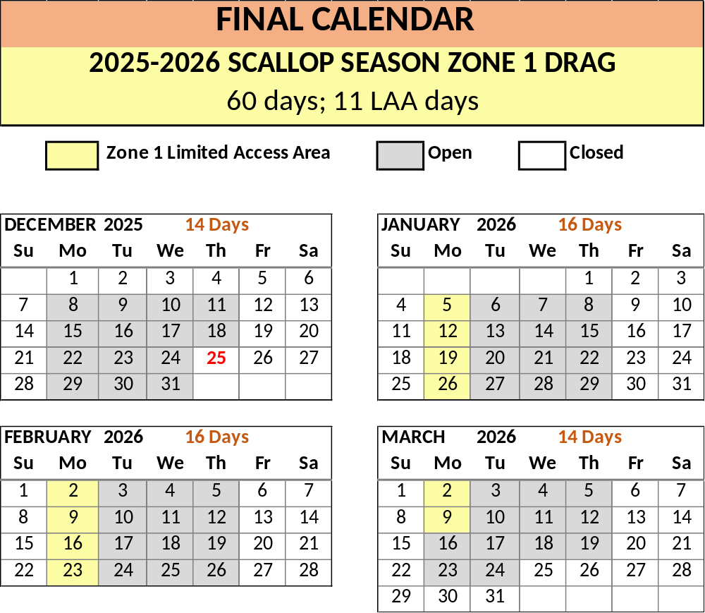

Appendix B:

Open Harvest Dates for Zone 1 Dive

This calendar diagram depicts the open harvest days for Zone 1 Dive, refer to section 11.11(2).

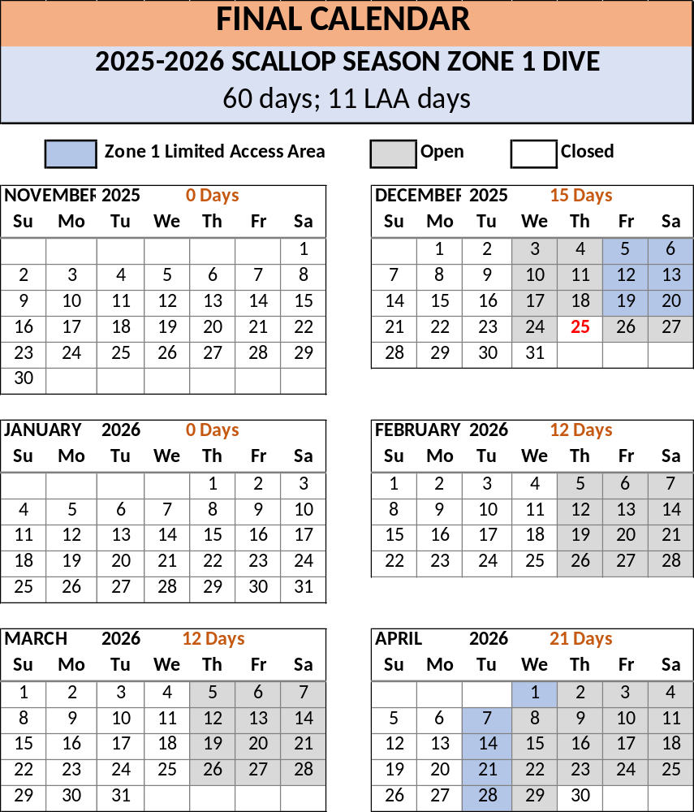

Appendix C:

Open Harvest Dates for Zone 2 Drag

This calendar diagram depicts the open harvest days for Zone 2 Drag, refer to section 11.11(3).

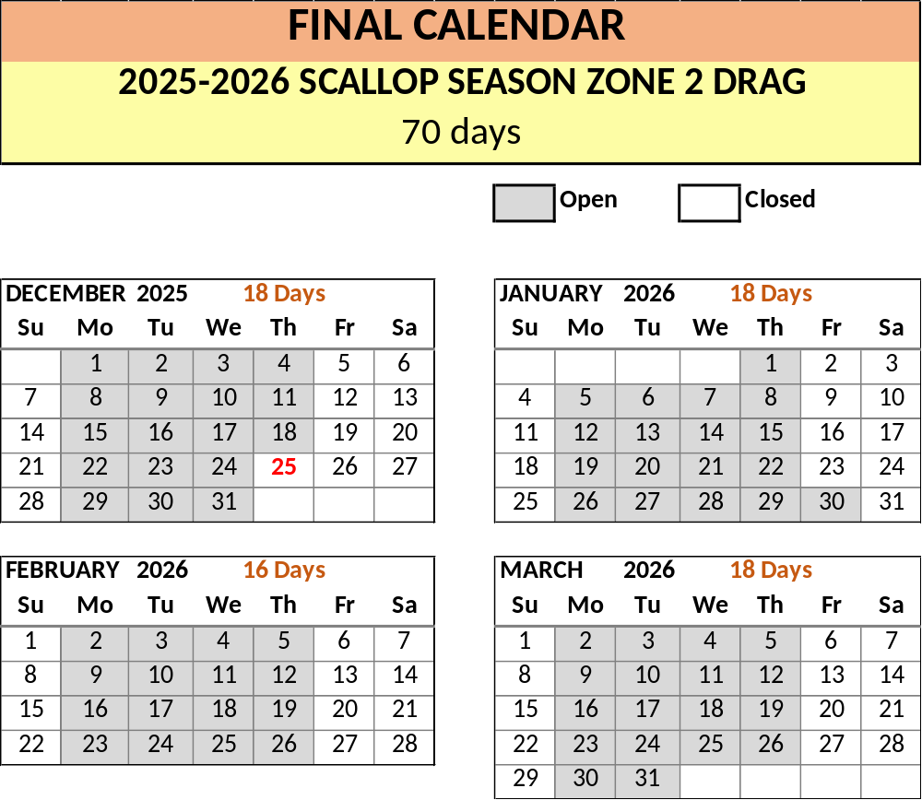

Appendix D:

Open Harvest Dates for Zone 2 Dive

This calendar diagram depicts the open harvest days for Zone 2 Dive, refer to section 11.11(4).

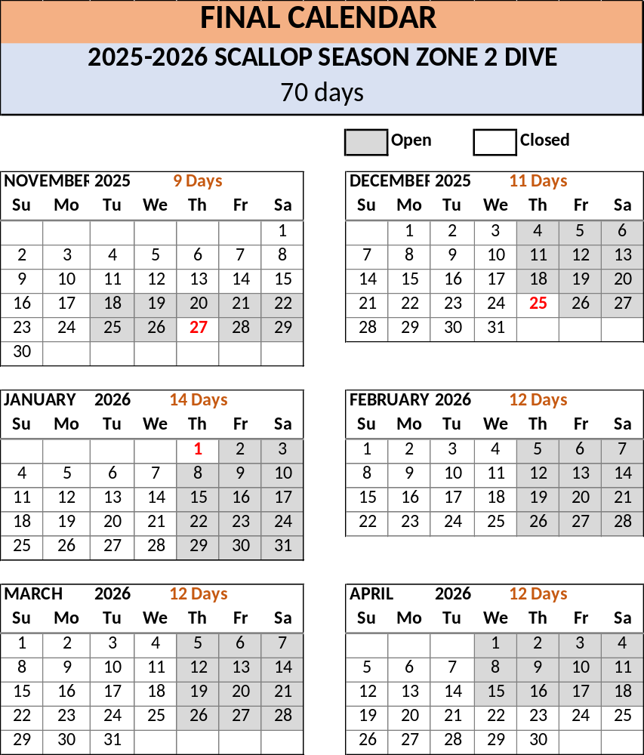

Appendix E:

Open Harvest Dates for Zone 3 Drag

This calendar diagram depicts the open harvest days for Zone 3 Drag, refer to section 11.11(6).

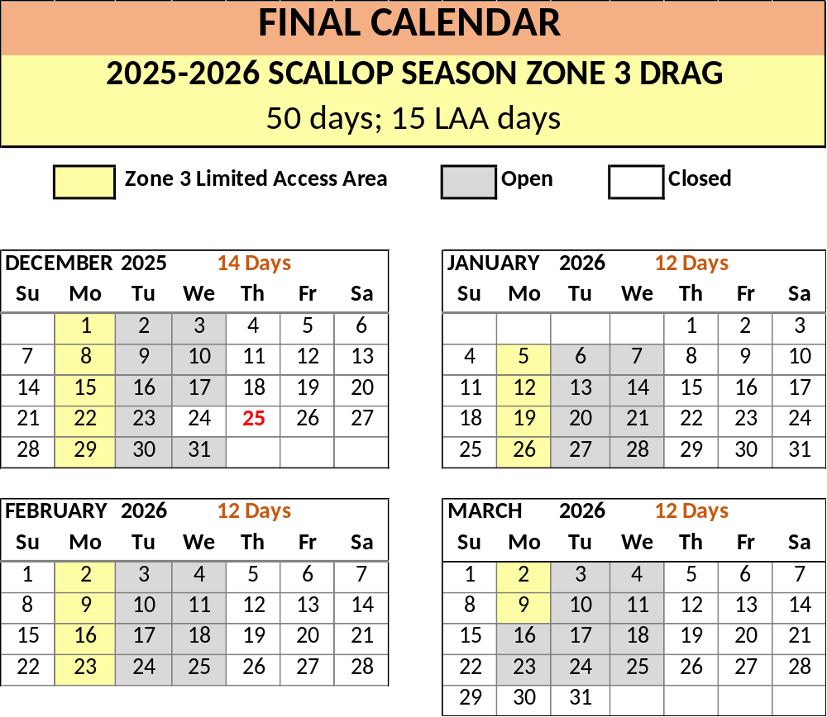

Appendix F:

Open Harvest Dates for Zone 3 Dive

This calendar diagram depicts the open harvest days for Zone 3 Dive, refer to section 11.11(7).

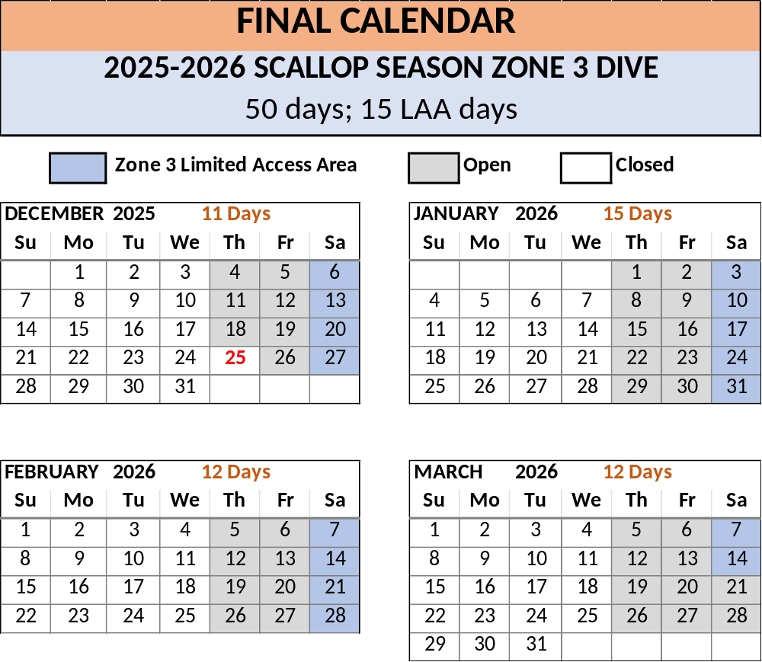

INDEX

STATUTORY AUTHORITY:
12 M.R.S. §§ 6171, 6171-A, 6706, 6726, 6728

EFFECTIVE DATE:
PS&L 1965, c. 14.

AMENDED:
September 20, 1980 – Section 11.02
November 1, 1981 – Section 11.03 (Expires 04/15/82)
November 1, 1981 – Section 11.04 (Expires 04/15/82)
November 1, 1982 – Sections 11.03, 11.04
November 1, 1983 – Sections 11.04, 11.05
November 6, 1984 – Section 11.05 (EMERGENCY)
November 1, 1985 – Section 11.10(A)
January 7, 1986 – Section 11.10(B)
January 21, 1986 – Section 11.10 (C,D)
August 24, 1986 – Sections 11.03(C), 11.04, 11.05, 11.10(C)
December 16, 1986 – Section 11.10(E,F)
January 26, 1987 – Sections 11.03(B) 11.10(A,B)
October 25, 1987 – Section 11.10(E)
December 15, 1987 – Section 11.15 (EMERGENCY)
December 18, 1987 – Section 11.15 (EMERGENCY)
September 4, 1988 – Section 11.03(B)
October 27, 1988 – Section 11.15 (EMERGENCY)
November 30, 1988 – Section 11.03(C) (EMERGENCY)
October 31, 1989 – Section 11.03 (A,B)
November 22, 1989 – Section 11.10 (E,F) (REPEALED)
November 1, 1990 – Section 11.16 (EMERGENCY)
December 31, 1990 – Section 11.16 repealed (EMERGENCY)
October 29, 1991 – Section 11.16
October 31, 1991 – Section 11.04(A) (EMERGENCY)
November 1, 1991 – Section 11.03(A)(2) (EMERGENCY)
October 27, 1992 – Section 11.03(A) (EMERGENCY)
October 27, 1992 – Section 11.03(B) (EMERGENCY)
October 27, 1992 – Section 11.04 (EMERGENCY)
November 13, 1992 – Section 11.03(A) (EMERGENCY)
December 5, 1992 – Section 11.05
October 24, 1993 – Section 11.03(A)
October 27, 1993 – Section 11.03(B) (EMERGENCY)
February 8, 1994 – Section 11.17 (EMERGENCY)
October 3, 1994 – Section 11.17 (EMERGENCY)
October 24, 1994 – Sections 11.02, 11.10(A,C),11.18 (EMERGENCY)
February 5, 1995 – Sections 11.02, 11.10(A,C); 11.18
July 3, 1995 – Section 11.10(B)
August 31, 1997 – Section 11.16
September 19, 1997 – renumbering; new Sections 11.01, 11.07
March 18, 2000 – Sections 11.02, 11.04, 11.05, 11.10(C)(1) repealed; Sections 11.10(C)(2)-
11.10(C)(1) renumbered; 11.10(A,D) amended
December 1, 2001 – Section 11.01(4) punctuation; Section 11.15 heading removed; Section
11.19 added
November 25, 2002 – Section 11.07(1)(a)
November 25, 2002 – Section 11.10(B)
November 25, 2002 – Section 11.10(E)
November 25, 2002 – Section 11.20(A), chart
September 16, 2003 – Section 11.19
November 25, 2003 – Section 11.07(1)(a)(i), 11.10(B)
April 27, 2004 – Section 11.07(1)(a)(iii)
June 22, 2007 – Section 11.15 (EXPIRED May 1, 2010) (Maj. Substantive)
September 23, 2008 – Section 11.02 and 11.10(B)
November 24, 2008 – Section 11.07(3) added
November 24, 2008 – Sections 11.09 (Expires 05/01/09); Section 11.10(F), 11.10(G) added;
Chapter renumbered
February 4, 2009 – Section 11.10(1)(H) added (EMERGENCY, Expires 05/01/09)
February 21, 2009 – Section 11.10(1)(H) (EMERGENCY, Expires 05/01/09)
July 20, 2009 – Sections 11.10(1)(A), 11.15(2)
September 21, 2009 – Sections 11.09, 11.10(1)(H)
September 21, 2009 – Sections 11.10(1)(H)(10),11.19(1)(E), 11.20(1) - removed chart
December 21, 2009 – Section 11.10(1)(H)(1)(2)(3)(8)(c)
September 20, 2010 – Sections 11.09, 11.10(1)(D,E), 11.10(1)(H), 11.19(1)(B-D)
August 22, 2011 – Sections 11.09, 11.10(1)(H)(5), 11.15 removed
January 2, 2012 – Section 11.10(1)(H)(11) (EMERGENCY, Expires 04/01/12)
November 14, 2012 – Sections 11.01(5-7) added; Sections 11.09(1) amended and (2)
added; Sections 11.10(1)(H), 11.19, 11.21, 11.22 added
December 8, 2012 – Sections 11.10(1)(F),11.22 (10) added (EMERGENCY, Expires
03/08/13)
December 22, 2012 – Section 11.22(11-13) added (EMERGENCY, Expires 03/22/13)
January 16, 2013 – Sections 11.10(1)(F)(2), 11.10(G) (EMERGENCY, Expires 0/08/13)
January 19, 2013 – Section 11.22(14-16) added (EMERGENCY, Expires 03/22/13)
February 4, 2013 – Section 11.22(10,13) (EMERGENCY, Expires 03/22/13)
February 23, 2013 – Section 11.22(17-19) added (EMERGENCY, Expires 03/22/13)
March 9, 2013 – Section 11.09(2)(C) amended; Section11.22(20) added (EMEGENCY,
Expires 03/22/13)
October 17, 2013 – Sections 11.09(1-4), 11.10(F-H), 11.22 amended
January 18, 2014 – Section 11.22(2,7,8,10) amended; Section 11.22(13,14) added
(EMERGENCY, Expires 04/18/14)
January 24, 2014 – Sections 11.22(8) amended; Section 11.22(15,16) added (EMERGENCY,
Expires 04/24/14)
February 8, 2014 – Sections 11.09(3,4), 11.22(8,10,13-16) amended; Section 11.22(17-19)
added; (EMERGENCY, Expires 05/01/14)
February 22, 2014 – Sections 11.22 (20,21) added; (EMERGENCY, Expires 05/01/14)
October 7, 2014 – Sections 11.09 (1-4), 11.10(1)(F,H), 11.19(1)(B,C), 11.19(2), 11.22
amended; Sections 11.23, 11.24 added.
December 27, 2014 – Sections 11.22(6,7) added (EMERGENCY, Expires 03/26/14)
February 26, 2015 – Sections 11.10, 11.22 amended (EMERGENCY, Section 11.22 Expires
05/01/15)
October 26, 2015 – Section 11.04, 11.22 (6-11) added; Sections11.09, 11.10(1)(H),
11.21(1)(B)(5,6), 11.21(1)(C)(5), 11.22(1-5), 11.24 amended
December 13, 2015 – Section 11.22(1,12-14) (EMERGENCY, Expires 03/11/16)
January 16, 2016 – Section 11.22(6, 15,16) (EMERGENCY)
January 23, 2016 – Section 11.22(1,17) (EMERGENCY)
March 20, 2016 – Section 11.22(21-27) (EMERGENCY)
July 12, 2016 – Chapter 11 – Restructuring
November 15, 2016 – Section 11.08 (1,3-10,11), 11.09 (5,6), 11.11 (1-6), 11.21 (A-C)
January 1, 2017 – Sections 11.05(3), 11.08(10-13), 11.09(5), 11.12 (EMERGENCY)
January 2, 2017 – Section11.08(1,14,15) (EMERGENCY)
February 5, 2017 – Section 11.08(11,13,15-18) (EMERGENCY)
February 26, 2017 – Section 11.08(13,15-18) (EMERGENCY)
March 12, 2017 – Section 11.08(19) (EMERGENCY)
November 14, 2017 – Sections 11.01(6,7), 11.07(B)(1)(2), 11.08, 11.09, 11.10, 11.11,
11.12(1)(A)(8)
January 1, 2018 – Section 11.08(10,11), 11.11(5) (EMERGENCY)
January 21, 2018 – Section 11.08(12,13) (EMERGENCY)
February 4, 2018 – Section 11.08(11,13) (EMERGENCY)
February 18, 2018 – Section 11.08(14,15) (EMERGENCY)
March 4, 2018 – Section 11.08(13,14,16) (EMERGENCY)
June 24, 2018 – Sections 11.01(8), 11.14 (Maj. Substantive) added
November 14, 2018 – Sections 11.03, 11.05, 11.07, 11.08, 11.09, 11.10, 11.11, 11.12(1)(C)
December 16, 2018 – Section 11.08(7) (EMERGENCY)
December 30, 2018 – Section 11.08(8) (EMERGENCY)
January 6, 2019 – Section 11.08(9) (EMERGENCY)
January 27, 2019 – Section 11.08(8-11) (EMERGENCY)
February 10, 2019 – Section 11.08(7-9) (EMERGENCY)
February 24, 2019 – Section 11.08(11-14) (EMERGENCY)
March 17, 2019 – Section 11.08(14) (EMERGENCY)
November 13, 2019 – Section 11.05, 11.08, 11.09, 11.11, 11.12(1)(B)
December 8, 2019 – Section 11.08(8) (EMERGENCY)
January 5, 2020 – Section 11.08(9) (EMERGENCY)
January 19, 2020 – Section 11.08(10) (EMERGENCY)
February 2, 2020 – Section 11.08(11,12) (EMERGENCY)
February 16, 2020 – Section 11.08(13) (EMERGENCY)
November 9, 2020 – Sections 11.08, 11.09, 11.11
January 17, 2021 – Section 11.08 (EMERGENCY)
February 14, 2021 – Section 11.08 (EMERGENCY)
March 7, 2021 – Section 11.08 (EMERGENCY)
October 31, 2021 – Sections 11.06,11.08, 11.09, 11.11, 11.12, 11.14
January 2, 2022 – Section 11.08 (EMERGENCY)
February 6, 2022 – Section 11.08 (EMERGENCY)
February 20, 2022 – Section 11.08 (EMERGENCY)
November 1, 2022 – Sections 11.08, 11.09, 11.11, 11.12
January 8, 2023 – Section 11.08 (EMERGENCY)
February 19, 2023 – Section 11.08 (EMERGENCY)
November 5, 2023 – Sections 11.07, 11.08, 11.09, 11.11, 11.12
December 24, 2023 – Section 11.08 (EMERGENCY)
January 28, 2023 – Section 11.08 (EMERGENCY)
November 12, 2024 – Sections 11.03, 11.08, 11.09, 11.11, 11.12
November 15, 2025 – Sections 11.08, 11.09, 11.11, 11.12
January 11, 2026 – Sections 11.08, 11.09 (EMERGENCY)
February 1, 2026 – Section 11.08 (EMERGENCY)
August 19, 2026 – Section 11.14

