HCBS Access Measures
This page is updated quarterly and reflects data as of June 2023. Please contact oads@maine.gov regarding any questions about this data.

Developmental Disabilities and Brain Injury Program Participants and Waitlists
WAIVER PROGRAM | PARTICIPANTS | WAITLIST | WITH OTHER COVERAGE | WITHOUT OTHER COVERAGE | PERCENT OF CURRENT PARTICIPANTS WITHOUT OTHER COVERAGE
Brain Injury (Section 18) | 193 | 185 | 102 | 83 | 43%
Other related Conditions (Section 20) | 44 | 26 | 12 | 14 | 32%
Comprehensive Services for IDD/ASD (Section 21) | 3,371 | 2,102 | 1,617 | 485 | 14%
Support Services for IDD/ASD (Section 29) | 2,972 | 170 | 83 | 87 | 3%
Unduplicated Member* Totals | 5,791 | 2,266 | 1,755 | 511 | 9%
*Members can be on multiple waitlists simultaneously.

Developmental Disabilities Lengths of Wait Time
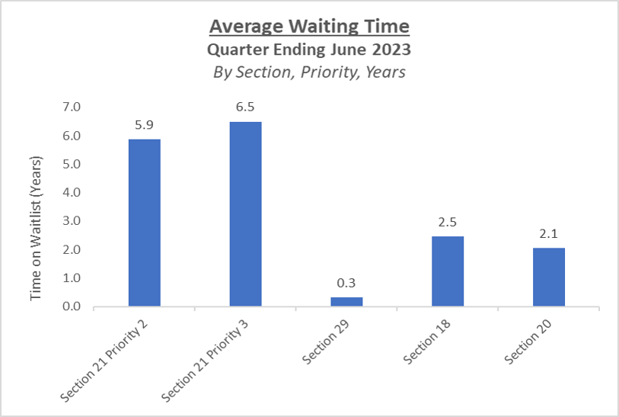
Notes:
Wait time is reported regardless of other coverage Members who meet Section 21 Priority 1 criteria receive an immediate offer More information regarding Section 21 priority level determination can be found in the MaineCare Benefits Manual Ch. II Section 21

Medicaid and State Funded Services for Older and Disabled Adults Participants and Waitlists
PROGRAM | PARTICIPANTS | WAITLIST
Home and Community Benefits for Older and Disabled Adults (Section 19) | 2,515 | 0
Private Duty Nursing and Personal Care Services (Section 96) | 3,152 | N/A
Consumer Directed Attendant Services (Section 12) | 306 | N/A
State Funded Home Based Care (Section 63) | 1244 | 0
State Funded Consumer Directed Home Based Care (Chapter 11) | 83
State Funded Independent Support Services (aka Homemaker) (Section 69) | 1,375 | 1,414
Totals | 8,675 | 1,414

