Chartbook

Quality Indicators for
MaineCare Long Term Services
and Supports across Three Settings

State Fiscal Year 2010

Muskie School of Public Service

Quality Indicators for
MaineCare Long Term Services
and Supports across Three Settings
State Fiscal Year 2010

March 2016
This document was prepared by the Muskie School of Public Service at the University of Southern Maine for the Maine Department of Health and Human Services.

Muskie School Project Staff | DHHS Lead
Stuart Bratesman  Catherine McGuire  Tina Gressani  Julie Fralich | Gary Wolcott, Director  Office of Aging and Disability Services  Maine Dept. of Health and Human Services

When referencing or using the charts or other materials in this book, please use the following citation:
Bratesman, S., et al, Quality Indicators for MaineCare Long Term Services and Supports across Three Settings, 2015.

Funding for this document was through a contract between the Maine Department of Health and Human Services and the University of Southern Maine. The analysis of the MaineCare and Medicare data and the preparation of this report were conducted under DHHS Agreement # ADS-15-9312A.

Acknowledgements

Many people contributed to presentation of the charts and data in this report, one in a series of reports commissioned and funded under contract with the Maine Office of Aging and Disability Services (OADS). Since so many users of MaineCare funded Long Term Services and Supports (LTSS) are dually eligible for MaineCare and Medicare Services, this report would not have been possible without an earlier collaboration between the Muskie School and JEN Associates of Cambridge, Mass. to create a linked database of MaineCare and Medicare claims data. The data was studied using JEN's Integrated Medical Management Research System (IMMRS), a secure data analytics tool which allows detailed analyses without revealing any personally identifiable information to the user.

The construction and use of large complex data sets is not always an easy task. The Muskie School's Tina Gressani and Cathy McGuire provided extensive subject matter expertise related to the MaineCare data that was invaluable in assessing the data structures, coding algorithms and classification systems used for the MaineCare-Medicare analysis. They provided ongoing technical support in defining and translating the populations, variables and data elements in the JEN dataset and continuously assessed the quality and validity of the analysis. Dan Gilden from JEN Associates provided many, many hours of assistance in customizing the variables and measures in the IMMRS system for use by Maine DHHS and the Muskie School.

Julie Fralich used her extensive expertise and knowledge of long term care systems to direct and guide the project.

We are also indebted to Jim Martin, Gary Wolcott, Debra Halm and their colleagues at OADS for their valuable feedback, advice and support.

Stuart Bratesman

Introduction
This report is one of a series of reports the Muskie School has prepared on MaineCare Members who use MaineCare-reimbursed Long Term Services and Supports (LTSS). This report compares quality indicator (QI) measures for State Fiscal Year (SFY) 2010 across three long term care settings, nursing facilities, Case Mix Residential Care, and the home and community-based (HCBS) long term care waiver services provided in a Member's home.
The report looks at the results of four measures: the HEDIS® measure for Adult’s Access to Preventive/Ambulatory Health Services; the frequency of Emergency Room visits during the year, the frequency of inpatient hospital admissions during the year, and the percentage of Members hospitalized at least once during the year who were re-hospitalized within 30 days of a prior hospital discharge. For purposes of comparison, we limited the study population to Members who were enrolled with full MaineCare benefits for at least eleven of the twelve months ending in June 2010.
The reader should keep in mind that while Members qualifying for Waiver participation must meet the same medical eligibility criteria used for nursing facility admission, and while some Case Mix Residential Care residents could meet those same medical eligibility criteria, the settings do differ in age distribution and by other characteristics. In addition, different settings are staffed differently. A person living at home may be more likely to go to the emergency room than a person in a facility who has access to staff right there to assess the situation. Therefore, the reader should guard against using the report to compare settings. Rather, it should be used to better understand what is happening in each setting and identify opportunities for improvement.

A Brief Overview of Three Settings for Long Term Services and Supports (LTSS)
This report looks at quality measures for MaineCare-reimbursed LTSS in SFY 2010 across three long term care settings: nursing facilities; case mix residential care; and home and community based services (HCBS) in a Member's home. Within the HCBS setting, the report focuses on services provided by two Medicaid Waivers, MaineCare's Waiver for Elderly and Adults with Disabilities; and the consumer-directed Waiver for the Physically Disabled.
Nursing Facilities provide “professional nursing care or rehabilitative services for injured, disabled or sick persons,” when it is impractical to provide the care in any other setting and when the care is required daily. For persons eligible for Medicare, when ordered by a physician, Medicare will reimburse the costs for up to 100 days of nursing facility care for skilled nursing or rehabilitation services for a hospital-related medical condition following a minimum three-day hospital inpatient stay. Otherwise, MaineCare will reimburse nursing facility costs for residents who meet financial eligibility and medical requirements defined in the MaineCare Benefits Manual.
Case Mix Residential Care is provided in a Private Non-Medical Institution (PNMI) for Medical and Remedial Services (Section 97 of MaineCare Benefits Manual (MBM) Chapter III Appendix C). The MaineCare Benefits Manual, Section 97.01 defines a PNMI as, “…an agency or facility that is not, as a matter of regular business, a health insuring organization, hospital, nursing home, or a community health care center, that provides food, shelter, and treatment services to four or more residents in single or multiple facilities or scattered site facilities. Private Non-Medical Institution services or facilities must be licensed by the Department of Health and Human Services, or must meet comparable licensure standards and/or requirements and staffing patterns as determined by the Department….”
Appendix C PNMIs, "are maintained wholly or partly for the purpose of providing residents with medical and remedial treatment services and licensed by the Department of Health and Human Services under the "Regulations Governing the Licensing and Functioning of Assisted Living Facilities." Each facility's reimbursement rate is adjusted to its residents' average case mix, that is, the average level of need as determined by a standard assessment.
Home and Community Based Waivers offer specific grants of authority by the federal Centers for Medicare and Medicaid Services (CMS) for state Medicaid programs to reimburse for medical and long term care services provided at a nursing home level of care in Members' homes. This report describes quality measures for the Elderly and Adults with Disabilities, and Consumer-Directed Services for the Physically Disabled waivers.

Waiver for the Elderly and Adults with Disabilities
The HCBS Waiver for the Elderly and Adults with Disabilities offers, "…in-home care and other services, designed as a package, to assist eligible Members to remain in their homes, or other residential community settings, and thereby avoid or delay institutional nursing facility care.… Services include: Care Coordination, Adult Day Health, Assistive Technology, Attendant Services, Home Health Services, Financial Management Services, Personal Care Services, Personal Emergency Response Systems, Respite Care, Transportation services, and Environmental Modifications.”
Note: Quality measures for elders (age 65 and above) and adults (age 18 to 64) served by the Waiver for the Elderly and Adults with Disabilities are calculated separately throughout the report. They are identified on each chart as the Elder/Adult Waiver 18-64 and Elder/Adult Waiver 65+.

Waiver for the Physically Disabled (Consumer Directed - Personal Care Assistance Services Waiver)
This Waiver trains and supplies on-going support for eligible adults, age 18 and above, to hire their own personal care attendant to provide personal care services, "related to a member’s physical requirements for assistance with the activities of daily living, including assistance with related health maintenance activities."

Distribution of MaineCare LTSS service users by setting in SFY 2010
Of the nearly 136,000 adult Members who had 11 or more months of full MaineCare eligibility during SFY 2010, 9,422 received Long Term Services and Supports (LTSS) in a Nursing Facility, in a Case Mix Residential Care PNMI, from the Home and Community Based (HCBS) Waiver for the Elderly and Adults with Disabilities, or from the HCBS consumer-directed Waiver for the Physically Disabled. The pairs of columns in Chart 1 (below) display the distribution of these MaineCare LTSS service users across settings. Within each setting, the height of the darker column represents the number of MaineCare Members who had at least one MaineCare or Medicare claim for that service at any time during SFY 2010. The lighter columns represent the number of MaineCare Members who had claims for that setting for each of at least 11 months during the Fiscal Year. A comparison of the darker columns illustrates that Members residing in a nursing facility at any time during the year was greater than the combined number of MaineCare Members using Case Mix Residential Care or an LTSS Waiver.
There was quite a bit of overlap between settings. Among the 9,422 Members in the settings described above, about 1 out of 8 received services in more than one setting.
- Number of MaineCare Members with 11+ months of full eligibility in SFY 2010 who received LTSS services in a given LTSS setting at any time during SFY 2010; or in the same LTSS setting for at least 11 months during SFY 2010.
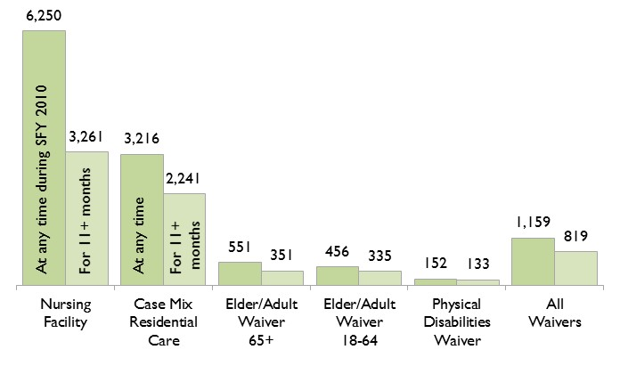

Chart 2 illustrates that Members tend to stay in nursing facilities for a shorter length of time than in Case Mix Residential Care or in the HCBS Waiver programs. While many residents leave the nursing home after a few weeks of post-hospital rehabilitation, the typical service user in residential care or an LTSS Waiver tends to remain in those settings much longer.
- Turn-over rates vary by LTSS setting. Average number of months that LTSS service users with 11+ months of full MaineCare eligibility spent in a given LTSS setting during SFY 2010
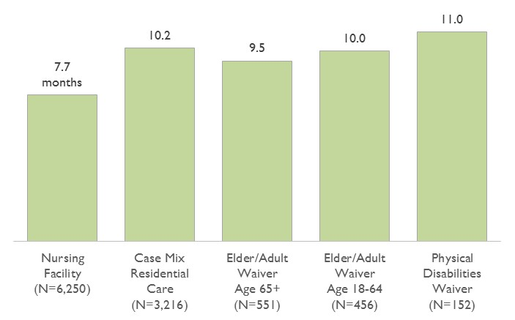
Before making any direct comparisons, the reader should keep in mind differences between programs and settings by age and other characteristics that could affect the measures of quality described in the Section 3. While the nursing facility and case mix residential care populations are somewhat similar in their age distributions, the typical Waiver participant is much younger.
- Age distribution of MaineCare LTSS services users with 11+ months of full MaineCare eligibility spent in a given LTSS setting during SFY 2010
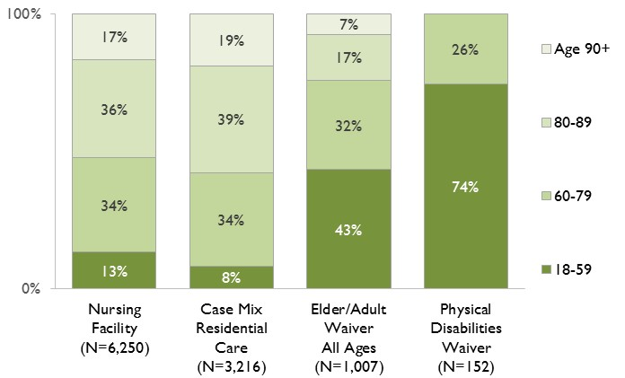

Quality measures across settings
The report looks at the results of four measures: the HEDIS® measure for Adult’s Access to Preventive/Ambulatory Health Services; the frequency of Emergency Room visits during the year, the frequency of inpatient hospital admissions during the year, and the percentage of Members hospitalized at least once during the year who were re-hospitalized within 30 days of a prior hospital discharge. For purposes of comparison, we limited the study population to Members who were enrolled with full MaineCare benefits for at least eleven of the twelve months ending in June 2010. All of the measures are based on MaineCare claims data for MaineCare-only Members, and linked Medicare and MaineCare claims data for Members who were dually eligible for MaineCare and Medicare services. The analyses were performed using JEN Associates' Integrated Medical Management Research System (IMMRS) data analytics tool.
The reader should keep in mind that while Members qualifying for Waiver participation must meet the same medical eligibility criteria used for nursing facility admission, and while some Case Mix Residential Care residents could meet those same medical eligibility criteria, the different settings do differ in age distribution and by other characteristics. In addition, different settings are staffed differently. A person living at home may be more likely to go to the emergency room than a person in a facility who has access to staff right there to assess the situation. Therefore, the reader should guard against using the report to compare settings. Rather, it should be used to better understand what is happening in each setting and identify opportunities for improvement.

Adult's Access to Preventive/Ambulatory Health Services (HEDIS®)
This measure calculates the percentage of Members who had at least one ambulatory or preventive care visit during the state fiscal year. Access to basic ambulatory or preventive care is important for monitoring health status, proper care of chronic conditions, early diagnosis of medical or potentially serious problems, and provides patient counseling on diet, physical activity and other behaviors to maintain or improve the Member's health.
As illustrated by Chart 3, 9 out of 10 Members served by an LTSS Waiver, and better than 9 out of 10 Members residing in a nursing facility or Case Mix Residential Care had at least one claim for a primary care visit during SFY 2010.
- Adult Access to Preventive/Ambulatory Services (HEDIS® 2010):
Percent of MaineCare Members served in the same LTSS setting for 11+
months in SFY 2010 who had access to preventive or ambulatory care
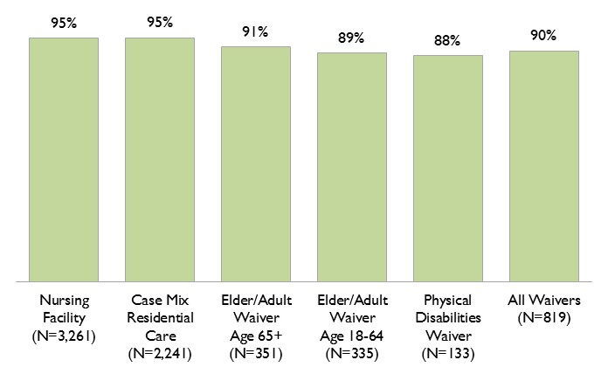

Emergency Room Use by MaineCare Members using LTSS services
While some emergency department use is appropriate and necessary, high rates of emergency room visits could indicate inappropriate use, poor access to primary care, or poor maintenance of chronic conditions. Higher rates of emergency room visits can also be reflective of a care setting or program that serves a population with an intrinsically higher risk for serious medical problems, given its relative age or the nature of its eligibility requirements. Different settings are staffed differently. A person living at home may be more likely to go to the emergency room than a person in a facility who has access to staff to assess the situation.
In Charts 5 and 6, below, we measure emergency department use in two ways, the number of emergency department visits per 1,000 Member months in a given LTSS setting, and the distribution of Members, within settings, by the number of ER visits during SFY 2010. Members residing in nursing facilities had markedly lower rates of ER use than did Members in the other settings.
(Note: Multiple emergency room visits occurring on the same day (which often reflect a transfer from one hospital's emergency department to another), are counted as a single visit.)
- Number of ER visits per 1,000 Member months in each LTSS setting during SFY 2010
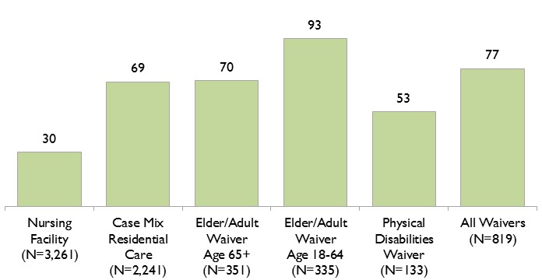
(Limited to MaineCare Members using LTSS services in the same setting for at least 11 months during SFY 2010)

Chart 6 displays the frequency of emergency room visits, by setting for MaineCare Members who were served in that setting for at least 11 months during SFY 2010. The number above each column indicates the proportion of Members who had any emergency room visits in that year. The shaded areas within each column represent the percentage of all Members who had 1 to 2 visits, 3 to 5 visits or 6 or more ER visits in SFY 2010.
For example, 8% of all Members served for at least 11 months within the Case Mix Residential Care setting, had between 3 and 5 ER visits during the Fiscal Year.
- Distribution of LTSS service users by number of emergency room visits among Members who were in each setting for 11 or more months in SFY 2010
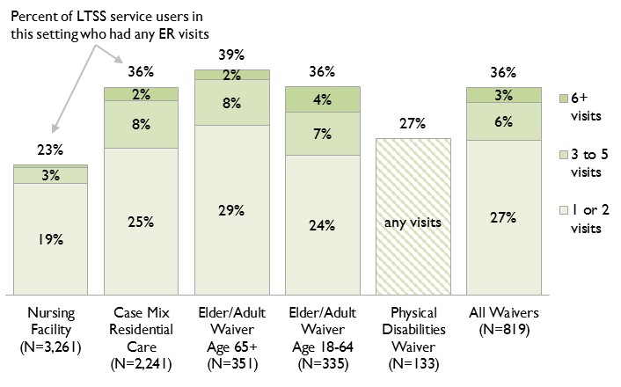
(Note: Due to the small number of Members and to confidentiality restrictions, the number of service users in the Physical Disabilities Waiver who had multiple emergency room visits was too low to report separately from users who had only one visit.)

Hospital inpatient utilization by MaineCare Members using LTSS Services
Charts 7 and 8 indicate the frequency of inpatient hospital admissions, by LTSS setting, among MaineCare Members who received services in that setting for at least 11 months during SFY 2010. Chart 7 displays the annual rate of inpatient hospital admissions per 1,000 member months by setting. Chart 8, on the following page, displays the distribution of Members, within settings, by the number of inpatient admissions during SFY 2010.
The rate of hospital admissions per 1,000 member months was lower for nursing facilities, case mix residential care, and the consumer-directed Waiver for Persons with Physical Disabilities than for Members receiving services within the Waiver for the Elderly and Adults with Disabilities.
- Number of inpatient admissions per 1,000 member months that MaineCare Members were served in each LTSS setting in SFY 2010
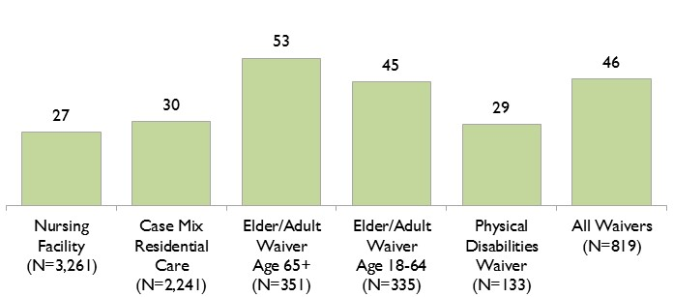
(Limited to MaineCare Members using LTSS services in the same setting for at least 11 months during SFY 2010)

- Distribution of LTSS service users by number of inpatient hospital admissions among Members with full MaineCare eligibility for 11 or more months in SFY 2010
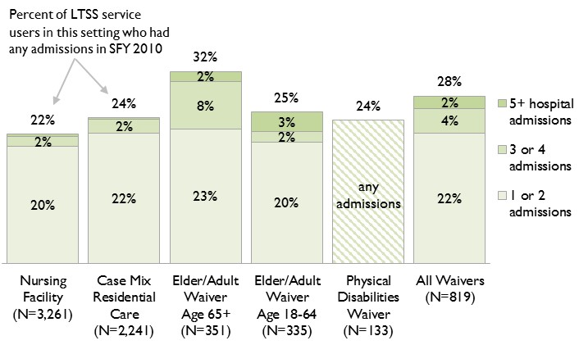
(Note: Due to the small number of Members and to confidentiality restrictions, the number of service users in the Physical Disabilities Waiver who had multiple hospital admissions was too low to report separately from users who had only one admission.)

Hospital re-admissions within 30 days of prior discharge
High rates of inpatient re-admissions within 30 days of the previous discharge may be associated with poor hospital care, or a lack of coordination and poor communication during the transition from the hospital back to the facility or home-and-community-based setting, resulting in poor follow-up care.
Chart 9: Percentage of Members hospitalized during SFY 2010 who
had at least one inpatient readmission within 30 days of prior discharge.
Among the 1,483 MaineCare Members in this report who had any inpatient hospital admissions during SFY 2010, only 30 (2%) had one or more readmissions within 30 days of prior discharge in that same year. For nursing facility residents, the rate was 2.0% (14 residents out of the 706 who had been hospitalized at any point during the year). Due to precautions to protect patient confidentiality, the numbers for Case Mix Residential Care and the HCBS Waivers were too small to individually report. However, the rates for those programs varied between 0.9% and 7.1% with a weighted average of 2.1% across Residential Care and the Waivers.

Conclusion
As would be expected, quality indicators for MaineCare Members using Long Term Services and Supports (LTSS) do vary across programs and care settings. These differences are due to a variety of factors including differences in level of care and monitoring, age distribution, and the eligibility criteria for each program or setting.
Nursing facility residents had the greatest access to primary care, lower rates of emergency room visits, and lower rates of inpatient hospitalization. Access to primary care was lower for Members enrolled in the Waiver for the Elderly and Adults with Disabilities, and they had the highest rates of emergency room use and hospitalization. However, more information is needed in order to understand the relationship between service setting and these quality measures.
With the new availability of comprehensive Medicare claims data within MaineCare's MIHMS database, it will be possible to compute these and a broader variety of claims-based quality indicators in the future without having to arrange a CMS data request or rely on third parties to compile the data. These data will inform a closer to “real time” analysis of the quality indicators and will allow administrators and policymakers to focus on improvement activities.

The definitions appear in the MaineCare Benefits Manual found at: http://www.maine.gov/sos/cec/rules/10/ch101.htm
MaineCare Benefits Manual, Chapter II, Section 19, p. 1.
MaineCare Benefits Manual, Chapter II, Section 22, pp. 12-14. (This waiver program was recently combined with the Elder/Adult Waiver and is now part of Section 19, referenced in note 2.)

