Highlights of the Maine Department of Health and Human Services Biennial Budget Proposal
for FY 2022 and FY 2023

Governor Mills’ Part 2 budget for the FY22-23 biennium, in addition to making an historic investment in Maine schools, proposes funding a host of bipartisan priorities, including initiatives to improve the health of Maine people; tax relief for low- and middle-income Maine people; enhanced revenue sharing for municipalities; PFAS remediation; and infrastructure upgrades – all while adding money to the Budget Stabilization or “Rainy Day” Fund.

As the largest department in State government, the Maine Department of Health and Human Services (DHHS or Department) is a central component of the proposal, providing health care and social services to approximately one-third of the state’s population, including children, families, and older Mainers, as well as individuals with disabilities, mental health, and substance use disorders.

Overall Budget

Governor Mills’ budget proposal for the FY22-23 Biennial biennium continues policy efforts initiated at the outset of her Administration – rebuilding critical parts of State government, such as services for Maine’s most vulnerable residents, and public health infrastructure, and expanding access to affordable health care coverage to better serve and protect Maine families.

For DHHS, the Governor is proposing $2.87 billion in General Fund (GF) appropriations for FY22-23, an increase of 4.6 percent over the current biennium. This $2.87 billion amount includes an increase of $92.3 million proposed in this Part 2 Budget Proposal as well as the decrease of $60.8 million approved in Chapter 29 earlier this year.

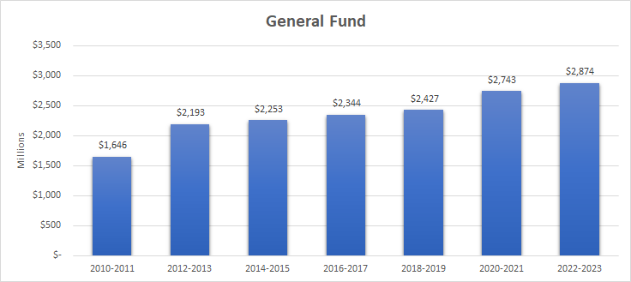

Highlights of New Initiatives included in the Part 2 Budget:

- $23.4 million in MaineCare rate reform proposals that align with Department priorities, and where there is a clear case for investment and high potential to reduce downstream costs and improve member health
  - Examples include a cost-of-living adjustment for services not otherwise annually adjusted, standardization of various payment rates pegged to Medicare, and targeted investments for dental and SUD outpatient and residential services
- $22.4 million in MaineCare value-based proposals to align policies to promote early, effective health care to improve health outcomes, reduce the treatment cost of preventable conditions, and improve long-term program sustainability
  - Examples include new adult dental benefit, coordinated specialty care / First Episode Psychosis, and restoring coverage of immigrant children and pregnant people
- $90 million (from the enhanced Federal Medical Assistance Percentage (FMAP) tied to the Public Health Emergency) dedicated to the Medicaid Stabilization Fund for potential MaineCare expenses, future rate reform, and other contingencies
- $15.4 million in one-time COVID-related financial support for hospitals, nursing facilities, and residential care facilities
- 40 new positions (28 permanent and 12 limited-period) including:
  - 12 new CDC positions that will continue to rebuild and invest in our public health infrastructure
  - 10 OMS positions that will support MaineCare rate reform efforts, and to develop a Certified Community Behavioral Health Clinic model to reform behavioral health service delivery and payment

Additional Detail

The major policy initiatives include the following (includes both new and previously proposed initiatives):

Reinvesting in public health:

- $4 million for the Maine CDC for additional capacity at the Health and Environmental Testing Lab (HETL), the Health Inspection Program (HIP), the Maine Immunization Program, and the Public Health Emergency Preparedness Program; and
- $6 million to ensure the continued effectiveness and efficiency of the Maine CDC’s HETL and HIP.

Further strengthening services for adults with intellectual and developmental disabilities:
- $6 million to fund an additional 30 slots per month over the biennial for Section 29 services to support adults with developmental disabilities living in their homes and communities.

In addition to the $46 million in new MaineCare investment, additional MaineCare rate increases originally proposed in the Biennial Budget released in January 2021:

- $25 million for Section 21 and 29 rate increases to support adults with intellectual and developmental disabilities; Nursing facility cost-of-living adjustments and rebasing increases; Residential facilities that serve children to meet the Qualified Residential Treatment Provider status; and other rate increases for residential care for older Mainers, adult family care homes, Federally Qualified Health Centers, and rural health clinics.

In addition to the behavioral health proposals included in the MaineCare reform package above, we are further bolstering mental health and substance use disorder services:

- $6.4 million to increase rates related to children’s residential facilities to ensure services will meet the requirements of the Family First Prevention Services Act.
- $4.2 million for a Mental Health Intensive Outpatient Program for high acuity MaineCare members to address the gap in Maine's behavioral health service system.
- $2 million for a Justice and Health Team at the Department to reduce the strain on emergency departments, jails, state psychiatric facilities, and the criminal justice system with the goal of providing appropriate care for people with acute mental health issues, substance use disorders, and/or intellectual and developmental disabilities in the most appropriate setting.
- $2 million (from Fund for a Healthy Maine) to promote the Overdose Prevention Through Intensive Outreach, Naloxone and Safety (OPTIONS) Initiative to dispatch mobile response teams to communities with high rates of drug overdoses in every Maine county.
- $500,000 for community mental health and substance use disorder services, including funds for crisis services in Cumberland County

Continuing improvements in child welfare:
- 15 additional child welfare positions focused on preventing abuse and neglect;
- $9.2 million to support children in foster care and resolve the structural gap in child welfare funding; and
- $4.2 million to finish modernizing the core child welfare information technology system.

Background

DHHS is comprised of nine offices and divisions that oversee and administer critical programs and services for Mainers. The General Fund Proposed Appropriated Budgets for these offices in FY 2022-23 is as follows:

- The Office of MaineCare Services (OMS), in collaboration with other offices, provides health care coverage to over 360,000 people – and counting – as the expansion of the MaineCare program continues. OMS works closely with the Office for Family Independence (OFI), which complements health benefits with food supplemental payments, work supports, and financial assistance for low-income families. Both offices partner closely with the federal government to provide benefits and services. The General Fund appropriation for OMS is $1.89 billion for the biennium, while the General Fund appropriation for OFI is $162 million for the same period.

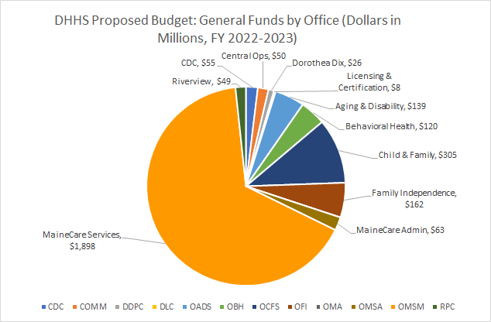

- Both the Office of Aging and Disability Services (OADS) and the Office of Behavioral Health (OBH) work closely with OMS. The General Fund appropriation is about $139 million for OADS and $120 million for OBH. OBH provides prevention, community-based, and residential services, complementing the work of our two State-run psychiatric hospitals, Riverview and Dorothea Dix, whose General Fund appropriations are $49 million and $26 million respectively.

- Prevention is the core mission of the Maine CDC, which has the additional goal of limiting the spread of acute and chronic illness. While the General Fund Appropriation is $55 million, that represents less than 20 percent of the total Maine CDC budget given other sources of funding. It, along with the Division of Licensing and Certification (General Fund appropriation of $8 million), enforces standards for safety, quality, and public health.

- The Office of Child and Family Services oversees programs for early childhood development, children’s behavioral health services, and critical child protective services. The General Fund appropriation for 2022-2023 is $305 million.

