

**quarterly report on**

**organizational performance excellence**

**FIRST state fiscal quarter 2016**

July, August, September 2015

**Robert J. Harper**  
Superintendent

October 23, 2015

**Blue-wave**

**THIS PAGE INTENTIONALLY LEFT BLANK**

**Table of Contents**

GLOSSARY OF TERMS, ACRONYMS, AND ABBREVIATIONS i

INTRODUCTION iii

**CONSENT DECREE**

STANDARDS FOR DEFINING SUBSTANTIAL COMPLIANCE

CONSENT DECREE PLAN 1

PATIENT RIGHTS 1

ADMISSIONS 2

PEER SUPPORTS 9

TREATMENT PLANNING 10

MEDICATIONS 14

DISCHARGES 15

STAFFING AND STAFF TRAINING 19

USE OF SECLUSION AND RESTRAINTS 23

PATIENT ELOPEMENTS 38

PATIENT INJURIES 40

PATIENT ABUSE, NEGLECT, EXPLOITATION, INJURY OR DEATH 44

PERFORMANCE IMPROVEMENT AND QUALITY ASSURANCE 45

COMPLIANCE RESPONSE TO ELIZABETH JONES REPORT 46

**JOINT COMMISSION PERFORMANCE MEASURES**

HOSPITAL-BASED INPATIENT PSYCHIATRIC SERVICES (HBIPS) 55

ADMISSION SCREENING (INITIAL ASSESSMENT) 57

HOURS OF RESTRAINT USE 58

HOURS OF SECLUSION USE 59

PATIENTS DISCHARGED ON MULTIPLE ANTIPSYCHOTIC MEDICATIONS 60

PATIENTS DISCHARGED ON MULTIPLE ANTIPSYCHOTIC MEDICATIONS

WITH JUSTIFICATION 62

POST DISCHARGE CONTINUING CARE PLAN CREATED 64

POST DISCHARGE CONTINUING CARE PLAN TRANSMITTED 65

**JOINT COMMISSION PRIORITY FOCUS AREAS**

CONTRACT PERFORMANCE INDICATORS 66

ADVERSE REACTIONS TO SEDATION OR ANESTHESIA 68

HEALTHCARE ACQUIRED INFECTIONS MONITORING & MANAGEMENT 70

MEDICATION ERRORS AND ADVERSE DRUG REACTIONS 74

INPATIENT CONSUMER SURVEY 79

FALL REDUCTION STRATEGIES 86

**STRATEGIC PERFORMANCE EXCELLENCE**

PROCESS IMPROVEMENT PLANS 88

ADMISSIONS 91

CAPITAL COMMUNITY CLINIC – DENTAL CLINIC 97

CAPITAL COMMUNITY CLINIC – MEDICATION MANAGEMENT CLINIC 101

DIETARY SERVICES 103

EMERGENCY MANAGEMENT 106  
 HARBOR TREATMENT MALL 110

HEALTH INFORMATION TECHNOLOGY (MEDICAL RECORDS) 111

HOUSEKEEPING 115

HUMAN RESOURCES 116

MEDICAL STAFF 118

NURSING 132

OUTPATIENT SERVICES 139

PEER SUPPORT 140

PHARMACY SERVICES 143

PSYCHOLOGY 148

REHABILITATION SERVICES 150

SAFETY & SECURITY 152

SOCIAL WORK 154

**Blue-wave**

**THIS PAGE INTENTIONALLY LEFT BLANK**

**Glossary of Terms, Acronyms & Abbreviations**

|  |  |
| --- | --- |
| ADC | Automated Dispensing Cabinets (for medications) |
| ADON | Assistant Director of Nursing |
| AOC | Administrator on Call |
| CCM | Continuation of Care Management (Social Work Services) |
| CCP | Continuation of Care Plan |
| CH/CON | Charges/Convicted |
| CMS | Centers for Medicare & Medicaid Services |
| CIVIL | Voluntary, No Criminal Justice Involvement |
| CIVIL-INVOL | Involuntary Civil Court Commitment (No Criminal Justice Involvement) |
| CoP | Community of Practice or  Conditions of Participation (CMS) |
| CPI | Continuous Process (or Performance) Improvement |
| CPR | Cardio-Pulmonary Resuscitation |
| CSP | Comprehensive Service Plan |
| DCC | Involuntary District Court Committed |
| DCC-PTP | Involuntary District Court Committed, Progressive Treatment Plan |
| GAP | Goal, Assessment, Plan Documentation |
| HOC | Hand off Communication |
| IMD | Institute for Mental Disease |
| ICDCC | Involuntary Civil District Court Commitment |
| ICDCC-M | Involuntary Civil District Court Commitment, Court Ordered Medications |
| ICDCC-PTP | Involuntary Civil District Court Commitment, Progressive Treatment Plan |
| IC-PTP+M | Involuntary Commitment, Progressive Treatment Plan, Court Ordered Medications |
| ICRDCC | Involuntary Criminal District Court Commitment |
| INVOL CRIM | Involuntary Criminal Commitment |
| INVOL-CIV | Involuntary Civil Commitment |
| ISP | Individualized Service Plan |
| IST | Incompetent to Stand Trial |
| JAIL TRANS | A patient who has been transferred to RPC from jail. |
| JTF | A patient who has been transferred to RPC from jail. |
| LCSW | Licensed Clinical Social Worker |
| LEGHOLD | Legal Hold |
| LPN | Licensed Practical Nurse |
| MAR | Medication Administration Record |
| MHW | Mental Health Worker |
| MRDO | Medication Resistant Disease Organism (MRSA, VRE, C-Dif) |
| NASMHPD | National Association of State Mental Health Program Directors |
|  |  |
| i | |
| NCR | Not Criminally Responsible |
| NOD | Nurse on Duty |
| NP | Nurse Practitioner |
| NPSG | National Patient Safety Goals (established by The Joint Commission) |
| NRI | NASMHPD Research Institute, Inc. |
| OPS | Outpatient Services Program (formally the ACT Team) |
| OT | Occupational Therapist |
| PA or PA-C | Physician’s Assistant (Certified) |
| PCHDCC | Pending Court Hearing |
| PCHDCC+M | Pending Court Hearing for Court Ordered Medications |
| PPR | Periodic Performance Review – a self-assessment based upon TJC standards that are conducted annually by each department head. |
| PSD | Program Services Director |
| PTP | Progressive Treatment Plan |
| PRET | Pretrial Evaluation |
| R.A.C.E. | Rescue/Alarm/Confine/Extinguish |
| RN | Registered Nurse |
| RPC | Riverview Psychiatric Center |
| RT | Recreation Therapist |
| SA | Substance Abuse |
| SAMHSA | Substance Abuse and Mental Health Services Administration (Federal) |
| SAMHS | Substance Abuse and Mental Health Services, Office of (Maine DHHS) |
| SBAR | Acronym for a model of concise communications first developed by the US Navy Submarine Command. S = Situation, B = Background, A = Assessment, R = Recommendation |
| SD | Standard Deviation – a measure of data variability.  Staff Development. |
| Seclusion, Locked | Patient is placed in a secured room with the door locked. |
| Seclusion, Open | Patient is placed in a room and instructed not to leave the room. |
| SRC | Single Room Care (seclusion) |
| STAGE III | 60 Day Forensic Evaluation |
| TJC | The Joint Commission (formerly JCAHO, Joint Commission on Accreditation of Healthcare Organizations) |
| URI | Upper Respiratory Infection |
| UTI | Urinary Tract Infection |
| VOL | Voluntary – Self |
| VOL-OTHER | Voluntary – Others (Guardian) |
|  |  |

ii

**Introduction**

The Riverview Psychiatric Center Quarterly Report on Organizational Performance Excellence has been created to highlight the efforts of the hospital and its staff members to provide evidence of a commitment to patient recovery, safety in culture and practices, and fiscal accountability. The report is structured to reflect a philosophy and contemporary practices in addressing overall organizational performance in a systems improvement approach instead of a purely compliance approach. The structure of the report also reflects a focus on meaningful measures of organizational process improvement while maintaining measures of compliance that are mandated through regulatory and legal standards.

The methods of reporting are driven by a nationally accepted focused approach that seeks out areas for improvement that were clearly identified as performance priorities. The American Society for Quality, National Quality Forum, Baldrige National Quality Program and the National Patient Safety Foundation all recommend a systems-based approach where organizational improvement activities are focused on strategic priorities rather than compliance standards.

There are three major sections that make up this report:

The first section reflects compliance factors related to the Consent Decree and includes those performance measures described in the Order Adopting Compliance Standards dated October 29, 2007. Comparison data is not always available for the last month in the quarter and is included in the next report.

The second section describes the hospital’s performance with regard to Joint Commission performance measures that are derived from the Hospital-Based Inpatient Psychiatric Services (HBIPS) that are reflected in The Joint Commissions quarterly ORYX Report and priority focus areas that are referenced in The Joint Commission standards:

I. Data Collection (PI.01.01.01)

II. Data Analysis (PI.02.01.01, PI.02.01.03)

III. Performance Improvement (PI.03.01.01)

The third section encompasses those departmental process improvement projects that are designed to improve the overall effectiveness and efficiency of the hospital’s operations and contribute to the system’s overall strategic performance excellence. Several departments and work areas have made significant progress in developing the concepts of this new methodology.

As with any change in how organizations operate, there are early adopters and those whose adoption of system changes is delayed. It is anticipated that over the next year, further contributors to this section of strategic performance excellence will be added as opportunities for improvement and methods of improving operational functions are defined.

iii

**Blue-wave**

**THIS PAGE INTENTIONALLY LEFT BLANK**

(Glossary of Terms, Acronyms & Abbreviations) (Back to Table of Contents)

|  |
| --- |
| CONSENT DECREE |

**Consent Decree Plan**

V1) The Consent Decree Plan, established pursuant to paragraphs 36, 37, 38, and 39 of the Settlement Agreement in Bates v. DHHS defines the role of Riverview Psychiatric Center in providing consumer-centered inpatient psychiatric care to Maine citizens with serious mental illness that meets constitutional, statutory, and regulatory standards.

The following elements outline the hospital’s processes for ensuring substantial compliance with the provisions of the Settlement Agreement as stipulated in an Order Adopting Compliance Standards dated October 29, 2007.

**Patient Rights**

V2) Riverview produces documentation that patients are routinely informed of their rights upon admission in accordance with ¶ 150 of the Settlement Agreement;

|  |  |  |  |  |
| --- | --- | --- | --- | --- |
| **Indicators** | **2Q2015** | **3Q2015** | **4Q2015** | **1Q2016** |
| 1. Patients are routinely informed of their rights upon admission. | 97%  57/59 | 95%  57/60 | 100%  45/45 | 100%  79/79 |

Patients are informed of their rights and asked to sign that information has been provided to them. If they refuse, staff documents the refusal and signs, dates & times the refusal.

V3) Grievance tracking data shows that the hospital responds to 90% of **Level II** grievances within five working days of the date of receipt or within a five-day extension.

|  |  |  |  |  |  |
| --- | --- | --- | --- | --- | --- |
| **Indicators** | **2Q2015** | **3Q2015** | **4Q2015** | **1Q2016** |  |
| 1. Level II grievances responded to by RPC on time. | 100%  3/3 | N/A | 100%  1/1 | 100%  1/1 |
| 1. Level I grievances responded to by RPC on time. | 100%  65/65 | 98%  96/98 | 52%  45/86 | 78%  129/165 |

(Glossary of Terms, Acronyms & Abbreviations) (Back to Table of Contents)

|  |
| --- |
| CONSENT DECREE |

**Admissions**

V4) Quarterly performance data shows that in 4 consecutive quarters,95% of admissions to Riverview meet legal criteria;



(Glossary of Terms, Acronyms & Abbreviations) (Back to Table of Contents)

|  |
| --- |
| CONSENT DECREE |

V5) Quarterly performance data shows that in 3 out of 4 consecutive quarters, the % of readmissions within 30 days of discharge does not exceed one standard deviation from the national mean as reported by NASMHPD

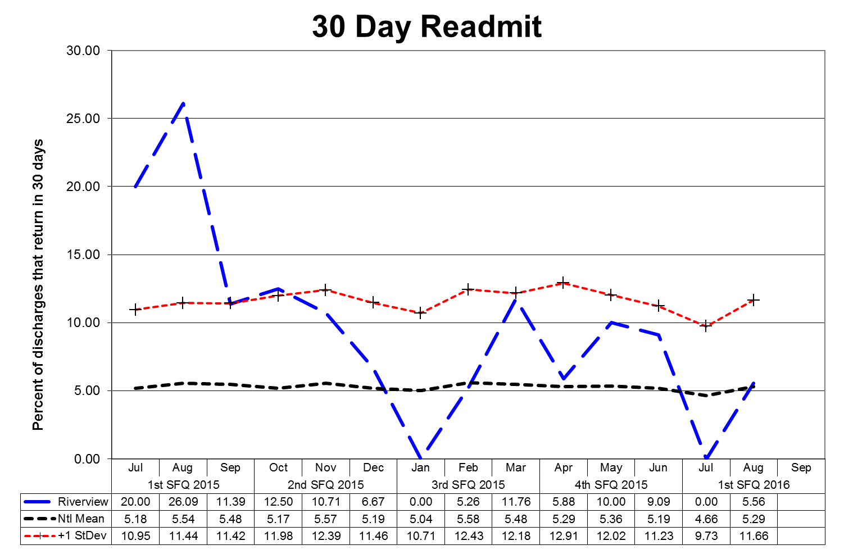

This graph depicts the percent of discharges from the facility that returned within 30 days of a discharge of the same patient from the same facility. For example; a rate of 10.0 means that 10% of all discharges were readmitted within 30 days.

Reasons for patient readmission are varied and may include decompensating or lack of compliance with a PTP. Specific causes for readmission are reviewed with each patient upon their return. These graphs are intended to provide an overview of the readmission picture and do not provide sufficient granularity to determine trends for causes of readmission. Between August 2013 and November 2014, the Lower Saco Unit was decertified; patients had to be discharged and readmitted in our Meditech Electronic Medical Record system whenever they transferred units within the hospital (either from or to Lower Saco), which caused them to show up as a 30 Day Readmission, even though they never left the hospital.

The graphs shown on the next page depict the percent of discharges from the facility that returned within 30 days of a discharge of the same patient from the same facility stratified by forensic or civil classifications. For example; a rate of 10.0 means that 10% of all discharges

were readmitted within 30 days.(Glossary of Terms, Acronyms & Abbreviations) (Back to Table of Contents)

|  |
| --- |
| CONSENT DECREE |

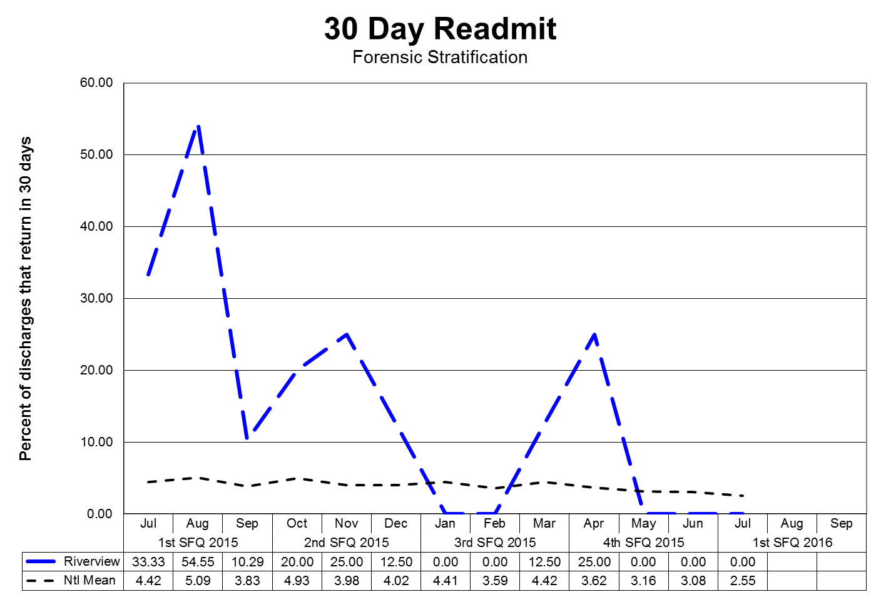

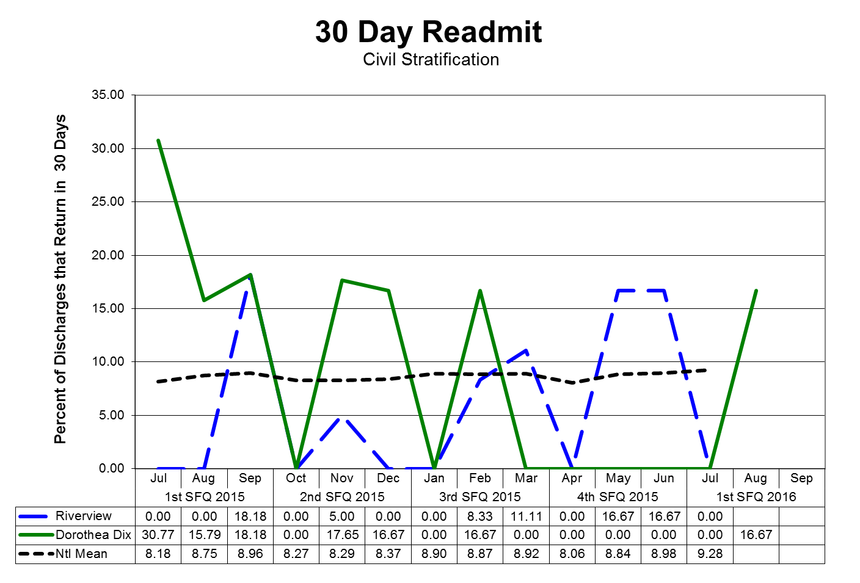

(Glossary of Terms, Acronyms & Abbreviations) (Back to Table of Contents)

|  |
| --- |
| CONSENT DECREE |

V6) Riverview documents, as part of the Performance Improvement & Quality Assurance process, that the Director of Social Work reviews all readmissions occurring within 60 days of the last discharge; and for each patient who spent fewer than 30 days in the community, evaluated the circumstances to determine whether the readmission indicated a need for resources or a change in treatment and discharge planning or a need for different resources and, where such a need or change was indicated, that corrective action was taken;

**REVIEW OF READMISSION OCCURRING WITHIN 60 DAYS**

|  |  |  |  |  |
| --- | --- | --- | --- | --- |
| **Indicators** | **2Q2015** | **3Q2015** | **4Q2015** | **1Q2016** |
| Director of Social Services reviews all readmissions occurring within 60 days of the last discharge, and for each patient who spent fewer than 30 days in the community, evaluated the circumstances of the readmission to determine an indicated need for resources or a change in treatment and discharge planning or the need for alternative resources; and, where such a need or change was indicated, that corrective action was taken. | 100%  4/4 | 100%  5/5 | 100%  2/2 | 100%  5/5 |

**1Q2016:**

Five patients were readmitted in Quarter 1. Of the five readmitted, all five spent less than 30 days in the community. Patient 1 spent 6 days in the community post discharge and was readmitted from his apartment under a PTP order. Patient 2 was discharged to a group home under care of the OPS team with PTP and was readmitted 13 days later for instability and eloping. Patient 3 was discharged to a co-occurring program, immediately eloped, and was readmitted 27 days later due to instability. Patient 4 was discharged to a Brain Injury waiver home and was readmitted 29 days later for setting a fire in a bedroom and threatening staff. Patient 5 was a forensic client readmitted on an IST order 28 days after the completion of a 60

day evaluation.(Glossary of Terms, Acronyms & Abbreviations) (Back to Table of Contents)

|  |
| --- |
| CONSENT DECREE |

Reduction of re-hospitalization for Outpatient Services Programs (OPS) Patients

|  |  |  |  |  |
| --- | --- | --- | --- | --- |
| **Indicators** | **2Q2015** | **3Q2015** | **4Q2015** | **1Q2016** |
| 1. The Program Service Director of the Outpatient Services Program will review all patient cases of re-hospitalization from the community for patterns and trends of the contributing factors leading to re-hospitalization each quarter. The following elements are considered during the review:    1. Length of stay in community    2. Type of residence (group home, apartment, etc.)    3. Geographic location of residence    4. Community support network    5. Patient demographics (age, gender, financial)    6. Behavior pattern/mental status    7. Medication adherence    8. Level of communication with Outpatient Treatment | 100%  3/3 | 100%  6/6 | 100%  1/1 | 100%  6/6 |
| 1. Outpatient Services will work closely with inpatient treatment team to create and apply discharge plan incorporating additional supports determined by review noted in #1. | 100% | 100% | 100% | 100% |

**1Q2016:**

1. Four NCR and two PTP clients returned to RPC: Four clients for psychiatric instability, one for use of alcohol, and one who returned from Hearthside (no fault of client). Five remain in RPC.

2. 100% attendance at RPC treatment team meetings that OPS was scheduled to attend.

(Glossary of Terms, Acronyms & Abbreviations) (Back to Table of Contents)

|  |
| --- |
| CONSENT DECREE |

V7) Riverview certifies that no more than 5% of patients admitted in any year have a primary diagnosis of mental retardation, traumatic brain injury, dementia, substance abuse or dependence.

|  |  |  |  |  |  |
| --- | --- | --- | --- | --- | --- |
| **Patient Admission Diagnoses** | **2Q15** | **3Q15** | **4Q15** | **1Q16** | **Total** |
| ADJUSTMENT DISORDER W/ MIXED DISTURBANCE OF EMOTIONS & CONDUCT |  |  | 1 | 1 | **2** |
| ADJUSTMENT REACTION NOS |  | 1 |  |  | **1** |
| ANTISOCIAL PERSONALITY |  |  |  | 1 | **1** |
| ANXIETY STATE NOS | 4 |  |  |  | **4** |
| ATTENTION DEFICIT W/ HYPERACTIVITY |  |  |  | 1 | **1** |
| BIPOLAR I, MOST REC EPIS (OR CURRENT) MIXED, UNSPEC | 4 | 1 |  |  | **5** |
| BIPOLAR DISORDER, UNSPECIFIED | 7 | 1 |  | 10 | **18** |
| BIPOLAR I DISORDER, SINGLE MANIC EPISODE, SEVERE, SPEC W/ PSYCHOTIC BEHAV |  |  | 1 | 1 | **2** |
| BIPOLAR I DISORDER, SINGLE MANIC EPISODE, SEVERE, W/O PSYCHOTIC FEATURES |  |  | 1 | 1 | **2** |
| BIPOLAR I, REC EPIS OR CURRENT MANIC, IN PARTIAL OR UNSPEC REMISSION |  |  | 1 | 1 | **2** |
| BIPOLAR I, REC EPIS OR CURRENT MANIC, SEVERE, W/ PSYCHOTIC BEHAV |  |  |  | 2 | **2** |
| DELUSIONAL DISORDER |  |  | 1 | 1 | **2** |
| DEPRESSIVE DISORDER-SEVERE |  | 1 | 2 |  | **3** |
| DEPRESSIVE DISORDER NEC |  |  |  | 3 | **3** |
| DEPRESSIVE DISORDER-UNSPEC | 1 |  |  | 1 | **2** |
| HEBEPHRENIA-UNSPEC |  | 2 |  |  | **2** |
| IMPULSE CONTROL DISORDER NOS |  |  | 1 |  | **1** |
| OTHER AND UNSPECIFIED BIPOLAR DISORDERS | 1 |  |  |  | **1** |
| OTHER SPEC PERVASIVE DEVELOPMENT DIS, CURRENT OR ACTIVE STATE | 5 | 1 | 2 |  | **8** |
| PARANOID SCHIZOPHRENIA-CHRONIC W/EXACERBATION | 1 | 3 |  |  | **4** |
| PARANOID SCHIZOPHRENIA-UNSPEC | 3 | 1 | 1 | 1 | **6** |
| POSTTRAUMATIC STRESS DISORDER | 11 | 8 | 8 | 5 | **32** |
| PSYCHOSIS NOS |  |  |  | 4 | **4** |
| RECURRENT DEPRESSIVE DISORDER-PSYCHOTIC | 1 |  | 1 | 1 | **3** |

(Glossary of Terms, Acronyms & Abbreviations) (Back to Table of Contents)

|  |
| --- |
| CONSENT DECREE |

|  |  |  |  |  |  |
| --- | --- | --- | --- | --- | --- |
| **Patient Admission Diagnoses** | **1Q15** | **2Q15** | **3Q15** | **4Q15** | **Total** |
| SCHIZOAFFECTIVE DISORDER, CHRONIC W/EXACER | 19 | 17 | 17 |  | **53** |
| SCHIZOAFFECTIVE DISORDER, UNSPECIFIED |  |  |  | 14 | **14** |
| SCHIZOPHRENIA NEC, UNSPECIFIED | 1 |  |  |  | **1** |
| SCHIZOPHRENIA NOS-CHRONIC | 4 | 1 | 5 |  | **10** |
| SCHIZOPHRENIA NOS-UNSPEC |  |  | 1 | 14 | **15** |
| SCHIZOPHRENIFORM DISORDER, UNSPECIFIED | 1 |  |  |  | **1** |
| UNSPECIFIED ALCOHOL-INDUCED MENTAL DISORDERS | 6 | 6 | 2 |  | **14** |
| UNSPECIFIED EPISODIC MOOD DISORDER |  |  |  | 2 | **2** |
| **Total Admissions** | **69** | **43** | **45** | **64** | **221** |
| Admitted with primary diagnosis of mental retardation, traumatic brain injury, dementia, substance abuse or dependence. | 0% | 0% | 0% | 0% | 0% |

(Glossary of Terms, Acronyms & Abbreviations) (Back to Table of Contents)

|  |
| --- |
| CONSENT DECREE |

**Peer Supports**

Quarterly performance data shows that in 3 out of 4 consecutive quarters:

V8) 100% of all patients have documented contact with a peer specialist during hospitalization;

V9) 80% of all treatment meetings involve a peer specialist.

|  |  |  |  |  |
| --- | --- | --- | --- | --- |
| **Indicators** | **2Q2015** | **3Q2015** | **4Q2015** | **1Q2016** |
| 1. Attendance at Comprehensive Treatment Team meetings. (v9) | 91%  381/482 | 96%  383/414 | 91%  383/414 | 89%  331/404  25 declined |
| 1. Attendance at Service Integration meetings. (v8) | Data not available | 93%  26/28 | 61%  19/31 | 97%  61/63 |
| 1. Contact during admission. (v8) | 100%  72/72 | 100%  43/43 | 100%  45/45 | 100%  64/64 |
| 1. Community Integration/Bridging Inpatient & OPS.   Inpatient trips  OPS | 100%  63  130 | 100%  71  163 | 100%  25  142 | 100%  58  27 |
| 1. Peer Support will make an attempt to assist all patients in recognizing their personal medicine and filling out form. | 100%  72/72 | 100%  43/43 | 100%  45/45 | 0%  0/64 |
| 1. Peer Support will make a documented attempt to have patients fill out a survey before discharge or annually to evaluate the effectiveness of the peer support relationship during hospitalization. | 30%  19/64 | 82%  46/56 | 62%  28/45 | 22%  14/63 |
| 1. Grievances responded to on time by Peer Support, within 1 day of receipt. | 100%  65/65 | 100%  98/98 | 100%  86/86 | 100%  161/161 |

**1Q2016:**

5, 6, 7: These indicators were inadvertently removed from the Peer Support Services contract effective July 1, 2015. Peer Support has since been informed that these are Consent Decree requirements and will remedy the situation and report on them in 2Q2016. #5, the Personal

Medicine Form, was being completed by Nursing Staff.(Glossary of Terms, Acronyms & Abbreviations) (Back to Table of Contents)

|  |
| --- |
| CONSENT DECREE |

**Treatment Planning**

V10) 95% of patients have a preliminary treatment and transition plan developed within 3 working days of admission;

|  |  |  |  |  |
| --- | --- | --- | --- | --- |
| **Indicators** | **2Q2015** | **3Q2015** | **4Q2015** | **1Q2016** |
| 1. Service Integration Meeting and form completed by the end of the 3rd day. | 100%  45/45 | 100%  45/45 | 100%  45/45 | 100%  45/45 |
| 2. Patient participation in Service Integration Meeting. | 95%  43/45 | 93%  42/45 | 95%  43/45 | 93%  42/45 |
| 3. Social Worker participation in Service Integration Meeting. | 100%  45/45 | 100%  45/45 | 100%  45/45 | 100%  45/45 |
| 4. Initial Comprehensive Psychosocial Assessments completed within 7 days of admission. | 95%  43/45 | 95%  43/45 | 95%  43/45 | 97%  44/45 |
| 5. Initial Comprehensive Assessment contains summary narrative with conclusion and recommendations for discharge and Social Worker role. | 100%  45/45 | 100%  45/45 | 100%  45/45 | 100%  45/45 |
| 6. Annual Psychosocial Assessment completed and current in chart. | 100%  15/15 | 100%  10/10 | 100%  10/10 | 100%  10/10 |

**1Q2016:**

2. Three patients declined to meet for the Service Integration Meeting and declined follow up.

4. One Comprehensive Psychosocial Assessment was not completed within the 7 day timeframe; it was completed at 10 days.

(Glossary of Terms, Acronyms & Abbreviations) (Back to Table of Contents)

|  |
| --- |
| CONSENT DECREE |

V11) 95% of patients also have individualized treatment plans in their records within 7 days thereafter;

|  |  |  |  |  |
| --- | --- | --- | --- | --- |
| **Indicators** | **2Q2015** | **3Q2015** | **4Q2015** | **1Q2016** |
| 1. Progress notes in GAP/Incidental/Contact format will indicate at minimum weekly 1:1 meeting with all patients on assigned **CCM** caseload. | 91%  41/45 | 97%  44/45 | 100%  45/45 | 91%  41/45 |
| 1. Treatment plans will have measurable goals and interventions listing patient strengths and areas of need related to transition to the community or transition back to a correctional facility. | 100%  45/45 | 100%  45/45 | 100%  45/45 | 100%  45/45 |

**1Q2016:**

1. Progress notes on one unit were discovered during chart audit to be late and not entered into the records within expected timeframes. The issue was addressed with the individual team member and a corrective action plan was instituted.

(Glossary of Terms, Acronyms & Abbreviations) (Back to Table of Contents)

|  |
| --- |
| CONSENT DECREE |

V12) Riverview certifies that all treatment modalities required by ¶155 are available.

The treatment modalities listed below as listed in ¶155 are offered to all patients according to the individual patient’s ability to participate in a safe and productive manner as determined by the treatment team and established in collaboration with the patient during the formulation of the individualized treatment plan.

|  |  |  |  |  |
| --- | --- | --- | --- | --- |
| **Treatment Modality** | **Provision of Services Normally by….** | | | |
| **Medical Staff**  **Psychology** | **Nursing** | **Social**  **Services** | **Rehabilitation Services/**  **Treatment Mall** |
| Group and Individual Psychotherapy | X |  |  |  |
| Psychopharmacological Therapy | X |  |  |  |
| Social Services |  |  | X |  |
| Physical Therapy |  |  |  | X |
| Occupational Therapy |  |  |  | X |
| ADL Skills Training |  | X |  | X |
| Recreational Therapy |  |  |  | X |
| Vocational/Educational Programs |  |  |  | X |
| Family Support Services and Education |  | X | X | X |
| Substance Abuse Services | X |  |  |  |
| Sexual/Physical Abuse Counseling | X |  |  |  |
| Introduction to Basic Principles of Health, Hygiene, and Nutrition |  | X |  | X |

(Glossary of Terms, Acronyms & Abbreviations) (Back to Table of Contents)

|  |
| --- |
| CONSENT DECREE |

An evaluation of treatment planning and implementation, performed in accordance with **Attachment D**, demonstrates that, for 90% of the cases reviewed:

V13) The treatment plans reflect:

* Screening of the patient’s needs in all the domains listed in ¶61;
* Consideration of the patient’s need for the services listed in ¶155;
* Treatment goals for each area of need identified, unless the patient chooses not, or is not yet ready, to address that treatment goal;
* Appropriate interventions to address treatment goals;
* Provision of services listed in ¶155 for which the patient has an assessed need;
* Treatment goals necessary to meet discharge criteria; and
* Assessments of whether the patient is clinically safe for discharge;

V14) The treatment provided is consistent with the individual treatment plans;

V15) If the record reflects limitations on a patient’s rights listed in ¶159, those limitations were imposed consistent with the Rights of Recipients of Mental Health Services

An abstraction of pertinent elements of a random selection of charts is periodically conducted to determine compliance with the compliance standards of the consent decree outlined in parts V13, V14, and V15.

This review of randomly selected charts revealed substantial compliance with the consent decree elements. Individual charts can be reviewed by authorized individuals to validate this chart review.

(Glossary of Terms, Acronyms & Abbreviations) (Back to Table of Contents)

|  |
| --- |
| CONSENT DECREE |

**Medications**

V16) Riverview certifies that the pharmacy computer database system for monitoring the use of psychoactive medications is in place and in use, and that the system as used meets the objectives of ¶168.



Riverview utilizes a Pyxis Medstation 4000 System for the dispensing of medications on each patient care unit. A total of six devices, one on each of the four main units and in each of the two special care units, provide access to all medications used for patient care, the pharmacy medication record, and allow review of dispensing and administration of pharmaceuticals.

A database program, HCS Medics, contains records of medication use for each patient and allows access by an after-hours remote pharmacy service to these records, to the Pyxis Medstation 4000 System. The purpose of this after-hours service is to maintain 24 hour coverage and pharmacy validation and verification services for prescribers.

Records of transactions are evaluated by the Director of Pharmacy and the Clinical Director to validate the appropriate utilization of all medication classes dispensed by the hospital. The Pharmacy and Therapeutics Committee, a multidisciplinary group of physicians, pharmacists, and other clinical staff, evaluate issues related to the prescribing, dispensing, and administration of all pharmaceuticals.

The system as described is capable of providing information to process reviewers on the status of medications management in the hospital and to ensure the appropriate use of psychoactive and other medications.

The effectiveness and accuracy of the Pyxis Medstation 4000 System is analyzed regularly through the conduct of process improvement and functional efficiency studies. These studies can be found in the Medication Management and Pharmacy Services sections of this report.

(Glossary of Terms, Acronyms & Abbreviations) (Back to Table of Contents)

|  |
| --- |
| CONSENT DECREE |

**Discharges**

Quarterly performance data shows that in 3 consecutive quarters:

V17) 70% of patients who remained ready for discharge were transitioned out of the hospital within 7 days of a determination that they had received maximum benefit from inpatient care;

V18) 80% of patients who remained ready for discharge were transitioned out of the hospital within 30 days of a determination that they had received maximum benefit from inpatient care;

V19) 90% of patients who remained ready for discharge were transitioned out of the hospital within 45 days of a determination that they had received maximum benefit from inpatient care (with certain patients excepted, by agreement of the parties and Court Master).

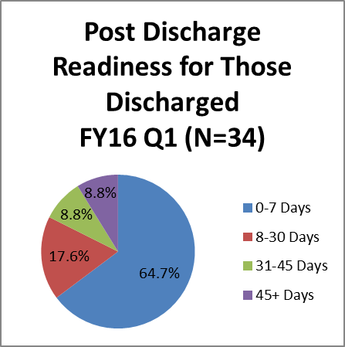

**Cumulative percentages & targets are as follows:**

Within 7 days = (22) 64.7% (target 70%)

Within 30 days = (6) 82.3% (target 80%)

Within 45 days = (3) 91.1% (target 90%)

Post 45 days = (3) 8.8% (target 0%)

**Barriers to Discharge Following Clinical Readiness:**

|  |  |
| --- | --- |
| Residential Supports (0)   * 1 patient discharged 8-30 days post clinical readiness (15 days). | Housing (7)   * 5 patients discharged 8-30 days post clinical readiness (16, 21, 21, 22, and 26 days) * 3 patients discharged 31-45 days post clinical readiness (32, 38, and 41 days) * 3 patients discharged 45+ days post clinical readiness (62, 64, and 84 days) |
| Treatment Services (0)  No barriers in this area |
| Other (0)  No barriers in this area |

(Glossary of Terms, Acronyms & Abbreviations) (Back to Table of Contents)

|  |
| --- |
| CONSENT DECREE |

**The previous four quarters are displayed in the table below**

|  |  |  |  |  |  |
| --- | --- | --- | --- | --- | --- |
| Target >> | | **Within 7 days** | **Within 30 days** | **Within 45 days** | **45+ days** |
| **70%** | **80%** | **90%** | **< 10%** |
| 4Q2015 | N=29 | 65.6% | 86.2% | 93.1% | 6.9% |
| 3Q2015 | N=38 | 78.9% | 86.8% | 89.4% | 10.5% |
| 2Q2015 | N=39 | 82.1% | 87.2% | 89.7% | 10.3% |
| 1Q2015 | N=38 | 81.6% | 92.1% | 94.7% | 5.3% |

(Glossary of Terms, Acronyms & Abbreviations) (Back to Table of Contents)

|  |
| --- |
| CONSENT DECREE |

An evaluation of treatment and discharge planning, performed in accordance with **Attachment D**, demonstrates that, for 90% of the cases reviewed:

V20) Treatment and discharge plans reflect interventions appropriate to address discharge and transition goals;

V20a) For patients who have been found not criminally responsible or not guilty by reason of insanity, appropriate interventions include timely reviews of progress toward the maximum levels allowed by court order; and the record reflects timely reviews of progress toward the maximum levels allowed by court order;

V21) Interventions to address discharge and transition planning goals are in fact being implemented;

V21a) For patients who have been found not criminally responsible or not guilty by reason of insanity, this means that, if the treatment team determines that the patient is ready for an increase in levels beyond those allowed by the current court order, Riverview is taking reasonable steps to support a court petition for an increase in levels.

|  |  |  |  |  |
| --- | --- | --- | --- | --- |
| **Indicators** | **2Q2015** | **3Q2015** | **4Q2015** | **1Q2016** |
| 1. The Patient Discharge Plan Report will be updated/reviewed by each **Social Worker minimally one time per week.** | 100%  11/11 | 100%  10/10 | 100%  12/12 | 100%  12/12 |
| 1. The Patient Discharge Plan Report will be reviewed/updated minimally one time per week by the Director of Social Services. | 100%  11/11 | 100%  10/10 | 100%  12/12 | 100%  12/12 |
| 3. The Patient Discharge Plan Report will be sent out weekly as indicated in the approved court plan. | 100%  11/11 | 90%  9/10 | 92%  11/12 | 83%  10/12 |
| 1. Each week the Social Work team and Director will meet and discuss current housing options provided by the respective regions and prioritize referrals. | 100%  11/11 | 100%  10/10 | 100%  12/12 | 100%  12/12 |

**1Q2016:**

3. On two occasions the report was not sent out electronically during a week, it was presented at the Wednesday housing meeting due to computer issues and inaccurate information in the report.(Glossary of Terms, Acronyms & Abbreviations) (Back to Table of Contents)

|  |
| --- |
| CONSENT DECREE |

V22) The Department demonstrates that 95% of the annual reports for forensic patients are submitted to the Commissioner and forwarded to the court on time.

|  |  |  |  |  |
| --- | --- | --- | --- | --- |
| **Indicators** | **2Q2015** | **3Q2015** | **4Q2015** | **1Q2016** |
| 1. Institutional Reports will be completed, reviewed internally, and delivered to the court within 10 business days of request. | 0%  0/5 | 0%  0/8 | 66%  2/3 | 66%  2/3 |
| 1. The assigned **CCM** will review the new court order with the patient and document the meeting in a progress note or treatment team note. | 100%  3/3 | 100%  2/2 | 100%  3/3 | 100%  3/3 |
| 1. Annual Reports (due in December) to the Commissioner for all inpatient NCR patients are submitted annually | 100%  25/25 | N/A | N/A | N/A |

**1Q2016:**

1. Three Institutional Reports were done. Two of the reports were completed in the 10 business day timeframe. We continue to monitor the process to track the reports in the quarter to get improved results for completion.

(Glossary of Terms, Acronyms & Abbreviations) (Back to Table of Contents)

|  |
| --- |
| CONSENT DECREE |

**Staffing and Staff Training**

V23) Riverview performance data shows that 95% of direct care staff have received 90% of their annual training.

|  |  |  |  |  |  |
| --- | --- | --- | --- | --- | --- |
| **Indicators** | **2Q2015** | **3Q2015** | **4Q2015** | **1Q2016** | **YTD**  **Findings** |
| 1. Riverview and Contract staff will attend CPR training bi-annually. | 100%  37/37 | 100%  26/26 | 98%  55/56 | 100%  55/55 | 99%  173/174 |
| 2. Riverview and Contract staff will attend Annual training. | 83%  72/87 | 74%  34/46 | 89%  25/28 | 86%  89/104 | 83%  220/265 |
| 3. Riverview and contract staff will attend MOAB training bi-annually | 87%  393/451 | 99%  389/391 | 94%  421/446 | 100%  28/28 | 94%  1231/  1316 |

**1Q2016:**

2. Employees who are out of compliance have been notified and corrective action is being taken.

3. MOAB was initiated in January 2014. This quarter a total of 28 employees received MOAB training. Since the initiation date 376 current employees have completed MOAB training.

**I. Measure Name: Ongoing Education and Training**

**Measure Description:** HR.01.05.03 requires that staff will participate in ongoing

education and training to increase and maintain their competency.

**Type of Measure:** Performance Improvement

**Goal:** 90% of direct support staff will attend Non Violent Communication and Motivational Interviewing training by June 2016. Attendance will be tracked by Staffing and Organizational Development. Progress will be reported quarterly.

**Progress:** To date, 216 out of 375 current employees have attended Non-Violent Communication (NVC) Training. 85 have attended eight hour NVC training. 111 employees have attended Motivational Interviewing Training to date.

**Comments:** Neither Non-Violent Communication of Motivational Interviewing was offered in 1Q2016 due to staff shortages and budgetary constraints. RPC remains committed to this goal.

(Glossary of Terms, Acronyms & Abbreviations) (Back to Table of Contents)

|  |
| --- |
| CONSENT DECREE |

**II. Measure Name: Seclusion and Restraint Reduction**

**Measure Description:** Because restraint and seclusion have the potential to produce

serious consequences, such as physical and psychological harm, loss of dignity,

violation of the rights of an individual served, and even death, organizations

continually explore ways to prevent, reduce, and strive to eliminate restraint and

seclusion through effective performance improvement initiatives.

**Type of Measure:** Performance Improvement

**Goal:** RPC will decrease the use of seclusion and restraint by 50%.

**Data:**

|  |  |  |  |  |
| --- | --- | --- | --- | --- |
| **FY 2015** | **Manual Holds** | **Mechanical Restraints** | **Locked Seclusion** | **Total Events Per Quarter** |
| **Quarter 1** | 99 | 10 | 105 | **214** |
| **Quarter 2** | 107 | 16 | 97 | **220** |
| **Quarter 3** | 61 | 1 | 62 | **124** |
| **Quarter 4** | 94 | 4 | 92 | **190** |
| **Total # of events** | **361** | **31** | **356** | **748** |

**\*Average # of events per month in FY 2015: 62.3**

|  |  |  |  |  |
| --- | --- | --- | --- | --- |
| **FY 2016** | **Manual Holds** | **Mechanical Restraints** | **Locked Seclusion** | **Total Events Per Quarter** |
| **Quarter 1** | 94 | 6 | 74 | **174** |
| **Quarter 2** |  |  |  |  |
| **Quarter 3** |  |  |  |  |
| **Quarter 4** |  |  |  |  |
| **Total # of events** | **94** | **6** | **74** | **174** |

**\*Average # of events per month in FY 2016 to date: 58**

**Action Plan:**

Staff will receive initial and ongoing education training in MOAB, Non Violent Communication, Motivational interviewing to assist in establish therapeutic relationships so that, when a crisis begins, staff will be more influential and effective in preventing the use of seclusion and restraint. Staff development will provide ongoing education to reinforce the organization’s commitment to ensuring a caring, respectful, therapeutic environment. Data gathered through hospital performance measures will be analyzed to determine progress.

(Glossary of Terms, Acronyms & Abbreviations) (Back to Table of Contents)

|  |
| --- |
| CONSENT DECREE |

V24) Riverview certifies that 95% of professional staff have maintained professionally-required continuing education credits and have received the ten hours of annual cross-training required by ¶216;

|  |  |  |  |
| --- | --- | --- | --- |
| **DATE** | **HRS** | **TITLE** | **PRESENTER** |
| 2Q2015 | 13 | October – December 2014 |  |
| 3Q2015 | 13 | January – March 2015 |  |
| 4Q2015 | 17 | April – June 2015 |  |
| 9/10/2015 | 1 | Outpatient Readiness Scale | Art DiRocco, PhD |
| 9/15/2015 | 1 | Med Staff PI & QA Committee | Brendan Kirby, MD |
| 9/17/2015 | 1 | Compassion Fatigue: The Burden of Care | Kristen Stevens, LMSW-CC |
| 9/24/2015 | 1 | Brief Cognitive Screen | Noel Ngai, Post Doc Intern |

(Glossary of Terms, Acronyms & Abbreviations) (Back to Table of Contents)

|  |
| --- |
| CONSENT DECREE |

V25) Riverview certifies that staffing ratios required by ¶202 are met, and makes available documentation that shows actual staffing for up to one recent month;

|  |  |
| --- | --- |
| **Staff Type** | **Consent Decree Ratio** |
| General Medicine Physicians | 1:75 |
| Psychiatrists | 1:25 |
| Psychologists | 1:25 |
| Nursing | 1:20 |
| Social Workers | 1:15 |
| Mental Health Workers | 1:6 |
| Recreational/Occupational Therapists/Aides | 1:8 |

With 92 beds, Riverview regularly meets or exceeds the staffing ratio requirements of the consent decree.

Staffing levels are most often determined by an analysis of unit acuity, individual monitoring needs of the patients who reside on specific units, and unit census.

V26) The evaluation of treatment and discharge planning, performed in accordance with **Attachment D**, demonstrates that staffing was sufficient to provide patients access to activities necessary to achieve the patients’ treatment goals, and to enable patients to exercise daily and to recreate outdoors consistent with their treatment plans.

Treatment teams regularly monitor the needs of individual patients and make recommendations for ongoing treatment modalities. Staffing levels are carefully monitored to ensure that all treatment goals, exercise needs, and outdoor activities are achievable. Staffing does not present a barrier to the fulfillment of patient needs. Staffing deficiencies that may periodically be present are rectified through utilization of overtime or mandated staff members.

(Glossary of Terms, Acronyms & Abbreviations) (Back to Table of Contents)

|  |
| --- |
| CONSENT DECREE |

**Use of Seclusion and Restraints**

V27) Quarterly performance data shows that, in 5 out of 6 quarters, total seclusion and restraint hours do not exceed one standard deviation from the national mean as reported by NASMHPD;

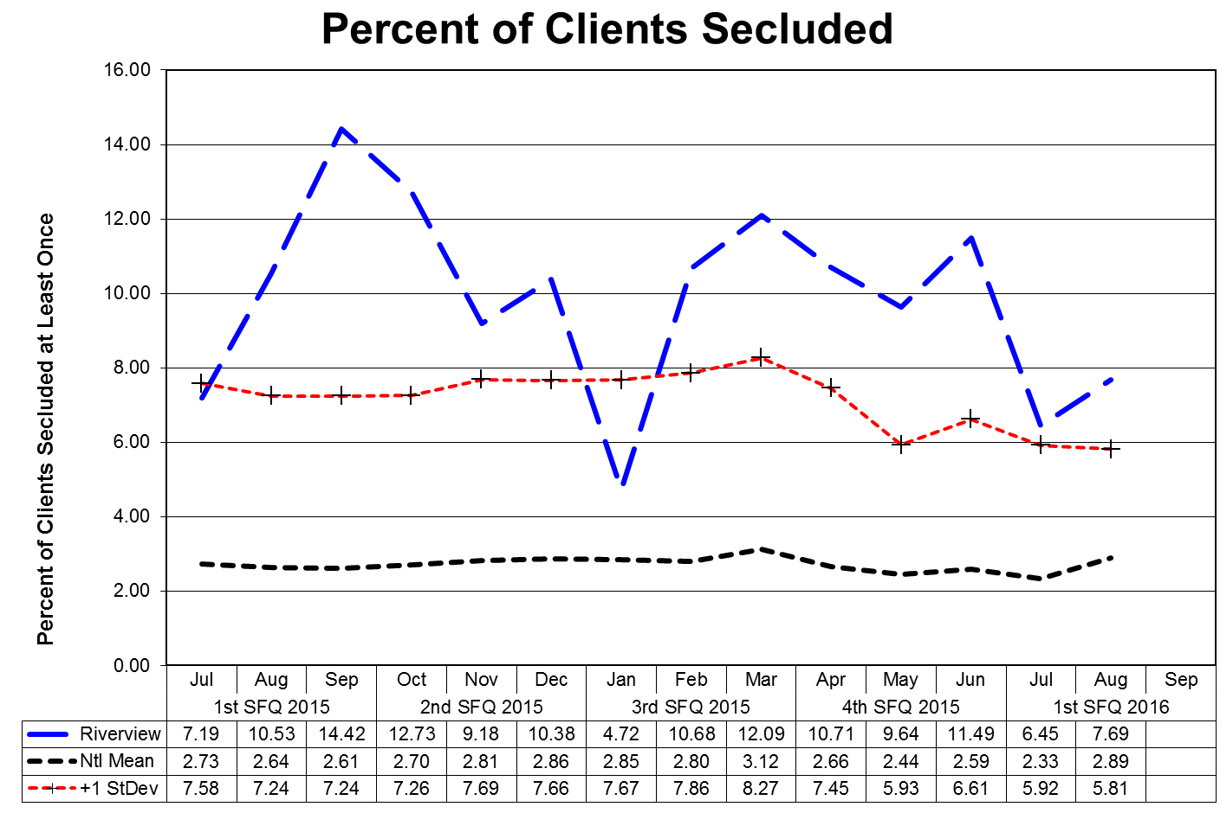

This graph depicts the percent of unique patients who were secluded at least once. For example, rates of 3.0 means that 3% of the unique patients served were secluded at least once.

The following graphs depict the percent of unique patients who were secluded at least once stratified by forensic or civil classifications. For example; rates of 3.0 means that 3% of the unique patients served were secluded at least once. The hospital-wide results from Dorothea Dix are compared to the civil population results at Riverview due to the homogeneous nature of these two sample groups.

(Glossary of Terms, Acronyms & Abbreviations) (Back to Table of Contents)

|  |
| --- |
| CONSENT DECREE |

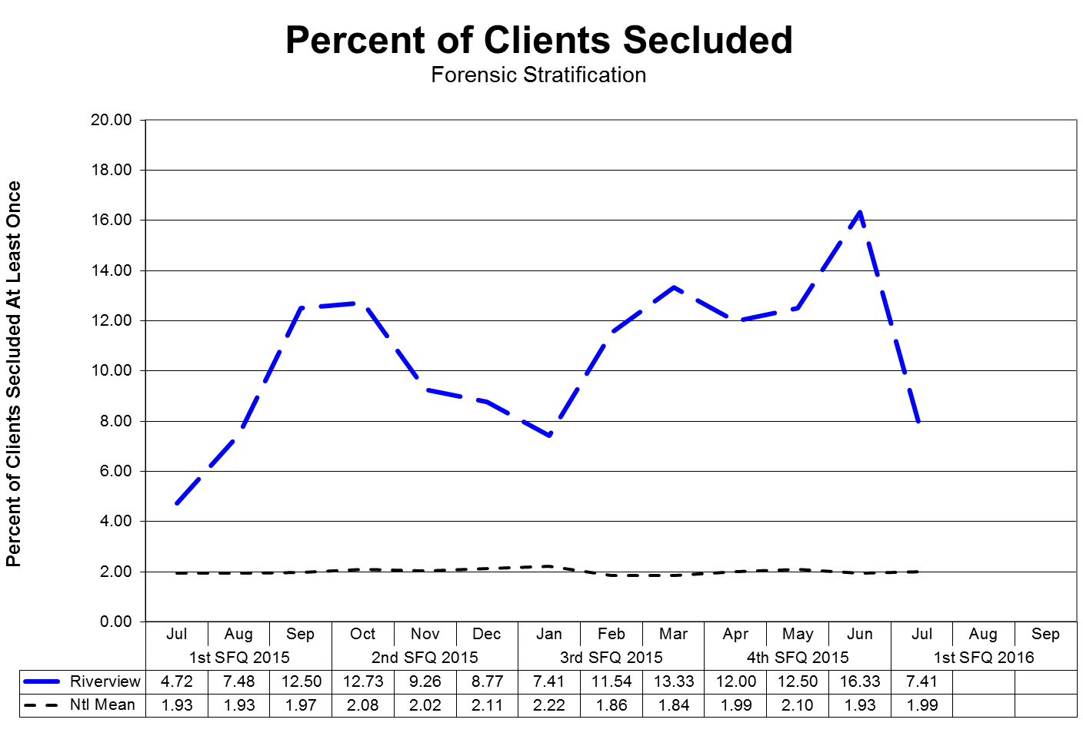

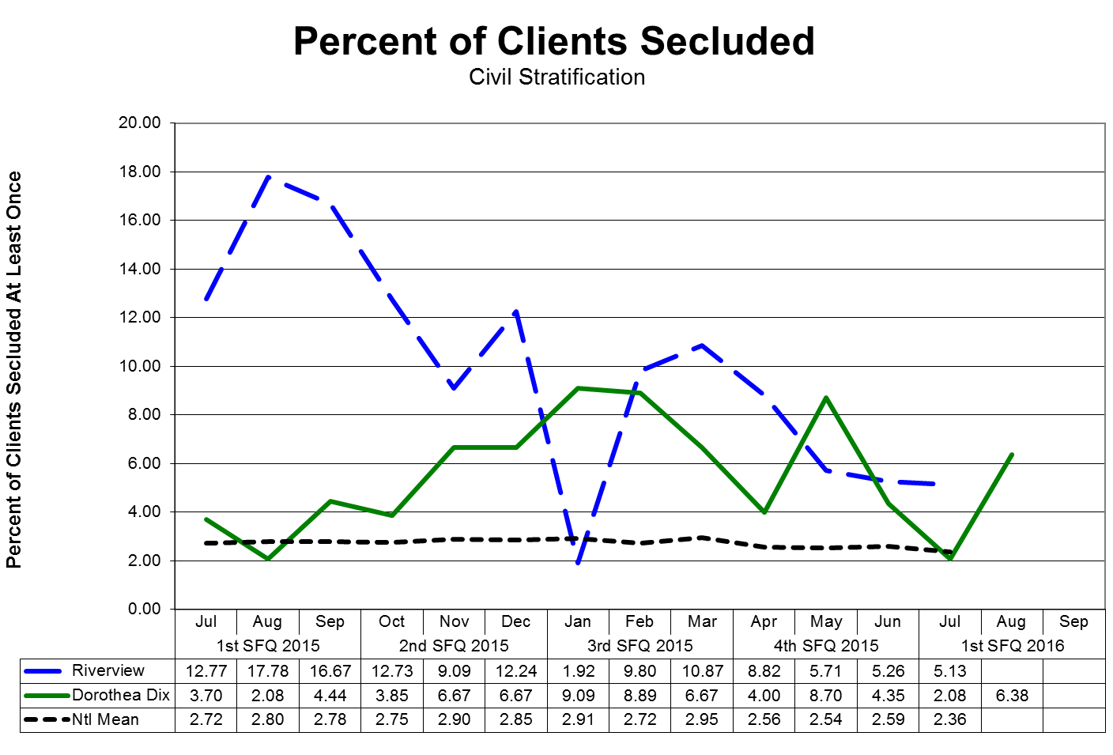

(Glossary of Terms, Acronyms & Abbreviations) (Back to Table of Contents)

|  |
| --- |
| CONSENT DECREE |

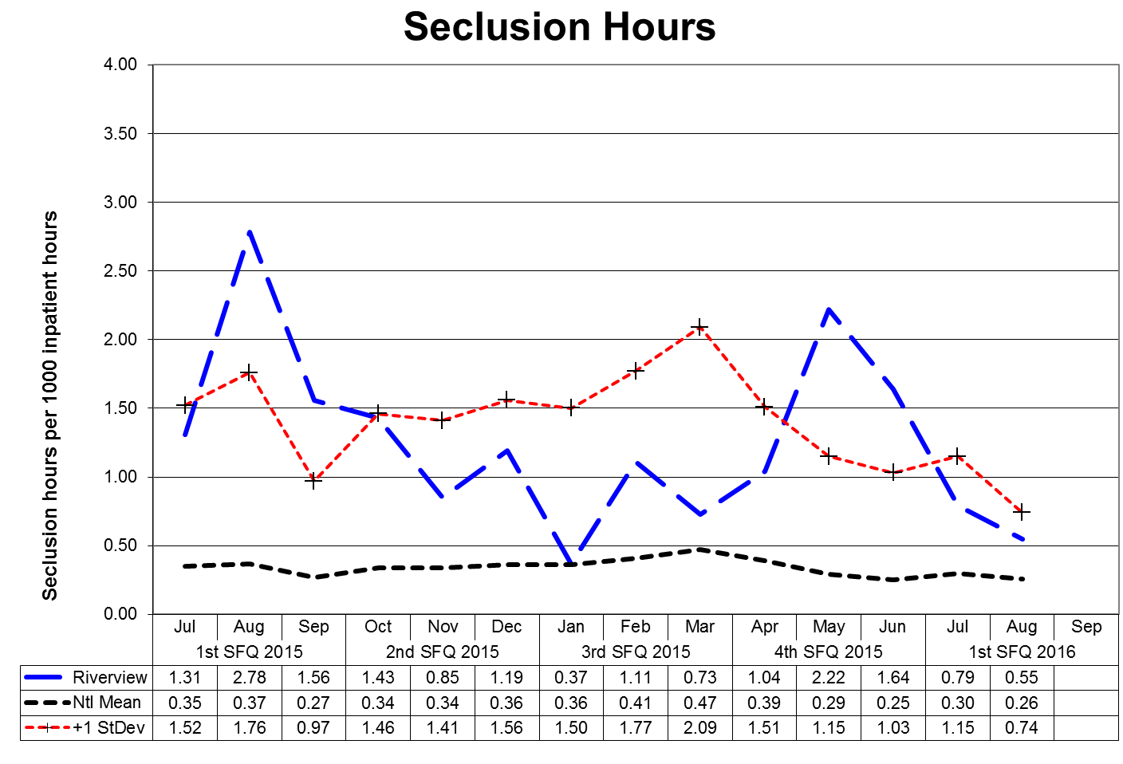

This graph depicts the number of hours patients spent in seclusion for every 1000 inpatient hours. For example, a rate of 0.8 means that 1 hour was spent in seclusion for each 1250 inpatient hours.

The following graphs depict the number of hours patients spent in seclusion for every 1000 inpatient hours stratified by forensic or civil classifications. For example, a rate of 0.8 means that 1 hour was spent in seclusion for each 1250 inpatient hours. The hospital-wide results from Dorothea Dix are compared to the civil population results at Riverview due to the homogeneous nature of these two sample groups.

(Glossary of Terms, Acronyms & Abbreviations) (Back to Table of Contents)

|  |
| --- |
| CONSENT DECREE |

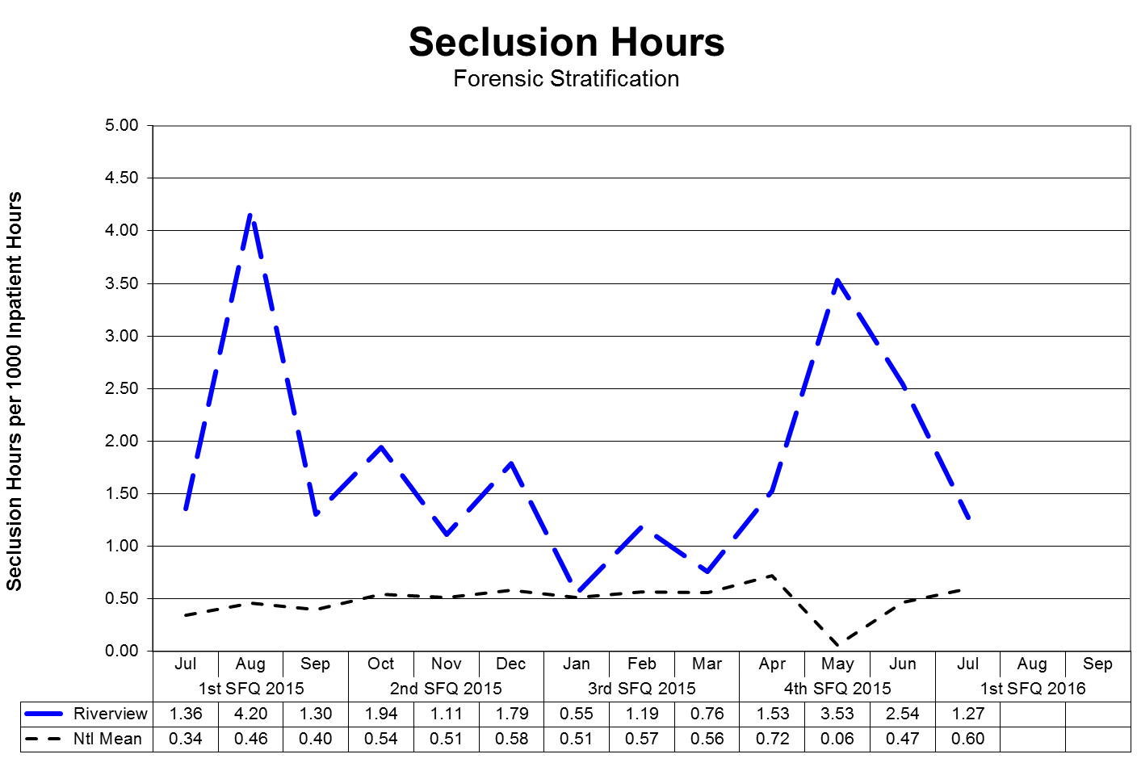



(Glossary of Terms, Acronyms & Abbreviations) (Back to Table of Contents)

|  |
| --- |
| CONSENT DECREE |

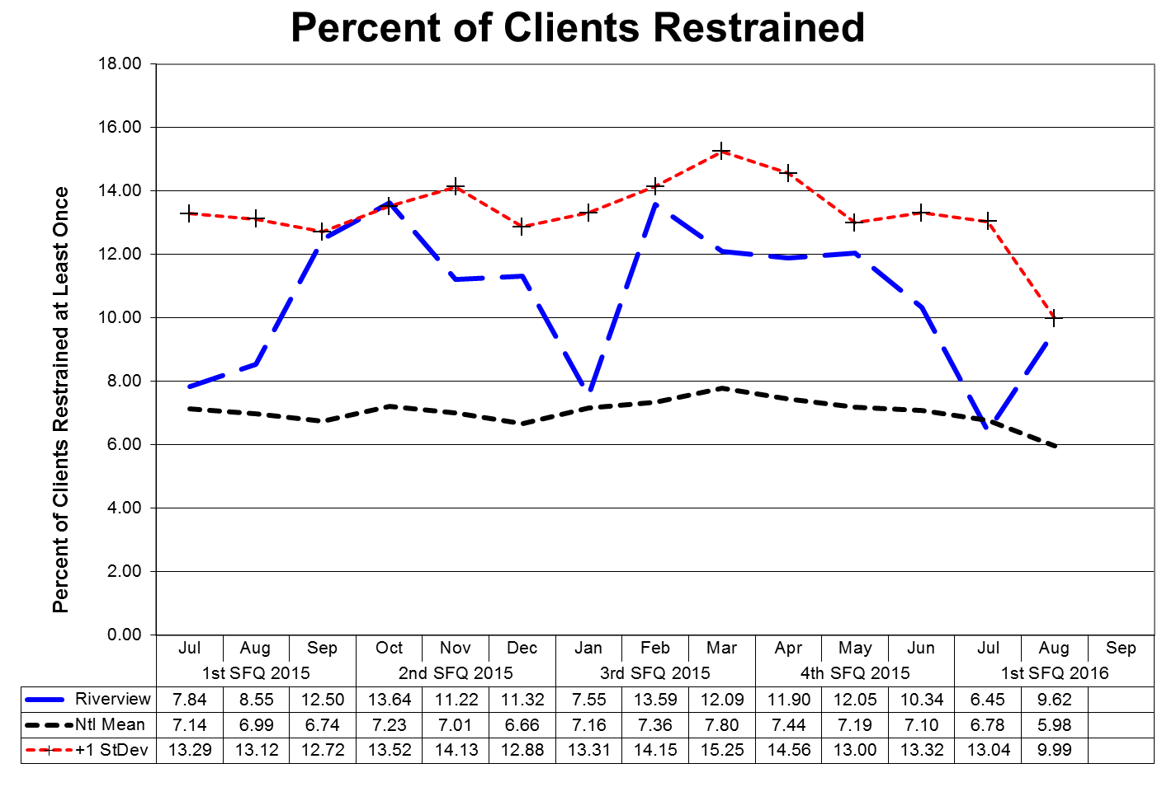

This graph depicts the percent of unique patients who were restrained at least once and includes all forms of restraint of any duration. For example; a rate of 4.0 means that 4% of the unique patients served were restrained at least once.

The following graphs depict the percent of unique patients who were restrained at least once stratified by forensic or civil classifications, and includes all forms of restraint of any duration. For example; a rate of 4.0 means that 4% of the unique patients served were restrained at least once. The hospital-wide results from Dorothea Dix are compared to the civil population results at Riverview due to the homogeneous nature of these two sample groups.

(Glossary of Terms, Acronyms & Abbreviations) (Back to Table of Contents)

|  |
| --- |
| CONSENT DECREE |

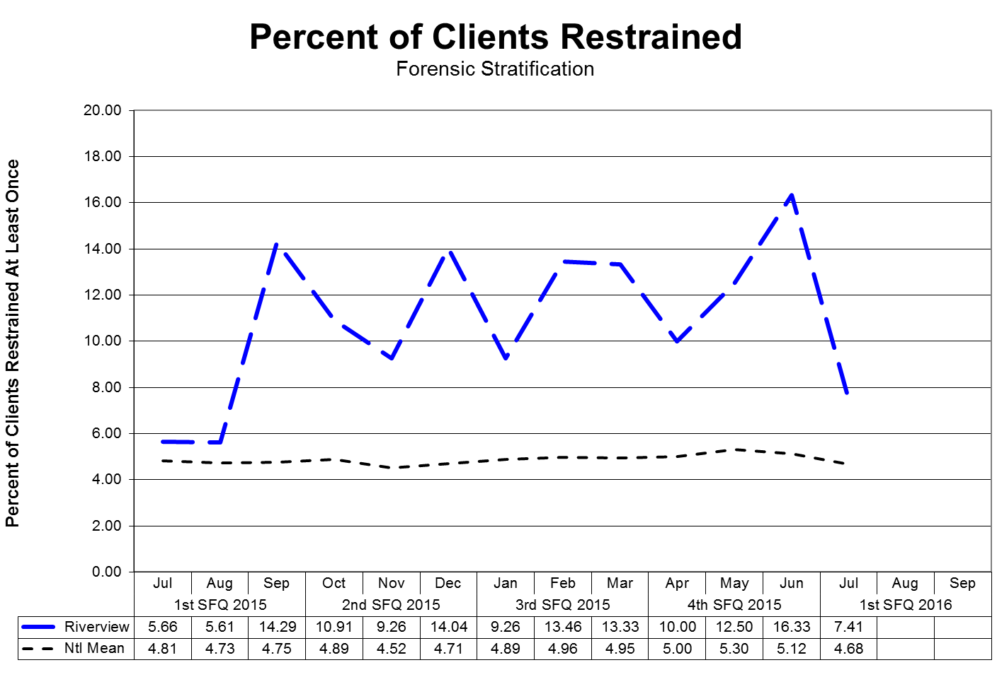

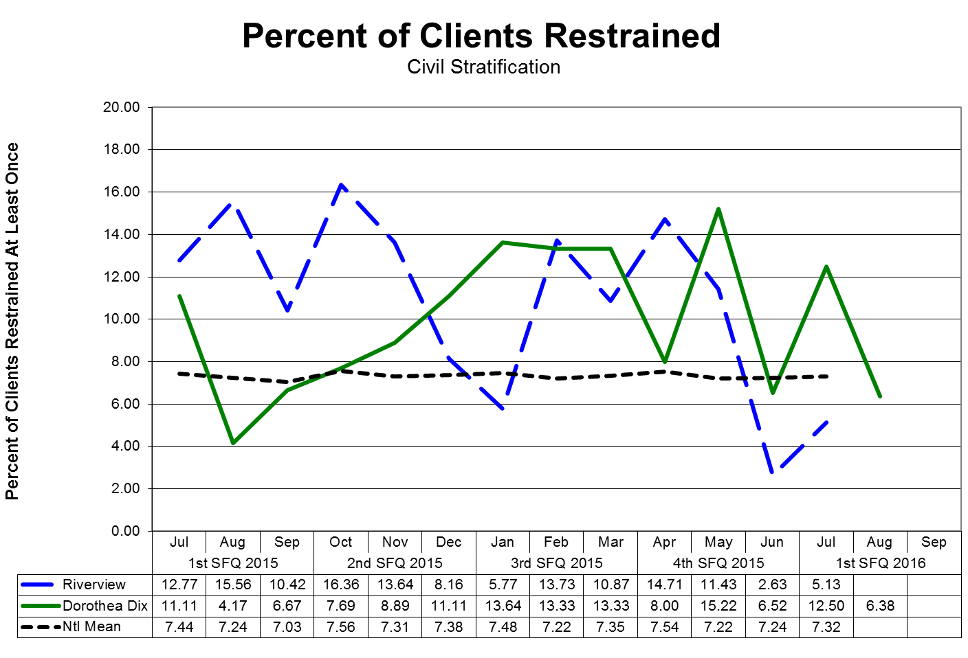

(Glossary of Terms, Acronyms & Abbreviations) (Back to Table of Contents)

|  |
| --- |
| CONSENT DECREE |

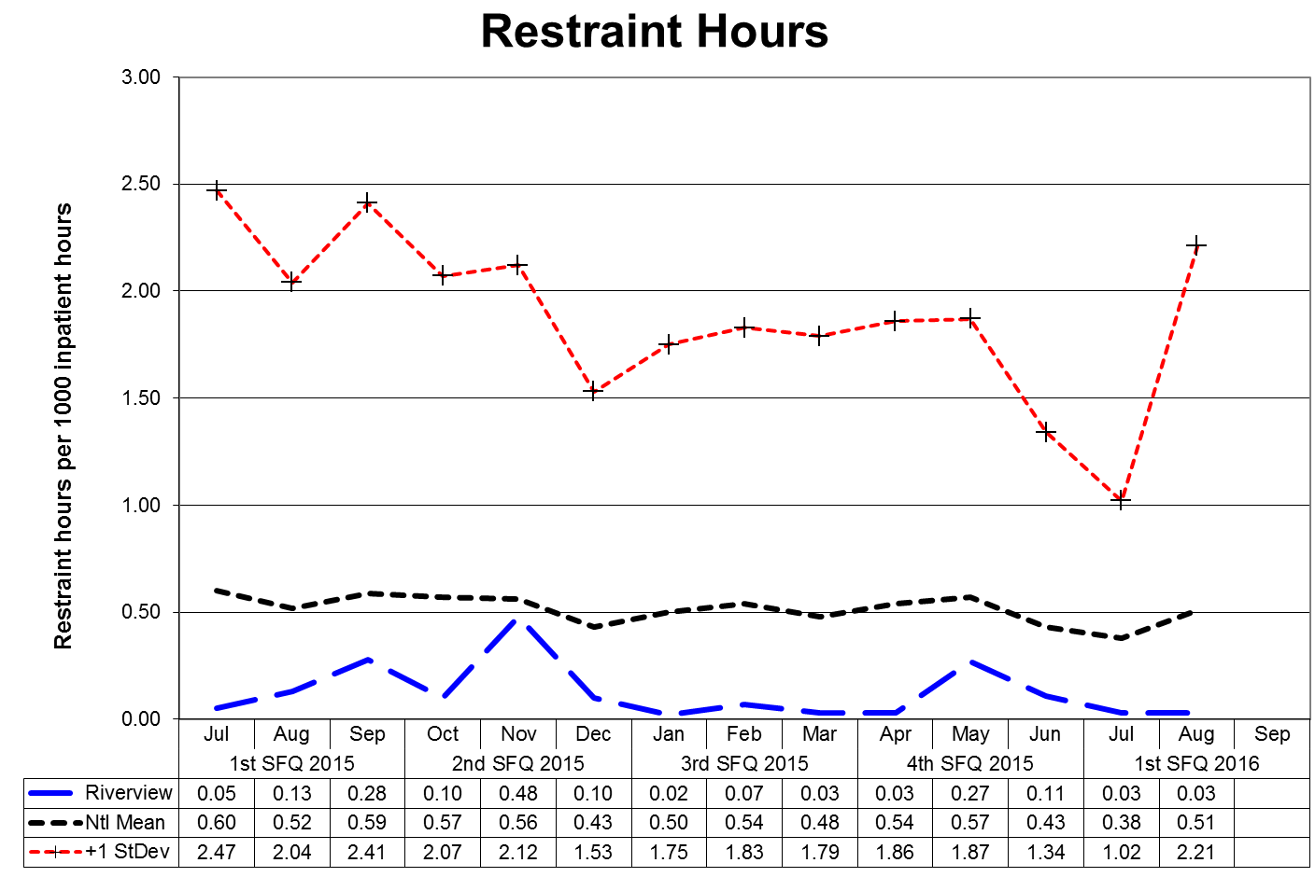

This graph depicts the number of hours patients spent in restraint for every 1000 inpatient hours - includes all forms of restraint of any duration. For example; a rate of 1.6 means those 2 hours were spent in restraint for each 1250 inpatient hours.

The following graphs depict the number of hours patients spent in restraint for every 1000 inpatient hours stratified by forensic or civil classifications - includes all forms of restraint of any duration. For example; a rate of 1.6 means those 2 hours were spent in restraint for each 1250 inpatient hours. The hospital-wide results from Dorothea Dix are compared to the civil population results at Riverview due to the homogeneous nature of these two sample groups.

(Glossary of Terms, Acronyms & Abbreviations) (Back to Table of Contents)

|  |
| --- |
| CONSENT DECREE |

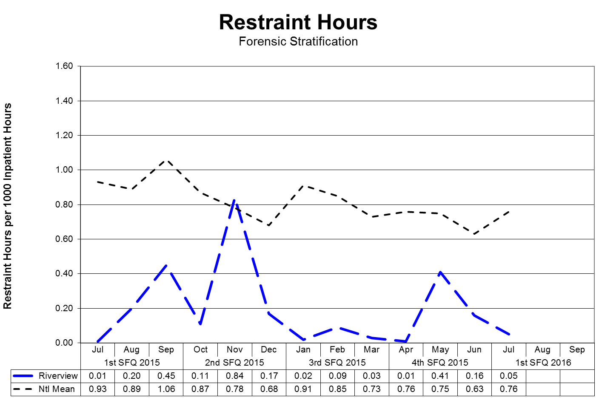

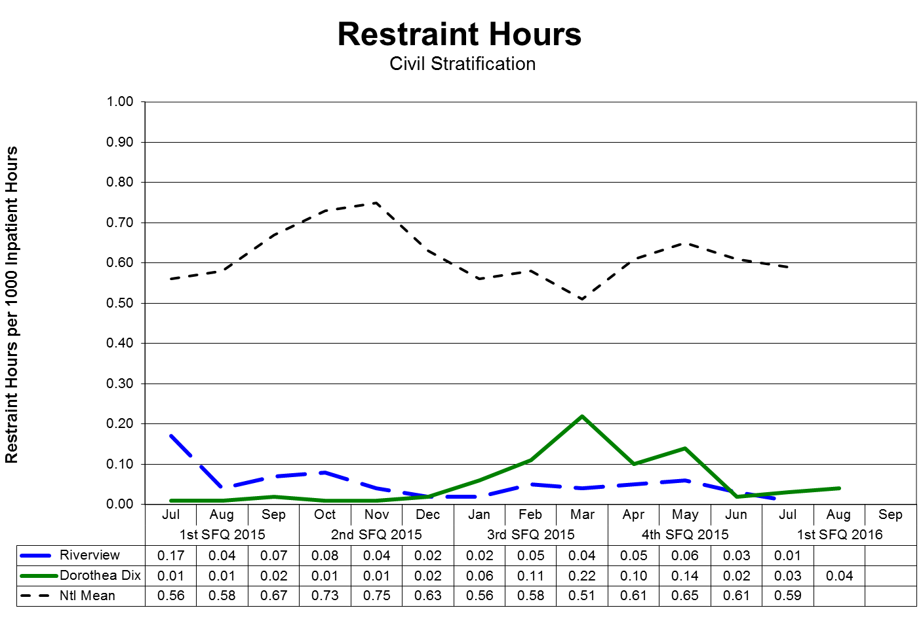

(Glossary of Terms, Acronyms & Abbreviations) (Back to Table of Contents)

|  |
| --- |
| CONSENT DECREE |

**Confinement Event Detail**

1Q2016

|  |  |  |  |  |  |  |
| --- | --- | --- | --- | --- | --- | --- |
|  | **Manual Hold** | **Mechanical Restraint** | **Locked  Seclusion** | **Grand Total** | **% of Total** | **Cumulative %** |
| MR3374 | 39 |  | 33 | 72 | 41.38% | 41.38% |
| MR7495 | 18 | 6 | 4 | 28 | 16.09% | 57.47% |
| MR5267 | 5 |  | 8 | 13 | 7.47% | 64.94% |
| MR7750 | 4 |  | 5 | 9 | 5.17% | 70.12% |
| MR91 | 4 |  | 3 | 7 | 4.02% | 74.14% |
| MR1187 | 2 |  | 3 | 5 | 2.87% | 77.01% |
| MR7127 | 3 |  | 2 | 5 | 2.87% | 79.89% |
| MR763 | 2 |  | 2 | 4 | 2.30% | 82.18% |
| MR7764 | 3 |  | 1 | 4 | 2.30% | 84.48% |
| MR7809 | 1 |  | 3 | 4 | 2.30% | 86.78% |
| MR7801 | 2 |  | 1 | 3 | 1.72% | 88.51% |
| MR5625 |  |  | 2 | 2 | 1.15% | 89.66% |
| MR5969 |  |  | 2 | 2 | 1.15% | 90.81% |
| MR7665 | 2 |  |  | 2 | 1.15% | 91.95% |
| MR7735 | 1 |  | 1 | 2 | 1.15% | 93.10% |
| MR7768 | 1 |  | 1 | 2 | 1.15% | 94.25% |
| MR7820 | 1 |  | 1 | 2 | 1.15% | 95.40% |
| MR2187 | 1 |  |  | 1 | 0.57% | 95.98% |
| MR4417 |  |  | 1 | 1 | 0.57% | 96.55% |
| MR7032 | 1 |  |  | 1 | 0.57% | 97.13% |
| MR7724 | 1 |  |  | 1 | 0.57% | 97.70% |
| MR7736 | 1 |  |  | 1 | 0.57% | 98.28% |
| MR7739 | 1 |  |  | 1 | 0.57% | 98.85% |
| MR7784 | 1 |  |  | 1 | 0.57% | 99.43% |
| MR7814 |  |  | 1 | 1 | 0.57% | 100.00% |
|  | **94** | **6** | **74** | **174** |  |  |

32% (25/77) of the average hospital population experienced some form of confinement event during 1Q2016. Five of these patients (6% of the average hospital population) accounted for 74% of the containment events.

(Glossary of Terms, Acronyms & Abbreviations) (Back to Table of Contents)

|  |
| --- |
| CONSENT DECREE |

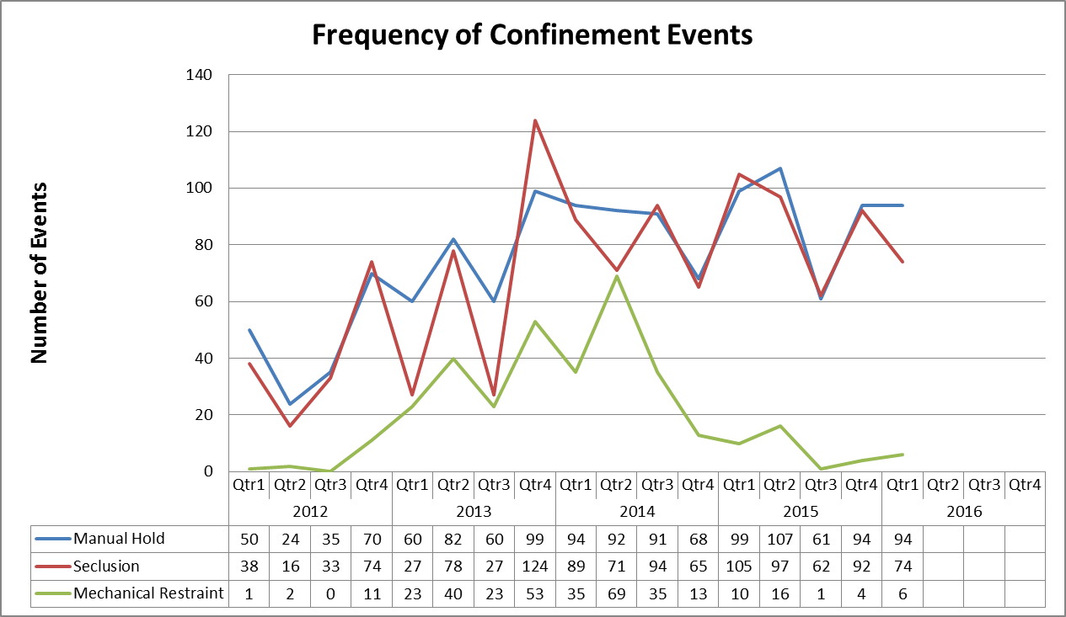(Glossary of Terms, Acronyms & Abbreviations) (Back to Table of Contents)

|  |
| --- |
| CONSENT DECREE |

V28) Riverview demonstrates that, based on a review of two quarters of data, for 95% of seclusion events, seclusion was employed only when absolutely necessary to protect the patient from causing physical harm to self or others or for the management of violent behavior;

**Factors of Causation Related to Seclusion Events**

|  |  |  |  |  |  |
| --- | --- | --- | --- | --- | --- |
|  | **2Q2015** | **3Q2015** | **4Q2015** | **1Q2016** | **Total** |
| **Danger to Others/Self** | 8 | 7 | 88 | 74 | **177** |
| **Danger to Others** | 89 | 55 | 1 |  | **145** |
| **Danger to Self** |  |  | 3 |  | **3** |
| **% Dangerous Precipitation** | 100% | 100% | 100% | 100% | **100%** |
| **Total Events** | **97** | **62** | **92** | **74** | **325** |

V29) Riverview demonstrates that, based on a review of two quarters of data, for 95% of restraint events involving mechanical restraints, the restraint was used only when absolutely necessary to protect the patient from serious physical injury to self or others;

**Factors of Causation Related to Mechanical Restraint Events**

|  |  |  |  |  |  |
| --- | --- | --- | --- | --- | --- |
|  | **2Q2015** | **3Q2015** | **4Q2015** | **1Q2016** | **Total** |
| **Danger to Others/Self** | 6 |  | 4 | 6 | **16** |
| **Danger to Others** | 9 | 1 |  |  | **10** |
| **Danger to Self** | 1 |  |  |  | **1** |
| **% Dangerous Precipitation** | 100% | 100% | 100% | 100% | **100%** |
| **Total Events** | **16** | **1** | **4** | **6** | **27** |

V30) Riverview demonstrates that, based on a review of two quarters of data, for 95% of seclusion and restraint events, the hospital achieved an acceptable rating for meeting the requirements of paragraphs 182 and 184 of the Settlement Agreement, in accordance with a methodology defined in **Attachments E-1 and E-2.**

***See Pages 30 & 31***

(Glossary of Terms, Acronyms & Abbreviations) (Back to Table of Contents)

|  |
| --- |
| CONSENT DECREE |

**Confinement Events Management**

**Seclusion Events** (74) Events

|  |  |  |  |  |  |  |  |  |  |  |  |  |  |  |  |  |  |  |  |  |  |  |  |  |  |  |  |  |  |  |  |
| --- | --- | --- | --- | --- | --- | --- | --- | --- | --- | --- | --- | --- | --- | --- | --- | --- | --- | --- | --- | --- | --- | --- | --- | --- | --- | --- | --- | --- | --- | --- | --- |
| |  |  |  | | --- | --- | --- | | **Standard** | **Threshold** | **Compliance** | | The record reflects that seclusion was absolutely necessary to protect the patient from causing physical harm to self or others, or if the patient was examined by a physician or physician extender prior to implementation of seclusion, to prevent further serious disruption that significantly interferes with other patients’ treatment. | 95% | 99% | | The record reflects that lesser restrictive alternatives were inappropriate or ineffective. This can be reflected anywhere in record. | 90% | 99% | | The record reflects that the decision to place the patient in seclusion was made by a physician or physician extender. | 90% | 99% | | The decision to place the patient in seclusion was entered in the patient’s records as a medical order. | 90% | 99% | | The record reflects that, if the physician or physician extender was not immediately available to examine the patient, the patient was placed in seclusion following an examination by a nurse. | 90% | 100% | | The record reflects that the physician or physician extender personally evaluated the patient within 30 minutes after the patient has been placed in seclusion, and if there is a delay, the reasons for the delay. | 90% | 100% | | The record reflects that the patient was monitored every 15 minutes. (Compliance will be deemed if the patient was monitored at least 3 times per hour.) | 90% | 100% | | Individuals implementing seclusion have been trained in techniques and alternatives. | 90% | 100% | | The record reflects that reasonable efforts were taken to notify guardian or designated representative as soon as possible that patient was placed in seclusion. | 75% | 100% | |  |

(Glossary of Terms, Acronyms & Abbreviations) (Back to Table of Contents)

|  |
| --- |
| CONSENT DECREE |

**Confinement Events Management**

**Seclusion Events, Continued** (74) Events

|  |  |  |
| --- | --- | --- |
| **Standard** | **Threshold** | **Compliance** |
| The medical order states time of entry of order and that number of hours in seclusion shall not exceed 4. | 85% | 100% |
| The medical order states the conditions under which the patient may be sooner released. | 85% | 100% |
| The record reflects that the need for seclusion is re-evaluated at least every 2 hours by a nurse. | 90% | 100% |
| The record reflects that the 2 hour re-evaluation was conducted while the patient was out of seclusion room unless clinically contraindicated. | 70% | 100% |
| The record includes a special check sheet that has been filled out to document reason for seclusion, description of behavior and the lesser restrictive alternatives considered. | 85% | 100% |
| The record reflects that the patient was released, unless clinically contraindicated, at least every 2 hours or as necessary for eating, drinking, bathing, toileting or special medical orders. | 85% | 100% |
| Reports of seclusion events were forwarded to Clinical Director and Patient Advocate. | 90% | 100% |
| The record reflects that, for persons with mental retardation, the regulations governing seclusion of patients with mental retardation were met. | 85% | 100% |
| The medical order for seclusion was not entered as a PRN order. | 90% | 100% |
| Where there was a PRN order, there is evidence that physician was counseled. | 95% | N/A |

(Glossary of Terms, Acronyms & Abbreviations) (Back to Table of Contents)

|  |
| --- |
| CONSENT DECREE |

**Confinement Events Management**

**Mechanical Restraint Events** (6) Events

|  |  |  |  |  |  |  |  |  |  |  |  |  |  |  |  |  |  |  |  |  |  |  |  |  |  |  |  |  |  |  |  |  |  |  |  |  |  |
| --- | --- | --- | --- | --- | --- | --- | --- | --- | --- | --- | --- | --- | --- | --- | --- | --- | --- | --- | --- | --- | --- | --- | --- | --- | --- | --- | --- | --- | --- | --- | --- | --- | --- | --- | --- | --- | --- |
| |  |  |  | | --- | --- | --- | | **Standard** | **Threshold** | **Compliance** | | The record reflects that restraint was absolutely necessary to protect the patient from causing serious physical injury to self or others. | 95% | 100% | | The record reflects that lesser restrictive alternatives were inappropriate or ineffective. | 90% | 100% | | The record reflects that the decision to place the patient in restraint was made by a physician or physician extender | 90% | 100% | | The decision to place the patient in restraint was entered in the patient’s records as a medical order. | 90% | 100% | | The record reflects that, if a physician or physician extended was not immediately available to examine the patient, the patient was placed in restraint following an examination by a nurse. | 90% | 100% | | The record reflects that the physician or physician extender personally evaluated the patient within 30 minutes after the patient has been placed in restraint, or, if there was a delay, the reasons for the delay. | 90% | 100% | | The record reflects that the patient was kept under constant observation during restraint. | 95% | 100% | | Individuals implementing restraint have been trained in techniques and alternatives. | 90% | 100% | | The record reflects that reasonable efforts taken to notify guardian or designated representative as soon as possible that patient was placed in restraint. | 75% | 100% | | The medical order states time of entry of order and that number of hours shall not exceed four. | 90% | 100% | | The medical order shall state the conditions under which the patient may be sooner released. | 85% | 100% | |  |

(Glossary of Terms, Acronyms & Abbreviations) (Back to Table of Contents)

|  |
| --- |
| CONSENT DECREE |

**Confinement Events Management**

**Mechanical Restraint Events, Continued** (6) Events

|  |  |  |
| --- | --- | --- |
| **Standard** | **Threshold** | **Compliance** |
| The record reflects that the need for restraint was re-evaluated every 2 hours by a nurse. | 90% | 100% |
| The record reflects that re-evaluation was conducted while the patient was free of restraints unless clinically contraindicated. | 70% | 100% |
| The record includes a special check sheet that has been filled out to document the reason for the restraint, description of behavior and the lesser restrictive alternatives considered. | 85% | 100% |
| The record reflects that the patient was released as necessary for eating, drinking, bathing, toileting or special medical orders. | 90% | 100% |
| The record reflects that the patient’s extremities were released sequentially, with one released at least every fifteen minutes. | 90% | 100% |
| Copies of events were forwarded to Clinical Director and Patient Advocate. | 90% | 100% |
| For persons with mental retardation, the applicable regulations were met. | 85% | 100% |
| The record reflects that the order was not entered as a PRN order. | 90% | 100% |
| Where there was a PRN order, there is evidence that physician was counseled. | 95% | N/A |
| A restraint event that exceeds 24 hours will be reviewed against the following requirement: If total consecutive hours in restraint, with renewals, exceeded 24 hours, the record reflects that the patient was medically assessed and treated for any injuries; that the order extending restraint beyond 24 hours was entered by Clinical Director (or if the Clinical Director is out of the hospital, by the individual acting in the Clinical Director’s stead) following examination of the patient; and that the patient’s guardian or representative has been notified. | 90% | 100% |

(Glossary of Terms, Acronyms & Abbreviations) (Back to Table of Contents)

|  |
| --- |
| CONSENT DECREE |

**Patient Elopements**

V31) Quarterly performance data shows that, in 5 out of 6 quarters, the number of patient elopements does not exceed one standard deviation from the national mean as reported by NASMHPD.

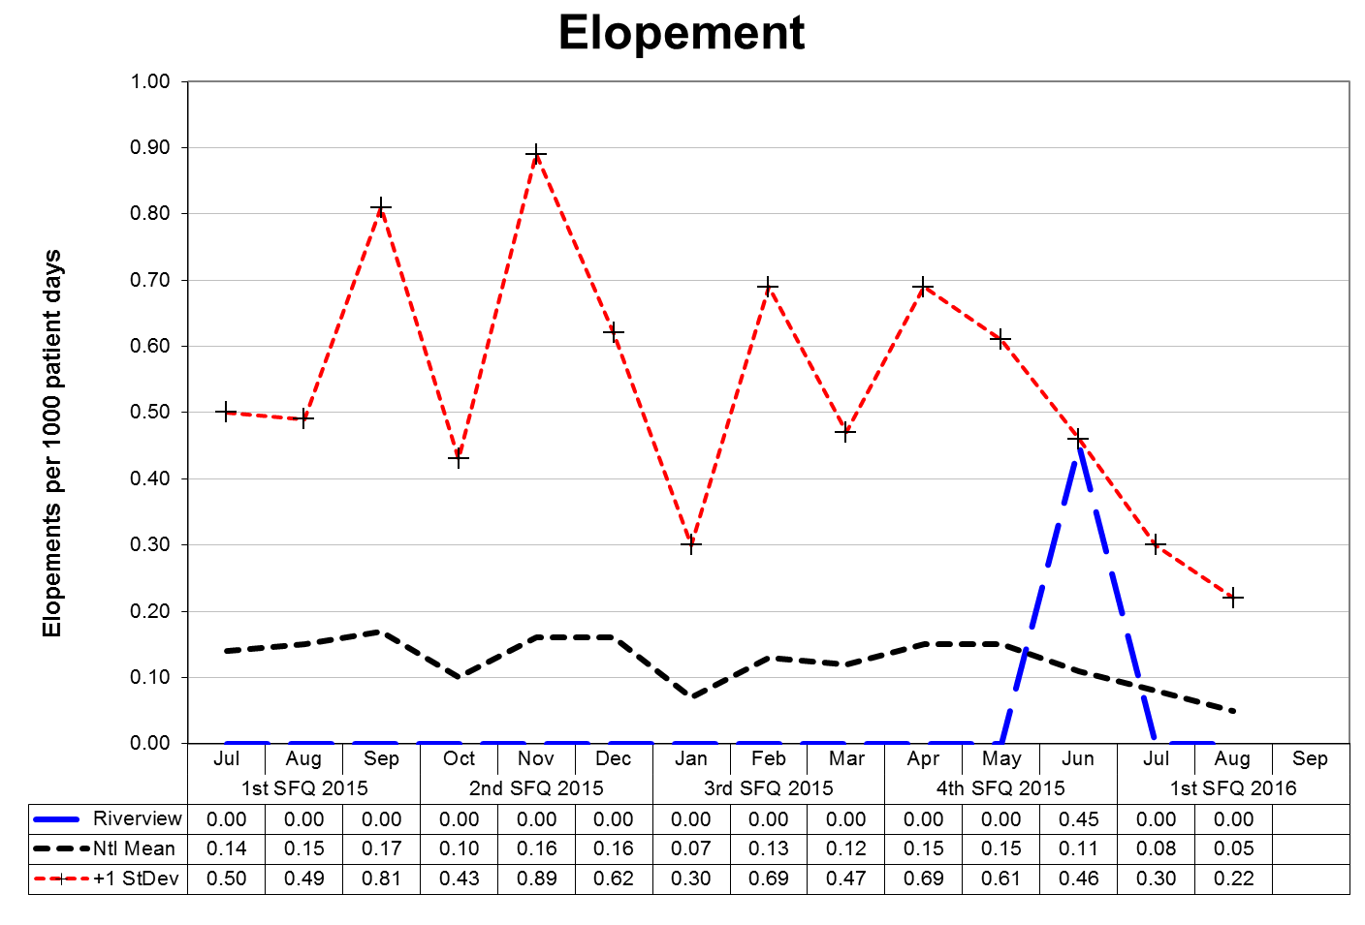

This graph depicts the number of elopements that occurred for every 1000 inpatient days. For example, a rate of 0.25 means that 1 elopement occurred for each 4000 inpatient days.

An elopement is defined as any time a patient is “absent from a location defined by the patient’s privilege status regardless of the patient’s leave or legal status.”

The following graphs depict the number of elopements stratified by forensic or civil classifications that occurred for every 1000 inpatient days. For example, a rate of 0.25 means that 1 elopement occurred for each 4000 inpatient days. The hospital-wide results from Dorothea Dix are compared to the civil population results at Riverview due to the

homogeneous nature of these two sample groups.(Glossary of Terms, Acronyms & Abbreviations) (Back to Table of Contents)

|  |
| --- |
| CONSENT DECREE |

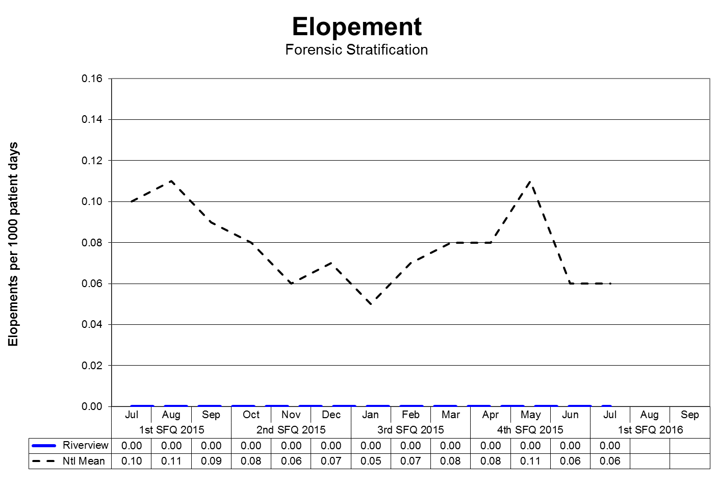

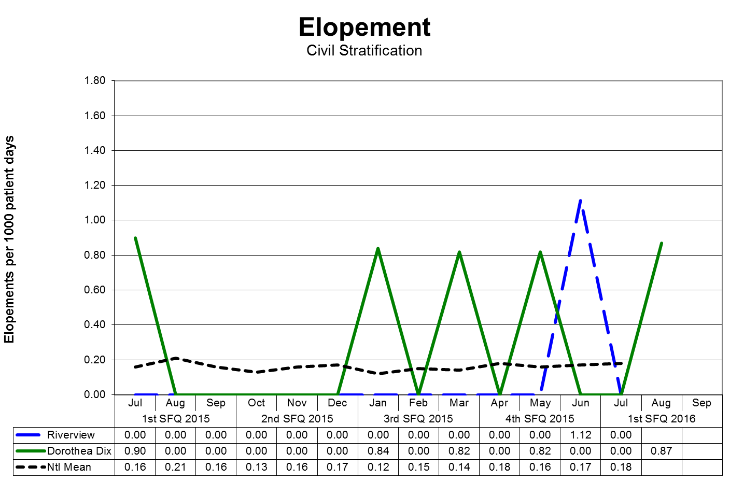

(Glossary of Terms, Acronyms & Abbreviations) (Back to Table of Contents)

|  |
| --- |
| CONSENT DECREE |

**Patient Injuries**

V32) Quarterly performance data shows that, in 5 out of 6 quarters, the number of patient injuries does not exceed one standard deviation from the national mean as reported by NASMHPD.

The NASMHPD standards for measuring patient injuries differentiate between injuries that are considered reportable to the Joint Commission as a performance measure and those injuries that are of a less severe nature. While all injuries are currently reported internally, only certain types of injuries are documented and reported to NRI for inclusion in the performance measure analysis process.

“Non-reportable” injuries include those that require: 1) No Treatment, or 2) Minor First Aid

Reportable injuries include those that require: 3) Medical Intervention, 4) Hospitalization or where, 5) Death Occurred.

* No Treatment – The injury received by a patient may be examined by a clinician but no treatment is applied to the injury.
* Minor First Aid – The injury received is of minor severity and requires the administration of minor first aid.
* Medical Intervention Needed – The injury received is severe enough to require the treatment of the patient by a licensed practitioner, but does not require hospitalization.
* Hospitalization Required – The injury is so severe that it requires medical intervention and treatment as well as care of the injured patient at a general acute care medical ward within the facility or at a general acute care hospital outside the facility.
* Death Occurred – The injury received was so severe that if resulted in, or complications of the injury lead to, the termination of the life of the injured patient.

The comparative statistics graph only includes those events that are considered “Reportable” by NASMHPD.

(Glossary of Terms, Acronyms & Abbreviations) (Back to Table of Contents)

|  |
| --- |
| CONSENT DECREE |

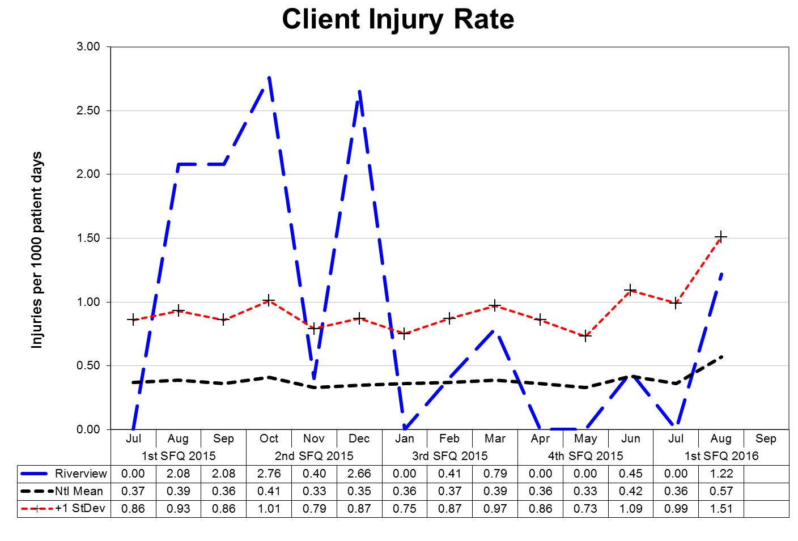

This graph depicts the number of patient injury events that occurred for every 1000 inpatient days. For example, a rate of 0.5 means that 1 injury occurred for each 2000 inpatient days.

The following graphs depict the number of patient injury events stratified by forensic or civil classifications that occurred for every 1000 inpatient days. For example, a rate of 0.5 means that 1 injury occurred for each 2000 inpatient days. The hospital-wide results from Dorothea Dix are compared to the civil population results at Riverview due to the homogeneous nature

of these two sample groups.(Glossary of Terms, Acronyms & Abbreviations) (Back to Table of Contents)

|  |
| --- |
| CONSENT DECREE |

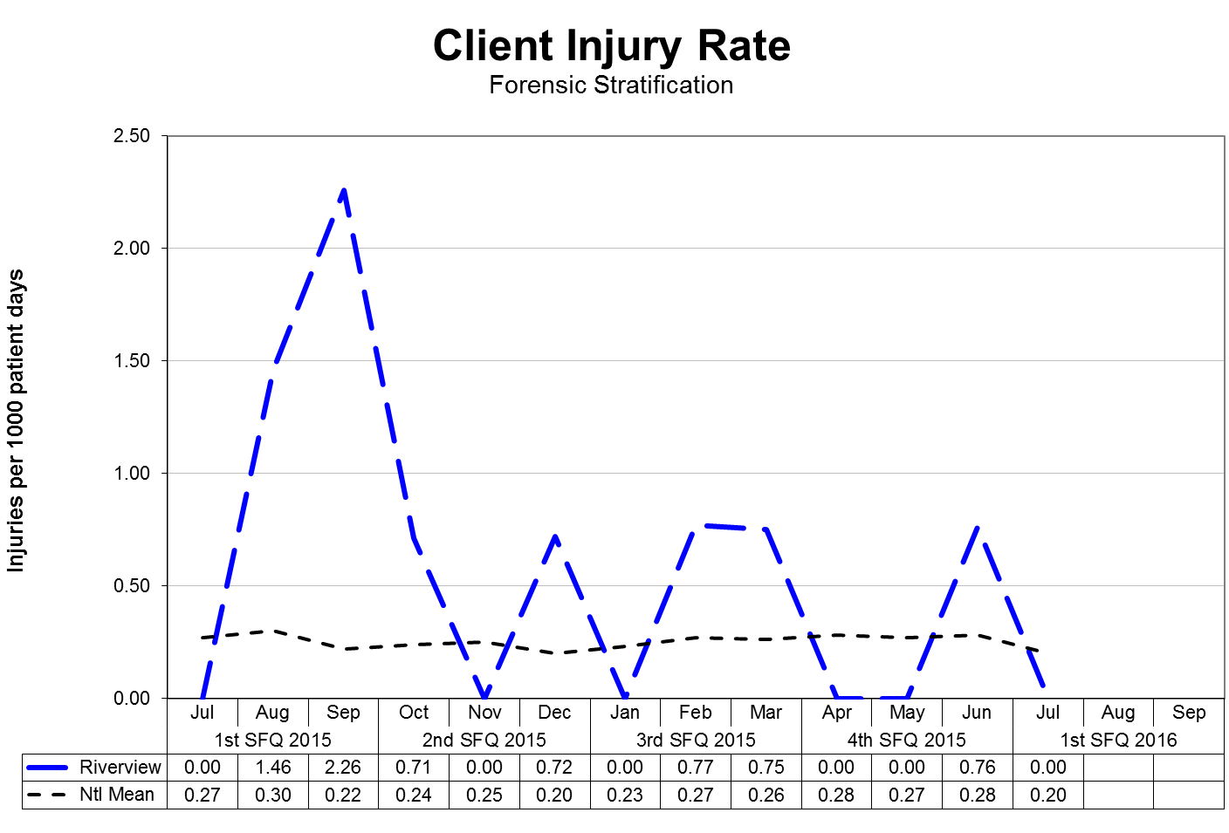

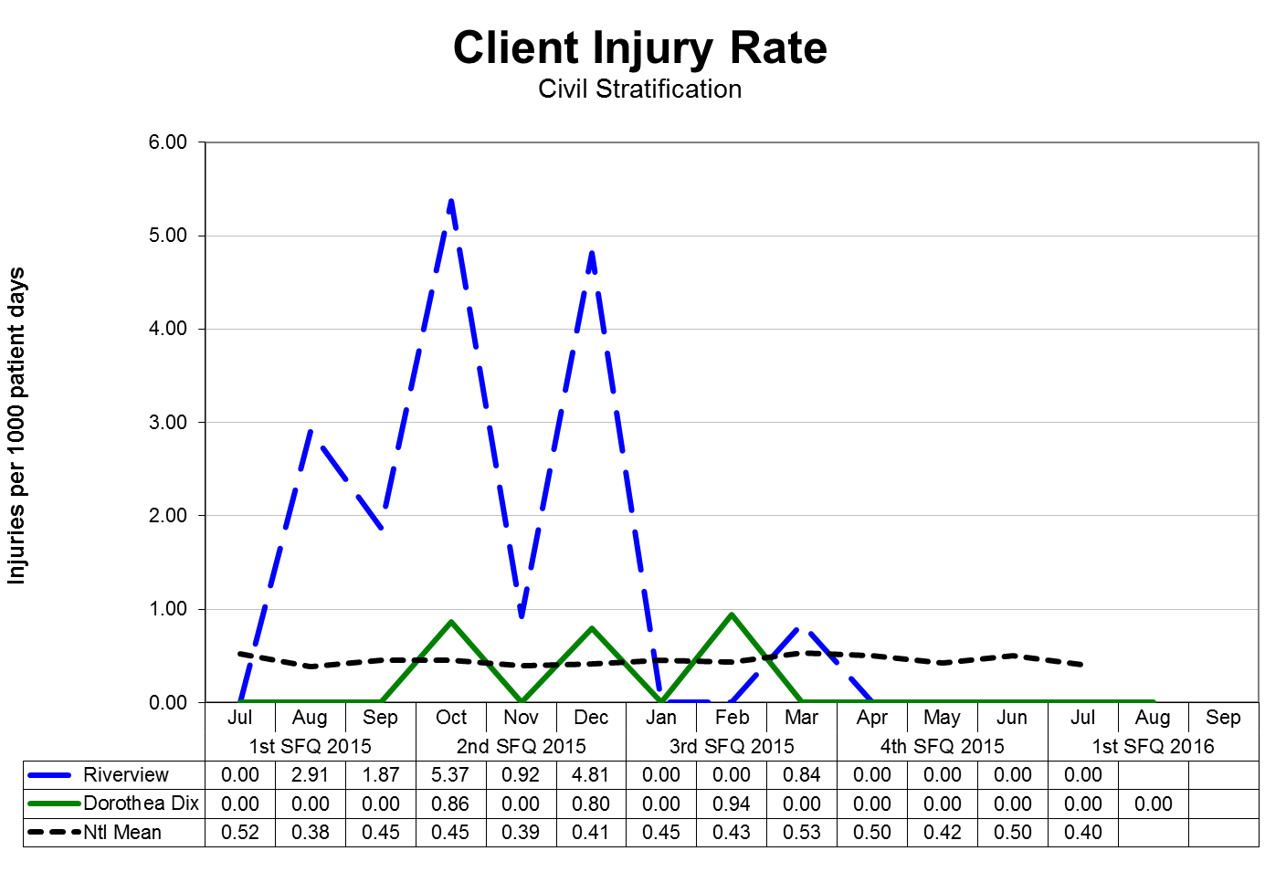

(Glossary of Terms, Acronyms & Abbreviations) (Back to Table of Contents)

|  |
| --- |
| CONSENT DECREE |

**Type and Cause of Injury by Month**

|  |  |  |  |  |
| --- | --- | --- | --- | --- |
| **Type - Cause** | **JULY** | **AUG** | **SEPT** | **1Q2016** |
| Accident – Fall | 4 | 3 | 2 | **9** |
| Accident – Other |  | 4 | 5 | **9** |
| Assault – Patient to Patient | 3 | 1 | 2 | **6** |
| Injury – Other | 1 | 2 | 4 | **7** |
| Self-Injurious Behavior |  | 8 | 3 | **11** |
| **Total** | **8** | **18** | **16** | **42** |

**Severity of Injury by Month**

|  |  |  |  |  |
| --- | --- | --- | --- | --- |
| **Severity** | **JULY** | **AUG** | **SEPT** | **1Q2016** |
| No Treatment | 3 | 9 | 9 | **21** |
| Minor First Aid | 5 | 9 | 5 | **19** |
| Medical Intervention Required |  |  | 2 | **2** |
| Hospitalization Required |  |  |  |  |
| Death Occurred |  |  |  |  |
| **Total** | **8** | **18** | **16** | **42** |

**Note: Previous quarterly report numbers may have been higher as they included data on incidents as well as injuries. This report has been modified to only include injuries. Per NASMHPD, injuries occur when harm or damage is done.**

Due to changes in reporting standards related to “criminal” events as defined by the “State of Maine Rules for Reporting Sentinel Events”, effective February 1, 2013, as defined the by “National Quality Forum 2011 List of Serious Reportable Events,” the number of reportable “assaults” that occur as the result of patient interactions increased significantly. This change is due primarily as a result of the methods and rules related to data collection and abstraction.

Further information on Fall Reduction Strategies can be found under The Joint Commission Priority Focus Areas section of this report.

(Glossary of Terms, Acronyms & Abbreviations) (Back to Table of Contents)

|  |
| --- |
| CONSENT DECREE |

**Patient Abuse, Neglect, Exploitation, Injury or Death**

V33) Riverview certifies that it is reporting and responding to instances of patient abuse, neglect, exploitation, injury or death consistent with the requirements of ¶ 192-201 of the Settlement Agreement.

|  |  |  |  |  |  |
| --- | --- | --- | --- | --- | --- |
| **Type of Allegation** | **2Q2015** | **3Q2015** | **4Q2015** | **1Q2016** | **Total** |
| Abuse Physical | 10 | 14 | 9 | 14 | **47** |
| Abuse Sexual | 17 | 11 | 6 | 27 | **61** |
| Abuse Verbal | 4 | 3 | 5 | 8 | **20** |
| Coercion/Exploitation | 7 |  | 3 | 2 | **12** |
| Neglect | 1 | 1 |  | 3 | **5** |
| **Total** | **39** | **29** | **23** | **54** | **145** |

Riverview utilizes several vehicles to communicate concerns or allegations related to abuse, neglect, or exploitation:

1. Staff members complete an incident report upon becoming aware of an incident or an allegation of any form of abuse, neglect, or exploitation.
2. Patients have the option to complete a grievance or communicate allegations of abuse, neglect, or exploitation during any interaction with staff at all levels, Peer Support personnel, or the Patient Advocate(s).
3. Any allegation of abuse, neglect, or exploitation is reported both internally and externally to appropriate stakeholders, including:

* Superintendent and/or AOC
* Adult Protective Services
* Guardian
* Patient Advocate

1. Allegations are reported to the Risk Manager through the incident reporting system and fact-finding or investigations occur at multiple levels. The purpose of this investigation is to evaluate the event to determine if the allegations can be substantiated or not and to refer the incident to the patient’s treatment team, hospital administration, or outside entities.
2. When appropriate to the allegation and circumstances, investigations involving law enforcement, family members, or human resources may be conducted.
3. The Human Rights Committee, a group consisting of consumers, family members, providers, and interested community members, and the Medical Executive Committee receive a report on the incident of alleged abuse, neglect, and exploitation monthly.

(Glossary of Terms, Acronyms & Abbreviations) (Back to Table of Contents)

|  |
| --- |
| CONSENT DECREE |

**Performance Improvement and Quality Assurance**

V34) Riverview maintains Joint Commission accreditation;

Riverview successfully completed an accreditation survey with The Joint Commission on in 2013 and is due for an upcoming reaccreditation visit in 2016. The hospital is currently completing its annual application for accreditation and completing the required Focused Standard Assessment.

V35) Riverview maintains its hospital license;

Riverview maintains its licensing status as required through the Maine Department of Health and Human Services Division of Licensing and Regulatory Services.  The hospital is licensed through October 31, 2016.

V36) The hospital seeks CMS certification;

The hospital was terminated from the Medicare Provider Agreement on September 2, 2013 for failing to show evidence of substantial compliance in eight areas by August 27, 2013.  Plans are being developed to apply for certification in 2016.

V37) Riverview conducts quarterly monitoring of performance indicators in key areas of hospital administration, in accordance with the Consent Decree Plan, the accreditation standards of The Joint Commission, and according to a QAPI plan reviewed and approved by the Advisory Board each biennium, and demonstrates through quarterly reports that management uses that data to improve institutional performance, prioritize resources and evaluate strategic operations.

Riverview complies with this element of substantial compliance as evidenced by the current Integrated Plan for Performance Excellence, the data and reports presented in

this document, the work of the Integrated Performance Excellence Committee, and sub-groups of this committee that are engaged in a transition to an improvement orientated methodology that is supported by The Joint Commission and is consistent with modern principles of process management and strategic methods of promoting organizational performance excellence.  The Advisory Board approved the Integrated Plan for Performance Excellence in August 2015.

(Glossary of Terms, Acronyms & Abbreviations) (Back to Table of Contents)

|  |
| --- |
| CONSENT DECREE |

**Quality Improvement Measures from “Response to the Recommendations from the Report by Elizabeth Jones, Consultant”**

Approved by the Maine Superior Court on February 27, 2015

Leadership met on Friday, March 6th to review the corrective action steps outlined in the hospital’s response.

|  |  |  |
| --- | --- | --- |
| **Recommendation** | **Quality Improvement Measure** | **Actions Taken During the Quarter** |
| Prior to his/her treatment team meeting, the class members should be provided the opportunity to meet with a peer specialist in order to prepare for the discussion and to clearly outline any preferences for treatment or discharge planning. Recovery-oriented approaches to treatment, including employment, should be consistently explored with and offered to class member, despite disinterest or refusal at the time of admission. | Treatment Team Coordinators will document all patient engagement in preparation for Treatment Team meetings. The daily chart audit form used by Treatment Team Coordinators/Auditors will be updated by Medical Records to reflect which patients received pre-treatment team meeting engagement. | Treatment Team Coordinators developed & use an audit tool on each record as it is reviewed / revised the day of the team meeting.  TTCs handout to the patient, the ‘Your Input is Essential” form 2-3 days prior to the meeting and offer to assist the patient to complete the form (if needed) prior to the meeting. The form is attached to the treatment plan. If patient refuses to complete the from, this is noted on the form and signed by the staff. |
| Riverview's leadership should take immediate steps to ensure that the principles of the Recovery model are clearly defined, articulated, and supported throughout each of the four units. | 100% of patient records will include documentation of the patient's input into their individualized treatment plan and that the input was used during the Treatment Team meeting. | Staff orientation has increased focus on the principles of recovery. As part of this effort staff are encouraged to support patients with making their needs, goals and life expectations made know. Where appropriate and in consistency with the TP, the patients’ comments are incorporated into treatment planning activities. |

(Glossary of Terms, Acronyms & Abbreviations) (Back to Table of Contents)

|  |
| --- |
| CONSENT DECREE |

|  |  |  |
| --- | --- | --- |
| **Recommendation** | **Quality Improvement Measure** | **Actions Taken During the Quarter** |
| Riverview's clinical leadership should work with nursing and Mental Health Worker staff to design and implement case conferences or Grand Rounds so that there is greater knowledge, skills, and support in working with class members with challenging behaviors. | The list of case conferences and Grand Rounds will be maintained. The roster of staff participation will be maintained by the Staff and Organizational Development Office. These data will be reported in the Quarterly Report. | Clinical case conference occurs regularly on Thursdays at 12 noon. In addition, longer audiovisual conferences with faculty at Dartmouth College occur three times per year and will move to a similar Thursday noon slot for the next academic year. Attendance list for the clinical case conference is now kept, in addition to those individuals who wish to fill in the appropriate sheets to obtain continuing medical education (CME) credits.  It is noted that attendance at the clinical case conference for academic year 2015 increased to 1142 from 694 in academic year 2014. This represents a 65 percent increase in attendance at the clinical case conferences.  Attendance by nursing staff, acuity specialists, and mental health workers continues to lag behind other disciplines. For this reason, academic year 2016 has been identified as the year to ensure marked increase in nursing, acuity specialist, and mental health worker attendance. I have met with the current nursing leadership to set the expectation for nursing attendance at clinical case conference. The response |

(Glossary of Terms, Acronyms & Abbreviations) (Back to Table of Contents)

|  |
| --- |
| CONSENT DECREE |

|  |  |  |
| --- | --- | --- |
| **Recommendation** | **Quality Improvement Measure** | **Actions Taken During the Quarter** |
|  |  | has been positive. The previous commitment from director of nursing, R. Pushard, to provide relief from senior nursing so that unit nurses and mental health workers could attend the clinical case conference did not produce an increase in attendance. At continuing medical education committee meeting on July 7, 2015, nursing attendance at clinical case conference we the sole item on the agenda and a number of positive suggestions for increasing nursing attendance at clinical case conference were obtained. This supplemented suggestions solicited and obtained from staff and organizational development, which had occurred in April 2015. Figures for attendance at clinical case conference will be forwarded for inclusion in the Quarterly Report. |
| Efforts should be initiated to intensify the opportunities offered to class members on the Forensic Units in order to increase their social skills and their knowledge and performance competencies about subjects of interest to them. | PatientIndividualized Treatment Plans will contain documentation of participation in all treatment activities. Treatment Team Coordinators will conduct daily chart audits to ensure documentation. | All disciplines involved in the patient’s care are included in the treatment team meetings. Plans for treatment are individualized to each patient. The Treatment Team Coordinators conduct chart audits to ensure that all documentation is current and accurate. |

(Glossary of Terms, Acronyms & Abbreviations) (Back to Table of Contents)

|  |
| --- |
| CONSENT DECREE |

|  |  |  |
| --- | --- | --- |
| **Recommendation** | **Quality Improvement Measure** | **Actions Taken During the Quarter** |
| Riverview should be managed as a single Hospital and the exclusion of Lower Saco from the federal Medicaid program should be reconsidered as an urgent priority. | Completed in November 2014. | Completed in November 2014. |
| In order to ensure that any limitations are not in violation of the Consent Decree, restrictive practices, including access to outdoor areas, should be reviewed with involvement by class members and mental health workers. | Unit activity logs will be reviewed on a monthly basis to determine whether any limitations in a patient’s access to treatment or services occurred. Unit community meetings will include a standing agenda item to review whether any restrictive practices were in place. | Administration reviews all grievances from patient, staff and advocate relative to any violations of the Consent Decree. Currently the RPC management is negotiating with the employee unions around the creation of unit based staffing and core staff assignments. Following these negotiations we will be focusing on the systematic review of unit practices that may restrict or inhibit access to outdoor areas and the roles of employees to relieve these restrictions. |
| The use of seclusion and restraint requires continued independent review to ensure that there are adequate alternatives designed and implemented for any class member potentially subject to such restrictive measures. Specifically, class members with a history of unacceptable behavior, such as aggression towards peers and/or staff, need to be reviewed again by the | The Risk Manager reviews 100% of cases of seclusion and restraint events including the content and timeliness of events. The hospital sends weekly reports of seclusion and restraint events to the Court Master. The Staff and Organizational Development Office will conduct its first annual review of the MOAB program and present results to Executive Leadership in January 2015. | The Risk Manager continues to review 100% of cases of seclusion and restraint events including the content and timeliness of events.  A weekly report of seclusion and restraint events is sent to the Court Master weekly.  The Staff and Organizational Development Office identified a consultant to conduct a review of the |

(Glossary of Terms, Acronyms & Abbreviations) (Back to Table of Contents)

|  |
| --- |
| CONSENT DECREE |

|  |  |  |
| --- | --- | --- |
| **Recommendation** | **Quality Improvement Measure** | **Actions Taken During the Quarter** |
| treatment team, and, if necessary, by an independent clinical consultant, to determine whether sufficiently individualized interventions are being designed and consistently implemented to replace unacceptable behavior with appropriate alternative behaviors. |  | MOAB program. A draft report was developed. Additional testing of the MOAB program occurred in October 2015. The report was submitted to Elizabeth Jones, auditor for the Court Master. |
| The reporting requirements by Paragraphs 188 and 189 of the Consent Decree should be completed as mandated. | On an annual basis (starting in January 2015), the Staff and Organizational Development Office will present a report to Executive Leadership at the hospital on the Behavioral Management system being used. The report will include (but is not limited to) information on:   * Documentation on certification and external reviews of behavioral management system * Number of staff trained * Number of staff retrained * Results of inter-rater reliability tests for trainers * Number of staff injuries * Number of patient injuries * Number of incident reports showing that | Riverview identified a consultant with expertise in MOAB. A report on the MOAB review has been sent to Elizabeth Jones, auditor, for the Court Master.  Training data are reported in the hospital’s Quarterly Report.  Injury data are reported in the hospital’s Quarterly Report.  The Risk Manager continues to provide the Court Master a summary report of all seclusion and restraint events. |

(Glossary of Terms, Acronyms & Abbreviations) (Back to Table of Contents)

|  |
| --- |
| CONSENT DECREE |

|  |  |  |
| --- | --- | --- |
| **Recommendation** | **Quality Improvement Measure** | **Actions Taken During the Quarter** |
|  | staff varied from techniques   * Review of fact-findings or investigations where behavioral management system failed to achieve goals * Findings from external reviews of the MOAB program   The Risk Manager reviews 100% of all incident reports for seclusion and restraint daily to determine whether further actions are required. A summary report of 100% of all seclusion and restraint events are sent to the Court Master weekly. |  |
| In light of the current demographics of admissions to Riverview, the adequacy of staffing requires further independent review. It is highly recommended that staffing ratios be determined by acuity rather than by census on the units. | The hospital will continue to monitor the staffing ratio as defined in the Consent Decree. In addition, the Integrated Quality team will work with Clinical Leadership to establish measurements to test the reliability and validity of data used with acuity based models to ensure that, in addition to meeting the Consent Decree’s minimum staffing ratios, staffing is sufficient to carry out Consent Decree requirements. | Nursing works with staffing office daily to ensure that each unit, each shift has adequate numbers of staff based upon Consent Decree and taking into account a minimum of 8 additional acuity factors including: increased level of observation- medical issues – outside appointments – coercive events – admissions – discharges – increased dangerousness level -  Nursing has offered flex shifts and is looking at unit based staffing. |

(Glossary of Terms, Acronyms & Abbreviations) (Back to Table of Contents)

|  |
| --- |
| CONSENT DECREE |

|  |  |  |
| --- | --- | --- |
| **Recommendation** | **Quality Improvement Measure** | **Actions Taken During the Quarter** |
|  |  | Riverview is cooperating with State Psychiatric Hospitals in Maine, Vermont and New Hampshire to test two acuity assessment tools: The “Modified Overt Aggression Scale” and the “Staff Observation Aggression Scale.” Meetings among staff at the hospitals are occurring to define measurement. A decision is being made to submit either single or multiple IRB applications for use of the instruments for research purposes. |
| The use of "float" staff, especially those recently hired at Riverview, requires review in order to reduce the likelihood of risk due to unfamiliarity with and knowledge of the individuals with challenging behaviors or the need for specialized interventions. This review is especially critical for any assignment to the Forensic Units. | 100% of new staff on acute units will have received and passed competency based skills training before being assigned. | All new staff must complete skills training as outlined by the hospital prior to being released from orientation. Some of these skills include MOAB training, CPR & power point presentations with competency quizzes on the subjects of Incident Reports, documentation, Patient Rights and seclusion/ restraint. |
| There should be consideration of supplemental pay for staff assigned to the Lower Saco unit. | The Human Resource office reviews its payroll records to ensure that staff who are eligible for the supplemental pay are receiving it according to Human Resource guidance. | Effective 9/1/15, by contract, all MHW’s assigned to the Lower Saco and Lower Kennebec units will receive a stipend of $1.00 per hour for hours worked on those units. |
| Discussions should be held with Mental Health Workers and nursing staff to | Action steps will be developed based on the results of the DHHS Human | The day NOD and Nurse IV’s meet every weekday morning and have been meeting more |

(Glossary of Terms, Acronyms & Abbreviations) (Back to Table of Contents)

|  |
| --- |
| CONSENT DECREE |

|  |  |  |
| --- | --- | --- |
| **Recommendation** | **Quality Improvement Measure** | **Actions Taken During the Quarter** |
| determine what additional measures are required to reduce the pressures experienced by staff and the resulting effects on the class members hospitalized for treatment. | Resources survey. The results of the survey and subsequent action steps will be reported to the Quality Improvement Committee and distributed to staff and included in the Quarterly Report. | regularly to specifically develop a new staffing pattern to reduce staff stress. In addition, a more aggressive effort to quickly review Family Medical Leave requests is being created to assist in reducing these pressures. |
| Qualification for Mental Health Workers should not be reduced. | 100% of Mental Health workers meet and maintain the competencies required for their positions. | Applications for mental health workers are verified by Human Resources against the minimum qualifications established by the state DER (Employee Relations). If a candidate does not meet minimum qualifications they cannot proceed in the application process. |
| Continuing effort is required to ensure that all staff understand the mandate for reporting any suspected abuse, neglect, or exploitation of class members. | 100% of incidents of abuse, neglect or exploitation are reported to Adult Protective Services. This will be monitored by a monthly review of incident reports. On a bi-monthly basis, the hospital’s survey team (comprised of quality improvement staff from both Riverview and Dorothea Dix) will conduct an audit of the patient records for seclusion/restraint events to ensure that all events have been reported. | The Risk Manager continues to verify that all allegations of abuse, neglect or exploitation are reported to Adult Protective Services. All incidents are reviewed. A monthly report is sent to hospital’s Human Rights Committee for review. On a monthly review of Incident Reports, the hospital’s survey team (comprised of quality improvement staff from both RPC and DDPC) conduct an audit of the patient records for seclusion/restraint events to ensure that all events have been reported. |
| With consultation from class members and staff on the units, there should an | A content analysis will be conducted on all debriefing forms to determine themes | The hospital’s Human Rights Committee has reviewed a patient survey instrument. |

(Glossary of Terms, Acronyms & Abbreviations) (Back to Table of Contents)

|  |
| --- |
| CONSENT DECREE |

|  |  |  |
| --- | --- | --- |
| **Recommendation** | **Quality Improvement Measure** | **Actions Taken During the Quarter** |
| examination of the weaknesses and vulnerabilities that could lead to abuse, neglect and exploitation at Riverview. | and patterns. The results from this analysis will be shared with leadership and included in the Quarterly Report. Results of staff surveys will be included in the Quarterly Report. The results of the patient discharge survey will continue to be included in the Quarterly Report. | Members of the Peer Support Office will conduct the survey across the hospital. After completion of the survey, staff will meet with patients and staff on the units about weaknesses and vulnerabilities about abuse, neglect and exploitation.  Patient discharge survey data are included in the Quarterly Report. |
| The Consent Decree language should be modified to specify that timely reporting of abuse and neglect cases should be made to Adult Protective Services (APS), Licensing, the Court Master and Plaintiffs' Counsel. | 100% of alleged cases of abuse, neglect, or exploitation are reviewed and reported as required by statute, rule, and Consent Decree. The Court Master and Patient Advocate will receive copies of the validation form received after submitting reports to Adult Protective Services. A monthly summary report of all allegations of abuse, neglect, and exploration is prepared for the hospital’s Human Rights Committee. Substantiated claims of abuse, neglect, or exploitation are noted in the hospital's Quarterly Report. | The Risk Manager continues to verify that all cases of abuse, neglect, or exploitation are reviewed and reported as required by statute, rule, and Consent Decree. The Court Master and Patient Advocates receive copies of the validation form received after submitting reports to APS. A monthly summary is prepared for the hospital’s HRC. Substantiated claims of abuse, neglect, or exploitation are noted in the hospital’s Quarterly Report. |

(Glossary of Terms, Acronyms & Abbreviations) (Back to Table of Contents)

|  |
| --- |
| JOINT COMMISSION |

**Hospital-Based Inpatient Psychiatric Services (ORYX Data Elements)**

**The Joint Commission Quality Initiatives**

In 1987, The Joint Commission announced its *Agenda for Change,* which outlined a series of major steps designed to modernize the accreditation process. A key component of the *Agenda for Change* was the eventual introduction of standardized core performance measures into the accreditation process. As the vision to integrate performance measurement into accreditation became more focused, the name ORYX® was chosen for the entire initiative. The ORYX initiative became operational in March of 1999, when performance measurement systems began transmitting data to The Joint Commission on behalf of accredited hospitals and long term care organizations. Since that time, home care and behavioral healthcare organizations have been included in the ORYX initiative.

The initial phase of the ORYX initiative provided healthcare organizations a great degree of flexibility, offering greater than 100 measurement systems capable of meeting an accredited organization’s internal measurement goals and The Joint Commission’s ORYX requirements. This flexibility, however, also presented certain challenges. The most significant challenge was the lack of standardization of measure specifications across systems. Although many ORYX measures appeared to be similar, valid comparisons could only be made between health care organizations using the same measures that were designed and collected based on standard specifications. The availability of over 8,000 disparate ORYX measures also limited the size of some comparison groups and hindered statistically valid data analyses. To address these challenges, standardized sets of valid, reliable, and evidence-based quality measures have been implemented by The Joint Commission for use within the ORYX initiative.

**Hospital-Based Inpatient Psychiatric Services (HBIPS) Core Measure Set**

Driven by an overwhelming request from the field, The Joint Commission was approached in late 2003 by the National Association of Psychiatric Health Systems (NAPHS), the National Association of State Mental Health Program Directors (NASMHPD) and the NASMHPD Research Institute, Inc. (NRI) to work together to identify and implement a set of core performance measures for hospital-based inpatient psychiatric services. Project activities were launched in March 2004. At this time, a diverse panel of stakeholders convened to discuss and recommend an overarching initial framework for the identification of HBIPS core performance measures. The Technical Advisory Panel (TAP) was established in March 2005 consisting of many prominent experts in the field.

(Glossary of Terms, Acronyms & Abbreviations) (Back to Table of Contents)

|  |
| --- |
| JOINT COMMISSION |

The first meeting of the TAP was held May 2005 and a framework and priorities for performance measures was established for an initial set of core measures. The framework consisted of seven domains:

* Assessment
* Treatment Planning and Implementation
* Hope and Empowerment
* Patient Driven Care
* Patient Safety
* Continuity and Transition of Care
* Outcomes

The current HBIPS standards reflected in this report are designed to reflect these core domains in the delivery of psychiatric care.(Glossary of Terms, Acronyms & Abbreviations) (Back to Table of Contents)

|  |
| --- |
| JOINT COMMISSION |

**Admissions Screening (HBIPS 1)**For Violence Risk, Substance Use, Psychological Trauma History, and Patient Strengths

**Description**

Patients admitted to a hospital-based inpatient psychiatric setting who are screened within the first three days of admission for all of the following: risk of violence to self or others, substance use, psychological trauma history, and patient strengths.

**Rationale**

Substantial evidence exists that there is a high prevalence of co-occurring substance use disorders as well as history of trauma among persons admitted to acute psychiatric settings. Professional literature suggests that these factors are under-identified yet integral to current psychiatric status and should be assessed in order to develop appropriate treatment (Ziedonis, 2004; NASMHPD, 2005). Similarly, persons admitted to inpatient settings require a careful assessment of risk for violence and the use of seclusion and restraint. Careful assessment of risk is critical to safety and treatment. Effective, individualized treatment relies on assessments that explicitly recognize patients’ strengths. These strengths may be characteristics of the individuals themselves, supports provided by families and others, or contributions made by the individuals’ community or cultural environment (Rapp, 1998). In the same way, inpatient environments require assessment for factors that lead to conflict or less than optimal outcomes.

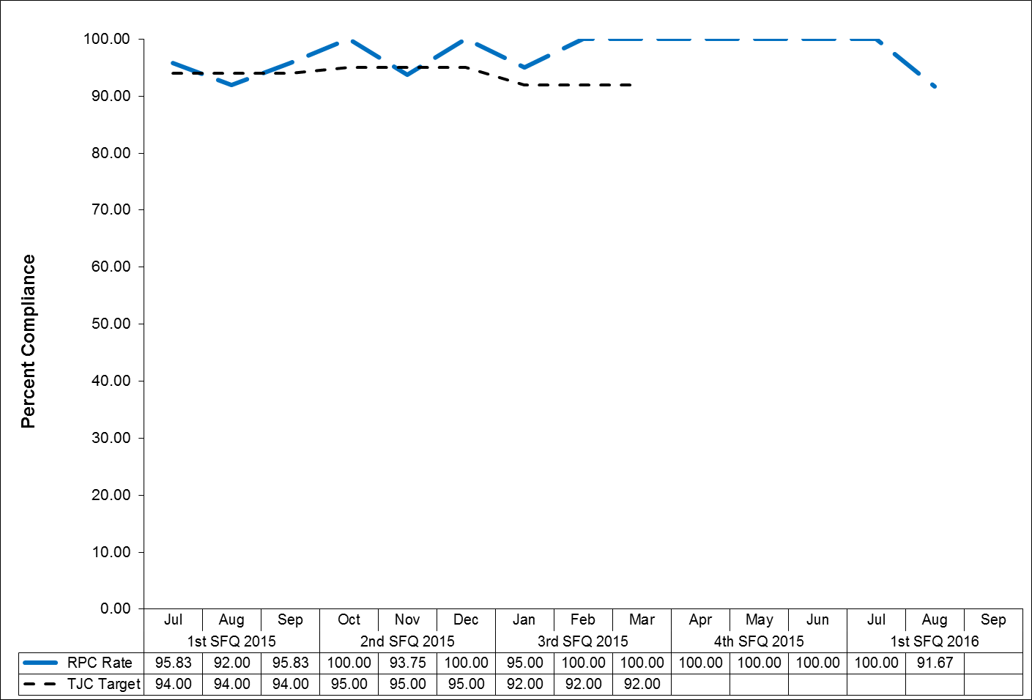

(Glossary of Terms, Acronyms & Abbreviations) (Back to Table of Contents)

|  |
| --- |
| JOINT COMMISSION |

**Physical Restraint (HBIPS 2)**

Hours of Use

**Description**

The total number of hours that all patients, admitted to a hospital-based inpatient psychiatric setting, were maintained in physical restraint.

**Rationale**

Mental health providers that value and respect an individual’s autonomy, independence and safety seek to avoid the use of dangerous or restrictive interventions at all times (Donat, 2003). The use of seclusion and restraint is limited to situations deemed to meet the threshold of imminent danger and when restraint and seclusion are used; such use is rigorously monitored and analyzed to prevent future use. Providers also seek to prevent violence or aggression from occurring in their treatment environments by focusing their attention on prevention activities that have a growing evidence base (Donat, 2003).

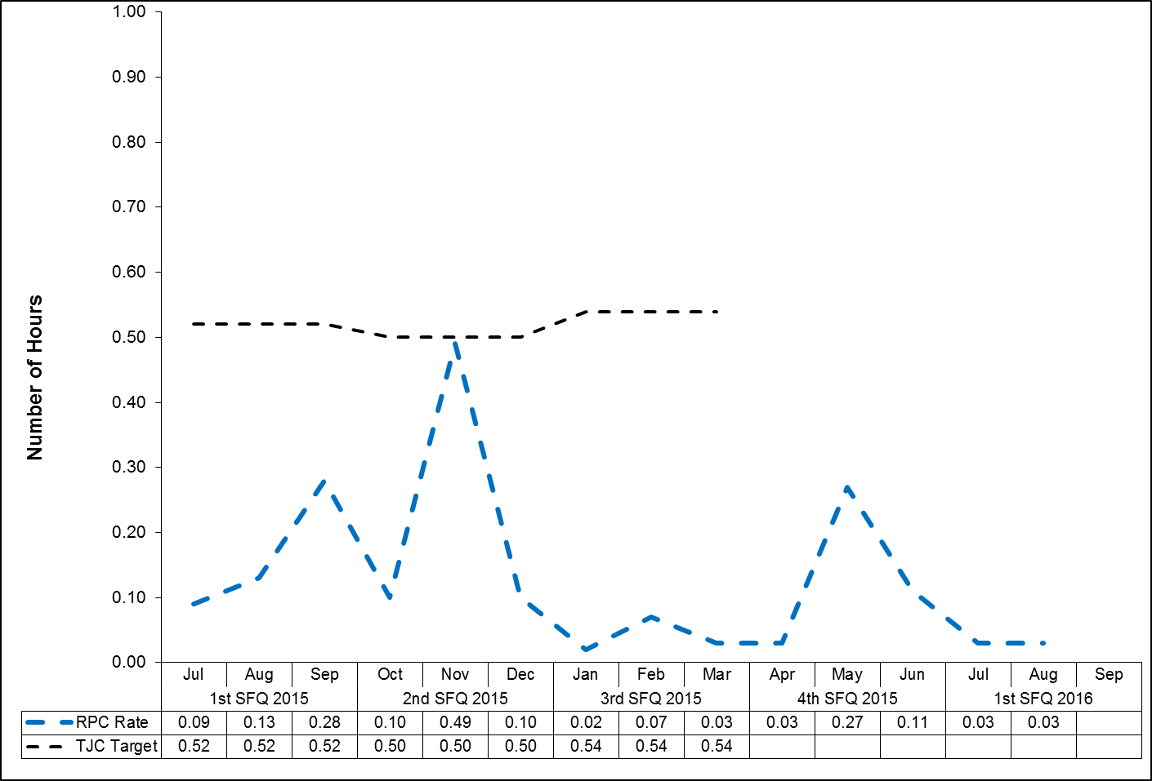

(Glossary of Terms, Acronyms & Abbreviations) (Back to Table of Contents)

|  |
| --- |
| JOINT COMMISSION |

**Seclusion (HBIPS 3)**Hours of Use

**Description**

The total number of hours that all patients, admitted to a hospital-based inpatient psychiatric setting, were held in seclusion.

**Rationale**

Mental health providers that value and respect an individual’s autonomy, independence and safety seek to avoid the use of dangerous or restrictive interventions at all times (Donat, 2003). The use of seclusion and restraint is limited to situations deemed to meet the threshold of imminent danger and when restraint or seclusion are used; such use is rigorously monitored and analyzed to prevent future use. Providers also seek to prevent violence or aggression from occurring in their treatment environments by focusing their attention on prevention activities that have a growing evidence base (Donat, 2003).

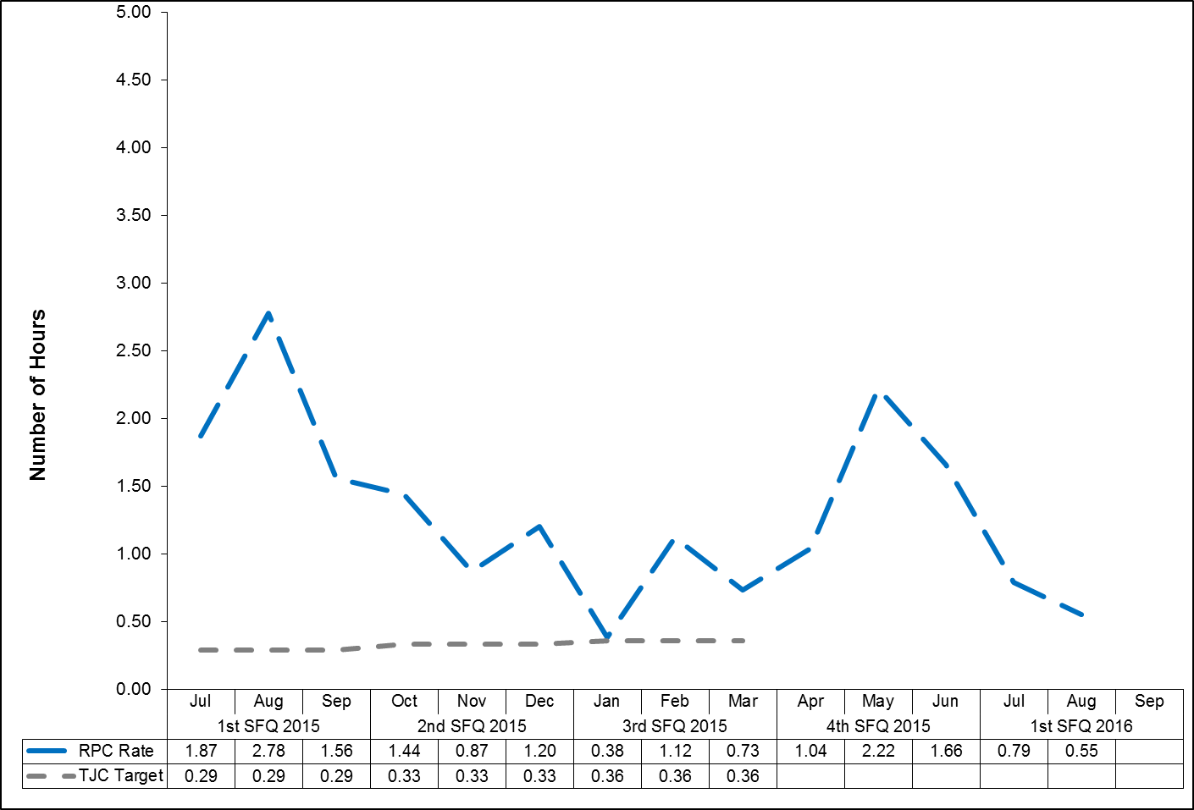

(Glossary of Terms, Acronyms & Abbreviations) (Back to Table of Contents)

|  |
| --- |
| JOINT COMMISSION |

**Multiple Antipsychotic Medications on Discharge (HBIPS 4)**

**Description**

Patients discharged from a hospital-based inpatient psychiatric setting on two or more antipsychotic medications.

**Rationale**

Research studies have found that 4-35% of outpatients and 30-50% of inpatients treated with an antipsychotic medication concurrently received 2 or more antipsychotics (Covell, Jackson, Evans, & Essock, 2002; Ganguly, Kotzan, Miller, Kennedy, & Martin, 2004; Gilmer, Dolder, Folsom, Mastin, & Jeste, 2007; Kreyenbuhl, Valenstein, McCarthy, Ganocyz, & Blow, 2006; Stahl & Grady, 2004). One study reported 4.6% of patients concurrently received 3 or more antipsychotics (Jaffe & Levine, 2003). These findings are seen across diverse sectors: state mental health authorities, the Veterans Health System and Medicaid-financed care. Antipsychotic polypharmacy can lead to greater side effects, often without improving clinical outcomes (Ananth, Parameswaran, & Gunatilake, 2004; Stahl & Grady, 2004). As a result, a range of stakeholders have called for efforts to reduce unnecessary use of multiple antipsychotics (Centorrino, Gören, Hennen, Salvatore, Kelleher, & Baldessarini, 2004; Gilmer, Dolder, Folsom, Mastin, & Jeste, 2007; National Association of State Mental Health Program Directors, 2001; University HealthSystem Consortium, 2006). Practice guidelines recommend the use of a second antipsychotic only after multiple trials of a single antipsychotic have proven inadequate (American Psychiatric Association [APA] Practice Guidelines, 2004). Randomized controlled trials (RCTs) provide some evidence to support augmentation with a second antipsychotic in *treatment resistant* patients. Most of these studies were limited to augmentation of clozapine with another second-generation antipsychotic (Tranulis, Skalli, Lalonde, & Nicole, 2008). Among patients *without* a documented history of previous treatment failures of antipsychotic monotherapy, multiple RCTs and other controlled trials failed to show a benefit of antipsychotic polypharmacy over monotherapy (Ananth, Parameswaran, & Gunatilake, 2004; Centorrino, Gören, Hennen, Salvatore, Kelleher, & Baldessarini, 2004; Potkin, Thyrum, Alva, Bera, Yeh, & Arvanitis, 2002; Shim et al., 2007; Stahl,& Grady, 2004). Clinical circumstances, such as shorter inpatient stays, may require hospitals to discharge a patient on multiple antipsychotics with an aftercare plan to transition to monotherapy. In such cases, effective communication between the inpatient and aftercare clinician is an essential element of care.

(Glossary of Terms, Acronyms & Abbreviations) (Back to Table of Contents)

|  |
| --- |
| JOINT COMMISSION |

**Multiple Antipsychotic Medications on Discharge (HBIPS 4)**

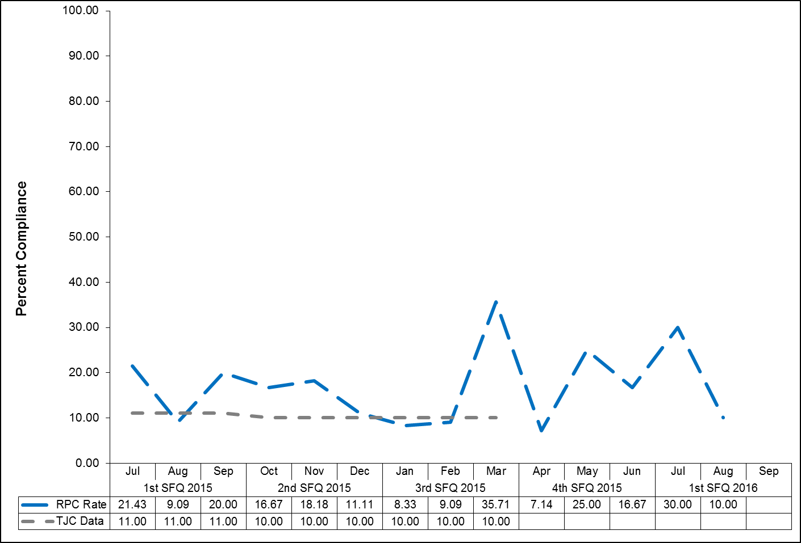(Glossary of Terms, Acronyms & Abbreviations) (Back to Table of Contents)

|  |
| --- |
| JOINT COMMISSION |

**Multiple Antipsychotic Medications at Discharge with Justification (HBIPS 5)**

**Description**

Patients discharged from a hospital-based inpatient psychiatric setting on two or more antipsychotic medications with appropriate justification.

**Rationale**

Research studies have found that 4-35% of outpatients and 30-50% of inpatients treated with an antipsychotic medication concurrently received 2 or more antipsychotics (Covell, Jackson, Evans, & Essock, 2002; Ganguly, Kotzan, Miller, Kennedy, & Martin, 2004; Gilmer, Dolder, Folsom, Mastin, & Jeste, 2007; Kreyenbuhl, Valenstein, McCarthy, Ganocyz, & Blow, 2006; Stahl & Grady, 2004). One study reported 4.6% of patients concurrently received 3 or more antipsychotics (Jaffe & Levine, 2003). These findings are seen across diverse sectors: state mental health authorities, the Veterans Health System and Medicaid-financed care. Antipsychotic polypharmacy can lead to greater side effects, often without improving clinical outcomes (Ananth, Parameswaran, & Gunatilake, 2004; Stahl & Grady, 2004). As a result, a range of stakeholders have called for efforts to reduce unnecessary use of multiple antipsychotics (Centorrino, Gören, Hennen, Salvatore, Kelleher, & Baldessarini, 2004; Gilmer, Dolder, Folsom, Mastin, & Jeste, 2007; National Association of State Mental Health Program Directors, 2001; University HealthSystem Consortium, 2006). Practice guidelines recommend the use of a second antipsychotic only after multiple trials of a single antipsychotic have proven inadequate (American Psychiatric Association [APA] Practice Guidelines, 2004). Randomized controlled trials (RCTs) provide some evidence to support augmentation with a second antipsychotic in *treatment resistant* patients. Most of these studies were limited to augmentation of clozapine with another second-generation antipsychotic (Tranulis, Skalli, Lalonde, & Nicole, 2008). Among patients *without* a documented history of previous treatment failures of antipsychotic monotherapy, multiple RCTs and other controlled trials failed to show a benefit of antipsychotic polypharmacy over monotherapy (Ananth, Parameswaran, & Gunatilake, 2004; Centorrino, Gören, Hennen, Salvatore, Kelleher, & Baldessarini, 2004; Potkin, Thyrum, Alva, Bera, Yeh, & Arvanitis, 2002; Shim et al., 2007; Stahl,& Grady, 2004). Clinical circumstances, such as shorter inpatient stays, may require hospitals to discharge a patient on multiple antipsychotics with an aftercare plan to transition to monotherapy. In such cases, effective communication between the inpatient and aftercare clinician is an essential element of care.

(Glossary of Terms, Acronyms & Abbreviations) (Back to Table of Contents)

|  |
| --- |
| JOINT COMMISSION |

**Multiple Antipsychotic Medications at Discharge with Justification (HBIPS 5)**

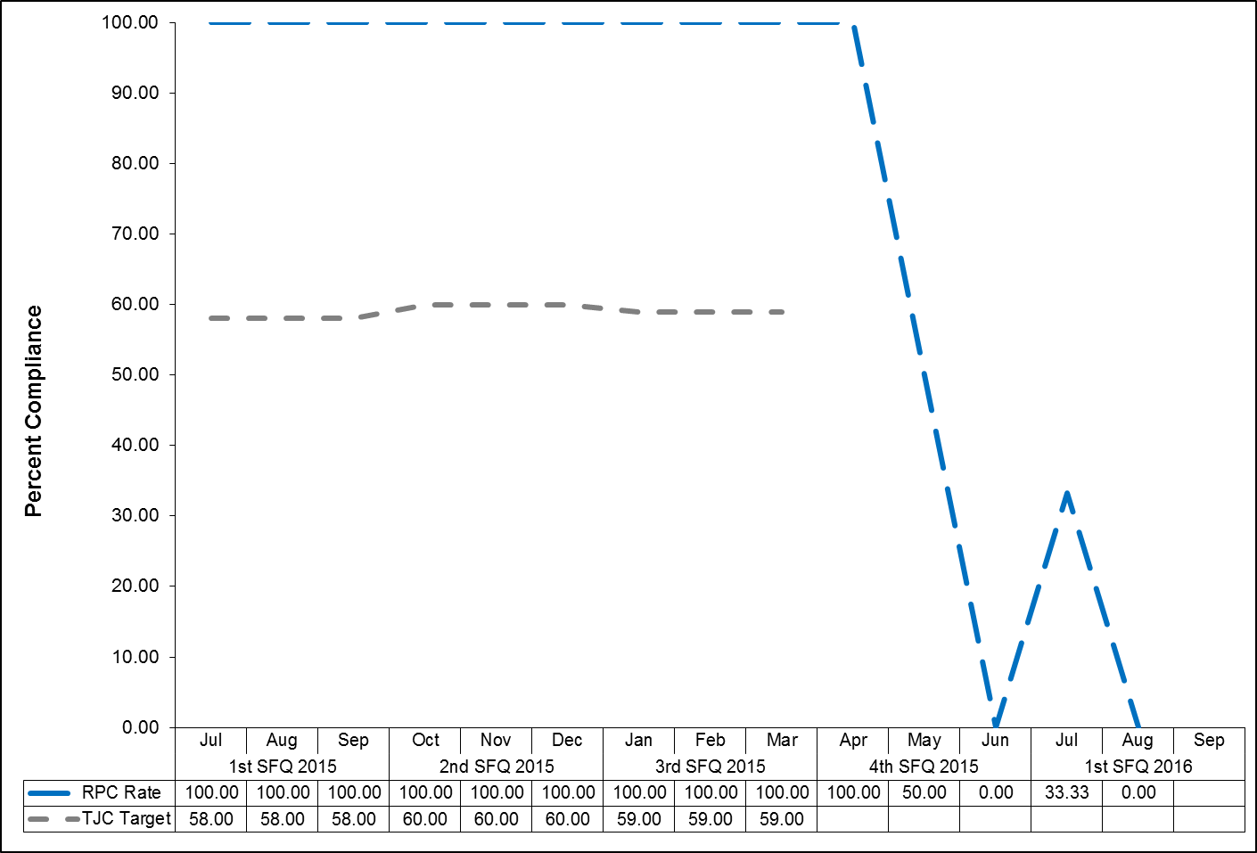

(Glossary of Terms, Acronyms & Abbreviations) (Back to Table of Contents)

|  |
| --- |
| JOINT COMMISSION |

**Post Discharge Continuing Care Plan (HBIPS 6)**

**Description**

Patients discharged from a hospital-based inpatient psychiatric setting with a continuing care plan created.

**Rationale**

Patients may not be able to fully report to their next level of care health-care provider their course of hospitalization or discharge treatment recommendations. The aftercare instructions given the patient may not be available to the next level of care provider at the patient’s initial intake or follow-up appointment. In order to provide optimum care, next level of care providers need to know details of precipitating events immediately preceding hospital admission, the patient’s treatment course during hospitalization, discharge medications and next level of care recommendations (American Association of Community Psychiatrists [AACP], 2001).

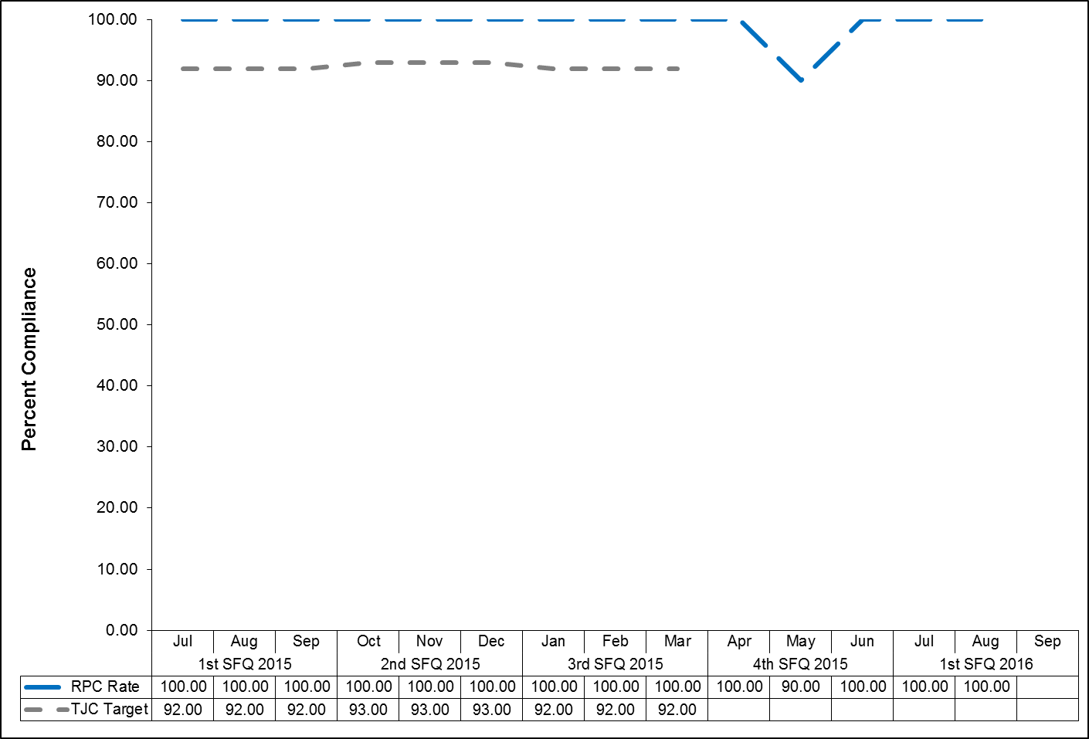

(Glossary of Terms, Acronyms & Abbreviations) (Back to Table of Contents)

|  |
| --- |
| JOINT COMMISSION |

**Post Discharge Continuing Care Plan Transmitted (HBIPS 7)**

To Next Level of Care Provider on Discharge

**Description**

Patients discharged from a hospital-based inpatient psychiatric setting with a continuing care plan provided to the next level of care clinician or entity.

**Rationale**

Patients may not be able to fully report to their next level of care health-care provider their course of hospitalization or discharge treatment recommendations. The aftercare instructions given the patient may not be available to the next level of care provider at the patient’s initial intake or follow-up appointment. In order to provide optimum care, next level of care providers need to know details of precipitating events immediately preceding hospital admission, the patient’s treatment course during hospitalization, discharge medications and next level of care recommendations (American Association of Community Psychiatrists [AACP], 2001).

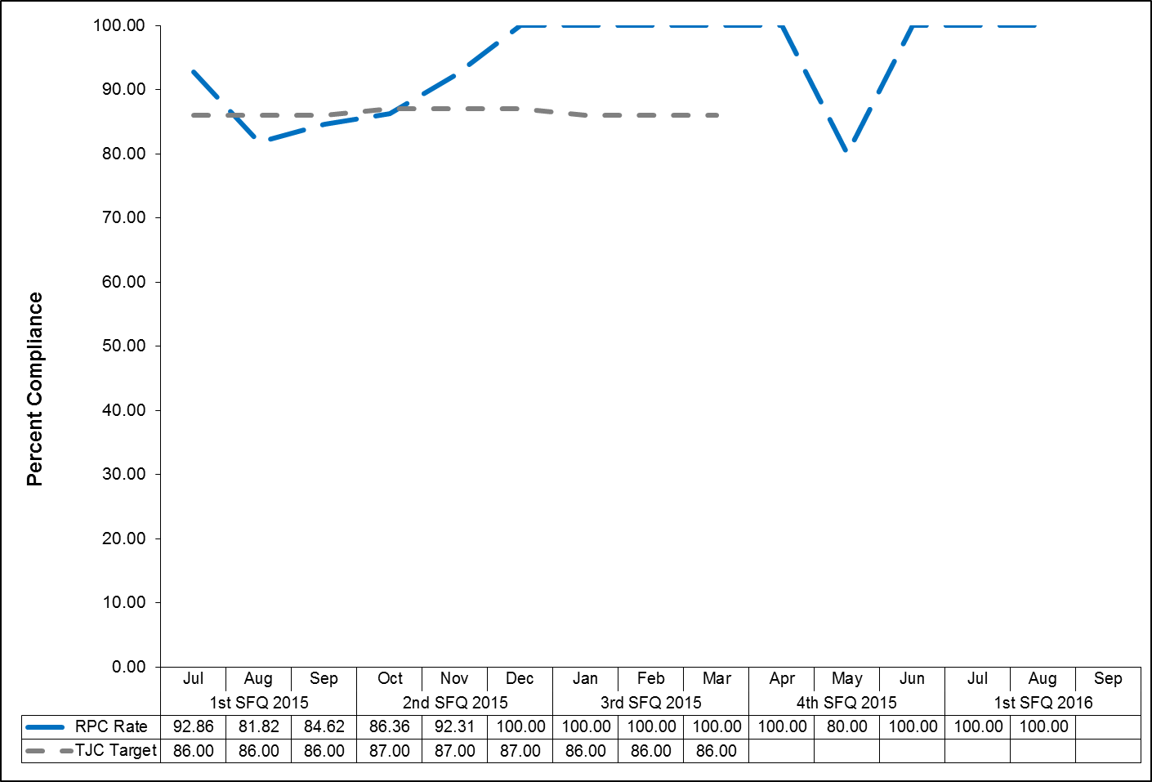

(Glossary of Terms, Acronyms & Abbreviations) (Back to Table of Contents)

|  |
| --- |
| JOINT COMMISSION |

**Contract Performance Indicators**

TJC LD.04.03.09 The same level of care should be delivered to patients regardless of whether services are provided directly by the hospital or through contractual agreement. Leaders provide oversight to make sure that care, treatment, and services provided directly are safe and effective. Likewise, leaders must also oversee contracted services to make sure that they are provided safely and effectively.

|  |  |  |
| --- | --- | --- |
| **FY 2015 Quarter 4 Results** | | |
| **Contractor** | **Program Administrator** | **Summary of Performance** |
| Amistad Peer Support Services | Robert J. Harper  Acting Superintendent | One indicator did not meet standards: 100% of Service Integration Meetings Attended (97% were attended). All other indicators exceeded standards. |
| Community Dental, Region II | Dr. Brendan Kirby  Clinical Director | All indicators met standards. |
| Comprehensive Pharmacy Services | Dr. Brendan Kirby  Clinical Director | All indicators met standards. |
| Comtec Security | Debora Proctor  Executive Housekeeper | All indicators met standards. |
| Cummins Northeast | Richard Levesque  Director of Support Services | All indicators met standards. |
| Dartmouth Medical School | Robert J. Harper  Superintendent | All indicators exceeded standards. |
| Disability Rights Center | Robert J. Harper  Superintendent | All indicators met standards. |
| G & E Roofing | Richard Levesque  Director of Support Services | No services were provided during this timeframe. |
| Goodspeed & O’Donnell | Dr. Brendan Kirby  Clinical Director | All indicators met standards. |
| Liberty Healthcare – After Hours Coverage | Dr. Brendan Kirby  Clinical Director | All indicators met or exceeded standards. |
| Liberty Healthcare – Physician Staffing | Dr. Brendan Kirby  Clinical Director | All indicators met standards. |
| Maine General Community Care/Healthreach | Dr. Brendan Kirby  Clinical Director | All indicators met standards. |
| Maine General Medical Center – Laboratory Services | Dr. Brendan Kirby  Clinical Director | All indicators met standards. |

(Glossary of Terms, Acronyms & Abbreviations) (Back to Table of Contents)

|  |
| --- |
| JOINT COMMISSION |

|  |  |  |
| --- | --- | --- |
| **Contractor** | **Program Administrator** | **Summary of Performance** |
| MD-IT Transcription Service | Joseph Riddick  Director of Integrated Quality & Informatics | All indicators met standards. |
| Mechanical Services | Richard Levesque  Director of Support Services | All indicators met standards. |
| Medical Staffing and Services of Maine | Dr. Brendan Kirby  Clinical Director | All indicators met standards. |
| Motivational Services | Dr. Brendan Kirby  Clinical director | All indicators met or exceeded standards. |
| Occupational Therapy Consultation and Rehabilitation Services | Janet Barrett  Director of Rehabilitation | No services were provided during this timeframe. |
| Otis Elevator | Richard Levesque  Director of Support Services | All indicators met standards. |
| Pine Tree Legal Assistance | Dr. Brendan Kirby  Clinical Director | No services were provided during this timeframe. |
| Project Staffing | Cindy Michaud  Business Services Manager | All indicators exceeded standards. |
| Protection One | Richard Levesque  Director of Support Services | No services were provided during this timeframe. |
| Securitas Security Services | Philip Tricarico  Safety Compliance Officer | All indicators met or exceeded standards. |
| Unifirst Corporation | Richard Levesque  Director of Support Services | All indicators met standards. |
| Waste Management | Debora Proctor  Executive Housekeeper | All indicators met standards. |

(Glossary of Terms, Acronyms & Abbreviations) (Back to Table of Contents)

|  |
| --- |
| JOINT COMMISSION |

**Adverse Reactions to Sedation or Anesthesia**

TJC PI.01.01.01 EP6: The hospital collects data on the following: adverse events related to using moderate or deep sedation or anesthesia. (See also LD.04.04.01, EP 2)

**Capital Community Clinic - Dental Clinic**

**Dental Clinic Timeout/Identification of Patient**

|  |  |  |  |  |  |
| --- | --- | --- | --- | --- | --- |
| **Indicators** | **2Q2015** | **3Q2015** | **4Q2015** | **1Q2016** | **Total** |
| National Patent Safety Goals  Goal 1: Improve the accuracy of Patient  Identification.  Capital Community Dental Clinic assures accurate patient identification by: asking the patient to state his/her name and date of birth.  A time out will be taken before the procedure to verify location and numbered tooth. The time out section is in the progress notes of the patient chart. This page will be signed by the Dentist as well as the Dental Assistant. | **Oct** 100% 9/9  **Nov** 100% 3/3  **Dec** 100% 2/2  **Total** 100% 14/14 | **Jan** 100% 4/4  **Feb** 100% 6/6  **Mar** 100% 4/4  **Total** 100% 14/14 | **April** 100% 3/3  **May** N/A  0/0  **June** 100% 1/1  **Total** 100% 4/4 | **July** 100% 3/3  **Aug**  N/A  0/0  **Sept** N/A 0/0  **Total** 100% 3/3 | **100% 35/35** |

(Glossary of Terms, Acronyms & Abbreviations) (Back to Table of Contents)

|  |
| --- |
| JOINT COMMISSION |

**Dental Clinic Post Extraction Prevention of Complications and Follow-up**

|  |  |  |  |  |  |
| --- | --- | --- | --- | --- | --- |
| **Indicators** | **2Q2015** | **3Q2015** | **4Q2015** | **1Q2016** | **Total** |
| 1. All patients with tooth extractions will be assessed and have teaching post procedure on the following topics, as provided by the Dentist or Dental Assistant:  * Bleeding * Swelling * Pain * Muscle soreness * Mouth care * Diet * Signs/symptoms of infection  1. The patient, post procedure tooth extraction, will verbalize understanding of the above by repeating instructions given by Dental Assistant/Hygienist. 2. Post dental extraction patients will receive a follow-up phone call from the clinic within 24 hours of procedure to assess for post procedure complications | **Oct** 100% 9/9  **Nov** 100% 3/3  **Dec** 100% 2/2  **Total** 100% 14/14 | **Jan** 100% 4/4  **Feb** 100% 6/6  **Mar** 100% 4/4  **Total** 100% 14/14 | **April** 100% 3/3  **May** N/A  0/0  **June** 100% 1/1  **Total** 100% 4/4 | **July** 100% 3/3  **Aug**  N/A  0/0  **Sept** N/A 0/0  **Total** 100% 3/3 | **100% 35/35** |

(Glossary of Terms, Acronyms & Abbreviations) (Back to Table of Contents)

|  |
| --- |
| JOINT COMMISSION |

**Healthcare Acquired Infections Monitoring and Management**

NPSG.07.03.01 Implement evidence-based practices to prevent health care–associated infections due to multidrug-resistant organisms in acute care hospitals.

**Infection Control**

**Responsible Party: George Davis, MD, Chairperson of Infection Control Committee**

**Kathleen Mitton, RN, Infection Control Nurse**

**I. Measure Name: Hospital Associated Infection (HAI) Rate**

**Measure Description:** Monitor and measure of Hospital Associated Infections.

**Measure Type:** Quality Assurance

|  |  |  |  |  |  |  |  |
| --- | --- | --- | --- | --- | --- | --- | --- |
| **Results** | | | | | | | |
| **Target** | **Unit** | **Baseline** | **2Q2015** | **3Q2015** | **4Q2015** | **1Q2016** | **YTD** |
| Within 1 STDV of the Mean | Hospital Associated Infection Rate | FY 2014  1 STDV within the mean | 4 HAI/IC Rate 2.2 | 7 HAI/IC Rate 1.1 | 4 HAI/IC  Rate 0.83 | 12 HAI/IC  Rate 1.7 | HAI – 1.46 |
| **Actual**  **Outcome** | At 1 STDV | 1 STDV within the mean | 1 STDV within the mean |  |  |

A **Hospital Acquired Infection (HAI**) is any infection present, incubating or exposed to more than 72 hours **after admission** (unless the patient is off hospital grounds during that time) or declared by a physician, a physician’s assistant or advanced practice nurse to be a HAI.

A **Community Acquired Infection (CAI)** is any infection present, incubating or exposed to prior to admission; while on pass; during off-site medical, dental, or surgical care; by a visitor, any prophylaxis treatment of a condition or treatment of a condition for which the patient has a history of chronic infection no matter how long the patient has been hospitalized; or declared by the physician, physician’s assistant, or advanced practice nurse to be a community acquired infection.

An **Idiosyncratic Infection** is any infection that occurs after admission and is the result of the patient’s action toward himself or herself.

(Glossary of Terms, Acronyms & Abbreviations) (Back to Table of Contents)

|  |
| --- |
| JOINT COMMISSION |

|  |  |  |
| --- | --- | --- |
| **Lower Kennebec:** |  | **Upper Saco:** |
| Acne Vulgaris – CAI |  | Cellulitis Rt. Lower Leg - HAI |
| Candida Intertrigo secondary to poor hygiene and diabetes - CAI |  | Folliculitis/Question Fungal infection - CAI |
| **Lower Kennebec SCU:** |  | Traumatic Blister of the heal - CAI |
| Chronic bacterial vaginosis – CAI |  | Laceration left Thumb/? Human Bite - HAI |
| Probable pre-septal cellulitis, either buccal or parotitis – HAI |  | Prophylactic treatment - CAI |
| Lesion Rt. Calf – HAI |  | Chronic Testicular pain - CAI |
| **Lower Saco:** |  | Conjunctivitis - HAI |
| Onychomycosis 2nd, 3rd, & 5th fingers Rt. Hand - CAI |  | Eye (upper lid) infection - HAI |
| Lyme Disease – CAI |  | Paronychia secondary to ingrown nail - CAI |
| Infected Toe – CAI |  | Cellulitis Rt. Great Toe - HAI |
| Sinus infection – HAI |  | **Lower Saco SCU:** |
| Herpes Simplex Genitalis – CAI |  | Human Bite – HAI |
| Cellulitis of Buttocks – HAI |  | Acne – CAI |
| Pneumonia – HAI |  | Acute left Olecranis Bursitis with furuncle & cellulitis - HAI |
| Question DVT/calf pain secondary to a fall – HAI |  |  |
| **Upper Kennebec:** |  |  |
| Rt. Great Toe infection secondary to ingrown toenail – CAI |  |  |
| Dental Infection – CAI |  |  |

**Data Analysis**:

Total Infections: 27 – 3.7

HAI: 12 – 1.7

CAI: 16 – 2.3

Idiosyncratic Infections: 0

Patient Days: 7058

**Plan:** Ongoing surveillance

(Glossary of Terms, Acronyms & Abbreviations) (Back to Table of Contents)

|  |
| --- |
| JOINT COMMISSION |

**II. Measure Name: Employee Hand Hygiene Rate**

**Measure Description:**

* Staff will observe the hand hygiene practice of nurses as they pass medications. (10 observations per month)
* Staff will do ten (10) hand hygiene observations per month (before & after client contact) in the milieu on the **7-3 shift.**
* Staff will do ten (10) hand hygiene observations per month (before & after client contact) in the milieu on the **3-11 shift**

**Measure Type:** Performance Improvement

|  |  |  |  |  |  |  |  |
| --- | --- | --- | --- | --- | --- | --- | --- |
| **Results** | | | | | | | |
|  | **Unit** | **Baseline** | **1Q2016** | **2Q2016** | **3Q2016** | **4Q2016** | **YTD** |
| **Target** | Employee  Hand Hygiene Compliance | 80%  FY 2015 | >90% | >90% | >90% | >90% | **>90%** |
| **Actual** | 95% |  |  |  | **95%** |

**Data:**

Upper Saco Meds – 100% Upper Kennebec Meds – 97%

Upper Saco Milieu 7-3 – 100% Upper Kennebec Milieu 7-3 – 98%

Upper Saco Milieu 3-11 – 92% Upper Kennebec Milieu 3-11 – 100%

Lower Kennebec Meds – 100% Lower Saco Meds – 100%

Lower Kennebec Milieu 7-3 – 98% Lower Saco Milieu 7-3 – 100%

Lower Kennebec Milieu 3-11 – 93% Lower Saco Milieu 3-11 – 100%

Infection Control Nurse – 20%

**Plan:** Continue to monitor and measure.

(Glossary of Terms, Acronyms & Abbreviations) (Back to Table of Contents)

|  |
| --- |
| JOINT COMMISSION |

**III. Measure Name: Assisting Patients with Daily Hygiene**

**Measure Description:** Staff offer hand gel to patients prior to breakfast, lunch, and dinner, thirty (30) days per month.

**Measure Type:** Quality Assurance

|  |  |  |  |  |  |  |  |
| --- | --- | --- | --- | --- | --- | --- | --- |
| **Results** | | | | | | | |
|  | **Unit** | **Baseline** | **1Q2016** | **2Q2016** | **3Q2016** | **4Q2016** | **YTD** |
| **Target** | Employee  Hand Hygiene Compliance | 98%  FY 2015 | >90% | >90% | >90% | >90% | **>90%** |
| **Actual** | 95% |  |  |  | **95%** |

**Data:**

The mean compliance rate for July 2015 is 97%.

The mean compliance rate for August 2015 is 94%.

The mean compliance rate for September 2015 is 95%.

**Plan:** Continue to monitor and measure.

(Glossary of Terms, Acronyms & Abbreviations) (Back to Table of Contents)

|  |
| --- |
| JOINT COMMISSION |

**Medication Errors and Adverse Reactions**

TJC PI.01.01.01 EP14: The hospital collects data on the following: Significant medication errors. (See also LD.04.04.01, EP 2; MM.08.01.01, EP 1)

TJC PI.01.01.01 EP15: The hospital collects data on the following: Significant adverse drug reactions. (See also LD.04.04.01, EP 2; MM.08.01.01, EP 1)

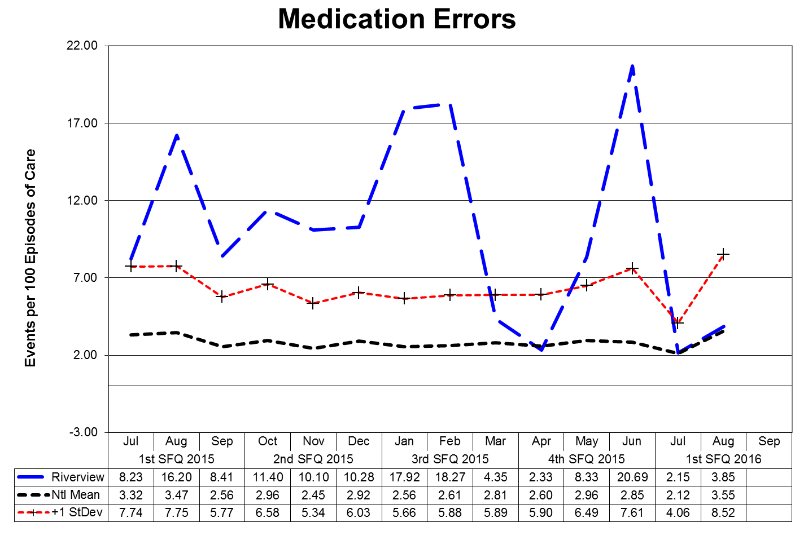

This graph depicts the number of medication error events that occurred for every 100 episodes of care (duplicated patient count). For example, a rate of 1.6 means that 2 medication error events occurred for each 125 episodes of care.

The following graphs depict the number of medication error events that occurred for every 100 episodes of care (duplicated patient count) stratified by forensic or civil classifications. For example, a rate of 1.6 means that 2 medication error events occurred for each 125 episodes of care. The hospital-wide results from Dorothea Dix are compared to the civil population results at Riverview due to the homogeneous nature of these two sample groups.

(Glossary of Terms, Acronyms & Abbreviations) (Back to Table of Contents)

|  |
| --- |
| JOINT COMMISSION |

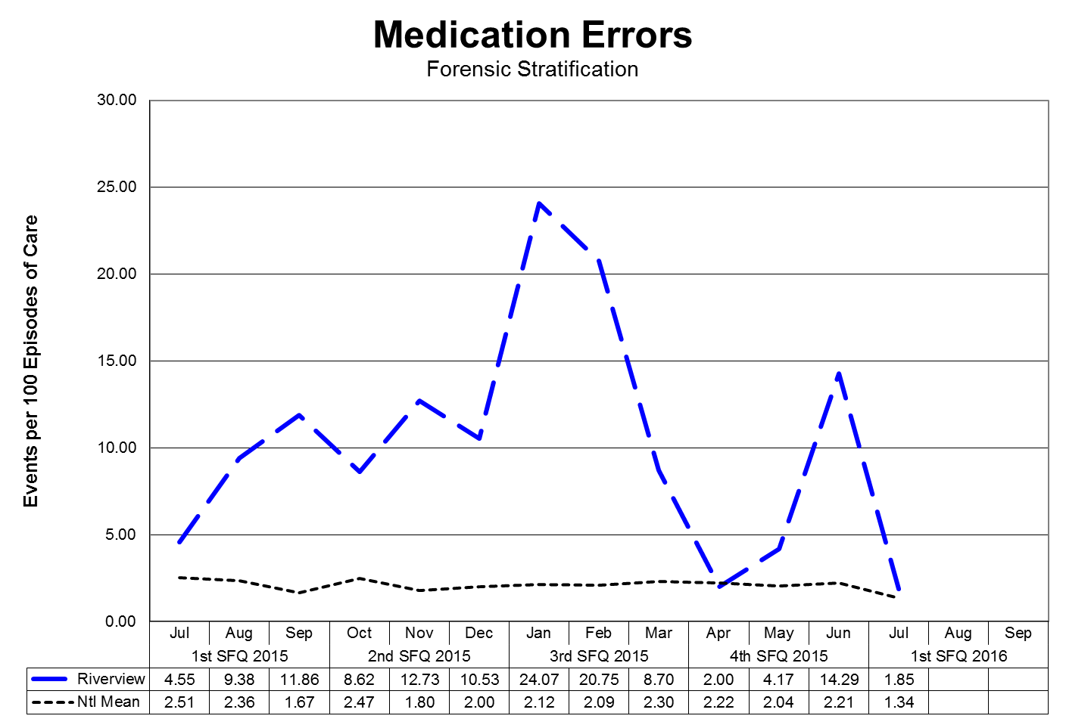

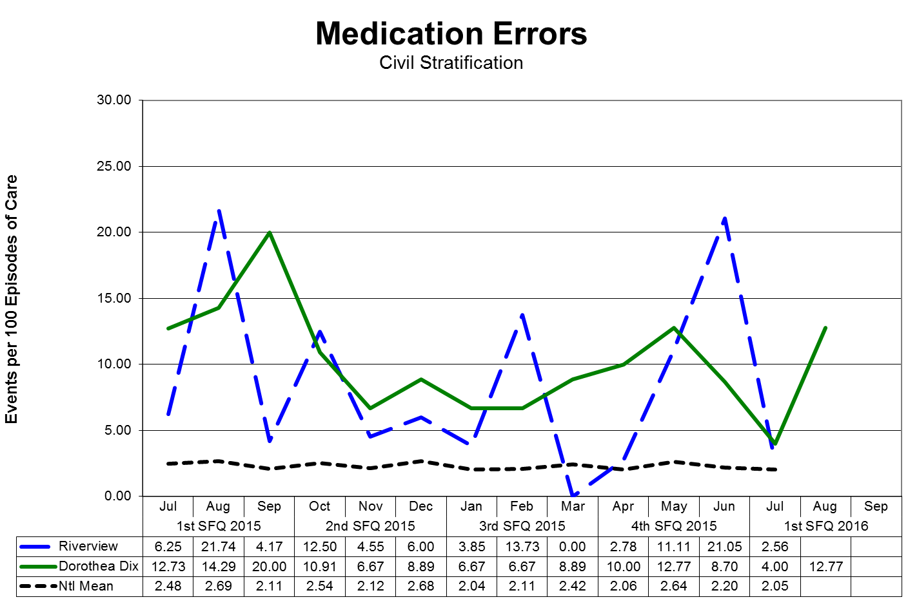

(Glossary of Terms, Acronyms & Abbreviations) (Back to Table of Contents)

|  |
| --- |
| JOINT COMMISSION |

**Medication Variances**

Medication variances are classified according to four major areas related to the area of service delivery. The error must have resulted in some form of variance in the desired treatment or outcome of care. A variance in treatment may involve one incident but multiple medications; each medication variance is counted separately irrespective of whether it involves one error event or many. Medication error classifications include:

Prescribing

* An error of prescribing occurs when there is an incorrect selection of drug, drug dose, dosage form, quantity, route, concentration, rate of administration, or instructions for use of a drug product ordered or authorized by physician or other legitimate prescriber. Errors may occur due to improper evaluation of indications, contraindications, known allergies, existing drug therapy and other factors. Illegible prescriptions or medication orders that lead to patient level errors are also defined as errors of prescribing in identifying and ordering the appropriate medication to be used in the care of the patient.

Dispensing

* An error of dispensing occurs when the incorrect drug, drug dose or concentration, dosage form, or quantity is formulated and delivered for use to the point of intended use.

Administration

* An error of administration occurs when there is an incorrect selection and administration of drug, drug dose, dosage form, quantity, route, concentration, rate of administration, or instructions for use of a drug product ordered or authorized by physician or other legitimate prescriber.

Complex

* An error which resulted from two or more distinct errors of different types is classified as a complex error.

Review, Reporting and Follow-up Process:

The Medication Variances Process Review Team (PRT) meets weekly to evaluate the causation factors related to the medication variances reported on the units and in the pharmacy and makes recommendations, through its multi-disciplinary membership, for changes to workflow, environmental factor, and patient care practices. The team consists of the Clinical Director (or designee), the Director of Nursing (or designee), the Director of Pharmacy (or designee), and the Clinical Risk Manager or the Performance Improvement Manager.

The activities and recommendations of the Medication Variances PRT are reported monthly to the Integrated Performance Excellence Committee.

(Glossary of Terms, Acronyms & Abbreviations) (Back to Table of Contents)

|  |
| --- |
| JOINT COMMISSION |

Administration Process

Medication Errors Related to Staffing Effectiveness

|  |  |  |  |  |  |  |  |  |  |
| --- | --- | --- | --- | --- | --- | --- | --- | --- | --- |
| **Date** | **Omit** | **Type of Error** | **Float** | **New** | **O/T** | **Unit** | **Staff Mix** | | |
| **RN** | **LPN** | **MHW** |
| 6/20/2015 | N | EXTRA DOSE X1 | N | N | N | US | 2 | 1 | 3 |
| 7/4/2015 | N | EXTRA DOSE X1 | Y | N | N | UK | 2 | 1 | 2 |
| 7/10/2015 | Y | OMISSION X1 | N | N | N | US | 2 | 1 | 3 |
| 7/14/2015 | N | WRONG SCHEDULE | Y | N | N | LK SCU | 3 | 1 | 6 |
| 7/20/2015 | N | EXTRA DOSE X1 | N | N | N | LK SCU | 3 | 1 | 0 |
| 8/3/2015 | N | EXTRA DOSE X1 | N | N | N | US | 3 | 0 | 4 |
| 8/4/2015 | N | PROTOCOL ERROR | N | Y | N | US | 3 | 1 | 4 |
| 8/5/2015 | Y | OMISSION X1 | N | N | N | LS | 3 | 1 | 7 |
| 8/6/2015 | Y | OMISSION X1 | N | N | N | LS | 3 | 1 | 7 |
| 8/20/2015 | Y | OMISSION | N | Y | N | UK | 2 | 0 | 3 |
| 8/20/2015 | N | WRONG TIME | N | N | N | US | 1 | 0 | 3 |
| 8/24/2015 | Y | OMISSION | N | Y | N | UK | 2 | 0 | 3 |
| 8/25/2015 | N | WRONG TIME X4 | N | Y | N | UK | 2 | 0 | 4 |
| 8/25/2015 | Y | OMISSION X4 | N | Y | N | UK | 2 | 0 | 4 |
| 8/27/2015 | N | WRONG TIME | N | Y | N | LK | 2 | 0 | 0 |
| 8/31/2015 | Y | OMISSION X2 | N | N | N | LS | 3 | 1 | 7 |
| 9/4/2015 | Y | OMISSION X1 | N | Y | N | LS SCU | 3 | 1 | 7 |
| 9/7/2015 | N | WRONG TIME | N | N | N | LS | 3 | 1 | 7 |
| 9/15/2015 | Y | OMISSION | N | N | N | LS | 3 | 1 | 0 |
| 9/15/2015 | N | WRONG DRUG | N | Y | N | US | 2 | 1 | 0 |
| 9/27/2015 | Y | OMISSION X1 | N | N | Y | LS | 2 | 2 | 3 |
| **Totals** | **14** |  | **2** | **14** | **1** | **LS: 8** | **US:  6** | **LK: 3** | **UK: 11** |
| **Percent** | **50%** | **28 Total Errors** | **7%** | **50%** | **4%** | **29%** | **21%** | **11%** | **39%** |

*Each dose of medication is documented as an individual variance (error)

(Glossary of Terms, Acronyms & Abbreviations) (Back to Table of Contents)

|  |
| --- |
| JOINT COMMISSION |

**Dispensing Process**

|  |  |  |  |  |  |  |  |
| --- | --- | --- | --- | --- | --- | --- | --- |
| **Measure** | **Unit** | **Baseline 2014** | **Goal** | **2Q**  **2015** | **3Q 2015** | **4Q 2015** | **1Q**  **2016** |
| 1. Controlled Substance Loss Data: Daily Pyxis-CII Safe Compare Report. | All | 0.875% | 0%  Target:  Actual: | 0%  0% | 0%  0% | 0%  0% | 0%  0% |
| 2. Controlled Substance Loss Data: Monthly CII Safe Vendor Receipt Report. | Rx | 0 | 0  Target:  Actual: | 0  0 | 0  0 | 0  0 | 0  0 |
| 3. Controlled Substance Loss Data:  Monthly Pyxis Controlled Drug discrepancies. | All | 22/mo | 0  Target:  Actual: | 0  66  (22/  mo) | 0  42  (14/  mo) | 0  37  (12/  mo) | 0  22  7/  mo |
| 4. Medication Management Monitoring: Measures of drug reactions, adverse drug events and other management data. | Rx | 8/year | 0  Target:  Actual: | 0  1 | 0  2 | 0  3 | 0  0 |
| 5. Medication Management Monitoring: Resource Documentation Reports of Clinical Interventions. | Rx | 99/ quarter | 100%  Target:  Actual: | 100%  79 | 100%  73 | 100%  56 | 100%  31 |
| 6. Psychiatric Emergency Process: Monthly audit of all psych emergencies measures against 9 criteria. | All | 100% | 100%  Target:  Actual: | 100%  95% | 100%  93% | 100%  94% | 100%  78% |
| 7. Operational Audit:  Monthly audit of 3 operational indicators from CPS contract. | Rx | 100% | 100%  Target:  Actual: | 100%  100% | 100%  100% | 100%  100% | 100%  100% |

**1Q2016:**

6. One psych emergency (PE) was reported during the quarter. Two of the nine criteria were not met: MAR/s printed/brought to unit by RPh and PH checking new MARs vs. updated MARs completing by nursing & reconciliation performed. The PE ended over the weekend and it is unclear if the protocol was followed. Re-education will be done to correct the process.

(Glossary of Terms, Acronyms & Abbreviations) (Back to Table of Contents)

|  |
| --- |
| JOINT COMMISSION |

**Inpatient Consumer Survey**

TJC PI.01.01.01 EP16: The hospital collects data on the following: Patient perception of the safety and quality of care, treatment, and services.

The **Inpatient Consumer Survey (ICS)** is a standardized national survey of customer satisfaction. The National Association of State Mental Health Program Directors Research Institute (NRI) collects data from state psychiatric hospitals throughout the country in an effort to compare the results of patient satisfaction in six areas or domains of focus. These domains include Outcomes, Dignity, Rights, Participation, Environment, and Empowerment.

Inpatient Consumer Survey (ICS) has been recently endorsed by NQF, under the Patient Outcomes Phase 3: Child Health and Mental Health Project, as an outcome measure to assess the results, and thereby improve care provided to people with mental illness. The endorsement supports the ICS as a scientifically sound and meaningful measure to help standardize performance measures and assures quality of care.

**Rate of Response for the Inpatient Consumer Survey:**

Due to the operational and safety need to refrain from complete openness regarding plans for discharge and dates of discharge for forensic patients, the process of administering the inpatient survey is difficult to administer. Whenever possible, Peer Support staff work to gather information from patients on their perception of the care provided to then while at Riverview Psychiatric Center.

The Peer Support group has identified a need to improve the overall response rate for the survey. This process improvement project is defined and described in the section on Patient Satisfaction Survey Return Rate of this report.

There is currently no aggregated date on a forensic stratification of responses to the survey.

**Note:** When the Riverview field is blank for a month it means that no patients responded to the survey questions on that page in that particular month.

(Glossary of Terms, Acronyms & Abbreviations) (Back to Table of Contents)

|  |
| --- |
| JOINT COMMISSION |

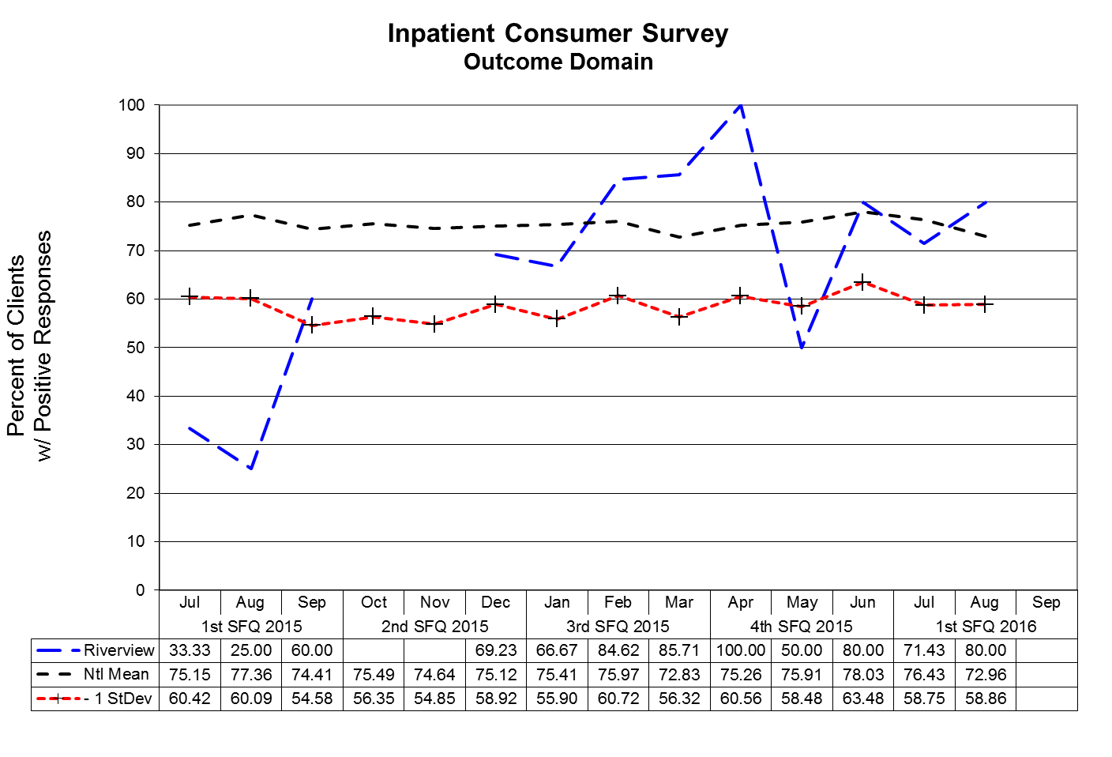

**Outcome Domain Questions:**

1. I am better able to deal with crisis.
2. My symptoms are not bothering me as much.
3. I do better in social situations.
4. I deal more effectively with daily problems.

(Glossary of Terms, Acronyms & Abbreviations) (Back to Table of Contents)

|  |
| --- |
| JOINT COMMISSION |

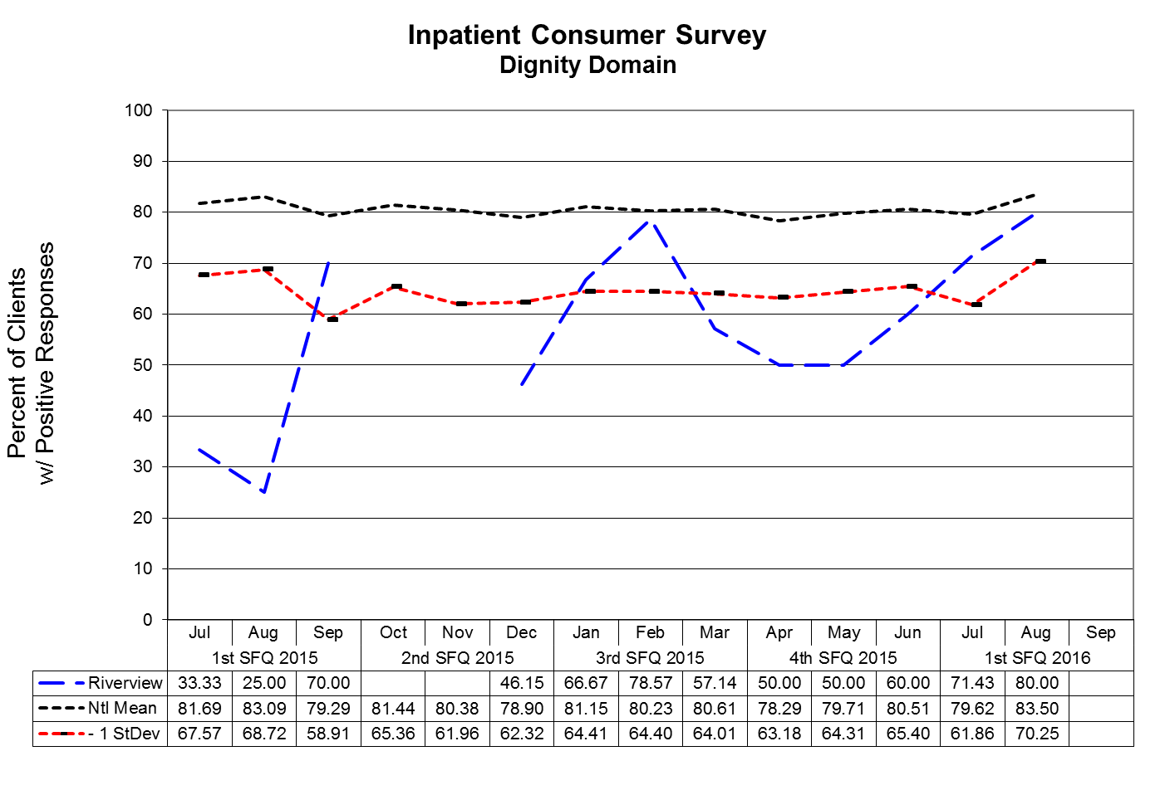

**Dignity Domain Questions:**

1. I was treated with dignity and respect.
2. Staff here believed that I could grow, change and recover.
3. I felt comfortable asking questions about my treatment and medications.
4. I was encouraged to use self-help/support groups.

(Glossary of Terms, Acronyms & Abbreviations) (Back to Table of Contents)

|  |
| --- |
| JOINT COMMISSION |

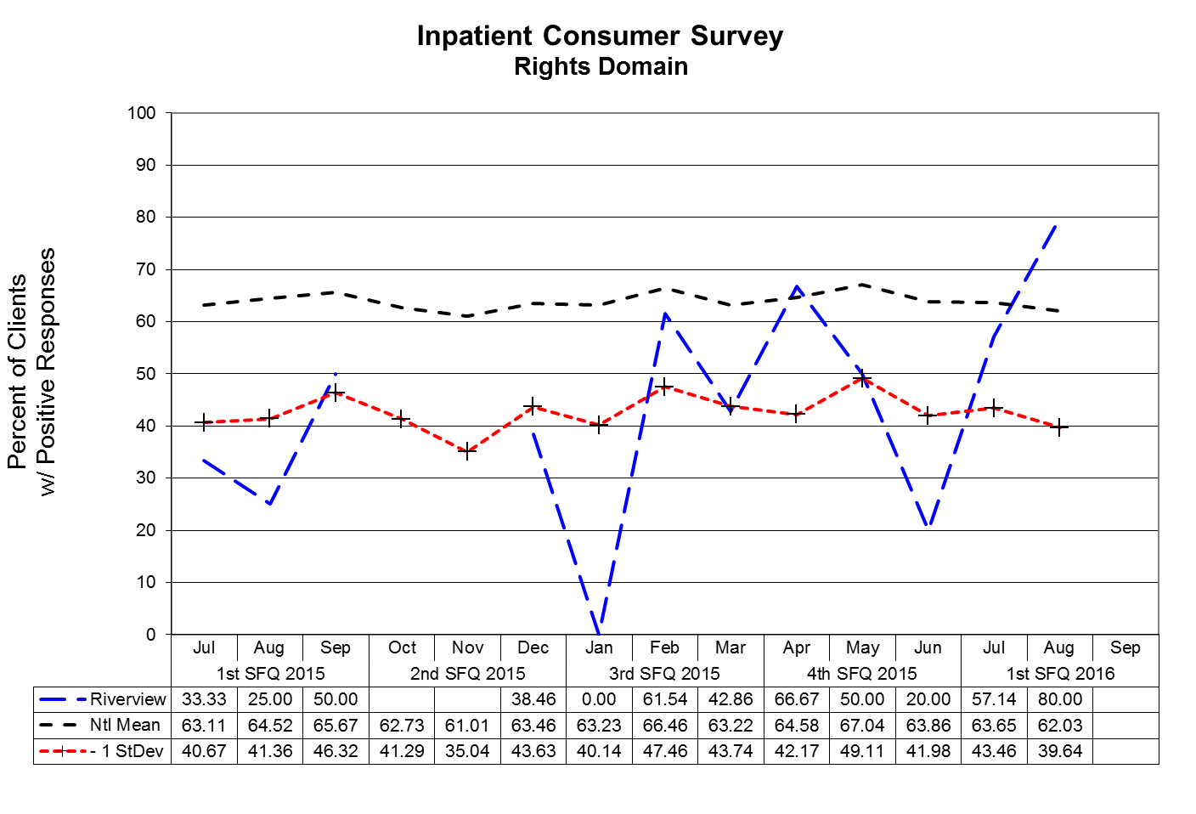

**Rights Domain Questions:**

1. I felt free to complain without fear of retaliation.
2. I felt safe to refuse medication or treatment during my hospital stay.
3. My complaints and grievances were addressed.

(Glossary of Terms, Acronyms & Abbreviations) (Back to Table of Contents)

|  |
| --- |
| JOINT COMMISSION |

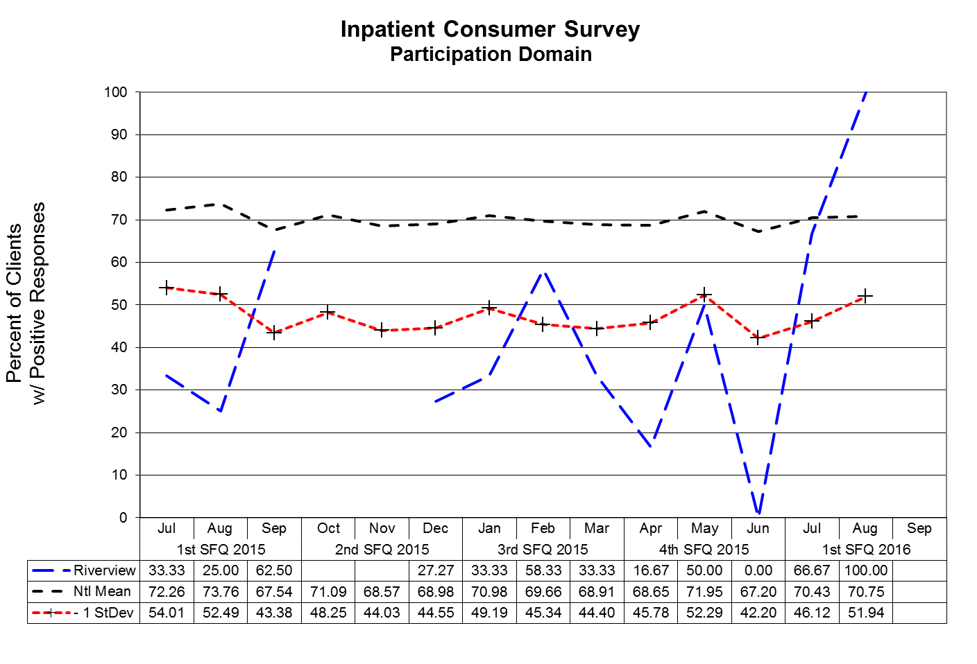

**Participation Domain Questions:**

1. I participated in planning my discharge.
2. Both I and my doctor or therapists from the community were actively involved in my hospital treatment plan.
3. I had an opportunity to talk with my doctor or therapist from the community prior to discharge.

(Glossary of Terms, Acronyms & Abbreviations) (Back to Table of Contents)

|  |
| --- |
| JOINT COMMISSION |

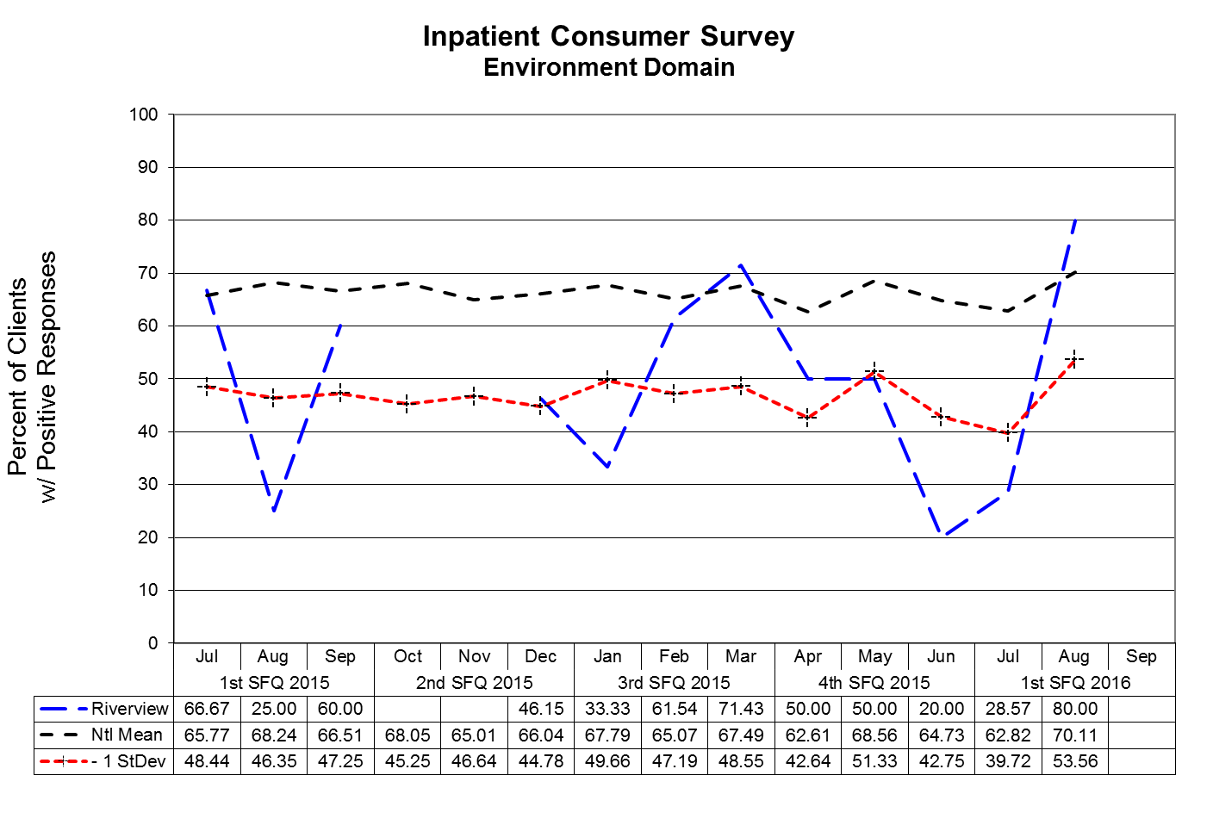

**Environment Domain Questions:**

1. The surroundings and atmosphere at the hospital helped me get better.
2. I felt I had enough privacy in the hospital.
3. I felt safe while I was in the hospital.
4. The hospital environment was clean and comfortable.

(Glossary of Terms, Acronyms & Abbreviations) (Back to Table of Contents)

|  |
| --- |
| JOINT COMMISSION |

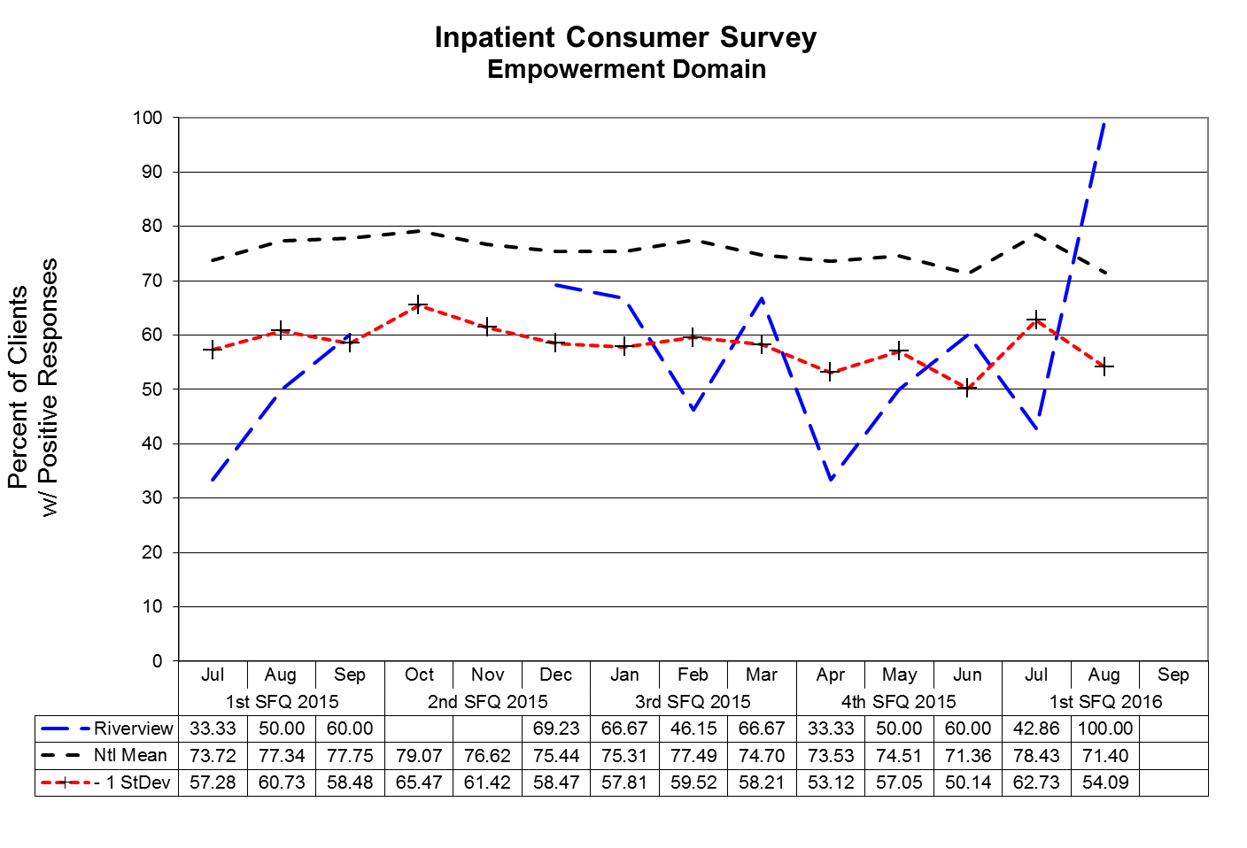

**Empowerment Domain Questions:**

1. I had a choice of treatment options.
2. My contact with my Doctor was helpful.
3. My contact with nurses and therapists was helpful.

(Glossary of Terms, Acronyms & Abbreviations) (Back to Table of Contents)

|  |
| --- |
| JOINT COMMISSION |

**Fall Reduction Strategies**

TJC PI.01.01.01 EP38: The hospital evaluates the effectiveness of all fall reduction activities including assessment, interventions, and education.

TJC PC.01.02.08: The hospital assesses and manages the patient's risks for falls.

EP01: The hospital assesses the patient’s risk for falls based on the patient population and setting.

EP02: The hospital implements interventions to reduce falls based on the patient’s assessed risk.

The Falls Risk Management Team has been created to be facilitated by a member of the team with data supplied by the Risk Manager. The role of this team is to conduct root cause analyses on each of the falls incidents and to identify trends and common contributing factors and to make recommendations for changes in the environment and process of care for those patients identified as having a high potential for falls.

**Type of Fall by Patient and Month:**

|  |  |  |  |  |  |
| --- | --- | --- | --- | --- | --- |
| **Fall Type** | **Patient** | **JULY** | **AUG** | **SEPT** | **1Q2016** |
| Un-witnessed | MR1033 | 7 |  | 3 | **10** |
| MR3374 | 1 | 1 |  | **2** |
| MR6274 |  | 1 |  | **1** |
| MR7032 |  | 1 | 1 | **2** |
| MR7127* |  |  | 1 | **1** |
| MR7736 |  |  | 1 | **1** |
| MR7799 |  | 1 |  | **1** |
| **Totals** | **8** | **4** | **6** | **18** |

*Patients have experienced witnessed and un-witnessed falls during the reporting quarter.

(Glossary of Terms, Acronyms & Abbreviations) (Back to Table of Contents)

|  |
| --- |
| JOINT COMMISSION |

|  |  |  |  |  |  |
| --- | --- | --- | --- | --- | --- |
| **Fall Type** | **Patient** | **JULY** | **AUG** | **SEPT** | **1Q2016** |
| Witnessed | MR7742 | 2 |  |  | **2** |
| MR7810 |  |  | 1 | **1** |
| MR7764 | 2 |  |  | **2** |
| MR5053 | 1 |  |  | **1** |
| MR317 |  | 1 |  | **1** |
| MR7795 |  |  | 1 | **1** |
| MR7495 |  |  | 1 | **1** |
| MR7127* |  |  | 1 | **1** |
| MR5625 |  |  | 1 | **1** |
| MR7559 |  | 1 |  | **1** |
| MR5901 |  | 1 |  | **1** |
| MR7575 | 1 |  |  | **1** |
| **Totals** | **6** | **3** | **5** | **14** |

*Patients have experienced witnessed and un-witnessed falls during the reporting quarter.

(Glossary of Terms, Acronyms & Abbreviations) (Back to Table of Contents)

|  |
| --- |
| STRATEGIC PERFORMANCE EXCELLENCE |

**Process Improvement Plans**

**Priority Focus Areas for Strategic Performance Excellence**

In an effort to ensure that quality management methods used within the Maine Psychiatric Hospitals System are consistent with modern approaches of systems engineering, culture transformation, and process focused improvement strategies and in response to the evolution of Joint Commission methods to a more modern systems-based approach instead of compliance-based approach

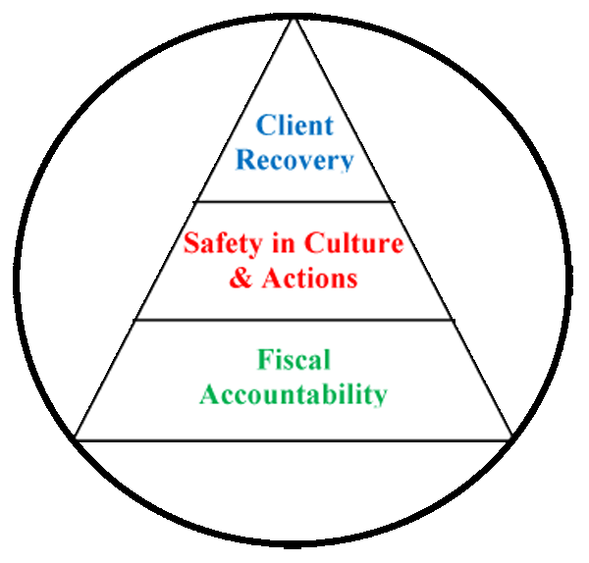

**Building a framework for patient recovery by ensuring fiscal accountability   
and a culture of organizational safety through the promotion of…**

* The conviction that staff members are concerned with doing the right thing in support of patient rights and recovery;
* A philosophy that promotes an understanding that errors most often occur as a result of deficiencies in system design or deployment;
* Systems and processes that strive to evaluate and mitigate risks and identify the root cause of operational deficits or deficiencies without erroneously assigning blame to system stakeholders;
* The practice of engaging staff members and patients in the planning and implementing of organizational policy and protocol as a critical step in the development of a system that fulfills ethical and regulatory requirements while maintaining a practicable workflow;
* A cycle of improvement that aligns organizational performance objectives with key success factors determined by stakeholder defined strategic imperatives;
* Enhanced communications and collaborative relationships within and between cross-functional work teams to support organizational change and effective process improvement;
* Transitions of care practices where knowledge is freely shared to improve the safety of patients before, during, and after care;
* A just culture that supports the emotional and physical needs of staff members, patients, and family members that are impacted by serious, acute, and cumulative events.

(Glossary of Terms, Acronyms & Abbreviations) (Back to Table of Contents)

|  |
| --- |
| STRATEGIC PERFORMANCE EXCELLENCE |

**Strategic Performance Excellence Model Reporting Process**

Department of Health and Human Services Goals

|  |
| --- |
| Protect and enhance the health and well-being of Maine people  Promote independence and self sufficiency  Protect and care for those who are unable to care for themselves  Provide effective stewardship for the resources entrusted to the Department |

Dorothea Dix and Riverview Psychiatric Centers

**Priority Focus Areas**

|  |
| --- |
| **Ensure and Promote Fiscal Accountability by…**  Identifying and employing efficiency in operations and clinical practice  Promoting vigilance and accountability in fiscal decision-making.  **Promote a Safety Culture by…**  Improving Communication  Improving Staffing Capacity and Capability  Evaluating and Mitigating Errors and Risk Factors  Promoting Critical Thinking  Supporting the Engagement and Empowerment of Staff Members  **Enhance Patient Recovery by…**  Develop Active Treatment Programs and Options for Patients  Supporting patients in their discovery of personal coping and improvement activities. |

(Glossary of Terms, Acronyms & Abbreviations) (Back to Table of Contents)

|  |
| --- |
| STRATEGIC PERFORMANCE EXCELLENCE |

Each Department Determines Unique Opportunities and

Methods to Address the Hospital Goals

The Quarterly Report Consists of the Following:

Opportunities for Improvement (OFIs)

**DEFINE**

Performance Objectives

Opportunities for Improvement (OFI’s)

**MEASURE**

Current

Performance

**ANALYZE**

Current

Performance

Gaps

Current

Work

Flow

Process

Identify Root

Causes of

Performance Gaps

(Glossary of Terms, Acronyms & Abbreviations) (Back to Table of Contents)

Validate Improvements Achieved

Develop Systems to Sustain Improvements

**CONTROL**

Establish Incremental Goals & Measures

Implement the Planned Changes

Work Process Plans and Procedures

**IMPROVE**

|  |
| --- |
| STRATEGIC PERFORMANCE EXCELLENCE |

**Admissions**

**Responsible Party: Jamie Meader, RN, Admissions Nurse**

**Number of Admissions:**



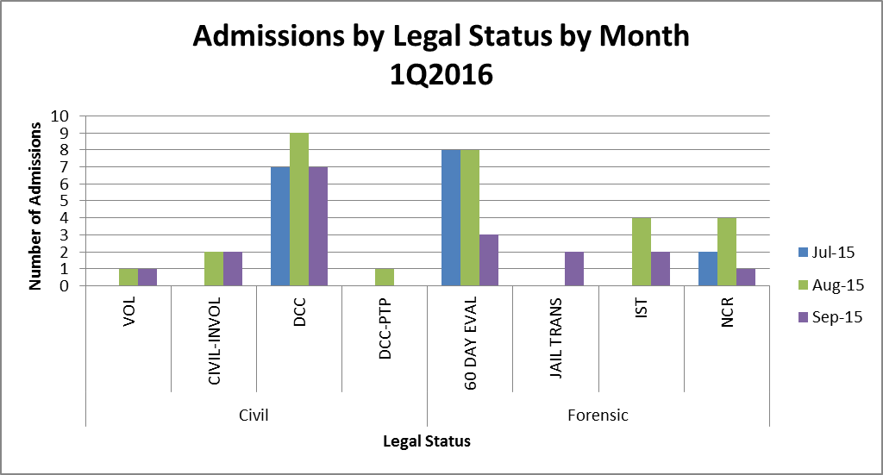

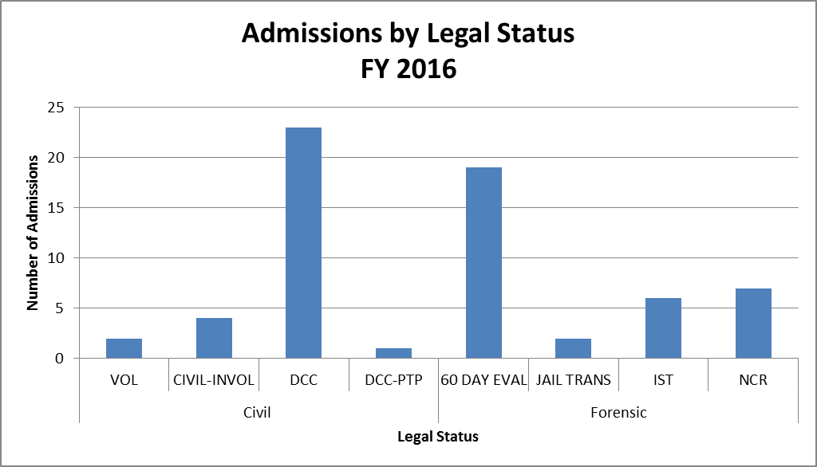(Glossary of Terms, Acronyms & Abbreviations) (Back to Table of Contents)

|  |
| --- |
| STRATEGIC PERFORMANCE EXCELLENCE |

**Average Number of Wait Days:**



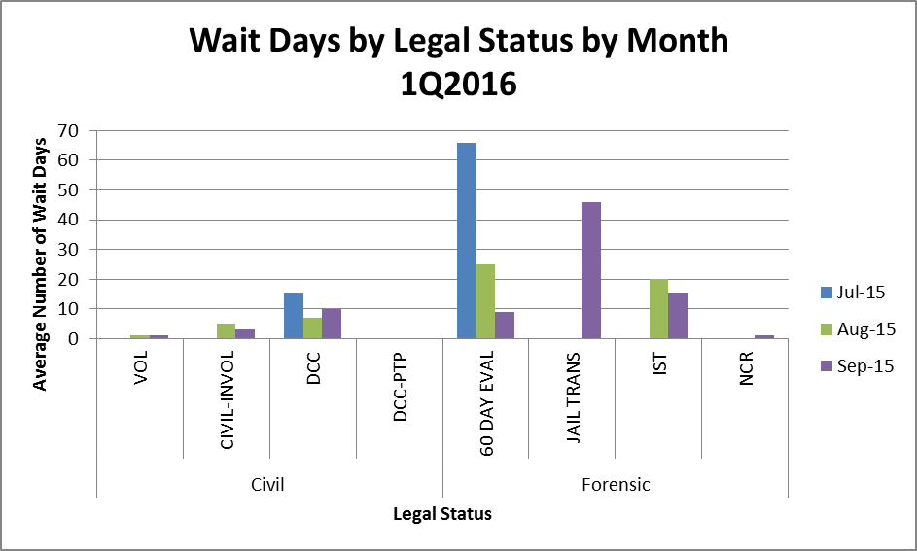

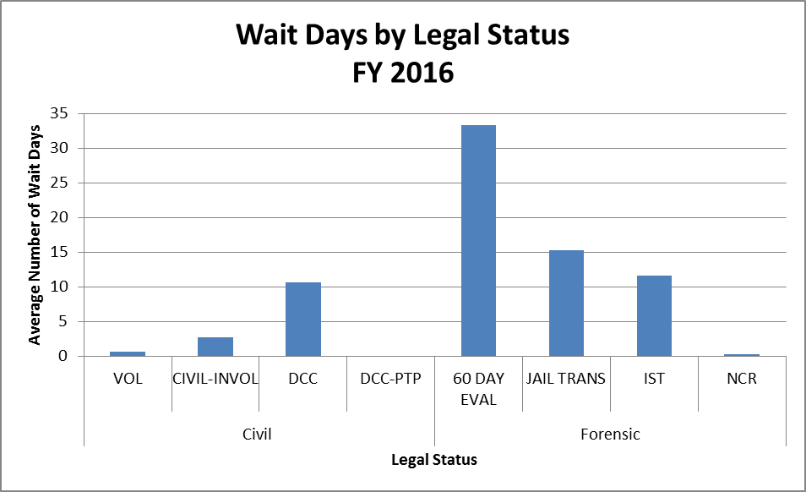

(Glossary of Terms, Acronyms & Abbreviations) (Back to Table of Contents)

|  |
| --- |
| STRATEGIC PERFORMANCE EXCELLENCE |

**Number of Discharges:**



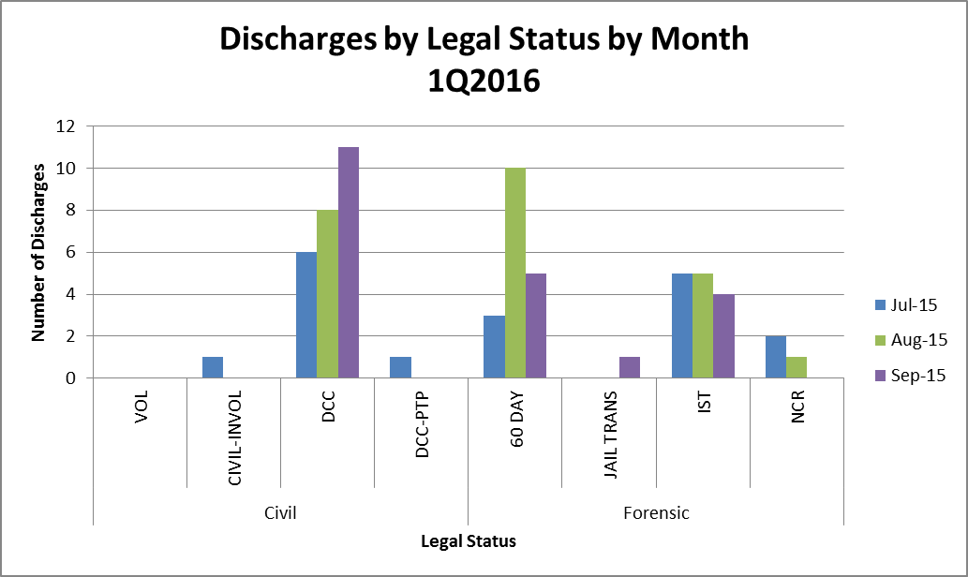

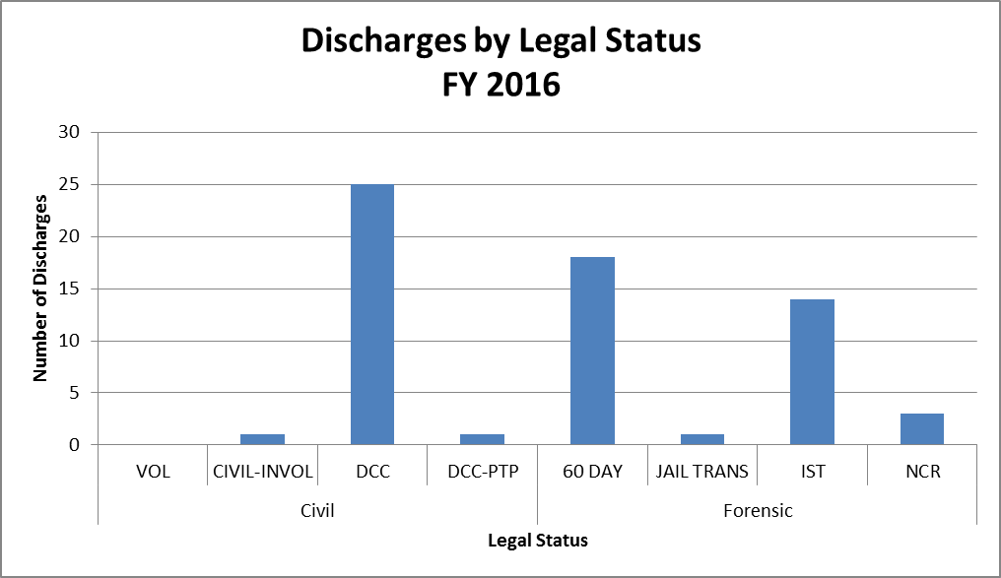(Glossary of Terms, Acronyms & Abbreviations) (Back to Table of Contents)

|  |
| --- |
| STRATEGIC PERFORMANCE EXCELLENCE |

**Average Length of Stay (Days):**



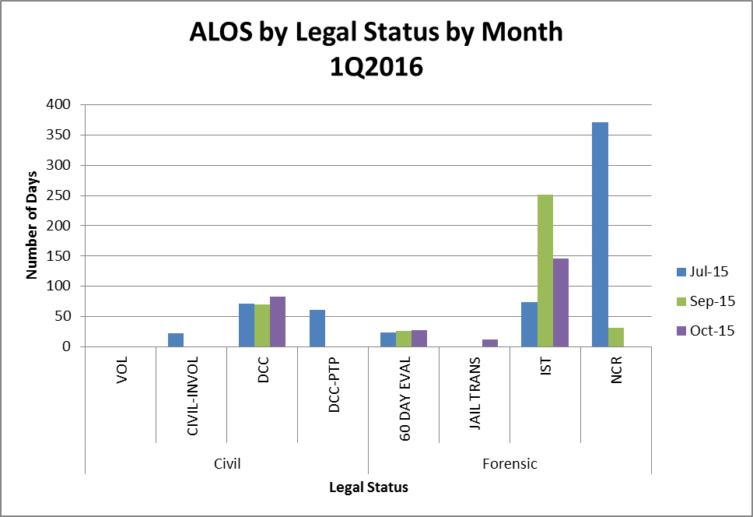

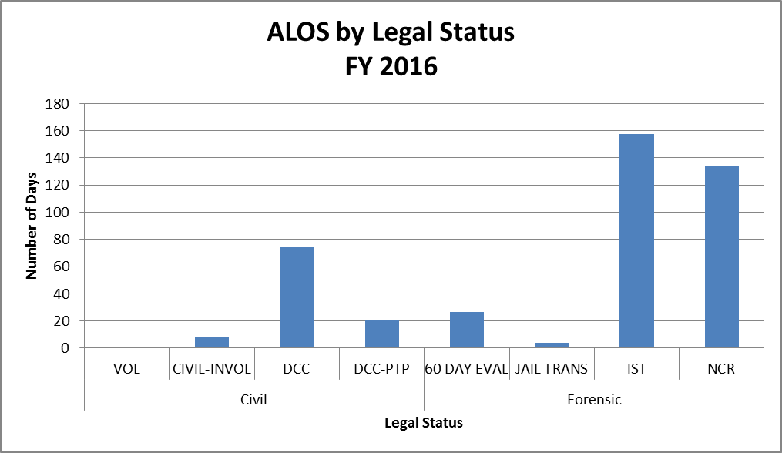

(Glossary of Terms, Acronyms & Abbreviations) (Back to Table of Contents)

|  |
| --- |
| STRATEGIC PERFORMANCE EXCELLENCE |

**I. Measure Name: NCR Admissions**

**Measure Description:** Admittance of all NCR patients within 24 hours oreferral.

**Type of Measure:** Quality Assurance

|  |  |  |  |  |  |  |  |
| --- | --- | --- | --- | --- | --- | --- | --- |
| **Results** | | | | | | | |
|  | **Unit** | **Baseline** | **1Q2016** | **2Q2016** | **3Q2016** | **4Q2016** | **YTD** |
| **Target** | NCR referrals admitted within 24 hours | N/A | 100% | 100% | 100% | 100% | **100%** |
| **Actual** | 86%  6/7 |  |  |  | **86%**  **6/7** |

**Data Analysis:** One admission waited one day for admission after being referred. This was due to a transportation issue with the referring facility as they could not transport until the following day due to the long distance. All other NCR referrals were admitted upon the date of referral.

**Action Plan:** Continue to gather data on wait days for NCR admissions. Keep one bed available on the Forensic unit for NCR admissions at all times.

**Graph/Chart:**

|  |  |  |  |  |
| --- | --- | --- | --- | --- |
|  | **July 2015** | **August 2015** | **September 2015** | **1Q2016** |
| **# of NCR Admissions** | 2 | 4 | 1 | **7**  **(Total)** |
| **Wait Days** | 0 | 0 | 1 | **0.33**  **(Average)** |

(Glossary of Terms, Acronyms & Abbreviations) (Back to Table of Contents)

|  |
| --- |
| STRATEGIC PERFORMANCE EXCELLENCE |

**II. Measure Name: Jail Transfer Bed**

**Measure Description:** Keep one Jail Transfer bed open and track length of stay and legal outcomes.

**Type of Measure:** Performance Improvement

**Data Analysis:** Two Jail Transfers were admitted this quarter. The 1st jail transfer patient admitted had a LOS of 12 days (charges resolved after discharge). The 2nd jail transfer patient admitted is still in RPC at this time (DCC for 120 days civilly, medical guardian obtained).

**Action Plan:** Continue to track data and keep one bed available for jail transfers.

**Graph/Chart:**

|  |  |  |  |  |
| --- | --- | --- | --- | --- |
|  | **July 2015** | **August 2015** | **September 2015** | **1Q2016**  **Total** |
| **# of Jail Transfer (JTF) Admissions)** | 0 | 0 | 2 | **2** |
| **# of Jail Transfer (JTF) Discharges** | 0 | 0 | 1 | **1** |

**III. Measure Name: Off Shift PA Admission Paperwork**

**Measure Description:** All required documentation will be complete and accurate for admissions on the off shifts by the PA.

**Type of Measure:** Performance Improvement

|  |  |  |  |  |  |  |  |
| --- | --- | --- | --- | --- | --- | --- | --- |
| **Results** | | | | | | | |
|  | **Unit** | **Baseline** | **1Q2016** | **2Q2016** | **3Q2016** | **4Q2016** | **YTD** |
| **Target** | Documentation complete and accurate for admissions on off shifts | N/A | 100% | 100% | 100% | 100% | **100%** |
| **Actual** | 100%  3/3 |  |  |  | **100%**  **3/3** |

**Data Analysis:** Three off shift admissions occurred this quarter. All the paperwork was completed as needed.

**Action Plan:** Continue to monitor data so paperwork is completed accurately and timely.

(Glossary of Terms, Acronyms & Abbreviations) (Back to Table of Contents)

|  |
| --- |
| STRATEGIC PERFORMANCE EXCELLENCE |

**Capital Community Clinic**

**Dental Clinic**

**Responsible Party: Dr. Ingrid Prikryl, Dentist**

**I. Measure Name: Yearly Periodontal Charting**

**Measure Description:** Complete a full mouth periodontal charting.

**Type of Measure:** Performance Improvement

|  |  |  |  |  |  |  |  |
| --- | --- | --- | --- | --- | --- | --- | --- |
| **Results** | | | | | | | |
|  | **Unit** | **Baseline** | **1Q2016** | **2Q2016** | **3Q2016** | **4Q2016** | **YTD** |
| **Target** | % of appointments where full mouth periodontal charting was completed | FY 2015  42% | 50% | 55% | 60% | 65% | **75%** |
| **Actual** | 43% |  |  |  | **43%** |

**Data Analysis:** FY 2015showed an increase in periodontal charting but slightly declined in the Q4 because of a change in provider.

**Action Plan:** Charting to be completed by the hygienist during prophy appointments and/or with dentist during exam appointment.

**Comments:** Would like to be at 60% by the next six month recall cycle and then at 75% after 12 month recall. This is a challenge because not all patients are able and willing to sit for periodontal charting.

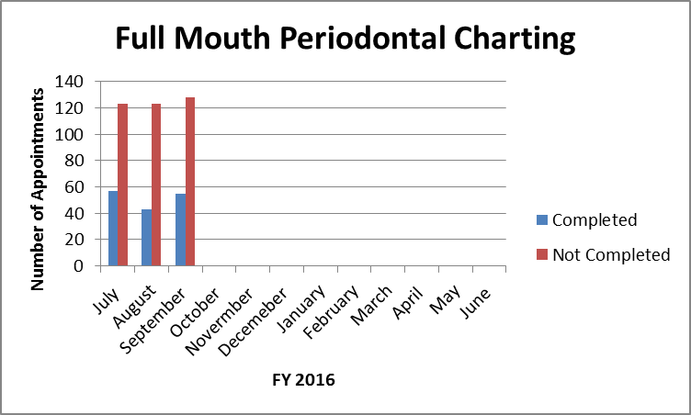

(Glossary of Terms, Acronyms & Abbreviations) (Back to Table of Contents)

|  |
| --- |
| STRATEGIC PERFORMANCE EXCELLENCE |

**II. Measure Name: Improving Oral Hygiene**

**Measure Description:** Monitoring patients’ oral hygiene and working to improve it.

**Type of Measure:** Performance Improvement

|  |  |  |  |  |  |  |  |
| --- | --- | --- | --- | --- | --- | --- | --- |
| **Results** | | | | | | | |
|  | **Unit** | **Baseline** | **1Q2016** | **2Q2016** | **3Q2016** | **4Q2016** | **YTD** |
| **Target** | Plaque Score Monthly | Fair  213.25 | Fair  (220-16) |  |  |  |  |
| **Actual** | Poor  221 |  |  |  | **221** |

**Data Analysis:** Smaller numbers demonstrate less plaque on our patients’ teeth, therefore improved oral hygiene.

**Action Plan:** Plaque scores should increase in a 6 month cycle with proper oral hygiene instructions.

**Comments:** Trying to educate our patients on brushing daily and its importance for proper oral care and retention of teeth.

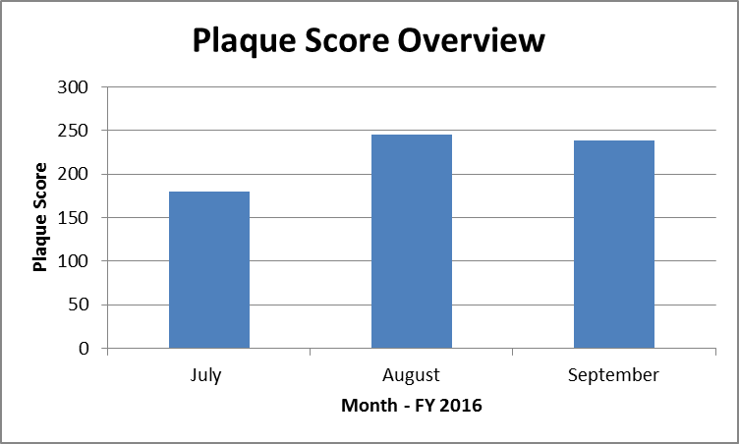

(Glossary of Terms, Acronyms & Abbreviations) (Back to Table of Contents)

|  |
| --- |
| STRATEGIC PERFORMANCE EXCELLENCE |

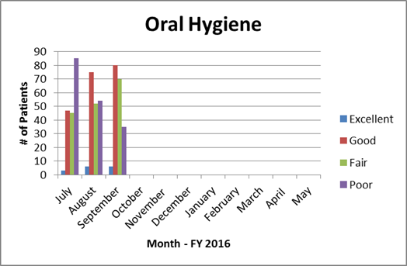

**III. Measure Name: Next Visit**

**Measure Description:** Writing Next Visit in progress note.

**Type of Measure:** Performance Improvement

|  |  |  |  |  |  |  |  |
| --- | --- | --- | --- | --- | --- | --- | --- |
| **Results** | | | | | | | |
|  | **Unit** | **Baseline** | **1Q2016** | **2Q2016** | **3Q2016** | **4Q2016** | **YTD** |
| **Target** | # of progress notes with next visit documented | 66%  FY 2015 | 70% | 75% | 80% | 85% | **90%** |
| **Actual** | 60% |  |  |  | **60%** |

**Data Analysis:** FY 2015 YTD was 66% therefore it has become a performance improvement would like this to be at 90 – 100%.

**Action Plan:** Write at the end of every progress note what the next visit is going to be even if it is a 3 MRC or denture adjustment as needed. Random weekly checks on most recent progress note will be measured on daily tally sheet.

(Glossary of Terms, Acronyms & Abbreviations) (Back to Table of Contents)

|  |
| --- |
| STRATEGIC PERFORMANCE EXCELLENCE |

**IV. Measure Name: RMH and MEDS**

**Measure Description:** Review medical history and medications at the start of each appointment.

**Type of Measure:** Quality Assurance

|  |  |  |  |  |  |  |  |
| --- | --- | --- | --- | --- | --- | --- | --- |
| **Results** | | | | | | | |
|  | **Unit** | **Baseline** | **1Q2016** | **2Q2016** | **3Q2016** | **4Q2016** | **YTD** |
| **Target** | # of appointments with medical history and medications reviewed | N/A  New Measure | 70% | 80% | 90% | 100% |  |
| **Actual** | 90% |  |  |  | **90%** |

**Data Analysis:** As of the FY 2015 a new measure was implemented that the medical history and medication list be reviewed at each appointment.

**Action Plan:** Review patient medical history and medication list at the start of each appointment.

**V. Measure Name: Blood Pressure**

**Measure Description:** Blood pressure and pulse taken at each dental appointment.

**Type of Measure:** Quality Assurance

|  |  |  |  |  |  |  |  |
| --- | --- | --- | --- | --- | --- | --- | --- |
| **Results** | | | | | | | |
|  | **Unit** | **Baseline** | **1Q2016** | **2Q2016** | **3Q2016** | **4Q2016** | **YTD** |
| **Target** | # of appointments with blood pressure and pulse taken. | N/A  New Measure | 90% | 90% | 90% | 90% | **90%** |
| **Actual** | 95% |  |  |  | **95%** |

**Action Plan:** Take blood pressure and pulse at the start of all dental appointments; weekly check of charts will be recorded.

**Comments:** To withstand dental care blood pressure should be less than 160/90.

(Glossary of Terms, Acronyms & Abbreviations) (Back to Table of Contents)

|  |
| --- |
| STRATEGIC PERFORMANCE EXCELLENCE |

**Capital Community Clinic**

**Medication Management Clinic**

**Responsible Party: Robin Weeks, Medical Assistant**

**Measure Name: Reconciliation of Outpatient Medication List**

**Measure Description:** Each visit will cover reconciliation of medical & psychotropic medications with patients.

**Measure Type:** Performance Improvement

|  |  |  |  |  |  |  |  |
| --- | --- | --- | --- | --- | --- | --- | --- |
| **Results** | | | | | | | |
|  | **Unit** | **Baseline** | **2Q2015** | **3Q2015** | **4Q2015** | **1Q2016** | **YTD** |
| **Target** | Reconciliation completed per visit. | FY15 Q2  73% | 100% | 100% | 100% | 100% | **100%** |
| **Actual** | 73%  40/55 | 85%  46/54 | 100%  59/59 | 94%  59/63 | **88%**  **204/231** |

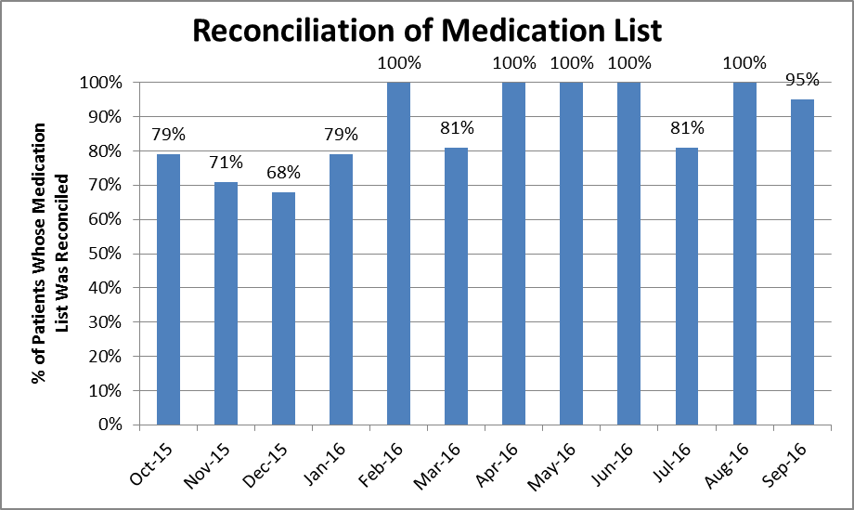

(Glossary of Terms, Acronyms & Abbreviations) (Back to Table of Contents)

|  |
| --- |
| STRATEGIC PERFORMANCE EXCELLENCE |

**Measure Name: Vital Signs**

**Measure Description:** Taking vital signs each visit will give us an idea of the effects of the prescribed medications and early detection of possible medical problems with the patient.

**Measure Type:** Quality Improvement

|  |  |  |  |  |  |  |  |
| --- | --- | --- | --- | --- | --- | --- | --- |
| **Results** | | | | | | | |
|  | **Unit** | **Baseline** | **2Q2015** | **3Q2015** | **4Q2015** | **1Q2016** | **YTD** |
| **Target** | Reconciliation completed per visit. | FY15 Q1  73% | 100% | 100% | 100% | 100% | **100%** |
| **Actual** | 74%  40/54 | 61%  28/46 | 97%  57/59 | 92%  58/63 | **82%**  **183/222** |

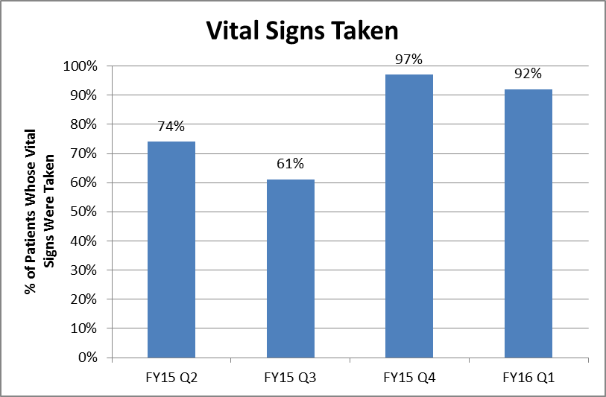

(Glossary of Terms, Acronyms & Abbreviations) (Back to Table of Contents)

|  |
| --- |
| STRATEGIC PERFORMANCE EXCELLENCE |

**Dietary Services**

**Responsible Party:** **Kristen Piela, Dietetic Services Manager**

1. **Measure Name:** **Nutrition Screen Completion**

**Measure Description:** The Registered Dietitian will review each patient’s Nursing Admission Data to assess ongoing compliance with the completion of the Nutrition Screen tool; within 24 hours of admission.

**Type of Measure:** Quality Assurance

|  |  |  |  |  |  |  |  |
| --- | --- | --- | --- | --- | --- | --- | --- |
| **Results** | | | | | | | |
|  | **Unit** | **Baseline** | **1Q2016** | **2Q2016** | **3Q2016** | **4Q2016** | **YTD** |
| **Target** | Percent of Nutrition screens completed on time | FY 2015  95% | 95% | 95% | 95% | 95% | **95%** |
| **Actual** | 60/60  100% |  |  |  | **60/60**  **100%** |

**Data Analysis:** Completion of the nutrition screens within 24 hours of admission has remained above target levels. This monitor began as an indicator in FY 2013.

**Action Plan:** To assure optimum care for our patients, this monitor will remain a quality assurance measure. As a follow up to this measure, there has been a performance improvement monitor developed to evaluate the accuracy of the screens being completed.

**Comments:** This is a multidisciplinary measure that has proven successful.

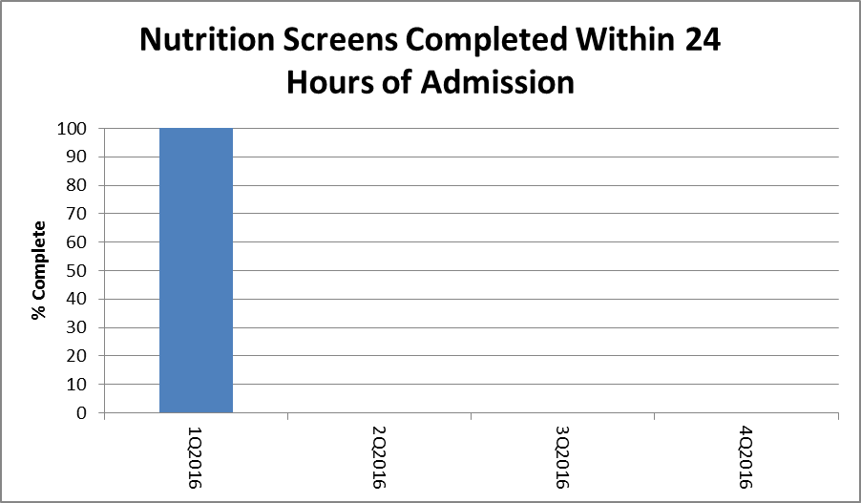

(Glossary of Terms, Acronyms & Abbreviations) (Back to Table of Contents)

|  |
| --- |
| STRATEGIC PERFORMANCE EXCELLENCE |

**II. Measure Name: Nutrition Screen Accuracy**

**Measure Description:** The Registered Dietitian will review every patient’s Nursing Admission Data, upon admission, to assess ongoing compliance with the accuracy of the Nutrition Screen tool.This screen is utilized to attain nutrition indicators that necessitate dietary intervention.

**Type of Measure:** Performance Improvement

|  |  |  |  |  |  |  |  |
| --- | --- | --- | --- | --- | --- | --- | --- |
| **Results** | | | | | | | |
|  | **Unit** | **Baseline** | **1Q2016** | **2Q2016** | **3Q2016** | **4Q2016** | **YTD** |
| **Target** | Percent of Nutrition screens completed accurately | FY 2016  Q1  68.3%  41/60 | Baseline  established |  |  |  | **95%** |
| **Actual** | 68.3%  41/60 |  |  |  | **68.3%**  **41/60** |

**Data Analysis:** These results indicate there is opportunity for improving the accuracy of the information gathered on the nutrition screen. The nutrition screen is completed by the nurse responsible for the admission.

**Action Plan:**

* Determine similarities within the incomplete nutrition screens.
* Provide proper training to the nurses responsible for completing the nutrition screen upon admission.
* Identify the diagnoses on the nutrition screen that have common inaccuracies.

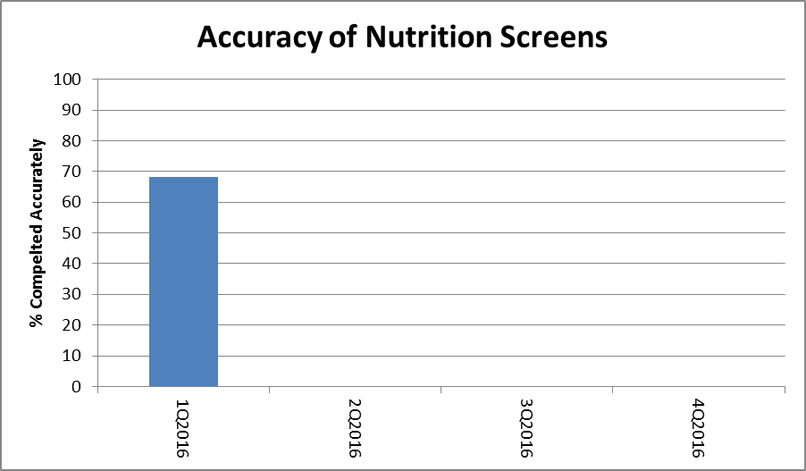

(Glossary of Terms, Acronyms & Abbreviations) (Back to Table of Contents)

|  |
| --- |
| STRATEGIC PERFORMANCE EXCELLENCE |

**III. Measure Name: Hand Hygiene Compliance**

**Measure Description:** Supervisory staff: including the Food Service Manager and Cook III’s, will observe all dietary employees, as they return from break, for proper hand hygiene.

**Type of Measure:** Performance Improvement

|  |  |  |  |  |  |  |  |
| --- | --- | --- | --- | --- | --- | --- | --- |
| **Results** | | | | | | | |
|  | **Unit** | **Baseline** | **1Q2016** | **2Q2016** | **3Q2016** | **4Q2016** | **YTD** |
| **Target** | Percent of Dietary employees washing hands after break | FY 2015  97.7%  338/346 | 90% |  |  |  | **95%** |
| **Actual** | 96.3%  343/356 |  |  |  | **96.3%**  **343/356** |

**Data Analysis:** The results of this quarter remain above 90%. This measure began as a performance improvement indicator in the first quarter of FY13 with 58% compliance. By the third quarter of FY15 the compliance rate had risen to above 90% and remains there.

**Action Plan:**

* Continue to have front line supervisors monitor handwashing compliance after breaks.
* Provide hand hygiene training annually
* Encourage front line supervisors to promote hand hygiene with their staff throughout the day.

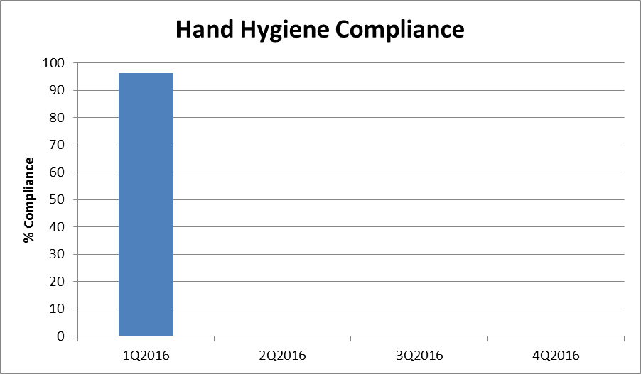(Glossary of Terms, Acronyms & Abbreviations) (Back to Table of Contents)

|  |
| --- |
| STRATEGIC PERFORMANCE EXCELLENCE |

**Emergency Management**

**Responsible Party: Robert Patnaude, Emergency Management Coordinator**

**Measure Name: Communications Equipment/Two-way radios**

**Measure Description:**

The Joint Commission states the following in EM.02.02.01: “As part of its Emergency Operations Plan, the hospital prepares for how it will communicate during emergencies. *The hospital maintains reliable communications capabilities for the purpose of communicating response efforts to staff, patients, and external organizations.”*

In the event of an unforeseen emergency which could impact the safety and security of patients, staff, and visitors, communications equipment, more specifically, two-way radios are a major solution to getting accurate information to and from staff in a timely manner. The objective of the Emergency Management Communications PI is to ensure compliance with The Joint Commission standard with the overall objective of ensuring that the two-way radio system is fully functional and that staff are proficient in its use.

**Type of Measure:** Performance Improvement

**Methodology:** Each month, the Emergency Management Coordinator or designee will perform a combination of partial and hospital-wide radio drills. Such drills will utilize a specific form to track the drills (see attached). In conjunction with the drills, environmental rounds will be conducted for the purpose of inspecting communications equipment. Any deficiencies shall have the appropriate corrective measure immediately instituted until compliance is met.

The numerator is the number of timely and appropriate responses by staff utilizing the two-way radios by assignments. The denominator will be the total number of two-way radios by assignments.

**Baseline Data:** To assure that critical emergency information is disseminated in a timely and accurate manner, **a minimum of 90%** compliance has been established. This data will be reported monthly to the Emergency Management Committee, IPEC, and the Environment of Care (EOC) Committee. Areas that fail to meet the threshold will be immediately reported to the aforementioned committees.

(Glossary of Terms, Acronyms & Abbreviations) (Back to Table of Contents)

|  |
| --- |
| STRATEGIC PERFORMANCE EXCELLENCE |

|  |  |  |  |  |  |  |  |
| --- | --- | --- | --- | --- | --- | --- | --- |
| **Results** | | | | | | | |
|  | **Unit** | **Baseline** | **1Q2016** | **2Q2016** | **3Q2016** | **4Q2016** | **YTD** |
| **Target** | Percent of timely and appropriate responses | FY 2016  90% | 90%  144/159 | 90%  144/159 |  |  | **90%**  **144/159** |
| **Actual** | 92%  147/159 |  |  |  | **92%**  **147/159** |

**Data Analysis**: With a significant amount of hands-on demonstrations, radio tests, and an increase in the use of radios, data showed that staff has become very familiar with operating the radio. Although the actual percentage of timely and appropriate responses has increased by 2%, the critical components such as having alert notification equipment in ready order needs improvement. We continue to investigate the most appropriate equipment that is not so dependent on staff oversight.

**Action Plan**:

1. Continued tests and remedial training to staff along with supporting handouts as needed.
2. Increased surveillance of mass notification equipment such as alert pagers.

**Comments**: 92% of assigned radio equipment is placed into service in a timely manner. This response adequately assures that the majority of occupants will receive timely and critical information.

(Glossary of Terms, Acronyms & Abbreviations) (Back to Table of Contents)

|  |
| --- |
| STRATEGIC PERFORMANCE EXCELLENCE |

|  |  |  |  |  |  |  |  |  |  |  |  |  |  |
| --- | --- | --- | --- | --- | --- | --- | --- | --- | --- | --- | --- | --- | --- |
| **Areas/Groups Monitored**  **N = Numerator**  **D = Denominator** | **JUL**  **2015** | **AUG**  **2015** | **SEPT**  **2015** | **OCT**  **2015** | **NOV**  **2015** | **DEC**  **2015** | **JAN 2016** | **FEB 2016** | **MAR 2016** | **APR 2016** | **MAY 2016** | **JUNE**  **2016** | **JULY2016** |
| **Patient Care Areas/**  **# of radios** |  |  |  |  |  |  |  |  |  |  |  |  |  |
| Job Coach/1 | 1/  1* | 1/  1 | 1/  1* |  |  |  |  |  |  |  |  |  |  |
| OPS/2 | 2/  2* | 2/2 | 1/  2*1 |  |  |  |  |  |  |  |  |  |  |
| Tx Mall, Clinic, Dietary, Med Rec/5 | 5/  5* | 5/5 | 3/  5*2 |  |  |  |  |  |  |  |  |  |  |
| US, UK, LS, LSSCU, LK, LKSCU/10 | 9/  10 | 10/  10 | 8/  10*3 |  |  |  |  |  |  |  |  |  |  |
| **Support Services/**  **# of radios** |  |  |  |  |  |  |  |  |  |  |  |  |  |
| Administration/3 | 3/  3* | 3/  3 | 3/  3 |  |  |  |  |  |  |  |  |  |  |
| Housekeeping/  10 | 9/ 10** | 10/  10 | 9/  10*3 |  |  |  |  |  |  |  |  |  |  |
| Maintenance/14 | 14/ 14* | 14/  14 | 12/  14*4 |  |  |  |  |  |  |  |  |  |  |
| NOD/1 | 1/1 | 1/1 | 1/1 |  |  |  |  |  |  |  |  |  |  |
| Nursing Services/1 | 1/  1* | 1/  1 | 0/  1*5 |  |  |  |  |  |  |  |  |  |  |
| Operations/1 | 1/1 | 1/1 | 1/1 |  |  |  |  |  |  |  |  |  |  |
| Security/4 | 4/4 | 4/4 | 4/4 |  |  |  |  |  |  |  |  |  |  |
| State Forensic Services/1 | 1/  1* | 1/  1 | 0/  1*6 |  |  |  |  |  |  |  |  |  |  |
| **Patient Care Areas** | **17/**  **18** | **18/**  **18** | **13/**  **18** |  |  |  |  |  |  |  |  |  |  |
| **Support Services** | **34/**  **35** | **32/**  **35** | **30/**  **35** |  |  |  |  |  |  |  |  |  |  |
| **Total** | **51/**  **53** | **53/**  **53** | **43/**  **53** |  |  |  |  |  |  |  |  |  |  |

(Glossary of Terms, Acronyms & Abbreviations) (Back to Table of Contents)

|  |
| --- |
| STRATEGIC PERFORMANCE EXCELLENCE |

EMC = Emergency Management Coordinator

*Radio units not on duty due to shift assignment therefore given same weight in order not to have a negative impact.

*1- Security responded, staff did not. Remedial training held with staff

*2- Treatment Mall Staff on unpaid break. EMC to further look into practice. Dietary did not respond to page due to inability to properly read the pager. Remedial training.

*3- Did not hear test due to radio being turned down. Remedial training held for staff.

*4- Maintenance Staff did not answer page. Supervisor addressed with staff.

*5- General staff in area were not aware that radio was assigned to that location. EMC educated staff.

*6- Alert pager assigned to area was inoperative due to dead battery: NOTE: This is a repeat occurrence. Supervisor to address with staff. EMC to follow up.

(Glossary of Terms, Acronyms & Abbreviations) (Back to Table of Contents)

|  |
| --- |
| STRATEGIC PERFORMANCE EXCELLENCE |

**Harbor Treatment Mall**

**Responsible Party: Rebecca Eastman, RN**

**Measure: Harbor Mall Hand-off Communication**

|  |  |  |  |  |  |
| --- | --- | --- | --- | --- | --- |
| **Objectives** | **2Q 2015** | **3Q 2015** | **4Q 2015** | **1Q 2016** | **YTD** |
| 1. Hand-off communication sheet was received at the Harbor Mall within the designated time frame. | 76%  32/42 | 86%  36/42 | 76%  32/42 | 79%  44/56 | **79%**  **144/182** |
| 2. SBAR information completed from the units to the Harbor Mall. | 86%  36/42 | 86%  36/42 | 74%  31/42 | 79%  44/56 | **81%**  **147/182** |

**Define:** To provide the exchange of patient-specific information between the patient care units and the Harbor Mall for the purpose of ensuring continuity of care and safety within designated time frames.

**Measure:** Indicator number one has decreased from 93% for February, to 79% for March, 93% for April, 79% for May, 57% for June, 86% for July, 86% for August, and 86% for September. Indicator number two has decreased from 86% for February, to 93% for March, 79% for April, 64% for May, 79% for June, 71% for July, 86% for August, and 93% for September.

**Analyze:** For February the specific time frame for being late was fifteen minutes. For March the specific time frame for being late was three minutes, five minutes and fourteen minutes. For April the specific time frame for being late was three minutes. For May the specific time frame for being late was three minutes, five minutes, and eighty minutes. For June the specific time frame for being late was two minutes, three minutes, ten minutes (2), thirty-three minutes, and forty-seven minutes. For July the specific time frame for being late was five minutes and twenty-six minutes. For August the specific time frame for being late was three minutes and forty minutes. For September the specific time frame for being late was five minutes and five hours five minutes. We will continue to concentrate on both indicators to maintain current performance.

**Improve:** I will review the results of this report with the RN IV’s from each unit. I will also review the data for HOC sheets that did not arrive at the mall within the designated time frame from the units. We also added a statement at the bottom of the sheet reminding them to be turned in by ten minutes after the hour so the leaders know if there are any issues with the Patients and it is highlighted in yellow.

**Control:** To continue to monitor the data and follow up with any unit(s) that may be having difficulties in developing or maintaining a process to meet the objectives above.

(Glossary of Terms, Acronyms & Abbreviations) (Back to Table of Contents)

|  |
| --- |
| STRATEGIC PERFORMANCE EXCELLENCE |

**Health Information Technology (Medical Records)**

**Responsible Party: Joseph Riddick, Director of Integrated Quality & Informatics**

**Documentation and Timeliness:**

|  |  |  |  |
| --- | --- | --- | --- |
| **Indicators** | **1Q2016**  **Findings** | **1Q2016**  **Compliance** | **Threshold Percentile** |
| Records will be completed within Joint Commission standards, state requirements and Medical Staff bylaws timeframes. | 18 charts for patients released during the quarter were samples. 100% of the charts were completed within the required timeframe. | 100% | 80% |
| Discharge summaries will be completed within 15 days of discharge. | 17 of the 18 discharge summaries were completed within 15 days of discharge. | 94% | 100% |
| All forms/revisions to be placed in the medical record will be approved by the Medical Records Committee. | 2 forms were approved/ revised (see minutes). | 100% | 100% |
| Medical transcription will be timely and accurate. | Out of requested dictated reports, all were completed within 24 hours. | 100% | 90% |

**Summary:** The indicators are based on the review of all discharged records. There was 100% compliance with 30 day record completion. Weekly “charts needing attention” lists are distributed to medical staff, including the Clinical Director, along with the Superintendent, Risk Manager and the Quality Improvement Manager. There was 100% compliance with timely & accurate medical transcription services.

**Actions:**  Continue to monitor.

(Glossary of Terms, Acronyms & Abbreviations) (Back to Table of Contents)

|  |
| --- |
| STRATEGIC PERFORMANCE EXCELLENCE |

**Confidentiality:**

|  |  |  |  |
| --- | --- | --- | --- |
| **Indicators** | **1Q2016**  **Findings** | **1Q2016**  **Compliance** | **Threshold Percentile** |
| All patient information released from the Health Information Department will meet all Joint Commission, State, Federal & HIPAA standards. | 1,111 requests for information (160 requests for patient information and 951 police checks) were released. | 100% | 100% |
| All new employees/contract staff will attend confidentiality/HIPAA training. | All new employees/contract staff attended confidentiality/HIPAA training. | 100% | 100% |
| Confidentiality/privacy issues tracked through incident reports. | 0 privacy-related incident reports. |  |  |

**Summary:** The indicators are based on the review of all requests for information, orientation for all new employees/contract staff and confidentiality/privacy-related incident reports.

No problems were found in 1Q2016 related to release of information from the Health Information Department and training of new employees/contract staff, however compliance with current law and HIPAA regulations need to be strictly adhered to requiring training, education and policy development at all levels.

**Actions:**  The above indicators will continue to be monitored.

(Glossary of Terms, Acronyms & Abbreviations) (Back to Table of Contents)

|  |
| --- |
| STRATEGIC PERFORMANCE EXCELLENCE |

**Release of Information for Concealed Carry Permits:**

**Define:**

The process of conducting background checks on applicants for concealed carry permits is the responsibility of the two State psychiatric hospitals. Patients admitted to private psychiatric hospitals, voluntarily or by court order, are not subject to this review. Delays in the processing of background checks has become problematic due to an increasing volume of applications and complaints received regarding delays in the processing of these requests

**Analyze:**

Data collected for the 1Q2016 showed that we received 951 applications.  This is a decrease from last quarter 4Q2015 when we received 1961 applications.

**Improve:**

The process has been streamlined as we have been working with the state police by eliminating the mailing of the applications from them to RPC and DDPC. RPC has reactivated the medical records email to receive lists of the applicants from the state police that include the DOB and any alias they may have had. This has cut down on paper as well as time taken sorting all the applications. OIT has also created a new patient index in which we are in the process of consolidating sources we search into this one system. Over time this will decrease time spent searching as we will no longer have to search several sources. This is ongoing.

**Note**: In July 2015, a new State of Maine law was approved that will take effect in October 2015. This law no longer requires citizens to have a concealed carry permit to carry a concealed weapon within the State of Maine. However, if citizens want to carry concealed outside Maine they will still need to apply for a concealed carry permit. We expect this to decrease the number of concealed carry permit applications we receive and process.

|  |  |  |  |  |  |  |  |  |  |  |  |  |  |
| --- | --- | --- | --- | --- | --- | --- | --- | --- | --- | --- | --- | --- | --- |
| **Year** | **FY 2015** | | | | | | | | | **FY 2016** | | | **Total** |
| **Month** | **Oct** | **Nov** | **Dec** | **Jan** | **Feb** | **Mar** | **Apr** | **May** | **Jun** | **Jul** | **Aug** | **Sep** |
| # Applications Received | 842 | 640 | 612 | 655 | 594 | 806 | 732 | 713 | 516 | 353 | 302 | 304 | 8018 |

(Glossary of Terms, Acronyms & Abbreviations) (Back to Table of Contents)

|  |
| --- |
| STRATEGIC PERFORMANCE EXCELLENCE |

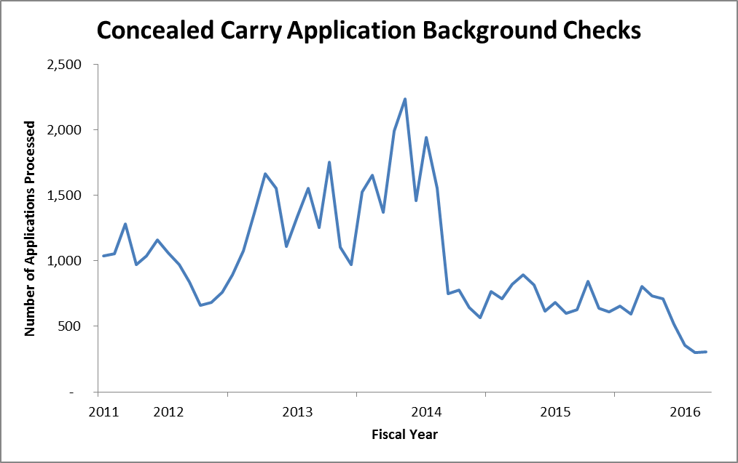

(Glossary of Terms, Acronyms & Abbreviations) (Back to Table of Contents)

|  |
| --- |
| STRATEGIC PERFORMANCE EXCELLENCE |

**Housek****eeping**

**Responsible Party: Debora Proctor, Housekeeping Supervisor**

**I. Measure Name: Patient Living Area**

The Housekeeping Department will maintain an acceptable standard of cleanliness and sanitation in patient living areas.

**Measure Description:** The Housekeeping Supervisor or designee will perform a monthly inspection of the patient living area and record the findings on the Housekeeping Inspection Form. Any unit not meeting the threshold will be inspected every two weeks until compliance is met

**Method of Monitoring:** Inspection scores will be summarized monthly. Patient areas that fail to meet the threshold will be reported to the IPEC group, EOC, and the Director of Support Services. This report will include any actions taken.

**Results:**

|  |  |  |  |  |  |  |
| --- | --- | --- | --- | --- | --- | --- |
| **Unit** | **Target** | **4Q2015** | **1Q2016** | **2Q2016** | **3Q2016** | **YTD** |
| **Lower Saco** | 85% | 91% | 89% |  |  | **90%** |
| **Upper Saco** | 85% | 88% | 87% |  |  | **88%** |
| **Lower Kennebec** | 85% | 85% | 89% |  |  | **87%** |
| **Upper Kennebec** | 85% | 90% | 87% |  |  | **89%** |
| **Overall Average** | **85%** | **89%** | **88%** |  |  | **89%** |

**Data Analysis:** Housekeeping Supervisor inspected units monthly and found that window cleaning, water cooler cleaning and floor care in the nurses station were consistent problem areas.

**Action Plan:** Housekeeping supervisor will continue to do weekly inspections to assure that cleanliness of the environment continues to improve.

(Glossary of Terms, Acronyms & Abbreviations) (Back to Table of Contents)

|  |
| --- |
| STRATEGIC PERFORMANCE EXCELLENCE |

**Human Resources**

**Person Responsible: Aimee Rice, Human Resources Manager**

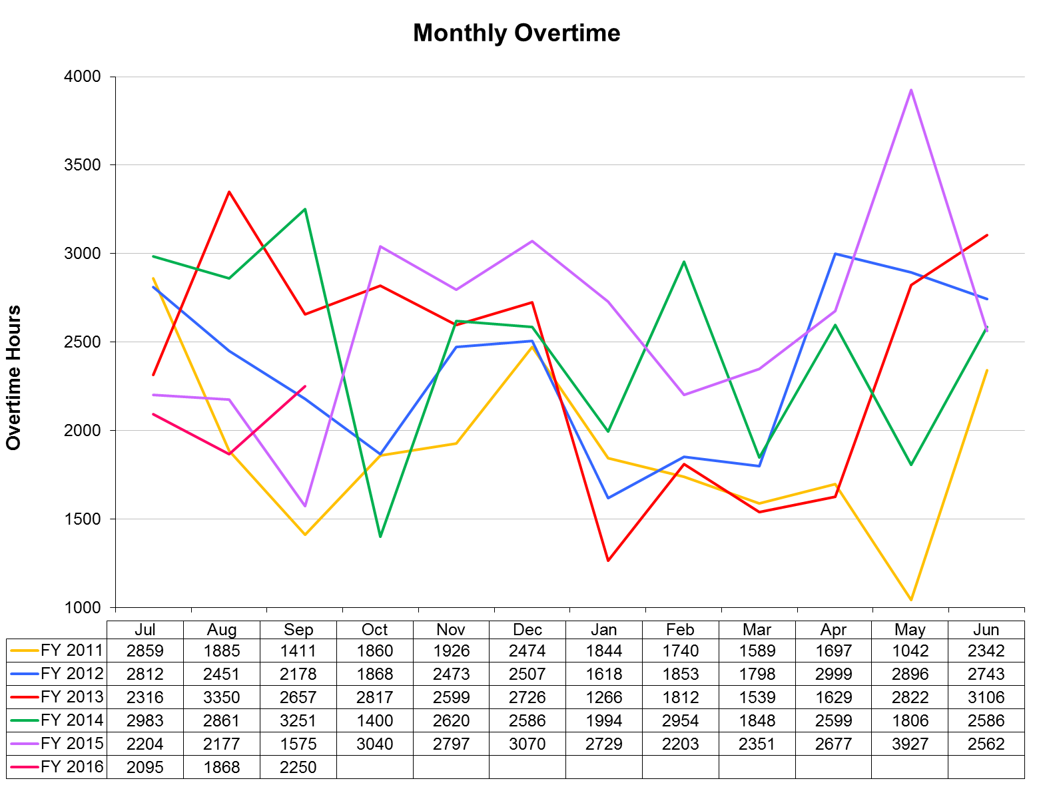

(Glossary of Terms, Acronyms & Abbreviations) (Back to Table of Contents)

|  |
| --- |
| STRATEGIC PERFORMANCE EXCELLENCE |

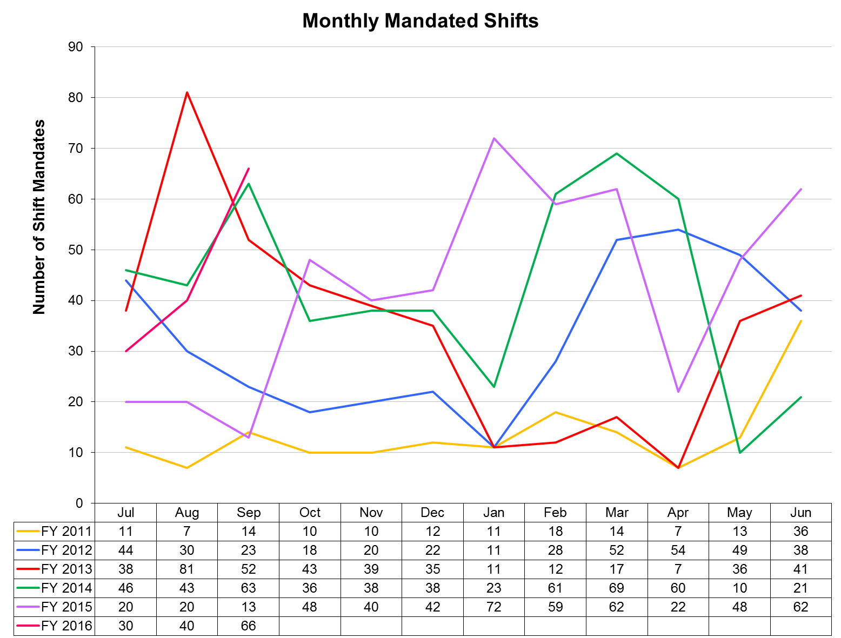

**I. Measure Name: License Reviews**

**Measure Description:** Ensuring that licenses/registry entries are verified via the appropriate source prior to hire for all licensed (or potentially licensed) new hires.

**Type of Measure:** Quality Assurance

|  |  |  |  |  |  |  |  |
| --- | --- | --- | --- | --- | --- | --- | --- |
| **Results** | | | | | | | |
|  | **Unit** | **Baseline** | **1Q2016** | **2Q2016** | **3Q2016** | **4Q2016** | **YTD** |
| **Target** | Percentage  Licenses Reviewed | FY 2014  98% | 100/100 |  |  |  |  |
| **Actual** | 100% |  |  |  | **100%** |

**Data Analysis:** During the quarter, there were 23 new hires. Of those, 19 were licensed, or potentially licensed. License and CNA Registry checks were performed prior to hire on all 19.

**Action Plan:** No action is needed at this time.

(Glossary of Terms, Acronyms & Abbreviations) (Back to Table of Contents)

|  |
| --- |
| STRATEGIC PERFORMANCE EXCELLENCE |

**Medical Staff**

**Responsible Party: Dr. Brendan Kirby, Clinical Director**

**Quality Improvement Plan**

**2015-2016**

As specified in Article Seven of the Medical Staff Bylaws, the improvement and assurance of medical staff quality and performance is of paramount importance to the hospital. This plan insures that the standards of patient care are consistent across all clinical services and all specialties and categories of responsible practitioners. Through a combination of internal and external peer review, indicator monitoring, focused case reviews of adverse outcomes or sentinel events, routine case reviews of patients with less than optimal outcomes, and the establishment of performance improvement teams when clinical process problems arise, the medical staff will insure quality surveillance and intervention activities appropriate to the volume and complexity of Riverview’s clinical workload. Medical Staff Quality Improvement efforts will be fully integrated with the hospital-wide Integrated Performance Excellence Committee (IPEC) so that information can be sent to and received from other clinical and administrative units of the hospital. The Clinical Director, assisted by the President of the Medical Staff, will serve as the primary liaison between the MEC and IPEC. Oversight of the Medical Staff Performance Improvement Plan is primarily delegated to the Clinical Director in conjunction with the President of the Medical Staff, the Director of Integrated Quality and Informatics, the Superintendent, and ultimately to the Advisory Board.

The goal of the Medical Staff Quality Improvement Plan is to provide care that is:

**Safe**

**Effective**

**Patient centered**

**Timely**

**Efficient**

**Equitable**

**Designed to improve clinical outcomes**

To achieve this goal, medical staff members will participate in ongoing and systematic performance improvement efforts. The performance improvement efforts will focus on direct patient care processes and support processes that promote optimal patient outcomes. This is accomplished through peer review, clinical outcomes review, variance analysis, performance appraisals, and other appropriate quality improvement techniques.

(Glossary of Terms, Acronyms & Abbreviations) (Back to Table of Contents)

|  |
| --- |
| STRATEGIC PERFORMANCE EXCELLENCE |

1. **Peer Review Activities**:

1. Regularly scheduled internal peer review by full time medical staff occurs on a monthly basis at the Peer Review and Quality Assurance Committee. The group of assembled clinicians will review case histories and treatment plans, and offer recommendations for possible changes in treatment plans, for any patient judged by the attending physician or psychologist, or others (including nursing, administration, the risk manager, or the Clinical Director), and upon request, to not be exhibiting a satisfactory response to their medical, psychological, or psychiatric regimens. Our goal is to discuss a case monthly. Detailed minutes of these reviews will be maintained, and the effectiveness of the reviews will be determined by recording feedback from the reviewed clinician as to the helpfulness of the recommendations, and by subsequent reports of any clinical improvements or changes noted in the patients discussed over time. Such intensive case reviews can also serve as the generator of new clinical monitors if frequent or systematic problem areas are uncovered. In addition all medical staff members (full and part-time) will have a minimum of one chart every other month peer reviewed and rated for clinical pertinence of diagnosis and treatment as well as for documentation. These may include admission histories and physicals, discharge summaries, and progress notes. The results of these chart audits are available to the reviewed practitioners and trends will be monitored by the Clinical Director as part of performance review and credentialing decisions.
2. Special internal peer review or focused review. At the direction of the Clinical Director a peer chart review is ordered for any significant adverse clinical event or significant unexpected variance. Examples would be a death, seclusion or restraint of one patient for eight or more continuous hours, patient elopement, the prescribing of three or more atypical antipsychotics for the same patient at the same time, or significant patient injury attributable to a medical intervention or error.
3. External peer review occurs regularly through contracts with the Maine Medical Association and the Community Dental Clinic program. We plan to continue our recent tradition of a biannual assessment of the psychiatry service and the medical service by peers in those clinical areas based on random record assessment of 25 cases in each service. An outside dentist from Community Dental will also review 20 charts of the hospital dentist for clinical appropriateness at least annually. Our contract with the Maine Medical Association also allows for special focused peer reviews of any unexpected death or when there is a question of a significant departure from the standard of care.

(Glossary of Terms, Acronyms & Abbreviations) (Back to Table of Contents)

|  |
| --- |
| STRATEGIC PERFORMANCE EXCELLENCE |

1. **MEC Subcommittee and IPEC Indicator Monitoring Activities**:

The subcommittees of the MEC and the Integrated Performance Excellence Committee are the primary methods by which the medical staff monitor and analyze for trends all hospital-wide quality performance data as well as trends more specific to medical staff performance. The subcommittees, in turn, report their findings on a monthly basis to the Medical Executive Committee and to the Clinical Director for any needed action. The respective committees monitor the following indicators:

1. Integrated Performance Excellence Committee (this is not a subcommittee of the Medical Staff but the Clinical Director serves as a member and is the primary liaison to the Medical Executive Committee).
   * Psychiatric Emergencies
   * Seclusion and Restraint Events
   * Staff or Patient Injuries
   * Priority I Incident Reports
   * Other clinical/administrative department monitoring activity
2. Pharmacy and Therapeutics Committee:
   * Medication Errors Including Unapproved abbreviations
   * Adverse Drug Reactions
   * Pharmacy Interventions
   * Antibiotic Monitoring
   * Medication Use Evaluations
   * Psychiatric Emergency process
3. Medical Records Committee:
   * Chart Completion Rate/Delinquencies
   * Clinical Pertinence of Documentation of Closed Records
4. Infection Control Committee:
   * Infection Rates (hospital acquired and community acquired)
   * Staff Vaccination Rates/Titers
5. Utilization Management Committee:
   * Admission Denials
   * Timeliness of Discharges After Denials
6. Peer Review and Quality Assurance Committee:

* Hospital-wide Core Measures and NASMHPD Data
* Patient Satisfaction Surveys
* Administrative concerns about quality
* Special quality improvement monitors for the current year (see also the Appendix and number 6 below).
* Reports from the Human Rights Committee regarding patient rights and safety issues
* Specific case reviews

(Glossary of Terms, Acronyms & Abbreviations) (Back to Table of Contents)

|  |
| --- |
| STRATEGIC PERFORMANCE EXCELLENCE |

3. **Performance or Process Improvement Teams**:

When requested by or initiated by other disciplines or by hospital administration, or when performance issues are identified by the medical staff itself during its monitoring activities, the Clinical Director will appoint a medical staff member to an ad hoc performance improvement team. This is generally a multidisciplinary team looking at ways to improve hospital wide processes. Currently the following performance improvement teams involving medical staff are in existence or have recently completed their reviews:

1. Review of treatment plans
2. Lower Saco Unit

4. **Miscellaneous Performance Improvement Activities**:

In addition to the formal monitoring and peer review activities described above, the Clinical Director is vigilant for methods to improve the delivery of clinical care in the hospital from interactions with, and feedback from, other discipline chiefs, from patients or from their complaints and grievances, and from community practitioners who interact with hospital medical staff. These interactions may result in reports to the Medical Executive Committee, in the creation of performance improvement teams, performance of a root-cause analysis, or counseling of individual practitioners.

5. **Reports of Practitioner-specific Data to Individual Practitioners**:

The office of the Clinical Director will provide confidential outcomes of practitioner-specific data to each medical staff member within 30 days of the end of the fiscal year. This information will be available without the necessity of the practitioner requesting it. It will be placed in the confidential section of the practitioner’s medical staff file and freely accessible during normal business hours. The office of the Clinical Director will notify all medical staff members when the data is available for review. Each medical staff member may discuss the data with the Clinical Director at any time.

6. **Process to amend the quality improvement plan, including adding or deleting any monitors or processes:**

Upon the recommendation of the Clinical Director, upon recommendation of the MEC as a whole after a request from any member of the medical staff, from a recommendation of the Integrated Performance Excellence Committee, or upon recommendation of the Advisory Board, this plan may be amended with appropriate approvals at any time. Examples of when amendments might be necessary are the detection of new clinical problems requiring monitoring or when it is discovered that current monitors are consistently at or near target thresholds for six consecutive months. Should the number of active clinical monitors fall below four at any time, replacement monitors will be activated within two months of termination of the previous monitor (s). The Clinical Director, the Medical Staff President, and the MEC are jointly responsible for maintaining an active monitoring system at all times and to

(Glossary of Terms, Acronyms & Abbreviations) (Back to Table of Contents)

|  |
| --- |
| STRATEGIC PERFORMANCE EXCELLENCE |

insure that all relevant clinical service areas or services are involved in monitoring. The Director of Integrated Quality will also assist in assuring the ongoing presence of appropriate monitors.

**Quality Improvement Reporting Schedule to**

**Medical Executive Committee**

Pharmacy & Therapeutics Committee: Chair reports monthly

Medical Records Committee: Chair reports monthly

Infection Control Committee: Chair reports monthly

Utilization Management Committee: Chair reports bimonthly

QA/PI/Peer Review Committee Clinical Director reports monthly and to

Individual practitioners as necessary

Research Committee Clinical Director reports bimonthly

CME Committee Chair reports bimonthly

Human Rights Committee (Allegations of Abuse, Clinical Director reports monthly

Neglect, and Exploitation)

**APPENDIX - UPDATE**

August 31, 2015

**Update on Medical Staff Quality Assurance and Performance Improvement Indicators:**

The Medical Staff Quality and Performance Improvement Plan continues to actively evaluate areas of improvement, create performance improvement indicators, frequently engage in educational activities in relation to those indicators, and monitors the improvement until such time as the indicators can be moved over to quality assurance monitoring.

**Psychology related Medical Staff Quality Assurance and Performance Improvement**

The current medical staff indicators which include psychological monitors are as follows:

The Outpatient Readiness Scale (ORS) previously referred to as the COTREI is a therapist or team administered tool which evaluates a patient's progress in 15 areas related to their suitability to move forward in their NCR (not criminally responsible), recovery process.

(Glossary of Terms, Acronyms & Abbreviations) (Back to Table of Contents)

|  |
| --- |
| STRATEGIC PERFORMANCE EXCELLENCE |

**ORS introduction:**

The first performance improvement indicator was to ensure that this test had been administered to each inpatient who is in the NCR program. This is occurring with sufficient frequency and consistency to move this indicator on to quality assurance.

**ORS incorporation into treatment plans:**

With regard to performance improvement, the target of **90% of the in-patients in this category would within 4 months have evidence of the Outpatient Readiness Scale incorporated into their treatment plan** is currently under way.

**ORS introduction into Out-Patient Services:**

A large number of patients in the NCR recovery program have transitioned to the outpatient services and the performance improvement monitor in that area is to establish at least a baseline Outpatient Readiness Scale on each individual. Again, with a target of 90% coverage within the next 4 months. Although titled Outpatient Readiness Scale, the factors which this scale looks at and reviews continue to be of relevance as a patient continues their progress under the care of the DHHS commissioner in an outpatient setting.

Educational Correlate: Dr. DiRocco, Director of Psychology, will co-present with Dr. Kirby early in September at the opening clinical case conference of the academic year. They will focus specifically on the Outpatient Readiness Scale to increase the awareness and understanding of this scale’s integration into the NCR recovery program, particularly with a view to creating a therapeutic language by which future clinical progress and risk evaluations can occur.

**Assessment Battery on newly admitted patients:**

A further performance improvement indicator based in the psychology department is the **number of assessment batteries completed on newly admitted patients. The target is to ensure completion of a three-part screening tool on at least 90% of newly admitted patient's.**

**Pharmacy related Medical Staff Quality Assurance and Performance Improvement:**

**Multiple Anti-Psychotic Use:**

In-house use of more than 1 antipsychotic medication is now a quality assurance indicator. We have shown marked improvement in eliminating patients treated with 4 or 3 antipsychotics and reducing markedly the number of patients treated with 2 antipsychotics. We continue to monitor the justification for individuals on 2 antipsychotics adding pharmacological appropriateness (ensuring different chemical classes are used if a second anti-psychotic is used. to the generally accepted cross taper, augmentation of Clozaril and failed previous monotherapy trials.

(Glossary of Terms, Acronyms & Abbreviations) (Back to Table of Contents)

|  |
| --- |
| STRATEGIC PERFORMANCE EXCELLENCE |

**Metabolic Monitoring:**

Pharmacy Performance improvement indicator is metabolic monitoring of individuals on newer anti-psychotic medications. Marked improvement in the completeness of appropriate metabolic monitoring for patients on newer antipsychotic medication had occurred; however, some stagnation of the progress has occurred and some tracking of some incomplete parts of the database will now occur. Some of this reduction may relate to education of newer medical staff and if this is the case, appropriate educational intervention will then occur.

**Polytherapy Indicator:**

At medical staff peer review committee, the patients who are on large numbers of medications have been reviewed for appropriateness of the polytherapy and some reduction has occurred. However, a tendency for the same patients to have their medication profile increased again has been noted, and for this reason, a decision is made to review again patients who may have experienced an initial dip in prescribed medications, but are now experiencing a further increase.

**Discontinuation of Psychiatric Emergencies:**

Finally, orders which discontinue a psychiatric emergency are used to produce appropriate medication reconciliation at the end of a psychiatric emergency. Medical staff has improved markedly, close to being persistently 100 percent in this regard and in addition, one aspect of the pharmacy involvement, the nighttime coverage pharmacy has now also responded after identifying this as a problem area for appropriate notification of end of psychiatric emergencies and triggering the appropriate medication reconciliation process.

**Infection Control Monitor to improve immunization:** Medical staff identified lack of acceptance of flu shots and other immunizations including DTaP, hepatitis B, and possibly Pneumovax as an area of concern. In particular, patient's turning down the option of vaccination appears to be likely at the time of admission. This indicator involves tracking individuals who initially decline the vaccination with a view to re-offering after a 2 week period. We will then monitor the efficacy of this as an intervention with the goal of improving the overall vaccination status of our patient population with concomitant benefits to the patients who are then appropriately vaccinated.

**Clinic Indicators:**

The dental clinic continues to monitor **patient plaque scores** and **staff periodontal charting as performance improvement indicators** as well as a number of quality assurance measures.

The psychiatric out-patient clinic is monitoring **Medication Reconciliation** for performance improvement and Vital signs as a Quality Assurance measure.

(Glossary of Terms, Acronyms & Abbreviations) (Back to Table of Contents)

|  |
| --- |
| STRATEGIC PERFORMANCE EXCELLENCE |

**After-Hours Staff:**

We continue to monitor signing of telephone orders for after-hours staff quality assurance. Any deficiencies are discussed with the provider by the after-hours supervisor and the clinical director.

**I. Measure Name: Polyantipsychotic Therapy**

**Measure Description:** The use of two or more antipsychotic medications (polyantipsychotic therapy) is discouraged as current evidence suggests little to no added benefit with an increase in adverse effects when more than one antipsychotic is used. The Joint Commission Core (TJC) Measure HBIPS-5 requires that justification be provided when more than one antipsychotic is used. Three appropriate justifications are recognized: 1) Failure of 3 adequate monotherapy trials, 2) Plan to taper to monotherapy (cross taper) and 3) Augmentation of clozapine therapy. This measure aligns itself with the HBIPS-5 core measure and requires the attending psychiatrist to provide justification for using more than one antipsychotic. In addition to the justification, the clinical/pharmacological appropriateness is also evaluated.

**Type of Measure:** Quality Assurance

|  |  |  |  |  |  |  |  |
| --- | --- | --- | --- | --- | --- | --- | --- |
| **Results** | | | | | | | |
|  | **Unit** | **Baseline** | **2Q2015** | **3Q2015** | **4Q2015** | **1Q2016** | **YTD** |
| **Target** | Justified Polyantipsychotic Therapy | 90% (2014) | 90% | 90% | 90% | 90% | **90%** |
| **Actual** | 90% | 93% | 63% | 45% | **73%** |

**Data Analysis:** All medication profiles in the hospital are reviewed in each month of the quarter for antipsychotic medication orders. Attending psychiatrists are required to complete a Polyantipsychotic Therapy Justification Form when a patient is prescribed more than one antipsychotic. The percentage of justified polyantipsychotic therapy amongst those patients prescribed two or more antipsychotics is reported here. This quarter saw a decrease in the number of patients on justifiable polyantipsychotic therapy. An analysis of the patients on polyantipsychotic therapy yielded the following results: One patient was discharged on two antipsychotics without justification for the polyantipsychotic therapy, although the combination was pharmacologically rational. During this past quarter, 29 inpatients are prescribed two scheduled antipsychotics. Fourteen of the 29 patients do not have justification for the polyantipsychotic therapy, though 10 of those regimens are pharmacologically rational. There are 20 inpatients currently prescribed 2 antipsychotics; one scheduled and one PRN (as needed). Seventeen of these do not have justification with 15 regimens deemed pharmacologically rational.

(Glossary of Terms, Acronyms & Abbreviations) (Back to Table of Contents)

|  |
| --- |
| STRATEGIC PERFORMANCE EXCELLENCE |

**Action Plan:** This monitor was moved to Quality Assurance at the end of the second quarter. We will continue to monitor for appropriate justification of polyantipsychotic therapy. The pharmacists have reorganized the process within the pharmacy, less susceptible to changes within the department. New pharmacy staff is being educated on the process and new tracking measures. The pharmacy continues to investigate how to provide soft stop (or hard stop) reorders with the entire medication profile. Pharmacy will resume alerting providers to provide justifications implementing some. Hopefully, these strategies will provide the necessary prompts to Medical Staff as reminders to address and provide justification for polyantipsychotic therapy.

**Comments:** We this this quarter saw a decline in documentation of justification for a few reasons: 1) Less focus on the parameter as a QA indicator versus a PI indicator; 2) Further transitions in the pharmacy led to decreased attention and a deficit in delivery of the PAPT forms to physicians. Thus, the physicians had fewer prompts to provide justification for polyantipsychotic therapy. 3) Pharmacy has identified that some of the polyantipsychotic therapy is initiated by afterhours staff which RxRemote and per diem pharmacists may not pick up on, thus some incidences of polyantipsychotic therapy are missed by the pharmacy again missing the opportunity to prompt the prescriber for justification.

**Graph/Chart:**



(Glossary of Terms, Acronyms & Abbreviations) (Back to Table of Contents)

|  |
| --- |
| STRATEGIC PERFORMANCE EXCELLENCE |

Census & Number of Patients with 0, 1, 2, 3 & 4 Orders for Antipsychotics:

Number of Patients with 2+ Antipsychotic orders per Month:

(Glossary of Terms, Acronyms & Abbreviations) (Back to Table of Contents)

|  |
| --- |
| STRATEGIC PERFORMANCE EXCELLENCE |

**II. Measure Name: Metabolic Monitoring**

**Measure Description:** Metabolic syndrome is a well-known side effect of second generation antipsychotics (SGAs). The majority of patients prescribed antipsychotics are prescribed an entity from the SGA sub-class. The purpose of this monitor is to ensure that we are monitoring, or attempting to monitor, SGA therapy appropriately for those patients prescribed SGAs.

**Type of Measure:** Performance Improvement

|  |  |  |  |  |  |  |  |
| --- | --- | --- | --- | --- | --- | --- | --- |
| **Results** | | | | | | | |
|  | **Unit** | **Baseline** | **2Q2015** | **3Q2015** | **4Q2015** | **1Q2016** | **YTD** |
| **Target** | Complete/Up-to-date Metabolic Parameters | 56% | 75% | 75% | 75% | 75% | **75%** |
| **Actual** | 86% | 71% | 79% | 73% | **77%** |

**Data Analysis:** The pharmacy completed data collection of metabolic monitoring parameters for all patients in the hospital who were receiving atypical antipsychotics during the quarter.  Data elements collected on all patients included BMI (Body Mass Index) and BP (blood pressure) plus lab results including HDL cholesterol, triglycerides, fasting blood sugar, and hemoglobin A1C.

**Action Plan:** We will continue to monitor SGA therapy by monitoring for Metabolic Syndrome. The patient’s right to refuse assessment (weight, blood pressure and lab work) has been identified as a contributing factor to not being able to fully assess their metabolic status. Thus the goal of achieving 95% completed metabolic parameters is unrealistic and has been adjusted to a more reasonable goal of 75%. We have also started incorporating documentation of patient’s refusals. This indicates that the provider is making the attempt to monitor the medication. In an attempt to streamline lab work, the Medical Staff has decided to incorporate lab work with the annual physical. This may impact this monitor going forward as data has been collected based on the most recent lab work and addition or changes in SGA therapy.

**Comments:** We saw a decrease this last quarter to 73%, just slightly below our goal of 75%. Of the patients that did not have complete/up-to-date parameters collected, nine had documented refusals. For the remainder of the patients, it is likely that their annual physical is not due and thus annual labs have not been ordered.

(Glossary of Terms, Acronyms & Abbreviations) (Back to Table of Contents)

|  |
| --- |
| STRATEGIC PERFORMANCE EXCELLENCE |

**Graph/Chart:**

|  |  |  |  |  |
| --- | --- | --- | --- | --- |
|  | **3Q2015** | **2Q2015** | **1Q2015** | **4Q2015** |
| # of Patients on SGA | 90 | 100 | 105 | 56 |
| # of Patients with Complete/Up-to-date Parameters | 64 (71%) | 86 (86%) | 59 (56%) | 41 (73%) |
| # of Patients Missing/Not  Up-to-date Parameters | 26 (29%) | 14 (14%) | 46 (44%) | 15 (27%) |
| # of Patients Meeting Criteria for Metabolic Syndrome | 31 (34%) | 29 (29%) | 32 (30%) | 18 (32%) |
| # of Patients without Metabolic Syndrome | 47 (52%) | 64 (64%) | 44 (42%) | 30 (54%) |
| # Unable to Determine | 12 (13%) | 7 (7%) | 29 (28%) | 8 (14%) |
| Documented Refusals | 5 (19%) | 6 (43%) | N/A | 9 (16%) |

Collection of Monitoring Parameters

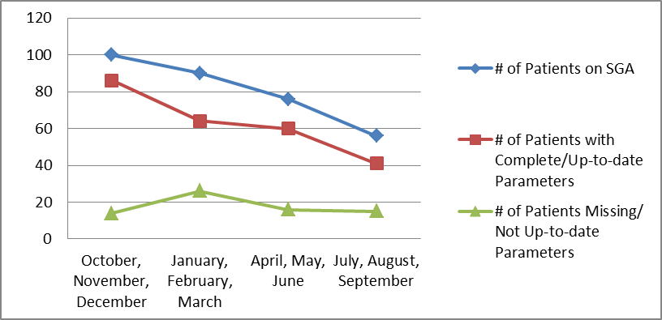

(Glossary of Terms, Acronyms & Abbreviations) (Back to Table of Contents)

|  |
| --- |
| STRATEGIC PERFORMANCE EXCELLENCE |

Metabolic Syndrome Evaluation

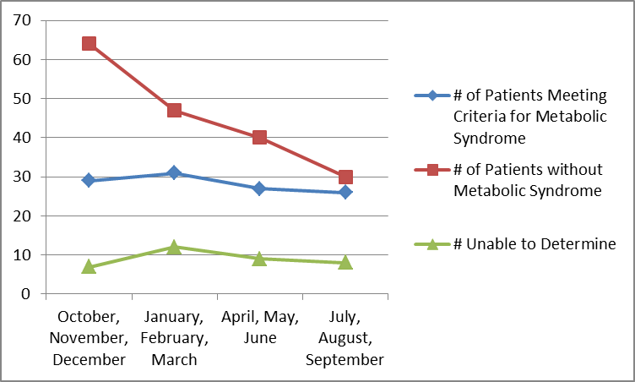

**III. Measure Name: Polytherapy**

**Measure Description:** Polytherapy is defined as “combined treatment of multiple conditions with multiple medications.” This differs from polypharmacy, the “treatment of a single condition with multiple medications from the same pharmacologic class or with the same mechanism of action” which our other monitor, Poly-antipsychotic therapy, addresses. Polypharmacy can lead to complex medication regimens and increases the chances of drug-drug interactions potentially negatively impacting or inhibiting another drug from exerting its intended therapeutic effect. When five or more medications are taken together there is almost a 100% chance of a drug-drug interaction. The purpose of this monitor is to evaluate polytherapy and actively discuss cases with the highest number of medications in an attempt to reduce polytherapy.

**Type of Measure:** Performance Improvement

**Data Analysis:** We have assessed a baseline group of patients with regards to their total number of medications prescribed and further broken it down to number of scheduled medications and number of PRN or “as needed” medications. Each month the patient medication profiles with the highest total number of medications for each unit will be reviewed at the Peer Review Committee to assess the potential for eliminating unnecessary medications. The number of actual profiles reviewed each month will be dependent on time constraints and presence/availability of the patient’s Psychiatric and Medical providers.

**Action Plan:** Our plan is to continue to review patients with numerous medication orders at the monthly Peer Review Committee Meeting. An effort will be made to obtain more information on medication adherence and PRN usage for the patients reviewed. This monitor

(Glossary of Terms, Acronyms & Abbreviations) (Back to Table of Contents)

|  |
| --- |
| STRATEGIC PERFORMANCE EXCELLENCE |

will be reported and discussed with the Medical Staff at the Peer Review and Pharmacy & Therapeutics (P&T) Committees.

**Comments:** A shift towards a higher number of medications ordered was seen again this quarter. It is difficult to determine if this is a result of patient specific factors or provider specific habits. The hospital saw more admissions this quarter and there were 2 months where profiles could not be reviewed at the Peer Review Committee. Efforts will be renewed and reenergized in the next quarter to refocus attention on Polytherapy at the Peer Review and P&T Committees.

**Graph/Chart:**

|  |  |  |  |  |  |  |  |  |  |  |
| --- | --- | --- | --- | --- | --- | --- | --- | --- | --- | --- |
|  | **Baseline Average** | **Baseline Range** | **Q4 2015 Average** | **Q4 2015**  **Range** | **7/08/15 Average** | **7/08/15 Range** | **8/13/15 Average** | **8/13/15 Range** | **9/15/15 Average** | **9/15/15 Range** |
| **Total Orders** | 11.4 | 4 - 37 | 12.1 | 0 – 31 | 12.1 | 0-41 | 12.5 | 0-40 | 12.7 | 0-42 |
| **Scheduled** | 5.5 | 0 - 21 | 4.9 | 0 – 17 | 5.9 | 0-20 | 6.1 | 0-21 | 6.5 | 0-20 |
| **PRNs** | 6 | 1 - 22 | 5.9 | 0 – 19 | 6.7 | 0-21 | 6.8 | 0-21 | 7 | 0-23 |

|  |  |  |  |  |  |  |
| --- | --- | --- | --- | --- | --- | --- |
| **Medication Number Range** | **Number of Patients (Baseline)** | **4Q2015** | **7/8/15** | **8/13/15** | **9/15/15** | **1Q2016** |
| < 5 | 4 | 9 | 5 | 7 | 5 | 17 |
| 5 – 9 | 28 | 32 | 18 | 14 | 18 | 50 |
| 10 – 14 | 33 | 42 | 27 | 37 | 32 | 96 |
| 15 – 19 | 4 | 25 | 18 | 13 | 11 | 42 |
| 20 – 24 | 3 | 4 | 3 | 7 | 7 | 17 |
| 25 – 29 | 2 | 1 | 0 | 1 | 1 | 2 |
| > 30 | 1 | 2 | 2 | 1 | 2 | 5 |

Number of Patients Falling in to Range of Medication Orders:

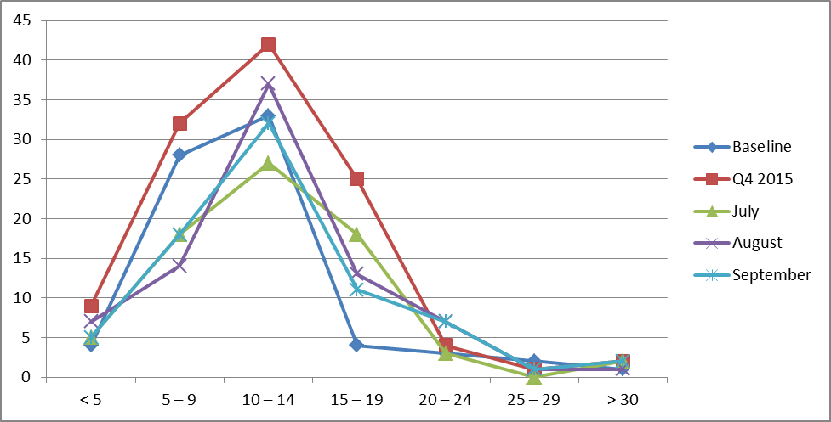

(Glossary of Terms, Acronyms & Abbreviations) (Back to Table of Contents)

|  |
| --- |
| STRATEGIC PERFORMANCE EXCELLENCE |

**Nursing**

**Indicator: Mandate Occurrences**

**Definition:**

When no volunteers are found to cover a required staffing need, an employee is mandated to cover the staffing need according to policy. This creates difficulty for the employee who is required to unexpectedly stay at work up to 16 hours. It also creates a safety risk.

**Objective:**

Through collaboration among direct care staff and management, solutions will be identified to improve the staffing process in order to reduce and eventually eliminate mandate occurrences. This process will foster safety in culture and actions by improving communication, improving staffing capacity, mitigating risk factors, supporting the engagement and empowerment of staff. It will also enhance fiscal accountability by promoting accountability and employing efficiency in operations.

**Those responsible for monitoring:**

Monitoring will be performed by members of the Staffing Improvement Task Force which includes representation of Nurses and Mental Health Workers on all units, Staffing Office and Nursing Leadership.

**Methods of monitoring**

Monitoring would be performed by;

* Staffing Office Database Tracking System
* Human Resources Department Payroll System

**Methods of reporting**

Reporting would occur by one or all of the following methods;

* Staffing Improvement Task Force
* Nursing Leadership
* Riverview Nursing Staff Communication

**Unit**

Mandate shift occurrences

**Baseline**

September 2013: Nurse Mandates 14 shifts, Mental Health Worker Mandates 49 shifts

**Monthly Targets**

10% reduction monthly x4 from baseline

(Glossary of Terms, Acronyms & Abbreviations) (Back to Table of Contents)

|  |
| --- |
| STRATEGIC PERFORMANCE EXCELLENCE |

|  |  |  |  |  |  |  |  |  |  |  |  |  |  |  |
| --- | --- | --- | --- | --- | --- | --- | --- | --- | --- | --- | --- | --- | --- | --- |
| **Mandate Occurrences:** When no volunteers are found to cover a required staffing need, an employee is mandated to cover the staffing need according to policy. | | | | | | | | | | | | | | |
|  | **New Baseline**  **Sept 2013** | **2Q2015** | | | **3Q2015** | | | **4Q2015** | | | **1Q2016** | | | **Goal** |
| **Oct 2014** | **Nov 2014** | **Dec 2014** | **Jan 2015** | **Feb 2015** | **Mar 2015** | **April 2015** | **May 2015** | **June 2015** | **July 2015** | **Aug 2015** | **Sept 2015** |
| Nursing Mandates | 14 | 3 | 1 | 4 | 6 | 20 | 11 | 2 | 4 | 6 | 2 | 1 | 8 | 10% reduction monthly x4 from baseline) |
| Mental Health Worker (MHW) Mandates | 49 | 45 | 39 | 38 | 66 | 39 | 51 | 20 | 44 | 56 | 28 | 39 | 58 | 10% reduction monthly x4 from baseline) |

Nursing mandates decreased from 12 last quarter to 11 this quarter.

MHW mandates increased from 120 last quarter to 125 this quarter.

(Glossary of Terms, Acronyms & Abbreviations) (Back to Table of Contents)

|  |
| --- |
| STRATEGIC PERFORMANCE EXCELLENCE |

**Nursing Department Initial Chart Compliance**

1Q2016 - Lower Saco

|  |  |  |
| --- | --- | --- |
| **Indicator** | **Findings** | **Compliance** |
| 1. Universal Assessment completed by RN within 24 hours | 33/33 | 100% |
| 2. All sections completed or deferred within document | 33/33 | 100% |
| 3. Initial Safety Treatment Plan initiated | 29/33  1 unable | 91% |
| 4. All sheets required signature authenticated by assessing RN | 7/33  26 n/a | 100% |
| 5. Medical Care Plan initiated if Medical problems identified | 33/33 | 100% |
| 6. Informed Consent sheet signed | 31/33  2 refused | 100% |
| 7. Potential for violence assessment upon admission | 33/33 | 100% |
| 8. Suicide potential assessed upon admission | 33/33 | 100% |
| 9. Fall Risk assessment completed upon admission | 4/33  29 n/a | 100% |
| 1 10. Score of 5 or above incorporated into problem need list | 33/33 | 100% |
| 11. Dangerous Risk Tool done upon admission | 12/33  21 n/a | 100% |
| 12. Score of 11 or above incorporated into Safety Problem | 32/33  1 unable | 100% |
| 13. Evidence that patients are routinely informed of their rights upon admission in accordance with ¶ 150 of the settlement agreement is found in the document of the charts reviewed | 33/33 | 100% |

(Glossary of Terms, Acronyms & Abbreviations) (Back to Table of Contents)

|  |
| --- |
| STRATEGIC PERFORMANCE EXCELLENCE |

**Nursing Department Initial Chart Compliance**

1Q2016 - Upper Saco

|  |  |  |
| --- | --- | --- |
| **Indicator** | **Findings** | **Compliance** |
| 1. Universal Assessment completed by RN within 24 hours | 1/1 | 100% |
| 2. All sections completed or deferred within document | 1/1 | 100% |
| 3. Initial Safety Treatment Plan initiated | 1/1 | 100% |
| 4. All sheets required signature authenticated by assessing RN | 1 n/a | 100% |
| 5. Medical Care Plan initiated if Medical problems identified | 1/1 | 100% |
| 6. Informed Consent sheet signed | 1/1 | 100% |
| 7. Potential for violence assessment upon admission | 1/1 | 100% |
| 8. Suicide potential assessed upon admission | 1/1 | 100% |
| 9. Fall Risk assessment completed upon admission | 1 n/a | 100% |
| 1 10. Score of 5 or above incorporated into problem need list | 1/1 | 100% |
| 11. Dangerous Risk Tool done upon admission | 1 n/a | 100% |
| 12. Score of 11 or above incorporated into Safety Problem | 1/1 | 100% |
| 13. Evidence that patients are routinely informed of their rights upon admission in accordance with ¶ 150 of the settlement agreement is found in the document of the charts reviewed. | 1/1 | 100% |

(Glossary of Terms, Acronyms & Abbreviations) (Back to Table of Contents)

|  |
| --- |
| STRATEGIC PERFORMANCE EXCELLENCE |

**Nursing Department Initial Chart Compliance**

1Q2016 - Lower Kennebec

|  |  |  |
| --- | --- | --- |
| **Indicator** | **Findings** | **Compliance** |
| 1. Universal Assessment completed by RN within 24 hours | 28/28 | 100% |
| 2. All sections completed or deferred within document | 28/28 | 100% |
| 3. Initial Safety Treatment Plan initiated | 26/28  2 loc. | 100% |
| 4. All sheets required signature authenticated by assessing RN | 2/28  26 n/a | 100% |
| 5. Medical Care Plan initiated if Medical problems identified | 28/28 | 100% |
| 6. Informed Consent sheet signed | 23/28  4 refused  1 unable | 100% |
| 7. Potential for violence assessment upon admission | 28/28 | 100% |
| 8. Suicide potential assessed upon admission | 28/28 | 100% |
| 9. Fall Risk assessment completed upon admission | 6/28  22 n/a | 100% |
| 1 10. Score of 5 or above incorporated into problem need list | 28/28 | 100% |
| 11. Dangerous Risk Tool done upon admission | 14/28  14 n/a | 100% |
| 12. Score of 11 or above incorporated into Safety Problem | 27/28  1 refused | 100% |
| 13. Evidence that patients are routinely informed of their rights upon admission in accordance with ¶ 150 of the settlement agreement is found in the document of the charts reviewed. | 28/28 | 100% |

(Glossary of Terms, Acronyms & Abbreviations) (Back to Table of Contents)

|  |
| --- |
| STRATEGIC PERFORMANCE EXCELLENCE |

**Nursing Department Initial Chart Compliance**

1Q2016 - Upper Kennebec

|  |  |  |
| --- | --- | --- |
| **Indicator** | **Findings** | **Compliance** |
| 1. Universal Assessment completed by RN within 24 hours | 17/17 | 100% |
| 2. All sections completed or deferred within document | 17/17 | 100% |
| 3. Initial Safety Treatment Plan initiated | 17/17 | 100% |
| 4. All sheets required signature authenticated by assessing RN | 3/17  14 n/a | 100% |
| 5. Medical Care Plan initiated if Medical problems identified | 17/17 | 100% |
| 6. Informed Consent sheet signed | 16/17  1 refused | 100% |
| 7. Potential for violence assessment upon admission | 17/17 | 100% |
| 8. Suicide potential assessed upon admission | 17/17 | 100% |
| 9. Fall Risk assessment completed upon admission | 2/17  15 n/a | 100% |
| 1 10. Score of 5 or above incorporated into problem need list | 17/17 | 100% |
| 11. Dangerous Risk Tool done upon admission | 6/17  11 n/a | 100% |
| 12. Score of 11 or above incorporated into Safety Problem | 17/17 | 100% |
| 13. Evidence that patients are routinely informed of their rights upon admission in accordance with ¶ 150 of the settlement agreement is found in the document of the charts reviewed. | 17/17 | 100% |

(Glossary of Terms, Acronyms & Abbreviations) (Back to Table of Contents)

|  |
| --- |
| STRATEGIC PERFORMANCE EXCELLENCE |

**Nursing Department Initial Chart Compliance**

1Q2015

Total – All Units

|  |  |  |
| --- | --- | --- |
| **Indicator** | **Findings** | **Compliance** |
| 1. Universal Assessment completed by RN within 24 hours | 79/79 | 100% |
| 2. All sections completed or deferred within document | 79/79 | 100% |
| 3. Initial Safety Treatment Plan initiated | 73/79  2 loc.  1 unable | 96% |
| 4. All sheets required signature authenticated by assessing RN | 12/79  67 n/a | 100% |
| 5. Medical Care Plan initiated if Medical problems identified | 79/79 | 100% |
| 6. Informed Consent sheet signed | 71/79  7 refused  1 unable | 100% |
| 7. Potential for violence assessment upon admission | 79/79 | 100% |
| 8. Suicide potential assessed upon admission | 79/79 | 100% |
| 9. Fall Risk assessment completed upon admission | 12/79  67 n/a | 100% |
| 1 10. Score of 5 or above incorporated into problem need list | 79/79 | 100% |
| 11. Dangerous Risk Tool done upon admission | 32/79  47 n/a | 100% |
| 12. Score of 11 or above incorporated into Safety Problem | 77/79  1 refused  1 unable | 100% |
| 13. Evidence that patients are routinely informed of their rights upon admission in accordance with ¶ 150 of the settlement agreement is found in the document of the charts reviewed. | 79/79 | 100% |

(Glossary of Terms, Acronyms & Abbreviations) (Back to Table of Contents)

|  |
| --- |
| STRATEGIC PERFORMANCE EXCELLENCE |

**Outpatient Services (OPS)**

**Responsible Party: Lisa Manwaring, Director**

**I. Measure Name: Admission Assessments**

**Measure Description:** Within 5 business days of admission initial assessments from Psychiatry, Psycho-social, and Nursing will be complete and in the chart. All three will need to be present to count.

**Measure Type:** Performance Improvement

|  |  |  |  |  |  |  |  |
| --- | --- | --- | --- | --- | --- | --- | --- |
| **Results** | | | | | | | |
|  | **Unit** | **Baseline** | **1Q2016** | **2Q2016** | **3Q2016** | **4Q2016** | **YTD** |
| **Target** | Percent of assessments completed on time | FY 2015  0%  0/4 | 85% | 85% | 85% | 85% | **85%** |
| **Actual** | 0%  0/3 |  |  |  | **0%**  **0/3** |

**Data Analysis:** We had one chart with all three assessments this quarter but it was late.

**Action Plan:** To review data results with the OPS staff to ensure compliance.

**Comments:** To provide education and admission packets with assessment reminders to help facilitate compliance.

(Glossary of Terms, Acronyms & Abbreviations) (Back to Table of Contents)

|  |
| --- |
| STRATEGIC PERFORMANCE EXCELLENCE |

**Peer Support**

**Responsible Party: Samantha St. Pierre, Peer Support Director**

|  |  |  |  |  |
| --- | --- | --- | --- | --- |
| **Indicator** | **1Q2016** | **2Q2016** | **3Q2016** | **4Q2016** |
| 1. Peer Specialist will meet with residents with 48 hours of admission and complete progress note to document meeting. | 100%  63/63 |  |  |  |
| 2. Each resident has documented contact with a peer supporter during their hospitalization (target is 100%). | 100%  63/63 |  |  |  |

**Indicator: Inpatient Consumer Survey Return Rate**

**Definition:**

There is a low number of satisfaction surveys completed and returned once offered to patients due to a number of factors.

**Objective:**

To increase the number of surveys offered to patients, as well as increase the return rate.

**Those responsible for Monitoring:**

Peer Support Director and Peer Support Team Leader will be responsible for developing tracking tools to monitor survey due dates and surveys that are offered, refused, and completed. Peer Support Staff will be responsible for offering surveys to patients and tracking them until the responsibility can be assigned to one person.

**Methods of Monitoring:**

* Biweekly supervision check-ins
* Monthly tracking sheets/reports submitted for review

**Methods of Reporting:**

* Patient Satisfaction Survey Tracking Sheet
* Completed surveys entered into spreadsheet/database

**Unit:** All patient care/residential units

**Baseline:** Determined from previous year’s data.

**Quarterly Targets:** Quarterly targets vary based on unit baseline with the end target being 50%.

(Glossary of Terms, Acronyms & Abbreviations) (Back to Table of Contents)

|  |
| --- |
| STRATEGIC PERFORMANCE EXCELLENCE |

|  |  |  |  |  |  |  |  |  |
| --- | --- | --- | --- | --- | --- | --- | --- | --- |
| **Survey Return Rate** | **Unit** | **Baseline** | **Target** | **2Q2015** | **3Q2015** | **4Q2015** | **1Q2016** | **YTD** |
| The inpatient consumer survey is the primary tool for collecting data on how patients feel about the services they are provided at the hospital. | **LK** | 15% | 50% | 17% | 37% | 20% | 41%  7/17 | **30%** |
| **LS** | 5% | 50% | 25% | 62% | 0% | 0%  0/21 | **22%** |
| **UK** | 45% | 50% | 28% | 26% | 27% | 18%  3/17 | **25%** |
| **US** | 30% | 50% | 25% | 100% | 100% | 88%  7/8 | **78%** |
|  | **Overall** |  |  |  |  |  | **27%**  **17/63** | **27%**  **17/63** |

**Comments:**

Percentages are calculated based on the number of people eligible to receive a survey vs. the number of people who completed the surveys.

**Inpatient Consumer Survey Results:**

|  |  |  |  |  |  |  |
| --- | --- | --- | --- | --- | --- | --- |
| # | **Indicators** | **2Q**  **2015** | **3Q**  **2015** | **4Q**  **2015** | **1Q**  **2016** | **Average** |
| 1 | I am better able to deal with crisis. | 79% | 75% | 69% | 69% | **73%** |
| 2 | My symptoms are not bothering me as much. | 71% | 73% | 69% | 79% | **73%** |
| 3 | The medications I am taking help me control symptoms that used to bother me. | 73% | 71% | 77% | 75% | **74%** |
| 4 | I do better in social situations. | 69% | 73% | 63% | 71% | **69%** |
| 5 | I deal more effectively with daily problems. | 69% | 75% | 71% | 73% | **72%** |
| 6 | I was treated with dignity and respect. | 65% | 69% | 73% | 71% | **69%** |
| 7 | Staff here believed that I could grow, change and recover. | 75% | 74% | 63% | 69% | **70%** |
| 8 | I felt comfortable asking questions about my treatment and medications. | 73% | 71% | 54% | 68% | **66%** |
| 9 | I was encouraged to use self-help/support groups. | 77% | 77% | 56% | 72% | **71%** |
| 10 | I was given information about how to manage my medication side effects. | 67% | 60% | 63% | 68% | **64%** |
| 11 | My other medical conditions were treated. | 56% | 69% | 65% | 65% | **64%** |
| 12 | I felt this hospital stay was necessary. | 67% | 50% | 67% | 65% | **62%** |

(Glossary of Terms, Acronyms & Abbreviations) (Back to Table of Contents)

|  |
| --- |
| STRATEGIC PERFORMANCE EXCELLENCE |

|  |  |  |  |  |  |  |
| --- | --- | --- | --- | --- | --- | --- |
| # | **Indicators** | **2Q**  **2015** | **3Q**  **2015** | **4Q**  **2015** | **1Q 2016** | **Average** |
| 13 | I felt free to complain without fear of retaliation. | 67% | 54% | 56% | 69% | **62%** |
| 14 | I felt safe to refuse medication or treatment during my hospital stay. | 60% | 49% | 54% | 62% | **56%** |
| 15 | My complaints and grievances were addressed. | 50% | 63% | 65% | 63% | **60%** |
| 16 | I participated in planning my discharge. | 60% | 66% | 38% | 75% | **60%** |
| 17 | Both I and my doctor or therapists from the community were actively involved in my hospital treatment plan. | 50% | 52% | 38% | 63% | **51%** |
| 18 | I had an opportunity to talk with my doctor or therapist from the community prior to discharge. | 57% | 47% | 54% | 63% | **55%** |
| 19 | The surroundings and atmosphere at the hospital helped me get better. | 58% | 61% | 60% | 68% | **62%** |
| 20 | I felt I had enough privacy in the hospital. | 63% | 66% | 58% | 64% | **63%** |
| 21 | I felt safe while I was in the hospital. | 50% | 72% | 69% | 62% | **63%** |
| 22 | The hospital environment was clean and comfortable. | 71% | 74% | 74% | 66% | **71%** |
| 23 | Staff were sensitive to my cultural background. | 60% | 65% | 65% | 61% | **63%** |
| 24 | My family and/or friends were able to visit me. | 50% | 68% | 73% | 69% | **65%** |
| 25 | I had a choice of treatment options. | 75% | 60% | 52% | 64% | **63%** |
| 26 | My contact with my doctor was helpful. | 69% | 55% | 62% | 66% | **63%** |
| 27 | My contact with nurses and therapists was helpful. | 69% | 57% | 53% | 66% | **61%** |
| 28 | If I had a choice of hospitals, I would still choose this one. | 67% | 54% | 60% | 55% | **59%** |
| 29 | Did anyone tell you about your rights? | 62% | 74% | 77% | 71% | **71%** |
| 30 | Are you told ahead of time of changes in your privileges, appointments, or daily routine? | 60% | 60% | 69% | 63% | **63%** |
| 31 | Do you know someone who can help you get what you want or stand up for your rights? | 73% | 77% | 77% | 74% | **75%** |
| 32 | My pain was managed. | 68% | 65% | 75% | 62% | **67%** |
|  | **Overall Score** | **65%** | **65%** | **63%** | **67%** | **65%** |

(Glossary of Terms, Acronyms & Abbreviations) (Back to Table of Contents)

|  |
| --- |
| STRATEGIC PERFORMANCE EXCELLENCE |

**Pharmacy Services**

**Responsible Party: Michael Migliore, Director of Pharmacy**

I. **Measure Name:** **Controlled Substance Loss Data**

**Measure Description:** Daily and monthly comparison of Pyxis vs CII Safe Transaction Report.

**Type of Measure:** Quality Assurance

|  |  |  |  |  |  |  |  |
| --- | --- | --- | --- | --- | --- | --- | --- |
|  | **Results** | | | | | | |
|  | **Unit** | **Baseline**  **FY 2015** | **1Q2016** | **2Q2016** | **3Q2016** | **4Q2016** | **YTD** |
| **Target** | Pharmacy | 0.185% | 0% | 0% | 0% | 0% | 0% |
| **Actual** | 0% | 0% | 0% | 0.38% | 0.1% |

**Data Analysis:** There were 22 controlled substance (CS) discrepancies out of a total of 5789 controlled substances dispensed from Pyxis CII Safe for the first quarter of FY 2016. All discrepancies were reconciled as there are no variances.

**Action Plan:** To track and understand what is causing the discrepancies.

**Comments:** Baseline for FY2015 was 0.875%. There has been a great improvement during FY2015 with a baseline of 0.185%.

**Graph/Chart:**

|  |  |  |  |
| --- | --- | --- | --- |
|  | **FY 2014** | **FY 2015** | **FY 2016** |
| **Baseline** | 0.88% | 0.19% |  |
| **1st Quarter** |  |  | 0.38% |
| **2nd Quarter** |  |  |  |
| **3rd Quarter** |  |  |  |
| **4th Quarter** |  |  |  |

(Glossary of Terms, Acronyms & Abbreviations) (Back to Table of Contents)

|  |
| --- |
| STRATEGIC PERFORMANCE EXCELLENCE |

II. **Measure Name: Invalid Orders**

**Measure Description:** Incomplete/invalid orders.

**Type of Measure:** Performance Improvement

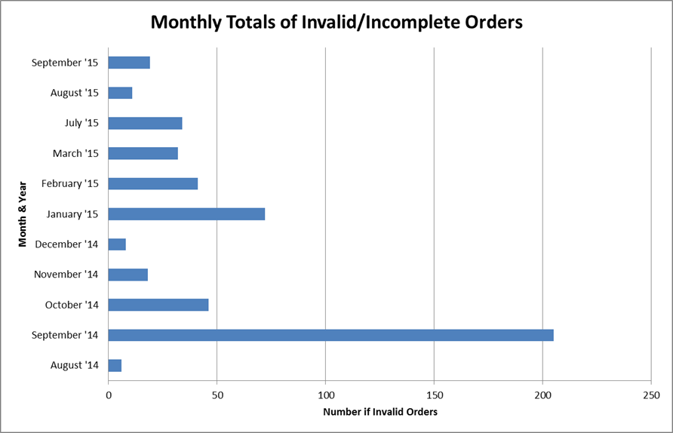

**Data Analysis:** Every time we receive an order that is incomplete we notate what we are missing and send that back to the unit as well as call the provider. The hospital has a zero tolerance policy for incomplete orders. The data for this quarter (July to September 2015) is included in the chart above.

**Action Plan:** Whenever an incomplete order is received by the pharmacy we do our best to make contact with both the unit and the prescriber to provide re-education on the spot. Most of the time it is a simple oversight, but with the newer providers it is especially important to help them become acclimated to our system.

**Comments:** The complete process for this data collection was not fully communicated to the present employees until the last couple of weeks. We have devised an enhanced system for more complete data collection regarding incomplete orders.

(Glossary of Terms, Acronyms & Abbreviations) (Back to Table of Contents)

|  |
| --- |
| STRATEGIC PERFORMANCE EXCELLENCE |

III. **Measure Name:** **Veriform Medication Room Audits**

**Measure Description:** Monthly comprehensive audits of 38 criteria (compliance audits).

**Type of Measure:** Quality Assurance

|  |  |  |  |  |  |  |  |
| --- | --- | --- | --- | --- | --- | --- | --- |
|  | **Results** | | | | | | |
|  | **Unit** | **Baseline**  **FY 2015** | **1Q2016** | **2Q2016** | **3Q2016** | **4Q2016** | **YTD** |
| **Target** | All | 98% | 100% | 100% | 100% | 100% | **100%** |
| **Actual** | 97% | 98% | 98% | 97% | **98%** |

**Data Analysis:** The audits for all the units have been completed for the quarter. Criteria found upon inspection that could be improved:

1. Five out of 18 inspections were not labeled with an expiration date or beyond use date.
2. Crash card daily readiness log was not always maintained.
3. On one inspection the crash cart was not secure and was not locked when not in use.
4. The daily record of refrigerator temperatures was not maintained twice.
5. Medication storage areas were not locked and secured in 6 out of 18 inspections.
6. Patient medication drawers could be more clean and organized.
7. Twice patient’s own meds were found not stored security according to policy.
8. Pharmaceutical waste containers were found out of place or used inappropriately.

All other criteria was found to be 100% met.

**Action Plan:** The findings will be communicated to the Pharmacy and Nursing staff to improve these criteria while maintaining our thoroughness on all of the criteria. Communication will be encouraged between departments.

**Comments:** The baseline for FY15 for criteria met was 98%, which leaves us room for improvement.

(Glossary of Terms, Acronyms & Abbreviations) (Back to Table of Contents)

|  |
| --- |
| STRATEGIC PERFORMANCE EXCELLENCE |

IV. **Measure Name: Fiscal Accountability**

**Measure Description:** Monthly and tracking of dispensed discharge prescriptions.

**Type of Measure:** Quality Assurance

|  |  |  |  |  |  |  |  |
| --- | --- | --- | --- | --- | --- | --- | --- |
|  | **Results** | | | | | | |
|  | **Unit** | **Baseline**  **FY 2015** | **2Q 2015** | **3Q 2015** | **4Q 2015** | **1Q 2016** | **YTD** |
| **Target** | All | $15,764 for 861 Rx’s |  |  |  | Limit to outpatient Rx’s |  |
| **Actual** | $2,731  for 135 Rx’s | $4,474  for 295  Rx’s | $5,266  for 261  Rx’s | $5,281  for  368  Rx’s | **$17,752 for 1,229 Rx’s** |

**Data Analysis:** Riverview is licensed to dispense as an outpatient pharmacy, in addition to inpatient. Outpatient prescriptions are done on a limited basis. Most of these prescriptions are for patients being discharged of which a 7 day supply is given. Dr. Kirby, the Clinical Director, can approve special circumstances which may need greater than a 7 day supply. The medications are given to overlap until the patients can get their own prescriptions filled.

**Action Plan:** We will involve Social Workers at Riverview in paving the way for third party payment before the patient is discharged, which would cut down on the discharge medications that Riverview provides.

**Comments:** Riverview can save money and increase revenue by working on the action plan above.

(Glossary of Terms, Acronyms & Abbreviations) (Back to Table of Contents)

|  |
| --- |
| STRATEGIC PERFORMANCE EXCELLENCE |

V. **Measure Name:** **Medication Management – Non Controlled Discrepancies**

**Measure Description:** Monthly monitoring of non-controlled discrepancies.

**Type of Measure:** Quality Assurance

|  |  |  |  |  |  |  |  |
| --- | --- | --- | --- | --- | --- | --- | --- |
|  | **Unit** | **Baseline 2014** | **2Q2015** | **3Q2015** | **4Q2015** | **1Q2016** | **YTD** |
| **Target** | All | 22/  month | 0 | 0 | 0 | 0 | 255  (21/mo) |
| **Actual** | 70  (23/mo) | 68  (23/mo) | 54  (18/mo) | 63  (18/mo) |

**Data Analysis:** Knowledge Portal showed 62.7 average number of non-controlled discrepancies for 1Q2016. This is a 3 month total out of a total 75,092 doses dispensed from Pyxis MedStation System.

**Action Plan:** We are to start documenting our discrepancies. From this information we should be able to reduce the number of discrepancies.

**Comments:** Our monthly numbers are staying consistent so far with the previous year.

(Glossary of Terms, Acronyms & Abbreviations) (Back to Table of Contents)

|  |
| --- |
| STRATEGIC PERFORMANCE EXCELLENCE |

**Psychology**

**Responsible Party: Arthur DiRocco, Ph.D., Director of Psychology**

**Measure Name:** Brief Cognitive Intake Assessments.

**Measure Description:** This measure is a performance improvement effort intended to provide clinicians and staff with information regarding the cognitive capacity of individuals admitted to RPC within 7 days of admission. Such information is considered to be beneficial for the treatment of our patients.

**Type of Measure:** Performance Improvement

|  |  |  |  |  |  |  |  |
| --- | --- | --- | --- | --- | --- | --- | --- |
|  | **Results** | | | | | | |
|  | **Unit** | **Baseline** | **2Q2015** | **3Q2015** | **4Q2015** | **1Q2016** | **YTD** |
| **Target** | Percent of assessments completed on time | FY14  Q3 & Q4  .055 | 90% | 90% | 90% | 90% | 90% |
| **Actual** | 26/65 40% | 20/34 59% | 24/39 62% | 26/41 60% | 106/198 54% |

**Data Analysis:** Results show significant improvement over baseline (3rd and 4th Quarter in FY 14). The 1st quarter (Oct 14 to Dec 14) yielded a promising start towards a goal of 90% assessments of incoming patients. The second and third quarters (Jan to Mar 15 and Apr to Jun 15) showed modest but continuing improvement in delivery of assessments. Fourth quarter results showed greater numbers of assessments but also a significant increase in the flow of patients. Several factors seem to limit our desired rate of growth: Rapid turn-around in patient stay, refusal, or incapacity to engage in the assessment process, increased patient numbers, and logistics of staffing. Departing interns and arrival of new interns in July creates a deficit of available psychology staff to conduct the assessments.

**Action Plan:** the department has instituted a calendar assignment process that has been implemented in August. This assigns a staff rotation to engage in the assessment rather than to have the burden fall solely on the intake unit staff.

(Glossary of Terms, Acronyms & Abbreviations) (Back to Table of Contents)

|  |
| --- |
| STRATEGIC PERFORMANCE EXCELLENCE |

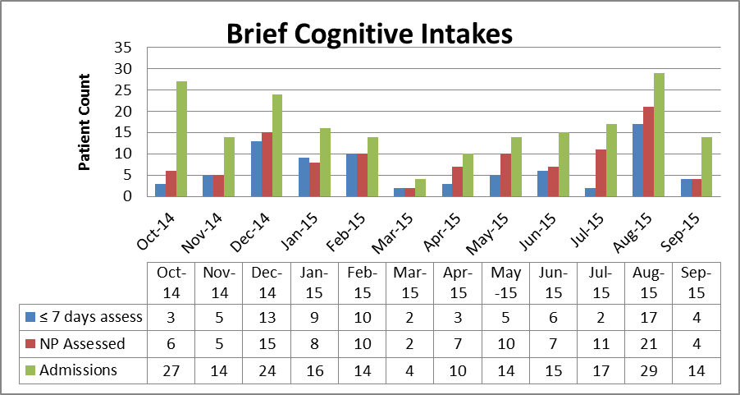

The accompanying chart shows the progress of assessment in relation to the number of admissions. The number of individuals assessed within 7 days of their arrival is showing considerable growth. September’s data is based on partial data and is expected to be higher by the close of the month.

(Glossary of Terms, Acronyms & Abbreviations) (Back to Table of Contents)

|  |
| --- |
| STRATEGIC PERFORMANCE EXCELLENCE |

**Rehabilitation Services**

**(Occupational Therapy, Therapeutic Recreation, Vocational Services,**

**Chaplaincy, Patient Education)**

**Responsible Party: Janet Barrett, CTRS, Director of Rehabilitation Services**

**I. Measure Name: Occupational Therapy Service Orders**

**Measure Description:** Improving health outcomes/patient care. In order to receive effective treatment, all patients receiving Occupational Therapy Services have a doctor’s order and referral sheet completed before services are initiated.

**Methodology:** Each quarter Rehabilitation Services Director will audit the Occupational Therapy Referral Log and review the list of all patients receiving services to ensure a doctor’s order for the service has been written and a referral to OT was completed before the patient began receiving services.

The numerator will be the number of OT Service referrals that include the required MD order, the denominator will be the total number of OT Service referrals received.

**Goal:** To achieve and maintain an overall goal of 100% for 4 consecutive Quarters

**Type of Measure:** Performance Improvement

|  |  |  |  |  |  |  |  |
| --- | --- | --- | --- | --- | --- | --- | --- |
| **Results** | | | | | | | |
|  | **Unit** | **Baseline** | **1Q2016** | **2Q2016** | **3Q2016** | **4Q2016** | **YTD** |
| **Target** | Each patient receiving OT services has an MD order | FY 2015  97% | 100% | 100% | 100% | 100% | **100%** |
| **Actual** | 100%  25/25 |  |  |  | **100%**  **25/25** |

**Data Analysis:**

In review of Occupational Therapy Services Log all patients referred for services from July 1st to September 30, 2015 had both the referral sheet completed as well at the doctor’s order attached to it.

**Action Plan:**

Reviewed the results of the audit with Occupational Therapy staff and reviewed with staff the licensing standard that references not beginning Rehab. Services without an MD order.

(Glossary of Terms, Acronyms & Abbreviations) (Back to Table of Contents)

|  |
| --- |
| STRATEGIC PERFORMANCE EXCELLENCE |

**II. Measure Name: Vocational Services Documentation**

**Measure Description:** Improving health outcomes/patient care. In order to receive effective treatment, all patients engaged in the Vocational Rehabilitation Program will have updated treatment plans and weekly documentation on the progress towards addressing the intervention outlines in the treatment plan.

**Methodology:** Each quarter Rehabilitation Services Director will audit the charts of the patients involved in the Vocational Rehabilitation Program to review treatment plans and progress notes to ensure they are being completed in a timely manner and updated on a regular basis.

The numerator will be the number of patient charts with the required documentation and the denominator will be the total number of patients in the Vocational Rehabilitation Program.

**Goal:** To achieve and maintain an overall goal of 100% for 4 consecutive Quarters

**Type of Measure:** Performance Improvement

|  |  |  |  |  |  |  |  |
| --- | --- | --- | --- | --- | --- | --- | --- |
| **Results** | | | | | | | |
|  | **Unit** | **Baseline** | **1Q2016** | **2Q2016** | **3Q2016** | **4Q2016** | **YTD** |
| **Target** | Each patient working in the Voc. Rehab. Program has required documentation | 60% | 100% | 100% | 100% | 100% | **100%** |
| **Actual** | 50%  6/12 |  |  |  | **50%**  **6/12** |

**Data Analysis:**

Charts were audited using the Rehab. Services –Vocational Services tool. It was discovered while doing chart audits that one Employment Specialist was not completing their documentation on a weekly basis. The staff person was educated and counseled on this performance indicator.

**Action Plan:**

Reviewed the results of the audit with Vocational Rehab staff and will do monthly audits instead of quarterly audits of the patient charts for those involved in the Vocational Rehab Program. This will capture any incomplete documentation in a more timely fashion. The above mentioned staff will submit copies of notes on a weekly basis for the next 3 months to ensure they are getting completed in a timely fashion

(Glossary of Terms, Acronyms & Abbreviations) (Back to Table of Contents)

|  |
| --- |
| STRATEGIC PERFORMANCE EXCELLENCE |

**Safety & Security**

**Responsible Party: Philip Tricarico, Safety Officer**

**Measure Name: Grounds Safety & Security Incidents**

**Measure Description:** Safety/Security incidents occurring on the grounds at Riverview. Grounds being defined as “outside the building footprint of the facility; being the secured yards, parking lots, pathways surrounding the footprint, unsecured exterior doors, and lawns.” Incidents being defined as, “Acts of thefts, vandalism, injuries, mischief, contraband found, and safety / security breaches.” These incidents shall also include “near misses, being of which if they had gone unnoticed, could have resulted in injury, an accident, or unwanted event”.

**Type of Measure:** Quality Assurance

|  |  |  |  |  |  |  |  |
| --- | --- | --- | --- | --- | --- | --- | --- |
| **Results** | | | | | | | |
|  | **Unit** | **Baseline** | **2Q2015** | **3Q2015** | **4Q2015** | **1Q2016** | **Total** |
| **Target** | # of Incidents | *Baseline of 10 | 12 | 16 | 4 | 2 | **34** |
| **Actual** | 17 | 4 | 2 | 4 | **27** |

**Summary of Events:**

The Q1 target was (2). Our actual number was (4). We did not make our goal. Prior to this we have been on a very good streak of meeting and even exceeding our goals. We have not had any issues this quarter with state owned pickup trucks and the contraband they frequently contained. We have been working with Capitol Police, Fleet Management and the Department of Conservation (agency the trucks are assigned to). There has been significant improvement in how often we are finding contraband items in these trucks. We will continue to work with all parties as we seek to resolve this issue. Our problem area for this quarter appears to be our fleet of rental vehicles. Even though Security asks every person who returns a vehicle if it is locked, we had two incidents of cars left unlocked. These vehicles contain state credit cards and other items of value. Our approach has been to treat this as a supervisory issue. We are pleased that in all of the events, our Security staff or clinical staff had discovered/processed the event before there was a negative impact to the patients. The reporting, which follows below, continues to provide a very clear picture of Safety and Security events, how they are handled, and that the use of surveillance equipment plays an integral part in combating safety and security threats to people and property. Our aggressive rounds by Securitas continues to prove its worth with regard to Security’s presence and patrol techniques. The stability and longevity of our Security staff along with its cohesiveness with the Clinical component of the hospital has proven to be most effective in our management of practices.

(Glossary of Terms, Acronyms & Abbreviations) (Back to Table of Contents)

|  |
| --- |
| STRATEGIC PERFORMANCE EXCELLENCE |

**Safety & Security Incidents:**

|  |  |  |  |  |  |
| --- | --- | --- | --- | --- | --- |
| **Event** | **Date** | **Time** | **Location** | **Disposition** | **Comments** |
| **1. Security Concern** (Unlocked, unsecured state vehicle #2565) | 8/24/15 | 0335 | Front Parking Lot | Relocked vehicle | While conducting routine rounds Security discovered a state vehicle completely unlocked. State credit card and other items exposed to theft. NOD notified. |
| **2. Security Concern** (Contraband, hammers and wrenches in the truck bed) | 8/25/15 | 0410 | Employee Parking Area | Removed contraband from truck bed | During routine rounds Security found a pickup truck with contraband items in the bed. The owner was found and the items removed. See IR #15-0327. |
| **3. Security Concern**  (Gate to the Fire Road left open, Saco side) | 8/29/15 | 0320 | Fire Road, Saco end | Gate closed and locked | During routine rounds Security discovered the gate on the Fire Road on the Saco side was open and unlocked. Security clocked and locked gate. See IR #15-0328. |
| **4. Security Concern** (Unlocked, unsecured state vehicle #2565) | 8/29/15 | 0338 | Front Parking Lot | Relocked vehicle | During routine rounds Security found state vehicle #2565 completely unlocked. State credit card and other items exposed to theft. See IR #15-0329. |

(Glossary of Terms, Acronyms & Abbreviations) (Back to Table of Contents)

|  |
| --- |
| STRATEGIC PERFORMANCE EXCELLENCE |

**Social Work**

**Responsible Party: Stephanie George-Roy, LCSW, Director of Social Work**

**Measure Name: Social Work Community Connections**

**Measure Description:** The Social Work Department will ensure that 100% of the time patients will be offered to have social work assist them in securing correctional, familial, and natural or community provider participation in their treatment during their admission to Riverview Psychiatric Center to facilitate continuity in discharge planning back to the community.

**Type of Measure:** Quality Assurance

**Methodology:**

The Social Worker will engage with client during Service Integration Meeting within 3 days of admission to ensure that the patient is informed of the opportunity to have external self-identified recovery supports participate in their treatment services at RPC.

**Goal:** To achieve and maintain an overall goal of 100% for 4 consecutive Quarters

|  |  |  |  |  |  |  |  |
| --- | --- | --- | --- | --- | --- | --- | --- |
| **Results** | | | | | | | |
|  | **Unit** | **Baseline** | **1Q2016** | **2Q2016** | **3Q2016** | **4Q2016** | **YTD** |
| **Target** | Each patient is offered assistance with securing identified recovery supports from the community | N/A new for FY 16 | 100% | 100% | 100% | 100% | **100%** |
| **Actual** | 100%  61/61 |  |  |  | **100%**  **61/61** |

**Data Analysis:**

In chart audits completed over the first quarter 61 patients completed the Service Integration Meeting with their assigned social worker and were asked to identify recovery supports from the community. Three patients declined (65 total admissions in the quarter) declined to participate in the Service Integration meeting and declined on follow up.

**Action Plan:**

Reviewed the results of the audit with Social Work staff and continue with chart audits and documenting results.