Date: May 22, 2008

Project: Proposal by Eastern Maine Medical Center

To: Catherine Cobb, Director of Licensing and Regulatory Services

Prepared by: Phyllis Powell, Certificate of Need Manager
Steven Keaten, Healthcare Financial Analyst
Larry Carbonneau, Healthcare Financial Analyst

Directly Affected Party: None

Recommendation: Disapprove

Proposed Approved
Per Applicant CON

Estimated Capital Expenditure $ 243,585,921 $ 0
Maximum Contingency $ 18,718,400 $ 0
Total Capital Expenditure with Contingency $ 262,304,321 $ 0
Third Year Incremental Operating Costs $ 25,400,660 $ 0

Capital Investment Fund (CIF) Impact: $ 18,368,698 $ 0
CIF debit 2008 $ 1,836,870 $ 0
CIF debit 2009 $ 1,836,870 $ 0
CIF debit 2010 $ 1,836,870 $ 0
CIF debit 2011 $ 1,836,870 $ 0
CIF debit 2012 $ 1,836,870 $ 0
CIF debit 2013 $ 1,836,870 $ 0
CIF debit 2014 $ 1,836,870 $ 0
CIF debit 2015 $ 1,836,870 $ 0
CIF debit 2016 $ 1,836,870 $ 0
CIF debit 2017 $ 1,836,870 $ 0

Bureau of Insurance Impact Estimate 1.114%

INTRODUCTION

CON application for Facility Plan - Phase to Construct New Inpatient Tower

“Eastern Maine Medical Center’s (EMMC) main inpatient tower is almost 35 years old. In the past year, EMMC has been functioning at an average close to 90+% occupancy of 344 available and staffed beds. Literature indicates that the most efficiently run facilities operate at 75 – 80% for semi-private rooms and 80-85% of private rooms. In 2006, EMMC engaged MorrisSwitzer Environments for Health (Architects) to assist with the development of a master facility plan. Up to this time, EMMC has made several critical decisions about the future of delivery. To ease congestion and to cater to the different demands of outpatients, EMMC has been successful in relocating a variety of ambulatory services, including chronic dialysis, outpatient therapies, eye surgery, primary care practices, and walk-in-care off of the main State Street campus. The CancerCare of Maine building, and the Outpatient Imaging Center are both due to open to patients in 2009. All of these services have been welcomed into the community and offer high quality outpatient care in convenient locations.”

Quality and Safety: Patients and Employees

“Safety for patients and employees is core to this project. EMMC expects quality indicators to improve with new efficient space and private rooms. Employees will be safer due to less congestion and more modern, evidence-based designed layout.”

Specific Elements of Inpatient Tower Phase – “The proposed project updates and enhances current services. The current plan was scaled back from the full master facility plan due to financial realities. Also EMMC’s cash position is weaker than usual due to high MaineCare receivables. The plan includes the following key elements:
- Add 67 additional available beds in private rooms, bringing available beds to the EMMC licensed bed number of 411. No new licensed beds are requested as part of this project.
- A new surgery suite comprised of 14 operating rooms, to share space with outpatient surgery and saving a significant FTE number due to shared resources and space.
- Relocated womens’ obstetrical (OB) and neonatal intensive care units (NICU), recognizing age and size of current program space in Grant tower. The NICU bed need is 30 beds.
- Elevating heart care - EMMC is recognized for excellent heart care. The plan would co-locate cardiac and telemetry beds and position EMMC to be officially recognized as a heart Center of Excellence.
- Add an 8 Bed Observation unit adjacent to the Emergency Room”

Capital Cost, Financial Feasibility and Third Year Incremental Operating Costs.

“This Inpatient Tower phase has a capital cost of approximately $253 million, with third year incremental operating costs of $18,368,698. The project is financially feasible and intends to serve the patients and healthcare workforce of the region for many years to come. The new facility will focus on staff efficiency, patient safety, and energy conservation.”

I. Project Description

A. From Applicant

Healthcare Delivery System in Northern, Eastern, Central Maine and EMMC’s role

“Since EMMC built the Grant Inpatient Tower in the early 70’s, healthcare in this most rural region of Maine has changed significantly. Twelve of 21 hospitals in the region are now designated as Critical Access Hospitals and are limited by length of stay criteria and by other considerations in the number and range of procedures they provide. Healthcare delivery is increasingly more reliant on technology that provides diagnosis and treatment services for patients but may not be affordable or feasible for regional hospitals to acquire.”

“EMMC has been a leader in assuring access to specialty services for rural Mainers through support for LifeFlight, employment of multiple specialists, including general and orthopaedic trauma surgeons; and investment in robust telehealth programs that bring radiologists to rural hospitals through PACS (picture archiving communications systems) and the soon to be available virtual ICU support.”

“Over the past few years, more and more patients are coming to EMMC for their acute inpatient services. Many are transferred from emergency departments or inpatient units of rural hospitals when they determine transfer to EMMC would be in the best interest of the patient.”

“Letters of support from regional hospitals and providers are included in Attachment K.”

“In the past year, EMMC has been functioning at an average 90+% occupancy of 344 available and staffed beds. Literature (See A Delicate Balance, Attachment B) indicates that the most efficiently run facilities operate at 75 – 80% for semi-private rooms and 80-85% of private rooms. A very high occupancy rate results in higher patient transfer numbers between rooms and greater noise levels which have been shown to be detrimental to patient recovery, and put patients and staff at greater risk for errors.”

Eastern Maine Medical Master Facility Plan
“In the spring of 2006 EMMC began work on a plan to determine how EMMC could continue to meet the needs of the region well into the 21st century.”

“The key recommendations of this planning process are that EMMC’s main hospital facility and State Street campus be utilized primarily for inpatient and specialty care services and that where feasible, outpatient services be relocated off-campus. EMMC’s recent CON approvals to relocate cancer care and outpatient imaging services off-campus are early steps in this process.”

“At this time, EMMC plans to update, upgrade and enhance current inpatient and surgical services.”

Values of the Master Facility Plan

“The following Values are part of the EMMC Master Plan:
- Create a spirit of partnership
- Improve the care of patients and staff
- Design for the future
- Promote fiscal responsibility
- Promote environmental responsibility
- Sustain regional mission – need capacity to serve all patients needing care in the region
- Utilize Evidence-Based Design ---Quality
  - Zero Defects – EMMC is committed to attaining “zero defects” on CMS “always” and “never indicators”. This is explained further in section VII on Quality.
  - Improve patient outcomes
  - Research (a representative sample of which is included in Attachment B) finds that a well-designed facility coupled with good processes can make patient stays better and safer, shorter and at a lower cost with:
    - Improved outcomes
    - Reduced length of stay
    - Reduced nosocomial infections
    - Reduced falls
    - Reduced transfers
    - Reduced pain medication and fewer medication errors
    - Reduced noise
    - Increased rest for patients
    - Increased privacy and confidentiality”

“The proposal contained in this application addresses the need to enhance inpatient and specialty services.”

“Ultimate Goals for EMMC’s Master Facility Plan:
- Increase capacity for care, particularly inpatient care
- Replace outdated surgical suites.
- Enhanced clinical services, particularly heart care, critical care and women & infant care
- Improve access to inpatient care for regional residents.
- All single rooms
- Improve access points for patients
- Create Centers for Women’s and Children, Cardio-Vascular and Rehab
- Demolish/Upgrade Non-productive buildings.”

“Not all of these goals can be attained at once. This proposal addresses the most crucial first:
- Expand the supply of inpatient acute care, critical care, and NICU beds.
- Improve the ability of the Emergency Department to respond to patient needs as they occur. By addressing space deficiencies throughout the medical center that have result in backlogs in the emergency, the number of patients leaving without being seen. (LWBS) will be reduced. The National Standard for patients leaving without being seen is less than 2% of visits. EMMC’s most recent results are 2.9% patient visits recorded as LWBS.
- To the extent possible, move services off the State Street campus to provide space for tertiary, trauma and specialty care services and to alleviate congestion.
- EMMC’s 35 year old inpatient operating suites must be replaced and upgraded. They are inadequate to serve current and future needs for equipment and technology in the realigning of space, utility support and support space.”

“Even though the bulk of the existing inpatient tower and operating rooms were built in the early 1970’s this is the “new” part of the EMMC campus. EMMC’s long range plans for the site will be to ultimately remove some of the outdated buildings on the campus that range from 60 to 110 years old, excluding the Mace House which is the birthplace of Bangor General Hospital in 1867.”

“Currently the Grant Tower at EMMC holds the majority of EMMC’s inpatient nursing units; including general med/surg, critical care, pediatrics and specialty units. Only acute rehab is located in other buildings. The Grant building also houses inpatient surgery, emergency services, critical care units, and some outpatient and diagnostic services.”

Phase to Construct New Inpatient Tower
“The proposal contained in this application is the next phase in EMMC’s Master Facility Plan. Major components include a new inpatient tower, new operating rooms and reorganization of the all surgical departments, relocation and expansion of women’s and infants’ inpatient services, and the addition of an observation unit to the emergency department and renovations of some existing space.”

“EMMC plans to construct a new eight-story patient tower adjacent to the Grant Tower on EMMC’s State Street campus. Other new construction will be for a relocated and expanded Neonatal Intensive Care Unit on the third level on the north side of the Grant Tower and an Observation Unit adjacent to the existing emergency department. These locations make best use of the investments already made to the facilities in this area over the last 35 years.”

“Our proposal to begin a phased expansion and modernization of inpatient space at EMMC is based on the following needs:”
- Increased access by expanding inpatient capacity
  - “Expert projections, as well as practical experience, indicate that demand will continue to increase, prompting a need to expand capacity and access. Currently, we can operate only about 344 beds due to space issues. Literature suggests hospitals should operate at 75 – 80% in semiprivate rooms and 80 to 85% in privates for peak efficiency. EMMC is routinely averaging 90% occupancy or greater. This results in uncomfortably long waits for admission in our Emergency Department and at sending hospitals throughout the region. We must operate to the full extent of our license—411 inpatient beds—an increase of approximately 65 beds.”

- Modern Surgical Space
  - “EMMC’s Advanced Surgical Care of Maine is operating in space designed for another era of surgery. Modern OR’s need more space, better IS capability, more robust electrical support, and specialty equipment, like boom technology. A new suite of 14 operating rooms is planned adjacent to outpatient ORs in the Kagan Building. This combined unit would share pre and post anesthesia care and other support services, improving staffing and patient flow efficiency and better utilizing surgeons’ time.”

- Relocated and modernized Cardiac, OB, Newborn Nursery, and NICU space
  - “EMMC is recognized for the excellence of its Heart Center, offering cardiac surgery and a full range of cardiac services since 1987. The plan would co-locate cardiac and telemetry beds creating needed adjacencies and efficiencies as well as positioning EMMC to be officially recognized as a Heart Center of Excellence. A future phase of the Master Facility Plan would relocate non-invasive and interventional cardiology services into the new tower in closer proximity to the rest of the heart services.
  - Women’s and Infants services require modern, organized inpatient care space to enhance efficiency and quality of care, with important adjacencies planned into space for modern monitoring and care. The original NICU was built for nine bassinets; changes over the years now accommodate 23 patients, and the current documented need is for 30 bassinets.
  - This plan includes the safety and efficiency of private rooms for inpatients, with family support space.”

“Building Design: Guiding Principles
- Improved Patient Safety and access
- Work toward all private rooms with family rooming in
- Visitor-oriented access and parking
- Maximize daylight and river views
- Evidence based design in decision making
- Reduced noise finishes and technology
- Places for respite for family and staff
- Consideration of environmental impact when selecting
- Energy efficient
- Attention to promotion of hand hygiene
- Efficient staff workflow”

“The new patient tower will be an eight story structure constructed to International Building Code – Type 1A, National Fire Protection Association 101, Life Safety Code – Type 1.”

“New nursing units will contain all single rooms with improved visibility from nurses, substations and space for family rooming. The new NICU will have rooms suitable for twins and the flexibility to convert adjoining rooms into space for triplets. Room layouts for private rooms and the NICU rooms are included in Attachment A”

“The space design suggested will include the following elements:
- Eight floors adjacent to Grant Tower
- New construction will be all private rooms. Patient rooms will include:
  - Family space and space for rooming-in.
  - Zones for staff use, patients and family to decrease “crossovers”
  - Extensive daylight
  - Large bath with shower
- Attentions to Flooring, furniture, fixtures to reduce noise levels
- Nursing units will include respite space for family and staff
- Decentralized nursing stations to reduce nurse workload”

“Main Project Components
- New Patient Tower with 8 floors.
  - Levels 1 and 2 will include a new main entrance and lobby. Visitor access to EMMC will be greatly enhanced compared to the current overcrowded main entrance.
  - Level 1 will include the addition of an eight bed Clinical Decision Unit/Observation Unit adjacent to the existing Emergency Department for the monitoring of patients not needing admission to the hospital.
  - There will also be space on the first and second levels that will be shelled for future use by programs in the next phase of the Master Facility Plan. The economics of the construction on this site are that if this shell space were constructed at a time after completion of the main tower it would add another several million dollars to the project cost. EMMC’s master plan anticipates the use of this space to consolidate non-invasive cardiology, invasive cardiology, interventional radiology and interventional vascular labs.
  - Level 3 includes 14 new operating rooms, integrated into Advanced SurgicalCare of Maine, to be located near the existing outpatient surgery department. This construction will allow the surgical department to reorganize around specialty teams regardless of whether cases are inpatient or outpatient. These new operating rooms will replace 35 year-old operating rooms currently on the first floor of the Grant building as well as three operating rooms on the current ob/gyn unit (Grant 7).
  - The third floor will also contain all peri-operative support services for the preparation and recovery of surgical patients. This new area will place four existing surgical prep/recovery areas around the medical center.
  - Level 4 will be a mechanical short floor to support the surgical areas.
  - Level 5 will be a 24 Bed Critical Care Unit used primarily for Heart Center cases. If census warrants beds may be used for surgical intensive care.
  - Levels 6 and 7 will include 64 inpatient heart center telemetry beds in two nursing units of 32 beds each.
  - Level 8 will be built as shell space for future inpatient beds. These beds are forecasted to be needed 5 to 10 years after completion of this phase of the master facility plan. It is estimated that adding this space simultaneously with construction of the new tower will save at least $3 million compared to building this floor at a future date as well as cause severe disturbances to adjacent nursing units.
  - The basement in the new patient tower will contain the Sterile Processing Department (SPD). This department will be expanded and modernized with dedicated elevators to the new surgical area. The existing SPD space will become storage for nutrition and give more space to the adjacent inpatient pharmacy program.”

- “A new 30 bed Neonatal Intensive Care Unit (NICU) will be built on a new third level adjacent to the obstetrics unit. Currently NICU patients are cared for in separate units on the 7th and 8th floors of the Grant Tower, as well as in the general pediatrics unit.”
- Renovations and Re-Use of Existing Space
  - “The Obstetrics Unit will be relocated from the seventh floor to third floor of existing Grant Tower (currently med/surg beds). This adjacency to the new surgery department will allow ob/gyn physicians to perform gyn surgery in the new surgical areas and still to be close to the inpatient obstetrics unit. The relocated unit will contain two c-section rooms for scheduled and emergency c-sections. The three existing operating rooms and peri-operative support space on the current ob/gyn floor will be taken out of service.
  - The current inpatient obstetrics beds will be converted to general med/surg beds with minimal renovations. Other space on Grant 7 will be converted to needed storage space.
  - The CancerCare of Maine space that will become available upon completion of the new cancer center will be used for contractors during construction and eventually for medical office space. The areas that currently contain the linear accelerator vaults will be demolished to make room for the new tower.
  - Endoscopy will be relocated to a portion of the old surgical space to facilitate the surgery reorganization.
  - Re-use of vacated space for storage will help reduce the severe lack of useable storage space on the State Street campus. Per AIA Guidelines, the programs currently located in the Grant Tower have only 34% of the space recommended (4,700 sf available for storage with 13,800 recommended for these programs).”

“Site plans and schematic floor plans are included as Attachment A.”

“Summary of net changes to EMMC capacity”
- Net increase of 34 Med/Surg Beds, primarily telemetry, (from 199 to 233)
- Net Increase of 18 ICU/CCU beds (from 44 to 62)
- Net Increase of 2 Obstetrics Beds (from 24 to 26)
- Net Increase of 7 NICU beds (from 23 to 30)
- Net Increase of 2 Operating Rooms (from 22 to 24)
- Addition of 8 ED Observation Beds (total rooms from 26 to 34)

“Implementation Timetable
- CON Approval July 2008
- Design and Related Activities 2008-2012
- Construction of New Patient Tower 2010-2012
- Surgery Construction and Relocation 2010-2012
- Obstetrics Renovation and Relocation 2012-2013
- NICU Construction and Relocation 2011-2013
- ED Observation Unit Construction 2010
- Year 1 of operation – New Patient Tower 2013
- Year 3 of operation – New Patient Tower 2015”

MAJOR PROGRAM COMPONENTS

“All space designs and room programming lists are include in Attachment A.”

General Med/Surg Units
“The proposed new inpatient nursing units will each contain 32 beds. This is an optimal size for patient management and flexibility. Units will be built in 8-bed pods with nursing substations providing improved visual of and access to the patients. Because the planning horizon is so far out, these nursing units are being designed with a high degree of flexibility. Rooms will be variable acuity rooms. If the region’s needs change and more critical care beds are required, a 32-bed med/surg unit could be converted to s 24 bed critical care unit. The resulting lower bed count is due to the fact that critical care units require more support space than med/surg units. Similarly if the need is for additional med/surg beds and fewer critical care beds, the proposed 24-bed CCU can be readily converted to 32 med/surg beds. EMMC’s forecast model, discussed in detail in Section IV, projected total beds needed and then projected the distribution of beds by category: adult med/surg, ICU/CCU, obstetrics, pediatrics, NICU and rehab. The flexibility of the proposed design greatly enhances the probability that the projected needs will be met.”

Critical Care Unit Design
“The proposed critical care unit will be built as two 12 bed units. EMMC has found 12 bed critical care units to be the optimal size for quality patient care delivered efficiently. As discussed, if needs change, one or both of these 12-bed units could be used as med/surg beds.”

Obstetrics
“EMMC is proposes to relocate the obstetrics department from Grant 7 to space on the third floor of the Grant patient tower now occupied by a med/surg unit. The relocated unit will have 26 beds; the current unit has 24 beds. This location is adjacent to the proposed new operating suites on the third floor of the new patient care tower this adjacency to the current outpatient operating rooms will allow ob/gyn physicians to more efficiently care for their post-partum patients, gyn surgical patients, and laboring patients. Support space for inpatient and outpatient surgery will be newly configured in new space to more efficiently support both areas. EMMC will no longer need to duplicate gyn surgical support space that now exists on the 7th floor. The three operating rooms located in the current obstetrics/gyn area, as well as the recovery and surgical prep areas will be taken out of service.”

“The relocation and redesign of the obstetrics unit as part of EMMC’s overall master facility plan will allow EMMC to accommodate the changing needs of the region. Although EMMC is not projecting an overall increased need for obstetric beds in the region, its forecasting model tested scenarios including the effect of one or more community hospitals discontinuing obstetrical services. The planning range of beds needed to cover the projected need is 23-29 beds. EMMC’s proposed unit will be 26 beds in private rooms. There are many reasons for use of single rooms in an obstetrics unit that are detailed in Section IV of this application.”

Neonatal Intensive Care Unit (NICU)
“When built in 1982 the NICU was designed for 9 beds. The lowest census in EMMC’s NICU over the last two years has been 10 patients, reached only a few times. Because of the dramatic increase in NICU census (to an average daily census of 17.5 in 2007) EMMC has had to re-design and expand the NICU area multiple times over the last 25 years. EMMC cares for neonates needing NICU level care in three locations: the main NICU on Grant 7 (12 beds) for the most acutely ill and complex cases, the Continuing Care Nursery on the Grant 8 (11 beds), and when necessary, in the pediatrics unit on the 8th floor.”

“The proposed 30 bed NICU will be in newly constructed space on the third level adjacent to the relocated obstetrics unit and labor and delivery area. The increased NICU capacity will allow virtually all NICU patients to be cared for in one centralized unit. Currently, due to high census statewide, some NICU patients are treated in pediatric intensive care or in semi-private locations.”

Surgical Departments
“EMMC proposes to construct a new surgery suite comprised of 14 operating rooms in the new patient tower. One operating room will be dedicated to Trauma cases. This new surgical area will be contiguous to the existing outpatient operating rooms in the Kagan building. This relocation will allow the development of a single post anesthesia recovery unit (PACU) and prep area. Currently these functions are in four different locations at EMMC.”

Consolidation of Peri-operative Areas
“Because current surgical suites are in disparate locations EMMC must maintain four different locations for the surgical preparation and post-surgical recovery of patients. These areas are located in Grant 1 (inpatient surgery), Kagan Building (outpatient surgery), Grant 7 (ob/gyn surgery) and Kelley 5 (procedural patients). The proposed new surgical area will consolidate these areas into one location between the current OSC and new OR suites. This new design and re-organization will result in more efficient staffing. These savings are included in the Financial Feasibility discussion, Section III of this application.”

“The adjacency of all surgical departments coupled with innovative design and expanded space will allow for service teams to concentrate on specific services and areas of expertise regardless of whether the cases are inpatient or outpatient. These teams will be organized along major service lines surgery such as: orthopedics, vascular, gynecology and others. This reorganization will enhance staff proficiency, increase standardization of and familiarity with surgical procedures, thus improving patient safety and outcomes and reduce training costs.”

“The proposed new and renovated surgical suites and support areas will also allow EMMC to investigate and implement more innovations that are currently not feasible in many of the existing operating rooms. An example of EMMC’s commitment to innovation and improved patient care is the year-old Blood Conservation Management Program at EMMC. This program is the first of its kind in Maine. A recent Bangor Daily News article describing the use of the program for open heart surgery is included in Attachment N. During surgery a patient’s blood is recovered using Cell Saver technology and returned to the patient. This reduces the need for transfusions. Besides conserving a life-saving resource that is frequently in short supply, there are direct benefits to the patient. In addition to the rare but potential risk from transfusions, a patient’s immune system is suppressed by blood transfusions – increasing the risk for hospital-acquired infections.”

“In the past year, the Blood Management Program (See Attachment N) has reduced the need for transfusions by 30%. The new operating rooms will be large enough to allow the use of this equipment in all operating rooms. This program is an example of an innovative approach to improving patient safety and lower operating costs.”

“The new operating suites will allow more integrated communication and technology enhancements that improve patient safety. Surgeons will be able to use the Picture Archiving and Communication System (PACS) from the sterile field to view updated images. There will also be voice activated controls for lights and surgical equipment. This will decrease the possibilities of infections. The symmetry of the design in the new operating rooms will facilitate use of safety protocols. Improved ergonomics will be incorporated into the design to reduce strain on surgeons and other staff.”

“The surgical prep/stage II recovery area will be subdivided into zones that reflect appropriate separation of patient populations. The proximity of these two functional areas and this flexible design will allow fluctuations in volume across service lines as well as variations in the population of pre- and post-operative patients through the course of the day. This area will improve confidentiality and privacy for patients. Savings from this re-organization are included in the Financial analysis, Section III of this application. Currently there are three PACU’s; they will be consolidated into one centralized unit.”

“The layout of the surgical departments (illustrated in Attachment A) will improve the maintenance of sterile and clean areas by well-designed circulation patterns. The sterile core will be at the center serving all operating suites. Sterile Processing Department will be located directly the below OR suites with internal vertical connections, reducing current access problems that can sometimes cause delays. The PACU and stage II recovery areas will be accessible to OR’s without crossing public corridors.”

“The proposed design is configured to enable separation of inpatient and outpatient flows while providing flexibility in the use if the operating suite. All operating suites will be designed to meet minimal functional standards that will allow use for almost any type of case. Some OR’s will include additional resources to accommodate specialty equipment or unusually complex cases or case set-ups.”

Equipment and supply storage will be centralized. This will reduce costs by eliminating unnecessary duplication of equipment in surgical areas located in different parts of the medical center.

“Needed staff support space will be added. There will also be improved space for families, and for private consultations.”

Sterile Processing Department (SPD)
“The SPD processes all sterile instruments for the EMMC campus as well as a few off-campus locations. The current sterile processing department was completed in 1974 and sized to serve a hospital with 12 operating rooms. The proposed department will serve 24 instead of 12 operating rooms. Today’s sterile processing departments, besides handling a higher volume, are also working with providing more specialized and diverse equipment. EMMC’s sterile processing department will be relocated and expanded as part of the reorganization of the operating rooms and peri-operative services. The location in the basement of the new tower will have direct connections to the central sterile core in the surgical suites.”

“The additional space will allow the implementation of a closed case cart system. The advantages of using closed case carts are increased safety, also the reduced possibility of contamination and greater efficiency for surgical teams. Such a system reduces storage needs within the surgical suites.”

“The proposed location will provide a direct connection to the central sterile core within the operating suites. Case carts, instrument transfer carts and other material will be delivered to the surgical suite on the third floor via a dedicated clean elevator. “Dirty” carts will be returned via a dedicated service elevator.”

“A future phase of EMMC’s overall facility plan will include using the shell space to be built on the second floor of the new tower for interventional suites. The SPD’s new location will enable it to easily serve these programs as well.”

Clinical Decision Unit/Observation Unit
“EMMC proposes to develop an 8 bed observation unit adjacent to the emergency department. The identified patients will be assigned to a protocol driven 6-18 hour stay for targeted medical conditions. This unit will also accommodate patients awaiting outcome of a treatment, test or assessment. A dedicated observation unit will free up exam rooms for patients, decrease the number of patients who leave without being seen, reduce inappropriate admissions, and better service needs of patients, families and clinicians. Staff in this unit will be cross-trained in the ED and this unit will also serve as “surge” capacity to support regional hospital emergency preparedness and provide some overflow capacity for EMMC’s very busy ED.”

“The 2006 Guidelines for Design and Construction of Hospitals and Healthcare Facilities from the AIA recommend separate Observation/Holding Units that are near or adjacent to the Emergency Department. Detailed references are included in Section IV.”

Shell space
“Because this proposal is one step in EMMC’s Master Plan for the upgrade and needed expansion of a very complex facility on a site that is extremely difficult to build on, a significant amount of shell space is included for practical and cost efficiency reasons. There is precedence for the inclusion of shell space in complex CON projects in the State of Maine.”

“In the early 1970’s EMMC proposed, received CON approval and implemented a major modernization and expansion project. The major component of that project, the Grant Tower was built in 1974 as 6 floors, with the 6th floor shelled for future use. EMMC staff and State planners recognized the economic sense of completing the shell space at the time of the major construction project and completing the interior work when future need warranted.”

“In 1978, to meet the need for an additional 40 med/surg beds in the region and unforeseen need for new obstetrics beds (St. Joseph Hospital had just closed its obstetrics unit ), EMMC proposed completion of the shelled 6th floor, and the addition of two floors including one floor of shell space for anticipated future need.”

“During the CON review process EMMC amended the proposal to build out the 6th floor for inpatient beds, and add the obstetrics and NICU beds of 7th floor and to not build the shell space. EMMC also agreed to not build a 400-space parking garage. These changes reduced the cost of the project (completed in 1982) by $1 million. Later, when the Pediatrics unit was added in 1992 the cost to build a new floor was over $5.5 million. If the shell space had been retained in the 1978 proposal, several million dollars would have been saved.”

“Maine Medical Center’s 2003 CON project in for Women’s and Infants services included 27,000 square feet of shell space adjacent to the emergency department. Maine Medical Center’s ten year plan recognized the advantage building shell space during a major construction project when a future use was clearly evident. EMMC’s campus is similarly constricted. The major components of this proposal will occupy the third to seventh floors of the inpatient tower. The integration with existing services most requires the new surgical suites to be on the third floor, with critical care and telemetry units above surgery. The sterile processing department will be located in space at the basement level with direct, internal connections to the operating rooms. If the first two floors were not shelled, less efficient, more convoluted transportation of patients, staff and materials would be required. The next phase of EMMC’s long range plans envisions the use of the shell space on the first and second levels of the new patient tower for interventional procedure rooms, to gain the efficiencies of being adjacent to the surgical areas, and for non-invasive cardiology to be closer to the telemetry and coronary care intensive care units.”

“The eighth floor of EMMC’s inpatient tower will be built as shell space. Because the services and functions of the new tower complement those of the existing eight story Grant tower, significant construction such as elevators, mechanicals and circulation must be built anyway. EMMC’s experience with the complexities of building after completion of a similar tower clearly support the logic and cost-effectiveness of shelling this space when the tower is built. Coming back at a future date will add significant cost (estimated to be at least $3-4 million extra) as well as requiring the temporary closing of at least one nursing unit during the construction period. EMMC’s preliminary estimate is that the eighth floor of the new tower would be needed approximately 5 years after implementation of this proposal. If the eighth floor is not built at this time, when the need arises for additional beds at the EMMC campus, a significantly more costly alternative will have to be found.”

Re-use of existing spaces:
“Several spaces will be vacated as a result of this proposal and recent CON approvals. The proposed uses of these space are as follows:
- CancerCare of Maine (will be relocating off campus as a result of the 2006 CON approval). Some of this space will be demolished as part of the construction of the new patient tower. Some of the space will be reused as temporary homes for some programs being relocated. This space will also be used by construction managers and engineers during the construction of the project. After construction is completed in 2009, EMMC space needs will be evaluated to find the most appropriate use of the space.
- Outpatient Imaging. In the 2007 CON cycle EMMC received approval to relocate and consolidate most of its outpatient imaging services to the Eastern Maine Healthcare Mall on Union Street in Bangor. Plans are currently being finalized and the implementation of this project is expected in 2009. As discussed in the CON application for that project, existing imaging space will be used to decompress the currently over-crowded imaging department. This space is not part of the current application.
- Main Operating Rooms on Grant 1. This space will be used for the relocated endoscopy suite and for needed storage space.
- The current Sterile Processing Department space on level 2 will be converted to storage space needed for nutrition services and the hospital pharmacy.
- Grant 7 inpatient beds will be used as general med/surg beds. This will require minimal renovation.
- Ob/gyn operating rooms and NICU on Grant 7 will be used as storage, primarily to replace the storage lost on Grant 8 when that space was converted to the Continuing Care Nursery.
- Continuing Care Nursery space on Grant 8 (originally storage space) that is made available by the consolidation of existing NICU spaces will be converted to office space for social workers and case managers. Currently these staff are based in space at the far end of the EMMC campus that is quite distant from most of the inpatient nursing units. Because their work is directly related to patient flow and length of stay, it is important that they be close to patients and caregivers.”

DESIGN CONSIDERATIONS

Private rooms for inpatient areas
“Inpatient rooms being built today are almost always private rooms, both nationally and in the State of Maine. Please see Attachment B for more detailed discussion of the benefit of building private rooms. It is extremely difficult to maintain patient confidentiality and privacy in a semi-private room. Risk of infection is increased in multi-patient rooms. EMMC’s goal of involving families in the care and support of their loved ones is enhanced in a single family/single patient room. It is easier to adjust the physical environment to meet the needs of the patient in a single room. Studies are finding the importance of rest in a patients care to be vital; adequate sleep is much easier in a private room and aids in speeding recovery and shortening patient hospital stays. As a practical matter it is easier to run at a higher occupancy rate in private rooms, where issues of matching gender and other issues involved in semi-private rooms can lower efficiency - transferring patients is labor intensive and adds costs.”

“The 2006 edition of the Guidelines for Design and Construction of Health Care Facilities, page 40 recommends that all new construction should be built as single occupancy rooms, as per the following excerpt:
3.1.1 Typical Patient Room
Each patient room shall meet the following standards:
3.1.1.1 Capacity
(1) In new construction the maximum number of beds per room shall be one unless the functional program demonstrates the necessity of a two-bed arrangement. Approval of a two-bed arrangement shall be obtained from the licensing authority.
(2) Where renovation work is undertaken and the present capacity is more than one patient, maximum room capacity shall be no more than the present capacity, with a maximum of four patients.”

“Patient rooms in the new tower will have a standardized design. This facilitates nurses finding needed supplies and equipment quickly during an emergency, another safety enhancement. The layout of the typical private room proposed in the new Inpatient Tower is included in Attachment A5.”

“EMMC’s long-term Master Facility Plan will be a carefully planned, phased approach, and because development of the site is so complex, full implementation of private rooms will take many years. Even with implementation of the proposed inpatient tower 40% of EMMC’s med/surg beds will be in semi-private rooms.”

Patient / Family Centered Care
“The new facility will allow EMMC to expand on its efforts to promote Patient/Family Centered Care. EMMC believes Patient/ Family Centered Care is valuable as patients and families partner with healthcare providers to improve care outcomes.”

“Patient/Family Centered Care is an approach to planning, delivering, and evaluating patient healthcare that is grounded by partnering patients, families, and healthcare providers together. Patients and their families play vital roles in care. It is crucial that families have an active role in the decisions patients make in their care.”

“Families follow and support their loved ones. A sense of transparency means that all decisions and actions are open, visible, and accepted by the patient, the provider, and all those in direct contact with the patient or the family.”

“Eastern Maine Medical Center is committed to moving toward Patient/Family Centered Care. Patient/Family Centered Care will provide new and more effective ways of ensuring optimal health outcomes. It will improve patient, family, and staff satisfaction and provide high quality, cost-effective care. An initial advisory council has been built by Pediatrics. Patients and family members partner with health care professionals to govern or plan facility design, initiate quality and safety measures, train, educate, and hire new staff. Their input is highly valuable for success. Families enlighten providers and planners.”

“As health professionals, Patient/Family Centered Care is assumed. Patients and families have often expressed the need to remain close to the bedside and play active roles in the care of their loved ones. Families feel they have and can contribute to the patient’s well being. Patients experience better outcomes in the end and their visits are shorter. Families are better prepared to help with care needed after patients are discharged. Revisits to the hospital are reduced. It is vital that Eastern Maine Medical Center provide the space or room for patients’ families to be at the bedside. Visitation is no longer restricted and families feel welcomed to stay. Drawings indicating family zones in patient rooms are in Attachment A.”

“The ultimate goal of Patient/Family Centered Care is to create partnerships that will lead to the best outcomes. Providers need to be open, share all information, encourage them to stay and participate in care, and collaborate with each other to gain any insight. Eastern Maine Medical Center certainly benefits from placing patients and families in the center of this journey. The facility design will accommodate the Patient and Family Centered care model.”

Researching the Impact of Facility Design on Safety and Outcomes – the “Pebble” Project
“EMMC is one of 47 projects nationwide to participate in groundbreaking studies to improve patient and staff care through evidence-based design. Eastern Maine Medical Center (EMMC) joined as a Partner Organization to The Center of Healthcare Design (CHD) in June 2007 to participate in research projects around healthcare building designs and its impact on health outcomes. This Project includes such hospitals as M.D. Anderson and Massachusetts General.”

“The Center for Health Design is a leading research and advocacy organization of forward-thinking healthcare and design professionals who are leading the quest to improve the quality of healthcare through building architecture and design. Studies related to evidence-based design and impact on patient care and patient and staff safety are included in Attachment B.”

“The CHD’s mission is to transform healthcare settings - including hospitals, clinics, physician offices, and nursing homes - into healing environments that contribute to health and improve outcomes through the creative use of evidence-based design.”

“The partnerships the Center has developed are based on the concept of tossing a pebble in a pond, which creates a ripple effect. The purpose of the Pebble Project is to create a ripple effect in the healthcare community by providing researched and documented examples of healthcare facility projects that have used evidence-based design to create healing environments for patients, families, and staff.”

“EMMC will be participating in a number of research projects as integral to the design of the new Inpatient Tower. Currently, research ideas are in the process of being filed with the Institutional Review Board (IRB) exemption application proposing to study the design and construction decisions related to the opening of EMMC’s new 12 bed ICU in August 2007.”

“The current EMMC Pebble research project will study the impact of patient electronic lifts in every new ICU room on the fall rate, employee and patient injury and potential effects on skin impairment. The research will also measure the impact of Patient/Family Centered Care and rooming-in on clinical outcomes and length of stay of ICU patients.”

“With the approval of this CON, EMMC will expand our involvement with the Pebble Project into every aspect of building design and its impact on healthcare outcomes, costs and efficiency savings through the used of evidence-based designs. Below is the list of study areas EMMC will be focusing research efforts in:
- Improve patient safety: These are studies that examine the impact of the physical environment on different types of patient safety outcomes such as nosocomial infections, medical errors and patient falls
- Reduce patient stress and improve related clinical outcomes: These are studies that examine how the physical environment impacts patient stress and other clinical outcomes such as pain, depression, sleep, anxiety etc.
- Improve quality of care: These are studies that examine the impact of the physical environment on patient and staff satisfaction, length of stay, readmission rates and other indicators of quality.”

Future Phase(s) of EMMC Master Plan
“EMMC recognizes that the Inpatient Tower phase of the Master Plan addresses several priorities; inpatient bed capacity, critical care, surgery, observation, and women & infant care, but does not respond to needs in other areas. Future phases of the Master Plan will address other needs, including: completion of shell space in the basement, shell space on levels 1 & 2 for invasive labs and noninvasive cardiology, completion of 8th floor shell space for additional patient rooms and sufficient space for EMMC essential ancillary and support departments. These include: pharmacy, morgue, materials management, facilities, loading dock and receiving area, dietary, parking garage for staff, and laundry. These areas will be addressed as resources become available.”

“Another goal of the Master Plan is to continue to maintain a greater percentage of private rooms, as recommended by many architectural, patient advocacy and safety groups. This project brings the private room percentage to 60% of total beds by 2015.”

“The current design for the Inpatient Tower presents a flexible design with the opportunity to address space needs in the future.”

B. CONU Discussion

Eastern Maine Medical Center’s (EMMC) main hospital campus is composed of several buildings located on the south side of State Street in Bangor, Maine. The Penobscot River borders the hospital to the south running parallel with State Street which borders the hospital to the north with Hancock Street bordering the hospital to the west. The main entrance of the campus is accessed by entering the facility from the Hancock Street entrance while the emergency walk-in entrance and ambulance entrance is accessed by entering the facility from the State Street entrance.

The major scope of this project proposes the construction of an eight-story patient tower to be located between the Grant Tower and Webber East building where the Stetson building currently is located. The Stetson building will be demolished and will be replaced with this new proposed eight-story patient tower. Some spaces that will be displaced by the demolition of the Stetson building include a portion of the existing CancerCare of Maine, a Physicians Lounge, Hearing Center, Credit Union, and Retail Pharmacy space. It is unclear what the current square footage of these areas are and where they will end up, with the exception of the DHHS CON approved relocation of the CancerCare of Maine to a new facility in Brewer.

- The basement (Level 0) will consist of 23,060 net sq. ft. of new construction space which will include 12,380 net sq. ft. for the Sterile Processing Department and 10,680 net sq. ft. of shell space and vacant shaft space. The Sterile Processing Department is currently located on level 2 of the Grant Building and will be converted to storage space for nutrition services and pharmacy.

- Floor 1 (Level 1) will consist of 38,930 net sq. ft of new construction space which will consist of 2,780 net sq. ft. for a 8-bed observation unit in the Emergency Department, 6,470 net sq. ft. for Lobby, Registration, Gift Shop, Security areas etc. and 29,680 net sq. ft. of shell space.

- Floor 2 (Level 2) will consist of 42,510 net sq. ft. of new construction space and which will consist of 6,470 net sq. ft. for second floor Lobby, 3,480 net sq. ft. for expanded Dining Room and 32,560 net sq. ft. of shell space.

- Floor 3 (Level 3) will consist of 31,360 net sq. ft. of new construction space which will consist of 26,960 net sq. ft. for a new surgery suite and 4,400 net sq. ft. of mechanical/vacant shaft space. The new surgery suite will consist of 14 OR’s. The current inpatient surgery suit is currently located on Floor 3 (Level 3) of the Grant Tower. This vacated space from the Grant Tower (Level 3) is proposed to be the new site of the Obstetrical Unit once renovated.

- Floor 4 (Level 4) will consist of 32,980 net sq. ft. of new construction space which will consist of 4,720 net sq. ft. for mechanical platform space and 28,260 net sq. ft. of interstitial space.

- Floor 5 (Level 5) will consist of 15,200 net sq. ft. of new construction which will consist of 15,200 net sq. ft. for the CCU/CSU Unit. This new unit will have 24 private inpatient rooms/beds.

- Floor 6 (Level 6) will consist of 15,410 net sq. ft. of new construction which will consist of 15,410 net sq. ft. for an acute inpatient nursing unit that will have 32 private inpatient rooms/beds.

- Floor 7 (Level 7) will consist of 15,410 net sq. ft. of new construction which will consist of 15,410 net sq. ft. for an acute inpatient nursing unit that will have 32 private inpatient rooms/beds.

- Floor 8 (Level 8) will consist of 24,500 net sq. ft. of new construction which will consist of primarily shell space.

This proposal includes the addition of a Floor 3 (Level 3) to be added to the Grant Building and renovating Floor 3 (Level 3) of the Grant Tower to have NICU and the Obstetrical Unit all on the same floor adjacent to each other.

- This new addition will consist of 13,170 net sq. ft. of new construction to relocate the NICU from its’ current locations on the 7th and 8th floors of the Grant Tower to a new Floor 3 (Level 3) of the Grant Building. The new NICU will have 30 inpatient rooms/beds.

- The new Obstetrical Unit will consist of 15,560 net sq. ft. of renovated space that is currently occupied by the inpatient surgical suite on Floor 3 (Level 3) of the Grant Tower. The current OB Unit is located on Floor 7 (Level 7) of the Grant Tower. The new Obstetrical Unit will have 26 private inpatient rooms/beds according to the applicant but there appears to be 32 private inpatient rooms/beds in the schematic floor plans. The current inpatient obstetrics beds currently located on Floor 7 (Level 7) of the Grant Tower will be converted to general med/surg beds.

- OB/GYN operating rooms currently located on Floor 7 (Level 7) and NICU units currently located on Floors 7 & 8 (Levels 7 & 8) of the Grant Tower will be converted to needed storage space.

Additional new construction and renovations to Floor 3 (Level 3) of the Kagan building are also planned.

- Floor 3 (Level 3) of the Kagan Building will include new construction and renovation of 4,640 net sq. ft. for a new PACU. The new PACU will be located and connected so it will serve as the PACU for both the renovated outpatient surgery center located on floor 3 (Level 3) of the Kagan Building and Floor 3 (Level 3) of the new patient tower where the proposed inpatient surgery suite will be located. This new PACU connects Floor 3 (Level 3) of both buildings. A current PACU located on Floor 1 (Level 1) of the Grant building will be renovated for the relocation of the Endoscopy suite from Floor 3 (Level 3) of the Kagan Building. The new PACU will have 28 cubicles.

- Additional renovations on Floor 3 (Level 3) of the Kagan Building will consist of 14,100 net sq. ft. 5,160 net sq. ft. will be renovated as a public area/waiting area while 8,940 net sq. ft. will be renovated for the new Perioperative Nursing Unit. This new Pre-Op/Recovery space will be located where the Endoscopy suite is currently located. It will have space for 30 cubicles. The 8 OR’s located on Floor 3 (Level 3) of the Kagan Building will remain intact.

Once the new cancer center is completed, the CancerCare of Maine space will be temporarily used for contractors during construction and then later converted into medical office space.

Description Existing Proposed Change

Licensed Beds 411 411 0

Staffed Beds
Med/Surg Beds 199 233 +34
ICU/CCU Beds 44 62 +18
Pediatrics/PICU Beds 24 24 0
OB/GYN Beds 24 26 +2
NICU Beds 23 30 +7
Rehabilitation Beds 36 36 0
Total 350 411 +61

Operating Rooms
Inpatient 11 14 +3
Outpatient 8 8 0
OB/GYN 3 2 -1
Total 22 24 +2

Emergency Dept. Rooms
Exam/Treatment 26 26 0
Observation 0 8 +8
Total 26 34 +8

PACU Cubicles ? 28 ?

Pre-Op/Recovery Cubicles ? 30 ?

It is not clear how many PACU and Pre-OP/Recovery cubicles are currently in use. It is also unclear how many beds are currently in private rooms and how many beds are currently in semi-private rooms.

II. Profile of the Applicant

A. From Applicant

Eastern Maine Medical Center (EMMC)
“EMMC is an acute care, non-profit community hospital, which began operations in 1892. EMMC serves as the referral hospital for the region, which includes Penobscot, Piscataquis, Aroostook, Washington, Hancock, Waldo, Knox, Kennebec, and Somerset counties. EMMC is licensed for 411 acute care nursing beds. EMMC offers a full range of specialty services including cardiac, oncology, hematology, nephrology, orthopedics, obstetrics, pediatrics, rehabilitation and palliative care, along with general medical and surgical services, with an active medical staff of over 300 physicians. EMMC’s inpatient units operated at 82% occupancy using midnight census in FY2007; med/surg units operated at 87.4%. Attachment C includes a current copy of EMMC's acute care license. Eastern Maine Medical Center’s primary address is: EMMC, 489 State St., Bangor ME 04401.”

“In addition to acute care services, EMMC provides a wide range of ambulatory services. These include emergency, trauma and urgent care services, family practice services, outpatient surgery, physical and occupational therapy, cardiac wellness and rehabilitation, dialysis, diabetic and nutritional counseling, imaging services, and pediatric specialty services.”

“EMMC has a transfer agreement for referral services with virtually all of the critical access hospitals (12 CAH hospitals) in the region, EMMC is verified as a Level II trauma center by the American College of Surgeons, is one of three state designated trauma centers, and provides emergency preparedness services through the state Maine Regional Resource Center (MaRRC) grant program to 21 hospitals in this state. EMMC serves the largest geographic service area of any referral center in the state.”

“EMMC has been selected three years in a row as one of the top 10 hospitals in the country for overall patient satisfaction for those hospitals submitting information to the Avatar market survey system - an accomplishment only 3 other hospitals in Avatar’s national database have realized.”

“EMMC is accredited as in Bariatric Surgery Center of Excellence with the American Society of Bariatric Surgery. EMMC is the only hospital in Maine with this recognition.”

“EMMC is a subsidiary of Eastern Maine Healthcare Systems (EMHS). The table in Attachment D shows the relationship between EMMC and other EMHS subsidiaries. The EMMC Board of Trustees is listed in Attachment E. CVs and resumes of key individuals for the project are contained in Attachment F.”

“Attachment H includes FY 2006 audited financial statements. Financial measures are included in Section III of this application.”

Direct Service Affiliates
“Descriptions of EMMC’s affiliated direct care provider organizations appear in Attachment D. They include: Acadia Hospital Corp. (AHC), Affiliated Laboratory, Inc (ALI), Eastern Maine HomeCare, Blue Hill Memorial Hospital (BHMH), Charles A. Dean Memorial Hospital and Nursing Home, Inland Hospital, Rosscare, Sebasticook Valley Hospital (SVH), and The Aroostook Medical Center (TAMC).”

B. CONU Discussion

i. Criterion

Relevant criterion for inclusion in this section are specific to the determination that the applicant is fit, willing and able to provide the proposed services at the proper standard of care as demonstrated by, among other factors, whether the quality of any health care provided in the past by the applicant or a related party under the applicant's control meets industry standards;

ii. Analysis

EMMC’s current license is effective February 1, 2008 until January 31, 2009.

iii. Conclusion

CONU recommends that the Commissioner find that the applicant is fit, willing and able to provide the proposed services at the proper standard of care as demonstrated by, among other factors, whether the quality of any health care provided in the past by the applicant or related party under the applicant’s control meets industry standards.

III. Capital Expenditures & Financing

A. From Applicant

The applicant provided the following information in regards to proposed capital expenditures, availability of capital financing, staffing, financial feasibility, economic feasibility and the compliance with rules and regulations of local, State and Federal agencies.

Financial feasibility and stewardship
“EMMC has been facing growth and capacity challenges for many years, with inpatient growth in particular straining the available resources of not only EMMC staff, but staff in the region as hospitals and regional providers recognize the need and benefits of having patients treated at EMMC.”

“This phase of the Master plan has been evolving over the past several years, culminating with the engagement of MorrisSwitzer architects to design the main campus for the future. EMMC also engaged Besler consultants, financial analysis experts, to assist with long range financial forecasting and to test the feasibility of the proposed initial project. Based on Besler’s analysis, EMMC determined that it was necessary to scale back the project and to focus on the priorities as outlined in this application, with plans to complete remaining phases of the Master Plan in the future.”

Detailed Financial Projections.
“EMMC has completed detailed financial reports required which are included in Attachment I. Summary capital cost and incremental operating costs are included in this section as Tables 1 through 3 below. Changes made to calculations by EMMC’s Chief Financial Officer are highlighted in yellow on the attached spreadsheet.”

External experts
“To complete the process, MorrisSwitzer and EMMC engaged Gilbane Construction and Barr & Barr to develop cost estimates based on the schematic design drawings. Design Development drawings have not yet been developed. Equipment planners from Korbel Associates were engaged to assist with completing the equipment list included in Attachment L. Kurt Salmon Associates from Minneapolis were engaged to work with the EMMC administrators and planning staff to develop in-depth analysis of future volume projections. These are described at length in the Regional Needs to be met, section IV and reports are included in Attachment G.”

Operating Costs

Operational Efficiencies and Space Consolidation
“EMMC expects staff efficiencies in the surgical areas as specialty surgical teams provide support and expertise for both inpatient and outpatient cases. As the workforce ages, it is imperative that the design works for future healthcare workers. The bed units in the new inpatient tower design offer decentralized workstations for nurses and other caregivers to limit the time required to walk to and from centralized areas, and thus making more time available for them to care for patients at the bedside. Units will be wired with up to date information systems technology to leverage the greater efficiencies these technologies provide.”

“Nursing units in the new tower will have room-side nurse stations with a typical distance of 15 feet to the patient bedside. Distance from the central nurse station to patient rooms will be reduced from an average of 80 feet to 67 feet. Average distance from the medication rooms to the patient room will be reduced from an average 98 feet to 67 feet.”

“The new space consolidates care: NICU patients are now spread out in three locations and, in the proposed plan, patient care will be consolidated. Operating room waiting, recovery and preparation areas, now in four different locations, will be consolidated in the new tower. Observation patients will be consolidated to one specialty unit adjacent to the emergency department, and much needed clinical storage space will be available.”

Surgery Design Efficiencies
“Projected savings from staffing efficiencies are included in the financial attachments in this application. Other efficiencies with potential cost savings that have not yet been included in the financial projections but have clear qualitative benefits are reviewed in Section IV of this application.”

“These efficiencies have led EMMC to project a net increase of only one operating suite (from 22 to 24), a 9% increase in physical capacity, despite a forecasted increase in surgical volume of 13 % by 2015. Staffing will be reduced by 20 FTE’s resulting from space and specialty team consolidation.”

Energy Utilization and Efficiency
“In 2004, EMMC received a CON to develop the first hospital based Combined Heat & Power (CHP) “co-generation” plant in Maine. The plan to develop this power plant was based on cost savings anticipated as fuel costs continued to increase. The EMMC CHP plant has met expectations with energy savings of $800,000 to date and has reduced overall carbon emissions by approximately 20%. The plant would contribute to the energy profile of the proposed inpatient tower at a 20% lower rate than industry averages. Also, the CHP plant will provide the new proposed inpatient tower with dependable, redundant electrical power. The weblink showing the real time savings of the CHP Plant is emmccogen.org.”

“In addition, the new Inpatient Tower will incorporate the latest energy efficient technologies that will include energy efficient lighting and occupancy sensors, energy efficient air handlers, and energy efficient air conditioning systems that as a whole is estimated to result in an overall 10 percent reduction in energy costs (per square foot of space).”

Effect on Health Care Charges
“This project is deemed to be affordable based on the financial projections. EMMC keeps close watch on payor mix, and assumed a higher Medicare payor mix in the future as the population ages. It is important to note that there would be a greater cost in not implementing this project due to the potential loss of specialty services in the area if the facility cannot support specialty care.”

Meeting Dirigo Targets
“In Fiscal year 2007, EMMC complied with the Dirigo voluntary operating margin and case mix adjusted discharge per case (CMAD) targets, maintaining an operating margin less than 3% and and actually decreasing the CMAD by 2%. A decline in charges per case resulted from increased volume while closely controlling costs.”

TABLE 1 CAPITAL EXPENDITURES BUDGET
 |  | Estimated Cost |  | Notes
Purchase of Land
Purchase of Buildings
Architects/Engineering Fees |  | $13,357,511 |  | Estimated at 8% of construction
Engineering |  |  |  | Included in A&E
Project Supervision |  | 2,907,708 |  | Includes Construction Management
Construction |  | 165,989,550 |  | see (1) below
Fixed Equipment/Furnishings |  | 387,399 |  | Outside construction contract
Moveable Equipment |  | 30,790,164 |  | Total Including Replacement (Attachment M)
Consultant Fees |  | 1,847,619 |  | Programming, Commissioning, IS, Others
Legal |  | -
Insurance |  | 2,287,617 |  | Const Bond, Liability
Fees |  | 727,167 |  | Includes Building Permit
Interest During Construction |  | 20,741,186 |  | Assumes 100% financing
MHHEFA Financing Fes |  | 4,300,000
Total Costs |  | $243,335,921
Less: Replacement Equipment |  | (9,282,976) |  | Replacement, See Attachment M
Net without Project Contingency |  | $234,052,945
Project Contingency |  | $18,724,236 |  | (2) 8% of Total before CON filing fee
Net with Project Contingency |  | $252,777,181
CON Filing Fee |  | 250,000 |  | Maximum Fee
TOTAL |  | $253,027,181
(1) Construction includes the following:
New Constructions |  | $136,319,732 |  | Includes, telecommunication, cleaning, moving, general conditions
Renovations |  | 19,049,364 |  | Includes endoscopy relocation
Site Work |  | 2,458,626
Central Utility Plant Expansion |  | 8,161,828
 |  | $165,989,550
Square feet
New Construction |  | 316,100
Renovated Space |  | 36,890
Utility Plant |  | 5,000
Project Total |  | 357,990
(2) Rules adopted in 2006 for project contingency allow a range of 5%-8% depending on the project. Because of the complexities of building on the EMMC campus, 8% is assumed. For example, Mid Coast's 2007 approval for adding to their facility used 7.7% for their project.

“Capital costs were developed with assumptions regarding the location of the site, and current and projected future building costs in consultation with EMMC’s architectural and engineering consultants.”

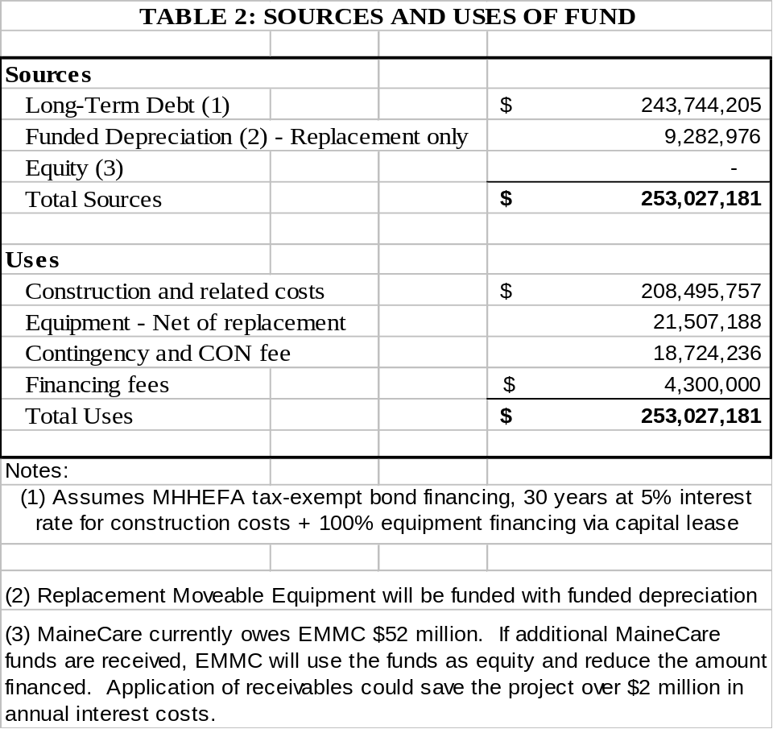

“EMMC is committed to the optimal financing mix for this project. Given cash constraints brought on in part by MaineCare receivable, EMMC proposes to seek a high percentage of debt financing for this project.”

Bureau of Insurance Schedule
“Schedules requested by the Maine Bureau of Insurance are included as Attachment J.”

Table 3

Third year (2015) Incremental Operating Costs
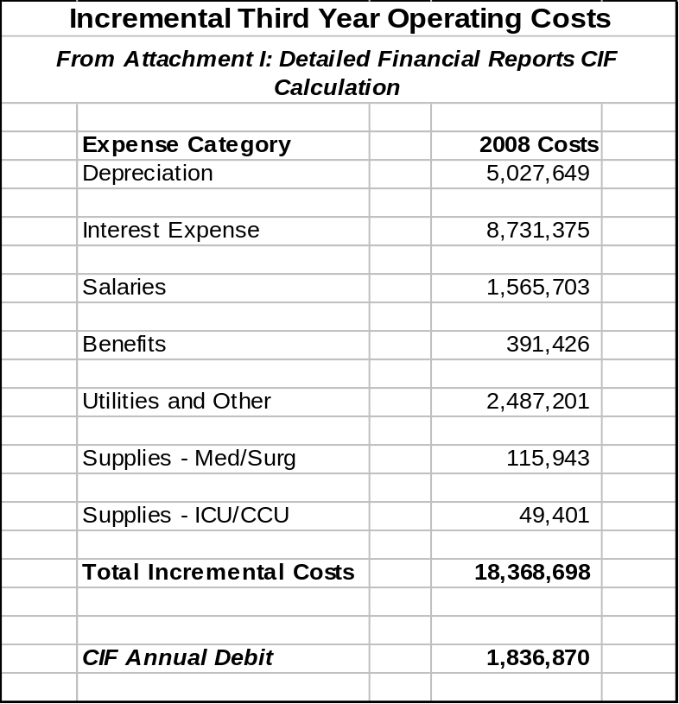

“Table 3 above summarizes the detailed projections in Attachment I which include the schedules developed by the CON Unit for this cycle. EMMC fiscal staff and administrators worked diligently to project workforce and other needs required for the new tower assuming that beds and other space will become available in 2012. “

Staffing feasibility
“EMMC does not anticipate any problems staffing the units in the Inpatient Tower. EMMC is an employer of choice in this region.”
Financial Ratio Analysis

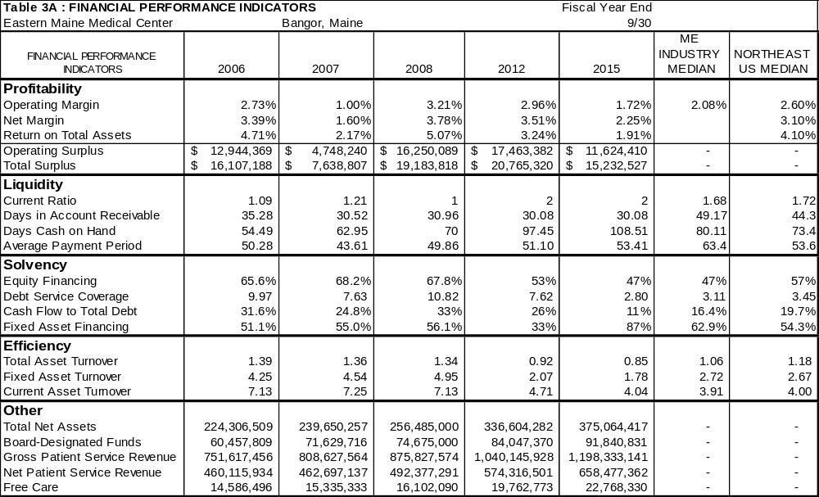
“Table 3-A above is excerpted from the detailed financial schedules in Attachment I. EMMC has the following comments about the financial ratio trends over the course of the project development and implementation.”

Profitability
“EMMC continues to see significant volume growth, and therefore increases in revenues, in both inpatient and outpatient services beyond prior years’ and budgeted levels. Cost reduction efforts are ongoing at EMMC, as described throughout this application. Lean process reviews are described is Section V.”

“Projected profitability margins per Table 3-A show EMMC in line with Maine hospitals on operating margin and slightly below on other ratios. This is a long term project based on conservative growth assumptions. EMMC will continue to monitor profitability ratios.”
Liquidity
“Liquidity ratios are in line with Maine projections. As mentioned in Table 2 above, any reduction in MaineCare past-due receivables, currently $52 million, will reduce debt and improve liquidity ratios.”

Solvency
“Debt financing the majority of the cost of this project will increase EMMC’s debt financing ratio. This appears to be the most feasible financing option at this time and will be considered again over the life of the project depending on receivables, volume growth, operational costs, and payor mix.”

Efficiency
“Turnover ratios are in line with Maine averages.”

Summary
“Based on the long-term financial projections required to assess the impact of this phase of the Master Facility Plan in 2015 (year 3), it appears that the project is financially and economically feasible.”

B. CONU Discussion

i. Criterion

Relevant criterion for inclusion in this section are specific to the determination that the economic feasibility of the proposed services is demonstrated in terms of the:

a. Capacity of the applicant to support the project financially over its useful life, in light of the rates the applicant expects to be able to charge for the services to be provided by the project; and

b. The applicant's ability to establish and operate the project in accordance with existing and reasonably anticipated future changes in federal, state and locan licensure and other applicable or potentially applicable rules.

ii. Analysis

Ongoing Projects

In 2007, EMMC applied for a Certificate of Need to move and consolidate their diagnostic outpatient imaging services to the Eastern Maine Healthcare Mall on Union Street in Bangor. This was approved. The 2007 CON was for 33,200 square feet of space for outpatient imagining.

In 2007, EMMC received approval to purchase a Surgical Robot.

In 2006, EMMC applied for and received approval to develop the CancerCare for Maine.

In 2005, EMMC applied for and received approval to expand their ICU on this campus. This project was completed in August 2007.

In 2004, EMMC received a CON to develop a “co-generation” plant. The plan to develop this power plant was based on cost savings anticipated as fuel costs continue to increase. The EMMC CHP plant has met expectations with energy savings of $800,000 to date. The plant would contribute to the energy profile of the proposed inpatient tower at a 20% lower rate than industry averages. The CHP plant will provide the new proposed inpatient tower with dependable, redundant electrical power. These savings are incorporated into the financial projections.

From the end of fiscal year 2004 to the end of fiscal year 2007, EMMC had $54 million dollars in investments in plant and equipment. During the eight years of this project from the planning stage, 2008 through 2015 (year 3 of operations), investment in plant and equipment is projected to be more than $443 million dollars. This does not include an estimate of the amount of funds needed to replace medical equipment that will exceed its operational life during the timeframe of the project.

As part of the Capital Expenditure Budget, the applicant included $ 8,161,828 in construction costs for a Central Utility Plant (CUP) expansion. This represents almost 5% of the construction budget and 14 % of the project renovation space. No details specific to this section of the capital costs were provided. CONU was unable to determine if this is an expansion of the co-gen facility, an existing CUP or an entirely new construction.

Incorporated Assumptions in Financial Forecast

EMMC commented that “the new Inpatient Tower will incorporate the latest energy efficient technologies that will include energy efficient lighting and occupancy sensors, energy efficient air handlers, and energy efficient air conditioning systems that as a whole is estimated to result in an overall 10 percent reduction in energy costs (per square foot of space).”

EMMC assumed a higher Medicare payor mix in the future as the population ages. The applicant believes that there would be a greater cost in not implementing this project due to the potential loss of specialty services in the area if the facility cannot support specialty care.

The applicant expects to initially finance 96% of this project meaning that the hospital will be contributing 9.3MM in internal funds for this project. Projected debt of $253,000,000 is expected to be financed from outside sources. This is generally undesirable from a cost containment view because the project involves substantial renovations and changes to existing services and does not add new services.

Financial Ratio Analysis

In an effort to sustain readability, the pertinent financial ratios, as well as financial projections are on file with CONU. The following discussion relies on the information as presented by the applicant. At the technical assistance meeting held in October 2007, the applicant was presented a format with which to complete significant financial projections, including construction timelines and operating expenses. Twenty-three ratios were developed with the applicant’s submission to help elucidate the current financial position of the hospital and the impact of the proposed project on its operating and financial feasibility.

The applicant completed the financial module presented by CONU and it appears to be completed in a concise and consistent manner with assumptions and comments made in other sections of the application. The applicant commented that they engaged a consulting firm to assist them in developing their projections. CONU was not provided any information regarding the output of these consultations.

The years presented are 2004 through 2007 (audited) and 2008 through 2015 (projected). Also, since the third operating year of the proposed project is 2015, that year is presented as modified for the effects of the CON on hospital operations. A final column related to the difference between the third year with CON compared to third year results without the CON project is also presented. The source for Maine Industry Medians and Northeast Regional Medians is the 2008 Almanac of Hospital Financial and Operating Indicators. We are presenting 2006 reported numbers for comparison to the project.

There are four areas of financial ratio analysis related to the ability of the project to be successful. These ratios are profitability, liquidity, capital structure, and activity ratios.

Profitability ratios attempt to show how well the hospital does in achieving an excess of revenues over expenditures or providing a return. Generating revenue in excess of expenditures is important to secure the resources necessary to update plant and equipment, implement strategic plans, or respond to emergent opportunities for investment. Losses, on the other hand, threaten liquidity, drain other investments, and may threaten the long-term viability of the organization. The profitability ratios reported here include the operating margin, which measures the profitability from operations alone, the net margin (called total margin in some sources), which measures profitability including other sources of income, and the return on total assets.

Financial Performance Indicators
Profitability | 2006 | 2007 | 2008 | 2012 | 2015 | 2006 ME  State Median | Northeast Median
Operating Margin | 2.73 % | 1.00 % | 3.21 % | 2.96 % | 1.72 % | 3.80 % | 1.83 %
Net Margin | 3.39 % | 1.60 % | 3.78 % | 3.51 % | 2.25 % | 4.68 % | 3.00 %
Return on Total Assets | 4.71 % | 2.17 % | 5.07 % | 3.24 % | 1.91 % | 5.26 % | 3.48 %

The CONU financial analysis considers information contained in the 2008 Almanac of Hospital Financial and Operating Indicators and generally accepted accounting standards in determining the financial capability of a hospital to support a proposed project.

The review of financial indicators is important because they can present a fair and equitable representation of the financial health of an organization and assist in presenting appropriate comparisons. This provides a sound basis for a determination of whether the hospital has the ability to commit the financial resources to develop and sustain the project. While there are a number of indicators that are used in the industry, the ones applied to this review have been selected due to their direct relevance to the financial health of the applicant. The following analysis is based upon information provided by the applicant in its application. These groups are based on the uppermost and lowermost quartiles of hospitals based on their return on investments. This analysis chose to not specifically discuss return on investment but decided instead to use that ratio to group all hospitals in regards to making a comparison to the particular project and applicant.

Non-profit hospitals need to perform at financially sustainable levels in order to carry out their public missions. An adequate operating margin is a key indicator of the financial health of a hospital. Of great concern to CONU is the determination of the reasonableness of the methodology the applicant has used in determining the appropriateness of the timing and scope of the project. Over time, capital expenditures can and need to be made in order to meet the goals expressed in the State Health Plan. CONU evaluates the applicant’s ability to organize and respond to its challenges in improving and maintaining the health care system.

Operating margins in the high performing hospital group have seen greater improvements in margins while hospitals in the low performance group are sliding. High performing hospitals are doing better now than five years ago. Over the same time, lower performing hospitals are generally doing worse than five years ago. There is a widening gap between high and low performing hospitals. Improvement in operating profits for high-performing hospitals drives this widening performance gap. As a comparison, operating margins in the Northeast Region are considerably lower than in other regions.

“EMMC continues to see significant volume growth, and therefore increases in revenues, in both inpatient and outpatient services beyond prior years’ and budgeted levels. Cost reduction efforts are ongoing at EMMC, as described throughout this application. Lean process reviews are described is Section V. Projected profitability margins per Table 3-A show EMMC in line with Maine hospitals on operating margin and slightly below on other ratios. This is a long term project based on conservative growth assumptions. EMMC will continue to monitor profitability ratios.”

EMMC would remain profitable if this project is approved. Operating margins are projected to increase slowly from 2.36% in 2008 to 3.61% in 2015. If the project were to be approved, the project reduces the operating margin by 2.87% in 2013. Operating margin in the first year of the project is only 0.38%. Because of the large number of patients served, EMMC has the means to take on additional expenses in regards to its excess of revenues over expenditures.

The Maine State average for operating margin in 2006 was 3.80%. EMMC in 2006 was 2.73%, which puts them lower than the median for hospitals in Maine.

The trend for operating margin in the State of Maine has been improving from a low of -1.35% to the present high of 3.8%. EMMC for the past four operating years including 2007 averaged 3.91%. 2005 operating margin for EMMC was 8.65% which helped to offset the 1.00% EMMC reported for 2007.

The effect of this project on operating margins, as projected by the applicant, is a decrease from 3.61% to 1.72%. This project is expected to cause a significant impact on the operating margin on the hospital. What the projections indicate is that additional projects may not be feasible during the first years of this project.

Financial Performance Indicators
Profitability | 2006 | 2007 | 2008 | 2012 | 2015
Operating Surplus | $ 12,94,369 | $ 4,748,240 | $ 16,250,089 | $ 17,463,382 | $ 11,624,410
Total Surplus | $ 16,107,188 | $ 7,638,807 | $ 19,183,818 | $ 20,765,320 | $ 15,232,527

This table validates that EMMC has the capacity to financially support this project.

Liquidity: Current ratios and acid test ratios are indicators of the ability of a hospital to meet its short-term obligations. The acid test ratio is generally considered to be a more stringent measure because it recognizes only the most liquid assets as resources available for short-term debt; the current ratio assumes that inventory and accounts receivable can be liquidated sufficiently to meet short-term obligations. Days in accounts receivable and average payment period also are used to monitor liquidity. Respectively, they indicate the average length of time the hospital takes to collect one dollar of receivables or pay one dollar of commercial credit. Together, they can provide a cursory indication of cash management performance.

Financial Performance Indicators
Liquidity | 2006 | 2007 | 2008 | 2012 | 2015 | 2006 ME  State Median | northeast Median
Current Ratio | 1.09 | 1.21 | 1.10 | 1.63 | 1.81 | 1.67 | 1.83
Days in Patient Accounts Receivable | 35.28 | 30.52 | 30.96 | 30.08 | 30.08 | 56.3 Days | 47.7 Days
Days Cash on Hand | 54.49 | 62.95 | 70.02 | 97.45 | 108.51 | 97.9 Days | 67.7 Days
Average Payment Period | 50.28 | 43.61 | 49.86 | 51.10 | 53.41 | 49.9 Days | 61.2 Days

Liquidity measures a hospitals ability to manage change and provide for short-term needs for cash. This liquidity alleviates the need for decision making to be focused on short term goals and allows for more efficient planning and operations of a hospital.

Days Cash on Hand is a ratio that is an industry accepted, easily calculated, method to determine a hospital’s ability to meet cash demands.

“Liquidity ratios are in line with Maine projections. As mentioned in Table 2 above, any reduction in MaineCare past-due receivables, currently $52 million, will reduce debt and improve liquidity ratios.”

In terms of liquidity, EMMC currently has slightly below adequate liquidity, with a payment lag of 15 days between being paid and paying for services. From past submissions and comments CONU knows that EMMC monitors days cash on hand. The average payment period stays between 50 and 53 days throughout the projection. Both of these numbers represent significantly better cash management than the Maine Industrial average. Days cash on hand was in a range of 50-60 days historically and is projected to increase significantly during the course of the project.

Activity and Capital Structure: Activity ratios indicate the efficiency with which an organization uses its resources, typically in an attempt to generate revenue. Activity ratios can present a complicated picture because they are influenced both by revenues and the value of assets owned by the organization. The total asset turnover ratio compares revenues to total assets. Total assets may rise (or fall) disproportionately in the year of heavy (dis)investment in plant and equipment, or decrease steadily with annual depreciation. Thus, it is helpful to view total asset turnover at the same time as age of plant. Debt service coverage is reviewed in greater detail. Debt Service coverage measures the ability of a hospital to cover its current year interest and balance payments.

2006 marked a steep decline of cash on hand. Nationally hospitals with revenue of greater than 150M have 77 days cash on hand. EMMC with Net patient service revenue of $462M and cash on hand of 55 days in 2006 has below the average cash on hand for its peer group. Interestingly, S & P Bond ratings showed no clear distinction between ratings and cash on hand for investment grade ratings. This may mean that high performing hospitals do attempt to control excess levels of on-hand cash.

In 2006 the average days cash on hand for all sources for hospitals in the State of Maine was 97.9 days. Calculated days cash on hand for EMMC in 2006 was approximately 55 days indicating that EMMC was in the 25-50th percentile.

According to the same source, between 2000 and 2004 the average days cash on hand remained about 68 days. In 2006 cash on hand reached a five year low. Between 2004 and 2015 average days cash on hand for EMMC is projected to increase by about 54 days. In 2004, Maine had 15% less days cash on hand than the Northeast Region at 80 days, 12 days more than the Maine average. In 2006, Maine hospitals had increased their cash on hand by 50% in two years to be 30 days above the regional average.

The impact of the proposed project is calculated to be a decrease of 20 days cash on hand in the third operating year as compared to the non CON operating projection (with and without this project). This is a significant decrease in days cash on hand. Based upon source information this hospital is projected to be about average for days cash on hand, compared to today’s industry averages, with or without the project. Therefore this project will not have a substantial impact on EMMC’s operating ability to meet its cash demands. Even if actual cash on hand is lower, based on additional investments in programs and technology, EMMC should be able to adequately support this project.

Financial Performance Indicators
Solvency | 2006 | 2007 | 2008 | 2012 | 2015 | 2006 ME  State Median | northeast Median
Equity Financing | 65.58 % | 68.15 % | 67.81 % | 52.59% | 47.04% | 58.00 % | 47.4 %
Debt Service Coverage | 9.97 | 7.63 | 10.82 | 7.62 | 2.80 | 3.48 | 3.52
Cash Flow to Total Debt | 31.57 % | 24.82 % | 32.74 % | 26.44 % | 11.41 % | 23.8 % | 18.2 %
Fixed Asset Financing | 51.05 % | 55.04 % | 56.14 % | 32.67 % | 87.19 % | 52.0 % | 65.3 %

Many long term creditors and bond rating agencies evaluate capital structure ratios to determine the hospital’s ability to increase its amount of financing. During the past 20 years, the hospital industry has radically increased its percentage of debt financing. This trend makes capital structure ratios important to hospital management because these ratios are widely used by outside creditors. Values for these ratios ultimately determine the amount of financing available for the hospital. Debt service coverage is the most widely used capital structure ratio. Debt service coverage minimums are often seen as loan requirements when obtaining financing. Debt service coverage is the ratio of earnings plus depreciation and interest expense to debt service requirements. In 2006 the median Maine hospital’s debt service coverage (DSC) was 3.48x.

Fixed Asset Financing: “Low performance hospitals have historically used more debt to finance net fixed assets than high performance hospitals. With the removal of capital cost pass through, long term debt will become most costly relative to equity. High performance hospitals are restructuring their capital positions to reflect this shift in the relative costs of debt and equity capital. However, we expect fixed asset financing ratios to continue to remain stable during the next 5 (five) years as hospitals curtail their growth in new capital expenditures and reduce their reliance on long term debt.”

Debt financing the majority of the cost of this project will increase EMMC’s debt financing ratio. EMMC commented that “this appears to be the most feasible financing option at this time and will be considered again over the life of the project depending on receivables, volume growth, operational costs, and payor mix.”

EMMC had a DSC in 2006 of 9.97x which places it in the range of 75-90th percentile. The statewide trend for 2002-2006 has been increasing with a low of 2.36x in 2002 and a high of 3.71x in 2004. The trend for EMMC in regards to debt service coverage has been inconsistent but excellent for the last 3 years ranging from 9.97x to 10.82x. The trend as projected by EMMC for the time frame of this project, 2008-2015, is that DSC is expected to decrease to 8.80x by 2015 without the project. The effect of the project is a decrease to 2.80x. As compared to the non-CON projection DSC is expected to decrease by 6.00x. While this is a large decrease in debt service coverage, it is still adequate.

EMMC has the capacity and the ability to have adequate debt service coverage. If EMMC were to maintain its debt service coverage at a ratio consistent with its recent history, a change of 6.00x would not impact its ability to service its loans.

The 2006 average fixed asset financing for hospitals in the State of Maine was 52 percent. In 2006, EMMC was at 51 percent which is at the state average.

The fixed asset financing ratio over the past 5 years has remained relatively consistent in the State of Maine. The proposed project financing and other project undertaken by EMMC will add about $300 million in liabilities to their bottom line by 2015.

Efficiency Ratios: Efficiency ratios measure various assets and how many times annual revenues exceed these assets.

Financial Performance Indicators
Efficiency | 2006 | 2007 | 2008 | 2012 | 2015 | 2006 ME  State Median | Northeast Median
Total Asset Turnover | 1.39 | 1.36 | 1.34 | 0.92 | 0.85 | 1.12 | 1.13
Fixed Asset Turnover | 4.25 | 4.54 | 4.95 | 2.07 | 1.78 | 2.74 | 2.77
Current Asset Turnover | 7.13 | 7.25 | 7.13 | 4.71 | 4.04 | 4.19 | 4.15

Total asset turnover (TAT) provides an index of the number of operating revenue dollars generated per dollar of asset investment. Higher values for this ratio imply greater generation of revenue from the existing investments of assets. Larger hospitals usually have lower values for turnover than smaller hospitals. This can be attributed to two factors. First, larger hospitals are most likely to have newer physical plants. Second, capital intensity is often greater in larger hospitals due to more special services and higher levels of technology.

In 2006, according to the source cited above, Maine hospitals had a TAT ratio of 1.12. For 2006, EMMC had a TAT ratio of 1.39 times, which is indicative of the relative age of the hospital actually being higher than most hospitals in Maine and is higher than expected given the number of construction projects EMMC has undertaken recently.

In the period of 2002 – 2006 there has been a steady increase in the TAT for Maine hospitals. The expected trend for EMMC is for TAT to lower during the time frame of this project 2008-2015. This is reflective of a hospital planning to spend significant funds for capital improvements or investments in technology. This is a capital intensive project. The capital nature of this project is indicated by the fact that revenues are expected to increase by $170M during the project time frame while expending $253 million in fixed asset purchases.

Operating Costs in the third operating year are expected to increase by $25,400,600. For CIF purposes, this expense is $24,472,362. The reduction is for depreciation expense for replacement equipment. For the Bureau of Insurance this amount is adjusted to a current value of $17,993,486. The impact on the CIF is $18,368,698. The $25,400,600 includes $7,938,573 in depreciation and $12,174,545 in interest expense. Additional costs for staffing and utilities amounts to $5,287,542 in 2015 dollars.

Projected demands on liquidity and capital structure are expected to be adequate to support operations. Due to the large scope of this project, financing and turnover ratios show a significant negative impact on the organization as a whole. The hospital has shown current earnings which are expected to be significantly impacted by this project but as proposed the hospital will remain profitable. The limited profitability that the applicant projects for the three operating years if continued into the future could negatively impact the hospital’s ability to react to future needs.

The applicant did not provide information to CONU regarding costs associated with purchasing versus leasing equipment. CONU is unable to determine the impact of leasing versus purchasing.

Staffing

“EMMC does not anticipate any problems staffing the units in the Inpatient Tower. EMMC is an employer of choice in this region.”

Changing Laws and Regulations

CONU staff is not aware of any imminent or proposed changed in laws and regulations that would impact the project. EMMC presently has the organizational strength to adjust to reasonable changes in laws and regulations.

Capability of Applicant to Utilize Shell Space in the Future

As part of its review of the financial capabilities of such an extremely large project, consideration must be given as to what unexpectedly higher expenses or lower efficiencies may do the profitability of the hospital. Currently, EMMC is responsible as a transferring hospital for 12 Critical Area Hospitals in its extended service area. Financial solvency of this hospital is critical to meeting the health care needs of many patients in the area.

The hospital mentions that the planning for this project has been ongoing and while they did not provide details of their plans, this plan has clearly been scaled back from the original conception.

“This phase of the Master plan has been evolving over the past several years, culminating with the engagement of MorrisSwitzer architects to design the main campus for the future. EMMC also engaged Besler consultants, financial analysis experts, to assist with long range financial forecasting and to test the feasibility of the proposed initial project. Based on Besler’s analysis, EMMC determined that it was necessary to scale back the project and to focus on the priorities as outlined in this application, with plans to complete remaining phases of the Master Plan in the future.”

A significant percentage (39%) of the physical space being developed is for shell space in areas where originally EMMC identified needs but determined they were not affordable at this time. The question as to when EMMC will be able to undertake those portions of the plan are not outlined. This project may be too big in its current scope to allow EMMC to reasonably respond to needs not addressed by the current project due to the amount of resources being consumed. This project will expend approximately $262 million, which is $23 million more than the total net assets of the applicant at the end of fiscal year 2007.

Another serious concern is the impact of miscalculations of the expenses of this project. This project is expected to cost more than two times the operating surplus in 2015. This means that a 10% adjustment to project expenses will cause a 20% decrease in operating surplus. 20% of 2015’s operational surplus is due to savings expected from completing this project. A 1% drop in overall revenues or a corresponding increase in expenses would eliminate more than 50% of the operating surplus of this hospital. The application lacks information that demonstrates its ability to adjust to unmet current needs and future needs as they occur.

iii. Conclusion

EMMC has a large financial team and has engaged consultants with considerable expertise to assist in determining best estimates as to the effect this project will have on this hospital. However, EMMC failed to provide information regarding the alternatives to shell space and the plans to make those spaces operational to meet needs that EMMC has identified, CONU cannot conclude that EMMC has the financial capability to support this project in its entirety.

As presented, the CONU cannot conclude that the financial forecast of EMMC is reasonable and is in conformity with stated objectives of the project. If the proposed capital expenditure is in excess of five million dollars, the Certificate of Need application states that the applicant may be required to include a full-scope financial feasibility study conducted by an independent certified public accountant; all applicable assumptions and sources of data used in preparing the financial projections shall be disclosed. Since the applicant itself stated that certain design modifications were made due to feasibility concerns, it is incumbent on the applicant to provide adequate information including a feasibility study and associated information to allow CONU the ability to determine if EMMC would be able to make further physical changes to its plant to meet other needs as they present themselves. EMMC has failed to do so. It is recommended that any further review of this project not be undertaken without the inclusion of a full-scope financial feasibility study conducted by an independent certified public accountant or an alternative acceptable to the department.

CONU recommends that the Commissioner determine that EMMC has failed to meet its burden to demonstrate that the proposed project is economically feasible.

IV. Needs to be Met

A. From Applicant

Population to Be Served

“As the only tertiary referral and trauma center in the region, EMMC and this proposal serve virtually all patient populations in the EMHS service area This region includes the nine counties in northern, central and eastern Maine. This region has an estimated 2007 population of 514,000 people in an area of 23,600 square miles, 21.6 persons per square mile. Of the 21 acute care hospitals in the region, 12 are Critical Access Hospitals. Please see the following map.”
FIGURE 1 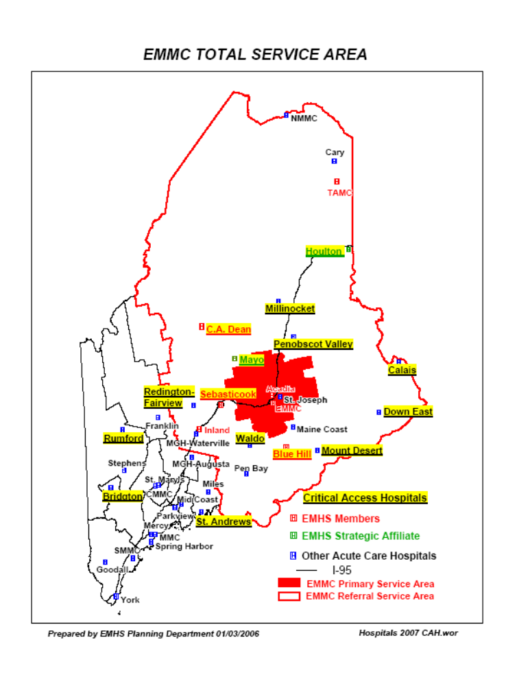
Regional Health Needs Assessment Study
“In 2006 EMHS contracted with the Center for Health Policy, Planning and Research at the University of New England to conduct a Community Health Needs Assessment of all areas served by EMHS affiliates. This was a follow-up to the study conducted in 2001. EMHS and the related philanthropic foundation, Healthcare Charities, invested $230,000 in this important regional study. The executive summary and the regional data summary by health indicator, the Health Status Profile, is included as Attachment M. The full 231 page report is available at EMHS’ website at emh.org. This report includes extensive data (84 pages) on Health Status Profiles comparing population-based indicators for 2001 and 2006. Other key points related to EMMC’s commitment to public and preventive health services are discussed in Section VIII.”

“After the completion of the study, EMHS conducted nine community forums throughout the region to review the findings and to seek input from local providers and community members. The forum in Bangor was co-sponsored by EMMC, St Joseph Hospital and Penobscot Community Health Care. All regional forums were hosted by community hospital executives and included local providers and community and wellness leaders.”

“Among the findings pertinent to the proposal in this application:
- Ambulatory Care Sensitive (ACS) admissions are high in many of the areas of the region but are below the State average in Bangor.
- Most regions in the total service area have higher rates of heart disease morbidity and mortality than the peer groups.
- ED visit rates are high in the region but are lower in the Bangor Region. Many patients still use the ED as their source of primary care. ED visits for mental health conditions are high.
- The chronic disease burden has increased since 2001.
- The Bangor Region Wellness Council (BRWC) promoting workplace wellness is a major initiative that helps numerous employers in the area have a positive impact on employee health. EMMC is a major sponsor of the BRWC
- Many premature births are related to the high incidence of mothers undergoing methadone treatment in eastern Maine.”

“The 2006 study includes a Health Status Profile which summarizes many indicators. In general terms, health status is worse in the primarily rural region that EMMC serves, even when compared to the rural peer group in southern and western Maine.”

Healthcare Delivery System in Northern, Eastern, Central Maine and EMMC’s Role

“Since EMMC built the Grant Inpatient Tower in the early 1970’s, healthcare in this most rural region of Maine has changed significantly. Twelve of 21 hospitals in the region are now designated as Critical Access Hospitals and are limited by length of stay criteria and by other considerations in the number and range of procedures they provide. Healthcare delivery is increasingly more reliant on technology that provides diagnosis and treatment services for patients but may not be affordable or feasible for regional hospitals to acquire.”

“EMMC has been a leader in assuring access to specialty services for rural Mainers through support for LifeFlight, employment of multiple specialists, including general and orthopaedic trauma surgeons; and investment in robust telehealth programs that bring radiologists to rural hospitals through PACS (picture archiving communications systems) and the future development of virtual ICU support.”

“Over the past years, more and more patients are coming to EMMC for their acute inpatient services. Many are transferred from emergency departments or inpatient units of rural hospitals when they feel transfer to EMMC would be in the best interest of the patient.”

“In the past year, EMMC has been functioning at an average 90+% occupancy of available and staffed med/surg beds. Literature indicates that the most efficiently run facilities operating at 75 – 80% for semi-private rooms and 80-85% of private rooms. A very high occupancy rate results in higher patient transfer numbers between rooms, greater noise levels which have been shown to be detrimental to patient recovery, and greater risk for errors. See three studies from A Delicate Balance from the Health Care Advisory Board in Attachment B (full report of 400 pages will be provided on request) as well as The Hospital of The Future also in Attachment B.”

Need for Acute Hospital Services
“To ensure that EMMC will be able to continue to fulfill its mission as a trauma center and tertiary care center well into the 21st century, EMMC began an extensive master facility planning process in 2006. Faced with the increasing inadequacy of aging facilities and space limitations at its State Street campus, and limited useable capacity elsewhere in the region, EMMC saw the need to develop a comprehensive plan that would enable it meet the needs of the region for the foreseeable future. The facilities at EMMC’s main campus are insufficient to meet the current needs of patients in the region, or to meet the growing need projected for the next 10-20 years.”

“As part of this planning process EMMC contracted with MorrisSwitzer Environments for Health and with Kurt Salmon Associates (KSA) to assist with the program development and space planning for the Master Facility Plan. KSA used Maine Health Data Organization (MHDO) data, Maine State Planning Office (MSPO) population projections, national databases, and their own proprietary databases to forecast regional need for hospital care in eastern and northern Maine. Summary data from KSA’s analysis is included in Attachment G.”

“The initial forecast of the regional need for hospital services was developed in late 2006 by KSA and EMMC staff. Over the winter and spring of 2007, during the programming planning phase of the project, EMMC and its consultants reviewed the baseline projections and tested all assumptions. This review resulted in minor revisions to the projections.”

Calculation of Regional Need and Volume Projection Methodology
“EMMC staff and its consultants balanced quantitative data with the qualitative insights of service line leaders, physicians and national experts. The intent of this process was to develop a solution that projected the regional need for services as accurately as possible and is flexible enough to meet changing demands over the next twenty years.”

“The methodology to determine regional need is a population-based analysis of the region served by EMMC. The Total Service Area includes the 18 Hospital Service Areas (as defined by the MHDO) in eastern and northern Maine. See Figure 1 above. EMMC’s Primary Service Area is defined as the Bangor HSA; the Referral Service Area consists of the Hospital Service Areas (HSA’s) in the region outside the Bangor HSA.”

Population Projections
- Population forecast was compiled from data available from the Maine State Planning Office. Estimates for the 2005 base year and projections for 2010 and 2015 were compiled by age group and service area (detail in Attachment G1).
- Total Service Area population will increase only 4.5% over the ten year forecast period; but the bulk of the increase will be in the older age groups, who have the greatest need for hospital care.
- The region is older than southern and western Maine and the State as a whole. The following 2007 data is from Maine State Planning Office.

TABLE 4

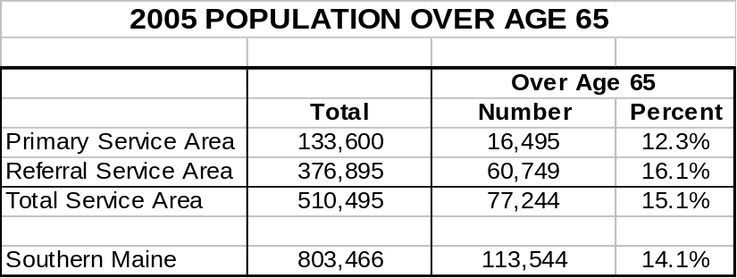

- The region’s population over age 65 will increase by 22.5% by 2015. This age group will increase from 15.1% of the total population to 17.7% by 2015 (State Planning Office data).

Addressing Utilization of High Cost Healthcare Services

“EMMC leaders are very aware of the issue of affordability of healthcare services to governmental and commercial payers, self-insured plans and to consumers. Every admission is reviewed for appropriateness. Continuous efforts are in place to assure the highest quality of care at the lowest possible cost. A few examples include EMMC’s significant investment in care managers and the employment of intensivists and medical hospitalists, who provide round the clock attention to patients so they can return home as soon as possible. A further example is EMMC’s commitment to NCQA certification for employed primary care practices which is recognized as the gold standard in best practice management of patients with chronic disease in the primary care setting. Another example is EMMC’s extensive investment in an electronic medical record (EMR) and, more recently, computerized physician order entry (CPOE) which clearly reduces medication errors.”

“The 2006 Community Health Needs Assessment results indicated that rates of admissions for ambulatory care sensitive admissions are often higher in rural areas. This may be due to lack of outpatient and community based resources to support care in the ambulatory setting before patients need acute services. EMMC is supporting regional hospitals in a variety of ways to decrease inappropriate admissions through telehealth, regional hospitalist support of patients and other ways, which are more fully described in Section V.”

“Utilization Rate Methodology Used for Projection”
- MHDO hospital data was grouped by service line for the entire region. Service lines were defined based on groups of DRGs (detail in Attachment G2).
- Historical admission rates and average length of stay by age group and service line were calculated. CY2005 was used as the base year.
- Base year admission rates were adjusted to account for assumptions due to changes in technology, lifestyle, and physician practice. For example, admission rates for heart surgery are assumed to decrease 4% by 2015 due to technology changes (such as the adoption of drug-eluding stents). Lifestyle changes such as the increasing chronicity of patients with multiple co-morbidities, will increase admission rates 1% by 2015. (Table G4).
- Similarly, base year average lengths of stay (ALOS) were adjusted for the projection period. For example, General Surgery ALOS is projected to decrease 10% by 2015 (increased adoption of minimally invasive surgical techniques); EMMC’s NICU ALOS is projected to increase 10% consistent with national trends (reproductive technology, fertility rates, advancing maternal age). (Table G4).
- Adjusted admission rates by age group and service line (Table G5) were applied to the projected population to determine the number of hospital admissions needed throughout the region in 2010 and 2015 (Table G6). The result is an 11.7% increase in admissions over the forecast period; summarized in Table 5 below. The bulk of this increase is primarily due to the aging of the population and their higher rate of hospital admissions. The use rate for each age cohort will change less than 1% but the higher proportion in the older age groups results in an increase of over 11% in the overall use rate.

TABLE 5

2006 MASTER FACILITY PLAN FORECAST: REGIONAL ADMISSIONS
(detail in table G6)
 |  |  |  | Change 2005-2015
 | 2005 | 2010 | 2015 | Number | Percent
Primary Service Area | 14,436 | 15,171 | 15,912 | 1,476 | 10.2%
Referral Service Area | 48,478 | 51,540 | 54,355 | 5,877 | 12.1%
Total Service Area | 62,914 | 66,711 | 70,267 | 7,353 | 11.7%

“The proportion of hospital admissions for residents of the total service area over age 65 will increase from 44% to 48% of all admissions over the forecast period. The longer average length of stay for the older age group will also tend to increase the need for beds in eastern and northern Maine.”

“EMMC’s projection model includes assumed decreases in the Average Length of Stay (ALOS) for some services. As a result, the projected patient day rate is increasing only 1%. This still results in an additional 16,893 patient days and an increase in the Average Daily Census (ADC) of 46.4 patients in the region. This is a larger census than any hospital in the region outside Bangor.”

Projections of Future Admissions to EMMC
“This forecast of the regional population’s need for hospitalization was completed in the fall of 2006. In early 2007 EMMC staff and its planning consultants completed the programming phase of the Master Facility Plan. This process included the facility and programming consultants, EMMC senior staff, managers, physicians, direct patient care staff, other clinical staff, and support staff. Participants reviewed the initial forecasts, care delivery models, overall facility design and detailed plans for their areas of expertise. As part of this process, the inpatient forecast, including assumptions of EMMC market share, length of stay and occupancy rates was reviewed. This review confirmed that the base assumptions of population-based need were still valid with with some small adjustments based on updated information.”

“These revisions and updates included:”
- Reduction in the original projection of increased referrals to EMMC from the referral area for orthopedics. The projections now assume that community hospitals will continue to perform procedures such as joint replacement.
- The projected average length of stay (ALOS) for obstetrics cases was revised from a reduction to a continuation of the current ALOS. Programmers felt this was a more accurate assessment of increasing acuity of obstetrics patients in the region and at EMMC.
- The Neonatal Intensive Care Unit (NICU) forecasted census was revised and now includes neonates currently cared for in EMMC’s Pediatrics Unit, an increasingly common occurrence. These neonates are cared for in pediatrics when the NICU census reaches capacity.

Admissions to EMMC from the Total Service Area
“After the regional need for hospital care was determined, the number of these admissions that would come to EMMC was projected.”

“EMMC and its consultants reviewed trends in market share patterns. Over the last ten year’s 12 of the 21 hospitals in the region have become Critical Access Hospitals. In fact, 11 of the 13 hospitals closest to EMMC (between Waterville and Presque Isle) are Critical Access Hospitals This has contributed to the current pressure on EMMC’s beds. The projection model includes testing the possibility that the shift of the more acutely ill patients to EMMC will continue. Critical Access Hospitals and other small hospitals increasingly do not have sufficient specialized, experienced staff and the other resources needed to care for these patients 24 hours a day 7 days a week. Some smaller hospitals may struggle to maintain the resources necessary to cover specialty services such as obstetrics, cardiology, vascular surgery, pulmonary medicine and orthopedics.”

“EMMC and its consultants reviewed historical trends and a wide range of projected scenarios. Table G7 includes EMMC’s share of admissions by service line for the base year as well as the projected changes in EMMC’s share by service line. EMMC is conservatively projecting no increase in most service lines, or at most a 1% increase over 5 years in a few service lines.”

“Services projected to have a 1% increase in EMMC market share over the projection period are: general surgery, heart center, NICU, obstetrics, oncology, orthopedics, pulmonary, and vascular. The higher acuity patients in these service lines will increasingly be admitted to EMMC as the most appropriate hospital to meet their needs. This will allow the smaller hospitals to concentrate on care more appropriate for their facility. The forecast methodology tested scenarios where these shifts do not occur, as well as scenarios where these shifts are greater than the base case. The range of these possible outcomes is part of the sensitivity analysis discussed later in this section of the application.”

“Even if none of the increases detailed in Table G7 were to occur, the resulting average census at EMMC would be reduced by only 9 general med/surg patients and 2 ICU patients. If EMMC’s share of these cases were larger than projected, EMMC’s facility plan is designed with enough flexibility to cover most such scenarios.”

“A projection of out of area admissions to EMMC from outside the service area, including admissions from out of state, was added to the projected admissions from the total service area. It was assumed that the change in volume of patients admitted to EMMC from outside the region would be in the same proportion as admissions within the service area.”

“ALOS projections were used to determine the patient days needed for regional patients in 2010 and 2015. The model tested included a range of assumptions in ALOS by service. Many services at EMMC are projected to have a shorter ALOS by 2015. Services projected to reduce ALOS by 10% include general surgery, heart center – medical, oncology, and others. Services decreasing ALOS 5% include orthopedics and vascular. Heart surgery ALOS is projected to decrease 20%. The NICU ALOS projected to increase 10%.”

“EMMC’s overall ALOS is projected to decrease from a base of 5.4 days to 5.0 days by 2015. Without this 7% decrease in ALOS, EMMC would need an additional 30 beds beyond those in this proposal. These would be primarily med/surg and critical care beds. EMMC has been working diligently for several years on various efforts to improve processes and has seen reduction in ALOS over the last year. Future reductions will be difficult in the current facilities because of continued challenges to recruit specialists and to maintain skills in specialty care at regional hospitals. EMMC’s continued efforts to support regional hospitals is described further in Section V.”

“As shown in Table 6 below in just two years from 2004 to 2006 there was a reduction of 80 acute care beds in the region. Even with the implementation of the 61 additional beds in this proposal, there will be fewer beds in the region then there were in 2004.”

Beds at EMMC
“Projected EMMC average lengths of stay by service line were applied to the projected admissions by service line to determine total patient days and the average patient census.”

“Based on EMMC historical distributions of patient census by nursing unit, projected total census was determined for each type of nursing unit needed to care for patients: general med/surg, ICU/CCU, pediatrics, obstetrics, rehabilitation, and NICU. This calculation determined the projected average census in each EMMC nursing unit category.”

“To determine the appropriate number of beds, the occupancy rates in the following Table 6 were applied to the projected census in the nursing unit categories. These occupancy rates were chosen for optimal patient care and to maximize efficiency.”

“EMMC’s planning and facility staff recommend review of the Health Care Advisory Board reports entitled Hospital of the Future and A Delicate Balance in Attachment B.”

Table 6 Occupancy Assumptions

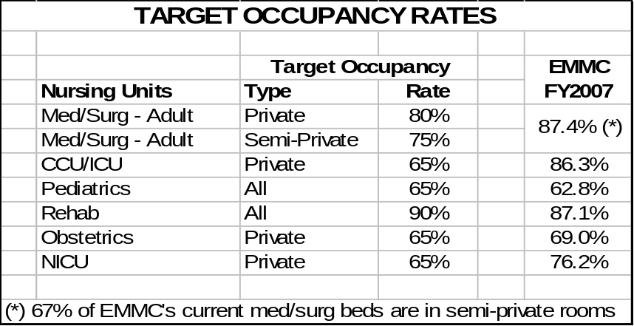

“The current near 90% occupancy rate of EMMC med/surg beds is a clear challenge and is not a sustainable work process. The occupancy rate is based on the midnight census and does not include observation patients occupying inpatient beds. If the outpatient days are included, EMMC’s med/surg beds averaged 90% for all of FY2007. Typically occupancy rates are 10% higher in the middle of the day. An average midnight census occupancy rate of 90% for 7 days a week, 365 days per year means that on many days of the year daytime occupancy rate is frequently at 100%. The Health Care Advisory Board 2001 study A Delicate Balance refers to a 90% average occupancy as “frequent Crisis Level”; occupancy between 80% and 90% as “stretched too thin” and between 70% and 80% as the occupancy “sweet spot” as the most efficient rate to provide quality patient care. In the 2007 The Advisory Board update Hospital of the Future includes data from a study of hospitals of over 100 beds that finds 75% is the most effective occupancy rate for adult med/surg beds. (Attachment B)”

“Operating at or near capacity results in back-ups in the emergency department and surgical recovery areas. When EMMC reaches capacity community hospitals in the region are forced to keep complex cases longer than they would normally or attempt to find a bed in Portland or further away. See the letter from the EMMC hospitalist group in Attachment K.”

“EMMC’s planning consultants have found in their work across the country that a more efficient model is to have a target of 75-80% for semi-private rooms and 80-85% for private rooms. The higher occupancy rate in single rooms is possible because the logistics of matching gender of patients, the need for isolating patients with infections and other issues are more efficiently handled in private rooms.”

“In EMMC’s 2006 CON application for addition beds, quoted sources projected the need for ICU beds to double nationally by 2015. At that time, EMMC used a target occupancy rate of 70% to estimate the needed number of ICU/CCU beds. Intensive care unit effective occupancy rates are typically lower at 65% due to the need to be able to accommodate peak volumes. With the uncertainty of future ICU availability in the region, EMMC feels that a target rate of 65% occupancy best allows EMMC to cover the variable need for these beds. As the only full service provider in the region, EMMC must responsibly plan for the right-sized capacity for the region.”

“High occupancy rates and a high proportion of semi-private rooms lead to an increased need to transfer patients to better match patients to nursing units with more appropriate resources because of changing patient acuity. Transfers are inefficient, can cause delays in discharge of a patient, increase the risk of medication errors, and result in other communication breakdowns.”

“EMMC projects that by 2015, its med/surg beds will be occupied at an overall rate of 80% (based on midnight census). Daytime occupancy would average about 90%.”

“In addition to projecting the base case as described above, to ensure confidence in the bed projections EMMC also conducted an in-depth sensitivity analysis.”
- In this analysis parameters were set for each assumption (high, low and likeliest value) of admission rate, length of stay, EMMC share, and other variables for each service line and bed category. Using statistical probability models, 10,000 trials of these parameters were tested.
- Given a base case of 237 med/surg beds, the range of projected need for med/surg beds is 238-247 beds at a 95% certainty level. Please refer to Table G13 for summaries of the sensitivity analysis statistics.
- Due to the complexities and scope of the project, EMMC has attempted as much as possible to be certain that the project is sized correctly. Constructing a facility that is too large would be costly and inefficient. It would also not be consistent with the orderly and economic development of the healthcare system if the project resulted in insufficient capacity over the next 10-20 years. The forecast methodology also tested various “extreme” scenarios; such as reduction in beds due to community hospitals converting to Critical Access or closing, reduction of the number hospitals offering obstetrics services. These scenarios would increase the need for some beds at EMMC but were not extreme enough to warrant the addition of nursing units beyond those in this proposal beyond the 8th floor shell space.

Summary of Bed Forecasts
“EMMC’s plan is consistent with the Maine State Health Plan goal of increased regionalization. The current capacity issues at EMMC mean that even when a community hospital needs to transfer a patient to EMMC, they sometimes cannot. See letters in Attachment K.”

“The analysis included a forecast of the number of inpatient beds needed at EMMC to care for its patients over the next years to meet the needs of the region through 2015 and beyond. This projection was developed in conjunction with EMMC’s program planning consultants, EMMC data, Maine and national data. Details are included in Attachment G.”

“Even though all the models and planning activity suggested an adult med/surg bed complement in the neighborhood of 245 beds (except the “extreme scenario” of one or more hospitals in the region closing resulting in an EMMC need for about 255 beds), EMMC decided to implement a plan that will result in a mix of 233 new and existing med/surg beds. To cover the planning basis of 241-246 beds would require one additional nursing unit. Since the footprint of the new tower uses 32 beds as the most efficient design, adding and staffing this many beds would result in an occupancy rate that would be too low for several years. By building this floor as shell space, EMMC’s plan provides for an orderly and economic development of inpatient capacity for the region in the future.”

“As discussed in Section II and in the Alternatives Considered, Section V, this is the first phase of EMMC’s plan to meet the regional inpatient needs well into the 21st century. This project is planned as a stand alone phase and is not dependent on future phases for its viability.”

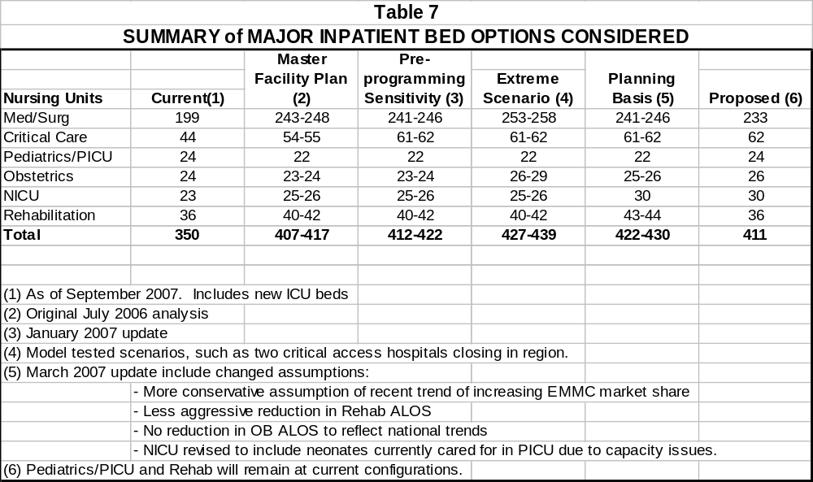
AVAILABLE BEDS IN THE EMMC SERVICE AREA

Key Findings
“There is insufficient inpatient capacity in the Bangor Hospital Service Area to care for the current need. To meet the future needs of the region, EMMC must make significant additions to its inpatient bed complement including adult med/surg and critical care beds as well as neonatal beds.”

“The addition of an 8-bed Critical Decision Unit/Observation Unit adjacent to the Emergency Department will reduce congestion, boarding and will reduce the number of outpatients that need to be cared for in inpatient units.”

“The number of staffed and available beds in the service area has decreased dramatically in the past several years as the majority of hospitals in the region of converted to critical access status. The reduction of 91 available beds in the critical access hospitals in EMMC’s service area, per Table 8 below, is putting pressure on EMMC’s capacity. Even after the beds in this proposal become available, there will be fewer available acute care beds in the region, than in 2004.”

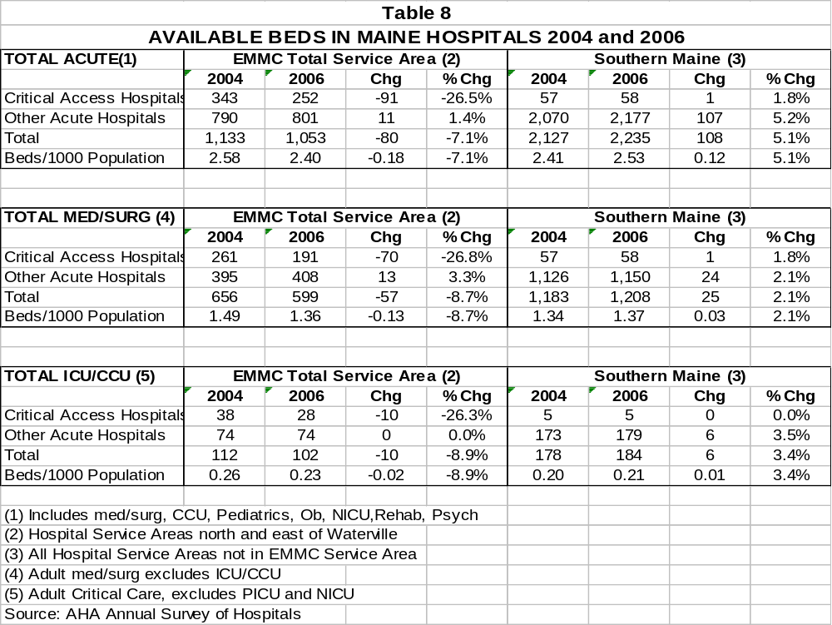

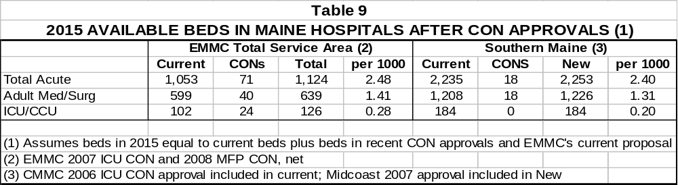

EMMC Transfer Status Yellow (TSY)
“EMMC maintains a “transfer status yellow” system for times when one or more of EMMC’s patient care areas is at capacity. At these times, each admission is reviewed by nurse access managers for assuring access to EMMC services in a timely way or to find an alternative facility for care. In the past year, EMMC’s various nursing units have on average been on “transfer status yellow” status 25% of the time due to lack of beds. In fiscal year 2007, EMMC’s nursing units were on Transfer Status Yellow 15% more hours than in FY2006.”

“Areas with an exceedingly high proportion of time on transfer status yellow are the telemetry unit (42% of time throughout the year), the Coronary Care Unit (39% of the year), the Intensive Care Unit (37% of the time) the Neonatal Intensive Care Unit (35% of the time). General med/surg units were on TSY 25% of the entire year.”

Table 10

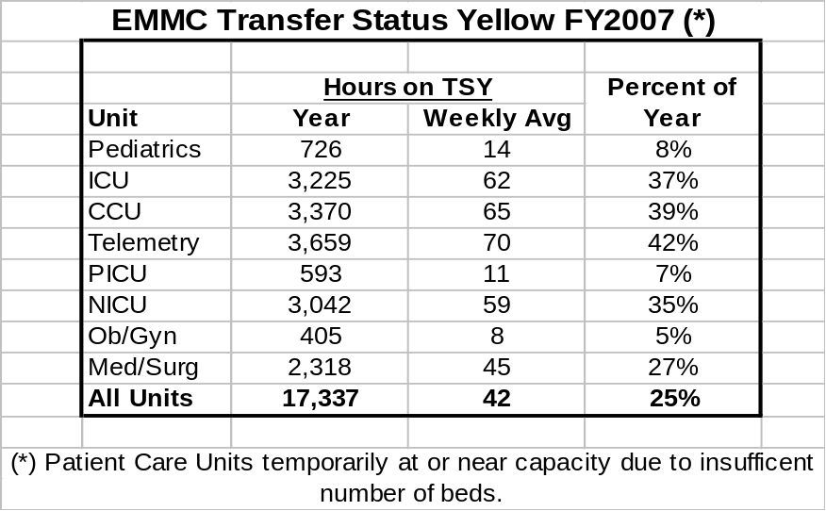

“During times when a transfer to EMMC is requested and beds are not available, several courses of actions may be followed. A patient may remain at the community hospital or if clinically necessary be diverted to another facility, such as Maine Medical Center in Portland or St. Joseph Hospital in Bangor. In FY2007 there were 136 cases requesting a med/surg or critical care bed diverted or deferred. In addition there were 17 maternal/neonatal diversions.”

“Even with the addition of new critical care beds in August 2007, EMMC’s critical units are still going on transfer status at times.”

“EMMC’s emergency department needed to go on diversion status 6 times in FY2007 due to lack of capacity. In all instances patients were diverted to St. Joseph Hospital.”

Beds Needed in Bangor
“Even though EMMC, the largest hospital in the region, and St. Joseph Hospital, are both located in Bangor, residents of the Bangor Hospital Service Area are hospitalized at a lower rate than the residents of the State. EMMC will to continue its procedures that ensure all admissions are appropriate. These procedures are discussed in Section VII.”

“In EMMC’s Primary Service Area (the Bangor Hospital Service Area) both the admission rate and the patient day rate is lower than the rate for the State. The admission rate for the Bangor HSA is 3% lower than the State average and the patient day rate is 8% lower. This is shown for the population ages 0-64 and for the over 65 population:”

Table 11

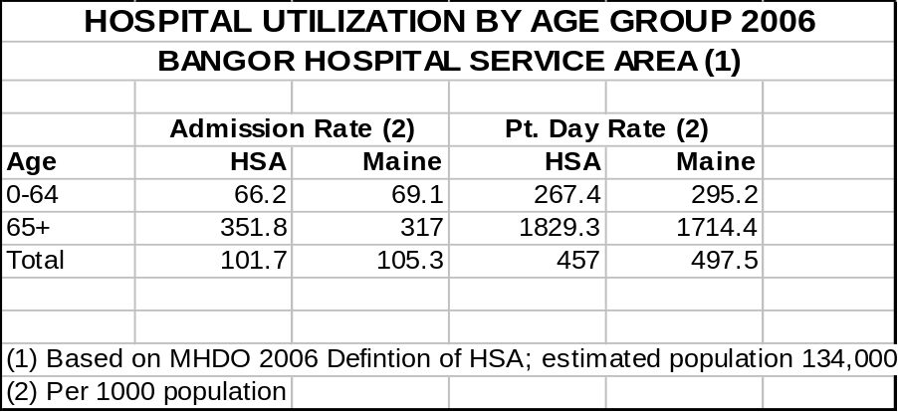

“St. Joseph Hospital is licensed for 112 beds and has 84 available (77 adult med/surg and 7 critical care beds). Data for St Joseph is shown in Table 12 below (source 2006 MHDO database). St. Joseph’s 2006 occupancy rates were 67% of med/surg beds and 46% of its ICU beds. As shown in Table 12 below, without the added capacity in this proposal, there will be a shortage of 43 med/surg beds and 15 ICU beds in Bangor by 2015.”

Table 12

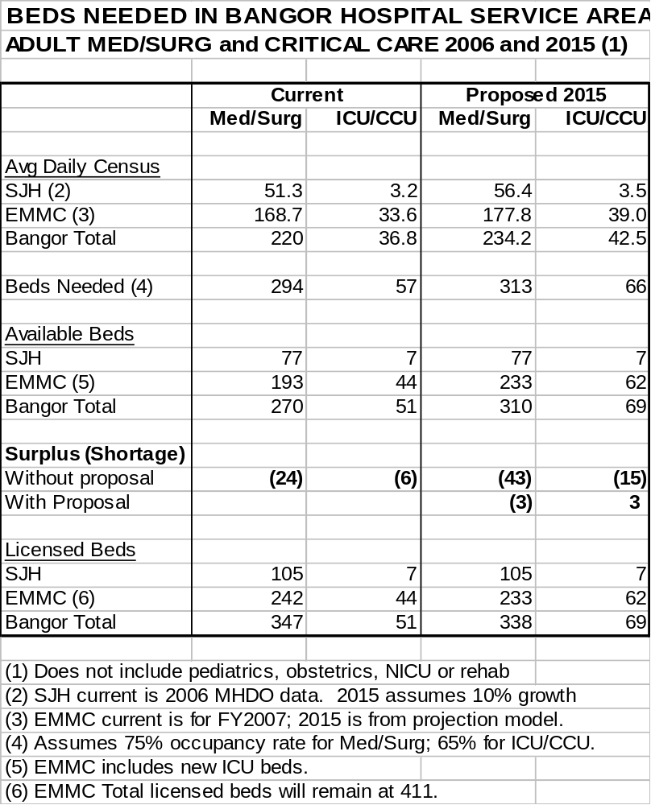

“EMMC has assumed that St. Joseph’s census in 2015 will increase at the same rate as the need for acute care services in EMMC’s projection model. This will result in an average census of 56.4 med/surg patients and 3.5 ICU patients. Occupancy rates would be 73% for their med/surg beds and 50% for ICU. These are appropriate rates for a hospital of this size. It is difficult for a small ICU to operate at a higher occupancy rate. SJH could accommodate an increase in its average daily census of about one additional ICU patient; that would increase its ICU occupancy rate to 65%.”

“The challenge of adding ICU beds elsewhere in the region is discussed later in this section. EMMC at this time cannot assume it would be feasible for SJH to add ICU beds; it is not just a matter of physical capacity but staffing and a range of needed support services.”

“EMMC and St. Joseph currently work to assist each other at times of high census. It is anticipated that these cooperative efforts will continue. EMMC diverts patients to SJH when necessary and clinically feasible. See letters of support, Attachment K.”

Other Hospital Beds in the Region
“EMMC’s projections assume virtually no change in market share and will have no effect on the volume of services at other hospitals. In fact, the instances where a community hospital has to hold complex cases better cared for at tertiary centers will be reduced; improving the quality of care and safety of patients. Utilization of services at community hospitals will be more appropriate.”

“EMMC’s forecast model assumes that the twelve Critical Access Hospitals located in EMMC’s referral service area will see their average census increase about 10% by 2015. If their rate increase was to be double that of the model (and twice the rate for EMMC), their average daily census would increase by about 12 patients and have little impact on the need for EMMC to add capacity.”

“Another approach is to look at patients coming to Bangor for treatment. Per MHDO data, there are 130 patients from outside the Bangor Hospital Service Area hospitalized in EMMC on an average day. If it were clinically sound, and the community hospitals had the staff and other resources to accept 10% of these patients, it would reduce the average daily census of patients hospitalized in Bangor by 13 patients. This is consistent with the calculation in the previous paragraph.”

“However, the community hospitals in the region face their own challenges including sufficient adequately trained staff and would be challenged to handle any material increase in the number of patients. EMMC is notified by hospitals in the region when those hospitals have limited bed availability. During the first 46 weeks of CY2007, eleven different community hospitals in the region notified EMMC of their limited bed availability for a total of 114 instances.”

“Restrictions range from lack of bed capacity, emergency department limitations and staff shortages.”

“The above projections of beds needed to serve the regional population were developed originally in 2006 with 2005 as the base year. These projections were updated and revised during the programming planning process in early 2007. EMMC’s patient census in FY2006 and FY2007 has been higher than the original forecast but is within the range of scenarios in the model’s sensitivity analysis. Table 13 below estimates the occupancy rates when FY2007 data is included.”

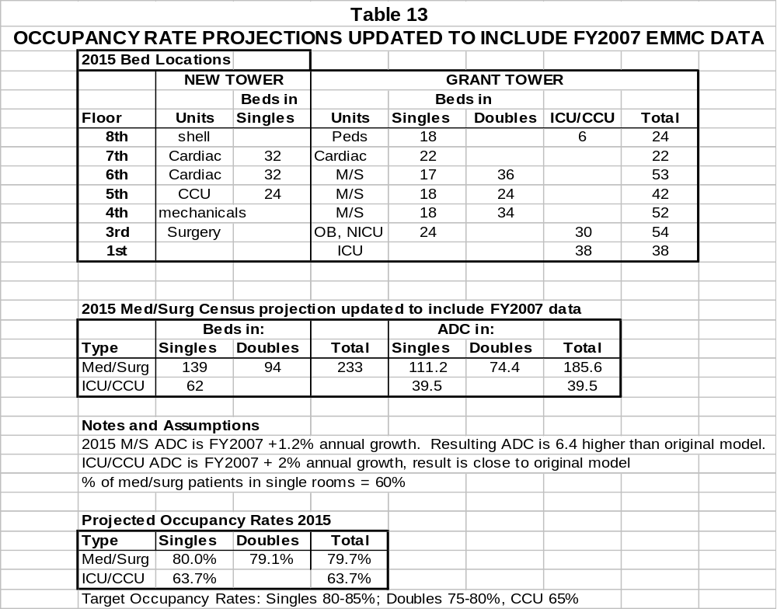
“EMMC’s projected med/surg occupancy rate of 80% in 2015 will be well above the current national mean of 65% for hospitals of 151-300 beds (Advisory Board, Attachment B). In fact EMMC will be close to 81% that marks the 90th percentile. Smaller hospitals have a mean occupancy rate of 48%.”

“EMMC projects that 60% of med/surg patients will be in private rooms in 2015, currently about 33% of EMMC’s med/surg patients are in private rooms.”

“The above forecast of EMMC occupancy rates assumes that the current census will increase a modest 1.2% per year. If the rate of increase is 2% annually, EMMC’s med/surg beds will be back to an occupancy rate of over 85% by 2015, even with the additional beds in this proposal. The proposed patient tower includes shell space for an additional nursing unit. If there were a 2% annual increase in need for med/surg beds, the shell space would be completed for 32 med/surg beds (pending future CON approval).”

Critical Care Beds (General Intensive Care and Coronary Intensive Care)
“The data in the shown in Tables 8 and 9 at the beginning of this section assume no hospitals reduce their current bed complement. If Critical Access Hospitals (CAH) are unable to continue offering critical care services, the number of per capita critical care beds in the region will be similar to that of southern Maine. Even though the critical access hospitals are listing CCU-level beds as part of their bed complement, they cannot offer the range of specialty and support services, such as intensivists, available at a tertiary referral center.”

“According to data compiled from the MHDO 2006 inpatient database, the average daily census in the CCU beds in critical access hospitals (CAH) was 7.6 patients; an occupancy rate of only 27%. It is difficult for a small unit of 2-4 beds to maintain a high occupancy rate. Individual CAH ICU occupancy rates ranged from 5% to 55%. The 28 ICU beds in the CAH hospitals in EMMC’s region are used at a rate equivalent to 10 beds at a larger facility. After the ICU beds in this proposal are added, the non-CAH ICU beds in EMMC’s region will be equivalent to that in southern Maine on a per capita basis.”

“Generally these ICU beds are used for patients not as complex as those treated at EMMC. The average hospital stay (including ICU and non-ICU days of patients using an ICU bed in a Critical Access Hospital is 3.0 days; the average hospital stay for patients using an ICU/CCU bed at EMMC (including non-ICU days) is 12.0 days.”

“If ICU patients in the regions’ CAH were admitted to a tertiary care center, many would be cared for in a non-ICU telemetry or other bed. EMMC’s projections of CCU need are not assuming that these patients will come to EMMC in the future. In fact, EMMC is working with many of these hospitals in developing a virtual ICU system to support care in these communities. EMMC’s forecasting model included testing scenarios that included the possibility of reduced ICU beds in the region. EMMC’s development of acuity-variable rooms and nursing units will allow the flexibility to maintain beds as either CCU or general med/surg to more efficiently care for the needs of the region.”

“In 2005 when EMMC filed its CON application for additional ICU beds there were 112 ICU/CCU beds in the region. Even with EMMC’s recently added ICU beds, the number of ICU beds in the region has decreased to 108. After EMMC’s proposed project is implemented, there will be 126 ICU beds in the region. This is an average annual increase of 1% in ICU capacity from 2004 to 2015, if no other hospitals discontinue offering critical care. EMMC feels that it would be reasonable to expect a 2% annual increase in need for critical care services based on patient demographics.”

“EMMC is supporting regional hospitals serving critically ill patients through the use of telehealth in emergency departments and via the soon to be available virtual ICU program. These regional hospital services and others are described in more detail in Section VII.”

“As stated in EMMC’s 2005 approved CON application to add 12 intensive care beds:”
- Any continued reduction in census at the community hospitals in EMMC’s region will also increase the pressure on EMMC’s general med/surg beds.
- To ensure that patients in our region are cared for safely, the region needs an adequate supply of ICU beds. Implementing new ICU beds, including facility renovations, acquiring equipment and most importantly finding and training ICU patient care staff, requires a significant length of time. Implementing this project at this time will contribute to the orderly conversion of more hospitals to Critical Access. If only two hospitals in our region proceed with this process over the next 5 years, or close their ICU’s without going to CAH status, there will not be a net increase in ICU beds in the region, even with EMMC’s proposal to add ICU services.

“Note: In fact 6 hospitals in the region converted to CAH status, increasing the total to 11.”

“Also from EMMC’s 2005 approved application to add 12 ICU beds:”
- The region will become increasingly dependent of EMMC as the regional provider of ICU services.
- While CAH regulations do not preclude a community hospital from having ICU beds, the rules governing the number of total beds and average length of stay mean that CAH must have agreements with referral centers such as EMMC to accept transfers of the more critical ill patients. Any continued reduction in census at the community hospitals in EMMC’s region will also increase the pressure on EMMC’s general med/surg beds.
- Although we can not quantify the effect on the number of ICU beds of additional hospitals in our region converting to CAH, it is highly probable that several hospitals in our region will be reducing the number of ICU beds. Even if they do not reduce the number of licensed beds, they will be reducing the number of critically ill patients cared for. To ensure that patients in our region are cared for safely, the region needs an adequate supply of ICU beds. Implementing new ICU beds, including facility renovations, acquiring equipment and most importantly finding and training ICU patient care staff, requires a significant length of time. Implementing this project at this time will contribute to the orderly conversion of more hospitals to Critical Access. If only two hospitals in our region proceed with this process over the next 5 years, or close their ICU’s without going to CAH status, there will not be a net increase in ICU beds in the region, even with EMMC’s proposal to add ICU services.
- EMMC now has board-certified intensive care physicians in house 24 hours a day but has not publicized this widely in the region because EMMC cannot handle the volume increases expected to result. Based on current and projected demand, EMMC needs 6 additional ICU beds even if no hospital in the region reduces ICU beds. To meet increases in demand over the past ten years EMMC developed two satellite critical care units on existing med/surg nursing units. There is no suitable site within EMMC for another 6-bed satellite.
- The supply of ICU services, including trained clinical and support staff, is decreasing in the region as smaller hospitals decrease their intensive care services. Many of the smaller hospitals are finding it increasingly more difficult to have trained staff available at all times. Increasingly, ICUs in community hospitals in the region are not able to staff their ICU beds in the evenings and on weekends and EMMC is contacted to arrange a transfer for the acutely ill patient.
- All of the Critical Access Hospitals in this region have signed transfer agreements to transport patients to EMMC as needed to meet their regulatory requirements.
- EMMC’s role as the regional trauma center for over one-half of the state, comprising the most rural region of Maine, requires that EMMC be ready to care for the sickest patients of the region. As Maine moves towards “regionalization” of care, the regional trauma and referral centers will be the destination site for patients requiring specialty services provided by specialists in all clinical disciplines.
- There is little alternative to EMMC for patients referred to us from the region for intensive care services. The only other comparable ICU in the state of Maine is Maine Medical Center’s, and its ICU is often full. The only other alternatives then are in Boston or other New England sites. Transporting these critically ill patients over such distances is a risk to the patient, and often these hospitals are also short on ICU beds.
- Current changes in intensive care management, supported by health care purchasers such as the Leapfrog Group, strongly demonstrate that patient safety and clinical outcomes are improved when specially trained intensivists manage patients in the ICU. In September, 2003, EMMC became the first hospital in Maine to commit to full time intensivists in the ICU. This is the highest level of intensive care available in the state. Since this time, Maine Medical Center has also achieved full-time intensivist coverage in their ICU. The need for intensivist level care makes it even more unlikely that smaller hospitals in the region will be able to maintain ICU beds for the duration of the patient’s stay in the ICU. Regional hospitals have and will increasingly convert to critical access hospital status due to the recent regulatory changes allowing hospitals to maintain 25 beds instead of 15, and rural hospitals are expected to increase transfers to EMMC’s ICU in order to comply with the 96 hour average length of stay.
- All of these points indicate clearly that this is a regional issue and that there is a critical need for additional ICU beds at this time.

“In its 2005 CON application EMMC’s forecast of ICU/CCU average daily census was 33.9 patients. EMMC’s updated forecast for 2010 ICU/CCU average census is 37.1 patients.”

“In its review of EMMC’s 2005 application the CONU stated:”
- “The Certificate of Need Unit has determined that EMMC has demonstrated a need for the proposed project. As more and more hospitals convert to Critical Access Hospitals and transfer their more difficult patients to EMMC, the need for additional ICU beds will and has increased. EMMC has demonstrated that they have taken steps to reduce the time that patients stay in their ICU with the recent addition of full-time intensivists in late 2003. Indeed this move did reduce the time patients stayed in their ICU as evidenced by the information they provided but it was a short term fix for a long term problem which is the demonstrated need for additional ICU beds.”

“The Maine CDC also concurred that the effect of hospitals converting to CAH also increased pressure on EMMC beds.”

Need for Neonatal Intensive Care Unit (NICU) relocation, redesign and expansion
“When built in 1982 the NICU was designed for 9 beds. The lowest census in the last two years has been 10 patients, reached only a few times. Because of the dramatic increase in NICU census (to an ADC of 17.5 in 2007) EMMC has had to re-design and expand the NICU area multiple times over the last 25 years.”

“EMMC has seen a dramatic increase of NAS (Neonatal Abstinence Syndrome) in the past four years from 25 in each of 2003 and 2004 to 50 in 2005 and 60 in 2006.”

“EMMC is working with Acadia hospital and regional providers on the factors around the increase of babies addicted to opiates that are born in this region and require immediate NICU care. This issue also impacts the needs for high risk obstetrics services, as described below.”

“The space limitations of the current NICU necessitate that up to 4 neonates and their families must share one room. With the amount of equipment required this can be very challenging for staff, patients, and families and presents safety risks to infants and staff. Obviously, there are also significant HIPAA and privacy problems with co-locating multiple patients in one care area.”

“EMMC is the only Level III NICU north of Portland. EMMC’s proposal will allow for the region’s smallest and most vulnerable patients to be cared for as close to home as possible. In the past year 11 neonates from region were deferred to Maine Medical Center in Portland due to capacity issues at EMMC. These are the sickest neonates with an average hospital stay of 40-60 days or more. The increased capacity at EMMC will allow more of these babies to be cared for closer to home.”

“The less these most fragile of patients are transported the better it is for their health. Traveling to Portland or out of state is a hardship on families already stressed by challenges of having their baby in intensive care. There are many reasons to avoid transporting neonates and mothers when possible including:”
1). Transporting neonates to southern Maine or Boston causes difficulties for families and interruption to family dynamics
  - housing, food, transportation costs for families due to distances involved is a concern for a many families in the region with limited income
  - families often have other children to care for at home
  - in cases with multiple births the other twin is not always transported out and the family is divided by babies hospitals140 miles apart
  - a spouse working in the area must take more time from work to be with his sick infant
  - coordination of care can be a challenge; mothers who receive care in a methadone clinic locally find it very difficult if not impossible to receive their medication outside their institution.
2). Referring hospitals will benefit knowing that EMMC will always have the capability to accept neonatal and maternal transports
3). Safety
  - Some infants are too critical to transport. These require a higher level or higher numbers of EMMC staff to participate in the transport
  - Risk of MVA during transport, especially during inclement weather
  - The proposed capacity will allow is also good practice to have 2 beds available for resuscitation

“The proposed increase in NICU capacity will allow virtually all NICU patients to be cared for in one centralized unit. Currently, due to high census statewide, EMMC cares for neonates needing NICU level care for in three locations: the main NICU on Grant 7 (12 beds) for the most acutely ill and complex cases, the Continuing Care Nursery on the Grant 8 (11 beds), and when necessary, in the pediatrics unit on the 8th floor. Since EMMC is the only Level III NICU north of Portland, planners and hospital staff were concerned that sufficient capacity be planned for. The new facility plan was revised to include 30 NICU beds instead of 25 beds.”

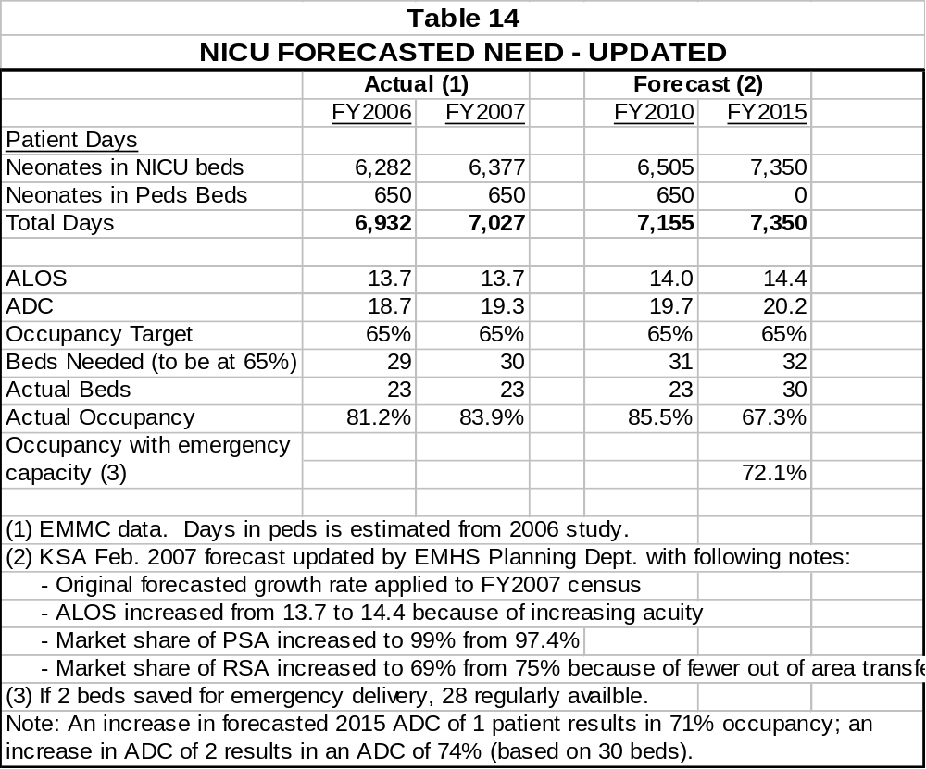

“The proposed capacity in the new unit will greatly increase EMMC’s flexibility in caring for the neonatal needs of the region. There will be fewer occasions when EMMC is 100% full and does not have space available for emergency deliveries where the neonatal (or neonates) need resuscitation and NICU care. Holding two rooms for emergency deliveries results in an effective working occupancy rate projected for 2015 of 72%. EMMC will have the capacity to meet the region’s need is higher than forecast. If the projected need were 5% higher than forecast, the occupancy rate would be 71% (based of 30 beds, 76% if based on 28). EMMC’s consultants have recommended an average occupancy rate of 65-70% to provide sufficient capacity to care the needs of EMMC’s large service area. As the only Level III facility in the region, it is important for EMMC to have this flex capacity built into the design of the space.”

“Since EMMC is the only Level III NICU north of Portland, planners and hospital staff were concerned that sufficient capacity be planned for. The new facility plan was revised to include 30 NICU beds instead of 25 beds.”

Perinatology Research and Evidence Based Design
“EMMC’s current insufficient space, with three to four neonates in per room in the main NICU, makes it difficult for families to be with their sick baby. EMMC will use evidence-based design in developing the new unit. Available studies still hampered by small sample sizes and are frequently facility specific. EMMC’s continuing participation in the Pebble Project and the Vermont Oxford Neonatal Quality Improvement Collaborative will provide EMMC with state-of-the art information on best practices in NICU design and procedures.”

“A particular focus of the new unit will be the enhancement of EMMC’s continuing efforts to fully implement Family Centered Care. The development of a NICU with single family rooms is imperative in this effort. The articles from the Journal of Perinatology: included in Attachment B summarize the advantages of single family rooms and other design aspects that are important in a modern NICU. This research addresses the importance of the sensory environment on the health and development of the neonate; the importance of privacy; ways to reduce stress on babies, families and staff; and the need for adequate sleep in neonatal brain development.”

“Single family rooms allow staff to adapt the environment (lighting, temperature) to the needs of each baby. With up to four neonates in a room in EMMC’s existing NICU, this is not really feasible. Because of the crowded conditions at EMMC’s NICU, families can be exposed to the stress of a neonate in the same room being resuscitated.”

“Single family rooms are becoming the standard of care in the modern NICU. EMMC has some experience on the advantages of the single family room. Because of space constraints on the current Ob/Gyn/NICU floor, the Continuing Care Nursery was developed in former storage space on the 8th floor adjacent to the pediatrics unit. NICU staff care for patients in both nurseries.”

“The Continuing Care Nursery is a nine bed intermediate nursery that features all private rooms, including two twin suites. This stepdown nursery provides an environment that allows the infants to grow. A quote from a mother of twin graduates from the CCN states, “this environment give the staff the chance to teach families how to care for their babies. It is very relaxing and quiet”. Having their baby “graduate” from the NICU to the CCN, gives the parents the sense that their baby is improving. It also gives the parents the opportunity to become more comfortable before they take their baby home. The most frequent comment parents make when transitioning to the CCN is, “the best thing about being here is I only hear my own baby’s monitor when it alarms and not everyone else’s”.”

Obstetrics
“EMMC’s current obstetrics inpatient unit is located on the seventh floor of the Grant building. The inpatient ob/gyn unit was originally designed for 30 beds, primarily in semi-private rooms. Also sharing space on the seventh floor is the well baby nursery, NICU, labor and delivery, three OB/Gyn operating rooms, and the surgical prep and recovery areas.”

“The growth in the programs sharing the seventh floor over the last 25 years, particularly the need for neonatal intensive care and gyn surgery, has made caring for all patients admitted to these services in this limited space very challenging.”

“The space on the 7th floor has been redesigned several times to accommodate these changing needs. Several inpatient rooms have been converted to space for NICU patients. The NICU also expanded into converted storage space on the 8th floor adjacent to the pediatrics unit has been converted to the Continuing Care Nursing for NICU patients needing intermediate level care. NICU staff care for patients in both of these units.”

“Need for inpatient obstetrics beds was part of the bed model described above. Little growth is expected in the forecasted regional population of women of child bearing age. Some increase in maternal acuity is expected. EMMC is working with others in the region to reduce the region’s high incidence of women with opiates and other drug abuse issues. EMMC is the only facility in the region that has the scope of services to care for these mothers and their babies.”

“The current obstetrics facility was designed and built at a time when usually one additional person attending a birth – at most. Women labored in a small labor room and then were moved to the delivery room (modern equivalent to an operating room) at the time of delivery where they were attended by the doctor and one nurse. The culture has changed dramatically and it is not unusual now to have, in addition to the nurse and provider. a husband or significant other, both sets of parents, one or two siblings and a best friend all wanting to attend a delivery. Unfortunately, because of space constraints at EMMC, family members are frequently asked to leave due to a lack of space, which is a significant upheaval at such a happy time. People are forced to choose who can stay and who must leave. Employees who want to provide support for families must often be the “bad guy” and ask a new grandmother to leave so the provider can have the room to provide good care. The new LDRP rooms will be designed to allow a reasonable number of family members to attend when it is appropriate.”

“EMMC’s current labor rooms have no shower or tub for the mother’s comfort during labor, and a water birth is out of the question. Women choices on the type of birth they wish to have are limited by the outdated facility and lack of space.”

“Semi-private rooms for post partum patients were state of the art 30 years ago, but are far from the standard for new families. The resulting loss of privacy and confidentiality jeopardizes the experience for the family and makes the staffs’ job more difficult. The rooms are small and do not lend themselves to infant rooming in and new parent bonding.”

“Learning to breastfeed is difficult to accomplish in shared rooms due to the lack of privacy with the other patient and her visitors present. Current breastfeeding rates in the region are far below the national average.”

“Patient satisfaction surveys over and over again have postpartum mothers requesting private rooms. An example of a recent and typical comment submitted with a patient satisfaction survey is included below:”
- “Also private rooms should be considered a minimum level of service on the maternity floor. Giving birth is a very private experience that should only be shared with family or friends. According to nurses, I wasn’t the only patient to complain about my first roommate. This roommate and her partner continuously used profanity, argued very loudly and had their TV very loud even when they left the room. After she left, I mentioned this to a nurse and she told me that this patient’s first roommate actually asked to switch rooms. Fortunately my second roommate was quiet and respectful to me and my family. Again, private rooms should be a must!!”

“The new design of the OB unit calls for one single nurse station with staff for both L&D and post partum working out of the same area. This design will maximize the efficiency of available staff to flex where the need is most acute. It will enhance communication and collaboration between the L&D and postpartum staff ad will allow for the needs of our high-risk pregnancies to be monitored in a less acute area than L&D, reducing their stress and ultimately improving outcomes.”

“The current floor plan does not have a functional triage area, which necessitates using a labor bed to evaluate an outpatient. The addition of a triage area will allow admission to a labor bed only when patients are in labor; maximizing the efficiency and throughput of the labor beds.”

“The bed need analysis for obstetrics beds is included in Tables 6 and 7 above.”

OPERATING ROOM NEED
“The main operating rooms were constructed in 1972. There have been many changes in surgical practice and technology over the last 35 years. The Outpatient Surgery Center (OSC) was added in 1999 in new construction adjacent to the third floor of the Grant tower.”

“The projection of the region’s need for surgical services was based on the population-based need by service portion of the master facility plan forecast model. The result is an average annual increase in need of 1.5% annually through the forecast period. Even though the need for total operating room hours is projected to increase by over 13% at EMMC by 2015, EMMC is proposing a net increase of only two operating rooms, a 9% increase in physical capacity. This is possible because the design of the new surgery areas will be more efficient, with fewer delayed cases and shorter turnaround time between cases.”

“EMMC’s projections of need for operating rooms are not assuming any material changes in market share. The net increase in one operating room will have no effect on St. Joseph’s Hospital six operating rooms, or on any hospitals in the region. The reasons for the proposed operating rooms are modernization, efficiency, improved patient care and outcomes.”

“The Main OR and Outpatient Schedule Follows:”
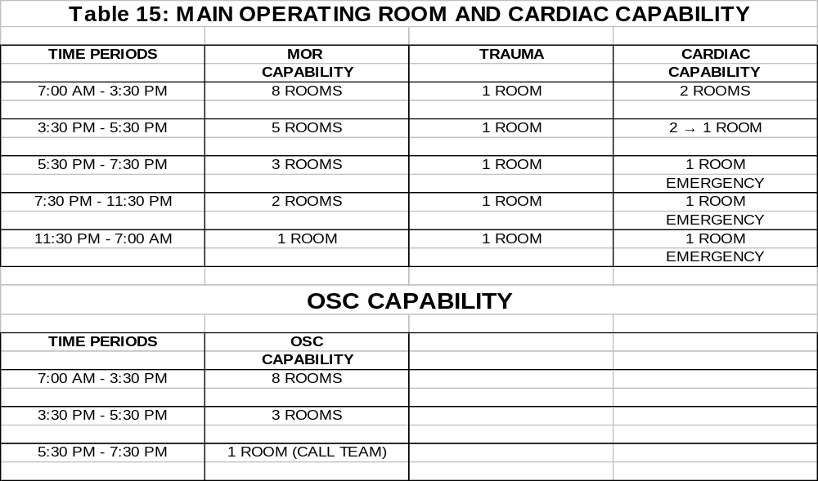

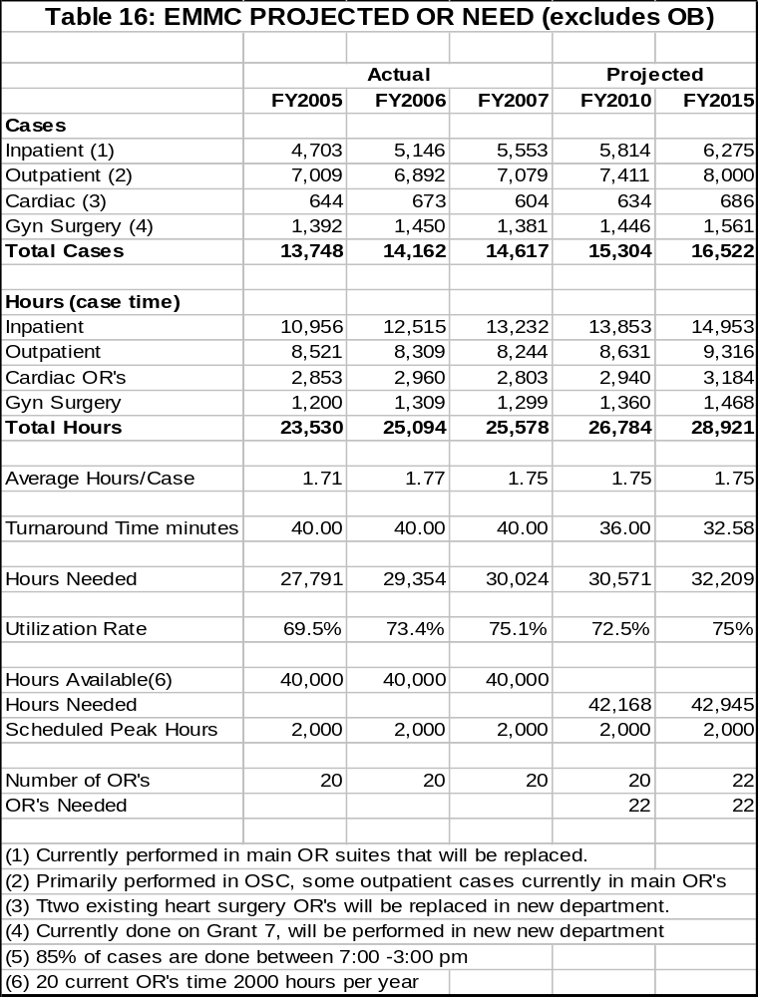

“During work on the Master Facility Plan EMMC and its consultants forecasted the need for inpatient and outpatient surgery. As the program planning proceeded, EMMC determined that great advantages in patient care could be achieved through staffing and efficiency by re-organizing along service lines teams instead of splitting inpatient and outpatient units. For example, orthopedics inpatient and outpatient cases will be cared for by the same team. This re-organization resulted in a design with one less operating room than first planned. If there is a greater shift from inpatient to outpatient than forecasted, it will be easily accommodated in the new facility. Outpatients will still have the same ease of access they have in the relatively new OSC.”

Table 17

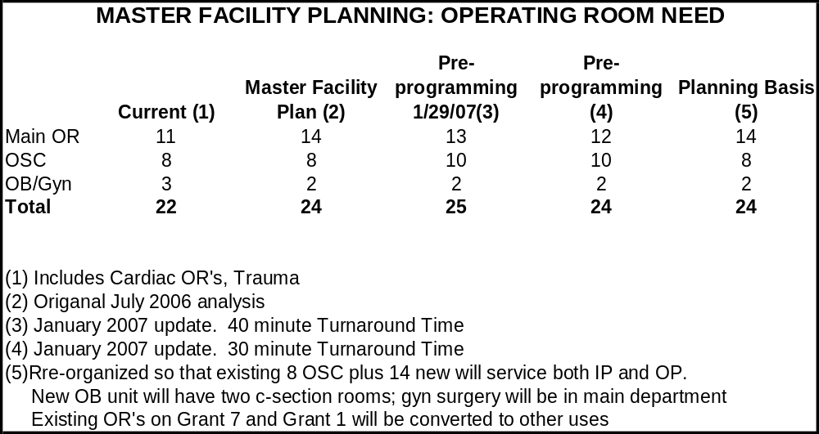

“The savings from consolidating the surgical departments are included in the operating costs in Section II of this application. There are efficiencies and benefits resulting from the re-organized operating room departments and the advantages of this plan for which the cost savings have not yet be projected, including:”
- Improved surgeon satisfaction and better utilization of their time. Surgeons will be able to remain in one area with reduced down time and an increased percentage of on-time starts for surgery cases.
- Increased efficiency of operating room staff.
- Decreased duplication of inventory/supplies.
- Increased OR utilization and scheduling efficiencies with better work flow.
- Decreased turnover time due to specialty service teams in specific OR’s.
- Improved storage space with easier and expedited access to equipment.
- Reduced number of instrument sets needed due to improved accessibility.
- Decreased duplication of equipment such as eye microscopes, laparoscopic towers, arthroscopy towers, OR tables, bovies, ortho power and ortho fracture sets.
- Improved support staff efficiencies with less time spent moving equipment and supplies back and forth between Kagan and the current “main” operating room.
- Reduced full time equivalents (FTE’s) with increased efficiency of staff utilization, improved staff scheduling. Decreased duplication of certain roles such as team leaders, etc.
- Reduction from two Intake Centers to one with combined resources and decreased duplication.
- Increased patient satisfaction with additional, consolidated waiting areas resulting in decreased confusion for patients and families.
- Improved efficiency for support services such as transport, pharmacy, radiology, and lab. These services will be able to operate more efficiently as they will be serving requests from one central area.
- Standardized QI/QA collection and improvement will be facilitated.
- Improved efficiency for Anesthesia coverage.

Sterile Processing
“The current sterile processing department was completed in 1974 and sized to serve a hospital with 12 operating rooms. The proposed department will serve 24 instead of 12 operating rooms. Today’s sterile processing departments, besides handling a higher volume, are also working with providing more specialized and diverse equipment. EMMC’s sterile processing department will be relocated and expanded as part of the reorganization of the operating rooms and peri-operative services. The location in the basement of the new tower will have direct connections to the central sterile core in the surgical suites. Sterile processing is sized according to the volume and utilization of surgical suites.”

“The additional space will allow the implantation of a closed case cart system. The advantages of using closed case carts are increased safety with reduced possibility of contamination and greater efficiency for surgical teams. Such a system reduces storage needs within the surgical suites.”

Critical Decision Unit/Medical Observation Unit.
“While the proposed observation unit adjacent to the existing Emergency Department (ED) is a small part of this phase of the Master Facility Plan, it is a key component of EMMC’s plan to improve patient care in a cost-effective and efficient manner.”

“EMMC proposes to develop an 8 bed observation unit adjacent to the emergency department. The identified patients will be assigned to a protocol driven 6-18 hour stay for targeted medical conditions. This unit will also accommodate patients awaiting outcome of a treatment, test or assessment. These patients will include STABLE non-threatening behavorial health patients, chest pain patients and asthma patients and others. A dedicated observation unit will free up exam rooms for patients, decrease the number of patients who leave without being seen, reduce inappropriate admissions, and better service needs of patients, families and clinicians. Staff in this unit will be cross-trained in the ED and this unit will also serve as “surge” capacity and provide some overflow capacity for EMMC’s very busy ED.”

“The 2006 Guidelines for Design and Construction of Hospitals and Healthcare Facilities from the AIA recommend separate Observation/Holding Units that are near or adjacent to the Emergency Department. AIA Guidelines Appendix A5.1.3.8(2), page 74, states”
- A5.1.3.8 (2) Observation/holding units for patients requiring observation up to 23 hours or admission to an inpatient unit should be located separately but near the main emergency department. The size will depend upon the function (observation and/or holding), patient acuity mix, and projected utilization.

“There are currently 26 treatment rooms in the Emergency Department (ED). Current EMMC ED volume of 44,000 visits results in 1,692 visits/room annually. Current guidelines from the American College of Emergency Physicians recommend a range of 1,200-1,600 annual visits per room. Even the successful operation of EMMC’s walk-in-care center on Union Street in 2006 has not alleviated the crowding and capacity issues in the ED. As shown in the following Table 18, EMMC has a higher ratio of annual ED visits per room than other hospital ED’s that have recently received CONs for ED expansion.”

Table 18

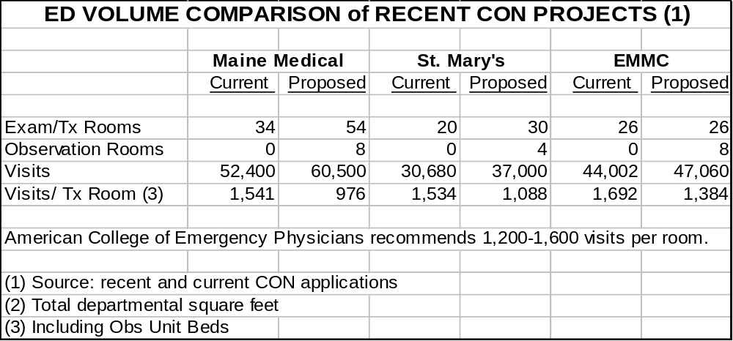

“The Benefits of the Proposed Observation Unit include (articles included in Attachment B):”
- Observation units have been shown to decrease cost and offer a more effective treatment alternative for selected diagnosis by utilizing protocols and treatment plans
- Decreased ED length of stay and decreased patients who Left Without Being Seen (LWBS)
- Use of chest pain protocols have been shown to decrease need for inpatient admissions
- Reduced ED diversions
- Patients with a predictably long ED stays are moved to the Observation Unit, freeing up the regular ED exam rooms for emergency and urgent cases
- The Observation Unit will reduce the need for certain outpatients such as chronic heart failure, dehydration, asthma, rule-outs and others from occupying inpatient beds

“Because of limited capacity in the ED, some patients that need extended observation can be cared for on EMMC’s already over-crowded inpatient units. In FY2007 the year-round average daily census of outpatients in inpatient beds was five patients. Patients that are appropriately cared for in the Observation Unit will no longer need to be cared for on an inpatient unit. EMMC believes that this will be a cost savings on the inpatient units, but has not yet calculated this saving for inclusion in the incremental operating cost, Table 3.”

“Section VIII describes the recently update Regional Community Health Needs Assessment which indicated continued need to monitor chronically ill patients and to control admissions for chronic disease. Observation areas reduce unnecessary admission for patients who might have emergent but not admissible needs. Thus admission rates for ambulatory sensitive care (ADC) diagnosis review in the Community Health Needs Assessment will be reduced.”

“In FY2007 EMMC went diversion for emergency six times for a total of 38.5 hours (16 patients were diverted to St Joseph Hospital). This is comparable to Maine Medical Center’s diversion statistics of 11 incidents for a total of 36 hours quoted in their recent ED expansion CON application. The proposed Observation Unit and increased inpatient capacity will reduce EMMC’s diversions.”

Ancillary department volumes
“The projected growth in the areas described above will also affect ancillary and support departments. The Master Facility Planning process also included projections for these areas, both inpatient and outpatient. These projections were tied to the regional population demographics and use rates as well as to the changes predicted in the main components of this project. These results are factored into the financial analysis included in Attachment I.”

B. CONU Discussion

i. Criterion

Relevant criterion for inclusion in this section are specific to the determination there is a public need for the proposed services as demonstrated by certain factors, including, but not limited to:

• Whether, and the extent to which, the project will substantially address specific health problems as measured by health needs in the area to be served by the project;
• Whether the project will have a positive impact on the health status indicators of the population to be served;
• Whether the services affected by the project will be accessible to all residents of the area proposed to be served; and
• Whether the project will provide demonstrable improvements in quality and outcome measures applicable to the services proposed in the project;

ii. Analysis

EMMC serves as the trauma and tertiary care center for northern, eastern and parts of central Maine. EMMC has transfer agreements with all hospitals located in their defined primary and secondary service area. Located in this service area are 12 Critical Access Hospitals (CAH) which are limited to length of stay requirements and the range of procedures that are provided. The applicant has conducted a regional health needs assessment study of the areas served by EMHS and all its affiliates to determine the need for the emergency rooms, inpatient and outpatient surgeries and inpatient beds. The proposed project includes a substantial amount of shell space for further development once resources become available. These include space for invasive labs and noninvasive cardiology, space for additional patient rooms and space for essential ancillary and support departments.

Part of the original construction plan included space to be used for additional inpatient beds, invasive and noninvasive cardiology space. The applicant has not stated when they expect these spaces to be completed or where they intend on treating these patients if there is not enough room in their current locations within the hospital.

The standard practice of a trauma hospital is to have a critical decision unit/medical decision unit located within the emergency department. Currently the applicant does not have such a unit. The information provided by the applicant demonstrates a current use rate resulting in 1,692 visits/rooms annually on volume of 44,002 visits/26 treatment rooms. The addition of an 8-bed critical decision/medical observation unit would lower the future use rate to 1,384 visits/rooms on future volume projections of 47,060 visits/32 treatment rooms. This is in line with other recently approved CON projects mentioned by the applicant.

However, in CONU recommendations to approve other emergency room expansions reliance was placed on other criteria that EMMC did not provide on boarding problems, length of stay times in ED and percentage of patients left without being seen rates etc. Absence of this additional information the CONU could not determine the need for additional emergency room beds.

This proposed CON application does not call for the addition of licensed beds but it will result in the increase of staffed beds from 350 to 411 (EMMC’s current licensed amount). Projected beds in private rooms will be 281 and projected beds in semi-private rooms will be 94. In addition there are 36 rehabilitation beds that are not identified as either private or semi-private for a total of 411 licensed and staffed beds.

The following table compares proposed square footage space verses recommended space requirements:

Department Proposed AIA Guidelines Hospital of the Future
Emergency Department 150 Minimum 120 130-150
Operating Room Suites 620-960 Minimum 350-600 600-800
PACU 100-140 Minimum 80 110-120
Recovery 150 Minimum 80 100-140
NICU 220 Minimum 120 150-160
OB 250 Minimum 120 350-400
CCU 290 Minimum 200 250-300
Inpatient Bed 290 Minimum 120 200-250

The existing 530 square foot Operating rooms will be enlarged to 700 square feet. Hospital of the Future – Lessons for Inpatient Facility Planning and Strategy (The Advisory Board 2007) (referred to as Hospital of the Future) implies the following on Operating Room sizes:
- “600-650 SF – “The Sweet Spot” – Comfortably accommodates surgical, imaging equipment while allowing for unimpeded circulation around room.

- 800-1,200 SF – “An Over-Indulgence” – Unused space along perimeter becomes unnecessary storage space for equipment, supplies.”

The applicant provided the Hospital of the Future guidelines as part of its documentation that show square footage for certain space requirements where as AIA guidelines show the minimum square footage requirements.

While the proposed Operating Rooms are larger than the recommended size, they are not overly excessive in size given these guidelines, with the exception of one brain lab at 960 net sq. ft. It is unclear what types of procedures will be performed in the brain lab that requires such a large OR. EMMC did not discuss whether they are already performing these services in a smaller existing OR, or if the hospital is planning a new service in the future.

Two PACU rooms are oversized by 20 net sq. ft and all 30 Recovery rooms in the Perioperative Nursing Unit are oversized by 10 net sq. ft. according to the Hospital of The Future guideline provided by the applicant.

The triple occupancy 320 square foot NICU rooms will become single occupancy rooms at 280 square feet. Hospital of the Future suggests that a net square footage target should be 150-160 SF for NICU rooms. The proposed sizes by EMMC are 75% larger than recommended sizes for a NICU room.

Existing private patient rooms are currently 210 square feet and would increase to 330 square feet. Hospital of the Future indicates the following in regards to private patient rooms:

- “240-290 SF – “The Sweet Spot” – Comfortably accommodates three distinct zones for caregivers, patient and family without excessive space.

- Over 290 SF – “An Over-Indulgence” – Larger room size increases walking distance for staff, decreased productivity; extra space used for equipment and supplies.”

EMMC is proposing to build private patient rooms at almost 14 % more square footage than this source indicates would be “an over-indulgence”.

EMMC has failed to demonstrate a need for the brain lab, PACU, NICU and private patient rooms to exceed the recommended space requirements.

This application has a considerable amount of shell space being built in the new patient tower. CONU has estimated it is approximately 39 percent of the total net square footage of all new construction with shell space on levels 0, 1, 2 and 8. The applicant has earmarked the potential use of this shell space for future projects which may or may not materialize. The applicant is assuming future CON approval and projecting in some instances that the space may not be utilized until 2020. CONU acknowledges it may be less costly to build now than later and has in the past approved shell space when appropriate.

The CONU does not recommend that this shell space be approved. The CONU finds that parts of this project are excessive in scope (i.e. proposed vs. recommended space). The applicant includes very few specific health problems to be met (other than their experience of increased births and mothers with addiction problems). The applicant does not indicate that health status indicators will improve, and does not provide any examples of improvements in quality and/or outcome measures. There are no throughout measures for the various services on which to base conclusion regarding effectiveness or efficiency.

The applicant is a not-for-profit hospital and therefore its services will be accessible to all residents of the area.

iii. Conclusion

CONU recommends that the Commissioner determine that EMMC has failed to meet its burden to show that the proposed project meets the public need.

V. Alternatives Considered

A. From Applicant

The applicant provided the following information in regards to alternatives considered for this project.

Review of Alternatives
“EMMC has considered a wide range of alternatives and phasing options to address the current capacity problems and the need to upgrade the facility.”

- Build a new hospital – There is some appeal to the concept of building a new inpatient facility on a new campus. EMMC’s current campus is landlocked between the Penobscot River and a major traffic artery, Rt 2, in Bangor. There would be no disruption for patients and staff during the construction period.

However, this is the most costly option. Consulting architects, MorrisSwitzer, advise that the replacement cost of EMMC’s inpatient services could range from $800 million to $1 billion and that a new campus would need 100 – 150 acres to develop the necessary facilities. If EMMC opted to build a new facility, the best use of the current facility would need to be explored. Options might be outpatient services, a specialty hospital such as rehab or long term acute care, or long term care.

This option is ruled out due to space needs, cost, and the historical investment in EMMC’s current inpatient campus.

- Stay as is – no changes – Based on the discussion in the Needs Section of the CON Application, it is clear the EMMC cannot continue to serve as a regional referral center without some significant change to the facility. As the population served continues to age, residents of northern, eastern and central Maine deserve to have an excellent referral hospital accessible. EMMC’s inpatient tower is over 30 years old and does not meet current standards as described earlier. EMMC continues to explore options to reduce length of stay and add efficiencies; however incremental efforts would not impact the need for this project.

There is a cost of “doing nothing” that includes loss of physicians, who expect a state of the art hospital with current medical equipment, increasing challenges with employee and patient safety, and other costs related to an aging physical plant.

This option is ruled out due to current age of plant, the need to address new patient and staff safety and quality standards, and to serve patient needs in the future.

- Build a Specialty hospital on new campus, such as heart, women/ infants or rehab facility – Another option considered was to carve out a distinct patient population and build a specialty hospital for the region. Acadia hospital is a successful example of a specialty hospital which, in its origins, was part of Eastern Maine Medical Center. Staff and architects considered populations such as those in acute rehab, heart center, and the women and infants centers at EMMC.

This option appears problematic for several reasons. First, diagnostic and imaging equipment would need to be duplicated to meet the basic needs of patients at two locations. Second, the medical staff leadership noted that the medical staff specialists are not “deep” enough to potentially cover two or more hospital campuses in Maine. This same determination came from nursing leadership, who stated that there may not be a large enough nursing pool to staff another acute facility; currently there is some flexibility in moving cross trained nurses around as needed throughout the hospital. Finally, building a specialty hospital takes away some flexibility in space usage in the future to the extent that beds are dedicated to a particular purpose.

This option is ruled out now due to concerns about costly duplication of space and equipment, lack of physician, nursing and clinical staff, and the need for maximum flexibility in the proposed project.

- Complete full phasing of the project now - The master facility plan drawn up by the architects completes the in-fill of the shell space on the current proposal. The phases on hold for the future include the re-location of the interventional suites to be closer to the new heart and critical care beds, and additional needed beds on the 8th floor of the new building.

A second new inpatient tower is also needed for full implementation of the Master Facility Plan.

The construction and related cost of this option was estimated at a cost of over $400 million and was deemed to be not financially feasible at the current time. The Planning team will continue to look for the optimal timing to proceed with the next phase of the master facility plan.

- Community based option – EMMC works closely with St. Joseph Hospital in Bangor and other hospitals in the region to support care as close to home as feasible. See support letter, Attachment K.

Another option considered was to support existing beds in regional hospitals and to possibly build programs that shift certain patient populations to other smaller hospitals in the region.

As described in this application and reinforced by the many attached letters of support (Attachment K), EMMC has good relationships with the regional hospitals and has initiated multiple programs which are intended to support care as close to home as feasible. These programs include PACS (imaging), a range of other telehealth programs, regional oncology clinics, and more. A grid outlining some of EMMC’s regional support and outreach activities is included as Attachment O. As patient care becomes more complex, providers, patients, and families need and demand the services of a high quality regional referral center.

EMMC is committed to continuing to work with regional hospitals. This option; however, is ruled out due to the duplication of specialists and equipment that would be required to set up special units in existing hospitals, the regulatory restrictions (length of stay) required for regional critical access hospitals, and the infeasibility of moving any significant volume of patients that would address EMMC’s current inpatient capacity challenges.

Summary – Review of Alternatives
“As discussed in the Needs section, even a material increase in inpatient volume at all community hospitals does not alleviate the need for significant capacity increase at EMMC. Community hospitals cannot and should not take on the high-end specialty services that comprise the bulk of this application. There is a need today to expand EMMC’s NICU and adult ICU/CCU, and heart center bed capacity, renovate and upgrade the operating suites. The most cost efficient and logical place for these services is at EMMC.”

Orderly and Economic Development of the Health Care System
“This proposal and its place in the Master Facility Plan has been developed over the past two years with significant input from design and space planning experts, from regional providers and stakeholders, and others. The EMMC Board, comprised of community and medical leaders, has provided constant oversight throughout the process.”

“This project is needed for the health delivery system which supports this region of Maine. The evolution of the majority of hospitals moving to Critical Access Hospital status has changed the complexion of the delivery system. Several new hospital projects, including critical access hospital construction, have been recognized as needed by the CONU; this is the next appropriate phase of development for EMMC as the regional referral trauma center for the northern two thirds of the State.”

Demonstrated efforts to coordinate services with other providers
“During the spring of 2007 Deborah Carey Johnson, RN met with 18 CEO’s of the other hospitals in our region. While EMMC has no official role in setting the direction for healthcare in the region, we feel our pursuit of a plan for EMMC has potential impact on all hospitals in the region. Therefore, consulting with other hospitals on their plans for services in the next decade and beyond, and their anticipated needs for support from EMMC, the regional specialty center, was an important component of our Master Facility Planning process.”

“CEOs in the region’s community hospitals are working to take care of the primary care needs of their patients: chronic disease management, general medical and surgical care, and some specialty services, such as orthopedics, some medical cardiology, etc. Their needs for support come in the areas of specialty and subspecialty services like trauma, multi-system medical management, oncology, specialized cardiac care, high risk OB, etc. Access to EMMC’s specialty surgeries, cardiac services, perinatal care, and adult and neonatal intensive care are among the top requests from these CEOs and, not coincidentally, these are the services prioritized in our Phase One Inpatient Tower proposal.”

“In addition, EMMC already provides support services to help manage costs and staffing shortages in many regional community hospitals, including centralized resources like pharmacy, imaging support through our PACS system, teletrauma services in some hospitals and, soon, our virtual ICU product-providing remote ICU monitoring and support, as described in further details below.”

“While hospitals in the region are committed to continuing to provide their local communities with the first line of medical care, they depend upon EMMC for the more specialized services, which we can provide by consolidating that care in Bangor. Conversely, Ms. Johnson was careful to point out to these CEOs that EMMC relies on the community hospitals to care for the more straightforward cases in their home communities, so beds in Bangor can be made available for the region’s sickest patients.”

“The shortage of ready beds at EMMC is a clear concern among regional CEOs. It’s fairly common practice for EMMC to prevail on those community hospitals to hold on to patients requesting transfer to specialty units, as we work to find the appropriate bed. In some cases, however, transfers to EMMC can not be delayed, and sometimes they are initiated without an identified bed, simply to get them access to the specialists and services available on at EMMC.”

“Hospital executives were supportive of this project and recognized the need, as evidenced by the many letters of support in Attachment K.”

“A regional support grid is included in Attachment O which includes some of the ways that EMMC is working with regional hospitals to support their missions. Examples include:”

- Telehealth: EMMC specialists provide a wide range of telehealth services, some in the development phases. Grants have been received for equipment to support delivering the following services via videomonitors: neuropsych, genetic counseling, nephrology for hemodialysis centers, and vascular. Recent activities include additional support to regional critical access hospitals. Trauma surgeons and pediatric intensivists are or will be available to assist with stabilization, management and transport services for adults and children in rural areas. This service is being evaluated as part of a HRSA grant and has also been used as a teaching opportunity for rural providers who don’t see the high volume of trauma cases that come to EMMC.

- PACS – Radiology telehealth
EMMC PACS program has been highly successful in extending radiology support and access throughout the region. EMMC and twelve other regional hospitals use or are in the development phase of being able to store and access digital images in one central storage area. Spectrum Radiologist, some of whom specialize in certain aspects of imaging, are able to view images at home and multiple work locations. EMMC was able to secure a $500,000 grant to support the start-up aspects of PACS in the region.

- Virtual ICU
Another program in development is regional virtual ICU. This program will bring intensivists and ICU nurses to regional hospitals via telemonitoring and special software. EMMC expects initial implementation in fiscal year 2008. The virtual ICU program will continue to support patients close to home, but will not impact the need for EMMC’s proposed additional critical care beds, as explained in Section IV of this application.

Each year, more than 4 million patients are admitted to intensive care units in the United States and about half a million die in ICUs. Many of those deaths can be traced to preventable medical errors, according to the Institute of Medicine and the Leapfrog Group, an influential coalition of more than 150 large public and private organizations that is leading the drive for patient safety and improved outcomes. Both groups have focused heavily on the ICU, where studies suggest that about one death in 10 could be avoided if intensivists managed patient care. These statistics can be applied to our region.

- The problem: With an estimated 6,000 intensivists nationwide, there aren't enough of them to go around. Eastern Maine Medical Center has contracted with Penobscot Respiratory for 24*7 intensivist coverage since November 2004. EMMC will be able to leverage its ability to provide intentivists managed care through out the region with the virtual ICU.

The virtual ICU allows critically ill people to have their care supplemented at a remote site (EMMC) by an Intensivist, nurse and others with critical care expertise. Critical Care nurses at the patient’s bedside maintain onsite direct patient care. Using voice, video, and data software and hardware, a remote staff assembled by a healthcare system (EMMC) can monitor the heart rates, blood pressures, and oxygen saturations of patients in the system's various ICUs. This staff can also check ventilator settings and wound dressings; review X-rays, lab results, and care plans that have been input or transferred electronically; and interact with patients and caregivers. Thus, the remote monitoring site provides a “virtual” physical exam, with real-time findings simultaneously visible to the remote team.

The Cerner’s Report Expert Critical Care package software is capable of identifying dangerous trends, such as a decreasing oxygen saturation that's combined with an increasing respiratory rate, and alerting remote staff, who can evaluate the alert and contact bedside caregivers as needed. The software is sensitive enough to detect subtle changes that the nurses and doctors at the bedside might miss. Cerner is EMMC’s clinical information system partner.
To picture how it works, imagine an air traffic control tower. The remote ICU staff, like those in the control tower, monitor, advise, issue warnings, and provide orders. But it's the bedside staff—like the airline pilots who fly the planes—that actually provide the hands-on intervention.

Time line at EMMC:

$500k grant awarded in Oct 2006 for the establishment of a Virtual Command Center to support our affiliates. This Command Center will go live in January 2008.

  - Phase 1 – INET EMMC went live with INET documentation for nursing in May 2007. Developed all protocol documentation and have interfaces for physiologic monitors in all critical care units.
  - Phase 2 was approved in June 2007. This will conclude in the fall of 2007/8, with roll-out of virtual ICU to all adult critical care beds at EMMC and with the build out of the command center. Once this is installed we will be able to begin to leverage our intentivists to cover the region and in house patients. This project will continue with implementations to our affiliates through out FY2008 and FY2009. Costs for this project to install virtual ICU for EMMC are ~$1.6 million. ROI will be within 24 months of installation.
  - Establishing a new cost center at EMMC for staffing of command center to track costs and revenues for the virtual ICU project.
  - Visits have been made to the following referral hospitals - Mayo, Calais, Millinocket, Pen Bay, and St. Joseph's. Will be scheduling a visit with Skowhegan. There are calls out to remainder of hospitals in EMMC’s referral area.
  - A second USDA Rural Grant was awarded for an additional $189k for regional rollout for non-affiliates. The following hospitals are participants in the grant; Mayo Regional, Calais Regional, and Millinocket Regional.

- Distance Education: EMMC offers many clinical training programs via real-time and streamed video to support the regional healthcare workforce. Tumor boards are available; as are the CME classes provided at EMMC, including Medical Grand Rounds, Pediatric Grand Rounds and Neurology Grand Rounds.

- Collaborations: In addition to many informal collaborations, EMMC has developed a formal collaboration in Bangor with St. Joseph Hospital and Penobscot Community Health Care to work on chronic disease and health status improvement in the greater Bangor region.

- Outreach Specialty Clinics: EMMC oncologists have gone to multiple hospital sites for many years to support chemotherapy services. EMMC has developed chronic dialysis centers in Ellsworth, Lincoln (with Pen Valley Hospital), and supports the Aroostook Medical Center dialysis program in Presque Isle. Another example is a Vascular surgery clinic recently commenced in Waterville.

- Transport Agreements: EMMC has referral center transport agreements with virtually every critical access hospital in northern, eastern and central Maine.

- Ancillary Support services: Clinical engineering experts from EMMC support many regional hospitals, helping them to maintain technical requirements for clinical equipment, which is extremely complex.

Potential duplication in region
“Section IV describes the detailed methodology used to analyze the need for beds, operating rooms, endoscopy, and observation services needed. This project does not duplicate currently available services, but responds to a need for additional capacity where specialty services are consolidated and available.”

B. CONU Discussion

i. Criterions

Relevant criterions for inclusion in this section are specific to the determination that the proposed services are consistent with the orderly and economic development of health facilities and health resources for the State as demonstrated by:

• The impact of the project on total health care expenditures after taking into account, to the extent practical, both the costs and benefits of the project and the competing demands in the local service area and statewide for available resources for health care;
• The availability of state funds to cover any increase in state costs associated with utilization of the project's services; and
• The likelihood that more effective, more accessible or less costly alternative technologies or methods of service delivery may become available;

ii. Analysis

Total projected 3rd year incremental operating costs are projected to be $25,400,660 and of that amount MaineCare’s 3rd year cost is $2,842,334 ($25,400,660 x 11.19%) (MaineCare payor mix projected by the applicant for CON project type of services only)), which is both the Federal and State portions combined. Currently the impact to the State portion of the budget by the third year of operation (2013) would be approximately $994,817 ($2,842,334 x 35%).

This applicant has provided 5 alternative solutions to their proposed project.

“Build a new hospital”: The first alternative would to be to build a new hospital. This would allow for a blank canvas for design and introduce the least amount of disruption for staff and patients while construction was taking place.

EMMC has consulted with MorrisSwitzer, an architect, about the possibilities and cost of such a project. This option was ruled out due to the cost and land requirements of such a building. EMMC does not currently have any space on their main campus to construct a new hospital. Their architect also quoted the costs of such a project to be anywhere between $800 million to $1 billion; additionally they would also need to purchase around 100-150 acres of land.

“Stay as is – no changes”: There is always the option to not change anything and continue to add efficiencies to their current facility. EMMC has stated that this is not a feasible option because they would be ignoring patient needs in the future. EMMC states that they have made numerous operational changes to increase efficiencies where possible; however, their volume continues to exceed their capacity. EMMC expects future changes in their physical plant, other than those stated in this project.

“Build a Specialty hospital on new campus, such as heart, women/infants or rehab facility”: EMMC has explored the option of relocating certain health care patients to a new location. The applicant mentions Acadia Hospital as an example where this has worked for other facilities. In consultation with architects and medical staff specialists, they came to the conclusion that this would be too costly and dampen their ability to be flexible with staff and bed availability. Should they pursue this option, EMMC would have to duplicate equipment for diagnostic testing and imaging to support these two locations. The applicant states that according to nursing leadership, there may not be enough medical staff specialists to perform at these two locations. Currently EMMC has the ability to switch nursing staff between departments due to their varied experiences. This would not be possible with nursing needs in two different physical locations. EMMC also has the option of transferring patients to different beds within the hospital based on the needs of the hospital because their beds are not specifically dedicated to a particular purpose. Should services be separated into different hospitals, it would limit the flexibility that EMMC currently has.

“Complete full phasing of the project now”: EMMC’s original plan was to complete this project all at once. CONU agrees that the full extent of their Master Facility Plan is not financially feasible at this time. As an alternative, they are proposing to complete this plan in phases, the first phase being this application to build a new inpatient tower. The applicant did not discuss how they determined which departments were higher priorities to complete first or when they anticipate the completion of the shell space proposed.

“Community based option”: EMMC has worked extensively with regional hospitals to help support care as close to the patient’s home as feasible. EMMC has good working relationships with the regional hospitals in their service area. This applicant considered trying to shift certain patient populations to the other smaller hospitals in their service area. The problems encountered were that the majority of other hospitals are now Critical Access hospitals and have regulatory restrictions, such as, the length of stay allowed. There would also be the problem recruiting enough specialists for these hospitals as well as costs for duplicated equipment. Although this particular option was ruled out, EMMC is still committed to working with the other hospitals to help deliver care “as close to home as feasible”.

EMMC did not discuss any alternatives in financing options. EMMC is proposing to finance 96% of this project. EMMC has stated numerous times that they work with other hospitals with their needs and that they assist patients when their local hospitals are incapable of providing sufficient services. EMMC did not discuss any anticipation of donations; either from surrounding hospitals, individuals or fundraising activities. It is evident from the large amount of support letters received for this application, that the majority, if not all, of the surrounding hospitals agree that this project is desirable to meet the patient demands from their individual service areas, as well as EMMC’s overall service area.

EMMC did not discuss building the project without shell space, or limiting the amount of shell space. The shell space is estimated to add an additional $ 11,470,640 in capital costs to this project. Current estimate is $ 34,850,000 to build out this shell space. Given the large amount of debt that this project will create for EMMC, it would not be feasible for them to begin another project until this project is completed in ten years. If this is the case, the three floors of shell space will remain empty for ten years while that money could have been invested elsewhere under the Capital Investment Fund.

iii. Conclusion

CONU recommends that the Commissioner determine that EMMC has failed to meet its burden to demonstrate that the proposed project is consistent with the orderly and economic development of health facilities and health resources for the state.

VI. State Health Plan

i. Introduction

This section includes information presented in the application relative to how the proposed project specifically relates to priorities in the State Health Plan (SHP). The applicant’s comments, as well as input received from the Maine CDC/DHHS, and CONU findings are incorporated under the respective priorities for the SHP. The complete text of the Public Health Assessment by the Maine CDC/DHHS is contained in the CONU record.

This year, Certificate of Need (CON) applicants were provided with two items that provided clarifying information regarding the State Health Plan.

The first item is a memo to Potential CON Applicants dated October 9, 2007. This memo was developed by the Advisory Council on Health Systems Development to provide clarification and guidance relative to the State Health Plan Priority “projects that directly and unambiguously protect the public’s health and safety,” more specifically: 1) “projects that have as a primary, overriding objective the elimination of threats to patient safety” and 2) “projects that center on a redirection of resources and focus toward population-based health and prevention; such efforts address our state’s greatest area of need . . .” The criteria and definitions contained in this memo will be used to evaluate the applications consistency with the State Health Plan. A copy of this memo is on file with CONU. It was included in packets distributed to attendees at the Technical Assistance Training, October 19, 2007.

The second item is a letter to CON Applicants dated January 10, 2008. This letter was developed to provide clarification specific to which State Health Plan guides the 2008 CON review process. The letter states that the current State Health Plan will guide the CON review.

Relevant criterion for inclusion in this section is specific to the determination that the project is consistent with the goals and priorities of the State Health Plan.

It is important to note that priorities are further defined within the CON section of the SHP. The CONU review of consistency with the SHP follows and is organized by priority.

ii. Analysis

Priority: Projects that protect public health and safety are of utmost importance.

Projects that have as a primary, overriding objective the elimination of specific threats to patient safety.

- Applicant’s Discussion on Priority

“This project is directly linked to improving patient safety. Inpatient units that are at consistently overly high occupancy rates present safety risks to patients and staff. Several articles in Attachment B relate the impact of the space environment to Patient Safety. Risks of overcrowding and consistently high occupancy include greater infection rates and greater fall rates.”

“The quality grid included in Section VII identifies several indicators which will be tracked for improvement as key to this project.”

“EMMC’s involvement in the Pebble Project will add to the understanding of how space effects patient and staff safety.”

“The ED Observation unit impacts safety by providing more access to timely care. Patients leaving without being seen present risks to themselves and others.”

- Maine CDC/DHHS Assessment

“The application states this project is linked to improving patient safety because it addresses overcrowding, with >90% current average occupancy of available and staffed beds, with associated potential risks to patients and staff such as increased infection rates, fall rates, and timely care.”

“Quality indicators could be more measurable, with current benchmarks and desired objectives stated.”

c. CONU Findings

The applicant states that this project is directly linked to improving patient safety however, the specific activities proposed do not present quantifiable measures. The applicant presents research studies and articles to support their presentation that inpatient units that are at consistently high occupancy rates present safety risks to patients and staff. The applicant did not quantify the extent of existing “safety risks” to patients at EMMC or quantify the baseline and measurable improvements in safety.

Several articles in Attachment B speak to the impact of space environment to Patient Safety. EMMC states that their involvement in the Pebble Project will add to the understanding of how space affects patient and staff safety. This is a positive factor; however, the applicant fails to detail how this will result in improved patient and staff safety at EMMC. No measurements for improvement are included.

Much of the body of literature contained in this application and beyond this application cites a “definite need for more research”. This is true for private patient rooms related to fall prevention, nosocomial disease transmission and prevention, and improved outcomes.

The applicant submitted a quality grid included in Section VII to present several indicators that will be tracked for improvement as key to this project. The applicant fails to state how they will specifically measure and quantify the outcomes.

The applicant states that the ED Observation unit impacts safety by providing more access to timely care but they have not quantified this statement. They also say that patients leaving without being seen present risks to themselves and others. There is no information specific to the incidence of elopements.

Projects that center on a redirection of resources and focus toward population-based health and prevention.

a. Applicant’s Discussion on Priority

“Current Investment in Chronic Disease Prevention and Management and Public Health Partnerships”

“EMMC is working in many areas that will strengthen public health in the region. While not specific to the proposed CON project, EMMC as applicant has been a substantial champion for prevention of illness on the community for many years. Examples of this commitment are:”

- “Since 1988, EMMC has dedicated the department of Community Wellness Services to the regional community. The professionals in that department provide risk factor assessment, health screening and health promotion education in both community and workplace setting. For the last 10 years, that investment on staff and services is approximately $350,000 per year. EMMC provides access to a full spectrum of comprehensive employee wellness programs from screening and health risk assessments, to coaching and nurse advocacy for high risk individuals and care management for catastrophic illness. Current clients include Jackson Lab and Maine Distributors.”
- “EMMC is the largest employer in the greater Bangor region, along with the University of Maine. EMMC has an expanded focus on employee wellness for this large workforce and their families and has achieved recognition with a Gold Award designation by the Wellness Councils of America (WELCOA) as a well workplace.”
- “EMMC and EMHS are charter members and strong supporters of the Bangor Region Wellness Council (BRWC). EMMC has been one of the primary drivers behind this program sponsored by the Bangor Region Chamber of Commerce. EMMC leadership helped form the BRWC to assist employers in establishing best practices for employee health promotion. In addition, in 2006 EMMC became a major sponsor of the BRWC, committing $10,000 a year for 3 years to help sustain this award winning initiative. In 2006, the Greater Bangor Region was recognized as the first “Well Region” in the nation by the Wellness Council of America (WELCOA), a non-profit group dedicated to employee wellness programs.”
- “EMMC’s Cardiac Wellness of Maine provides prevention programming to the greater Bangor region. The offerings, while broad, are specifically targeted to address lifestyle issues that contribute to heart disease. Programs include cooking demonstrations along with classes that focus on stress management, activity, lipid management, and risk reduction. Like other communities, heart disease is the major cause of death in central and northern Maine. For this reason, it is the mission of Cardiac Wellness of Maine to supply information to its constituents through Phase II programming, community outreach, and its cardiovascular learning center.”

“Participation in Comprehensive Community Health Coalition (CCHC)”
“Deborah Carey Johnson, RN, CEO of EMMC, is one of 16 members of the City of Bangor’s Public Health Advisory Board which is charged with advising the City on its role in public health efforts, lead by Shawn Yardley from the City of Bangor. The secondary goal is that these leaders will use this opportunity to collaborate throughout the community when it comes to public health issues/initiatives. Robert Holmberg, MD MPH, an EMMC employed pediatrician and Clinical Outreach Director, also serves as an advisory to the City on public health issues.”

“Ms. Johnson also serves on the Leadership Committee of the Greater Bangor Comprehensive Community Health Coalition. The CCHC has the goal of assessing and improving health status and is a linchpin in the State’s revised and enhanced public health infrastructure.”

“Collaboration with Bangor Based Providers”
“In 2007, EMHS signed a memorandum of understanding with St. Joseph Healthcare and Penobscot Community Health Care to work on common issues with a goal of improving health care of the citizens of the region. The first workgroup coming together is a Chronic Disease subgroup. EMMC clinicians and administrators will be the leaders in this team, bringing a great deal of expertise in practice based chronic disease management.”

“OneMaine Health Collaboration”
“In 2007, EMHS initiated a memorandum of understanding with MaineHealth and MaineGeneral to work together on comment areas of interest. One of the work teams proposed an approach to a future statewide health needs assessment, thus eliminating duplication and overlap in historical studies and providing a foundation of common data for many stakeholders to use for health improvement activities. This work team has also suggested that the health systems focus on Diabetes as there first area of common clinical impact. Diabetes is a high priority issue for the Maine CDC and Dr. Dora Mills. Eastern Maine Medical Center Chief Medical Officer James Raczek, MD and Heather Leclerc, RD manager of EMMC’s Diabetes, Endocrine and Nutrition Center, will be involved on the Statewide Diabetes Impact team.”

“NEW Investment in Public Health proposed as part of Project”
“EMMC, as described in the material above, is involved in multiple efforts targeted towards illness prevention, chronic disease management, and appropriate utilization of healthcare services.”

“The State Health Plan suggests that CON projects will be prioritized in some way based on NEW investment in public health. It is challenging to know what will be best to offer as the project comes to completion over the next seven years.”

“Because of the extent of heart disease in the region, and because the consolidation of heart center beds is a key element of this project, EMMC commits to an even deeper commitment to heart center community based education, prevention, and secondary prevention as the project is implemented. Table 19 includes current and proposed future short – and long-term activities for enhanced wellness services, particularly in the area of cardiac health, follows:”

TABLE 19
EMMC Wellness Offerings
Today, Tomorrow, & Future
Today  What is offered today? | Tomorrow (1-2 Years)  What is being added? | Future (3+ Years)  What should be looked at?
Non-Clinical Wellness – External (target population - community [hospital campus] – free service or nominal charge)  - Education/Behavioral Offerings  - Weight Management  - Stress Management  - Tobacco Cessation  - Risk Reduction  - Dietary/Cooking  - Life Skills  - CPR  - Assessments/Screenings  - Blood Pressure  - Cholesterol | Non-Clinical Wellness – External (target population - community [greater collaborative effort with bringing health message to churches, schools k-12, area Y’s, homeless shelters, health departments, & walk-in clinics] – free service or nominal charge)  - Assess need for Parish Nursing or similar program to coordinate faith based organizations  - Assess data collection system to follow groups longitudinally and to better address needs  - Assess organizational structure for decision support so to provide methodology to help with behavioral change  - Assess grant possibilities to support financial aspects of program | Non-Clinical Wellness – External (target population - community)  - Continued effort to work on an integrated delivery system for prevention services  - Greater emphasis on taking information to where the people are.
Non-Clinical Wellness – External (target population – industry – contracted services)  - Education/ Behavioral Offerings – classroom  - Weight Management  - Stress Management  - Tobacco Cessation  - Risk Reduction  - Dietary/Cooking  - Life Skills  - CPR  - Self-Care  - Assessments/Screenings  - Blood Pressure  - Cholesterol  - Glucose (in certain cases)  - Health Risk Appraisals  - Health Coaching  - Strategic Planning | Non-Clinical Wellness – External (target population – industry, municipalities, universities – contracted services)  - Education/Behavioral Offerings – virtual  - Risk Reduction  - Stress Management  - Executive Package  - Treadmill  - Total Lipid Profile  - Health Risk Appraisal  - Counseling | Non-Clinical Wellness – External (target population – industry, municipalities, universities – contracted services)  - Continued emphasis on providing the entire spectrum of wellness offerings  - Greater emphasis on the use of technology in the delivery of education (virtual). Industry is looking at ways to deliver needed information in a more cost effective manner.
Clinical Wellness – External (target population – industry – contracted services)  - Disease/Case Management  - Data mining | Clinical Wellness – External (target population – industry – contracted services)  - Pre-employment physicals  - EAP  - Assessments  - Counseling  - Depression  - Work/Life Balance  - Immunizations  - Drug Screenings  - Total lipid profiles  - Ergonomics  - Occupational Health  - Workers Compensation | Clinical Wellness – External (target population – industry – contracted services)  - Continue effort to expand services (and to partner) so to meet the clinical needs of companies
Clinical Wellness – Internal (target population – diseased – reimbursed service)  - Phase II Cardiac Rehabilitation  - Pulmonary Rehabilitation | Clinical Wellness – Internal (target population – diseased – reimbursed service)  - Implement condensed programming to address needs of low-income and those who do not live in an area that makes programming feasible  - Assess programming to address the needs for the obese and diabetic populations | Clinical Wellness – Internal (target population – diseased – reimbursed service)  - Continued emphasis on reimbursable services  - Continue discussions for obese and diabetic populations (along with others)

“EMMC and Healthcare Charities, the related philanthropic foundation, expend over $2 million annually in capital and program efforts for community health services.”

“At this time EMMC is implementing Community Benefit software that will allow better aggregation of the value of all community benefit activities. This information will be available over the coming years in public format and will be used as source information in the decision about where to apply the increased investment described below.”

“EMMC commits $100,000 in additional annual investment when the new project comes on line in five years. The use of this investment will be determined based on the next regional Community Needs Assessment, due to be published in 2011 using 2010 data and on other available community benefit and need data. The public health investment may take the form of peer education for chronically ill patients, support for regional Comprehensive Community Health Coalitions (CCHC), and/or additional prevention activities, including media, education, and screenings. Other examples are outlined in the grid above, Table 19. Funding will be sought through EMMC’s foundation, Healthcare Charities, from grants, and from operating revenues.”

b. Maine CDC/DHHS Assessment

“The application proposes to commit an additional $100,000 in annual investment in 5 years (when a Community Benefit software system is available) to address community health needs. The projects to be funded will be based on a 2011 regional Community Needs Assessment overseen and paid for by EMMC. Possible projects stated include peer education for chronically ill patients, support for the local comprehensive community health coalition (CCHC = Healthy Maine Partnership), media, education, and screenings.”

“The applicant states that they have a dedicated Community Wellness Services Department, has achieved the Gold Award designation as an employer by WELCOA, is a charted member of the Bangor Region Wellness Council, has a Cardiac Wellness Program, participates in the local Healthy Maine Partnership, collaborates with St. Josephs Healthcare and Penobscot Community Health Care on common issues as well as Maine Medical Center and MaineGeneral in the One Maine Health Collaborative.”

“The commitment to a prevention investment in five years of about $100,000 could be made stronger by being made sooner (this year) and on an ongoing basis, based on current need data for needs related to the project (and not waiting for a 2011 needs assessment), and investing in current prevention infrastructure (such as the local/regional Healthy Maine Partnerships or existing EMMC initiatives). It would be helpful if there is a commitment stated to work collaboratively with the local public health infrastructure on developing the newly funded initiatives. Relative to the cost of the project and to other recent CON applications, the proposed investment amount appears small.”

c. CONU Findings

The applicant has demonstrated historic and a projected commitment to population-based health and prevention. EMMC proposes an additional $100,000 investment in five years at project inception. The applicant has satisfied the requirement to devote a “portion” of the total value of the project to a new investment in a related public health effort; however, the amount proposed ($100,000) appears under-sized in comparison with the cost of this project ($262,304,321).

d. Determination

CONU finds that the applicant fails to meet its burden to demonstrate that this project will directly and unambiguously protect patient safety.

Priority: Projects that contribute to lower costs of care and increased efficiencies are also high priorities.

Projects that clearly demonstrate they will generate cost savings either through verifiable increased operational efficiencies or through strategies that will lead to lower demand for high cost services in the near or long term.

a. Applicant’s Discussion on Priority

Operational Efficiencies
“The EMMC Inpatient tower project will contribute to efficiencies as mentioned in other sections of this submission. We understand that building space conducive to staff efficiencies is significant. A common understanding in the architectural field sit that “every FTE saved contributes to $1.25 million in debt service.” The design proposed will contribute to staff efficiencies in the surgical area, as specialty teams are developed to serve in both inpatient and outpatient capacities as needed. On the med/ surg and critical care bed floors, the decentralized option for nurses to care for their assigned patients will result in less walking to central nurse areas and to more time caring for patients.”

EMMC Investment in Lean Services
“EMMC has trained staff to successfully create a culture of continual process improvement utilizing Lean Methodologies as a strategy that will focus on clinical, operational, productivity, and financial enhancements for EMMC.”

“The primary vision for creating a “Lean” thinking culture at EMMC has been focused on using Lean Methodologies to help with the elimination of waste and non-value added activities (from the patient’s perspective) from current and future processes and services offered at EMMC in order to achieve the mission of providing excellent compassionate primary and secondary healthcare services to promote the well being of the people of Maine. This activity is accomplished through a series of workshop and intensive rapid redesign sessions all focused on the elimination of waste, improving lead time, standardizing operations, and organizing & designing efficient facilities. Lean process improvement activities are resourced through the EMMC Project Management Office. EMMC has five certified Lean facilitators and countless administrative and clinical champions who help drive this effort.”

“The following are key goals that EMMC has utilized to integrate Lean Methodologies throughout all aspects of the organization.”

- Incorporate “Lean” thinking and problem solving into EMMC’s culture in order to achieve an organization-wide approach to customer service with an emphasis on elimination of waste and non-value added activities.
- Improve quality of care by eliminating non-value added activities, error-proofing processes and removing variation.
- Create processes that flow horizontally toward customers, across departments and functions; rather than vertical processes that are fragmented.
- Provide an adjunct to EMMC’s existing Performance Improvement and Safety Plan that identifies additional tools and techniques for process improvement.
- Change from activity-oriented projects to goal/result-oriented projects that are linked and aligned to the organization’s strategic plan.
- Provide a proactive approach to aligning key process improvement strategies through strategic planning, which will be utilized to achieve results in identified key result areas/key measurement areas.

“EMMC has used the Lean and Rapid Design Change process reviews in a number of area. To date, over $400,000 in recognized savings have been realized following these sessions. Examples of the processes reviewed using Lean methodology and/or Rapid design sessions follow:
- Charge capture in the Cardiac Cath Lab
- Patient flow in the ED
- On-time, first case starts in the Main OR
- Vascular Supplies
- Pharmacy Picking, Preparing and Packaging Process for Inpatient Medications
- Patient flow and access to Labor and Delivery
- Massive transfusion protocol
- Medication Reconciliation
- Process of utilization of Hospitality Unit for discharged patients.
- Hand Hygiene
- Process of sponge and instrument counts in the MOR, COR, OSC , L7 OR
- Husson Family Practice-Timeliness of returning clinical phone calls.
- Wasted transport trips to inpatient nursing units”

“EMMC is working towards a Lean culture to further eliminate waste in the complex processes that are integral to healthcare delivery and anticipates more cost savings in the future.”

Managing demand and utilization of high cost services
“EMMC is involved with multiple efforts to limit the need for hospitalizations, emergency room visits, and high cost tests and procedures, all of which will continue and impact the best practice use of the new facilities. These include:”

NCQA Accreditation of all EMMC employed primary care practice
“In 2006, EMMC received National Council for Quality Assurance (NCQA) accreditation for all employed primary care practices. EMMC has six practices which include 74 physicians, nurse practitioners, and physician assistants. This accreditation recognizes that EMMC has systems in place to provide excellent chronic care management services to the over 47,000 registered patients served. This accreditation is recognized by CMS and commercial payors as the highest standard of quality assurance for patient care and establishes authorization for additional “pay for performance” reimbursement. EMMC is currently supporting all EMHS practices to seek this designation for primary care across the region. The accreditation process represents EMMC’s significant investment in chronic disease management. EMMC has expended considerable time and cost to gain NCQA accreditation.”

Hospitalist Consultations
“Eastern Maine Inpatient Care (EMIC) is EMMC’s hospitalist group, providing attending physician services for a high percentage of EMMC inpatients. These specialists are trained to manage the complexities of inpatient care. EMIC hospitalist are available to consult with regional hospitals. As per the letter from Jim McCarthy, MD, in Attachment K, EMIC physicians are contacted frequently to advise on patient care in regional hospitals and to assess transfer needs.”

Emergency Department Support
“EMMC emergency department staff are often contacted to advise on patient cases in regional hospital emergency rooms. In addition, EMMC trauma and pediatric intensivists are using telemonitoring to assist with complicated adult and pediatric care throughout the region. This program, funded by a grant from the Federal Office for the Advancement of Telehealth, a division of the Health Resources and Services Administration (HRSA) is more fully described in Section V above.”

b. Maine CDC/DHHS Assessment

“The application states that the project will contribute toward efficiencies, especially those related to staff efficiencies in the surgical suites that are proposed to combine outpatient and inpatient surgical areas as well as efficiencies on the medical/surgical and critical care floors with decentralized nursing options and resulting less inefficient walking for staff to more distant nursing stations. Overall, the project is meant to address increasing demands because of a shift of patients from Critical Access Hospitals (CAHs) to EMMC. There is not a claim that demand will be lowered because of this project. However, EMMC is working with some of the CAHs on a possible virtual ICU system that would possibly reduce the projected increases in demands for transfers to EMMC.”
c. CONU Findings

CONU finds that the applicant has not clearly demonstrated that this project will contribute to increased efficiencies or demonstrated the cost savings associated with this project.

Projects that physically consolidate hospitals or services that serve all or part of the same area that demonstrate an appropriate, cost effective use for the “abandoned” infrastructure, that do not result in increased costs to the health care system and that, in accordance with state policy as expressed in Maine’s Growth Management Act, do not contribute to sprawl.

a. Applicant’s Discussion on Priority

Cost Effective Use of Vacated Space
“EMMC constantly assesses whether all available space is being put to the best use for patients, families, and staff. Space that will be vacated during the course of the new construction includes the main inpatient surgical suite, CancerCare of Maine (related to relocation of CCOM service to Brewer in 2008), and Grant 7, currently used for women & infant services. Below is listed the planned use for this space:
- The CancerCare of Maine space that will become available upon completion of the new cancer center will be used for contractors during construction and eventually for medical office space. The areas that currently contain the linear accelerator vaults will be demolished to make room for the new tower.
- Inpatient Operating Room – the current main inpatient surgical areas will be used for much needed storage space and to support relocated endoscopy services.
- Grant 7 – Grant 7 will be renovated to accommodate private med/surg rooms and will be essential as a “soft space” floor to allow patients to move from other floors desperately in need of updates and modest renovations.”

Cost Effective Use of Shell Space
“The plan is designed with some shell space 22,000 sf of shell spce on the 8th floor and a total of 62,000 to recognize that further changes will be necessary but are not financially feasible at this time. To build this now instead of in the future potentially save $3-$4 million for EMMC for the eight floor shell only, and likely much more for the shell spaces on levels 1 and 2 of the new tower. In addition, due to changes in seismic regulations and other building codes, it is wise to build out the 8th floor now as this might be the only opportunity to construct this space.”

“Current shell space proposed is on the 8th floor of the new inpatient tower, and some space on floors 1 & 2 of the new lobby area. Proposed use is as follows:

- Floor 8 – Future use will be additional med/surg beds in private rooms.
- Floors 1 and 2 of extended Grant Tower– This space is initially intended to be the future consolidation space for interventional cardiac and imaging suites. Currently these services are located in two areas of the hospital; EMMC is aware that there are operating efficiencies to consolidating these programs and sharing common reception, waiting and other staff support areas.”

“See a more detailed discussion of Shell space in Section II.”

b. Maine CDC/DHHS Assessment

“The spaces that will be vacated during the project and their proposed uses include:
- main inpatient surgical suite, which is proposed to be used as storage space and endoscopy services;
- cancer center (being relocated to Brewer), which is proposed to eventually be used for medical office space; and
- women and infant services areas (Grant 7), which are proposed to be private medical/surgical patient rooms for patients as other floors are renovated. No long term plans for this space are articulated.
- The project includes 62,000 sq feet of shell space on the 1st, 2nd, and 8th floors for future projects, which are estimated to save $3 - $4 million for the 8th floor if the space is built now. Proposed future uses include: additional private medical/surgical patient rooms for the 8th floor; a consolidated interventional cardiac and imaging suite for the 1st and 2nd floors. There is an argument made in the application that even a 2% annual rate of increase in inpatient admissions instead of 1.2% rate of increase could mean that the 8th floor shell space could be needed for an additional 32 med/surg beds by 2015.”

“Such a large investment in shell space poses dilemmas regarding compliance with the State Health Plan since it is part of the project that does not take a defined step towards achieving the priorities. Even if the shell space achieves cost savings in the long-run, the arguments for its needs are long-term, theoretical and dependent upon a future CON approval process.”

“Long term plans for Grant 7 (women and infant services) could be articulated.”

“There could be a stronger and more specific commitment to working with CAHs and other hospitals in the service area with excess capacity on such initiatives as virtual ICU systems that will reduce the projected increase in transfers to EMMC.”

c. CONU Findings

The triple occupancy 320 square foot NICU rooms will become single occupancy rooms at 280 square feet. Hospital of the Future suggests that a net square footage target should be 150-160 SF for NICU rooms. The proposed sizes by EMMC are 75% larger than recommended sizes for a NICU room.

Existing private patient rooms are currently 210 square feet and would increase to 330 square feet. Hospital of the Future indicates the following in regards to private patient rooms:

- “240-290 SF – “The Sweet Spot” – Comfortably accommodates three distinct zones for caregivers, patient and family without excessive space.

- Over 290 SF – “An Over-Indulgence” – Larger room size increases walking distance for staff, decreased productivity; extra space used for equipment and supplies.”

As discussed above, EMMC is proposing to build private patient rooms at almost 14 % more square footage than Hospital of the Future indicates would be “an over-indulgence.” According to this source “oversized spaces” may result in decreased productivity of nursing staff.

This application is not contributing to sprawl and does not result in abandoned infrastructure. It does result in unused shell space and room sizes in excess of those recommended in the literature. The future use of shell space is contingent on need at some future point in time.

An expanded discussion relative to strategies aimed at working with CAH’s excess capacity to reduce the projected increase in transfers to EMMC is warranted.

Telemedicine projects that facilitate improvements and cost-efficiencies in the quality of diagnosis and treatment in smaller, rural communities.

a. Applicant’s Discussion on Priority

The applicant did not provide information relative to this priority as this is not a telemedicine project.

b. Maine CDC/DHHS Assessment

“This is not a telemedicine project, though the applicant participates or is in process of developing several telemedicine initiatives, including those regarding the ED, neuropsychiatry, genetics counseling, nephrology, and vascular medicine. The applicant states they are working on developing a virtual ICU system that has potential for reducing the demand for transfers to EMMC. Three rural hospitals are in line to participate (as of the writing of the CON application) – Mayo, Calais, and Millinocket. Discussions are underway with other hospitals.”

c. CONU Findings

The project is not a telemedicine project.
d. Determination

CONU recommends that the Commissioner determine that EMMC did not meet its burden to show that this project would contribute to lower costs and increased efficiencies.

Priority: Projects that advance access to services and reflect a collaborative, evidence-based strategy for introducing new services and technologies are also priority projects.

a. Applicant’s Discussion on Priority

“EMMC plans to incorporate the latest technology and enhanced patient services in the inpatient tower phase of the master plan. Selected examples of this include:”

  - All inpatient areas:
    - Computerized physician order entry (CPOE), Electronic Medical Record
    - Zones in rooms: Staff, Patient and Family space (See typical room) Attachment A)
  - Surgery: See typical OR, Attachment A-5, and OR of the Future, Attachment B
    - Ceiling mounted booms for imaging and equipment access
    - Modular design for flexibility
    - Integrated communication technology and cameras
  - Critical Care
    - Zones: See typical design, Attachment A-5
  - Obstetrics: Water births
  - Observation
    - Heart monitoring

b. Maine CDC/DHHS Assessment

“The project does not seem to propose new services. It may be noteworthy that the CEO of the other Bangor hospital (St. Joseph) submitted a letter of support for EMMC’s project, which appears to be reflective of an overall collaborative approach to health in the Greater Bangor area.”

c. CONU Findings

The applicant did not discuss how the project would advance access to service. It does not appear that the applicant is proposing “new services”. The applicant does appear to be introducing advanced technology but they did not present the evidence to support this.

d. Determination

CONU recommends that the Commissioner determine that EMMC has not met its burden to demonstrate that the project satisfies the requirements for this priority.

Priority: Projects that include a complementary preventive component that will lead to a reduced need for services at the population level will receive the highest priority among all applications reviewed in a given review cycle.

a. Applicant’s Discussion on Priority

“EMMC’s project should meeting this high priority definition, given the description of current service outlined in the redirection of resources section about and the additional investment commitment included.”

“EMMC staff were very involved in the CHNA study which has as an ultimate goal to improve regional population health status. As noted, EMMC staff will be involved in a Statewide initiative with MaineHealth and MaineGeneral to target Diabetes prevention and management. This disease was specifically mentioned by Dr. Mills as needing the highest concentration of efforts and the health systems hopes and intentions are to come to consensus on guidelines, interventions and measurements to have Statewide impact.”

“EMMC’s current investment in illness prevention and chronic disease management is included below in the section regarding redirection of health resources. In this area, EMMC commits to additional resources in the future, to be defined based on highest identified need when the project commences.”

b. Maine CDC/DHHS Assessment

“While the applicant commits to future (in 5 years) new investments in preventive health and notes their many current contributions (participating in local public health efforts, cardiac wellness, a new statewide to-be-defined diabetes initiative), this project does not appear to be tied to these efforts either in terms of new investments or timing. The financial investment is tied to an EMMC-directed needs assessment to be published in 2011.”

c. CONU Findings

The applicant has presented considerable documentation specific to their involvement in prevention and community education, however the new investments proposed lack specificity and do not appear to be tied to this project.

d. Determination

CONU recommends that the Commissioner determine that EMMC has not met its burden to demonstrate that the project satisfies the requirements of this priority.

Priority: Projects and/or applicants that demonstrate a tangible, real investment in EMR and MHINT should be assigned a higher priority ranking.

a. Applicant’s Discussion on Priority

“EMMC’s project and efforts definitely meet this high priority ranking.”

EMHS’ and EMMC’s Role in HealthInfoNet
“EMHS plays an active role in HealthInfoNet (formerly MHINT), an independent information service provider seeking not for profit status, organized under the governance and oversight of representatives for consumers, health care providers, business, government, and payers. HealthInfoNet is a bridge to achieving coordinated continuity of care and enhanced safety for individuals seeking health care across the State of Maine and beyond. EMHS is involved in many aspects of HealthInfoNet. Dan Coffey, EMHS Executive Vice President is a Board Member and Treasurer. Cathy Bruno, EMHS Chief Information Officer, and Eric Hartz, M.D., EMHS Chief Medical Information Officer and an EMMC Oncologist, are members of the Technology and Professional Practice Advisory Committee, the group that will choose the technology vendor. John Branscombe, Practice Manager of EMMC's Center for Family Medicine, participated on the Consumer Advisory Committee up until late summer of 2007. Glenn Martin and Carl Faulstick, EMHS Corporate Compliance Officers serve on the Privacy and Security Variations Work Group. Len Giambalvo, EMHS Vice President for Legal Services, is a member of the Privacy and Security Legal Work Group. Carol King, EMHS Director of Provider Relations is a Technology Committee Subject Expert. In addition, to date, EMHS has donated $50,000 to help fund the start up of HealthInfoNet and is currently considering execution of a twenty-four month, $250,000 service agreement with HealthInfoNet to participate in the development of the first phase health information exchange offerings that will include build out of a statewide master person index, and the sharing of core clinical data such as laboratory results, prescription medication profiles and diagnostic test results.”

“EMMC certainly meets the higher priority ranking related to investment in EMR and other clinical information systems.”

Investment in Electronic Medical Record
“A key component to regional health is a medical record that is easily accessible with all of the appropriate safeguards for patient confidentiality. EMMC is committed to the development of a regional health record, beginning this initiative in the mid 1990's. EMMC first connected its oncology clinic in Blue Hill with operations on EMMC's campus. Since the beginning of the project, EMMC has spent nearly $40,000,000 in implementing Cerner Millennium clinical systems. In December 2004 another $14,208,000 was committed including annual maintenance on existing Cerner Millennium applications as well as software licenses for Cerner's newest applications like CVNet for cardiology, Inet for ICU, Profit for patient billing, and SURGInet for Anesthesiology. As of September 2004, EMMC signed a $23,000,000 multi-year contract for Cerner to be the remote host - one more step in assuring that when a provider needs the system to respond to patient care needs it will be available to support his/her delivery of care. These dollars will support the continued development of seamless access to information and safeguards that can come from physician order entry, automatic rules that prevent drug interactions and inappropriate dosing, assists to decision making assuring best practice interventions, and clear communication reducing the risk of misinterpretation - all enhancements to patient safety and best care outcome. Over the past two years, EMMC received two grants totaling $688,000 grant from the USDA to develop regional virtual ICU support. See regional hospital support grid, Attachment CCC.”

“EMMC has also committed to electronic medical record in the employed primary care practice offices. EMMC has invested over $1.5 million to purchase and implement the Centricity EMR and practice management system over the past 12 years. This does not include hardware costs. Practice based EMR is nationally recognized as essential in meeting full requirements for patient chronic care management and is will facilitate the success of Maine’s health information exchange, HealthInfoNet.”

Computerized Physician Order Entry
“In November, 2007, EMMC completed the implementation of inpatient Computerized Physician Order Entry (CPOE). CPOE is one of only three initiatives recommended to meet the Leapfrog Group’s Patient Safety standard. The program is highly valued as a way to reduce medication errors. EMMC’s CPOE is unique because it has a foundation of hundreds of evidence-based order sets, developed over time by EMMC clinical guideline teams. In addition, the EMMC CPOE, a Cerner product, includes a complex alert / “flag” system which appropriately alerts providers of serious drug allergies and interactions.”

b. Maine CDC/DHHS Assessment

“EMMC and their parent corporation, EMHS, have contributed several key leaders to the HealthInfoNet initiative as well as $50,000 to help fund its start up. EMHS/EMMC is considering an additional $250,000 service agreement with HealthInfoNet to help build the first phase of a statewide health information exchange.”

“EMMC has spent over $40 million over the years in implementing Cerner Millennium clinical systems, including their cardiology, ICU, patient billing and anesthesiology systems. Cerner is also now the remote host. EMMC has committed to EMR in its employed primary care practice offices by investing over $1.5 million in these systems. EMMC recently completed the inpatient computerized physician order entry (CPOE), as recommended by Leapfrog. The system includes “flag” alert systems as well as evidence-based order sets.”

c. CONU Findings

The applicant demonstrates an ongoing commitment to medical technology, although this is not a medical technology application.

d. Determination

CONU recommends that the Commissioner determine that EMMC has demonstrated that they meet the requirements of this priority.

PRIORITY: Projects that exercise less than a 0.5% increase on regional insurance premiums shall be given priority consideration under the CON review process.

a. Applicant’s Discussion on Priority

The applicant did not address the impact their project would have on regional insurance premiums. CONU, as a standard procedure, has consulted with the Bureau of Insurance during the review of all CON applications.

b. Bureau of Insurance Assessment

“Estimate[s] that the maximum impact of this CON project on private health insurance premiums in Eastern Maine Medical Center’s service area for the project’s third year of operation will be approximately 1.114% ($1.114 per $100) of premium. Further estimate that this project, in its third year of operation, will have an impact on statewide private health insurance premiums of approximately 0.297% ($0.297 per $100) of premium.

- Determination

Since the impact for regional insurance premiums exceeds 0.5% this project shall not be considered a priority project.

iii. Conclusion

The applicant has satisfied a few of the State Health Plan priorities. However, based upon the assessment by the Maine CDC/DHHS, the Bureau of Insurance and the number of priorities not satisfied, CONU recommends that the Commissioner determine that this applicant has not met its burden to show that this project is consistent with the State Health Plan.

VII. Outcomes and Community Impact

A. From Applicant

“EMMC has a longstanding process of continuous quality improvement and more recently, a commitment to total transparency of targeted quality indicators. EMMC staff are well aware of CMS, National Quality Forum, and other groups that monitor hospital quality.”

“EMMC has identified quality and safety indicators that will be tracked as part of proposed project. Because year 1 of the project is 2013, it is difficult to know what the baseline measure will be at the commencement of the project. EMMC is committed to improving the measures and will set detailed improvement targets as the commencement of the project becomes imminent.”

“Table 20 below is developed as per the recommendations of the Maine Quality Forum, which defines characteristics as: Safe, Timely, Equitable, Efficient, Effective, and Patient-Centered; and Metrics as: Structure, Process, or Outcome measures. Characteristics are in Description/ Features column in the Table below.”

“This schedule is also included in Attachment N, along with other relevant EMMC quality improvement and culture of safety information.”

Table 20: Evidence Based Design - Projected Studies for New inpatient tower
Study | Description/Features | Quality Analysis | Outcomes
Adult Acute Care (Medical/Surgical)
Impact of single bed rooms on nosocomial infection rates | Before-after intervention study  (Safety) | - Structure  - Process  X Outcome | Decreased rate of transmission of MRSA/VRE.
Impact of single bed rooms on patient falls | Location of Bathroom/ presence of family in room  (Safety) | - Structure  - Process  X Outcome | Decreased patient falls that lead to patient injury.
Impact on patient electronic lifts on patient falls | Before-after intervention study  (Safety/Efficiency) | - Structure  - Process  X Outcome | Decrease patient falls that lead to patient injury.
Impact of 32 bed unit design on LOS | Retrospective study  (Timeliness) | - Structure  X Process  X Outcome | Increase staff efficiency that leads to Decrease LOS.
Adult Acute Care (Critical Care)
Impact on patient electronic lifts on patient falls | Before-after intervention study  (Safety/Efficiency) | - Structure  - Process  X Outcome | Decrease patient falls that lead to patient injury.
Impact of patient/family centered care and rooming in of family/support members | Retrospective study  (Patient/Family Centered) | - Structure  - Process  X Outcome | Decrease in patient length of stay and complications in critical care.
Surgery and Procedures
Impact of combined outpatient and inpatient surgical services | Retroactive study  (Efficiency, Equitable, Timeliness) | X Structure  X Process  X Outcome | Increase staff and surgeon satisfaction.  Decrease resource utilization  Increase suite utilization  Standardization of care.  Decreased duplication of services, equipment, and supplies.
PACU LOS | Before – after intervention study  (Efficiency /Effectiveness) | - Structure  X Process  - Outcome | Decrease PACU LOS due to waiting for beds for patients.
First Case Starts | Before – after intervention study  (Timeliness/Patient/ Family Centered) | - Structure  X Process  - Outcome | Increase efficiency of through put process.
Intergrated ORs | Before – after intervention  (Efficiency) | - Structure  X Process  Outcome | More effective communication system within OR.
Instrument Tracking | Before – after intervention  (Safety, Equitable) | - Structure  X Process  Outcome | Staff efficiency gained through decrease time spent searching for missing instrumentation. Right instrument at the right time.  Increase efficiency when tracking repairs and/or purchase of new or additional instrumentation.  Increase productivity due to tracking ability, no longer subjective but objective.  Decrease “lost” instruments.
Case Tracking | Before – after intervention  (Patient/Family Centered) | Structure  Process  X Outcome | Family and patient satisfaction.
Turn over time for ORS | Before – after intervention study  (Efficiency) | Structure  X Process  Outcome | Decrease OR TOT through efficiency of equipment, supplies, and instrumentation in department and ready.
Standardize competencies/education/orientation  Between staff in both OR’s and PACU’s | Retrospective study  (Safety, Efficiency) | X Structure  X Process  X Outcome | Standardization =’s efficiency and safety.
Employee Safety | Retrospective study  (Safety) | X Structure  Process  X Outcome | Decrease # of employee work related injuries due to tripping over cords, moving heavy equipment through more efficient and safe environment (easy access to equipment, better storage, fewer cords on floor).
Emergency Department
Impact of Observation Unit on ED length of stay | Retrospective study  (Effectiveness, Efficiency) | - Structure  - Process  X Outcome | Decrease ED length of stay  Admission LOS <6.5 hours  Discharge LOS <3 hours  LWBS rate <4%
Impact on Observational Unit on ED patients resource utilization | Retrospective study  (Effectiveness, Efficiency) | - Structure  - Process  X Outcome | Decrease resource utilization by patient protocols in ED OBs Unit  Decrease outpatient in inpatient beds by 10%  Utilization of bedside POCT testing to decrease LOS.

Study |  | Description/Features | Quality Analysis | Outcomes
Obstetrics
Impact of patient/family satisfaction with new/ modern birthing facility | Before – After Intervention Study  (Patient/Family Centered) |  | - Structure  - Process  X Outcome | Improved patient and family satisfaction for OB services tracked using Patient Satisfaction survey.
Infection control risk in shared rooms | Before – After Intervention stuffy  (Safety) |  | - Structure  - Process  X Outcome | Decreased rate of transmission of infections.
Single Staff/Nurse Station Model | Retrospective Study  (Safety, Efficiency) |  | X Structure  X Process  X Outcome | Improved staff communication.  Improved staff satisfaction.
Impact of L&D Triage area | Retrospective Study  (Efficiency) |  | X Structure  X Process  X Outcome | Decreased OB false labor admissions.
Neonatal Intensive Care
Impact of single rooms on nosocomial infection rates | Retrospective Study  (Safety) |  | - Structure  - Process  X Outcome | Decreased transmission of MRSA/VRE.
Impact of single rooms on development | Retrospective Study  (Patient/Family Centered) |  | - Structure  X Process  - Outcome | Improved patient outcomes.
Impact of single rooms on breastfeeding rates. | Before-After Intervention Study  (Patient/Family Centered Care) |  | Structure  Process  X Outcome | Increase breastfeeding rates.
Impact of single rooms on family bonding and dynamics | Before/After Intervention Study  (Patient/Family Centered Care) |  | - Structure  - Process  X Outcome | Increased family bonding.
Study |  | Description/Features | Quality Analysis | Outcomes
Evidenced Based Environmental Design improvements
Impact of location of hand washing sinks in patient areas | Before-after study  (Safety) |  | X Structure  - Process  - Outcome | Improved hand washing observations.

- Ensuring high quality outcomes
“As noted in the extensive review above, EMMC currently insists about high quality outcomes and process improvement which will continue as part of the Inpatient Tower phase of the Master Facility Plan.”

- Project does not negatively affect the quality of care delivered by existing service providers

“EMMC is convinced that this project will not only improve EMMC’s systems, efficiency, and quality, but has potential to improve quality at regional hospitals as the regional healthcare system has better access to specialty inpatient and surgical services through facilities, telehealth, consultations, and other programs that may become available.”

  - Provide evidence project will decrease inappropriate utilization
“As stated in other sections of this application, inappropriate utilization will be impacted in the following ways:”
- Private med/ surg and adult and neonatal rooms will decrease hospital acquired infections and conditions
- Observation beds adjacent to the ED will reduce unneeded inpatient admissions and reduce the numbers of patients who leave without being seen, which may result in more acute need later on
- EMMC’s continuing involvement in public health and prevention activities will impact disease incidence and prevalence
- EMMC’s NCQA accreditation indicates improved and documented disease management to assist patients with chronic diseases to decrease acute visits.”

- “Using data from MHDO and others, weight must be given to information that proposed services are innovations in high-quality health care delivery…and that the facility proposing the new health services is designed to provide excellent quality health care”

“The new inpatient tower is designed to take advantage of the most recent research regarding evidenced based design which optimizes patient care and outcomes as well as the staff experience. Inpatient rooms have “zones” for hand-washing, family involvement, and physician and staff documentation. See inpatient room prototype in Attachment A.”

“Operating rooms will be flexible to accommodate all situations and to maximize the use of minimally invasive techniques.”

“Observation space will better accommodate patient needs for staff dedicated to their care during the observation and/or awaiting test results phase of their care.”

“Data used to support this program is drawn from the MHDO, the 2006 Regional Community Health Needs Assessment, EMMC’s historical quality and safety indicator results, industry benchmarks and quality expectations, research conducted by the Advisory Board and the Center for Health Design, and other sources.”

QUALITY INITIATIVES

“Eastern Maine Medical Center considers quality and safety in health care its highest priority and has a long history as a leader and innovator in these areas. EMMC’s quality indicators are summarized in Attachment N and detail is transparent on the website; URL is http://quality.emmc.org/.”
“Some of the highlights of the multi-faceted Quality programs include:”

“Zero Defects” Commitment
“EMMC has joined with all EMHS member hospitals to commit to Zero Defects using definitions of preventable adverse events by 2012, with demonstrable reduction each year. To assist in measuring this progress, the EMHS Chief Medical Officer is developing a “gap analysis” to measure the current status of data for CMS “must have” processes and “never” processes. This is in the current stages of development.”

Imaging - Over-reads and random reviews.
“With the implementation of an Imaging Picture Archiving and PACS solution, EMMC has algorithms in place to ensure that all after hours studies are re-interpreted by a radiologists practicing on days. EMMC utilizes the American College of Radiology (ACR) criteria to quantify disagreements over interpretation of imaging results. A notification system is in place to handle these discrepancies.”

Blood Conservation during surgery
“Attachment N includes an article describing EMMC’s leadership in working with surgeons and others to dramatically reduce the use of blood products during surgery. This is a quality, safety and cost savings innovation.”

Inpatient immunization rates
“With a concentrated effort, EMMC has improved pneumonia and influenza vaccination rates for inpatients significantly of the past few years.”

Medication errors
“The EMMC Patient Safety report included in Attachment N highlights improvements in medication errors. This is expected to improve further with the recent implementation of CPOE.”

EMMC Clinical Research Center (CRC)
“Two years ago, EMMC created the EMMC Clinical Research Center to support ongoing clinical trials, mainly in the oncology service line, to grow EMMC’s involvement in clinical trial research, and to support investigator initiated research and health services research. The CRC is working with multiple members of the medical staff to assist with study design and seeking funding to support pilot studies. Current research interests are in the areas of: orthopaedics, bariatric surgery, telehealth clinical impact, and the impact of health information technology on chronic care.”

CULTURE OF SAFETY

“Patient quality and safety are integrally connected.”

“Over the past several years, James Raczek, MD, Chief Medical Officer (CV in Attachment F), along with the EMMC Board, has initiated a campaign to raise awareness of patient safety and to improve systems to assure that safety is the top consideration for all staff.”

“Attachment N includes EMMC’s Semi-Annual Patient Safety Report, dated September 2007, presented by Dr. Raczek which reviews the focus of the culture of safety at EMMC.”
“EMMC has implemented the Leapfrog three major recommendations focused on improving patient safety, including full time intensivists in the Intensive Care Unit, Computerized Physician Order Entry (CPOE) and maintaining volume requirements for targeted surgical and interventional procedures.”

“EMMC also participated in the Institute for Healthcare Improvement (IHI) 100,000 lives campaign, implemented the Rapid Response Team as one the suggested IHI steps, and collects and manages data on the:”
- National Quality Forum 30 Safe Practices
- JCAHO – 2007 National Patient Safety Goals
- IHI - -The 5 million lives campaign

Neonatal and Maternal Outreach Safety
“EMMC engages in many efforts to increase patient safety. EMMC’s Neonatal Transport Team is staffed by neonatal specialty staff and travels to and from the referring hospital via either air or ground ambulance to ensure the safety of the patients.EMMC participates in the STABLE program that works with community providers to educate in the neonatal issues and improve outcomes and safety related to the safe transport of neonates in emergency medical vehicles.”

“EMMC also works with methadone clinics in Bangor and Calais to educate expectant mothers in these clinics with the intent to improve outcomes for mothers and babies. Related to this same issue of increasing numbers of pregnant women addicted to opiates giving birth at EMMC, EMMC NICU staff will be working with Acadia Hospital and the University of Mine on three potential studies (pending IRB approval) on neonatal alcohol syndrome with the intent to look at the active protocols to improve outcomes and hopefully reduce the average length of stay of these neonates.”

“EMMC has been an active participant in the Vermont Oxford project which measure quality of care of neonates in intensive care since 1995.”

B. CONU Discussion

i. Criterions

Relevant criterions for inclusion is specific to the determination that the project ensures high-quality outcomes and does not negatively affect the quality of care delivered by existing service providers;

ii. Analysis
Ensures High Quality Outcomes

The applicant refers to Table 20: Evidence Based Design-Projected Studies for New inpatient tower as well as information contained in attachment “N” to satisfy this criteria. Table 20 identifies 26 studies in seven categories: Adult Acute Care (medical/surgical), Adult Acute Care (critical care), Surgery and Procedures, Emergency Department, Obstetrics, Neonatal Intensive Care and Evidenced Based Environmental Design improvements.
The Outcomes section of this chart contains no measurement. For example, the outcome “decreased rate of transmission of MRSA/VRE” (specific to impact of private rooms on nosocomial infection rates) is not measurable because it is not quantified. The applicant states: “It is difficult to know what the baseline measure will be at the commencement of the project.” However, CONU believes that the applicant could have a targeted overall reduction measurement that could be supported by the actual incidents recorded prior to implementation of this study.

Additionally, a body of literature points to numerous factors that contribute to hospital acquired infections, several questions remain unanswered, such as: 1) How is the proposed study designed; 2) How will process be separated from structure; 3) Will there be a control group? 4) Is this considered research on a human subject; 5) Has the applicant studied the “contact pathway”?

Literature supports (Roger Ulrich, Craig Zimring) that “most infections are now acquired in the hospital via the contact pathway. It is well-established that the hands of healthcare staff are the principal cause of contact transmission from patient to patient.” EMMC, in Attachment N, includes instructions to staff relative to hand washing but there is no mention if EMMC conducted a study to measure the effectiveness of their hand washing campaign. Indeed, the literature states: “Even intensive education or training programs (classes, groups, feedback, etc.) produce only transient increases in hand washing (sic). CONU has similar questions about the other items being “studied”. These questions relate to the assurance of the development and implementation of measurable high quality patient outcomes.

Also, it is not clear why the applicant is studying different factors for certain indicators, i.e.: Structure, Process, Outcome and how they will control for the influence of these factors on the one being studied.

Does Not Negatively Affect the Quality of Care Delivered by Existing Service Providers

Although the applicant appears to enjoy popular support for this project, there is insufficient evidence that protocols are in place to prevent a negative impact on Community Access Hospitals. The magnitude of this project requires a systemic approach to service delivery. This project proposes to impact almost 50% of the population of the state.

EMMC has engaged in discussions with other hospitals, and does have letters of support, but EMMC, as a large tertiary facility, affects the entire healthcare network in the State. EMMC recognizes the presence and role of St. Joseph’s Hospital as well as CAHs with which they are affiliated. However, the applicant does not mention hospitals in Waterville, Augusta or Lewiston, nor does it mention any consultation with the two other tertiary care facilities in the state. This dialogue is important to articulate the areas of greatest need for the population of Maine.

Considering the high cost of health care in Maine, limited resources, and competing needs, it is imperative that applicants clearly quantify that the project proposed will not have a negative financial impact, type of care, or quality of care on smaller, rural, hospitals that are important to residents of rural Maine. EMMC has failed to do so.
iii. Conclusion

CONU recommends that the Commissioner determine that EMMC has failed to meet its burden to demonstrate that this project will ensure high-quality outcomes and will not negatively affect the quality of care delivered by existing service providers.

VIII. Service Utilization

A. From Applicant

“Addressing utilization of high cost healthcare services -EMMC leaders are very aware of the issue of affordability of healthcare services to governmental and commercial payers, self-insured plans and to consumers. Every admission is reviewed for appropriateness. Continuous efforts are in place to assure the highest quality of care at the lowest possible cost. A few examples include EMMC’s significant investment in care managers and the employment of intensivists and medical hospitalists, who provide round the clock attention to patients so they can return home as soon as possible. Another example is EMMC’s commitment to NCQA certification for employed primary care practices which is recognized as the gold standard in best practice management of patients with chronic disease in the primary care setting. Another example is EMMC’s extensive investment in an electronic medical record (EMR) and, more recently, computerized physician order entry (CPOE) which clearly reduces medication errors.”

“Services will be more available with continued aggressive utilization management at EMMC.”

“Other examples of utilization management are described in Sections II and VI.”

B. CONU Discussion

i. Criterion

Relevant criterion for inclusion in this section is specific to the determination that the project does not result in inappropriate increases in service utilization, according to the principles of evidence-based medicine adopted by the Maine Quality Forum.

ii. Analysis

Comments from the Maine Quality Forum:

“This application was reviewed for quality considerations with emphasis on the five characteristics of quality care (safe, timely, effective, efficient, equitable, and patient-centered) within the three domains of structure, process, and outcome. The applicant seeks to build an eight story bed tower, expanding the number of beds in use, and relocating OB/GYN and NICU services, and developing an observation unit in the emergency area.”

“As background, the institution performs quite well on quality and safety indicators, as measured by steadily improving performance on CMS core measures, MQF indicators, Maine Health Management Coalition indicators, and hospital safety initiatives. EMMC has one of the most robust infection control and prevention programs in Maine.”

“From a utilization standpoint, discharge data for the Bangor hospital service area (not updated since 2002) indicates that the rate of lumbar fusion was 50% lower than the state average and the frequency of back and neck surgery was 24% lower than the state average. Rates of lumbar surgery without fusion and of carotid endarterectomy were not significantly different than the state average. Total knee and total hip replacement occurred 28% and 13% more frequently than the state average rate. Hospital admission rates for cardiology, digestive medicine, and respiratory medicine were slightly but significantly higher than state averages. Notably, the discharge rate for ambulatory care sensitive conditions as a proportion of all discharges was, at 15.5%, the second lowest in Maine.”

“Most indicators which form the evidence basis for new hospital construction are, literally, structural. While there are few formal randomized controlled clinical trials to guide decisions concerning design, the applicant has cited evidence to support each structural descriptor, for example single patient rooms, single family rooms in neonatal ICUs, lighting issues, and the effect of observation units in emergency departments. The hospital has committed to following and measuring the effect of these structural features on patient length of stay, infection rates, and safety issues.”

iii. Conclusion

CONU recommends that the Commissioner determine that EMMC has not met its burden to demonstrate that inappropriate increases in service utilization will not occur.

IX. Finding in Capital Investment Fund

A. From Applicant

“The 2008 CIF Debit for this project is $1,836,870 per year over ten years. There are enough available CIF credits available for this project.”

B. CONU Discussion

i. Criterion

Relevant criterion for inclusion in this section are related to the needed determination that the project can be funded within the Capital Investment Fund.

ii. Analysis

This project, if approved, would charge a debit to the Capital Investment Fund for 10 years through 2017. The applicant estimates the cost to build this shell space adds $11,470,640 to the cost of the project. Additional cost to build out shell space now would have added an additional $34,850,000 to the cost of the project. With limited healthcare resources, this project has the potential to affect other projects for several years to come by approving this amount of shell space. The CONU estimates the proposed shell space adds an unnecessary debit to the CIF of approximately $85,000 and 3rd year operating costs of $ 850,000 per year in depreciation and interest costs. This is a sizeable debit to the CIF that can not be used by other applicants if the shell space is approved.

The large hospital project cycle is a competitive cycle. The capital investment fund has been introduced to limit the development of hospital projects to a level sustainable in regards to its impact on the growth of healthcare costs.

iii. Conclusion

Although there are sufficient funds in the Capital Investment Fund (CIF), CONU recommends that the project not be funded within the CIF.

X. Timely Notice

A. From Applicant

The applicant provided the following information in regards to timely notice.

“Letter of Intent Filed September 27, 2007
Technical Assistance Meeting with CON Unit and other agencies October 19, 2007
Application Filed and Declared Complete December 21, 2007”

“EMMC intends to comply with all notice requirements throughout the Certificate of Need review process.”

B. CONU Discussion

Letter of Intent filed: | September 26, 2007
Subject to CON review letter issued: | September 27, 2007
Technical assistance meeting held: | October 19, 2007
CON application filed: | December 20, 2007
CON certified as complete: | December 20, 2007
Public Information Meeting Held: | January 17, 2008
Public Hearing Held: | February 28, 2008
Public comment period ended: | March 29, 2008

XI. CONU Findings and Recommendations

Based on the preceding analysis and the record, the CONU recommends that the Commissioner make the following findings and recommendations:

A. That the applicant is fit, willing and able to provide the proposed services at the proper standard of care as demonstrated by, among other factors, whether the quality of any health care provided in the past by the applicant or a related party under the applicant’s control meets industry standards.

B. The applicant has failed to demonstrate the economic feasibility of the proposed services in terms of the:

1. Capacity of the applicant to support the project financially over its useful life, in light of the rates the applicant expects to be able to charge for the services to be provided by the project; and

2. The applicant’s ability to establish and operate the project in accordance with existing and reasonably anticipated future changes in federal, state and local licensure and other applicable or potentially applicable rules;

C. The applicant has not demonstrated that there is a public need for the proposed services certain factors, including, but not limited to;

1. The project will not substantially address specific health problems as measured by health needs in the area to be served by the project;

2. The project has not demonstrated that it will have a positive impact on the health status indicators of the population to be served;

3. The services affected by the project will be accessible to all residents of the area proposed to be served; and

4. The applicant has not demonstrated that the project will provide demonstrable improvements in quality and outcome measures applicable to the services proposed in the project;

D. The applicant has not demonstrated that the proposed services are consistent with the orderly and economic development of health facilities and health resources for the State as demonstrated by:

1. The applicant has not demonstrated what the impact of the project on total health care expenditures after taking into account, to the extent practical, both the costs and benefits of the project and the competing demands in the local service area and statewide for available resources for health care;

2. The availability of State funds to cover any increase in state costs associated with utilization of the project’s services; and

3. The likelihood that more effective, more accessible or less costly alternative technologies or methods of service delivery may become available was not demonstrated by the applicant;

In making a determination under this subsection, the commissioner shall use data available in the state health plan under Title 2, section 103, data from the Maine Health Data Organization established in chapter 1683 and other information available to the commissioner. Particular weight must be given to information that indicates that the proposed health services are innovations in high quality health care delivery, that the proposed health services are not reasonably available in the proposed area and that the facility proposing the new health services is designed to provide excellent quality health care.

E. The applicant has not demonstrated that the project is consistent with the State Health Plan;

F. The applicant has not demonstrated that the project ensures high-quality outcomes and does not negatively affect the quality of care delivered by existing service providers;

G. The applicant has demonstrated that the project does not result in inappropriate increases in service utilization, according to the principles of evidence-based medicine adopted by the Maine Quality Forum; and

H. That the project can be funded within the Capital Investment Fund.

For all the reasons contained in the preliminary analysis and in the public record, CONU recommends that the Commissioner determine that this project should be Disapproved.

