Maine’s Person Centered Planning Process
For Adults with Intellectual Disabilities or Autism Spectrum Disorders
Instruction Manual
Version 1.2 – January 2017
This Instruction Manual is designed to be a living document. Suggestions for revisions are currently being accepted and are encouraged. All suggestions will be considered by the PCP Board. Please send suggestions to PersonCenterPlanning.DHHS@maine.gov. This manual will be reviewed at least quarterly and updated as necessitated by change in policy and/or practice.

Table of Contents
Definitions 4
Introduction: Person-Centered Planning in Maine 6
Phases of Planning 7
Phase 1: Process Coordination Part 1 7
Phase 2: Services and Supports Planning 8
Phase 3: Process Coordination Part 2 9
Phase 4: Personal Plan Meeting 10
Timelines 11
Before the Meeting 13
Role of the Case Manager 13
Services and Supports Planning 13
Protocol to Ensure Timely Entry of PCP Service Descriptions 14
Team Members 16
Inviting the Advocate 17
Sensitive Issues 18
Documentation 19
Personal Profile 20
During the Meeting 21
Required Conversations 21
Employment 21
Health and Safety 23
Unmet Needs 23
Guardianship 23
Planning Team Monitoring Schedule 23
Coordinating Goals Across Service Areas 23
Communication 23
Person Satisfaction/Grievance Process 24
Medical/Dental Monitor 25
Critical Information Monitor 25
After the Meeting 26
Approval by the Team & Disseminating the PCP 26
Reversioning a Person Centered Plan 27
Planning for a New Annual Plan 27
Updating the Current Plan 29
Copying a Person Centered Plan 33
Pre/Post Placement Meeting 35
Necessary Assessments 35
DS Services and Supports (V7) 35
DS Comprehensive/Support Waiver (BMS 99) 35
DS Psychosocial Evaluation 35
Quality Assurance 36
Services and Supports Planning in More Detail 37
Service Description Forms for MaineCare Providers 37
Service Planning Narrative for MaineCare Providers 38
Goal Description Sheets 39
Goal Writing 40
Needs and Desires 41
Unmet Needs and Interim Plans 41
Habilitation Plans/Teaching Plans and the PCP 42
Making the Most of Goals / Coordinating Goals across Service Systems 42
Medical Add-On for Waiver Services 42
Behavioral Regulations 43
Review Team 43
Individual Support Team (IST) 43
Appendix A – PCP Date Fields 44
Reversioning for a New Annual Plan: 44
Reversioning for a Change in Services 46
Copying for a Change in Services 48
Appendix B – Understanding MaineCare Service Dimensions 50
Dimension Description – All Services 50
Service 51
Home Supports 51
Work Supports/Employment Specialist 52
Case Management 53
Community Supports 54
Assistive Technology 54
Career Planning 54
Ancillary Supports 55
Domains – All Services except Ancillary Supports 57
Appendix C – Exemplary, Satisfactory, and Unsatisfactory Goals 58
Appendix D – OADS Agreement Sheet 60

Definitions

Advocate – is someone who is familiar with the procedures involved in providing paid and unpaid services and supports to a person with an intellectual disability or autism spectrum disorder and is capable of advocating solely on behalf of that person. An advocate may be someone from the Disability Rights Maine, the designated protection and advocacy agency for Maine.
Agency Service Planner – is the person assigned to coordinate each agency’s Service Planning with the Person.
Case Management Planning – is the assessment and description of the type and purpose of case management services the Person needs, as well as quality assurance about overall goals and identification of needs and support.
Case Manager – is the individual assigned to coordinate paid and unpaid services and supports for the Person who receives adult Developmental Services.
Community Inclusion – Strengthening natural relationships and community membership.
Correspondent (Volunteer Correspondent) – is a person appointed by the Developmental Services Oversight and Advisory Board (O.A.B.) to act as next friend of a person with an intellectual disability or autism spectrum disorder when no private Guardian or family member is available to fill that role. (34-B MRSA §5001.1-B)
Department – is the Maine Department of Health and Human Services (DHHS.)
Effective Plan Date – is the date on which services identified in the Person- Centered Plan will begin. The Effective Plan Date is the same every year and is not the same as the meeting date.
EIS – is the DHHS data management system, the Enterprise Information System. EIS contains records, notes, plans and reports about individuals served by the Department.
Goal Description – is the outcome the Person wishes to achieve with the support he/she receives. A goal does not describe the support the Person will receive. The goal is a statement which describes something the Person identifies as a desirable outcome (or which the team, in its best understanding, believes the Person would identify).
Guardian – is an individual or suitable institution appointed by the Probate Court to make decisions on behalf of a person that the Probate Court has found to be incapacitated. The legal Guardian is responsible for making decisions in accordance with the person’s desires and best interests.
Habilitation Plan (Hab Plan)/Teaching Plan – is the part of the Personal Plan that describes specific support and teaching strategies that will be employed to increase the Person’s independent skills and support the Person to achieve his or her goals. The Hab Plan is not included in the PCP, though the outcomes should be described in the Service and Goal Descriptions. Different agencies may refer to these plans by different titles.
MaineCare Service Description Domain – is a single element of the Description of Support Services Assessment, signified by a unique identifier (Domain #). The identifier is used in the Goal Description to indicate which services will be offered to assist the Person to achieve that goal.
Office of Aging and Disability Services (OADS) – is an Office within the Department that promotes programs, including paid and unpaid services and supports, for adults with physical and intellectual disabilities, autism spectrum disorders, brain injuries, and the aging population.
Participant – is anyone who contributes ideas or activity to the process, whether they attend a planning meeting or not.
Person – is the Person who is being supported through the planning process and whose interests direct the process.
Personal Plan – is the Person-Centered Plan together with any other plans, e.g., health care plan, safety plan, behavior plan, etc.
PCP Coordination –is working with the Person and the team to: 1) ensure all parts of planning are complete, and 2) to create a plan that ensures opportunities for the Person to make choices and experience a meaningful life. The Case Manager is responsible for coordination of the planning process.
Planning Meeting – the meeting where Planning Team members work with the Person to address their needs and goals and create a comprehensive Person-Centered Plan.
Planning Team – at a minimum, the PCP Process requires participation by the Person, the Guardian, the Case Manager and the Volunteer Correspondent, if there is one. The Planning Team may include Agency Service Planners, an Advocate and other members chosen by the Person.
Purpose of Support – describes the desired outcome for the Person in that specific domain. When two categories of Purpose seem to apply, the team should select the one which most often fits. The list of purposes is: Skill Development, Skill Maintenance, and Completion of Care.
Process Coordination – is two separate phases within the planning process and includes ensuring that the Person’s specific needs and broader life goals are addressed across all service areas.
Reclassification – is the annual renewal of the authorization of services for a person who is receiving MaineCare waiver services under Section 21 or 29.
Service and Support Planning – is the assessment and description of the type and purpose of paid and unpaid services and support the Person needs and the identification of goals the Person would like to achieve.
State Contract Funding -is the Non-Medicaid funding given with prior approval through a district office of OADS.
Support Needed – describes the level of support the Person needs. When two categories of support seem to apply, the team should select the one which most often fits. These categories are: None, Monitoring, Prompting, Some Physical Assistance, and Total Assistance
Unpaid Supports – are natural supports provided by family, friends, or others to support the Person in achieving their goals.
Waiver Services – includes Section 21 and 29 Home and Community Based Benefits for Persons with Intellectual Disabilities or Autism Spectrum Disorders. These waivers are offered to eligible MaineCare members to live in a community based setting in order to avoid or delay institutional care. Waiver Services supplement, rather than replace unpaid supports. To be eligible, members must be MaineCare eligible and meet medical eligibility requirements to live in an Intermediate Care Facility for Individuals with Intellectual Disabilities (ICF/IID) and there must be a funded opening.

Introduction: Person-Centered Planning in Maine
Person-Centered Planning (PCP) is the required annual planning process for adults receiving developmental services in Maine. PCP involves identifying and describing the person’s needs and goals as well as the paid and unpaid supports and services the person requires to live a meaningful and self-directed life. When Person-Centered Planning works, people have enhanced opportunities to make personal choices and experience independence.
Every adult with an intellectual disability or autism spectrum disorder who is eligible for developmental services must be provided with the opportunity to engage in a personal planning process in which the needs and desires of the Person are articulated and identified. The personal planning process should reflect cultural considerations of the Person. Planning documents and other information should be provided in plain language and in a manner as accessible to the Person as possible. Through this process a plan must be developed for the delivery and coordination of paid and unpaid services and supports. The process must be understandable to the Person and focus on choices made by them. It must reflect the Person’s goals and aspirations. The planning process must be developed at the direction of the Person and include people they choose to participate. The planning process must minimally include the Person, the Guardian (if any), the correspondent (if any), and the case manager.
Personal planning must be flexible to accommodate changes as new opportunities arise and as the person’s needs and desires change. It must be offered at least annually, though the process includes the ability for the Person to request updates to the plan as needed. The plan must include all the needs and desires of the Person without respect to whether those desires are reasonably achievable or the needs are presently capable of being addressed. The planning process must also include a provision for ensuring the satisfaction of the person with the quality of the PCP and the supports the Person receives.
Maine’s PCP process is flexible enough to accommodate planning for people at varying levels of service need. The written plan collects all the necessary information for approval and implementation of the plan, authorization of MaineCare Waiver funding (if applicable) and quality assurance oversight. There can sometimes be a conflict of interest between the needs of a Person and the needs of the service system. The PCP process depends on the commitment of a team of people who care about the Person and will keep the Person as the primary focus. It is a process based on relationships which includes different conversations on different occasions among different people.
Maine’s Person-Centered Planning Process is defined to ensure personal choice and opportunities. At the same time, it meets regulatory requirements, addresses the resource allocation process, communicates changes, and ensures consistency and accountability.
The four phases of Maine’s Person-Centered Planning process are as follows:
- Phase One: Process Coordination, Part One
- Phase Two: Supports and Service Planning
- Phase Three: Process Coordination, Part Two
- Phase Four: Personal Plan Meeting
The next several pages will give an overview of the activities that take place during each of these phases, and then will discuss each phase in more depth.

Phases of Planning

Phase 1: Process Coordination Part 1

During the first phase of planning, the Person works with the Case Manager to schedule a Planning Meeting and facilitate completion of Service Planning. The Case Manager must provide the Person with necessary information and support to direct the planning process to the maximum extent possible, enabling the Person to make informed choices. The Planning Meeting must be held no more than 45 days prior to the Effective Plan Date.
The Person, with help from Case Manager and Guardian (if applicable), will:
- Arrange location, date and time of Planning Meeting date.
- Review services currently being received and the providers of those services. Case Manager will ensure Person is aware of their choice on whether they want to add, end or change any services or providers (including Case Management). Employment must be discussed.
- Discuss the Person’s Needs and Desires, including broad or long range goals and employment desires. Click here for more information on Goals.
- Discuss alternative settings and services the Person may utilize, including non-waiver services and unpaid supports.
- Identify whom they would like to attend their Planning Meeting, such as families, friends, and providers. Case Managers must notify the Person of the option to invite the Disability Rights Maine advocate. Notify the advocate if they are invited at least 2 weeks prior to the Plan Meeting Date.
- Review Reportable Events, Individual Support Teams, Safety Plan and Severely Intrusive Plan (if applicable).

- Inform people invited by the Person of the Planning Meeting date and location.

- Inform the chosen paid and unpaid providers, family, or friends of the services the Person would like to receive from them and notify them of the Planning Meeting date.
After this Phase 1 meeting, the Case Manager will:
- Inform the providers that the PCP assessment is open in EIS.

In EIS PCP Assessment, Case Manager will:
- Open PCP assessment 90 days prior to Plan Meeting Date. See click here for more information on opening new PCP assessments.

- Begin to complete Sections of the Personal Plan Face Sheet that, such as:
  - Plan Meeting, Effective, and Plan End Dates.
  - Funding Type
  - Case Worker Name and Agency
  - Names of Guardian(s) and Correspondent, if applicable
  - Name of advocate and if they were chosen to be invited
  - Type of Guardianship
  - Indication of Review of Reportable Events and ISTs
  - Indication of Person being afforded informed choice
  - Indication of Employment discussion
  - MaineCare Services Member Requested
  - Routine Health

- Begin to complete sections of the Personal Plan Narrative that can be completed prior to the Planning Meeting, such as:
  - Profile of Person
  - Summary of Process Coordination
- Begin to complete Case Management MaineCare Service Description Form, including Service Planning Narrative. Alternative home and community based settings and unpaid services considered by the Person must be recorded in the narrative.
- Begin to complete Case Management Goal Description Sheet
Some sections may need to be returned to and updated as future Phases of Planning are completed.

Phase 2: Services and Supports Planning
During the second phase, each agency receiving Waiver funding chosen by the Person to provide new or continued services must conduct Service Planning with the Person and Guardian (if applicable). Service Planning includes development of a complete description of services the Person needs and identification of the Person’s goals.

The Person, with help from Agency Service Planner and Guardian (if applicable), will:
- Meet with the Agency Service Planner to talk about what the Person wants and needs for services from the provider.

- Review previous Service and Goal Descriptions specific to this service. Click here for more information on Service Planning. Click here for more information on Goals.

- Share with the Agency Service Planner what their goals are for the upcoming year for this service area, including broad or long term goals, and identify their needs and desires.

- Review Reportable Events, IST, Safety Plan and Severely Intrusive Plan, if applicable.
The Case Manager will:
- Coordinate with Agency Service Planners to ensure everyone completes their respective Service and Goal Descriptions in EIS at least 30 days prior to the Planning Meeting.

- Work with all Planning Team Members (including Families and Friends) involved to ensure that all of the Person’s goals and needed services are included in the PCP.

In EIS PCP Assessment, Agency Service Planner will:
- Complete the MaineCare Service Description Form(s) for the service(s) they are providing 30 days prior to the Planning Meeting.
- Complete the Goal Description Sheet(s) for the service(s) they are providing 30 days prior to the Planning Meeting.
- Click here to view the Protocol to Ensure Timely Entry of PCP Service Descriptions.

In EIS PCP Assessment, Case Manager will:
- Review MaineCare Service Description Forms and Goal Description Sheets entered by various Agency Service Planners to:
  - Ensure all documentation is completed in EIS at least 30 days prior to the Planning Meeting.
  - Ensure all of the Person’s goals and services are included.
  - Review EIS documentation for potential obstacles and conflicts, for shared ideas of service coordination, and broader or more long-term goals.

Phase 3: Process Coordination Part 2
During the third planning phase, the Person, their Guardian (if applicable), and the Case Manager review the proposed Service and Goal Descriptions and identify potential obstacles and conflicts among unpaid and paid supports and services. The Person, their Guardian (if applicable), and the Case Manager will also identify shared areas of service coordination, plan for broader or more long-term goals, and develop a meeting agenda.

The Person, with help from Case Manager and Guardian (if applicable), will:
- Review Service and Goal Descriptions of all services to ensure they reflect the Person’s services, needs, and goals, identifying any broad and long-range goals.
- Identify any sensitive issues and make a plan to address them in a separate forum.
- Develop a personal planning agenda that includes, but is not limited to, the meeting discussion guidelines from the OADS Personal Plan Narrative:
  - A review of the previous plan and long-term goals.
  - The service needs and Goals identified for the year.
  - Any additional goals identified which are not already listed on Goal Descriptions in EIS, such as those that may be attained with family or friends.
  - Discuss Employment desires of the Person.
  - Any other topic(s) the Person would like to discuss.
Agendas should vary from Person to Person depending on what they would like to discuss. It should be uncommon for two People to have the exact same agenda.

The Case Manager will:
- Ensure the Person is offered choices regarding the services and supports they will be receiving and from whom they will be receiving them.

In EIS PCP Assessment, Case Manager will:
- Complete Sections of the Personal Plan Face Sheet that can now be completed, such as:
  - Indication of the Person being afforded informed choice regarding all services and providers, including Waiver services.
  - Indication of sensitive issues being identified or not, and if so whether they were discussed in another forum separate from the Planning Meeting.
  - Review MaineCare Services Member Requested and update if necessary.
  - Review Routine Health information and update if necessary.
- Complete the Profile Section of the Personal Plan Narrative.
- Write a summary of the conversations that took place in Process Coordination Part 1 and 2 in the Process Coordination section of the Personal Plan Narrative.
- Goals that will be worked towards by the Person and unpaid providers, such as family and friends, can be documented in the Process Coordination section of the Personal Plan Narrative.
- Document alternative Home and Community Based settings considered by the Person in the Service Planning Narrative of the Case Manager’s MaineCare Service Description Form.
- Ensure all providers documented the discussion of choice and services with the Person in their appropriate MaineCare Service Description Form.

Phase 4: Personal Plan Meeting
During the final planning phase, the team and anyone invited by the Person meets to discuss how to coordinate across service areas, coordinate planning topics, address broader or more long-term goals, and plan how to enhance opportunities for community inclusion.

At the Meeting, the Person, with help from Case Manager and Guardian (if applicable), will:
- Ensure facilitation of the planning meeting and that the agenda developed during Plan Coordination Part 2 is followed, including discussions on:
  - A brief review of the previous plan and long-term goals.
  - Coordinating the service needs and goals the Person has identified for the year.
  - Any additional goals the person identified which are not already listed on Goal Descriptions in EIS.
  - Discuss Employment desires of the Person.
- Identify those responsible for monitoring Medical/Dental care and for reporting critical information to Case Manager at least monthly.
- Ensure health and safety needs are identified and addressed.
- Document any Unmet Needs and associated Interim Plan(s) if there are any.
- Review current Guardianship status and if there should be any changes.
- Create a plan for assessing the Person’s satisfaction with their plan and services.
- Provide Grievance and Reportable Event process to the Person and their Guardian (if applicable).
- Establish a team monitoring schedule (monthly, quarterly, semi-annually, or annually).
At the Planning Meeting, the Agency Service Planner will:
- Participate in the Planning Meeting and make changes to Service and Goal Descriptions as needed.
In the EIS PCP assessment, Agency Service Planner will:
- Review Service and Goal Descriptions and complete any changes identified during the Planning Meeting.

In the EIS PCP assessment, Case Manager will:
- Complete all remaining sections of the Personal Plan Face Sheet (except for signatures).
- Complete the Summary of Plan Meeting Discussions on the Personal Plan Narrative.
- Review all areas of the plan to ensure its completion, and complete any changes as necessary.

Once the Plan is complete, Case Manager will:
- Print the Face Sheet to obtain signatures of the Person and Guardian (if applicable), and the Case Manager prior to the Effective Plan Date.
- Print the Agreement Sheet and obtain all necessary signatures prior to the Effective Plan Date.
- Update the Approval/Signature Dates on the Personal Plan Face Sheet.
- Complete the Final Case Management Approval dimension.
- Lock the PCP Assessment.
- Ensure this is all completed prior to the Effective Plan Date.
- Forward Personal Plan Face Sheet with Signatures to all service providers
- Forward Personal Plan Face Sheet with Signatures and the Agreement Sheet to the Resource Coordinator 30-60 Days prior to Reclassification. Plan must be less than 6 months old when sent to Resource Coordinator.
- Review EIS client information (Addresses, Critical Information, Relationships, Living Arrangements, etc.) and update as necessary.

Timelines
1. Phase 1: Process Coordination Part 1 – Begins 90 to 60 days before the Personal Plan Meeting (Phase 4).
2. Phase 2: Service Planning – Waiver Provider must complete MaineCare Service Description Form and Goal Description Sheet in EIS 30 days before the Personal Plan Meeting (Phase 4).
3. Phase 3: Process Coordination Part 2 – Once Waiver Providers have completed Service Planning (Phase 2), Case Manager must complete Process Coordination Part 2 (Phase 3) at least 15 days before the Personal Plan Meeting (Phase 4).
4. Phase 4: Personal Plan Meeting – Must occur no more than 45 days prior to Effective Plan Date, and no more than 6 months prior to Waiver Reclassification Date.
5. Effective Plan Date – This is a FIXED date and does not change from year to year. The PCP Plan must be completed and approved by the Case Manager prior to the Effective Plan date.
6. Waiver Reclassification date- This is a FIXED date and does not change from year to year, unless the Person has moved from Section 21 to Section 29. The complete* PCP must include a signed Face Sheet sent to the Resource Coordinator 30 - 60 days prior to Reclassification Date. The plan should be less than six (6) months old at the time of the member’s eligibility determination or redetermination (typically known as the Personal Plan Meeting).
*Complete PCP means the Face Sheet, Personal Plan Narrative, Service Descriptions and Goal Descriptions are completed for each service and entered into EIS; and that all required signatures approving the plan have been obtained on the Face Sheet and Agreement Sheet. The PCP must have been reviewed and approved by the Case Manager. Case Managers have until the Effective Plan Date to hold the meeting, review, complete and approve the plan in EIS and obtain all necessary signatures.
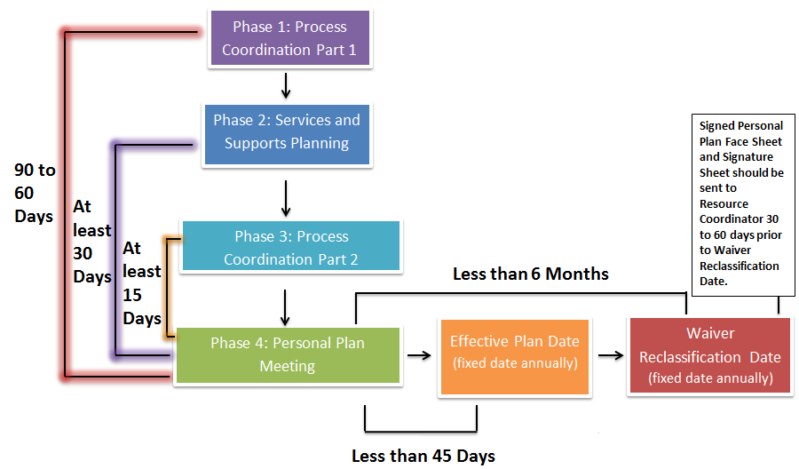

Before the Meeting

Role of the Case Manager
The Case Manager is responsible for plan coordination for all the people they provide case management services to. Coordination includes working with the Person and Guardian (if applicable) to initiate, facilitate and document the overall PCP process within the appropriate timeframes. The Case Manager ensures that the Person is listened to, feels respected and supported throughout the process, is aware of all paid and unpaid services and supports, and is offered choice of both services and providers.

Services and Supports Planning
Each service provider must conduct Service Planning as part of the planning process. Service Planning assesses the Person’s current service needs and levels of support needed in each service area. This phase also identifies the Person’s goals, which may be needs or desires. Service Planning links goals to the needed services that will be provided. Documentation of Service Planning (Phase 2) must be completed at least 30 days prior to the PCP Meeting. This allows the Case Manager at least 30 days to review Service Planning documentation with the Person and their Guardian (if applicable) in preparation for the Planning Meeting.
Agency Service Planners are expected to take part in the required Planning Meeting discussions about coordinating services, employment, Guardianship, health and safety. These discussions may lead to changes to specific Service and Goal Descriptions. Agency Service Planners need to be present for the discussion to be able to contribute ideas as well as make the required modifications to Service and Goal Descriptions.
Some strategies for successful Service Planning include:
- The Person is the center of the conversation. What is important to them and important for them should drive service planning.
- The Case Manager clearly explains services and supports to the Person and Guardian (if applicable).
- Agency Service Planners clearly explain the purpose of Service Planning to the Person and Guardian (if applicable).
- Planners allow for a conversation or several conversations with the Person.
- The Person can choose which paid and unpaid services and providers they want.
Click here for more details on Service Planning and Goal Writing. See Appendix A- PCP Date Fields , Appendix B – Understanding MaineCare Service Dimensions, and Appendix C- Exemplary, Satisfactory, and Unsatisfactory Goals for further assistance.

Protocol to Ensure Timely Entry of PCP Service Descriptions
Maine’s Person Centered Planning Process requires all Agency Service Planners to complete service specific Service and Goal Descriptions and enter them electronically in EIS at least 30 days prior to the scheduled PCP meeting date. In the event that the information is not entered in the EIS PCP assessment within 30 days prior to the scheduled PCP meeting date, the following protocol will be implemented:

- 30 days before the PCP Meeting: The Case Manager will ensure the MaineCare Service Descriptions are entered into EIS within the PCP. If they are not entered-accurately and/or completely a phone call and e-mail will be sent to the Provider immediately, and include their Case Management Supervisor in the message. The provider agency will have 24 hours to enter the information into EIS.

If the MaineCare Provider does not complete the Service Description as requested in step 1:

- 28 days before the PCP Meeting - The Case Management Supervisor will:
- Contact the supervisor of the Service Description author or Provider agency contact person to discuss potential barriers and solutions in order to ensure that the Provider understands the OADS PCP timeline requirements. The Case Management supervisor will also inform the contact person that they will check the assessment within 24 hours.
- Document the conversation in an email and forward to the supervisor of Provider agency. The OADS Program Administrator will be included in the message.
- Enter a note in EIS summarizing the contact with provider agency. Check EIS within 24 hours and notify the OADS Program Administrator if the Provider has not entered the required Service Description.
- Add a note in EIS documenting the notification of the OADS Program Administrator.

- 25 days before the PCP Meeting The OADS Program Administrator (PA) will:
- Contact the Executive Director (of the Provider Agency) to assess the problem and determine if the Provider intends to continue providing services and whether they are aware of the last authorized service date for which they can bill. The OADS PA will remind the Executive Director of the expectation that all Service Descriptions must be entered into the EIS 30 days prior and that their agency has missed the required deadline. Note: Requirements listed above apply. The OADS PA will reference MaineCare Sect 21 rule 21:04-1 that states “Medically necessary services and units of services must be identified in the Personal Plan”.
- The OADS PA will explain that in order to ensure ongoing MaineCare services the Service Description must be entered immediately.
- If this cannot be accomplished, the MaineCare Service will not be included in the Person Centered Plan.
- The OADS PA will send a letter to the Executive Director and follow this with an e-mail confirming both the conversation and the letter.
- The OADS PA will enter an EIS note in the consumer record regarding the conversation, letter and e-mail.

- 15 Days before the Meeting: if the Provider wants to continue to provide a MaineCare service, a special meeting and plan update will be required to be completed after the Planning date but before the Effective Plan Date to ensure funding for services is not interrupted.

- The OADS PA will follow up with the Case Management Supervisor and provide the date for data entry 14 days prior to the scheduled Planning meeting.
- Notify the OADS Resource Coordinator if the Service Provider is terminating a MaineCare service or has not responded to requests for information

- The OADS Resource Coordinator will notify KEPRO when appropriate.

- The Case Management Supervisor will work with the Case Manager to ensure that alternative services are identified and the PCP is amended to include all identified Service Providers.

Team Members

The PCP Process requires, at a minimum, participation by the Person, the Guardian (if applicable), and the Case Manager. The Personal Plan must also include input from Agency Service Planners, the appointed Volunteer Correspondent (if applicable) and other members chosen by the Person. If the Person objects to any of these members, the Case Manager should work with the Person to find a comfortable way to get input from each team member.
The Person is the key participant. The team needs to support the Person to understand their role in the process, as well as what to expect from others at each step in the process. The Person may also need coaching, practice and support in order to communicate his or her desires and take an active role in planning.
It is the responsibility of the team to ensure that the Person is meaningfully involved in each stage of planning. For this to be most effective, it is important that all team members understand their roles and the purpose of each step in the planning process.
If there is a legal Guardian, he or she must be informed of and involved in the planning process. When the Person has a Guardian, the Guardian’s signature is required prior to authorization of services. The Guardian’s participation must be documented in the plan narrative.
An appointed Volunteer Correspondent has the legal right to review the Person’s records, to be informed of what’s going on in the Person’s life, to be involved in the planning process, and to participate in decision making.
All Team Members who are responsible for implementing the plan (aside from the Case Manager, Guardian, and Person) must sign the Agreement Sheet.
In the EIS PCP Assessment:
Team members are documented in the Personal Plan Face Sheet:
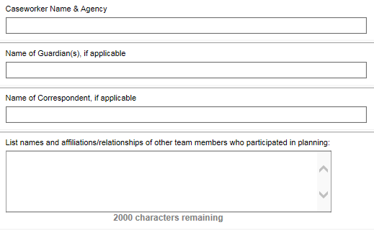
Some signatures are documented in the Personal Plan Face Sheet:
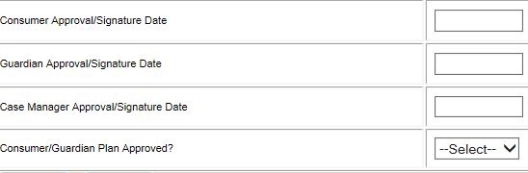

Inviting the Advocate
The Case Manager must ensure that the Person is notified of their right to invite the Advocate. It is the decision of the Person to invite the advocate or not, and this decision must be documented in the plan. It is the Case Manager’s responsibility to ensure the Advocate is aware of the Person’s request in the event the Person chooses to invite the Advocate.
The Advocate must be notified of any meetings where a Behavior Management Plan at Level 3 or above will be discussed.

Document the Notification and the Person’s choice of whether to invite the Advocate in the Summary of Process Coordination on the Personal Plan Narrative.
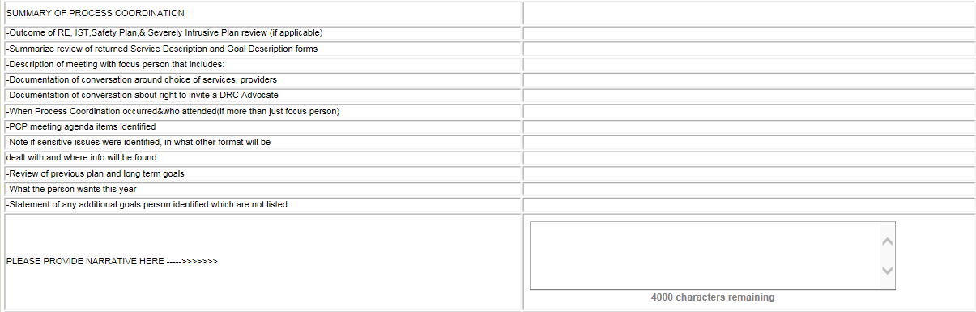

Sensitive Issues

Some aspects of the Person’s life are, or should be, personal and private. The Person may want information regarding these issues shared with only certain people. The Person may not even want the whole Planning Team to be aware that there is an issue. The Person may have concerns about having information on sensitive issues documented in their plan.
The Person identifies sensitive issues, not the Planning Team or any other Team member. Sensitive issues often relate to diet and weight control, hygiene, medical conditions, sexuality, smoking, money, intimate relationships or behavior. What is sensitive is really up to the Person. Sometimes planning an agenda creates an opportunity for discussion with the Person about public vs. private information. The Person has the right to control how information about him or her is shared, and may need assistance to consider and exercise that right.
When sensitive issues are identified, the Case Manager should assist the Person in considering options for addressing them. Some things to think about include:
♦ Who needs to know about this issue?
♦ How will it be addressed?
♦ How will it be monitored?
♦ How and where will it be documented?

Some sensitive issues may be addressed as part of routine health care and be documented in the medical record. They may not need to be specifically identified in the PCP document. Others may be referred to only generally, e.g., “Marie will meet with the nurse for health information”, without specifying whether it’s about smoking, sexual concerns, dieting, or incontinence.
All team members should know what is on the agenda before meeting. It is important to be sure all team members understand what will and what will not be discussed during a PCP meeting.

In the EIS PCP Assessment:
Sensitive Issues are identified on the Personal Plan Face Sheet:

The other forum or format sensitive issues are expanded upon is documented in the Summary of Process Coordination on the Personal Plan Narrative and the Case Management Services Description Form:
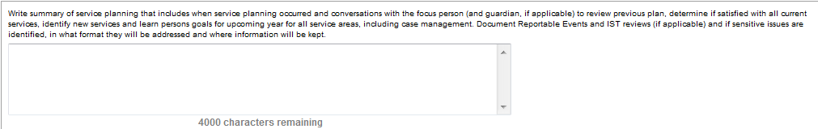

Documentation
To ensure the PCP is complete, all team members must be familiar with the PCP documentation requirements in their area of service so they can address them with the Person. Information requested via the PCP process is required to be in the plan and must be completed in EIS.
The Case Manager ensures completion of the PCP in EIS prior to the Effective Plan Date. Each Agency Service Planner must submit completed descriptions electronically within the timelines established in this manual.
For further documentation requirements for providers, please see Appendix A- PCP Date Fields , Appendix B – Understanding MaineCare Service Dimensions, and Appendix C- Satisfactory and Unsatisfactory Goals.

In the EIS PCP Assessment:
There are many dimensions for each service. Paid services that a Person is receiving must be documented by the appropriate Service Agency with both a MaineCare Service Description Form and a Goal Description Sheet under the dimension with which they provide services.
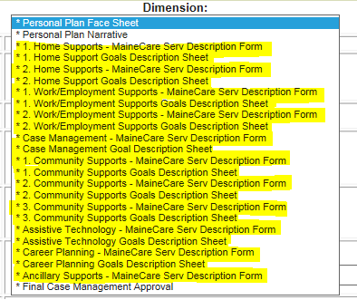

Personal Profile
A personal profile presents the Person in positive and personal terms rather than clinically and objectively. A personal profile is not a clinical description. The profile is more concerned with a Person’s abilities and supports that enable him or her to succeed, than with his or her deficits or limitations. The profile looks at the Person in the context of their life and their relationships, as well the Person’s individual characteristics. The best profiles are created by or with the Person.
A personal profile:
- Documents who the Person is, their interests and what they want in life
- Paints a current picture of the Person’s life
- Presents the Person as they want to be seen
- Provides information about the people they know and how they spend time together
- Identifies the roles they play in their community
- Contains what the Person wants and needs to be healthy and safe
- Supports the Person needs or desires and new things they want to learn
- Describes the Person’s dreams for the future
- Identifies their strengths and capacities
- Documents their gifts and talents.
A personal profile does not contain:
- Diagnoses and other labels
- Sensitive issues
- Medical and/or behavioral interventions
- A recap of all previous jobs and day programs
- Irrelevant history.
In the EIS PCP Assessment:
The Personal Profile is documented in the Profile of Person under the Personal Plan Narrative:

During the Meeting

Required Conversations
The Person and their Planning Team must specifically address a number of topics and document them in the narrative. At the same time, the team must be respectful of the Person’s wishes about these topics. If the Person clearly defines a required topic as a sensitive issue, then the team must find another way to address and document it separately. Below are some guidelines for approaching these required conversations.

Employment

DHHS is committed to supporting career development and meaningful employment for all working-age individuals who receive services.
Developmental Services is required under The Employment First Maine Act (Sec. A-1. 26 MRSA c. 39) to offer customized, individual employment services as the “first and preferred service option” before other day services.
Employment is part of the natural course of adult life and provides opportunities for economic gain, personal growth and contributing to one’s community. All individuals shall be presumed able and have the opportunity to work as defined in DHHS Policy CS-01-10, Employment of People Served Policy. For more information, go to: http://www.employmentforme.org
At least annually the Person and their Planning Team must engage in conversation about the benefits of working, services available to go to work and access to supports such as Career Planning, Vocational Rehabilitation, Work Incentive Counseling and long term support on the job. Concerns and barriers should be identified and planned support to address them included within the PCP.
If the Person works, the Person and the Planning Team should discuss employment and how it is going. This is the time to talk about paid and unpaid support needs, work hours (too much, too little), career growth, wages, transportation, workplace inclusion, and benefits planning. Overall, the conversation and documentation in service planning should include a general understanding of the employment situation and the paid or unpaid supports necessary to maintain employment.

In the EIS PCP Assessment:
Employment discussion is identified on the Personal Plan Face Sheet:

Employment discussion is expanded upon in the Summary of Plan Meeting Discussions in the Personal Plan Narrative:

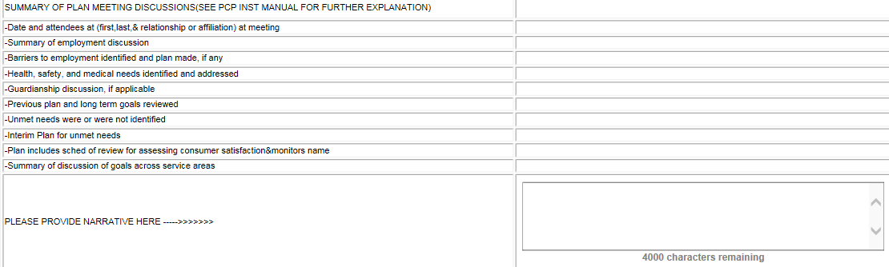

If the Person does not work, the conversation might begin with the following questions:
- Have you thought why work might help you in your life? (What does work look like for you? Can you describe it for me?)
- What are some jobs that interest you? (Do you know someone who does that? Where do your friends, parents, brother, etc. work?)
- What might you need to do to get ready for going to work? (State ID, references, learn to ride a bus, get a new watch)
- How much money would help you to live the life you want?
- Do you know you may be eligible for Career Planning to work with a person to discover what skills and interests you have?
- Have you met with a Work Incentives Counselor yet? ( To talk about money and benefits)
If the Person says he or she does not want to pursue work at this time, then the team should respectfully try to learn why not. It may be possible to share information that will assist the Person in making an informed choice about starting on a Pathway to Employment, including volunteer opportunities in order to gain work experience or Career Planning or meeting with a Work Incentives Counselor. Assisting the Person in understanding the benefits that work can bring to their life is critical: new relationships, money, control, benefits, and a sense of self-worth. Documentation of why work is not being pursued should be included in the plan and then re-visited on at least a yearly basis.
Wages:
If the Person is making below minimum wage, the plan must contain documentation that Federal and State Department of Labor Certificates exist in order for this to be legal. Access to Career Planning Services to assist the person to move toward a job at or above minimum wage should be discussed. The planning process must also include documentation of a discussion about a plan to move the Person toward employment at minimum wage or above. This work (wage) plan must be reviewed at least yearly.

Health and Safety
The Person and their Planning Team must talk about any health and safety issues that are present or anticipated in the coming year and ensure that a plan is designed to address them.

Unmet Needs
Unmet Needs must be identified and an Interim Plan developed by the Person and Planning Team.

Guardianship
If the Person has no Guardian, the Person and Planning Team should discuss what, if any, supports are needed around decision making and recommend any needed changes. If there is a Guardian, the Person and Planning Team must talk about the level of Guardianship currently in place and whether any changes to Guardianship are recommended. Note any changes in Guardianship authority or contact information and update EIS Relationships.

Planning Team Monitoring Schedule
The Case Manager must conduct a review of the PCP every 90 days. This is documented in the Services and Supports Assessment (V7). The Planning Team may meet more or less often, but must meet at least annually for the PCP Process.

Coordinating Goals Across Service Areas
The Person and Planning Team must talk about how to coordinate services and goals across service areas, including how to implement services in a way that increases opportunities for community inclusion. EIS documentation must be reviewed for potential obstacles and conflicts, for shared ideas of service coordination, and broader or more long-term goals.

Communication
The narrative summary must address the communication preferences of the person. If the communication preferences are such that they limit the Person’s direct input into the planning process, the narrative must describe how team members have attempted to understand the Person’s needs and desires. The planning process must be understandable to the Person and in plain language. If the Person is deaf, non-verbal or speaks a language other than English the process must include qualified interpreters.
In the EIS PCP Assessment:
Health and Safety, Unmet Needs, Guardianship, and Planning Team Monitoring Schedule can be identified in the Personal Plan Face Sheet:
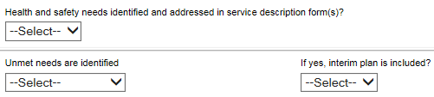

Health and Safety, Unmet Needs, Guardianship, Planning Team Monitoring Schedule, can be expanded upon in the Summary of Plan Meeting Discussions in the Personal Plan Narrative and the Case Management Service Description Narrative.
Coordinating Goals Across Service Areas and Communication can be documented and expanded upon in the Summary of Plan Meeting Discussions in the Personal Plan Narrative. Communication preferences can be documented in the Profile of Person in the Personal Plan Narrative and in all the MaineCare Service Description Forms by the appropriate Service Agency.

Person Satisfaction/Grievance Process
Each plan must include a description of how the Person and Planning Team will evaluate the Person’s ongoing satisfaction with:
- The planning process
- The plan that is developed, and
- The progress being made in accomplishing the goals in the plan.
Evaluation of Person satisfaction must include whether the goals are chosen by the Person, if those goals are addressed in the Service and Goal Descriptions, and a review of the progress being made towards accomplishing those goals. If service needs are being met, but the Person is not satisfied with the outcome(s), the services should be amended to better address what the Person has identified as their goal.
Person satisfaction should be assessed as part of the regular review of the plan, and as part of Service Planning for the next annual plan. If at any time a Person is dissatisfied with his or her plan or with any services, he or she is entitled to use the Developmental Services Grievance Process.
The consumer should be given the Grievance Process and Reportable Event insert at least annually during the Personal Plan Meeting, and more often as warranted.

In the EIS PCP Assessment:
Needs and Desired Outcomes, A Plan for Assessing Satisfaction, and the Grievance process can be identified in the Personal Plan Face Sheet:

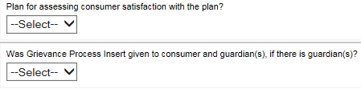
The Plan for Assessing Satisfaction can be expanded upon in the Summary of Plan Meeting on the Personal Plan Narrative:
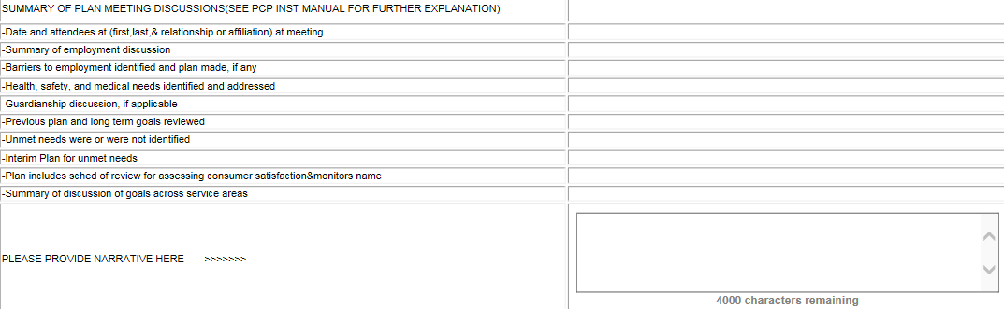

Medical/Dental Monitor
The Planning Team must designate the person responsible for monitoring the quality of medical and dental services. The Monitor sees that the Person is getting routine care and acute care as needed, and may seek a second opinion or additional consultation to ensure quality health care. The Medical/Dental Monitor is recorded on the OADS Personal Plan Face Sheet. A physician or dentist must prescribe any deviation from an annual schedule of medical and dental examinations and this must be explained in the Services and Supports assessment (V7).

Critical Information Monitor
The Planning Team must identify the person responsible for updating critical information and informing the Case Manager of any changes. This person is listed on the Personal Plan Face Sheet. Critical information is basic demographic information including: significant change in health/diagnosis/allergies, change in Person or Guardian’s residence or contact information, change in medical provider(s), change in medication, significant change in behavioral or other support needs.

In the EIS PCP Assessment:
The Medical/Dental Monitor, Critical Information Monitor, and Notifying the Advocate are documented on the Personal Plan Face Sheet:
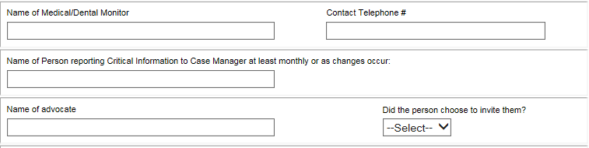

After the Meeting

Approval by the Team & Disseminating the PCP
The PCP must be approved by the Person or the Guardian (if there is one) before the plan is considered complete. The approval signatures of the Person (and/or the Guardian), the Case Manager, and all others who are responsible for implementing the plan are required. If the Person or the Guardian disapproves of all or part of a plan, the Planning Team must address these concerns in a new or amended plan.
Each Person, including those with a court appointed Guardian, will be supported to the maximum extent possible during the review and approval of the PCP. To the best of its ability, the Planning Team will determine if the Person is satisfied with the planning process and the PCP. The Person will be encouraged to show approval of the PCP with a signature, by making their mark, or by some other preferred method of communication.
The Person or Guardian’s approval may be obtained by signature or by a witnessed and documented telephone call. An e-mail indicating approval is not acceptable. If approval is obtained by phone call the face sheet still needs to be signed. The Case Manager will mail the face sheet for the physical signature to be documented in the Persons’ record.
The signed Face Sheet must be returned to the Case Manager prior to the Effective Plan Date. Only one Guardianship signature is required, but all Guardians must be provided a copy of the Plan. Other Team Members who are responsible for implementing the plan must sign the Agreement Sheet.

In the EIS PCP Assessment:
Signatures of the Person, their Guardian (if there is one) and the Case Manager and Approval of the Plan is documented in the Personal Plan Face Sheet:

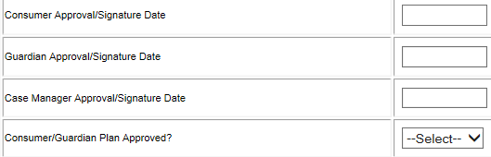

Once the plan is complete, the Case Manager can document as such by completing the Final Case Management Approval dimension. The completed Plan should then be locked and the Resource Coordinator updated 30 to 60 days prior to Reclassification date.
It is best practice to ensure that the Person and Guardian have the opportunity to review a finished PCP, in private or with a chosen supporter, prior to being asked to approve the plan. This supports them to review and approve all parts of the PCP, including the narrative of discussions around employment, health and safety, and inclusion, as well as any changes to Service or Goal Descriptions.
There may be instances where the Guardian or the Person wishes to sign the Face Sheet at the Planning Meeting. It is unlikely that the full PCP will be written at the meeting, but the Service and Goal Descriptions and other parts can be made available for review. Case Manager may facilitate approval and signing of the PCP prior to presentation of a finished written plan, if they do so in accordance with their agency’s informed consent policy. The Person and Guardian, if applicable, may rescind their approval once they review the completed plan.
The Case Manager distributes the approved PCP, along with the Developmental Services Grievance and Reportable Event insert, to the Person and Guardian, as well as to any Planning Team members who do not have access to EIS to view the plan.

Reversioning a Person Centered Plan
Reversioning the PCP Assessment in EIS means that you are creating a new version of the assessment. This new version has all of the information from the previous version. This is convenient because the case manager only has to update; they don’t need to enter all of the information again.
A PCP is to only be reversioned when planning for a New Annual Plan or Updating the Current Plan.

Planning for a New Annual Plan
The PCP needs to be reversioned at least once a year to allow for a new plan to be completed.
When reversioning for a new annual plan:
- The EIS Assessment Start Date is the date of the upcoming Effective Plan Date.
For example, if the upcoming Effective Plan Date is 09/03/2016:
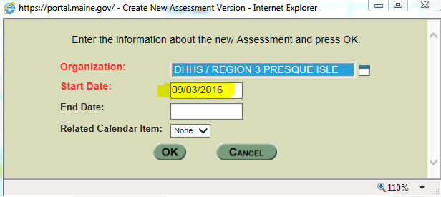

- Enter in the description box the reason for creating a new version.
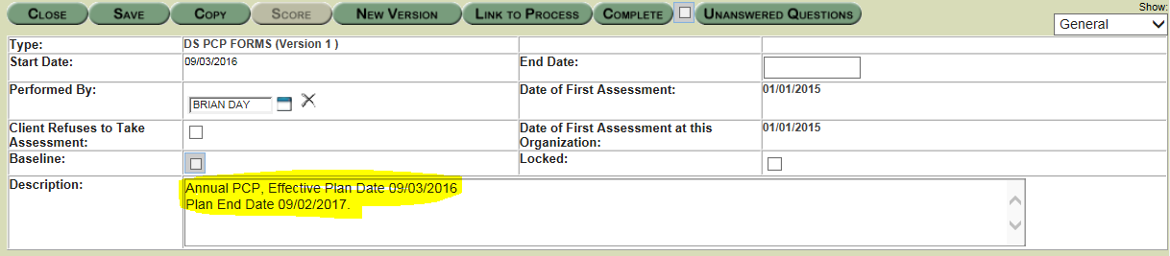
- The dates on the Face Sheet should be updated to reflect the new plan.
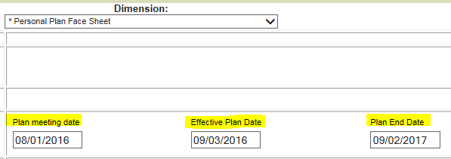
- Update the plan as necessary, such as entering changes to the profile if information has changed, deleting process and meeting information from assessment and updating with new planning information related to the new annual plan.
- Service Agencies will need to delete previous information and enter new goals and service descriptions for their applicable MaineCare Service Descriptions Forms and Goal Description Sheets.
Case Manager reviews the information entered by providers for accuracy. The Case Manager must complete the Final Case Management Approval dimension once this review is complete. Focus Person or Guardian approval is required for all reversions of plans. Reversioned, signed, and approved plans must be distributed to the team by the Case Manager. A completed plan is locked in EIS and requires approval signatures.

Updating the Current Plan
Over the course of the planning year a Focus Person may want to add or remove services, and/or other life events may occur that require the plan to be updated. The following are examples of when a PCP should be reversioned to update the current plan:
- Adding a Service (Example: John would like to add Career Planning)
- Ending a Service (Example: Jane no longer wants to attend Community Supports)
- Changing a Service (Example: John would like to receive Work Supports from a different agency)
- Major Life Changes that Affect Services (Example: Jane’s sister Joyce is now her Guardian)
When reversioning to update the current plan:
- Open the Assessment Page of the current plan and click on New Version.
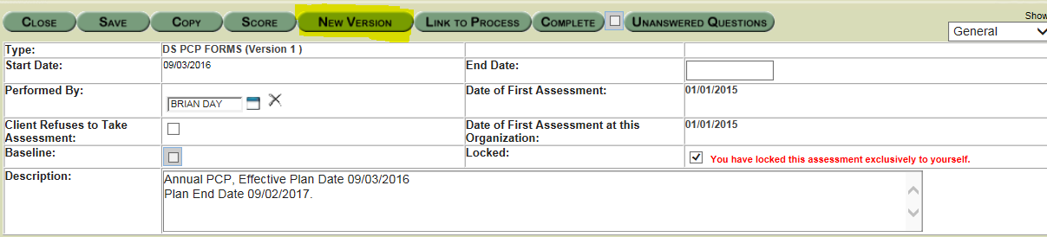
- The EIS Assessment Start Date is the date the Case Manager is reversioning the plan for data entry.
For example, if PCP assessment is being reversioned on 03/21/2017:
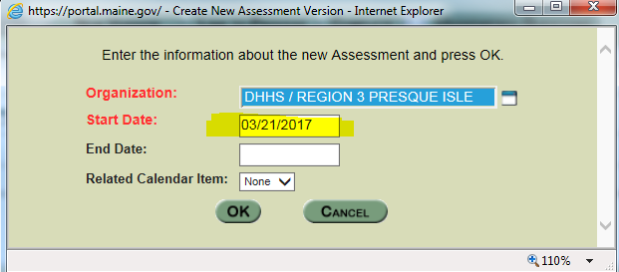

- Enter in the description box the reason for creating a new version.
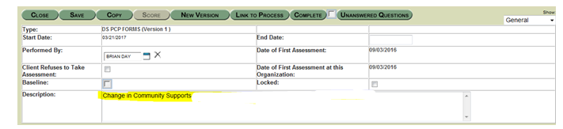
- On the Face Sheet DO update the Plan Meeting Date to reflect when the team met and made changes to the plan.
- On the Face Sheet DO NOT change the Effective Plan Date or Plan Ending Date.
- On the Face Sheet document whether the service is still being requested and the request type. In the example below, the focus person will still be receiving community supports but the provider is changing.
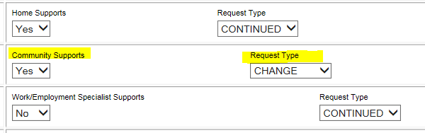
- Ensure unmet needs are updated if necessary.
- In the Personal Plan Narrative dimension, provide a summary of the process in the top of the narrative boxes. Leave the original information and add new information to the top by reviewing the topics on the left side and entering information where it is relevant and appropriate. Provide dates and summarize in a concise manner.
- The Summary of Process Coordination should be updated by entering the new information in the top of the text box. DO NOT delete prior information. (Example: CM met with John on 03/15/2015. He reported wanting a new CS program. Discussed program options and choice. John selected the Step Forward program.)
- The Summary of Plan Meeting should summarize the meeting in the top of the text box. DO NOT delete prior information. (Example: CM and John met with Sue Clark from Step Forward on 03/18/2015. Sue entered MaineCare Service Description and goals following meeting with Ann on 03/16/2015).
- If the Person is ending with a provider, the ending service provider needs to update the MaineCare Service Description dimension by entering “0” in the hours box and entering a sentence in the top of the narrative box indicating they are ending the service.
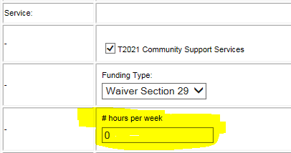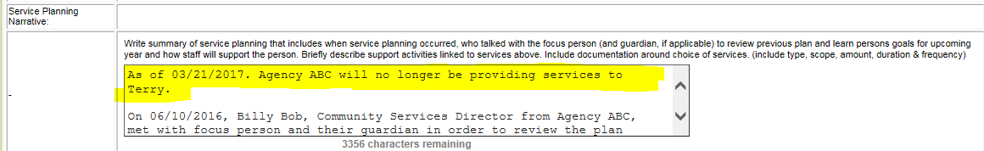
- If the consumer is ending with one provider, but continuing the service with a new provider, the new provider needs to complete the MaineCare Service Description dimension as the 2nd provider. 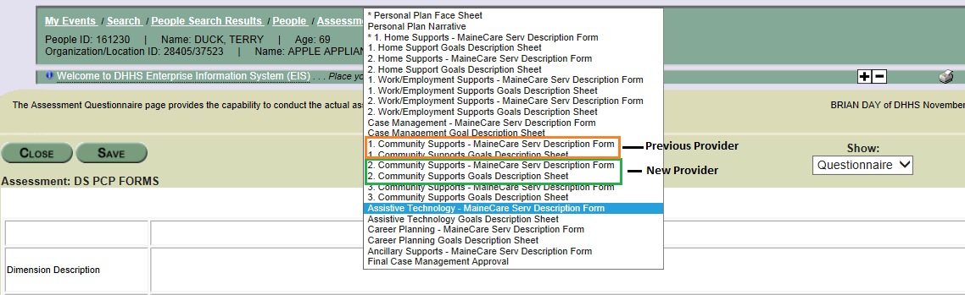
- Case Manager Service Description dimension (only if Case Manager contact information or Funding Received has changed)
    - Change the contact information if the Case Manager has changed.
    - Enter a check in the “Current Funding Type Received” box for any new funding.
    - Enter date the Case Manager is entering information for Date Submitted if updates to this section are being made.
    - In the top of the Service Planning Narrative box enter a summary of the change. If the new service meets an unmet need, document the need being met in narrative and goal page. DO NOT delete prior information.
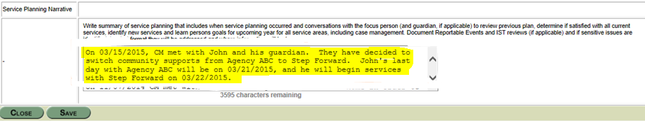
- Case Manager reviews the information entered by providers for accuracy. Focus Person or Guardian approval is required for all reversions of plans. Reversioned, signed, and approved plans must be distributed to the team by the Case Manager. The DS General Note that documents the changes must be printed and physically attached to the plan.
- The signed face sheet, Agreement Sheet and a completed Authorization Request Form must be provided to the Resource Coordinator by the Case Manager. Changes to the PCP are not official until the Resource Coordinator has confirmed this change.

Copying a Person Centered Plan
A PCP is only copied when you have already reversioned to allow pre-planning for the next annual plan. If you have not reversioned for the next year, then you just click on “New Version”.
This only occurs when your current annual plan is about to near its end date, and you have already reversioned the PCP assessment so that providers can begin to enter information in preparation for the Plan Meeting, but, before the current PCP ends and the new PCP begins the consumer decides they want to add, change, or end a service, or a major life event happens.
- In our example, the Person’s plan ends on 09/02/2017. The team will be having their Planning Meeting on 08/01/2017. In order for all of the providers to have their information entered 30 days prior to the Plan Meeting date, the case manager reversions the current PCP on 05/21/2017 with the Start Date of 09/03/2017 (60 days in advance).
- On 06/08/17 the Person decides to end his community supports immediately. Typically the case manager would reversion the current plan and the ending service provider would update the applicable MaineCare Service Description dimension – but the PCP has already been reversioned for the next annual plan and providers have already entered information for the next plan.
- As a result, the case manager will instead Copy the most recently signed and completed PCP. In our example, the most recently signed and completed PCP is from 3/21/2017 due to a change in service that happened at that time. When on the Assessment Page, click on Copy instead of New Version.
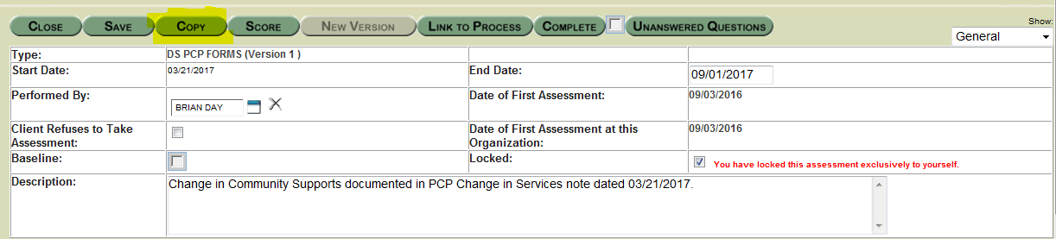

The EIS Assessment Start Date is the date the Case Manager is copying the plan for data entry. The EIS Assessment End Date is one day before the Effective Plan Date of the upcoming annual plan. Only when copying a plan do you need to enter an End Date. Reversioning end dates the assessment automatically.

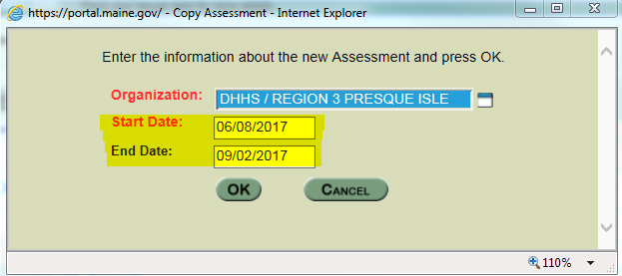

- Enter in the description box the reason for copying the assessment.
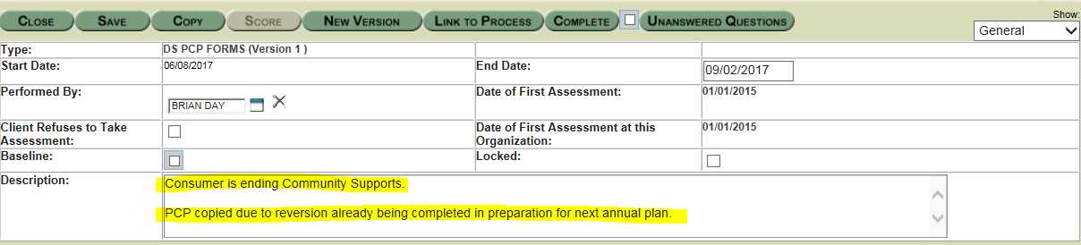
- Complete the rest of the changes the same you would when updating the current plan, including getting consumer and Guardian signatures.
- THE CHANGES IN THE COPIED PLAN WILL NOT BE IN THE NEXT ANNUAL PLAN BY DEFAULT. YOU WILL HAVE TO MAKE THE CHANGES YOURSELF FROM THE COPIED PLAN TO THE NEXT ANNUAL PLAN.
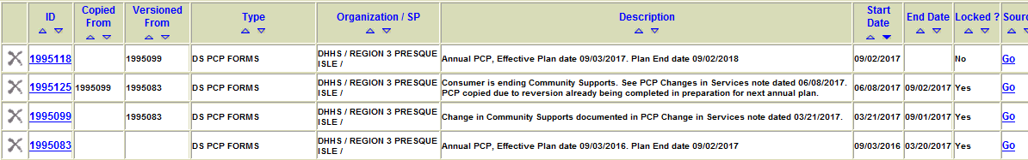

Pre/Post Placement Meeting
The Person and their Planning Team must hold Planning Meetings both prior to and subsequent to the Person moving to a new residence. This is required in order to coordinate supports and services and to evaluate the Person’s satisfaction with the change.
For the preplacement meeting, the Case Manager needs to reversion the plan so that service providers can enter new information. The Person and their Planning Team will meet to discuss what needs to be done before the move. The Case Manager will need to gather all necessary approval signatures and then lock the plan after signatures are received.
For the post placement meeting, which occurs 30 days after the move, the plan will need to reversioned again if there are any changes to service descriptions or goals. If there are changes, signatures will be needed again. If there are no changes in services, the plan will not need to be reversioned. The Case Manager will document the discussion summary in a general note.

Necessary Assessments
In order for the PCP process to meet federal and state guidelines, various assessments need to be completed on a regular basis. All of these assessments are located within EIS.

DS Services and Supports (V7)
This assessment, commonly referred to as the “V7”, must be completed within 90 days of the first Effective Plan Date, and every 90 days or less by the Case Manager from that point forward. The V7 must be updated sooner than 90 days if a change in the Person’s needs occur. The V7 contains dimensions that cover many areas of a Persons’ life, from medical information to legal needs. The V7 should include not only paid services, but unpaid services and non-waiver services the Person is utilizing. Information within the V7 should be accurate as the entire assessment is updated as changes in the Person’s needs occur or, at a minimum, every 90 days. This consistent update is known as the 90 Day Review and is documented in the last dimension of the V7. The 90 Day Review ensures any changes to the Person’s services and life situation are documented and known by the Case Manager. The first 90 Day Review occurs within 90 days of the Effective Plan Date, and every subsequent review must take place within 90 Days of the last 90 Day review.

DS Comprehensive/Support Waiver (BMS 99)
This assessment, commonly referred to as the “BMS 99”, is an independent assessment completed face to face by the Case Manager for the purpose of determining eligibility for the Section 21 and Section 29 waiver. The Comprehensive Waiver assessment determines eligibility for the Section 21 Waiver. The Support Waiver assessment determines eligibility for the Section 29 Waiver.
The initial BMS 99 is completed when applying for either Section 21 or Section29 services. If the Person is placed on a waitlist, the assessment must be updated once they are removed from the waitlist and approved for funding. The BMS 99 must be completed annually 30 to 60 days prior to the Reclassification Date.

DS Psychosocial Evaluation
This assessment, commonly referred to as the “Psychosocial”, is completed by the Case Manager to document the Person’s Social and Medical History. Information documented in the Psychosocial can be very useful to providers, future Case Managers, and can help guide the Planning process. This evaluation must be updated annually.

Quality Assurance
Person Centered Planning is critical to meeting the needs of people served by the State of Maine, and is driven by statutes governing DHHS services. The planning process and the plans developed are also an essential component of MaineCare funding, and may be audited to ensure compliance with state statute and federal Medicaid rules. Quality assurance mechanisms have been developed to ensure the quality of the planning process, including the relevance of the goals identified and whether they are achieved.
Data collected from the PCP process and other assessments in EIS allows the State to monitor trends in unmet needs, identify barriers to meeting needs, and report to the Commissioner of DHHS, the Governor, and the Legislature about outcomes, trends and needs in services provided to individuals with intellectual disabilities or autism spectrum disorders by OADS.

Services and Supports Planning in More Detail
Service Planning occurs when the Person and members of his or her Planning Team identify the services the Person needs (the Service Description) and how the Person would like to use those services (the Person’s goals, which are typically made up of both needs and desires). This part of the planning process is most essential to designing services that are person-centered. All needs and goals must be described in the plan, even if they are non-funded services and the Person is being helped by family or friends as opposed to paid providers.
One role of the Planning Team is to work with the Person to determine what services the Person needs that are medically necessary MaineCare services. The PCP must describe the Person’s needs. These include both the services needed and the goals that are identified as needs. Once the Planning Team has recommended services and described them in the plan, those MaineCare reimbursable services are deemed “medically necessary”. There is an expectation that written documentation be of professional quality, including appropriate spelling and grammar.

Service Description Forms for MaineCare Providers

Describing the services a Person needs or wants is an essential part of Services and Supports Planning. This Service Description must indicate the level and purpose of each service domain identified as a need. If a service domain is not needed, “None” or “Not Applicable” must be selected. Support Providers are expected to provide the services described across many venues and activities. For example, the Person might need support at home in the following areas: mobility, meal planning, safety, communication, accessing community and personal development.
Because the Planning Team identified these service needs as medically necessary, they are reimbursable by MaineCare once they are authorized by DHHS. Direct Service Professionals provide these services on a routine basis throughout the day, and they are reimbursable across different activities when they are supporting the Person.
Since Service Descriptions are not usually the goals that give meaning to the Person’s life, the Agency Service Planner’s next task is to identify the Person’s goals and connect them to the service needs where applicable.
The Service Planning Narrative should document when service planning occurred, who was present, a review of the previous plan, and the Person’s satisfaction with services. See Appendix A and Appendix B for more information regarding Service Description Forms.

In the EIS PCP Assessment:
Services can be identified in the Domains, then expanded upon in the Service Planning Narrative which are both located on the MaineCare Service Description form. Different services have different domains.
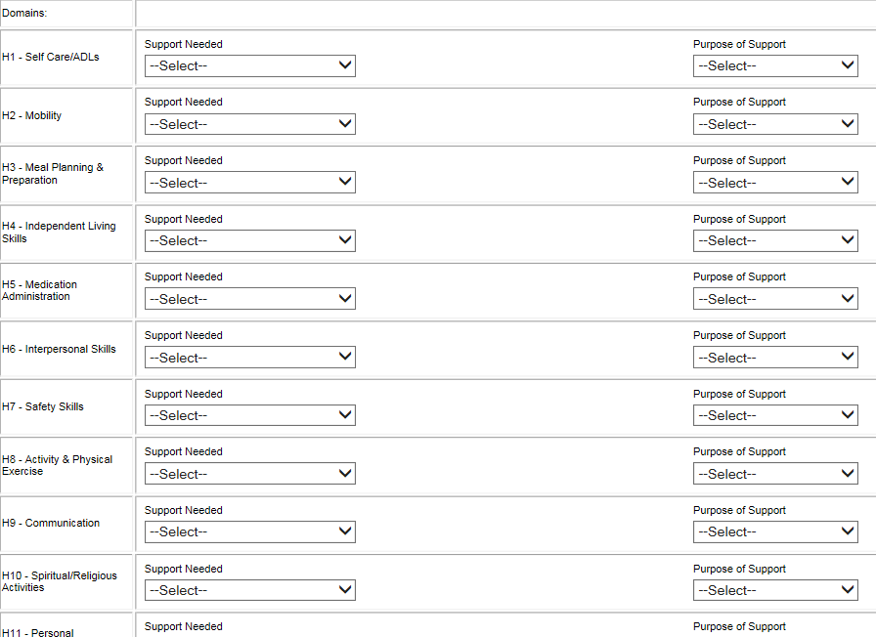

Service Planning Narrative for MaineCare Providers
Generally speaking, the narrative can be completed in four parts.

Service Planning: The agency representative who spoke with the Person (and guardian, if applicable) when reviewing the previous PCP and planning for the upcoming PCP must be documented. The date when this conversation took place and a brief summary of this conversation must be documented – including the choices of the Person (and guardian, if applicable).

Important to the Member - Supporting Goals: Though goals are documented on the Goal Description Sheet, the documentation of the Member choosing their goals (or how goals were determined based on their communication preferences) and how the Direct Service Provider will be supporting the Member in achieving those goals belong in the narrative.

Important for the Member - Supporting Services: Services that are not current goals of the Member, but important for the Member to engage in due to health and safety reasons or to generally benefit the Member needs to be documented. This includes generally documenting what the services will be, the Member’s agreeance to engage in these services, and generally how the Direct Service Provider will be supporting the Member in engaging in the services.

Frequency, Amount and Duration of Services: The frequency (days per week) and duration (hours per day) must be documented in the Narrative. The amount (hours per week) must be documented in the appropriate field. Once frequency and duration have their own separate fields then they will no longer need to be documented in the Narrative.

In the EIS PCP Assessment:
The narrative is completed in the Service Planning Narrative located on the MaineCare Service Description form.
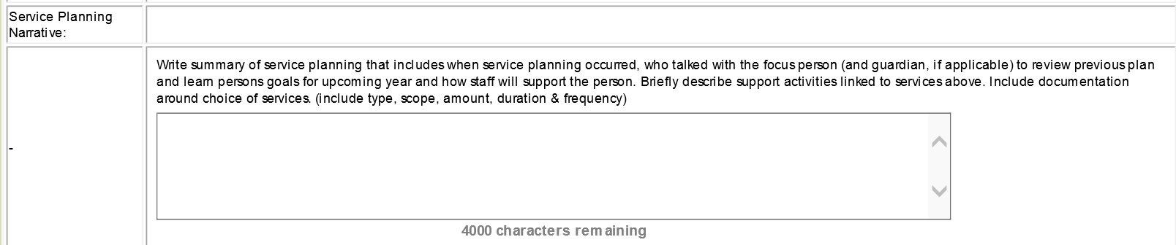

Goal Description Sheets
Goals differ from services and the two are not interchangeable. We all have self- improvement goals, similar to service needs, such as eating better or remembering to floss daily. Rarely, however, are these goals that give meaning to our lives. So while we may need a little support to remember to eat right, what we really want to do is get to play in that band, take our kids to the park more often, grow a garden or teach the dog a new trick.
We know what the service needs are for the person in the example above, but what if the Person would like to plant a garden and grow some flowers? The Planning Team needs to connect the goal of planting a garden with the services the Person needs to work toward that goal. The Goal Description makes this easy by using Service Domain Numbers from the Service Description. Goals must be tied to at least one Service Description. All identified services, except Case Management, need at least one goal.
The Service Description Domain links the services described on the Service Description with the Person’s goals on the Goal Description. Thus, Service Planning identifies the services the Person needs and the goals the Person has identified as needs or desires. The Service and Goal Description demonstrate to staff how they should provide the services described to support the Person in achieving his or her goals. All goals, except Case Management, need to have at least one identified MaineCare Service Description. Goals that cannot be tied to a MaineCare Service Description become a goal of the Case Manager.
If a goal has been met then the PCP needs to be reversioned. The goal that has been met must be updated by inserting a complete date in the appropriate field. If there are no other goals a new goal must be documented for that service to continue.
In the EIS PCP Assessment:
An example of a completed Goal Description sheet can be seen below.
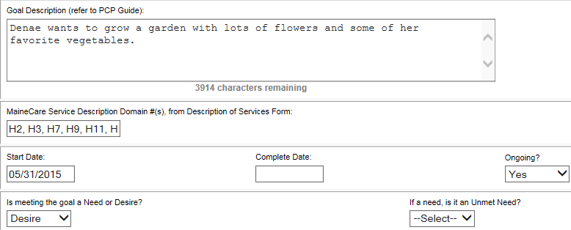

Goal Writing
Identifying the Person’s goals is a vital component of Service Planning. PCP goals quite simply describe the outcomes the Person has identified for the coming year. PCP goals must be written in plain language so the Person and their supporters understand what they will be working toward.
PCP goals must be observable. They should describe what will happen so the Person will know when a goal has been achieved. The goal must be written in plain language. Goals must not be driven by a habilitation plan or teaching plan and do not need to measure percentages of success or numbers of trials. A goal can be a simple statement, like “Denae wants to grow a garden with lots of flowers and some of her favorite vegetables.”
The written goal must address what the Person actually wants to do. For example, if the Person wants to get to know their neighbors, you need a goal that makes it clear what the Person wants. Having a goal that says, “June will go for a walk in her neighborhood several times a week,” does nothing to ensure that June meets any of her neighbors. The goal could instead be “June wants to get to know her neighbors.” Based on that goal, services could be generated to assist her with accomplishing the goal.
A particular challenge with goal writing is to find the balance between enough detail, so that people know what the Person will be supported to do, and enough open-endedness to allow for creativity and change. This is a good time to talk with the Person about how specific they want to be. For example, is his or her goal specifically to go skiing, to do any outdoor winter sports, or to participate in outside activities year round?
Goals are not “Hab Plans” or “Teaching Plans”, nor are they activities that have to relate to the services described. While some people might have a goal to improve their cooking skills, for many that is just a description of a service they need. Be careful not to let Service Descriptions drive your goal identification. True goals are the vehicles for the Person to express the things they want to do while receiving the supports they need.
Once the Person’s goals are identified, the Planning Team must support the Person to determine which goals are needs and which are desires. The Person must have at least one goal with each Service Agency providing services.
See Appendix C for more information on writing appropriate goals.

Needs and Desires
Once the Person’s goals are identified, the Planning Team, led by the Person, must identify which goals are needs and which are desires.
A NEED is identified by the Person/Guardian and the team as something that is required to maintain or improve the Person’s quality of life and that should be met within a specific timeframe.
A DESIRE is anything else the Person wishes to achieve, have, or obtain that is not a need.
Whether a goal is categorized as a need or desire will depend on the Person’s circumstances. A desire for one person may be a need for another, and what is a need or a desire may change over time.
The Planning Team must record the needs and desires of the Person, regardless of the ability of the system to meet those needs. All needs and desires must be documented, even if personnel, expertise, technology, funding or other necessary resources are not available to accomplish the goal.

Unmet Needs and Interim Plans
A need (not a desire) will be identified and treated as an “unmet need” when:
- It has not been met within the timeframe set by the team, or
- Whenever the team has determined, at any point in the process, that a resource required to meet the need is not available
Unmet Needs must be documented and include those identified by the Person as part of his or her goals under Case Management, as well as all Needs identified during Service Planning. (A person cannot have an Unmet Need for funding or other resources. An Unmet Need can only be a service or goal that has been identified by the Planning Team as a need.)
Each unmet need must be described on the Case Management Goal Description, and an Interim Plan must be developed for providing supports and services that come as close as possible to meeting the need while the team pursues the required resources for meeting the actual identified need. The interim plan must identify the interim objective, persons responsible, and timeframes.
Some individuals or agencies may feel that identifying a need as unmet reflects poorly on them or their organization. This is not true. It is important to acknowledge the needs that are beyond our current resources. Identifying unmet needs accurately enables DHHS to compile the unmet needs statewide and make the information available to advocates and legislators through reports and budget requests.

Habilitation Plans/Teaching Plans and the PCP
Many agencies use Habilitation (Hab) Plans, or Teaching Plans, to break down teaching or support steps. These Plans can be valuable tools for instructing staff and providing consistent learning opportunities for people supported. Agencies are encouraged to develop Habilitation/Teaching Plans when needed to enhance implementation of services and goals in the PCP.
Habilitation/Teaching Plans should not be included in the PCP. When they are used, they are a separate document that can be kept in the agency’s record and updated as needed. The Case Manager will review Habilitation /Teaching Plans to ensure they reflect Service Descriptions.

Making the Most of Goals / Coordinating Goals across Service Systems

One of the primary reasons the Person and their Planning Team comes together is to talk about how to coordinate goals across program areas. The challenge is to think bigger than a specific activity or service. The Person and the Planning Team should look beyond the service system for opportunities to enhance participation in the broader community.
Consultant and author John O’Brien has been studying the implementation of person-centered practices around the world for many years. He has proposed 5 essential areas to consider for building on an activity to increase the Person’s opportunities. They are:
- Presence: where, when, and in what context a Person has access to the community
- Participation: the quality, frequency, and duration of interaction with typical people
- Respect: building and maintaining positive images of the Person and the roles they play
- Autonomy: the extent to which the Person makes his or her own choices and is in control of their own life
- Contribution: what the Person has to offer to others
Based on the 5 essential areas, some questions the team could examine might include:
- Where can Denae garden where she will be with typical people who like to garden?
- How can Denae belong in a gardening community?
- What can Denae do with gardening that will build a positive image and allow her to contribute to her community?
- How can gardening help Denae increase her opportunities to make choices in her life?
Asking these questions could provide ideas to identify different services to assist Denae in accomplishing her goal.

Medical Add-On for Waiver Services
The Medical Add-On is a time-limited adjustment to Waiver reimbursement rates that can be requested under certain conditions. Add-On requirements and procedures are described in the MaineCare rules in the Appendices to Sections 21 and 29: http://www.maine.gov/sos/cec/rules/10/144/ch101/c2s021.doc and http://www.maine.gov/sos/cec/rules/10/144/ch101/c2s029.doc

Behavioral Regulations
Maine State Agency Rules Title 14-197 Chapter 5, Regulations Governing Behavioral Support, Modification and Management for People with Intellectual Disabilities or Autism Spectrum Disorders in Maine govern emergency interventions and the procedural steps that must be taken prior to the implementation of planned behavioral interventions. These regulations protect the rights of Maine citizens with an intellectual disability or autism spectrum disorder whenever these citizens are receiving any services that are provided, licensed, or funded in whole or in part, directly or through a contractor, by the Department of Health and Human Services.
Participants are entitled to the same rights as every other Maine citizen except as limited by reason of guardianship. The regulations, implemented as a result of Title 14-197 Chapter 5, are intended to ensure that any emergency or behavioral intervention that limits the exercise of any of a Participant’s rights must adhere to specific principles and procedures as outlines in these regulations.

Review Team
The Review Team is charged by rule with reviewing and approving all Behavior Management Plans at least annually or otherwise approved. The Review team abides by the rules as outlined in Title 14-197 Chapter 5 and Statute 34-B: §5605 to implement Maine laws regarding the rights of citizens with an intellectual disability or autism spectrum disorder. The Review Teams are formed in each District and consist of a representative from the Protection and Advocacy Agency, a representative designed by the Maine Developmental Services Oversight Advisory Board, and a representative from the Department of Health and Human Services.

Individual Support Team (IST)
An Individual Support Team consists of members of the Person's Planning Team, must have a member of the Crisis Team, and may have other professionals, family, or friends that the Planning Team determines would be supportive to the Person in a time of crisis. The role of the IST is to develop and coordinate services designed to prevent crisis situations, or provide support during a crisis. ISTs should be reviewed in service planning. Contact your District’s Crisis Team Leader for more information.

In the EIS PCP Assessment:
ISTs can be identified on the Personal Plan Face Sheet.

ISTs are expanded upon in the Summary of Process Coordination on the Personal Plan Narrative.
Behavior Management Plans should be identified and expanded upon in the Summary of Process Coordination.

Appendix A – PCP Date Fields

Reversioning for a New Annual Plan:
Start Date of the Assessment is the upcoming Effective Plan Date. End date is left blank.
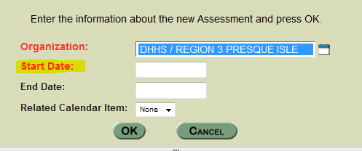
Plan Meeting Date, Effective Plan Date, and Plan End Date must be updated: 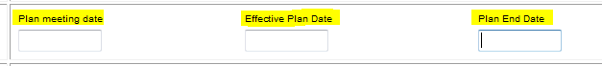
In each of the active Provider Service Description forms the Effective Plan Date and Submit Date is updated by the respective provider and the Proposed Change/Start Date is blank.
Signature fields on the Face Sheet are updated with the dates the identified individuals signed the plan.
The Final Case Management Approval decision date is updated once the plan has been signed.

Reversioning for a Change in Services
EIS Assessment Start Date is the date the Case Manager is reversioning the plan for data entry. End Date is left blank.
On the Face Sheet, the Plan Meeting Date must be updated. Effective Plan Date and Plan End Date do not change
In each of the changing Provider Service Description forms the Submit Date is updated by the respective provider to when information is being entered and the Proposed Change/Start Date is changed to the date provider would like services to begin or be changed. The Effective Plan Date does not change. If the service is ending the Proposed Change/Start date does not change.

Signature fields on the Face Sheet are updated with the dates the identified individuals signed the plan.
The Final Case Management Approval decision date is updated once the plan has been signed.

Copying for a Change in Services
A PCP is only copied when you have already reversioned to allow pre-planning for the next annual plan. If you have not reversioned for the next year, then you just click on “New Version”.
The EIS Assessment Start Date is the date the Case Manager is copying the plan for data entry. The EIS Assessment End Date is one day before the Effective Plan Date of the upcoming annual plan. Only when copying a plan do you need to enter an End Date.
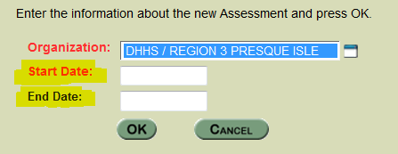
On the Face Sheet, the Plan Meeting Date must be updated. Effective Plan Date and Plan End Date do not change
In each of the changing Provider Service Description forms the Submit Date is updated by the respective provider to when information is being entered and the Proposed Change/Start Date is changed to the date provider would like services to begin or be changed. The Effective Plan Date does not change. If the service is ending the Proposed Change/Start date does not change.
Signature fields on the Face Sheet are updated with the dates the identified individuals signed the plan.
The Final Case Management Approval decision date is updated once the plan has been signed.

Appendix B – Understanding MaineCare Service Dimensions

Dimension Description – All Services
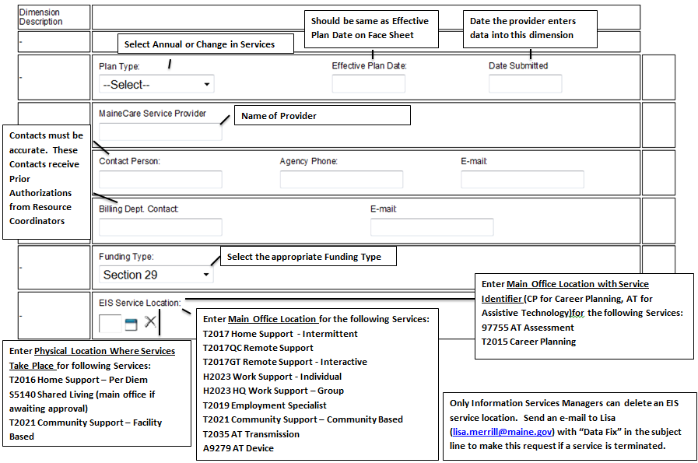

Service
Service sections of the MaineCare Service Description Forms are different for each service.

Home Supports
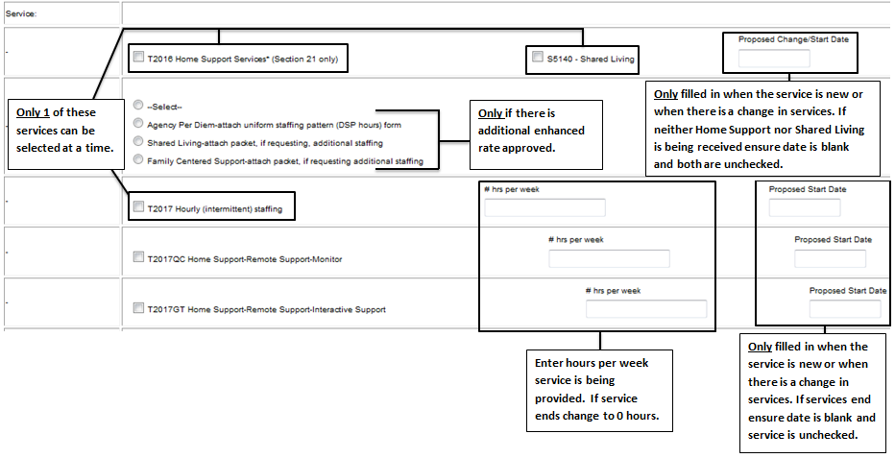

Work Supports/Employment Specialist
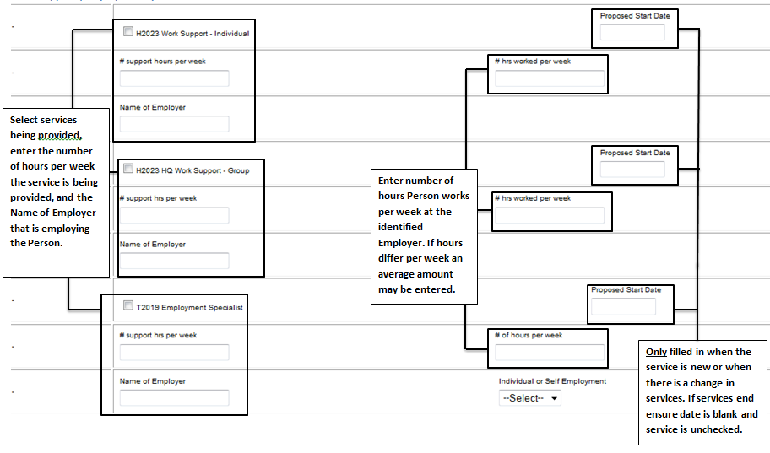

Case Management
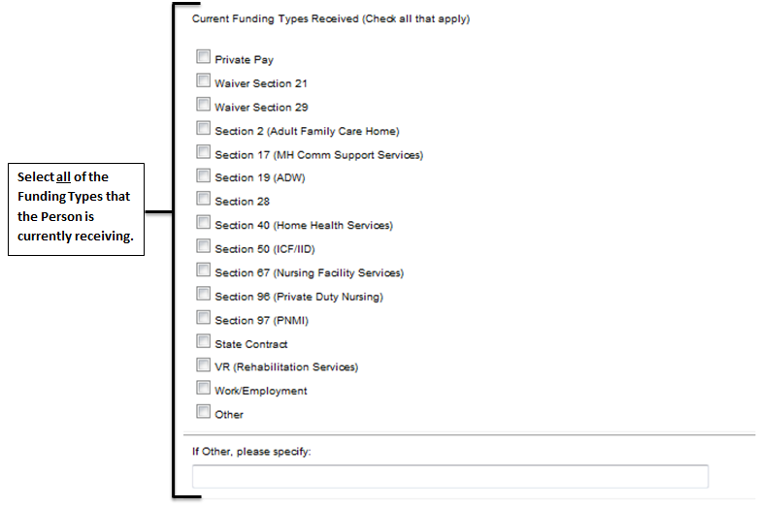

Community Supports
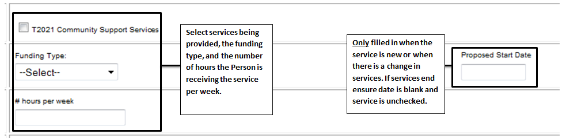

Assistive Technology
This dimension is completed by the Case Manager. All information entered is discussed in the Dimension Description and Domains sections.

Career Planning
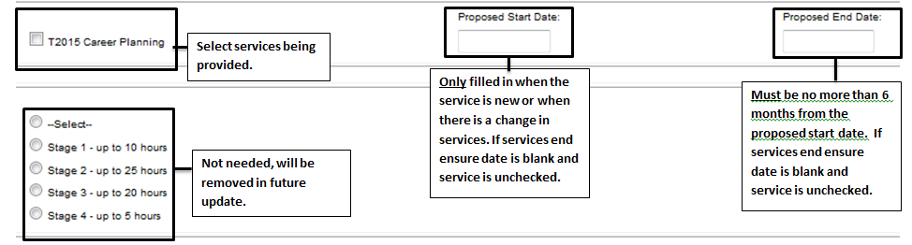

Ancillary Supports
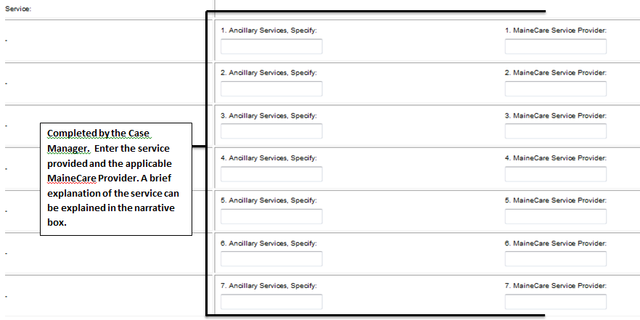

Domains – Ancillary Supports Only

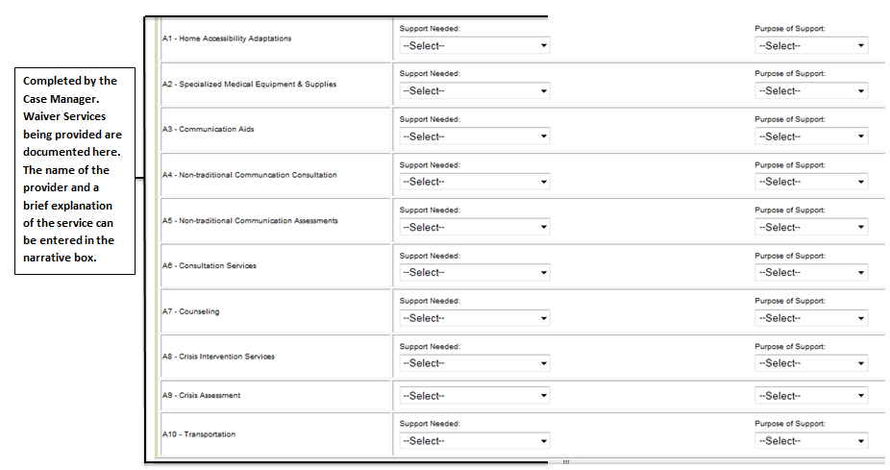

Domains – All Services except Ancillary Supports
Though there are different domains present for different services the general idea is the same. Domains link services to a MaineCare Billable component. All Domains in active services should have a support needed selected – even if the selection is “None” or “Not applicable”. If the Support Needed is something other than “None” or “Not applicable”, then the Purpose of Support should also be identified. Otherwise, the Purpose of Support does not need to be changed.
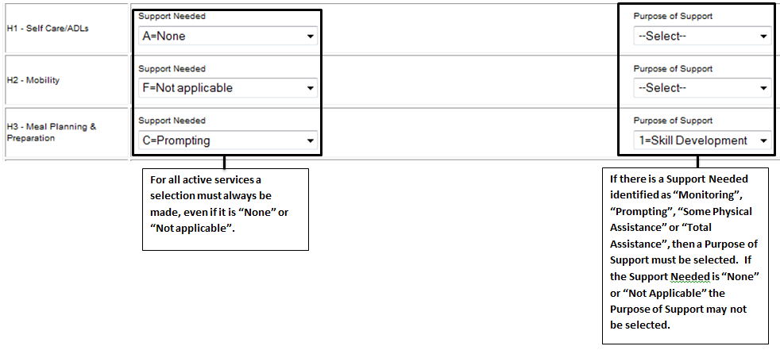

Appendix C – Exemplary, Satisfactory, and Unsatisfactory Goals
Exemplary Goals:
Using the 5 Service Accomplishments by Dr. John O’Brien, service providers can work with the Person to generate goals genuine to the person and balance between enough detail, so that people know what the Person will be supported to do, and enough open-endedness to allow for creativity and change.

Examples of Exemplary Goals and the corresponding Service Accomplishment:
- John will explore his new neighborhood by visiting places he can walk to.
  - Community Presence: Increases the presence of the Person in local community life.
- Bob will plan a BBQ and invite his family and friends to celebrate the 4th of July.
  - Community Participation: Expanding and deepening the Person’s relationships.
- Jane will discover opportunities for volunteering at the local library or Y day care
  - Valued Social Roles: Enhancing the reputation people have and increasing the number of valued ways people can contribute.
- Kim will choose what she does for the upcoming holidays.
  - Promoting Choice and Autonomy: Helping the Person have more control and choice in life.
- Laura will increase her production at work to be eligible for a pay raise.
  - Supporting Contribution: Assisting the person to develop more competencies.
Satisfactory Goals:
When first getting to know a Person, if the Person has difficulty communicating their needs and desires, or if the goal of the Person is specific it may be simpler to have straight forward goals.

Examples of Satisfactory Goals and the corresponding Service Accomplishment:
- I want to go to the YMCA.
  - Community Presence: Increases the presence of the Person in local community life.
- I want to perform in a play.
  - Community Participation: Expanding and deepening the Person’s relationships.
- I want to learn to drive a car.
  - Supporting Contribution: Assisting the person develop more competencies.
- I want to visit family in New Hampshire.
  - Valued Social Roles: Enhancing the reputation people have and increasing the number of valued ways people can contribute.
- Sally would like to go bowling.
  - Promoting Choice and Autonomy: Helping the Person have more control and choice in life.
- Scott wants to go to Boston.
  - Promoting Choice and Autonomy: Helping the Person have more control and choice in life.
- Jane would like to make new friends.
  - Valued Social Roles: Enhancing the reputation people have and increasing the number of valued ways people can contribute.

Unsatisfactory Goals:
The following goals are unsatisfactory, with the reason behind the unsatisfactory label listed under the goal.
- James states he has no goals but he would benefit from working on community Integration.
  - Every service chosen has to have at least 1 goal.
- Sue wants to continue attending day program 4 days per week.
  - Services already being received are not considered goals.
- Jane would like to make new friends. Community Supports staff will assist Jane in building natural supports in the community. Staff will support Jane with working on expressive language skills.
  - Jane wanting to make new friends is a valid goal. What Community Supports staff will do to assist is a service and is better documented in the Service Planning Narrative, not in the goal.
- Billy needs to work on safety skills while in the community. Billy does not pay attention to traffic in parking lots and has darted out in front of vehicles.
  - While this may be a health and safety issue worthy of a service, it does not appear to be a goal to Billy and therefore should not be included in the goals section.
- Sue will complete all morning chores without prompts 80% of the time.
  - Habilitation/Teaching plans do not belong in the PCP assessment.
- John wants to continue living in his apartment with supports.
  - Services already being received are not considered goals.

Appendix D – OADS Agreement Sheet
OADS Person Centered Plan Agreement Sheet
The undersigned agree to provide services as identified in the annual Person Centered Plan (PCP) for _____________ discussed on the Plan Meeting Date of ___________.
Name (print): | Name (print):
Signature:  Date of Signature: | Signature:  Date of Signature:
Title/Relationship to Person: | Title/Relationship to Person:
Organization (if applicable): | Organization (if applicable):
Name (print): | Name (print):
Signature:  Date of Signature: | Signature:  Date of Signature:
Title/Relationship to Person: | Title/Relationship to Person:
Organization (if applicable): | Organization (if applicable):
Name (print): | Name (print):
Signature:  Date of Signature: | Signature:  Date of Signature:
Title/Relationship to Person: | Title/Relationship to Person:
Organization (if applicable): | Organization (if applicable):
Name (print): | Name (print):
Signature:  Date of Signature: | Signature:  Date of Signature:
Title/Relationship to Person: | Title/Relationship to Person:
Organization (if applicable): | Organization (if applicable):

This Agreement Sheet must be physically signed by all Team Members responsible for implementing the Person Centered Plan prior to the Plan being effective. Case Manager, Guardian, and Consumer signatures must sign the Face Sheet.
When sending the Face Sheet to Resource Coordinators for Reclassification or for an Authorization Request an updated Agreement Sheet must be sent as well. If the plan is being reversioned only the affected Services/Providers need to sign. The Case Manager, Guardian, and Consumer must sign the face sheet when a plan is reversioned. Case Managers must maintain the original signatures; Resource Coordinators will accept copied signatures.

The Department of Health and Human Services (DHHS) does not discriminate on the basis of disability, race, color, creed, gender, sexual orientation, age, or national origin, in admission to, access to, or operations of its programs, services, or activities, or its hiring or employment practices. This notice is provided as required by Title II of the Americans with Disabilities Act of 1990 and in accordance with the Civil Rights Act of 1964 as amended, Section 504 of the Rehabilitation Act of 1973, as amended, the Age Discrimination Act of 1975, Title IX of the Education Amendments of 1972 and the Maine Human Rights Act and Executive Order Regarding State of Maine Contracts for Services. Questions, concerns, complaints or requests for additional information regarding the ADA may be forwarded to DHHS’ ADA Compliance/EEO Coordinators, 11 State House Station – 221 State Street, Augusta, Maine 04333, 207-287-4289 (V), 207-287-3488 (V), TTY users call Maine relay 711. Individuals who need auxiliary aids for effective communication in program and services of DHHS are invited to make their needs and preferences known to the ADA Compliance/EEO Coordinators. This notice is available in alternate formats, upon request.

