# Maine Zika Report

April 1, 2016

**Important Considerations**

* **The types of mosquitoes that can transmit Zika virus are NOT found in the state of Maine**

**Recent Global Updates**

* 3/31/2016 – WHO situation report determines that based on observational, cohort, and case-control studies there is strong scientific consensus that Zika virus is a cause of Guillain-Barre syndrome (GBS), microcephaly and other neurological disorders

**Current Data – Maine** (as of 4/1/16)

Countries and Territories in the Americas with Active Zika Virus Transmission (CDC, 3/30/16)

* Travel-associated Zika virus disease cases reported: 2
* # of samples submitted for testing: 71

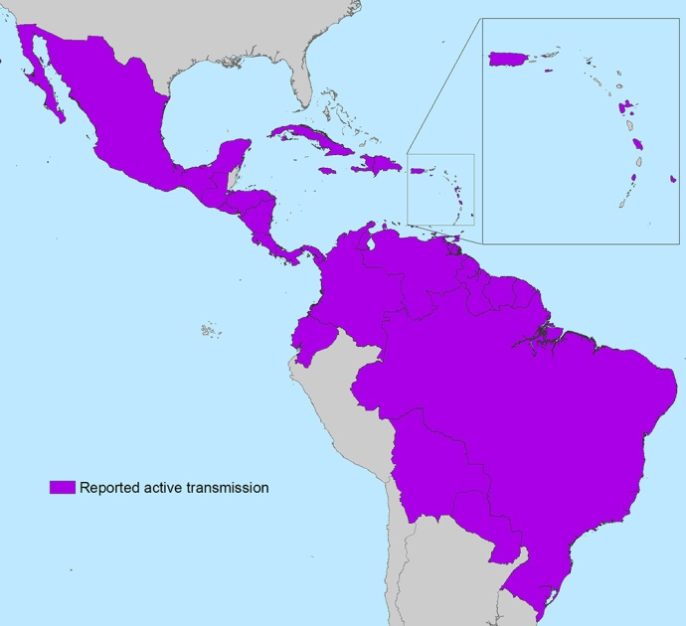

**Current Data – US States** (as of 3/30/16)

* Travel-associated Zika virus disease cases reported: 312
* Locally acquired vector-borne cases reported: 0
* Of the 312 cases reported, 27 were pregnant, 6 were

Sexually transmitted, and 1 had Guillain-Barre.

**Current Data – US Territories** (as of 3/30/16)

* Travel-associated Zika virus disease cases reported: 3
* Locally acquired vector-borne cases reported: 349
* Of the 352 cases reported, 37 were pregnant and 1 had

Guillain-Barre

**Countries currently affected by Zika** (as of 3/9/16)

* **Americas**: Aruba, Barbados, Bolivia, Bonaire, Brazil, Colombia, Costa Rica, Cuba, Curacao, Dominica, Dominican Republic, Ecuador, El Salvador, French Guiana, Guadeloupe, Guatemala, Guyana, Haiti, Honduras, Jamaica, Martinique, Mexico, Nicaragua, Panama, Paraguay, Puerto Rico, Saint Martin, Saint Vincent and the Grenadines, Sint Maarten, Suriname, Trinidad and Tobago, US Virgin Islands, Venezuela
* **Oceania/Pacific Islands**: American Samoa, Marshall Islands, New Caledonia, Samoa, Tonga

All Countries and Territories with Active Zika Virus Transmission (CDC, 3/30/16)

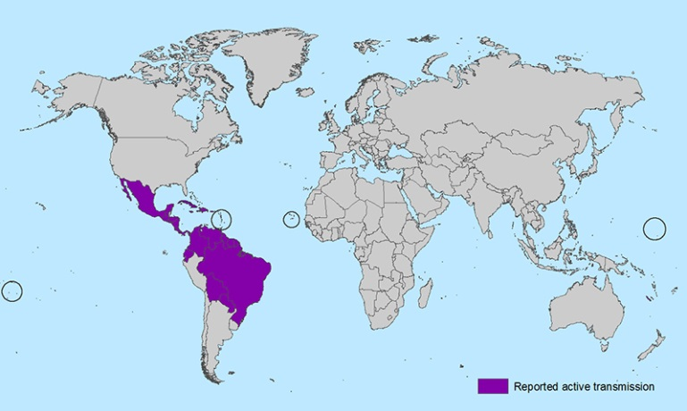

* **Africa**: Cape Verde