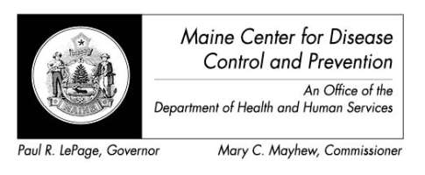

Maine Weekly Arboviral Surveillance Report
August 15, 2016

January 1, 2016 – August 13, 2016:

Humans – Domestic arboviral illnesses
 | Number Tested | WNV positive | EEE positive
Current Week | 5 | 0 | 0
2016 Year to Date | 32 | 0 | 0
Human arboviral testing performed at Maine’s Health and Environmental Testing Laboratory (HETL); testing may be performed year round

Humans – Imported arboviral illnesses
 | Chikungunya positive | Dengue positive | Zika positive*
2016 Year to Date | 0 | 1 | 10
Imported arboviral testing may be performed at HETL, CDC Fort Collins, or other national reference laboratories

Animals
 | Number Tested | WNV positive | EEE Positive
Current Week | 0 | 0 | 0
2016 Year to Date | 0 | 0 | 0
Animal arboviral testing may be performed at HETL or through the National Veterinary Services Laboratory (NVSL); testing may be performed year round

Mosquitoes – Domestic arboviruses
 | Pools Tested | WNV positive | EEE positive
Current Week | 0 | 0 | 0
2016 Year to Date | 109 | 0 | 0

Mosquitoes – Imported arboviruses
 | Pools Tested | CHIK positive | Zika positive
Current Week | 0 | 0 | 0
2016 Year to Date | 39 | 0 | 0
Mosquito arboviral testing performed at HETL; mosquito collection begins July 1 and continues through September 30

Only completed testing is included in this report.

WNV = West Nile Virus
EEE = Eastern Equine Encephalitis
CHIK = Chikungunya

*At this time there are confirmed locally acquired mosquito-borne Zika virus disease cases in Miami Florida, but nowhere else in the United States.

For more information about Zika include updated counts on travel associated cases and the US Zika pregnancy registry see www.cdc.gov/zika.

