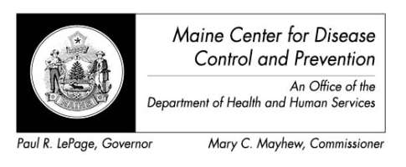

Maine Weekly Arboviral Surveillance Report
July 25, 2016

January 1, 2016 – July 23, 2016:

Humans – Domestic arboviral illnesses
 | Number Tested | WNV positive | EEE Positive
Current Week | 1 | 0 | 0
2016 Year to Date | 23 | 0 | 0
Human arboviral testing performed at Maine’s Health and Environmental Testing Laboratory (HETL); testing may be performed year round

Humans – Imported arboviral illnesses
 | Chikungunya positive | Dengue positive | Zika positive*
2016 Year to Date | 0 | 0 | 7
Imported arboviral testing may be performed at HETL, CDC Fort Collins, or other national reference laboratories

Animals
 | Number Tested | WNV positive | EEE Positive
Current Week | 0 | 0 | 0
2016 Year to Date | 0 | 0 | 0
Animal arboviral testing may be performed at HETL or through the National Veterinary Services Laboratory (NVSL); testing may be performed year round

Mosquitoes
 | Pools Tested | WNV positive | EEE Positive
Current Week | 41 | 0 | 0
2016 Year to Date | 70 | 0 | 0
Mosquito arboviral testing performed at HETL; mosquito collection begins July 1 and continues through September 30

Only completed testing is included in this report.

WNV = West Nile Virus
EEE = Eastern Equine Encephalitis

*At this time there are no confirmed locally acquired mosquito-borne Zika virus disease cases in the United States

For more information about Zika include updated counts on travel associated cases and the US Zika pregnancy registry see www.cdc.gov/zika.

