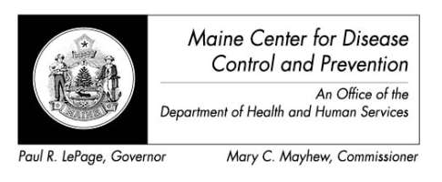

Maine Weekly Arboviral Surveillance Report
September 2, 2014

January 1, 2014 – August 30, 2014:

Humans
 | Number Tested | WNV positive | EEE Positive
Current Week | 1 | 0 | 0
2014 Year to Date | 36 | 0 | 1*
Human arboviral testing performed at Maine’s Health and Environmental Testing Laboratory (HETL); testing may be performed year round

*1 human tested positive for EEE in Maine, however the patient is a New Hampshire resident and will be counted as a case there

Animals
 | Number Tested | WNV positive | EEE Positive
Current Week | 0 | 0 | 0
2014 Year to Date | 0 | 0 | 0
Animal arboviral testing may be performed at HETL or through the National Veterinary Services Laboratory (NVSL); testing may be performed year round

Mosquitoes
 | Pools Tested | WNV positive | EEE Positive
Current Week | 29 | 0 | 1
2014 Year to Date | 175 | 0 | 1
Mosquito arboviral testing performed at HETL; mosquito collection begins July 1 and continues through September 30

Only completed testing is included in this report.

WNV = West Nile Virus
EEE = Eastern Equine Encephalitis

2014 Positive Results
Surveillance | Species | Date Collected | Town | County | Agent
Mosquito | Culex salinarius | 8/27/2014 | York | York | EEE

