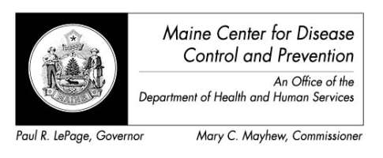

Maine Weekly Arboviral Surveillance Report
September 10, 2012

January 1, 2012 – September 8, 2012:

Humans
 | Number Tested | WNV positive | EEE Positive
Current Week | 11 | 0 | 0
2012 Year to Date | 48 | 1* | 0
Human arboviral testing performed at Maine’s Health and Environmental Testing Laboratory (HETL); testing may be performed year round

*1 human tested positive for WNV in Maine, however the patient was a Philadelphia resident and will be counted as a case in PA

Animals
 | Number Tested | WNV positive | EEE Positive
Current Week | 0 | 0 | 0
2012 Year to Date | 31 | 0 | 2*
Animal arboviral testing may be performed at HETL or through the National Veterinary Services Laboratory (NVSL); testing may be performed year round

* 28 mist-netted birds were submitted to CDC-Fort Collins as part of a serosurvey, 2 were sero-positive for EEE. Sero-positivity indicates exposure to the disease, not necessarily active infection.

Mosquitoes
 | Pools Tested | WNV positive | EEE Positive
Current Week | 0 | 0 | 0
2012 Year to Date | 827 | 4 | 0
Mosquito arboviral testing performed at HETL; mosquito collection begins July 1 and continues through September 30

Only completed testing is included in this report.

WNV = West Nile Virus
EEE = Eastern Equine Encephalitis

2012 Positive Results
Species | Date Collected | County | Agent
Veery | 05/21/2012 | Cumberland | EEE
Gray Catbird | 05/14/2012 | Cumberland | EEE
Culiseta melanura | 08/01/2012 | York | WNV
Culex pipiens/restuans | 08/01/2012 | Cumberland | WNV
Culiseta melanura | 08/23/2012 | Cumberland | WNV
Culiseta melanura | 08/23/2012 | Cumberland | WNV

* 28 mist-netted birds were submitted to CDC-Fort Collins as part of a serosurvey, 2 were sero-positive for EEE. Sero-positivity indicates exposure to the disease, not necessarily active infection.

