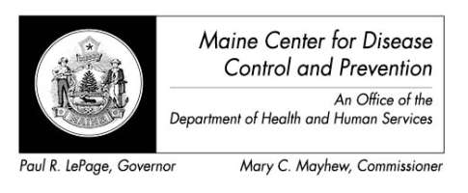

Maine Weekly Arboviral Surveillance Report
August 13, 2012

January 1, 2012 – August 11, 2012:

Humans
 | Number Tested | WNV positive | EEE Positive
Current Week | 2 | 0 | 0
2012 Year to Date | 20 | 0 | 0
Human arboviral testing performed at Maine’s Health and Environmental Testing Laboratory (HETL); testing may be performed year round

Animals
 | Number Tested | WNV positive | EEE Positive
Current Week | 1 | 0 | 0
2012 Year to Date | 30 | 0 | 2*
Animal arboviral testing may be performed at HETL or through the National Veterinary Services Laboratory (NVSL); testing may be performed year round

* 28 mist-netted birds were submitted to CDC-Fort Collins as part of a serosurvey, 2 were sero-positive for EEE. Sero-positivity indicates exposure to the disease, not necessarily active infection.

Mosquitoes
 | Pools Tested | WNV positive | EEE Positive
Current Week | 159 | 0 | 0
2012 Year to Date | 336 | 0 | 0
Mosquito arboviral testing performed at HETL; mosquito collection begins July 1 and continues through September 30

Only completed testing is included in this report.

WNV = West Nile Virus
EEE = Eastern Equine Encephalitis

2012 Positive Results
Species | Date Collected | County | Agent
Veery | 05/21/2012 | Cumberland | EEE
Gray Catbird | 05/14/2012 | Cumberland | EEE

* 28 mist-netted birds were submitted to CDC-Fort Collins as part of a serosurvey, 2 were sero-positive for EEE. Sero-positivity indicates exposure to the disease, not necessarily active infection.

