Ebola Preparedness: Mini Drills
Mini drills are a great way to test your facility preparedness for Ebola. They are intended to be limited to a section at a time and take approximately 5-10 minutes each. These mini drills can be used to test preparedness on different shifts and with different staffing rotations. They can be used pre-training, if a baseline is needed; or post-training to ‘test’ the training.

Sections:

- Identify
- Isolate
- Inform
- Personnel Protective Equipment
- Treatment & Care
- Transportation
- Waste Management and Cleaning & Disinfection

Several worksheets are available as links on the NETEC Healthcare Facility Special Pathogen Preparedness Checklist if a deeper dive is desired.

This tool developed by Maine CDC.
The questions for these mini drills come from the NETEC Health Care Facility Special Pathogen Preparedness Checklist.

Section 1: Identify
Scenario: A well-dressed, young female presents to your facility stating she doesn’t feel well and would like to see a doctor. Her main complaints are of a headache, fever, and sore throat.
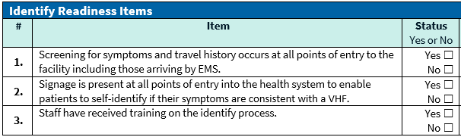
Section 2: Isolate
Scenario: A middle-aged male with muscle aches, fatigue, and a slight cough reports to your facility. You inquire about his travel history and find he has been a missionary in Budongo in Uganda the last two years (not in an outbreak region). He states he spent two nights in Kampala (outbreak region) then flew out of Uganda at the Entebbe International Airport 17 days ago. What should you do now?
Expanded Scenario: How would this differ if the patient also had the symptoms of vomiting, diarrhea, or bloody nose?

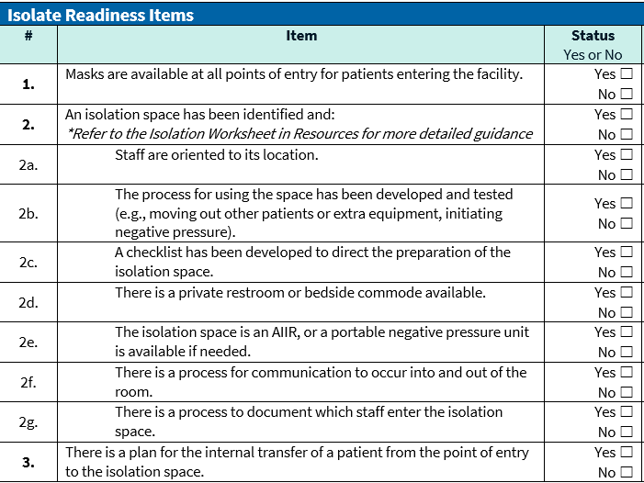
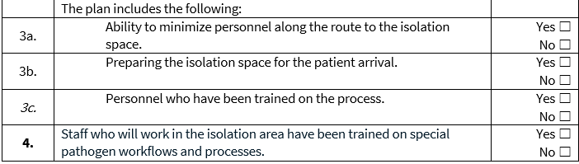
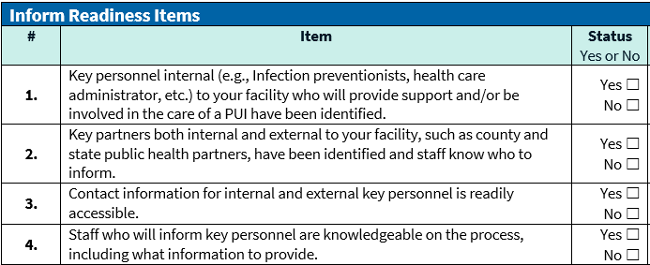
Section 3: Inform
Scenario: You have just identified that your patient, an older gentleman with a recent travel history to an Ebola outbreak region in Uganda, returning 10 days ago. He has signs and symptoms consistent with EVD. Now that he has been appropriately isolated, to whom will you communicate this information?

Section 4: Personal Protective Equipment (PPE)
Scenario: A college-aged male with muscle aches, fatigue, and a slight cough reports to your facility. He has been on a trip to Uganda visiting family over spring break, and these symptoms developed 5 days after returning. He has been masked and placed in the isolation room. What PPE should any HCW who is going to examine this patient wear?
Expanded Scenario: Same patient starts vomiting, what PPE is recommended then?

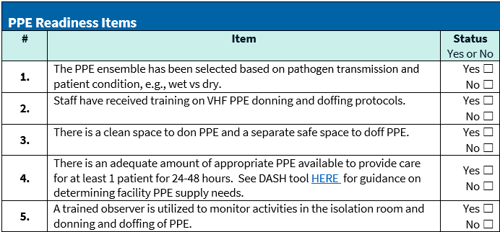
DASH tool link: https://dashtool.org/
Just for Reference
When the patient is a ‘stable’ or ‘dry’ patient PPE includes:
- Single-use (disposable) fluid-resistant gown that extends to at least mid-calf or single-use (disposable) fluid-resistant coveralls without integrated hood
- Single-use (disposable) full face shield
- Single-use (disposable) facemask
- Single-use (disposable) gloves with extended cuffs.
- Two pairs of gloves should be worn. At a minimum, outer gloves should have extended cuffs.
When the patient is an ‘unstable’ or ‘wet’ patient PPE includes:
- Impermeable Garment: single-sue (disposable) impermeable gown or coverall
- Respiratory, head, and face protection
  - PAPR (with full-face shield/helmet/ or headpiece)
  - NIOSH-certified N-95 respirator WITH single-use (disposable) hood AND single-use (disposable) full-face shield
- Single use (disposable) examination gloves with extended cuffs (2-pair)
- Single use (disposable) boot covers that extend to mid-calf. (Note: Single use (disposable) shoe covers may be used ONLY if used in combination with a coverall with integrated socks)
- Single use (disposable) apron

Section 5: Treatment & Care
Scenario: An older female reports to your facility with a travel history within the last 3 weeks of visiting family in Uganda for a funeral. She is determined to be a high-risk PUI. She is in an isolation room. How will treatment and care be provided?
Expanded Scenario: The patient is due for her insulin and needs her glucose levels checked to calculate the correct dosage. How will you provide care?

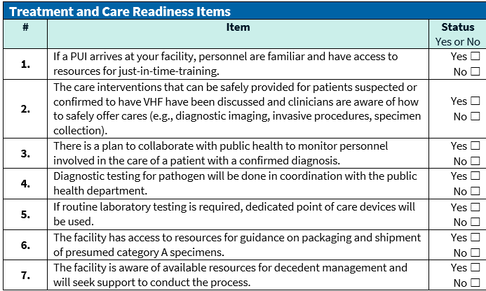

Section 6: Transportation
Scenario: A middle-aged gentleman, who has returned from Kampala, Uganda 5 days ago with weakness and fatigue, has now tested negative for Covid-19 and influenza. You are unable to rule out Ebola as a cause for signs and symptoms. You desire to transfer this patient to an Ebola Assessment Hospital. What are your next steps?
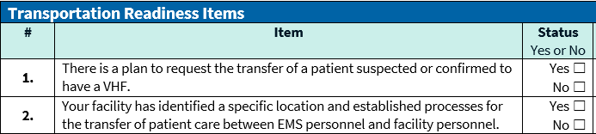

Section 7: Waste Management and Cleaning & Disinfection
Scenario: Your Ebola PUI has just left in the ambulance on her way to the Ebola Assessment Hospital and now the room needs to be turned over. How will you manage waste and clean and disinfect the room?
