Fight the Bite! Mosquito Jeopardy

Directions
This activity is intended for grades 3 – 5.
Draw a jeopardy board on a white board or chalkboard (see the board on the next page). Break the class into teams and designate an individual to provide answers. The teacher will determine the starting team.
The starting team will pick their first category and value and the teacher will read the corresponding question out loud. Once the teacher finishes reading, allow the teams to buzz in (or raise their hands). The first team to buzz in will have a chance to answer. If the answer is wrong, wait for another contestant to buzz in. If the answer is correct, that contestant gets the points and can choose the next clue.
If a contestant gets an answer wrong, they will lose the amount of points that clue was worth. In the television version, contestants can have negative points (you do not have to follow this rule).
Once the entire table is answered continue to Final Jeopardy. In Final Jeopardy, give each team a chance to write the amount they would like to wager. Reveal the question and give teams 60 seconds to write their answers. After 60 seconds, ask each team to share their answer and wager. Add or subtract points from their score and determine the winning team.
Alternatively, this game can also be played individually.
Supplies
- Jeopardy board (drawn on white board/chalkboard)
- Pen and paper to keep score
- Buzzer for each team or individual (optional)

Learning Objectives
- Identification of mosquito habitats
- Demonstrate personal protection methods
- Knowledge of mosquito biology and ecology
Jeopardy Clues
Mosquito Biology: 100
What is the first stage of a mosquito’s lifecycle?
A: Egg
Mosquito Biology: 200
True or False: Only female mosquitoes feed on blood?
A: True
Only female mosquitoes have a proboscis (a long, jagged mouth part on the mosquito’s head) that is adapted for piercing skin, and only the females feed on blood. Male mosquitoes typically feed on plant nectar.
Mosquito Biology: 300
What is the long, feathery organ on the mosquito’s head used to hear and smell?
A: Antenna
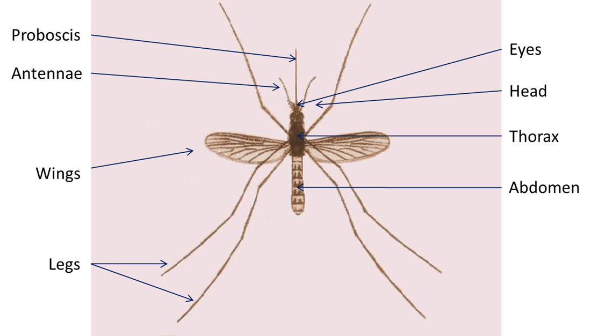

Mosquito Habitats: 100
True or false: All mosquitoes require water for their larvae to develop?
A: True
Larvae (larva, also called wigglers or wrigglers) is the part of the mosquito lifecycle that comes after the eggs hatch. The larvae hang from the surface of water and breathe through tubes. The larval stage lasts for about 1 week.
Mosquito Habitats: 200
What man-made containers can mosquitoes use as larval habitats?
A: Buckets, cans, flower pots, or old tires (among other things)
Mosquito Habitats: 300
What is the favored habitat for mosquitoes that can carry Eastern Equine Encephalitis (EEE)?
A: Bogs and swamps
Mosquito Protection: 100
When are mosquitoes most active?
A: At dawn and dusk (early morning and early evening)
Mosquito Protection: 200
What type of clothing should you wear when going outside to lessen your chance of getting bit by a mosquito?
A: Long sleeves and long pants
Mosquito Protection: 300
How often should you empty the water of containers like bird baths or pet bowls so that mosquito larvae won’t have time to complete their lifecycle?
A: At least once per week

Mosquito Diseases: 100
Name one of the viruses that mosquitoes can carry in Maine?
A: Eastern Equine Encephalitis (EEE), West Nile virus (WNV), or Jamestown Canyon virus (JCV)
Mosquito Diseases: 200
Name one of the diseases that you can get when traveling outside of the United States?
A: Malaria, Chikungunya, Zika, Dengue
Mosquito Diseases: 300
What is one symptom of EEE, WNV, or JCV?
A: Common symptoms include: fever, head and body aches, lack of energy, vomiting.
Serious symptoms include: disorientation, seizures, paralysis, coma, or death.
Final Jeopardy Question!
Name the repellent that is EPA approved for use on clothing only.
A: Permethrin

