This man is taking precautions to prevent mosquito bites (Using repellent) | 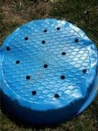  By making these holes we are preventing standing water in our yards (Holes in kiddie pool)
The first stage of the mosquito life cycle, the female mosquito lays between 50-300 of these every three days (Eggs)  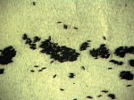 | 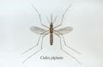  This diagram shows all the mosquito body parts (Mosquito diagram)
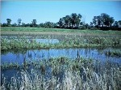  This open area is good habitat for mosquitoes that might carry EEE (Swamp) | 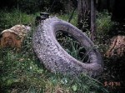  The number one mosquito breeding site in the United States (Tire)
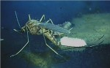  This mosquito is surrounded by the one thing all mosquitoes need to complete their life cycle (Water) | 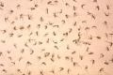  If all of these bit you, you would be very itchy (lots of mosquitoes)
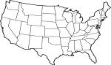  This shows where West Nile virus can be found (Continental US) | 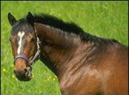  This animal, like humans, is a Dead-End Host (Horse)
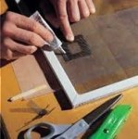  By fixing these you can keep mosquitoes from coming into your house (Screen) | 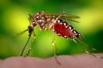  This picture must be a female because it is filled with blood (Mosquito)
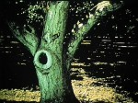  This natural container can hold water where mosquitoes might breed (Hole in tree) | 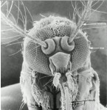  A mosquito uses these to hear and smell (Antennae)
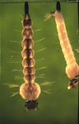  The second stage of the mosquito lifecycle after the eggs hatch (Larva) | 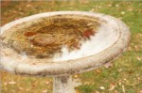  A place where birds clean up, and mosquitoes might lay their eggs (Birdbath)
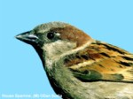  This animal can be a reservoir for Eastern Equine Encephalitis (Bird) | 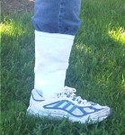  This prevention method minimizes skin exposure to mosquitoes (Pants tucked into socks)
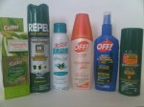  These are used on skin and clothing to help keep mosquitoes from biting you (Repellent) | 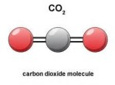  The chemical that all animals exhale that can attract mosquitoes (Carbon dioxide)
This habitat with trees is good for mosquitoes that might carry EEE (Bog) | 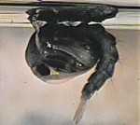  The third stage of the mosquito lifecyle which is partically encased in a coccon (Pupae)
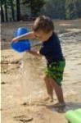  This is something you can do with your toys to help prevent them from filling with water (Emptying bucket) | This is the theme of our activities today (Fight the Bite)

