Maine Weekly Influenza Surveillance Report

December 21, 2006

Synopsis
During the week ending December 16, 2006 (MMWR week 50)*, no influenza activity was reported in Maine.

Moderate Disease Surveillance

Outpatient influenza-like illness (ILI)
During the week ending December 16, 2006, 0.8% of sentinel provider outpatient visits were due to ILI (range 0% - 3.2%).
Percentage of Patient Visits for Influenza-like Illness -- Maine, 2005-2007

# New England is defined as Connecticut, Maine, Massachusetts, New Hampshire, Rhode Island, and Vermont.

Severe Disease Surveillance

Hospital inpatients
During the week ending December 9, 2006 (week 49), 4.1% of admissions reported by four hospitals were due to respiratory illness (range 1.3% - 5.5%). During the week ending December 16, 2006 (week 50), 3.6% of admissions reported by three hospitals were due to respiratory illness (range 2.3% - 5.5%).

Percentage of Hospital Admissions due to Respiratory Illness -- Maine, 2005-07

Laboratory Reporting
As of December 16, 2006 a total of 43 respiratory specimens have been submitted for viral testing to the Maine Health and Environmental Testing Laboratory. Thirty-seven specimens were negative for influenza, three specimens were presumptive positive for enterovirus, and results are pending for three specimens.

As of December 16, 2006, a total of 152 specimens have been submitted for viral testing to two reference laboratories in Maine; all were negative for influenza, five specimens were positive for RSV, seven specimens were positive for adenovirus, and eight specimens were positive for enterovirus.

Fatalities Surveillance

Death Certificates
During the week ending December 16, 2006, 8.3% of deaths reported by two city vital records office were attributable to pneumonia and influenza.

Percentage of Deaths Attributable to Pneumonia and Influenza – Maine, New England and the United States, 2005-07
^ New England includes the following reporting areas: Boston, MA; Bridgeport, CT; Cambridge, MA; Fall River, MA; Hartford, CT; Lowell, MA; Lynn, MA; New Bedford, MA; New Haven, CT; Providence, RI; Somerville, MA; Springfield, MA; Waterbury, CT; Worcester, MA.

Pediatric Fatalities
As of December 16, 2006, no influenza-associated pediatric deaths have been reported in Maine this season.

National Influenza Activity
State health departments report the estimated level of influenza activity in their states each week. States report influenza activity as no activity, sporadic, local, regional, or widespread. Definitions of these levels can be found at: http://www.cdc.gov/flu/weekly/usmap.htm

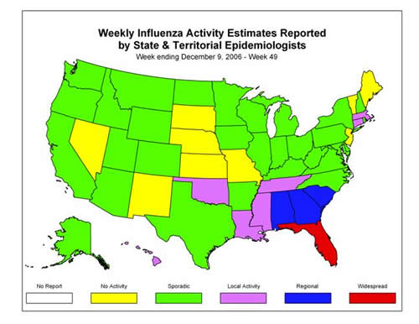

* At time of publication, reporting may be incomplete. Numbers presented here may change as more reports are received.

