Maine Weekly Influenza Surveillance Report

November 16, 2006

Synopsis
During the week ending November 11, 2006 (week 45)*, no influenza activity was reported in Maine.

Moderate Disease Surveillance

Outpatient influenza-like illness (ILI)
During the week ending November 11, 2006, 0.2% of sentinel provider outpatient visits were due to ILI (range 0% - 3.1%).
Percentage of Patient Visits for Influenza-like Illness -- Maine, 2005-2007

# New England is defined as Connecticut, Maine, Massachusetts, New Hampshire, Rhode Island, and Vermont.

Severe Disease Surveillance

Hospital inpatients
During the week ending November 4, 2006 (week 44), 3.7% of admissions reported by four hospitals were due to respiratory illness (range 0% - 9.0%). During the week ending November 11, 2006 (week 45), 0.6% of admissions reported by two hospitals were due to respiratory illness (range 0% - 1.2%).

Percentage of Hospital Admissions due to Respiratory Illness -- Maine, 2005-07

Laboratory Reporting
As of November 14, 2006 a total of 19 respiratory specimens have been submitted for viral testing to the Maine Health and Environmental Testing Laboratory. Nine specimens were negative for influenza, three specimens were presumptive positive for enterovirus, and results are pending for seven specimens.

As of the week ending November 11, 2006, a total of 46 specimens have been submitted for viral testing to two reference laboratories in Maine; all were negative for influenza and other respiratory viruses. On November 13, 2006 (week 46), one respiratory specimen tested positive for respiratory syncytial virus (RSV).

Fatalities Surveillance

Death Certificates
During the week ending November 11, 2006, 5.0% of deaths reported by two city vital records offices were attributable to pneumonia and influenza (Range 0% - 9.5%).

Percentage of Deaths Attributable to Pneumonia and Influenza – Maine, New England and the United States, 2005-07
^ New England includes the following reporting areas: Boston, MA; Bridgeport, CT; Cambridge, MA; Fall River, MA; Hartford, CT; Lowell, MA; Lynn, MA; New Bedford, MA; New Haven, CT; Providence, RI; Somerville, MA; Springfield, MA; Waterbury, CT; Worcester, MA.

Pediatric Fatalities
As of November 16, 2006, no influenza-associated pediatric deaths have been reported in Maine this season.

National Influenza Activity
State health departments report the estimated level of influenza activity in their states each week. States report influenza activity as no activity, sporadic, local, regional, or widespread. Definitions of these levels can be found at: http://www.cdc.gov/flu/weekly/usmap.htm

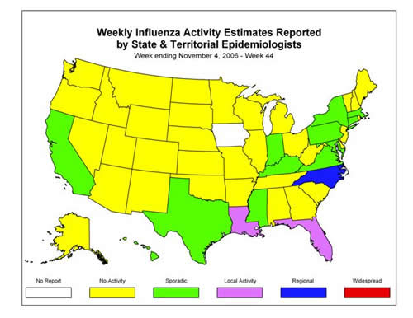
* At time of publication, reporting may be incomplete. Numbers presented here may change as more reports are received.

