DEP Environmental Education Curricula
Lesson Plan
GRADE/LEVEL: Middle School
LESSON TITLE: Wetland
Next Generation Science Standards
MS-ESS3-3 | MS-ESS3-3 | Apply scientific principles to design a method for monitoring and minimizing a  human impact on the environment.
 | Science and Engineering Practices | Constructing Explanations and Designing Solutions  Constructing explanations and designing solutions in 6–8 builds on K–5 experiences and progresses to include constructing explanations and designing solutions supported by multiple sources of evidence consistent with scientific ideas, principles, and theories.  Apply scientific principles to design an object, tool, process or system.
 | Disciplinary Core Ideas | ESS3.C: Human Impacts on Earth Systems  Human activities have significantly altered the biosphere, sometimes damaging or destroying natural habitats and causing the extinction of other species. But changes to Earth’s environments can have different impacts (negative and positive) for different living things.  Typically, as human populations and per-capita consumption of natural resources increase, so do the negative impacts on Earth unless the activities and technologies involved are engineered otherwise.
 | Crosscutting Concepts | Cause and Effect  Relationships can be classified as causal or correlational, and correlation does not necessarily imply causation.
Objectives
Objective 1: List the benefits of wetlands.
Objective 2: Understand the relationship between wetlands and the plants animals that utilize them.
Objective 3: Understand the benefits wetlands bring to an area in terms of flood control.
Vocabulary
 | Aquifer | A body of permeable rock that can contain or transmit groundwater.
 | Extirpated | Found and removed completely.
 | Flood Conveyance | The transport of floodwaters downstream, with little if any damage.
 | Groundwater | Groundwater is the water present beneath the ground’s surface in soil pores and in the rock fractures.
 | Heavy Metals | Heavy metals are naturally occurring elements that have a high atomic weight and a density at least five times greater than that of water.
 | Surface Water | Water that collects on the surface of the ground.
 | Turbidity | Turbidity is the measure of relative clarity of a liquid. It is an expression of the amount of light that is scattered by material in the water when a light is shined through the water sample.
 | Wetland | Wetlands are areas where water covers soil all or part of the time. They protect and improve water quality, provide fish and wildlife habitats, store floodwaters and maintain surface water flow during dry periods.
Background
Teacher Version  Selected Materials from … |  | Source: http://www.maine.gov/dep/water/wetlands/ipwetfv2.html

Background
Our famous jagged coastline and generally rugged terrain statewide have provided Maine with an abundance and diversity of wetlands unequalled in the Northeastern United States.
Fully 25 percent of Maine's land area is wetlands, four times the wetland area of the other five New England States combined.
Over five million acres of Maine's wetlands are freshwater types (wooded swamps, shrub swamps, bogs, freshwater meadows, freshwater marshes and floodplains). Only 157,500 acres are tidal types (tidal flats, salt marsh, brackish marsh, aquatic beds, beach bars and reefs).
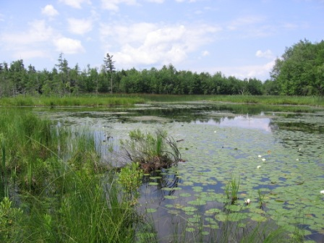
Maine Wetland
Photo Credit: http://www.maine.gov/dep/water/wetlands/
Wetlands are valuable not only for their beauty and the recreation opportunities they support, but also for critically important functions they perform in our environment.

What natural functions do wetlands perform?
Wetlands are important to natural systems including:
- water storage
- flood conveyance
- groundwater recharge and discharge
- shoreline erosion control
- water quality improvement
- source of timber resources
- provide habitat vital to fish and wildlife, including many rare and endangered species

How do wetlands serve as water storage areas?
Because of the capacity of their water retention associated with their abundant vegetation, wetlands serve as natural water storage areas. Their water retention also is determined by where the wetland is on the land and the type of soil that is present.
Along the coast, tidal flooding creates two readily identifiable zones in coastal wetlands:
(1) regularly flooded areas which are alternately flooded and exposed at least twice daily;
(2) irregularly flooded areas, the so-called high marsh, that is usually flooded for only brief periods but may be saturated near the surface during each high tide.
Nontidal wetlands receive their water mainly from
- surface water runoff
- groundwater discharge
- direct precipitation
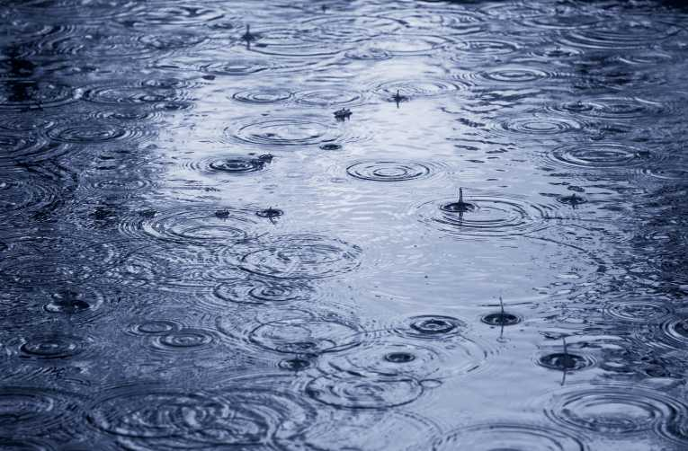
Direct Precipitation -
Photo Credit - https://www.hayspost.com
Surface water runoff collects in isolated depressions surrounded by high ground, or overflows from rivers and lakes following snowmelt or periods of heavy rainfall. In other areas where the groundwater is close to the surface, water may pond on the surface when there is a period of sustained rainfall. Groundwater also discharges periodically to spring or seepage areas when groundwater recharge exceeds subsurface capacity.

What is the value of this water storage function?
In the case of coastal wetlands, because tides vary with the seasons, this storage role has a major impact on the types and abundance of vegetation and wildlife.
In the case of freshwater wetlands, this storage capacity plays a vital role releasing water to lakes and streams to help maintain water levels needed for fish and wildlife, especially during critical spawning seasons, and for recreation uses.
The value of water storage is most easily seen in terms of flooding events.

How do wetlands help to control floods?
Wetlands play a vital role in controlling floods - Wetlands help to lessen the impacts of flooding by absorbing water and reducing the speed at which flood waters flow.
- Upstream wetlands can serve to store flood waters temporarily and release them slowly downstream.
- Along rivers, wetlands usually form natural pathways for flood waters from upstream to downstream points. If those pathways are altered or removed, flood waters can go elsewhere, potentially damaging property and threatening public safety.
Without wetlands as a natural flood control mechanism, flooding can become more severe.

How do wetlands contribute to shoreline erosion control?
Contributors to erosion
- natural tidal action
- river currents
- waves and currents generated by wind on lakes
- waves and wakes from motorboats
Erosion can result in
- loss of valuable beaches
- other property damage and loss
- increased sedimentation harmful to fish and wildlife
- other costly and harmful effects
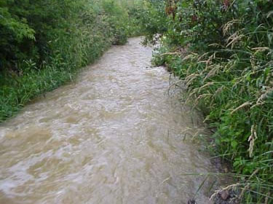
River Erosion
Photo Credit: Maine.gov
Erosion control provided by vegetation along the coast and shorelines of rivers and streams
- stabilizing soil
- encouraging sediment deposit
- dampening the effects of wave action

What role do wetlands perform in groundwater recharge and discharge?
In a natural cycle, water moves from the atmosphere through rain and other precipitation to surface storage areas in the oceans, rivers and lakes, and to sub-surface storage areas known as groundwater aquifers.
In Maine, fully half of the population depends on public or private wells drawing drinking water from such groundwater aquifers. Wetlands provide a key link in this cycle. Under specific circumstances, wetlands can provide a pathway for surface water to enter and thereby recharge groundwater. Wetlands also play an important role as the primary natural discharge path of some groundwater aquifers. Altering or filling wetlands can interfere with this natural cycle.
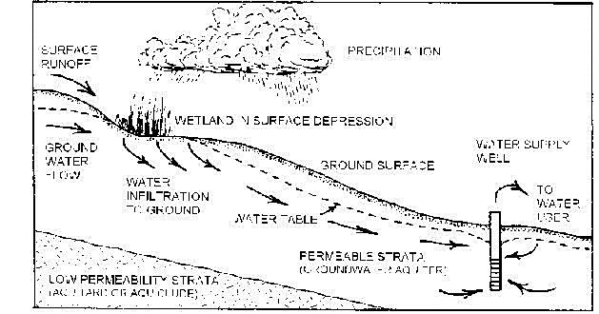

How do wetlands help to improve water quality?
Wetlands improve the quality of water flowing over and through them, a critical role in nature's own water quality restoration process.
- Wetland vegetation slows water flow and captures sediment suspended in the water, reducing turbidity, that murky quality that makes some waters unattractive for swimming and other recreation uses.
- Wetlands filter out, trap and naturally recycle nutrients like nitrogen and phosphorous that run off from the land and might be harmful in excessive quantities in surface waters. This filtration process saves millions of dollars that might otherwise be required to build and operate facilities to perform this function.
- Wetlands can capture pollutants like heavy metals, organic chemicals like pesticides and petroleum hydrocarbons, removing them at least temporarily and sometimes permanently from aquatic ecosystems.
Unfortunately, when wetlands accumulate pollutants, these harmful compounds can also enter the food chain through wetland vegetation and wildlife, ultimately finding their way into fish and wildlife people consume.

How are wetlands important to fish and wildlife?
Wetlands support many valuable species of fish and wildlife that thrive only in a wetland habitat. Other species that do not inhabit wetlands feed upon fish and wildlife that originate in wetlands.
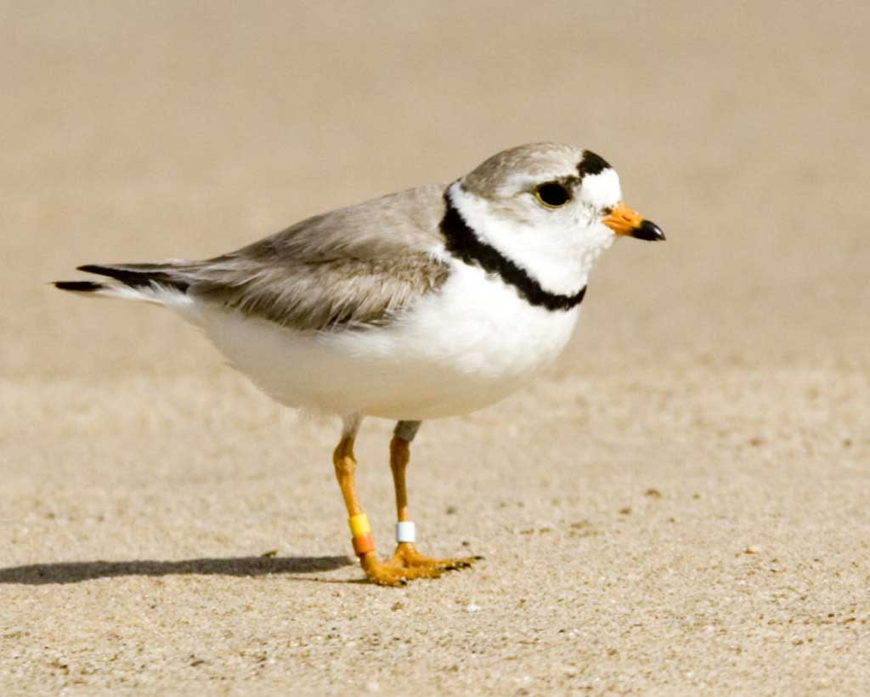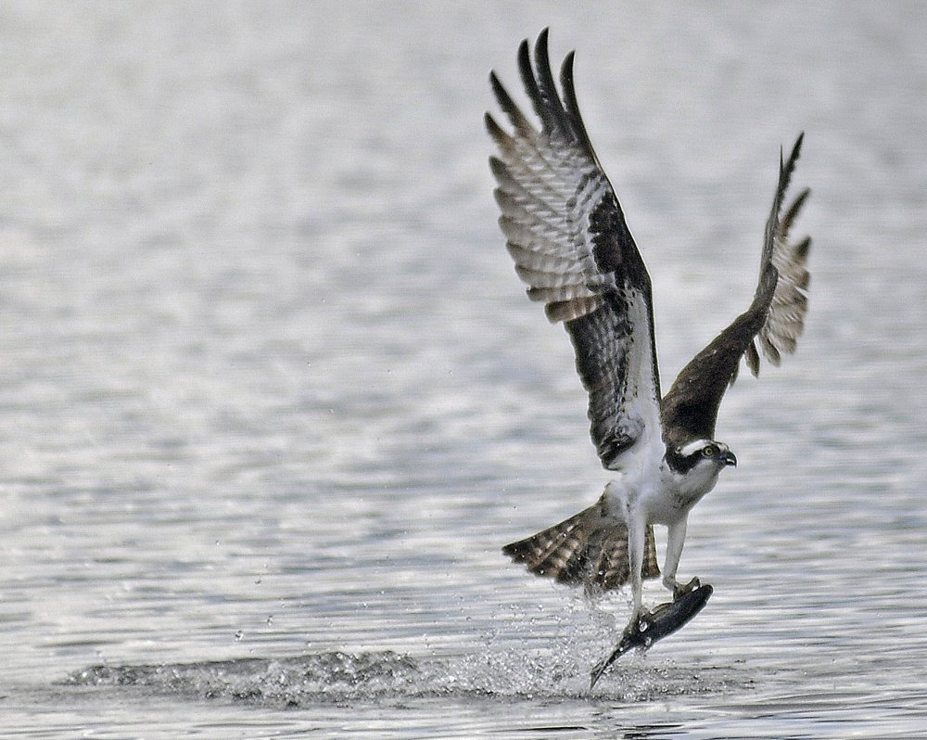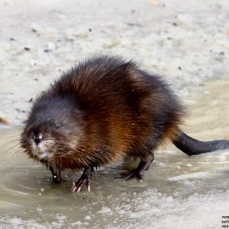
Piping Plover, Osprey, and Muskrat
Photo Credits: (left to right) http://www.audubon.org/field-guide/bird/piping-plover http://www.pressherald.com/2016/08/03/video-records-stealthy-eagle-snatching-osprey-juvenile-off-midcoast-nest/, http://bangordailynews.com/2012/03/13/outdoors/outdoor-gallery/meandering-muskrat-strikes-a-pose/
- Coastal wetlands provide critical habitat for shellfish like clams and mussels and for migratory and nesting shorebirds like sandpipers, plovers and the endangered piping plover.
- Salt marshes are renowned as duck habitat.
- Nesting birds like osprey, herons and the endangered bald eagle feed on both freshwater and saltwater wetland species.
- Certain mammals, including furbearers, live in or near wetlands. Muskrat, for example, live on wetland banks in houses made from wetland vegetation.

Are there rare and endangered species that rely upon wetlands?
Researchers estimate that about 30 plant species have been extirpated from Maine since European settlement. Yet Maine wetlands are treasure troves of many rare plants, including some that botanists once thought extirpated. Studies of bogs during the 1970s and 1980s, for example, resulted in the discovery of abundant collections of rare orchids that live only in rich wetland habitat. Similarly, certain wetland types are vital to endangered wildlife, including shore birds like the piping plover which nests in coastal wetlands and raptors like the bald eagle which feed in both marine and freshwater wetlands.
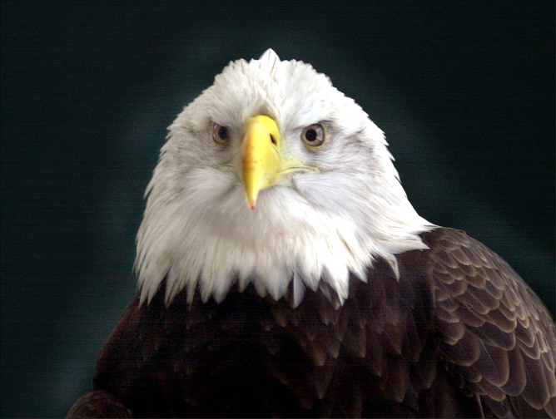
American Eagle - Photo Credit: Press Herald File Photo

How do wetlands contribute to Maine's economy and quality of life?
The functions wetlands perform are not only crucial to our environment, they contribute immeasurably to Maine's economy and to the quality of life Maine people and visitors to Maine enjoy. There are practical, economic and public health and safety values to each of the functions described above.

Maine's wetlands save millions of dollars annually through
- erosion control
- reduced flood damage
- pollution abatement
Their water quality and flood control functions protect the public from otherwise harmful effects. Wetlands are also the source of over three million acres of productive timberland.
By far, however, the greatest contributions from Maine's wetlands are those associated with their importance to our fish and wildlife resources.
Crosscutting Concept
Cause and Effect - Relationships can be classified as causal or correlational, and correlation does not necessarily imply causation.
Discuss with students the effects of humans removing, or filling in, wetlands. How might this affect an areas flood control? How are the species interconnected and how might it affect species diversity in the area in you change the atmosphere of the wetland (Food web, etc.)? Why might someone want to fill in a wetland?
Project – Food Chain Game |  |  | Material Source: Outdoor Biology Instructional Strategies (OBIS)  http://www.fitzwerc.org/downloads/Lesson%20Plans/WS/Lesson%206-%20Wetland%20Food%20Webs/Wetland%20Food%20Webs.pdf

Introduction

This game from OBIS provides a fun, fast-moving outdoor game designed to teach about food chains and the balance of nature. The goal for each player is to survive as an “animal” by getting enough to eat while avoiding being eaten.

To play this game you will need 4-5 liters of popcorn, chart paper, marking pens, plastic sandwich bags, masking tape, and 5- inch square construction paper cards in red and green. Have enough of each color for about two-thirds of your students. The sandwich bags will become “stomach bags.” Place a strip of masking tape across each sandwich bag so that the bottom edge of the tape is ½ inch from the bottom.

Choose a site, preferably outside about 50 feet square. (Any gymnasium or clear area may be used during inclement weather). Ask students if they know what eats mice and what mice eat. They may respond with mice eat seeds, and snakes eat mice. Then ask them what eats snakes. For the benefit of this game, use the answer hawks. Discuss the relationship students describe, and introduce it as a food chain. Ask students if they can think of other food chains, including one with humans.

How to Play
- Describe the play area boundaries. The spread popcorn over the area. Tell students you are distributing the plants that grasshoppers eat.
- Give plastic bags to one-third of your students. These students will be grasshoppers. When you say go, “grasshoppers” place “food” (popcorn) in their “stomachs” (bags).
- Give bags and green cards to a second one-third of the group, and red cards to the last third. When the game starts, “frogs” (green cards} try to capture (tag) grasshoppers, and “hawks” (red cards) pursue frogs. When a frog captures a grasshopper, the grasshoppers stomach is transferred to the frog. When a hawk captures a frog, he or she takes the frog’s stomach. Hawks do not eat grasshoppers in this game. Frogs and hawks must visibly carry their green and red cards, or you can attach them to students’ clothing with tape or clothespins.
- The first game usually lasts only a few seconds with one of two things happening: Grasshoppers are gobbled up before they have a chance to forage, or frogs are gobbled up, and grasshoppers continue to each popcorn and get fat.

Following the game, lead a discussion with students. How many of each kind of animal survived? For a grasshopper to survive, popcorn must fill the stomach bag to the top of the tape. Hawks must have the equivalent of one frog with sufficient food to survive. If at least one of each kind of animal survives, you have an ongoing food chain. Return the popcorn to the activity area after each game. Each round of play equals a day in the life of this food chain.

Ask students to suggest rule variations that may result in more balance after each playing cycle, or a day in the life of these creatures. Usually one rule is changed for each replay so students can see if it works. Students can use charge paper to record rule changes and population changes before and after each round. Tell them to remember that they are trying to end each day with at least one of each animal alive and kicking. After each game, analyze the results. How many grasshoppers got a full stomach? How many frogs? Hawks?

With enough playing time and enough times at trying new starting numbers for each animal, students come to realize that an area needs many, many more things at the bottom of the food chain than at the top. Generally, based on the energy chain pyramid, you would need ten frogs for each hawk, 100 grasshoppers for each frog, and 1,000 units of grasshopper food (popcorn) for each grasshopper to survive. (These numbers are a broad rule of thumb only).

Variables to Change Up the Game
- Change the number of grasshoppers and/or frogs and/or hawks.
- Let each grasshopper come back as another grasshopper once after being captured and transferring their “stomach” contents.
- Provide a SAFETY ZONE for frogs and/or grasshoppers where they can be safe.
- Schedule time releases. Let grasshoppers go first to forage unbothered. One minute later, release the frogs, and later the hawks.
- Spread out more popcorn.
Teacher Prep
 | Advanced Preparation Steps &  Duration | - Read and consider associated background material, demonstration procedures, and questions for discussion. (1 hour)  - Review video clip (14 minutes)  - Review Wetlands PowerPoint (15 minutes)  - Assemble Game Materials & Practice Game Instructions (1 hours)
Needed Materials
- Wetlands and Wonder https://www.youtube.com/watch?v=iX5yT7QSyc4 (14:02) Embedded in PowerPoint
- Wetlands PowerPoint
- Wetlands Lesson Plan
- Game Pieces - To play this game you will need 4-5 liters of popcorn, chart paper, marking pens, plastic sandwich bags, masking tape, and 5- inch square construction paper cards in red and green (number of cards depends on number of students playing the game).
- Internet Connection
 | Duration of activities | 60 minutes
 | Safety notes | Always follow school safety rules when playing the Food-Chain game, both inside or outside. Do not eat the game pieces (popcorn or other)!
Procedures for Instruction
 |  | Introduce the class to the idea of wetlands. |  | ~2 minutes
 |  | Discuss wetlands and watch the associated film. |  | ~25 minutes  (PowerPoint with embedded film)
 |  | Project - Feed-Chain Game |  | ~33 minutes
Student Materials
 | Background Informational Sheet | Reading assignment prior to the game day.
 | Vocabulary List | Available for clarification of terminology as students read their Background Informational Sheet.

Student Background Information Sheet – Wetlands

Background
Our famous jagged coastline and generally rugged terrain statewide have provided Maine with an abundance and diversity of wetlands unequalled in the Northeastern United States.
Fully 25 percent of Maine's land area is wetlands, four times the wetland area of the other five New England States combined.
Over five million acres of Maine's wetlands are freshwater types (wooded swamps, shrub swamps, bogs, freshwater meadows, freshwater marshes and floodplains). Only 157,500 acres are tidal types (tidal flats, salt marsh, brackish marsh, aquatic beds, beach bars and reefs).
Maine Wetland
Photo Credit: http://www.maine.gov/dep/water/wetlands/
Wetlands are valuable not only for their beauty and the recreation opportunities they support, but also for critically important functions they perform in our environment.

What natural functions do wetlands perform?
Wetlands are important to natural systems including:
- water storage
- flood conveyance
- groundwater recharge and discharge
- shoreline erosion control
- water quality improvement
- source of timber resources
- provide habitat vital to fish and wildlife, including many rare and endangered species

How do wetlands serve as water storage areas?
Because of the capacity of their water retention associated with their abundant vegetation, wetlands serve as natural water storage areas.
Direct Precipitation -
Photo Credit - https://www.hayspost.com

What is the value of this water storage function?
In the case of coastal wetlands, because tides vary with the seasons, this storage role has a major impact on the types and abundance of vegetation and wildlife.
In the case of freshwater wetlands, this storage capacity plays a vital role releasing water to lakes and streams to help maintain water levels needed for fish and wildlife, especially during critical spawning seasons, and for recreation uses.
The value of water storage is most easily seen in terms of flooding events.

How do wetlands help to control floods?
Wetlands play a vital role in controlling floods - Wetlands help to lessen the impacts of flooding by absorbing water and reducing the speed at which flood waters flow.
Without wetlands as a natural flood control mechanism, flooding can become more severe.

How do wetlands contribute to shoreline erosion control?
Contributors to erosion
- natural tidal action
- river currents
- waves and currents generated by wind on lakes
- waves and wakes from motorboats
Erosion can result in
- loss of valuable beaches
- other property damage and loss
- increased sedimentation harmful to fish and wildlife
- other costly and harmful effects
River Erosion
Photo Credit: Maine.gov
Erosion control provided by vegetation along the coast and shorelines of rivers and streams

What role do wetlands perform in groundwater recharge and discharge?
In a natural cycle, water moves from the atmosphere through rain and other precipitation to surface storage areas in the oceans, rivers and lakes, and to sub-surface storage areas known as groundwater aquifers.
In Maine, fully half of the population depends on public or private wells drawing drinking water from such groundwater aquifers. Wetlands provide a key link in this cycle. Under specific circumstances, wetlands can provide a pathway for surface water to enter and thereby recharge groundwater. Wetlands also play an important role as the primary natural discharge path of some groundwater aquifers. Altering or filling wetlands can interfere with this natural cycle.

How do wetlands help to improve water quality?
Wetlands improve the quality of water flowing over and through them, a critical role in nature's own water quality restoration process.
- Wetland vegetation slows water flow and captures sediment suspended in the water, reducing turbidity, that murky quality that makes some waters unattractive for swimming and other recreation uses.
- Wetlands filter out, trap and naturally recycle nutrients like nitrogen and phosphorous that run off from the land and might be harmful in excessive quantities in surface waters.
- Wetlands can capture pollutants like heavy metals, organic chemicals like pesticides and petroleum hydrocarbons, removing them at least temporarily and sometimes permanently from aquatic ecosystems.
Unfortunately, when wetlands accumulate pollutants, these harmful compounds can also enter the food chain through wetland vegetation and wildlife, ultimately finding their way into fish and wildlife people consume.

How are wetlands important to fish and wildlife?
Wetlands support many valuable species of fish and wildlife that thrive only in a wetland habitat. Other species that do not inhabit wetlands feed upon fish and wildlife that originate in wetlands.
Piping Plover, Osprey, and Muskrat
Photo Credits: (left to right) http://www.audubon.org/field-guide/bird/piping-plover http://www.pressherald.com/2016/08/03/video-records-stealthy-eagle-snatching-osprey-juvenile-off-midcoast-nest/, http://bangordailynews.com/2012/03/13/outdoors/outdoor-gallery/meandering-muskrat-strikes-a-pose/

Are there rare and endangered species that rely upon wetlands?
Researchers estimate that about 30 plant species have been extirpated from Maine since European settlement. Yet Maine wetlands are treasure troves of many rare plants, including some that botanists once thought extirpated. Studies of bogs during the 1970s and 1980s, for example, resulted in the discovery of abundant collections of rare orchids that live only in rich wetland habitat. Similarly, certain wetland types are vital to endangered wildlife, including shore birds like the piping plover which nests in coastal wetlands and raptors like the bald eagle which feed in both marine and freshwater wetlands.
American Eagle - Photo Credit: Press Herald File Photo

How do wetlands contribute to Maine's economy and quality of life?
The functions wetlands perform are not only crucial to our environment, they contribute immeasurably to Maine's economy and to the quality of life Maine people and visitors to Maine enjoy. There are practical, economic and public health and safety values to each of the functions described above.
By far, however, the greatest contributions from Maine's wetlands are those associated with their importance to our fish and wildlife resources.

Student Vocabulary List– Wetlands
Vocabulary
 | Aquifer | A body of permeable rock that can contain or transmit groundwater.
 | Extirpated | Found and removed completely.
 | Flood Conveyance | The transport of floodwaters downstream, with little if any damage.
 | Groundwater | Groundwater is the water present beneath the ground’s surface in soil pores and in the rock fractures.
 | Heavy Metals | Heavy metals are naturally occurring elements that have a high atomic weight and a density at least five times greater than that of water.
 | Surface Water | Water that collects on the surface of the ground.
 | Turbidity | Turbidity is the measure of relative clarity of a liquid. It is an expression of the amount of light that is scattered by material in the water when a light is shined through the water sample.
 | Wetland | Wetlands are areas where water covers soil all or part of the time. They protect and improve water quality, provide fish and wildlife habitats, store floodwaters and maintain surface water flow during dry periods.

Project Assessment
Project Title: ___________________________________________________________________________
Instructor/School/Grade: _______________________/______________________/________
Instructor Contact Information: __________________________________________________
Date you assigned this project to your class: _______ Number of Students Participating ______
The following questions are intended to help us understand your feelings regarding the presentation and materials. Your sincerity in answering these questions is appreciated. Please feel free to use the space at the end of the form for any additional comments that you may have. This form has been left in Microsoft Word format so that you may fill it in electronically. Please fill out the form completely and email your assessment to david.madore@maine.gov.
Ranking System
1 ~ Excellent / Strongly agree
2 ~ Good – Above average / Moderately agree
3 ~ Average – ok / Neutral in agree or disagree
4 ~ Poor – below average / Moderately disagree
4 ~ Very poor – not acceptable / Strongly disagree
NA / not applicable
Please continue on the second page…
1 | 2 | 3 | 4 | 5 | NA | Questions
 |  |  |  |  |  | Course Content
 |  |  |  |  |  | - Value of course content to you.
 |  |  |  |  |  | - Importance of course content given your teaching topic.
 |  |  |  |  |  | - Overall rating of course content.
 |  |  |  |  |  | - Ease of implementing materials into daily lessons.
 |  |  |  |  |  | Materials/Project
 |  |  |  |  |  | - Movie (if applicable) was easy to present.
 |  |  |  |  |  | - Student worksheet was useful and easy to follow.
 |  |  |  |  |  | - Student project stimulated thinking & conversation.
 |  |  |  |  |  | - The project put ideas across effectively.
 |  |  |  |  |  | - Teacher materials were useful and easy to follow.
 |  |  |  |  |  | - The method of material presentation encouraged students feel free to ask questions, disagree, express ideas, etc.
 |  |  |  |  |  | Self-Evaluation (Instructor)
 |  |  |  |  |  | - What was your level of knowledge concerning this topic prior to this presentation?
Please share any recommendations you feel would be helpful.

Thank you for providing your feedback!

Please email your assessment to david.madore@maine.gov.

