
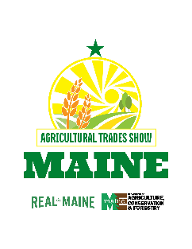
ATS Participant Checklist:
If you have already been selected to participate in the upcoming Agricultural Trades Show (ATS), you can use this checklist to guide your preparations.
☐ Start by reviewing and bookmarking participant services portion of webpage. You will need to refer to the webpage for several of the following tasks.
☐ If applicable: review the tentative conference schedule and confirm your final details (organizers reach out via email)
☐ Review and download terms and conditions (posted on the webpage)
☐ Review and download promotional materials; begin distributing to your target audience
☐ Receive invoice and payment instructions (sent via email)
☐ Complete and submit payment – PayMaine online payment encouraged (instructions available on webpage)
☐ Continue to cross-promote and prepare for the show
☐ Review Welcome Kit materials, including planning guides and organizer announcements (posted on the webpage)
☐ Arrive at the event

Updated May 2025

