Board of Trustees

MAINE CRIMINAL JUSTICE ACADEMY

ELECTRONIC SPEED MEASUREMENT DEVICE OPERATOR CERTIFICATION

Specification S-29

Purpose:

To establish certification requirements for training law enforcement officers in the use of Electronic Speed Measurement Devices (ESMD).

Requirements:

- Be a Maine certified law enforcement officer.
- Attend the ESMD Operator training course, which consists of classroom instruction and field training using the model curriculum developed by the NHTSA (National Highway Traffic Safety Administration) and IPTM (Institute of Police Technology and Management), as approved by the Director.
- Successfully complete the ESMD Operator training course by:
- Passing the ESMD Operator examination with a score of at least 80%.

- Demonstrating proficiency in setting up and checking unit accuracy (internal and external) according to manufacturer guidelines with 100% accuracy for both RADAR (Radio Detecting And Ranging) and LIDAR (Light Detection And Ranging) units.
- Demonstrating proficiency in conducting visual estimates of speed, verified for both RADAR and LIDAR, to the following standards:
- Conducting ten visual speed estimates, while stationary, with an average deviation of no greater than five miles per hour of the true speed as measured by use of RADAR.
- Conducting ten visual speed estimates, while moving, with an average deviation of no greater than five miles per hour of the true speed as measured by use of RADAR.
- Conduct ten target acquisitions (which include visual speed estimates) and speed measurements with an average deviation of no greater than five miles per hour of the true speed as measured by use of LIDAR.

- NOTE: If the student is a currently certified MCJA RADAR Operator, the student need not repeat the demonstration of proficiency required in sections C.3.a. and C.3.b. above, but must only demonstrate proficiency in use of LIDAR required in section C.3.c. above.

Procedure:

- Upon successful completion of the certification requirements, appropriate documentation (on approved Academy forms) will be submitted to Academy Staff for review.

- Following approval by Academy Staff, the Director will issue the ESMD Operator a Certificate of Competency.

Adopted: 03/06/2009
Amended: 11/08/2019
Review Date: 11/08/2022
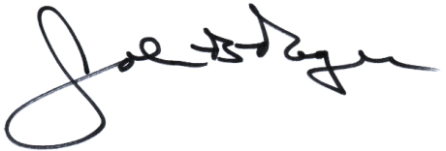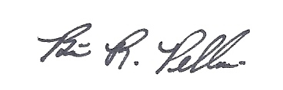
____________________________ __________________________
John B. Rogers, Director Brian R. Pellerin, Chair
Maine Criminal Justice Academy MCJA Board of Trustees

