STATE OF MAINE
Department of Defense, Veterans and Emergency Management
Military Bureau

RFP# 202403077
Lawn Care Services for Regional Training Institute (RTI), Bangor, ME & Armed Forces Reserve Center (AFRC), Bangor, ME

RFP Coordinator | All communication regarding the RFP must be made through the RFP Coordinator identified below.  Name: Sara Thompson Title: Contract Grant Specialist  Contact Information: sara.thompson@maine.gov
Mandatory Bidders’ Conference | Date: April 11, 2024, Time: 9:30 a.m., local time  Location: Regional Training Institute (RTI), 289 Hildreth Street North, Bangor, ME.
Submitted Questions Due | All questions must be received by the RFP Coordinator identified above by:  Date: April 15, 2024 no later than 11:59 p.m., local time
Proposal Submission Deadline | Proposals must be received by the Division of Procurement Services by:  Submission Deadline: Aprill 24, 2024, no later than 11:59 p.m., local time.  Proposals must be submitted electronically to: Proposals@maine.gov

TABLE OF CONTENTS
 | Page
PUBLIC NOTICE | 3
RFP DEFINITIONS/ACRONYMS | 4
PART I INTRODUCTION | 5
- PURPOSE AND BACKGROUND
- GENERAL PROVISIONS
- ELIGIBILITY TO SUBMIT BIDS
- CONTRACT TERMS
- NUMBER OF AWARDS
PART II SCOPE OF SERVICES TO BE PROVIDED | 7
PART III KEY RFP EVENTS | 13
- BIDDERS’ CONFERENCE
- QUESTIONS
- AMENDMENTS
- SUBMITTING THE PROPOSAL
PART IV PROPOSAL SUBMISSION REQUIREMENTS | 15
PART V PROPOSAL EVALUATION AND SELECTION | 18
- EVALUATION PROCESS – GENERAL INFORMATION
- SCORING WEIGHTS AND PROCESS
- SELECTION AND AWARD
- APPEAL OF CONTRACT AWARDS
PART VI CONTRACT ADMINISTRATION AND CONDITIONS | 20
- CONTRACT DOCUMENT
- STANDARD STATE CONTRACT PROVISIONS
PART VII RFP APPENDICES AND RELATED DOCUMENTS | 21
APPENDIX A – PROPOSAL COVER PAGE
APPENDIX B – DEBARMENT, PERFORMANCE, and
NON-COLLUSION CERTIFICATION
APPENDIX C – QUALIFICATIONS and EXPERIENCE FORM
APPENDIX D – COST PROPOSAL FORM
APPENDIX E – SUBMITTED QUESTIONS FORM

PUBLIC NOTICE

*************************************************

State of Maine
Department of Defense, Veterans & Emergency Management
RFP# 202403077
Lawn Care Services for Regional Training institute (RTI), Bangor, ME & Armed Forces Reserve Center (AFRC), Bangor, ME

The State of Maine is seeking proposals for Lawn Care Services at the Regional Training Institute (RTI) 289 Hildreth Street North, Bangor, ME and the AFRC, 300 Hildred Street North, Bangor, ME.

A copy of the RFP, as well as the Question & Answer Summary and all amendments related to the RFP, can be obtained at: https://www.maine.gov/dafs/bbm/procurementservices/vendors/rfps

A Mandatory Bidders’ Conference will be held on April 11, 2024, at 9:30 a.m. at the following location: RTI, 289 Hildreth Street North, Bangor, ME

Proposals must be submitted to the State of Maine Division of Procurement Services, via e-mail, at: Proposals@maine.gov. Proposal submissions must be received no later than 11:59 p.m., local time, on April 24, 2024 Proposals will be opened the following business day. Proposals not submitted to the Division of Procurement Services’ aforementioned e-mail address by the aforementioned deadline will not be considered for contract award.

*************************************************

RFP TERMS/ACRONYMS with DEFINITIONS

The following terms and acronyms, as referenced in the RFP, shall have the meanings indicated below:

Term/Acronym | Definition
AFRC | Armed Forces Reserve Center
Department | Department of Defense, Veterans & Emergency Management
RFP | Request for Proposal
RTI | Regional Training Institute
State | State of Maine

State of Maine - Department of Defense, Veterans and Emergency Management
Military Bureau
RFP# 202403077
Lawn Care Services for Regional Training Institute (RTI), Bangor, ME & Armed Forces Reserve Center (AFRC), Bangor, ME

PART I INTRODUCTION

- Purpose and Background

The Department of Defense, Veterans & Emergency Management (Department) is seeking Lawn Care Services as defined in this Request for Proposal (RFP) document. This document provides instructions for submitting proposals, the procedure and criteria by which the awarded Bidder will be selected, and the contractual terms which will govern the relationship between the State of Maine (State) and the awarded Bidder.

The Department does not have the manpower or equipment to maintain the lawns and grounds at the Regional Training Institute (RTI), 289 Hildreth Street, North, Bangor, ME, and Armed Forces Reserve Center (AFRC), 300 Hildreth Street, Bangor, ME. Through this RFP, the Department seeks to select a qualified Bidder to maintain the lawns and grounds at these facilities.

- General Provisions

  - From the time the RFP is issued until award notification is made, all contact with the State regarding the RFP must be made through the RFP Coordinator. No other person/ State employee is empowered to make binding statements regarding the RFP. Violation of this provision may lead to disqualification from the bidding process, at the State’s discretion.
  - Issuance of the RFP does not commit the Department to issue an award or to pay expenses incurred by a Bidder in the preparation of a response to the RFP. This includes attendance at personal interviews or other meetings and software or system demonstrations, where applicable.
  - All proposals must adhere to the instructions and format requirements outlined in the RFP and all written supplements and amendments (such as the Summary of Questions and Answers), issued by the Department. Proposals are to follow the format and respond to all questions and instructions specified below in the “Proposal Submission Requirements” section of the RFP.
  - Bidders will take careful note that in evaluating a proposal submitted in response to the RFP, the Department will consider materials provided in the proposal, information obtained through interviews/presentations (if any), and internal Departmental information of previous contract history with the Bidder (if any). The Department also reserves the right to consider other reliable references and publicly available information in evaluating a Bidder’s experience and capabilities.
  - The proposal must be signed by a person authorized to legally bind the Bidder and must contain a statement that the proposal and the pricing contained therein will remain valid and binding for a period of 180 days from the date and time of the bid opening.
  - The RFP and the awarded Bidder’s proposal, including all appendices or attachments, will be the basis for the final contract, as determined by the Department.
  - Following announcement of an award decision, all submissions in response to this RFP will be public records, available for public inspection pursuant to the State of Maine Freedom of Access Act (FOAA) (1 M.R.S. § 401 et seq.).
  - The Department, at its sole discretion, reserves the right to recognize and waive minor informalities and irregularities found in proposals received in response to the RFP.
  - All applicable laws, whether or not herein contained, are included by this reference. It is the Bidder’s responsibility to determine the applicability and requirements of any such laws and to abide by them.

- Contract Term

The Department is seeking a cost-efficient proposal to provide services, as defined in the RFP, for the anticipated contract period defined in the table below. Please note, the dates below are estimated and may be adjusted, as necessary, in order to comply with all procedural requirements associated with the RFP and the contracting process. The actual contract start date will be established by a completed and approved contract.

Contract Renewal: Following the initial term of the contract, the Department may opt to renew the contract for two (2) renewal periods, as shown in the table below, and subject to continued availability of funding and satisfactory performance.

The term of the anticipated contract, resulting from the RFP, is defined as follows:

Period | Start Date | End Date
Initial Period of Performance | May 1, 2024 | April 30, 2025
Renewal Period #1 | May 1, 2025 | April 30, 2027
Renewal Period #2 | May 1, 2027 | April 30, 2029

- Number of Awards

The Department anticipates making one (1) award as a result of the RFP process.

PART II SCOPE OF SERVICES TO BE PROVIDED

- Awarded Bidder shall furnish all personnel, equipment (riding mowers, walk behind & push mowers, etc.), power tools (weed whacker, edger & backpack blower/vacuum, etc.) and services in conformance with the terms and conditions as outlined.

- The Department will inspect the lawn care after each service has been completed. Any additional work not addressed in the lawn care service scheduled will be brought to the Maintenance Mechanic Supervisor’s attention.

- All planned lawn care service under the resulting agreement will be performed during the Department’s normal working hours defined as 7:30am to 4:00pm – Monday through Friday.

- No lawn care service shall be scheduled on state or federal https://www.opm.gov/policy-data-oversight/pay-leave/federal-holidays/holidays, unless authorized by the Maintenance Mechanic Supervisor.

- The Awarded Bidder shall not be relieved from assuming all responsibility for properly estimating the difficulties and the cost of performing the services required with this RFP, because of failure to inspect the conditions or become acquainted with all the information concerning the services to be performed.

- RTI Admin & Billeting Area Specific

- Mowing/Trimming

- RTI lawn areas shall be mowed and trimmed weekly and/or as needed throughout the growing season (May – October) to a uniform height a minimum of 4 inches not to exceed 6 inches. The awarded Bidder must use various mowing patterns to prevent ruts in the turf caused by mowers.

- Underdrain filter bed(s) grass as noted on Mowing Plan are to be left uncut to grow to a maximum height of 12 inches. The sides should be mowed to the 4 not to exceed 6-inch height of the other areas on the site. At the end of the mowing season, must be cut to 4 inches and allowed lay dormant until spring.

- All visible grass clippings and leaves after mowing shall be raked and bagged as needed and hauled away by the awarded Bidder; this will prevent thatch build up.

- All doorway entrances, walkways, parking lots and planting beds shall be vacuumed and/or blown free of debris and grass clippings accumulated as a result of mowing and/or trimming.

- All trash must be picked up throughout the grass and planting areas. The awarded Bidder will trim the inside and outside of the fence line perimeter, and keep the fence line clean of trash, vines, and weeds. Also, a 3-foot swath shall be maintained along the outside of the fence as needed.

- Mower blades shall be kept sharp at all times to prevent tearing of grass blades. Mulching or bagging type mowing equipment is mandatory on all mowers.

- Edging

- Edging shall be completed the same day and at the same frequency that the area is mowed.

- Use of hard surface edging equipment is required to outline and/or remove turf from along all sidewalks and curbs to maintain straight and sharp edges.

- Use String trimmers is required soft edging to outline and/or remove turf from all trees, planting beds, etc. to maintain the shape and configuration of all planting areas.

- RTI Track & Trail Area Specific

- Mowing/Trimming

- RTI track lawn areas shall be mowed and trimmed weekly and/or as needed throughout the growing season (May – October) to a uniform height a minimum of 4 inches not to exceed 6 inches. The awarded Bidder must use various mowing patterns to prevent ruts in the turf caused by mowers.

- The awarded Bidder will mow and/or trim the access trail to track (70,000 SF estimate) to a uniform height of 4 inches.

- The department will provide a rubber mat and/or plywood to lay across the rubberized track for the protection of any foot traffic and/or machinery when crossing to mow the track infield turf (100,000 SF estimate).

- The awarded Bidder will blow and/or vacuum any grass clippings off the track and pick up all debris within the track perimeter accumulated as a result of mowing and/or trimming.

- The awarded Bidder will also mow a 3-foot swath around the outside track perimeter (1,500 SF estimate) fence to a uniform height of 4 inches. Also, the awarded Bidder will trim the inside and outside of the track fence.

- All visible grass clippings and leaves after mowing shall be raked and bagged as needed and hauled away by the awarded Bidder to prevent thatch build up.

- Edging

- Edging shall be completed the same day and at the same frequency that the area is mowed.

- Use soft edging to outline and/or remove turf from the track edge to maintain the shape and configuration around the track.

- Additional Tasks

- For any additional tasks, the Program Administrator of the facility will notify the Maintenance Mechanic Supervisor for approval (Work Order) before any work is started.

- Additional tasks may include watering, fertilizing and keeping free of weeds within the flower beds and planting areas, spring clean-up, seeding, grading and rolling turf, and pest control.

- Filter beds will need maintaining and tilling of soil on a “will call basis” (usually the end of September).

C. AFRC Facility Specific

  - Mowing/Trimming

- AFRC lawn areas shall be mowed and trimmed weekly and/or as needed throughout the growing season (May – October) to a uniform height not to exceed 4 inches. The awarded Bidder must use various mowing patterns to prevent ruts in the turf caused by mowers.

- All grass clippings and leaves after mowing shall be raked and bagged as needed and haul away by the awarded Bidder to prevent thatch build up.

- All doorway entrances, walkways, parking lots and planting beds shall be vacuumed and/or blown free of debris and grass clippings accumulated as a result of mowing and/or trimming.

- All trash must be picked up throughout the grass and planting areas. The awarded Bidder will trim the inside and outside of the fence line perimeter and will remove trash, vines, and weeds within the fence. Also, a 3-foot swath shall be maintained along the outside of the fence as needed.

- Mower blades shall be kept sharp at all times to prevent tearing of grass blades. Mulching and/or bagging type mowing equipment is mandatory on all mowers.

  - Edging

- Edging shall be completed the same day and at the same frequency that the area is mowed.

- Use hard surface edging equipment is required to outline and/or remove turf from along all sidewalks and curbs to maintain straight and sharp edges.

- Use String trimming equipment is required to perform soft edging to outline and/or remove turf from all trees and planting beds, etc. to maintain the shape and configuration of all planting areas.

3. Additional Tasks

- The Facility Manager of the facility will notify the Maintenance Mechanic Supervisor for (Work Order) approval before any work is started on any additional tasks.

- Additional tasks may include: watering, fertilizing, and keeping free of weeds within the flower beds and planting areas, spring clean-up, seeding, grading and rolling turf, and pest control.

- Filter beds will need maintaining & tilling of soil - on a “will call basis” (end of September).

The Department may require an every other week Evaluation of Service Tour with the Contractor. The Department’s Program Administrator will email the Contractor to select a date and time that is mutually agreed upon for the tour. Email notification of the meeting will be given to the Contractor with a minimum of two (2) business days’ notice. Any issues with the services provided will be documented and signed by the Contractor and the Department’s representative. If the Contractor fails to attend the scheduled Evaluation of Service Tour, any service issues will be documented by the Department and the Contractor will not be able to dispute the evaluation. The Department reserves the right to request additional Evaluation of Service Tours based on performance issues.

Schedule

The awarded Bidder shall submit a permanent schedule listing the day of the week services shall be performed (weather permitting). If there are any changes to the schedule, the awarded Bidder will notify the Program Administrator of the facility when the service is being performed. The facility Program Administrator has the right to change the working schedule based on facility use and/or activity.

D. Vetting

- The Department retains the right to screen and restrict from the facility personnel employed by or representing the provider who do not receive a satisfactory/passing background check.
- All persons must pass a federal background check conducted by the Department of Defense, Veterans and Emergency Management (DVEM) before being allowed into/onto the facility grounds. This applies for all Maine National Guard facilities and grounds.
- The Contractor must supply a list of people who may be either involved in the work effort, accompanying the Contractor, subcontracted, or present at the facility to the Vetting Coordinator. This must happen within two weeks after the award of the contract or two weeks prior to the beginning of the contract whichever comes first. This also applies to any “new” employees that become part of the project for the contract’s length.
- The list will include first name, middle initial, last name, date of birth, maiden name, social security number or another federal issued identification number and driver’s license number & state issued for each person.
- The Department will provide to the Provider the names of those personnel that are acceptable for access, and those that are not acceptable for unescorted access into/onto our facilities. The Department will not be legally allowed to share any specifics regarding why certain personnel are considered unacceptable for any access.

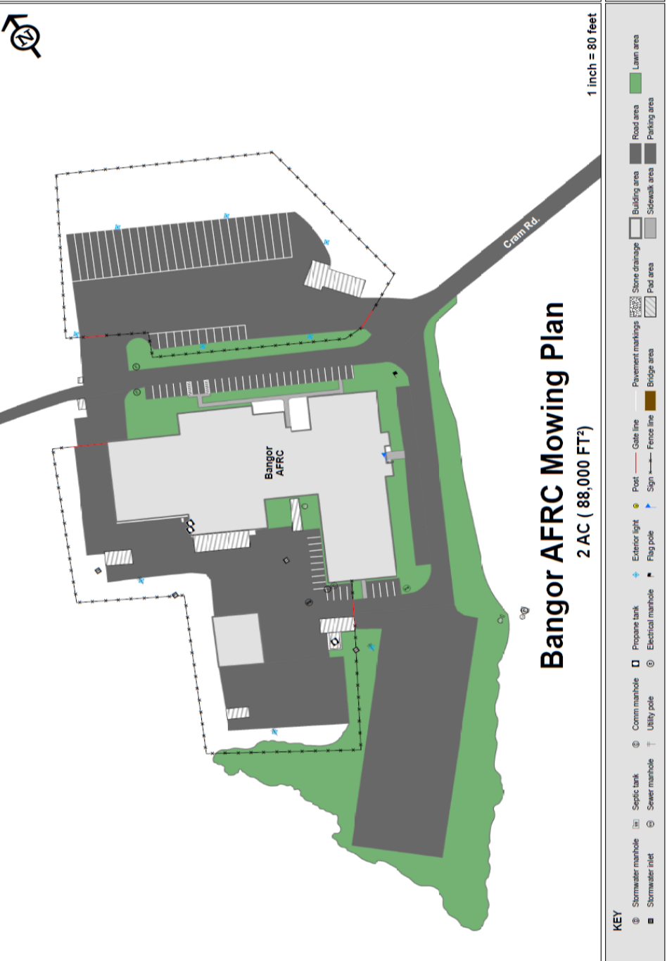

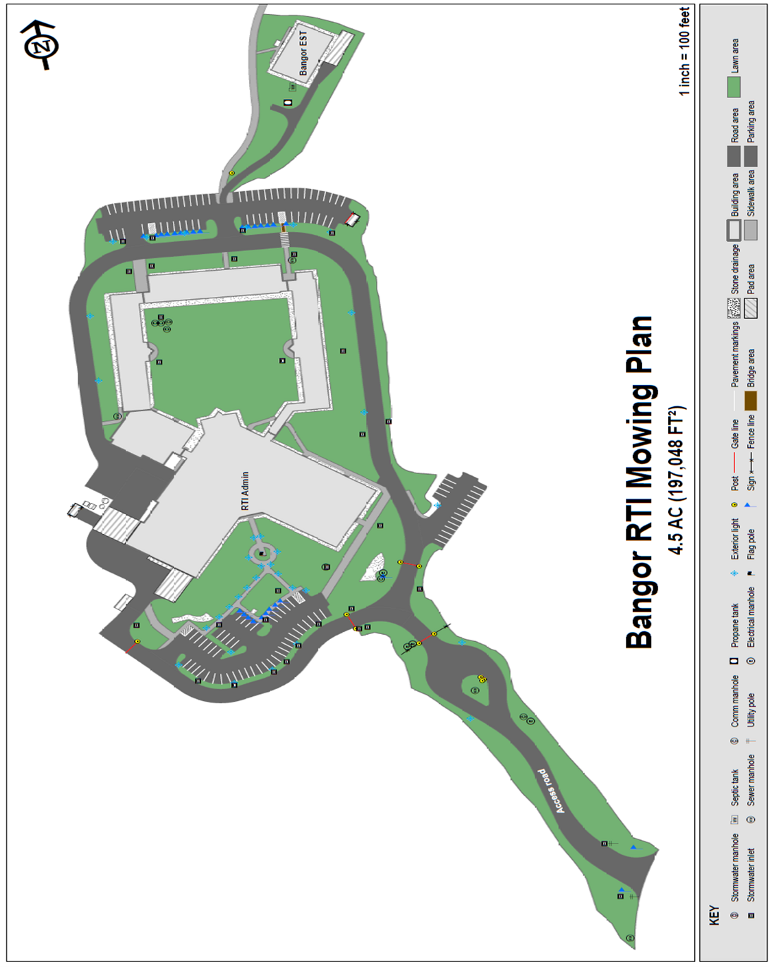

PART III KEY RFP EVENTS

- Bidders’ Conference

The Department will sponsor a Bidders’ Conference concerning the RFP beginning at the date, time and location shown on the RFP cover page. The purpose of the Bidders’ Conference is to answer and/or field questions, clarify for potential Bidders any aspect of the RFP requirements that may be necessary and provide supplemental information to assist potential Bidders in submitting responses to the RFP. Although attendance at the Bidders’ Conference is not mandatory, it is strongly encouraged that interested Bidders attend.

- Questions

  - General Instructions: It is the responsibility of all Bidders and other interested parties to examine the entire RFP and to seek clarification, in writing, if they do not understand any information or instructions.
    - Bidders and other interested parties should use Appendix E (Submitted Questions Form) for submission of questions. The form is to be submitted as a WORD document.
    - The Submitted Questions Form must be submitted, by e-mail, and received by the RFP Coordinator identified on the cover page of the RFP as soon as possible but no later than the date and time specified on the RFP cover page.
    - Submitted Questions must include the RFP Number and Title in the subject line of the e-mail. The Department assumes no liability for assuring accurate/complete/on time e-mail transmission and receipt.

  - Question & Answer Summary: Responses to all questions will be compiled in writing and posted on the following website no later than seven (7) calendar days prior to the proposal due date: Division of Procurement Services RFP Page. It is the responsibility of all interested parties to go to this website to obtain a copy of the Question & Answer Summary. Only those answers issued in writing on this website will be considered binding.

- Amendments

All amendments released in regard to the RFP will also be posted on the following website: Division of Procurement Services RFP Page. It is the responsibility of all interested parties to go to this website to obtain amendments. Only those amendments posted on this website are considered binding.

- Submitting the Proposal

  - Proposals Due: Proposals must be received no later than 11:59 p.m. local time, on the date listed on the cover page of the RFP.
    - Any e-mails containing original proposal submissions or any additional or revised proposal files, received after the 11:59 p.m. deadline, will be rejected without exception.

  - Delivery Instructions: E-mail proposal submissions are to be submitted to the State of Maine Division of Procurement Services at Proposals@maine.gov.
    - Only proposal submissions received by e-mail will be considered. The Department assumes no liability for assuring accurate/complete e-mail transmission and receipt.
      - Proposal submission e-mails that are successfully received by the proposals@maine.gov inbox will receive an automatic reply stating as such.
    - E-mails containing links to file sharing sites or online file repositories will not be accepted as submissions. Only e-mail proposal submissions that have the actual requested files attached will be accepted.
    - Encrypted e-mails received which require opening attachments and logging into a proprietary system will not be accepted as submissions. Please check with your organization’s Information Technology team to ensure that your security settings will not encrypt your proposal submission.
    - File size limits are 25MB per e-mail. Bidders may submit files separately across multiple e-mails, as necessary, due to file size concerns. All e-mails and files must be received by the due date and time listed above.
    - Bidders are to insert the following into the subject line of their e-mail proposal submission: “RFP# 202403077 Proposal Submission – [Bidder’s Name]”
    - Bidder’s proposal submissions are to be broken down into multiple files, with each file named as it is titled in bold below, and include:

- File 1 [Bidder’s Name] – Preliminary Information:
PDF format preferred
Appendix A (Proposal Cover Page)
Appendix B (Debarment, Performance and Non-Collusion Certification)
All required eligibility documentation stated in PART IV, Section I.

- File 2 [Bidder’s Name] – Organization Qualifications and Experience:
PDF format preferred
Appendix C (Organization Qualifications and Experience Form) and all required information and attachments stated in PART IV, Section II.

- File 3 [Bidder’s Name] – Proposed Services:
PDF format preferred
All required information and attachments stated in PART IV, Section III.

- File 4 [Bidder’s Name] – Cost Proposal:
PDF format preferred
Appendix D (Cost Proposal Form) and all required information and attachments stated in PART IV, Section IV.
PART IV PROPOSAL SUBMISSION REQUIREMENTS

This section contains instructions for Bidders to use in preparing their proposals. The Department seeks detailed yet succinct responses that demonstrate the Bidder’s qualifications, experience, and ability to perform the requirements specified throughout the RFP.

The Bidder’s proposal must follow the outline used below, including the numbering, section, and sub-section headings. Failure to use the outline specified in PART IV, or failure to respond to all questions and instructions throughout the RFP, may result in the proposal being disqualified as non-responsive or receiving a reduced score. The Department, and its evaluation team, has sole discretion to determine whether a variance from the RFP specifications will result either in disqualification or reduction in scoring of a proposal. Rephrasing of the content provided in the RFP will, at best, be considered minimally responsive.

Bidders are not to provide additional attachments beyond those specified in the RFP for the purpose of extending their response. Additional materials not requested will not be considered part of the proposal and will not be evaluated. Include any forms provided in the submission package or reproduce those forms as closely as possible. All information must be presented in the same order and format as described in the RFP.

Proposal Format and Contents

Section I Preliminary Information (File #1)

  - Proposal Cover Page
Bidders must complete Appendix A (Proposal Cover Page). It is critical that the cover page show the specific information requested, including Bidder address(es) and other details listed. The Proposal Cover Page must be dated and signed by a person authorized to enter into contracts on behalf of the Bidder.

  - Debarment, Performance and Non-Collusion Certification
Bidders must complete Appendix B (Debarment, Performance and Non-Collusion Certification Form). The Debarment, Performance and Non-Collusion Certification Form must be dated and signed by a person authorized to enter into contracts on behalf of the Bidder.

Section II Organization Qualifications and Experience (File #2)

  - Overview of the Organization
Bidders must complete Appendix C (Qualifications and Experience Form) describing their qualifications and skills to provide the requested services in the RFP. Bidders must include three examples of projects which demonstrate their experience and expertise in performing these services as well as highlighting the Bidder’s stated qualifications and skills.

  - Subcontractors
If subcontractors are to be used, Bidders must provide a list that specifies the name, address, phone number, contact person, and a brief description of the subcontractors’ organizational capacity and qualifications.

  - Organizational Chart
Bidders must provide an organizational chart. The organizational chart must include the project being proposed. Each position must be identified by position title and corresponding to the personnel job descriptions.

  - Litigation
Bidders must attach a list of all current litigation in which the Bidder is named and a list of all closed cases that have closed within the past five (5) years in which the Bidder paid the claimant either as part of a settlement or by decree. For each, list the entity bringing suit, the complaint, the accusation, amount, and outcome.

  - Licensure/Certification
Bidders may provide documentation of any applicable licensure/certification or specific credentials that are related to providing the proposed services of the RFP. This documentation may include:

  - Certificate of Insurance
Bidders must provide a certificate of insurance on a standard ACORD form (or the equivalent) evidencing the Bidder’s general liability, professional liability and any other relevant liability insurance policies that might be associated with the proposed services.

Section III Proposed Services (File #3)

  - Services to be Provided
Discuss the Scope of Services referenced above in Part II of the RFP and what the Bidder will offer. Give particular attention to describing the methods and resources you will use and how you will accomplish the tasks involved. Also, describe how you will ensure expectations and/or desired outcomes as a result of these services will be achieved. If subcontractors are involved, clearly identify the work each will perform.

  - Implementation - Work Plan
Provide a realistic work plan for the implementation of the program through the first contract period. Display the work plan in a timeline chart. Concisely describe each program development and implementation task, the month it will be carried out and the person or position responsible for each task. If applicable, make note of all tasks to be delegated to subcontractors.

Section IV Cost Proposal (File #4)

  - General Instructions
    - Bidders must submit a cost proposal that covers the period starting May 1, 2024 and ending on April 30, 2029.
    - The cost proposal must include the costs necessary for the Bidder to fully comply with the contract terms, conditions, and RFP requirements.
    - No costs related to the preparation of the proposal for the RFP, or to the negotiation of the contract with the Department, may be included in the proposal. Only costs to be incurred after the contract effective date that are specifically related to the implementation or operation of contracted services may be included.

  - Cost Proposal Form Instructions
Bidders must fill out Appendix D (Cost Proposal Form), following the instructions detailed here and in the form. Failure to provide the requested information, and to follow the required cost proposal format provided, may result in the exclusion of the proposal from consideration, at the discretion of the Department.

PART V PROPOSAL EVALUATION AND SELECTION

Evaluation of the submitted proposals will be accomplished as follows:

- Evaluation Process – General Information

  - An evaluation team, composed of qualified reviewers, will judge the merits of the proposals received in accordance with the criteria defined in the RFP.
  - Officials responsible for making decisions on the award selection will ensure that the selection process accords equal opportunity and appropriate consideration to all who are capable of meeting the specifications. The goals of the evaluation process are to ensure fairness and objectivity in review of the proposals and to ensure that the contract is awarded to the Bidder whose proposal provides the best value to the State of Maine.
  - The Department reserves the right to communicate and/or schedule interviews/presentations with Bidders, if needed, to obtain clarification of information contained in the proposals received. The Department may revise the scores assigned in the initial evaluation to reflect those communications and/or interviews/presentations. Changes to proposals, including updating or adding information, will not be permitted during any interview/presentation process and, therefore, Bidders must submit proposals that present their rates and other requested information as clearly and completely as possible.

- Scoring Weights and Process

  - Scoring Weights: The score will be based on a 100-point scale and will measure the degree to which each proposal meets the following criteria.

Section I. Organization Qualifications and Experience (40 points)
Includes all elements addressed above in Part IV, Section II.

Section II. Proposed Services (30 points)
Includes all elements addressed above in Part IV, Section III.

Section III. Cost Proposal (30 points)
Includes all elements addressed above in Part IV, Section IV.

  - Scoring Process: For proposals that demonstrate meeting the eligibility requirements in Section I, the evaluation team will use a consensus approach to evaluate and score Sections II & III above. Members of the evaluation team will not score those sections individually but, instead, will arrive at a consensus as to assignment of points for each of those sections. Sections IV, the Cost Proposal, will be scored as described below.

  - Scoring the Cost Proposal: The total cost proposed for conducting all the functions specified in the RFP will be assigned a score according to a mathematical formula. The lowest bid will be awarded 30 points. Proposals with higher bids values will be awarded proportionately fewer points calculated in comparison with the lowest bid.

The scoring formula is:

(Lowest submitted cost proposal / Cost of proposal being scored) x (30) = pro-rated score

No Best and Final Offers: The State of Maine will not seek or accept a best and final offer (BAFO) from any Bidder in this procurement process. All Bidders are expected to provide their best value pricing with the submission of their proposal.

  - Negotiations: The Department reserves the right to negotiate with the awarded Bidder to finalize a contract. Such negotiations may not significantly vary the content, nature or requirements of the proposal or the Department’s Request for Proposal to an extent that may affect the price of goods or services requested. The Department reserves the right to terminate contract negotiations with an awarded Bidder who submits a proposed contract significantly different from the proposal they submitted in response to the advertised RFP. In the event that an acceptable contract cannot be negotiated with the highest ranked Bidder, the Department may withdraw its award and negotiate with the next-highest ranked Bidder, and so on, until an acceptable contract has been finalized. Alternatively, the Department may cancel the RFP, at its sole discretion.

- Selection and Award

  - The final decision regarding the award of the contract will be made by representatives of the Department subject to approval by the State Procurement Review Committee.
  - Notification of conditional award selection or non-selection will be made in writing by the Department.
  - Issuance of the RFP in no way constitutes a commitment by the State of Maine to award a contract, to pay costs incurred in the preparation of a response to the RFP, or to pay costs incurred in procuring or contracting for services, supplies, physical space, personnel or any other costs incurred by the Bidder.
  - The Department reserves the right to reject any and all proposals or to make multiple awards.

- Appeal of Contract Awards

Any person aggrieved by the award decision that results from the RFP may appeal the decision to the Director of the Bureau of General Services in the manner prescribed in 5 M.R.S.A. § 1825-E and 18-554 Code of Maine Rules Chapter 120. The appeal must be in writing and filed with the Director of the Bureau of General Services, 9 State House Station, Augusta, Maine, 04333-0009 within 15 calendar days of receipt of notification of conditional contract award.

PART VI CONTRACT ADMINISTRATION AND CONDITIONS

- Contract Document

  - The awarded Bidder will be required to execute a State of Maine Service Contract with appropriate riders as determined by the issuing department.

The complete set of standard State of Maine Service Contract documents, along with other forms and contract documents commonly used by the State, may be found on the Division of Procurement Services’ website at the following link: Division of Procurement Services Forms Page

  - Allocation of funds is final upon successful negotiation and execution of the contract, subject to the review and approval of the State Procurement Review Committee. Contracts are not considered fully executed and valid until approved by the State Procurement Review Committee and funds are encumbered. No contract will be approved based on an RFP which has an effective date less than fourteen (14) calendar days after award notification to Bidders. (Referenced in the regulations of the Department of Administrative and Financial Services, Chapter 110, § 3(B)(i).)

This provision means that a contract cannot be effective until at least 14 calendar days after award notification.

  - The State recognizes that the actual contract effective date depends upon completion of the RFP process, date of formal award notification, length of contract negotiation, and preparation and approval by the State Procurement Review Committee. Any appeals to the Department’s award decision(s) may further postpone the actual contract effective date, depending upon the outcome. The contract effective date listed in the RFP may need to be adjusted, if necessary, to comply with mandated requirements.

  - In providing services and performing under the contract, the awarded Bidder must act as an independent contractor and not as an agent of the State of Maine.

- Standard State Contract Provisions

  - Contract Administration
Following the award, a Contract Administrator from the Department will be appointed to assist with the development and administration of the contract and to act as administrator during the entire contract period. Department staff will be available after the award to consult with the awarded Bidder in the finalization of the contract.

  - Payments and Other Provisions
The State anticipates paying the Contractor on the basis of net 30 payment terms, upon the receipt of an accurate and acceptable invoice. An invoice will be considered accurate and acceptable if it contains a reference to the State of Maine contract number, contains correct pricing information relative to the contract, and provides any required supporting documents, as applicable, and any other specific and agreed-upon requirements listed within the contract that results from the RFP.

PART VII LIST OF RFP APPENDICES AND RELATED DOCUMENTS

Appendix A – Proposal Cover Page

Appendix B – Debarment, Performance, and Non-Collusion Certification

Appendix C – Qualifications and Experience Form

Appendix D – Cost Proposal Form

Appendix E – Submitted Question Form

APPENDIX A

State of Maine
Department of Defense, Veterans & Emergency Management

PROPOSAL COVER PAGE
RFP# 202403077
Lawn Care Services for Regional Training Institute (RTI), Bangor, ME & Armed Forces Reserve Center (AFRC), Bangor, ME

Bidder’s Organization Name:
Chief Executive - Name/Title:
Tel: |  |  | E-mail:
Headquarters Street Address:
Headquarters City/State/Zip:
(Provide information requested below if different from above)
Lead Point of Contact for Proposal - Name/Title:
Tel: |  |  | E-mail:
Headquarters Street Address:
Headquarters City/State/Zip:

- This proposal and the pricing structure contained herein will remain firm for a period of 180 days from the date and time of the bid opening.
- No personnel currently employed by the Department, or any other State agency participated, either directly or indirectly, in any activities relating to the preparation of the Bidder’s proposal.
- No attempt has been made, or will be made, by the Bidder to induce any other person or firm to submit or not to submit a proposal.
- The above-named organization is the legal entity entering into the resulting contract with the Department if they are awarded the contract.
- The undersigned is authorized to enter contractual obligations on behalf of the above-named organization.

To the best of my knowledge, all information provided in the enclosed proposal, both programmatic and financial, is complete and accurate at the time of submission.

Name (Print): | Title:
Authorized Signature: | Date:

APPENDIX B

State of Maine
Department of Defense, Veterans and Emergency Management
DEBARMENT, PERFORMANCE, and NON-COLLUSION CERTIFICATION
RFP# 202403077
Lawn Care Services for Regional Training Institute (RTI), Bangor, ME & Armed Forces Reserve Center (AFRC) Bangor, ME

Bidder’s Organization Name:

By signing this document, I certify to the best of my knowledge and belief that the aforementioned organization, its principals and any subcontractors named in this proposal:
- Are not presently debarred, suspended, proposed for debarment, and declared ineligible or voluntarily excluded from bidding or working on contracts issued by any governmental agency.
- Have not within three years of submitting the proposal for this contract been convicted of or had a civil judgment rendered against them for:
  - Fraud or a criminal offense in connection with obtaining, attempting to obtain, or performing a federal, state, or local government transaction or contract.
  - Violating Federal or State antitrust statutes or committing embezzlement, theft, forgery, bribery, falsification or destruction of records, making false statements, or receiving stolen property.
- Are not presently indicted for or otherwise criminally or civilly charged by a governmental entity (Federal, State or Local) with commission of any of the offenses enumerated in paragraph (b) of this certification.
- Have not within a three (3) year period preceding this proposal had one or more federal, state, or local government transactions terminated for cause or default.
- Have not entered into a prior understanding, agreement, or connection with any corporation, firm, or person submitting a response for the same materials, supplies, equipment, or services and this proposal is in all respects fair and without collusion or fraud. The above-mentioned entities understand and agree that collusive bidding is a violation of state and federal law and can result in fines, prison sentences, and civil damage awards.
Name (Print): | Title:
Authorized Signature: | Date:

APPENDIX C

State of Maine
Department of Defense, Veterans and Emergency Management

QUALIFICATIONS and EXPERIENCE FORM
RFP# 202403077
Lawn Care Services for Regional Training Institute (RTI), Bangor, ME & Armed Forces Reserve Center (AFRC), Bangor, ME

Bidder’s Organization Name:

Present a brief statement of qualifications. Describe the history of the Bidder’s organization, especially regarding skills pertinent to the specific work required by the RFP and any special or unique characteristics of the organization which would make it especially qualified to perform the required work activities. You may expand this form and use additional pages to provide this information.

APPENDIX C (continued)

Provide a description of projects that occurred within the past five years which reflect experience and expertise needed in performing the functions described in Part II – Scope of Services to be Provided of the RFP. Please note that contract history with the State of Maine, whether positive or negative, may be considered in rating proposals even if not provided by the Bidder.

Project One
Client Name:
Client Contact Person:
Telephone:
E-Mail:
Brief Description of Project

Project Two
Client Name:
Client Contact Person:
Telephone:
E-Mail:
Brief Description of Project

Project Three
Client Name:
Client Contact Person:
Telephone:
E-Mail:
Brief Description of Project

APPENDIX D

State of Maine
Department of Defense, Veterans & Emergency Management

COST PROPOSAL FORM
RFP# 202403077
Lawn Care Services for Regional Training Institute (RTI), Bangor, ME & Armed Forces Reserve Center (AFRC), Bangor, ME

Bidder’s Organization Name:
Proposed Cost: | $

Season = May, June, July, August, September, and October.
APPENDIX E

State of Maine
Department of Defense, Veterans and Emergency Management

SUBMITTED QUESTIONS FORM
RFP# 202403077
Lawn Care Services for Regional Training Institute (RTI), Bangor, ME & Armed Forces Reserve Center (AFRC), Bangor, ME

This form should be used by Bidders when submitting written questions to the RFP Coordinator as defined in Part III of the RFP.

If a question is not related to any section of the RFP, enter “N/A” under the RFP Section & Page Number. Add additional rows as necessary.

Organization Name:

RFP Section & Page Number | Question

