STATE OF MAINE REQUEST FOR PROPOSALS

SUBMITTED QUESTIONS & ANSWERS SUMMARY

RFP NUMBER AND TITLE: | 202401014 Highway Data Collection Vehicle System
RFP ISSUED BY: | Department of Transportation
SUBMITTED QUESTIONS DUE DATE: | March 29, 2024
QUESTION & ANSWER SUMMARY ISSUED: | April 5, 2024
PROPOSAL DUE DATE: | April 24, 2024
PROPOSALS DUE TO: | Proposals@maine.gov

Provided below are submitted written questions received and the Department’s answer.

1 | RFP Section & Page Number | Question
 | N/A | What are the page limitations for expanding the table areas within the response form to insert our text?
 | Answer
 | There are no limitations although the Department encourages succinct responses. Please ensure it is readable using Acrobat Reader and/or Edge. If necessary, a specific response it may be submitted just below that table, clearly labelled, or in a supplemental document clearly titled with RFP section and question number, and included in the appropriate RFP submission file.

2 | RFP Section & Page Number | Question
 | N/A | Are graphics and imagery allowed within the response table/text areas?
 | Answer
 | Yes.

3 | RFP Section & Page Number | Question
 | N/A | Is the Department able to supply the composition percentages for asphalt, jointed concrete pavement, and continuously reinforced concrete pavement across the state-wide network?
 | Answer
 | 100% of MaineDOT’s road network is asphalt.

4 | RFP Section & Page Number | Question
 | N/A | Is the Department able to provide the composition percentages of asphalt, jointed concrete pavement, and continuously reinforced concrete pavement for the 2,000-mile scope assigned to the vendor?
 | Answer
 | 100% of MaineDOT’s road network is asphalt.

5 | RFP Section & Page Number | Question
 | N/A | When is the department planning to commence operations with the newly built Highway Data Collection Vehicle System – in 2024 or 2025?
 | Answer
 | The Department anticipates commencing operations for ad hoc work as soon as system is available. It must hold off on using it for the annual collection program until 2025.

6 | RFP Section & Page Number | Question
 | Part I, Page 7 | Does the Department’s reference to transferring quality control responsibilities to the bidder imply any additional responsibilities beyond those outlined in Appendix M?
 | Answer
 | No.

7 | RFP Section & Page Number | Question
 | RFP Page 11 6.a | Does Maine DOT currently own the proposed vehicle?
 | Answer
 | Yes.

8 | RFP Section & Page Number | Question
 | RFP Page 11 6.a | Can the DOT provide the VIN for the supplied 2023 Ford F150 Crew Cab?
 | Answer
 | 1FTFW1E52PKE32851

9 | RFP Section & Page Number | Question
 | RFP Page 11 6.a | What is the total length of the supplied 2023 Ford F150 Crew Cab inclusive of the truck bed?
 | Answer
 | 19’6” or 5.9436 meters

10 | RFP Section & Page Number | Question
 | RFP Page 11 6.a | What is the current total weight of 2023 Ford F150 Crew Cab equipped with an LED Arrow board and auxiliary radio?
 | Answer
 | Curb Weight - 4800 lbs

11 | RFP Section & Page Number | Question
 | RFP Page 11 Key Issue 6.a | Can the department provide images of the provided vehicle? Images of the front view, side view, rear and interior view would be appreciated.
 | Answer
 | Yes, see the images embedded at the end of this document.

12 | RFP Section & Page Number | Question
 | Part II, Page 11, Item 6a | “The Department supplied vehicle will be a 2023 Ford F150 Crew Cab equipped with an LED Arrow Board”. Equipped with an LED arrow board could take on several physical configurations. Could the Department please provide photographs or documentation of the proposed collection vehicle with the Arrow Board attached? Additional information about the Arrow Board and its mounting apparatus would be beneficial as well.
 | Answer
 | Yes, see the images embedded at the end of this document.

13 | RFP Section & Page Number | Question
 | RFP Page 11 Key Issue 6.ai | The RFP specifies that the monitor and keyboard can be installed by removing the center console. If the vendor has the capability to place the keyboard and mouse in the passenger seat by utilizing the passenger OEM seat brackets without obstruction or restriction of legroom or impacting ergonomic operation, will Maine DOT allow for the passenger seat mounting method to be utilized?
 | Answer
 | Yes.

14 | RFP Section & Page Number | Question
 | RFP Page 11 Key Issue 6.a | Can the arrow board be removed? If not, can the bidder relocate if needed?
 | Answer
 | Yes.

15 | RFP Section & Page Number | Question
 | RFP Page 11 Key Issue 6.a | Can the auxiliary radio be removed? If not, can the bidder relocate if needed?
 | Answer
 | Yes.

16 | RFP Section & Page Number | Question
 | RFP Page 11 6.a | What is the current GVWR with the current configuration of the supplied 2023 Ford F150 Crew Cab equipped with LED Arrow board and auxiliary radio?
 | Answer
 | GVWR = 7050, GCWR = 14,800

17 | RFP Section & Page Number | Question
 | RFP Page 31 Section III. OPTIONAL BID ITEMS | For The “Optional Data Collection Services” outlined in Appendix F is the anticipated quantity 2,000 miles per year for a total of 4,000 miles at the end of year 2? Please clarify the quantity of miles per year for planning and pricing purposes.
 | Answer
 | Up to 2000 miles per year, so up to 4000 miles by the end of year 2.

26 | RFP Section & Page Number | Question
 | Appendix F Section 4, page 37 | The RFP indicates a preference for overnight data transfer from the vehicle to the SaaS over a period of approximately 12 hours. Are there any required or preferred timelines for either a) producing processed data outputs or b) delivery to end PMS (dTIMS)?
 | Answer
 | As stated in Appendix F, Section 10.2, the final processed data should be available for export by mid-late January. Periodic processed data exports at earlier times are ideal to check to see if any routes need recollection before winter ends our collection season.

27 | RFP Section & Page Number | Question
 | Appendix G: Item 15, p51 | the RFP indicates a minimum transverse field of view, depth resolution, and depth accuracy. Is there a minimum sampling rate requirement?
 | Answer
 | The sampling rate must be adequate to meet or exceed all requirements of the most current version of the Standards listed in Appendix J on page 58

28 | RFP Section & Page Number | Question
 | Part VII, Appendix I, Page 57 | We are unable to download Appendix D – FHWA 1273.pdf from page 57 as the link appears to be broken. Can you please provide the document or a working link?
 | Answer
 | https://www.fhwa.dot.gov/programadmin/contracts/1273/1273.pdf

29 | RFP Section & Page Number | Question
 | Part VII, Appendix J, Page 58 | Are certifications similar to TTI, like those from NCAT or ICART, acceptable for meeting the vehicle requirements?
 | Answer
 | Yes, as long as they meet or exceed the most current version of the Standards listed in Appendix J on page 58.

30 | RFP Section & Page Number | Question
 | Part VII, Appendix K, page 59 | The phrase “Fatigue right wheel path – low” appears three times. Could this repetition be a typo? If so, is there additional data that should be included in this appendix?
 | Answer
 | It is a typo. Should say Fatigue right wheel path – low, Fatigue right wheel path – medium, Fatigue right wheel path – high.

Images in response to Question 11 and 12:

- Arrow Light Bar
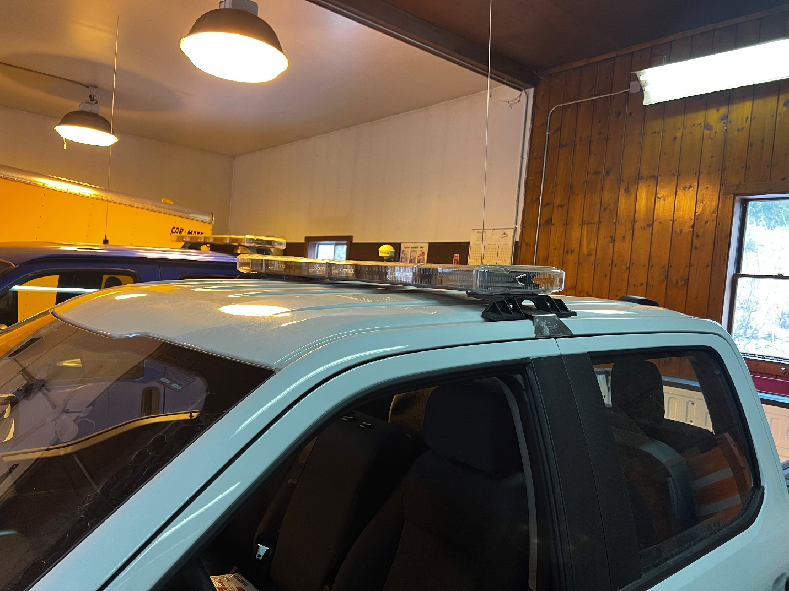

- Center Console Driver
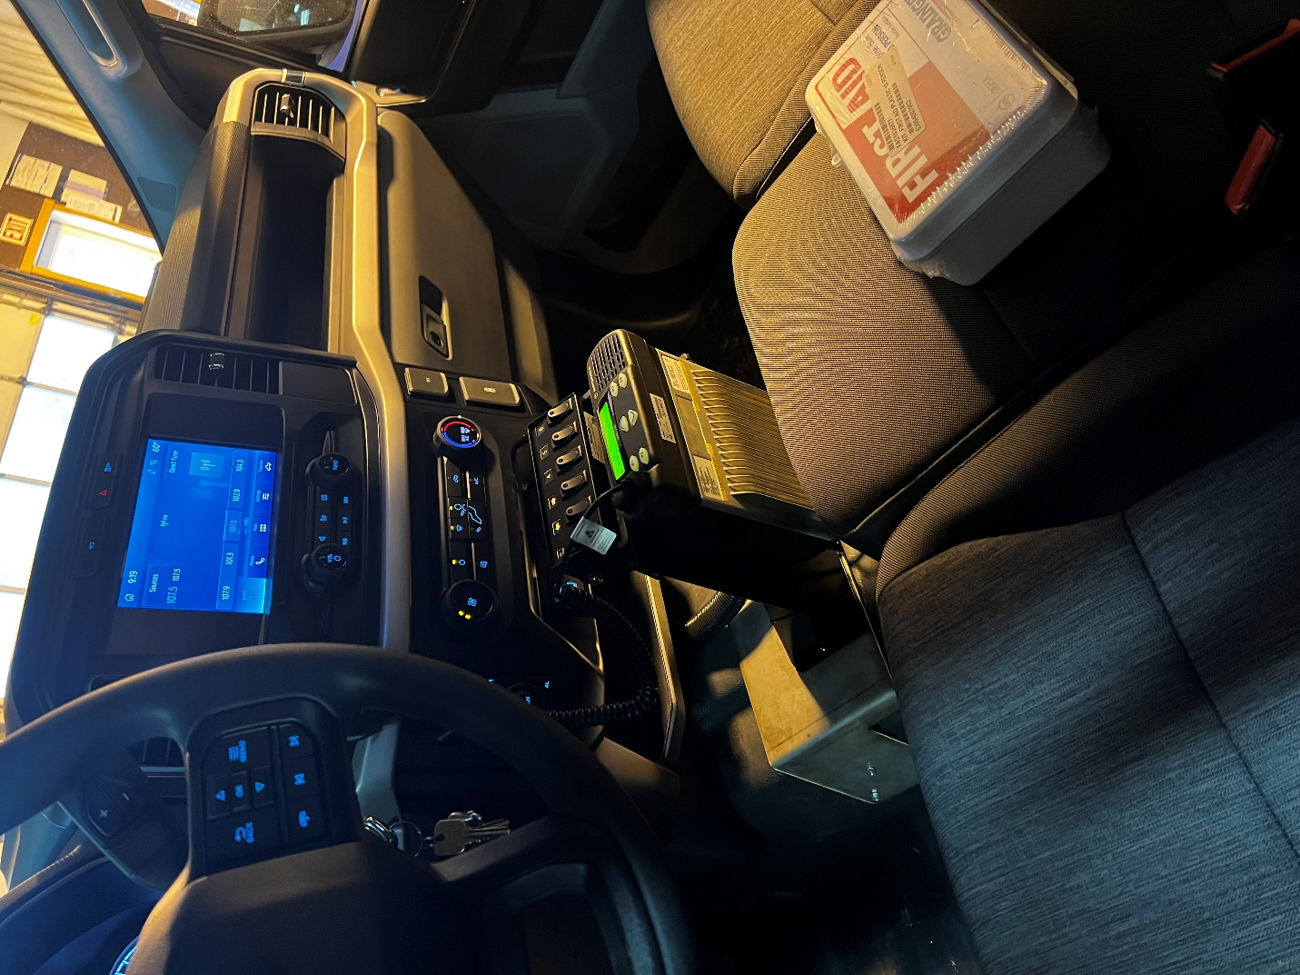

- Center Radio
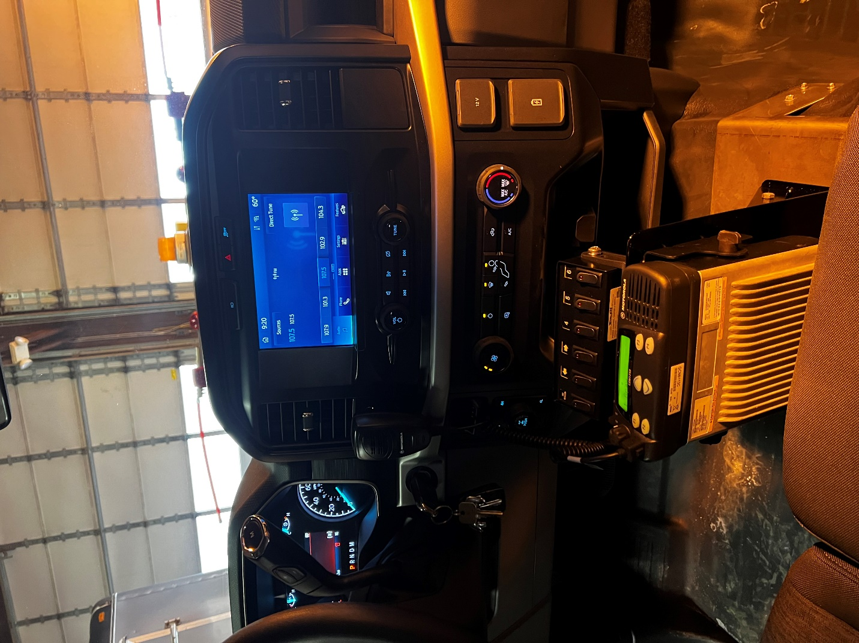

- Front View
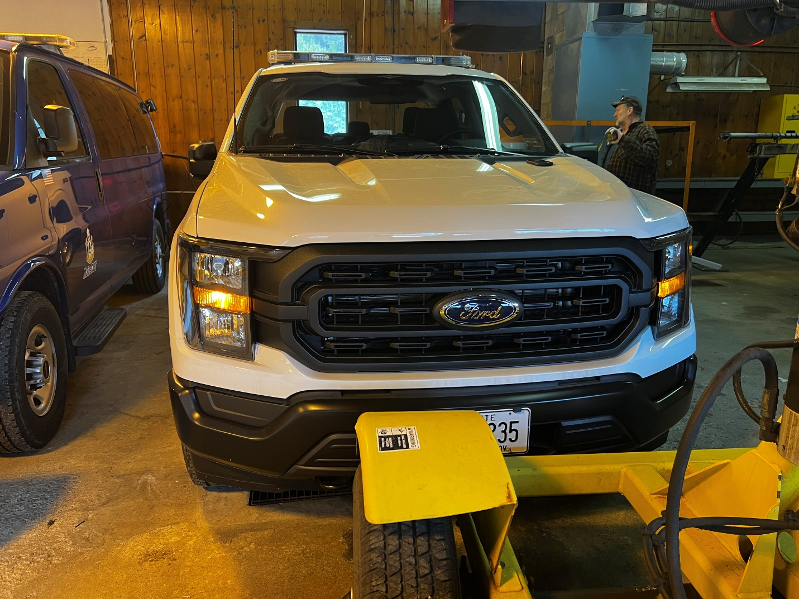

- Info Sheet
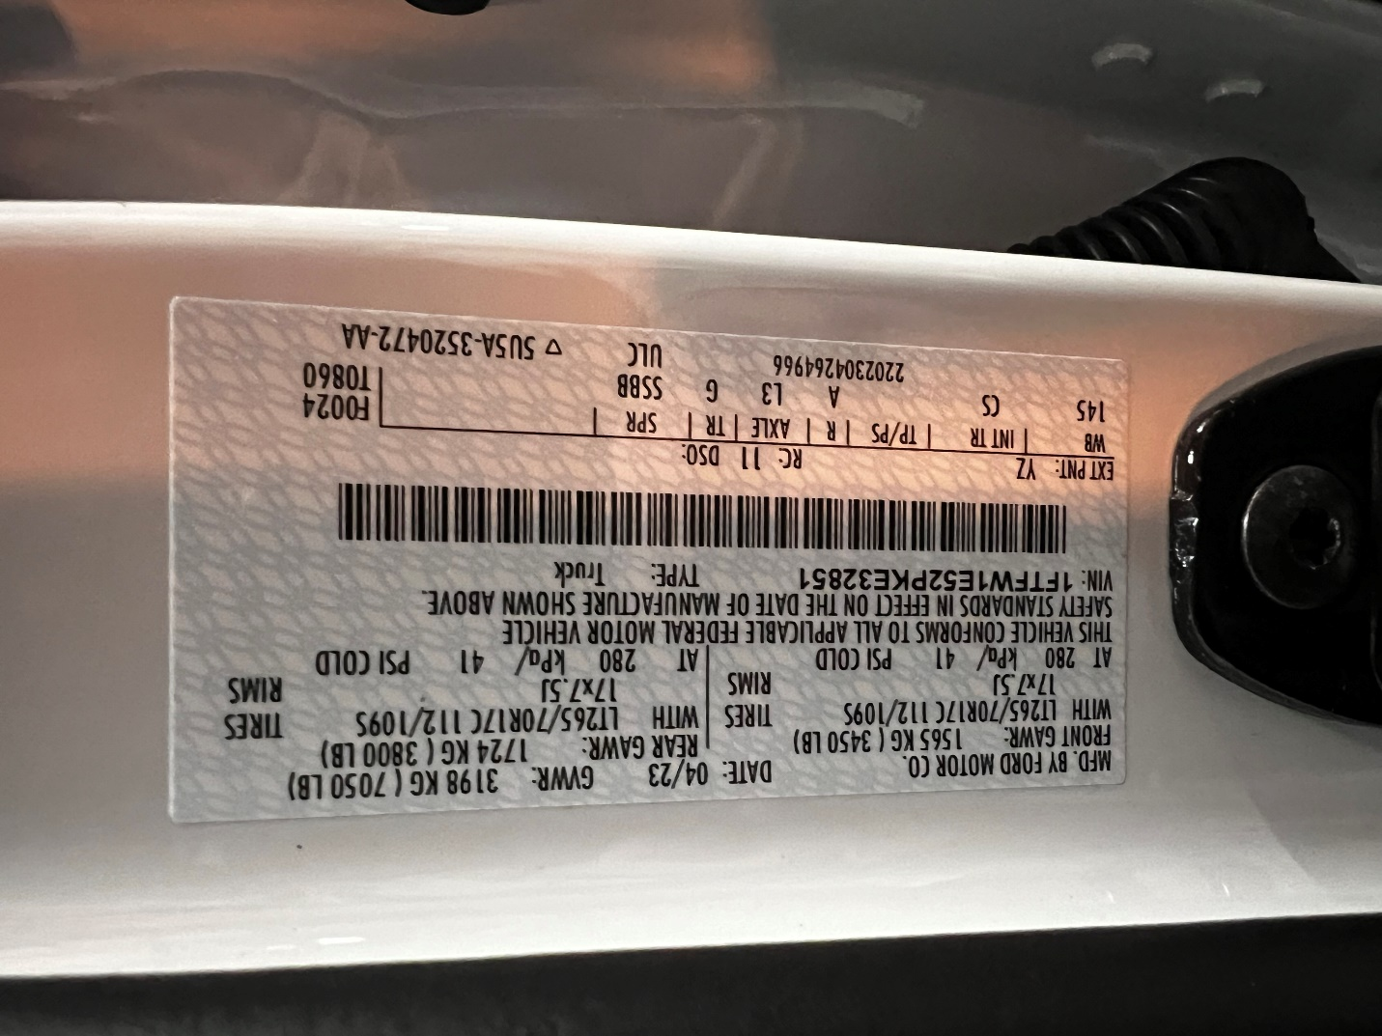

- Interior Driver
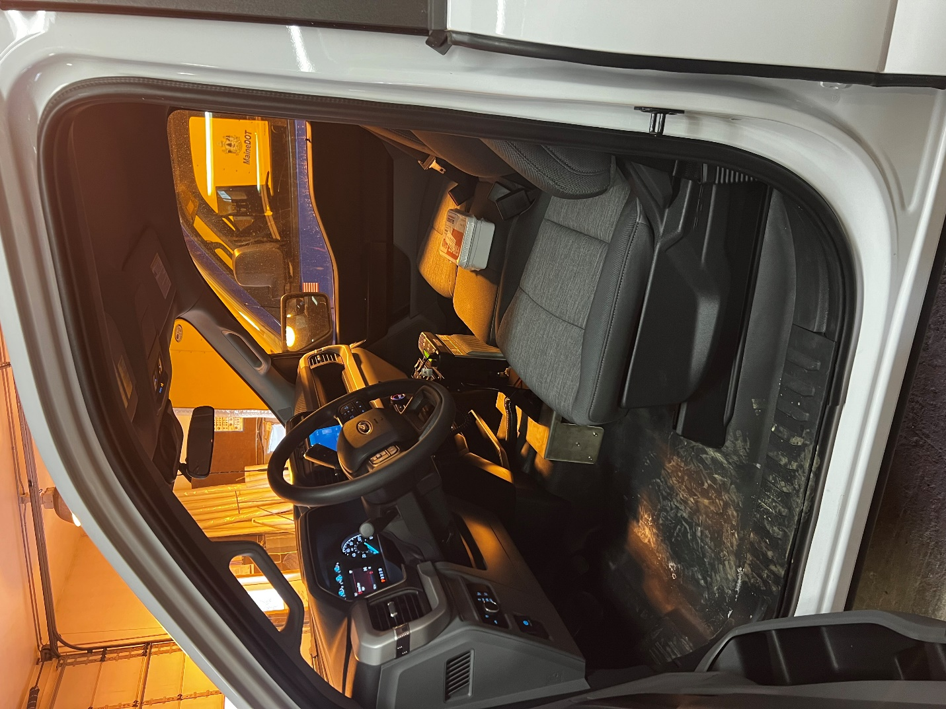

- Interior Passenger
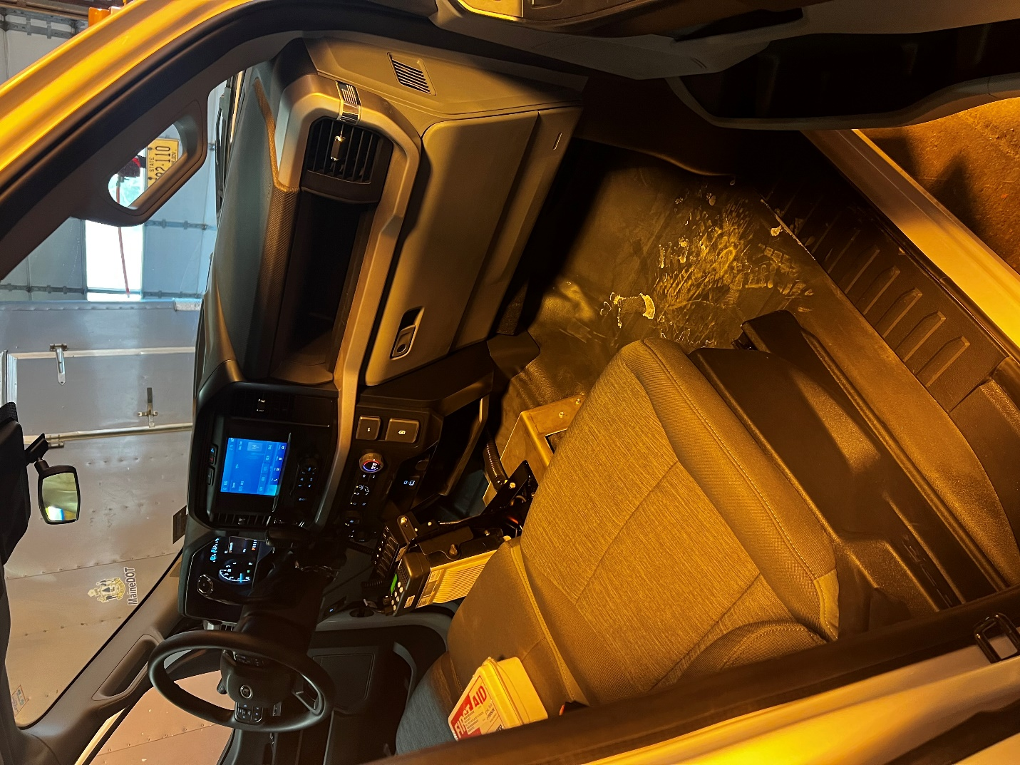

- Lightbar Bracket
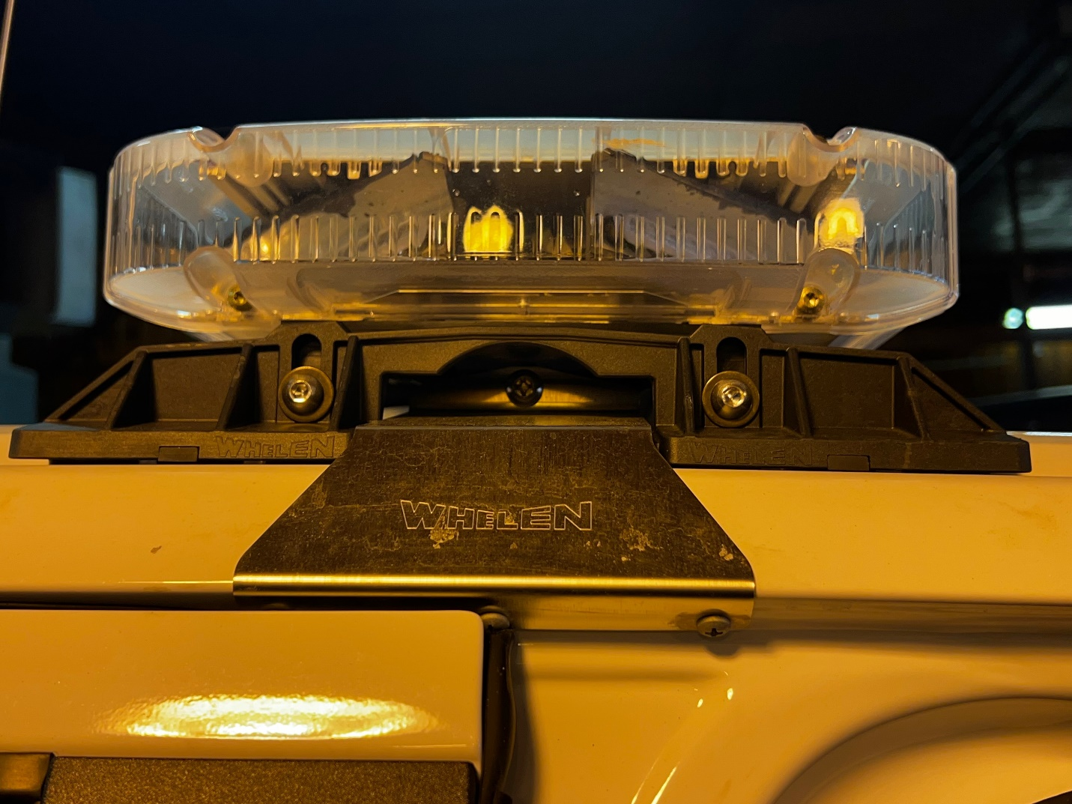

- Lightbar Wire
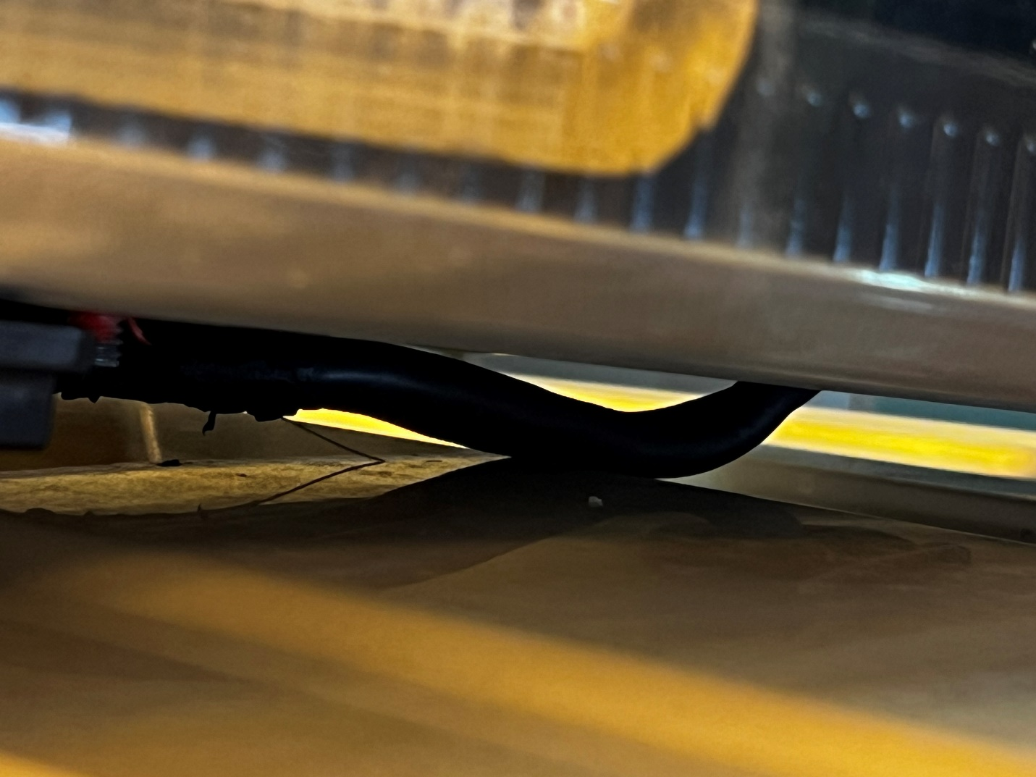

- Open Cab
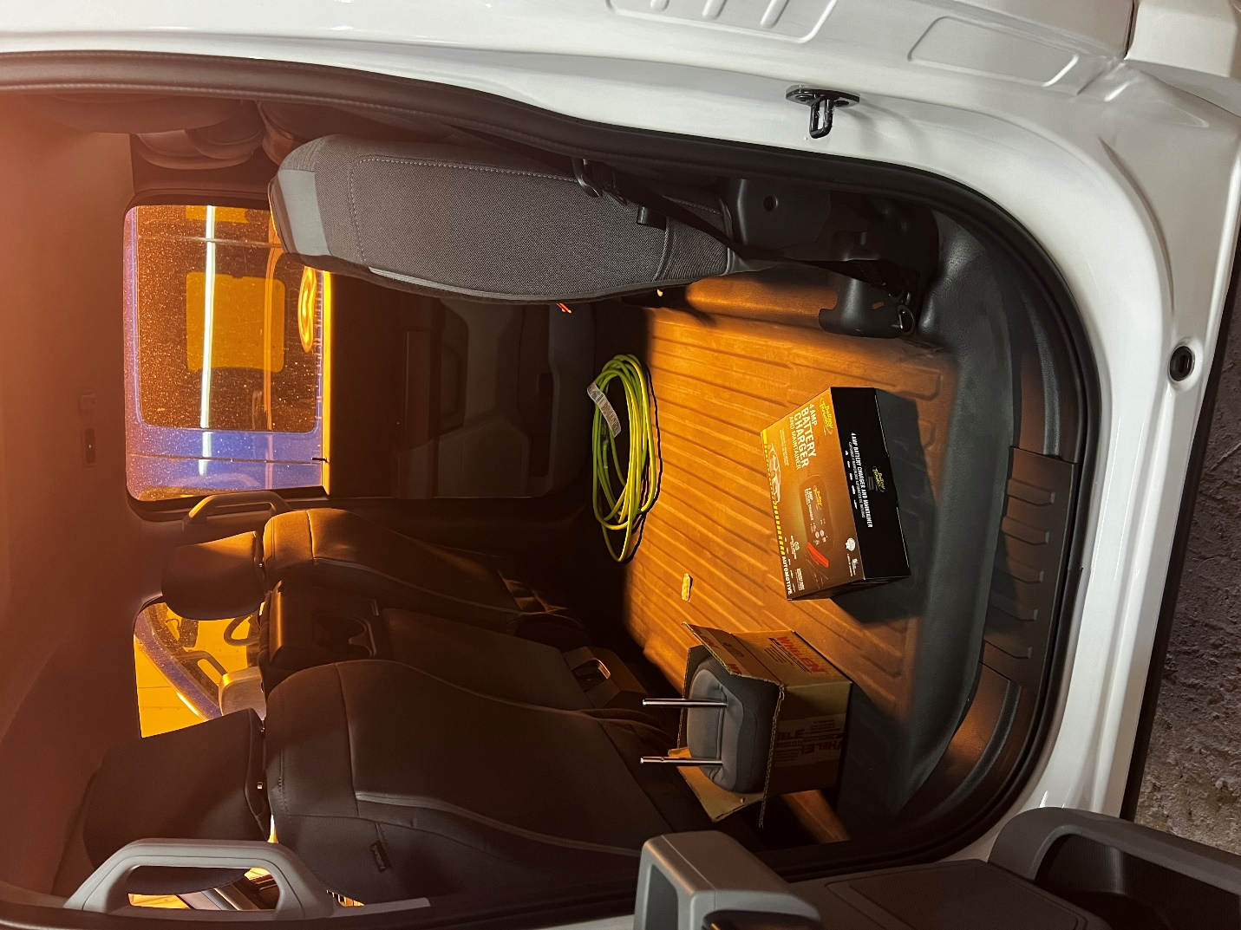

- Passenger Radio
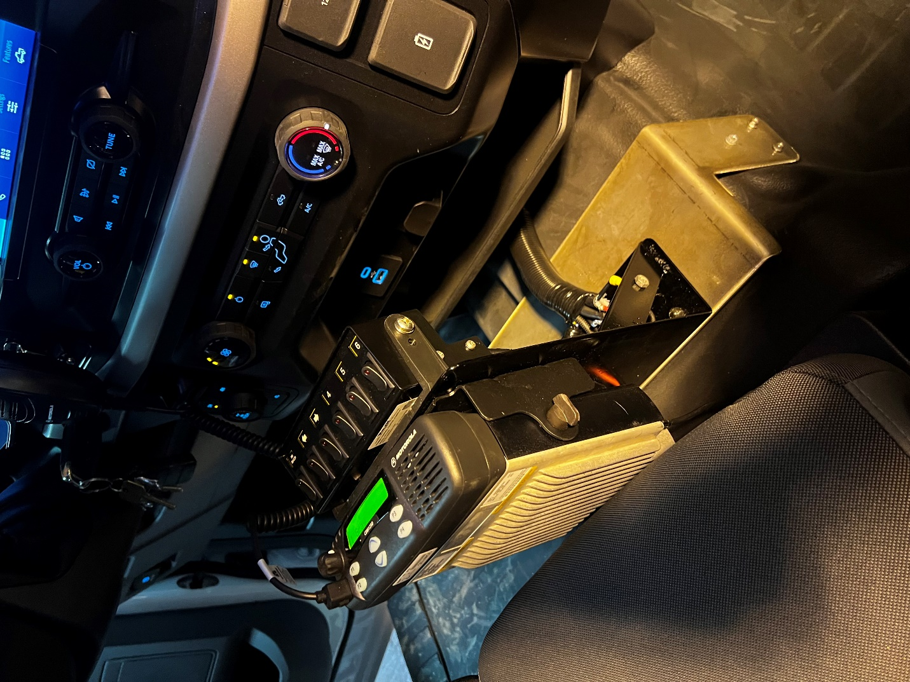

- Rear View
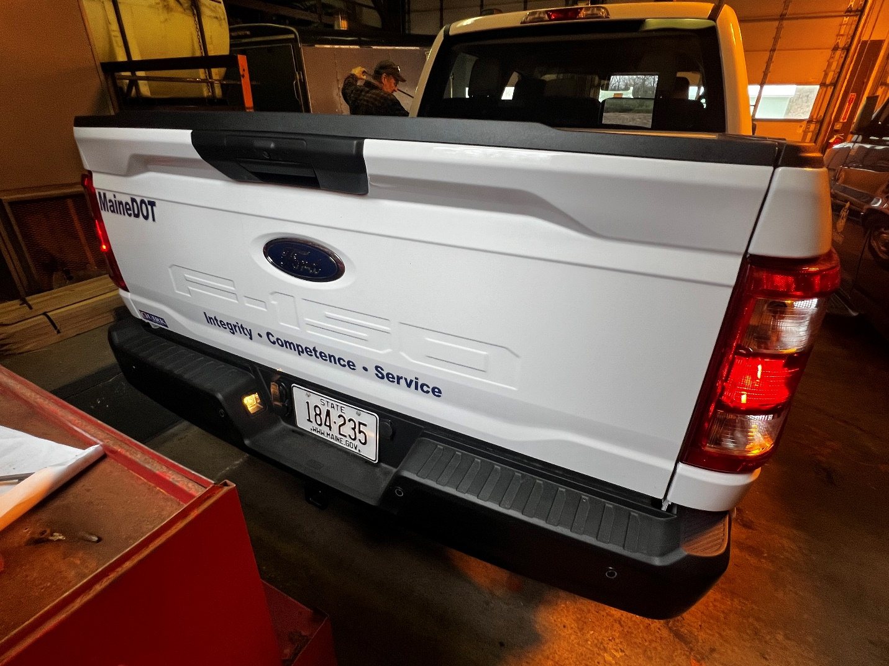

- Side View
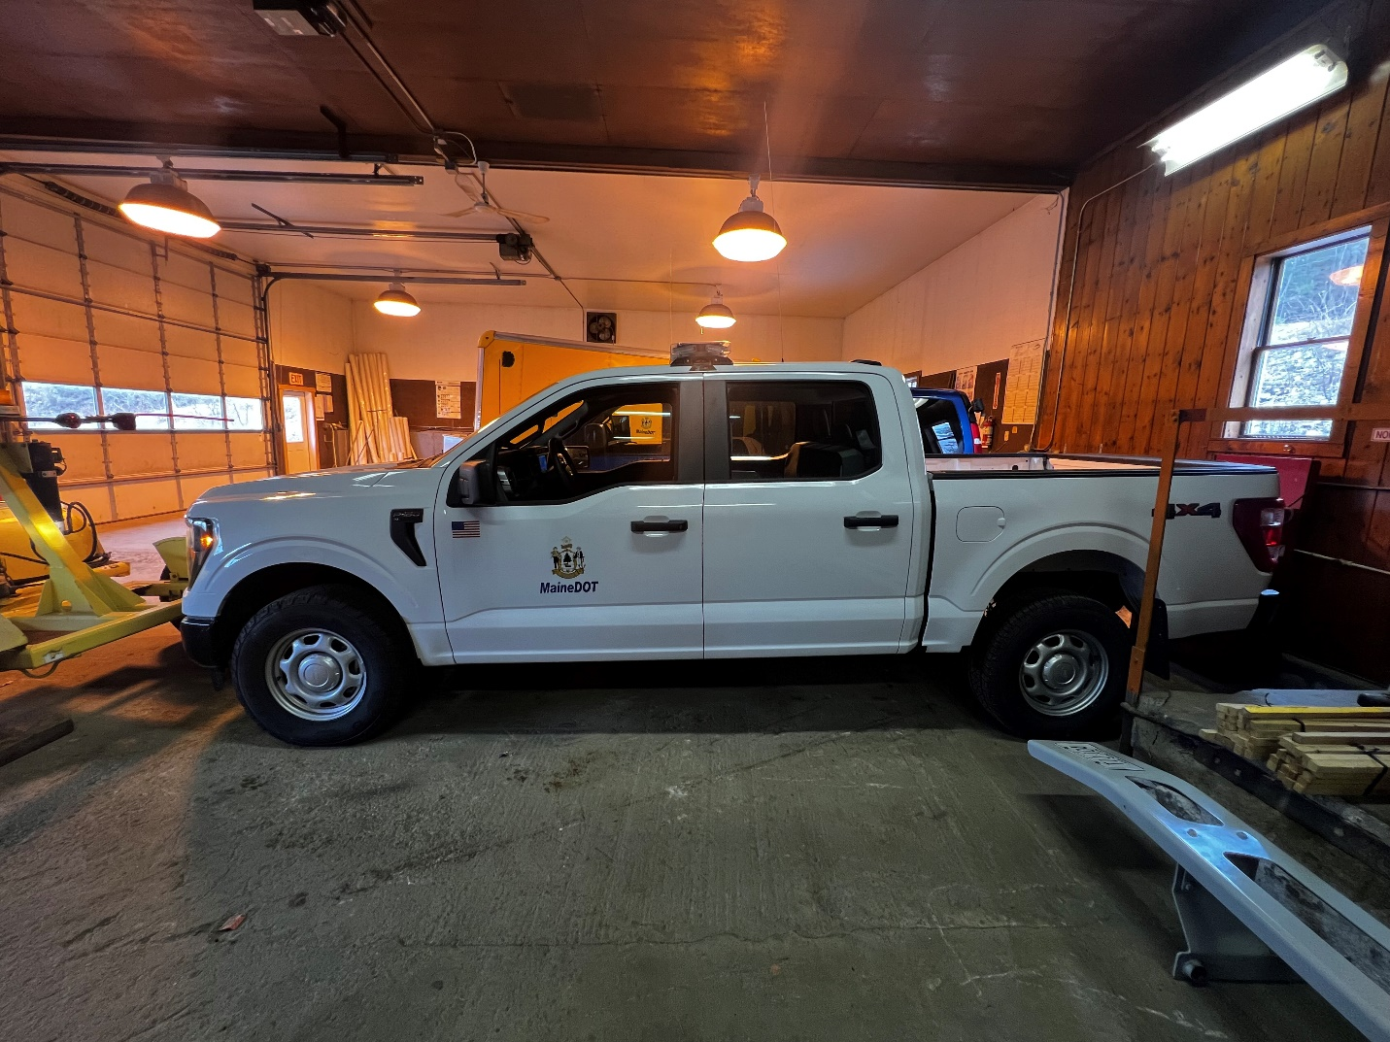

- Tire Info
